Working conditions in Mazowieckie Voivodship in 2025
0.4%
Decrease in the number of employed persons exposed to risk factors at work compared to the end 2024
In 2025, of the 1,395.5 thousand employees surveyed for working conditions, 31.2 thousand were exposed to risk factors at work. The sratio of employed persons exposed to risk factors at work per 1,000 employees in the units covered by the survey was 22.4 (compared to 21.9 in 2024).

The working conditions survey aims to identify harmful and strenuous factors in workplaces and examine their impact on employees. Proper assessment of working conditions and identification of potential risks allows employers to take preventative measures and implement appropriate occupational health and safety solutions.

Exposure to risk factors at work
In 2025, 31.2 thousand persons were exposed to risk factors at work in Mazowieckie Voivodship

In 2025, the working conditions survey in Mazowieckie Voivodship covered entities employing a total of 1,395.5 thousand persons. The survey results showed that at the end of December, 31.2 thousand persons, or 2.2% of all employees in the surveyed units, worked in harmful and strenuous conditions, compared to 405.0 thousand persons, or 6.0%, nationally. Women accounted for 14.2% of all employed persons in harmful conditions (17.6% in Poland). Compared to the previous year, the number of persons employed in the surveyed units in Mazowieckie Voivodship was 33.7 thousand (2.4%) lower, and persons exposed to risk factors at work 0.1 thousand (0.4%) lower.
Persons employed in workplaces may be exposed to risk factors arising from the work environment, strenuous work and associated with particularly dangerous machinery. Data for persons classified as the most predominant factor, i.e., the factor with the greatest harmful impact on a given workplace, is presented below.
Chart 1. Exposure to risk factors at work by group of risks in 2025
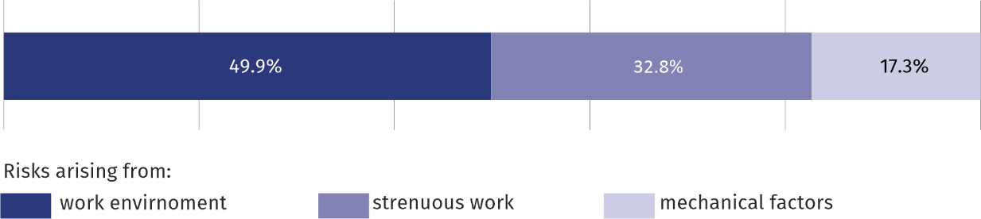
As of 31 December

Exposure to risk factors arising from the work environment
At the end of 2025, 15.6 thousand persons were exposed to risk factors arising from the work environment, representing 49.9% of all employees exposed to risk factors (compared to 47.9% the year before). Among persons employed in this risk group, the largest number worked in manufacturing (63.1%), followed by transportation and storage (8.1%) and trade; repair of motor vehicles (7.6%). Women accounted for 15.4% of the total number of persons exposed to risk factors arising from the work environment (compared to 15.5% in 2024).
In the group of persons exposed to risk factors arising from strenuous work, 18.4% are women

Exposure to risk factors arising from strenuous work
Among the employees in the group of risks related to the work environment, the largest percentage were persons employed in manufacturing (63.1%)
10.2 thousand persons were exposed to risk factors arising from strenuous work, representing 32.8% of all employees (36.0% in 2024). Among persons employed in this group of risks, the largest percentage were persons employed in manufacturing (44.9%), followed by those in transportation and storage (23.3%) and construction (10.2%). Women constituted 18.4% of the group exposed to risk factors arising from strenuous work (compared to 15.6% the previous year).

Exposure to mechanical risk factors associated with particularly dangerous machinery
Mechanical risk factors associated with particularly dangerous machinery posed a threat to 5.4 thousand persons, or 17.3% of all persons exposed to risk factors at work (compared to 16.1% the year before). Of the total number of persons exposed to mechanical risk factors, the largest number were in manufacturing (29.1%), followed by electricity, gas, steam, and air conditioning supply (25.7%), and construction (13.2%). Women accounted for 2.9% of this group (compared to 2.3% the year before).

Exposure to risk factors at work per 1,000 employees
The ratio of persons exposed to risk factors at work per 1,000 employees in the units covered by the survey for Mazowieckie Voivodship was 22.4
The scale of exposure to risk factors at work is indicated by the ratio representing the number of persons exposed to risk factors at work per 1,000 employees in the surveyed population. In the Voivodship, this indicator was 22.4 in 2025, compared to 21.9 a year earlier (nationally 59.9 against 63.9, respectively).
The risk ratio, measured by the number of employees exposed to risk factors per 1,000 employees in the surveyed unit, varies significantly depending on the type of economic activity conducted by the unit. Among the sections, the highest occupational health risk occurred in electricity, gas, steam, and air conditioning supply (125.2), followed by mining and quarrying (95.8), and water supply; sewerage, waste management and remediation activities (72.0). The safest jobs were in information and communication (2.3), followed by human health and social work activities (4.9) and professional, scientific and technical activities (5.4).
In the case of risk factors arising from the work environment, the highest ratio was recorded in electricity, gas, steam, and air conditioning supply (39.7), mining and quarrying (39.0) and manufacturing (30.8).
The most exposed to risk factors arising from strenuous work were persons employed in mining and quarrying (the ratio defining the scale of risk factors arising from strenuous work was 56.8), followed by water supply; sewerage, waste management and remediation activities (43.7), and electricity, gas, steam and air conditioning supply (20.5).
Persons employed in electricity, gas, steam and air conditioning supply were most exposed to risk factors arising from particularly dangerous machinery (the ratio showing the scale of risk was 64.9), followed by water supply; sewerage, waste management and remediation activities (18.6) and construction (8.2).
It's worth noting that employees in units may be simultaneously exposed to several risk factors (i.e., arising from the work environment, strenuous work, and risk factors associated with particularly dangerous machinery). Below, we present data on persons exposed to risk factors at work, counted as many times as they were exposed to these factors.
As of the end of December 2025, the number of persons exposed to risk factors at work was 35.4 thousand (compared to 34.0 thousand in the previous year). Of this number, 17.1 thousand, or 48.3%, were exposed to risk factors arising from the work environment. Risk factors arising from strenuous work affected 11.8 thousand, persons or 33.4%, while 6.5 thousand, or 18.3%, were exposed to risk factors associated with particularly dangerous machinery.
Among the risk factors arising from the work environment, the greatest threat was noise, which was at risk for 11.8 thousand persons, i.e. 69.0%, followed by cold microclimate (0.9 thousand, i.e. 5.4%), as well as vibrations (mechanical oscillations) – 0.9 thousand persons (5.1%).
Chart 2. Exposure ª to risk factors arising from the work environment by physical health risk factors in 2025
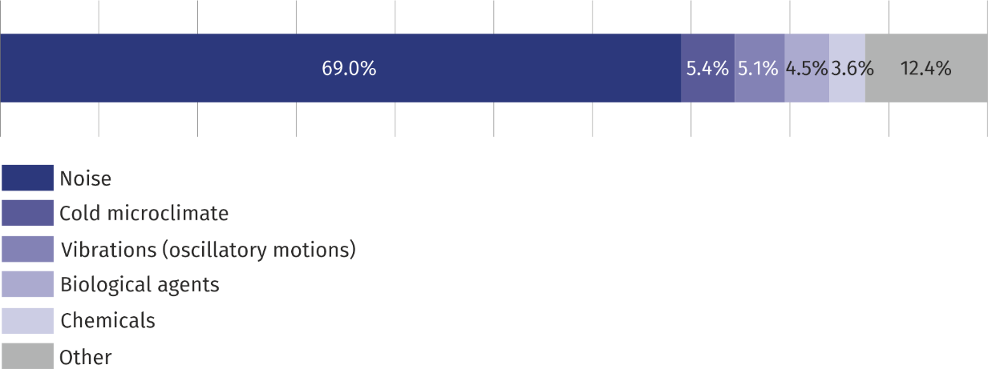
As of 31 December
a Employees listed as many times as the number of risks they are exposed to.
The group of risk factors arising from strenuous work includes, among others, excessive physical strain, which accounted for 56.0% of all risk factors arising from strenuous work, and insufficient lighting of workstations, which accounted for 18.2% of the discussed risk factors.
Chart 3. Exposure ª to risk factors arising from strenuous work by risk factors in 2025
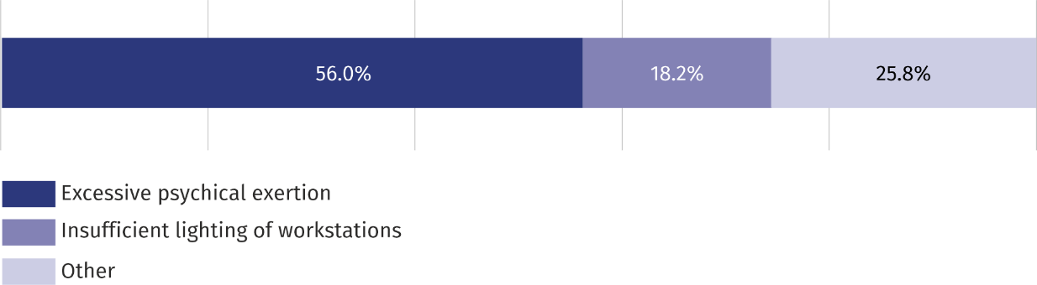
As of 31 December
a Employees listed as many times as the number of risks they are exposed to.
During the year, Mazowieckie Voivodship eliminated or reduced 10.5 thousand risk factors arising from the work environment, 1.6 thousand risk factors arising from strenuous work, and 1.5 thousand risk factors associated with particularly dangerous machinery. At the same time, 5.8 thousand newly emerged or newly identified risk factors related to the work environment, 1.8 thousand risk factors arising from strenuous work, and 1.1 thousand risk factors associated with particularly dangerous machinery were identified.
When quoting Statistics Poland data, please provide the information: “Source of data: Statistics Poland”, and when publishing calculations made on data published by Statis-tics Poland, please include the following disclaimer: “Own study based on figures from Statistics Poland”.

Prepared by:  Statistical Office in Warszawa  Director Agnieszka Ajdyn  Phone: (+48 22) 464 23 15 | Issued by:  Mazovian Centre for Regional Surveys  Statistical Information Centre  Marcin Kałuski  Mobile: (+48) 783 940 141
Press office in the Statistical Office in Warszawa  Mobile: (+48) 783 940 141  e-mail: m.kaluski@stat.gov.pl |   warszawa.new.stat.gov.pl/en/

@Warszawa_STAT

@UrzadStatystycznywWarszawie

gus_stat

glownyurzadstatystycznygus

glownyurzadstatystyczny
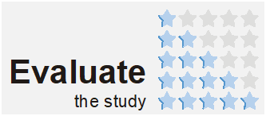
Related information
Methodological report – Working conditions – exposure to risk factors at work
Working conditions in 2025
Data available in databases
Local Data Bank
Knowledge Databases
Terms used in official statistics
Working conditions
Employees exposed to risk factors
Risks arising from work environment
Risks arising from strenuous work
Risks arising from mechanical factors associated with particularly dangerous machinery

