Students commuting to primary and post-primary schools in Mazowieckie Voivodship in the 2024/25 school year
In the 2024/25 school year, 133.4 thousand students, i.e. 16.9% of all persons aged 7-19, left their place of residence for primary and post-primary schools for children and youth. The commuting students constituted 5.7% of primary school students and 38.9% of secondary school students in Mazowieckie Voivodship.
Students commuting to schools are understood as students whose gmina of residence is different from the gmina in which they study

133.4 thousand
Number of students commuting to primary and post-primary schools for children and youth

Outgoing students to primary and post-primary schools for children and youth
In the 2024/25 school year, there was a total of 133.4 thousand students whose gmina of residence in Mazowieckie Voivodship was different from the gmina they attended primary and secondary schools for children and youth. On average, they constituted 16.9% of all persons aged 7-19 (nationally 18.2%), with the share of outgoing students in the age group corresponding to post-primary school (15-19) being significantly higher than for primary school (7-14), amounting to 35.4% and 5.9%, respectively (compared to 39.9% and 5.6% in the previous year).
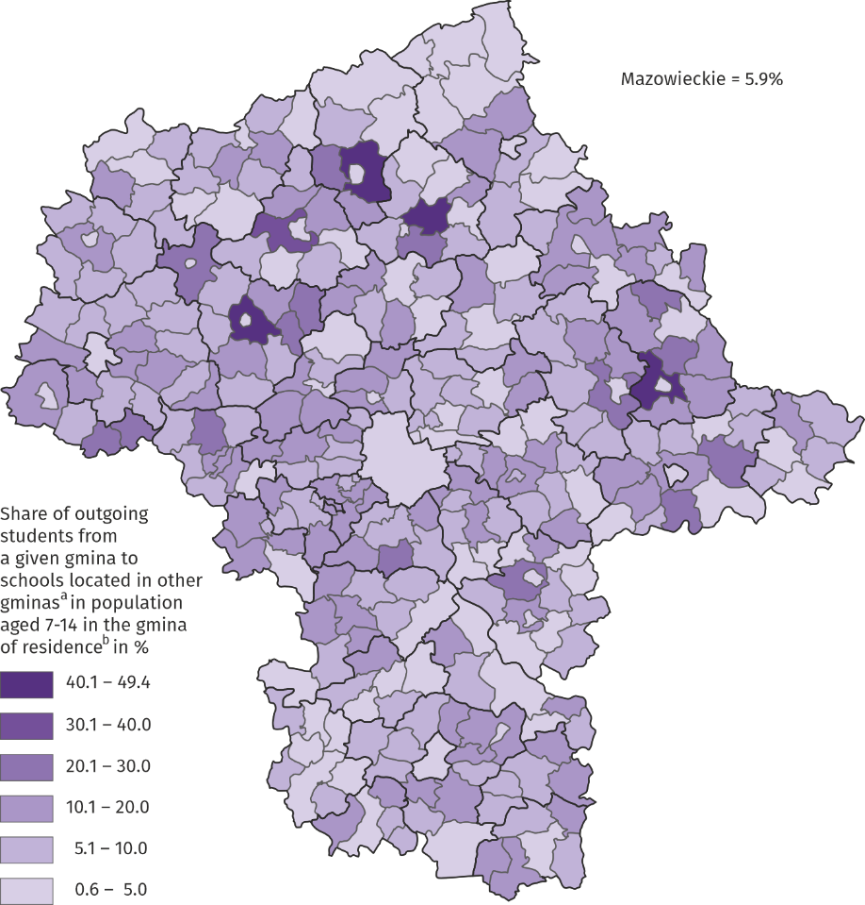
Map 1. Share of outgoing students to primary schools for children and youth by gmina of residence in the 2024/25 school year
Outgoing students are stu-dents who leave their gmina of residence in Mazowieckie Voivodship to any other gmi-na in the country where their school is located

a On 30 September 2024 b On 31 December 2024.
The share of students leaving their place of residence to go to school among both 7–14-year-olds and 15–19-year-olds varied significantly by territory.
In the case of children and youth studying in primary schools, the discussed indicator ranged from 0.6% to 49.4% and had the lowest values in urban gminas, while the highest in the rural gminas located in their vicinity. In five gminas, the percentage of persons aged 7–14 going to schools for children and youth exceeded 30%, reaching the highest value in the rural gminas of Sokołów Podlaski (49.4%) and Przasnysz (46.9%)
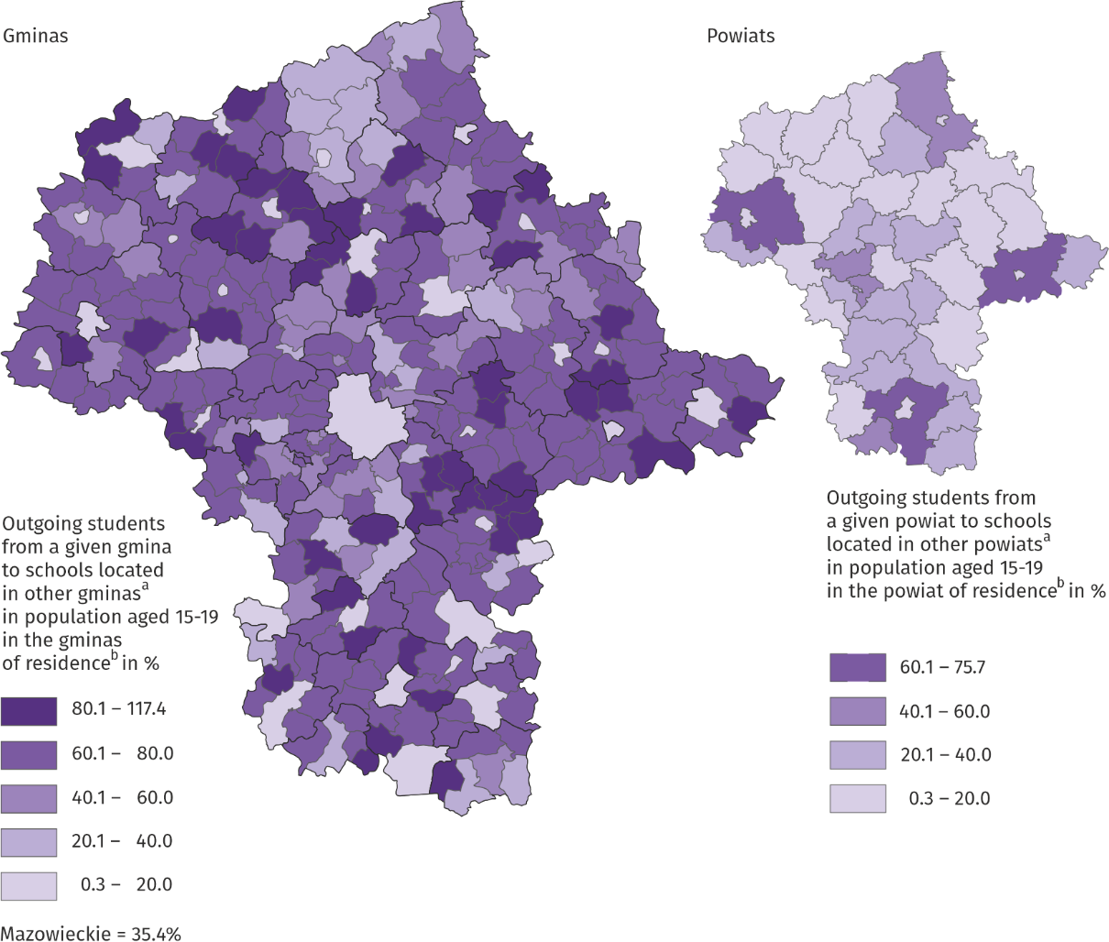
Map 2. Share of outgoing students to post-primary schools for children and youth by powiat of residence in the 2024/25 school year
In Mazowieckie Voivodship, 41% of all students leaving their homes for school were residents of 7 powiats bordering with Warszawa
a On 30 September 2024 b On 31 December 2024.
As many as 35.4% of persons aged 15–19 in Mazowieckie Voivodship received education in a gmina other than their place of residence, with one in five students in this age group attending school in a different powiat. This stems from the fact that when choosing a secondary school, young people usually look for a school offering vocational training in line with their interests or are guided by its reputation, and such schools are located mainly in larger urban centres. It's also significant that when choosing a post-primary school, young people are usually guided by the educational offerings of the institution, which align with their interests, reputation, and transportation accessibility. The share of students leaving their place of residence to attend post-secondary schools for youth was the lowest for cities with powiat status (below 1.8%), and the highest for the Brok gmina (117.4% – there are no post-secondary schools in the gminas and some of the outgoing students are aged other than 15–19) – in the case of inter-gmina flows, and for the following powiats: siedlecki, radomski and płocki (above 60%) in the case of inter-powiat flows.
The top ten gminas with the largest number of students leaving their place of residence for primary and post-primary schools included Warszawa and gminas located in its close surroundings. It is worth noting that the majority of those leaving the capital – unlike those in the surrounding gminas – are primary school students. [see Table 1.]
Some children and youth living in Mazowieckie Voivodship (approx. 3%) left for schools located in other voivodships. In the case of both primary and post-primary schools, the most common destinations were the gminas of Lubelskie and Łódzkie Voivodships.
Table 1. Gminas in Mazowieckie Voivodship with the largest number of outgoing students to schools for children and youth in the 2024/25 school year
As of 30 September
Gmina | Number of outgoing students | Mazowieckie Voivodship=100
Gm. m.st. Warszawa | 3747 | 2,8
Gm. m-w. Piaseczno | 3566 | 2,7
Gm. m-w. Grodzisk Mazowiecki | 2263 | 1,7
Gm. w. Lesznowola | 2218 | 1,7
Gm. m. Marki | 2146 | 1,6
Gm. m. Ząbki | 2004 | 1,5
Gm. m. Pruszków | 1995 | 1,5
Gm. m-w. Brwinów | 1976 | 1,5
Gm. m-w. Łomianki | 1676 | 1,3
Gm. w. Jabłonna | 1607 | 1,2
Incoming students to primary and post-primary schools for children and youth
Table 2. Gminas in Mazowieckie Voivodship with the largest number of incoming students to schools for children and youth in the 2024/2025 school year
Stan w dniu 30 września
Gmina | Number of incoming students | Mazowieckie Voivodship=100
Gm. m.st. Warszawa | 31605 | 23,9
Gm. m. Radom | 7996 | 6,1
Gm. m. Płock | 5382 | 4,1
Gm. m. Siedlce | 4612 | 3,5
Gm. m. Mińsk Mazowiecki | 4247 | 3,2
Gm. m. Ostrołęka | 3721 | 2,8
Gm. m. Garwolin | 2932 | 2,2
Gm. m. Ciechanów | 2740 | 2,1
Gm. m-w. Piaseczno | 2465 | 1,9
Gm. m. Sochaczew | 2265 | 1,7

In primary and post-primary schools for children and youth located in Mazowieckie Voivod-ship, a total of 132.1 thousand persons were studying who commuted from another gmina in the country. The incoming students constituted 5.7% of primary school students (as in the 2023/24 school year) and 38.9% of post-primary school students (by 1.3 pp less).
Among the 10 gminas in Mazowieckie Voivodship with the largest number of students coming to schools for children and youth, there were all cities with powiat status, which emphasises their position as centers of educational services in the region. The remaining ones are four district cities and one urban-rural gmina bordering the m.st. Warszawa. [see Table 2.]
The most frequently chosen city as a place of study was the capital. 12.6% of students of primary schools for children and youth and 27.1% of students of post-primary schools for youth whose place of residence was other than Warszawa attended institutions there.
Students coming from other voivodships to schools in Mazowieckie Voivodship constituted less than 2.0% of all incoming students. Most persons came to primary schools for children and youth from Lubelskie, Łódzkie and Podlaskie Voivodships. In post-primary schools for youth, more than every third student coming from outside the Voivodship was a resident of the Lublin region.
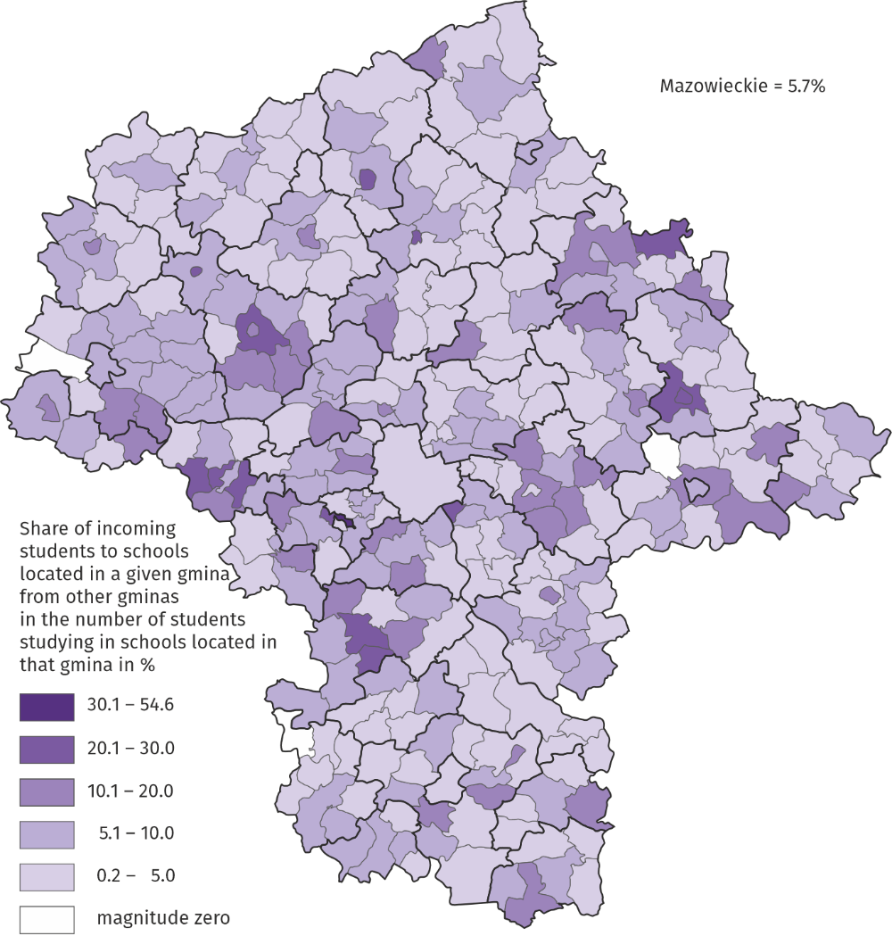
Map 3. Share of iIncoming students to primary schools for children and youth by gmina of receiving education in the 2024/25 school year
As of 30 September
Incoming students are stu-dents who come to the gmi-na where their place of study is located from any other gmina in the country

The share of students coming to primary schools from another gmina ranged from 0.2% to 54.6%; it was the highest in the town of Podkowa Leśna, followed by the urban gmina of Raciąż and the rural gmina of Goszczyn. In the facilities in the gminas of Nowy Duninów, Odrzywół and Mokobody there were no students commuting from other territorial units.
In Mazowieckie Voivodship, students coming to secondary schools from other powiats constituted an average of 22.7%, with the highest percentage occurring in two cities with powiat status – Ostrołęka and Siedlce (54.6% and 52.7%, respectively). In the case of inter-gmina flows, the highest share of students commuting to this type of institution (over 90%) was recorded in the following gminas: Siennica, Płoniawy-Bramura, Dębe Wielkie, and Klembów.
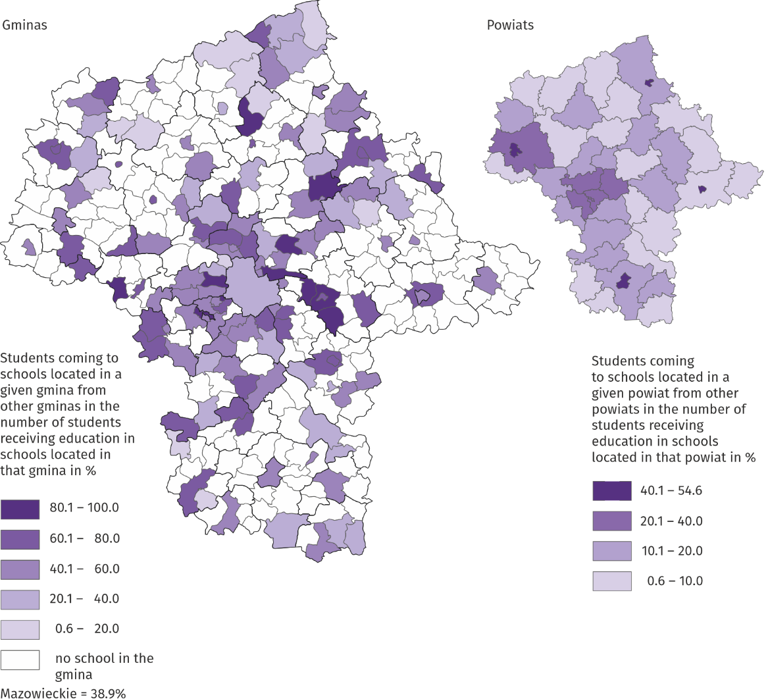
Map 4. Share of students coming to post-primary schools for youth by powiat of receiving education in the 2024/25 school year
As of 30 September

Arrivals at primary and post-primary schools for children and youth located in cities with powiat status in Mazowieckie Voivodship
Cities with powiat status, which are former voivodship cities, strongly attract children and youth to school facilities due to the large number of schools, comprehensive educational offer and well-organised public transport.
For these cities, the spheres of influence clearly differed in size and scope of influence. In the case of primary schools, they covered from a dozen to several dozen gminas forming a concentric system around the central city.
However, in the case of post-primary schools, the spheres of influence had a much larger scope, also of a supra-regional nature. In each of the cities with powiat status in Mazowieckie Voivodship, young people from other voivodships, mainly neighbouring ones, studied, and in the case of the m.st. Warszawa from almost all of Poland. The largest number of them attended institutions in Siedlce.
The maps below show the influence zones of individual cities with powiat status. These zones were determined by selecting from all recorded flows gminas in Mazowieckie Voivodship with at least five students attending schools in cities with powiat status.
Note to map 5 and 6. The inter-gmina flow matrices do not include flows of fewer than 5 persons.
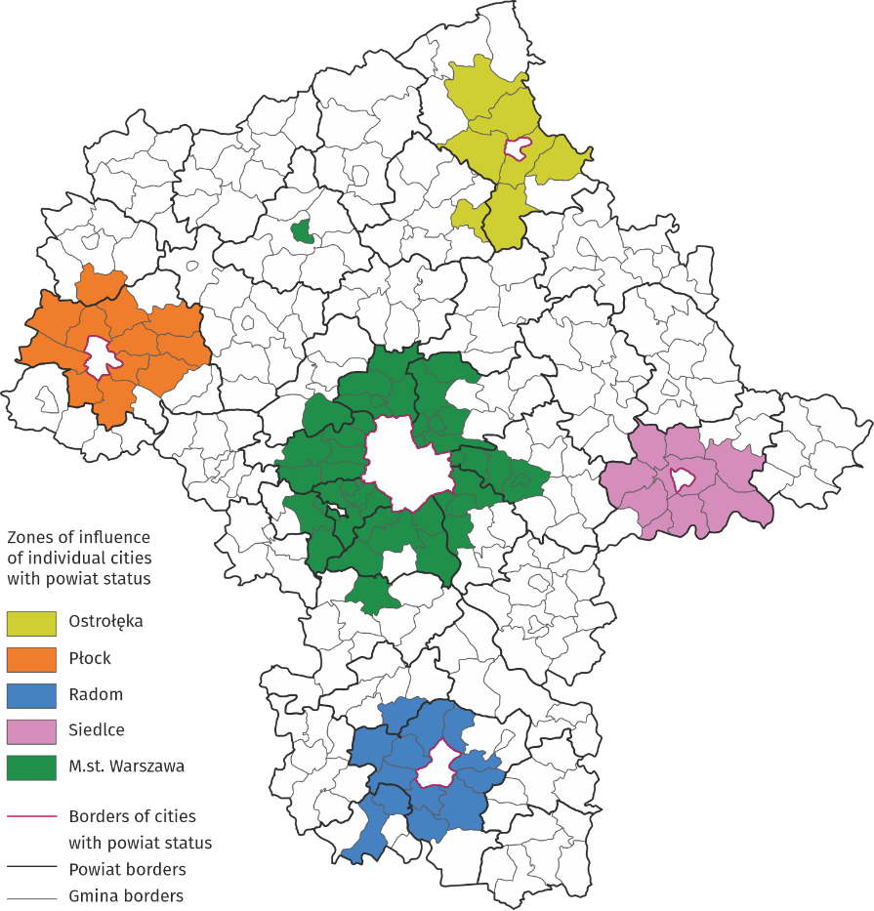
Map 5. Zones of influence of individual cities with powiats status in Mazowieckie Voivodship in the 2024/25 school year – primary schools for children and youth

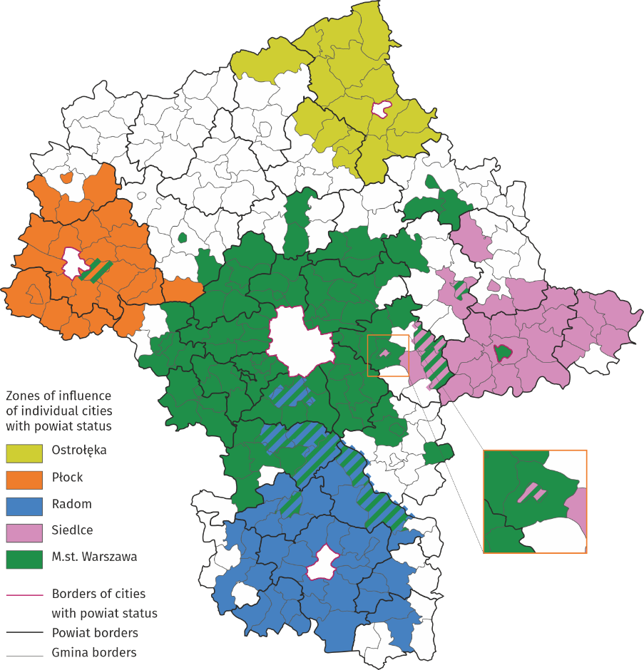
Map 6. Zones of influence of individual cities with powiat status in Mazowieckie Voivodship in the 2023/24 school year – post-primary schools for youth

Prepared by:  Statistical Office in Warszawa  Director Agnieszka Ajdyn  Phone: (+ 48 22) 464 23 15 | Issued by:  Mazovian Centre for Regional Surveys  Statistical Information Centre  Mobile: (+ 48) 783 940 141
Press office in the Statistical Office in Warszawa  Mobile: (+ 48) 783 940 141  e-mail: m.kaluski@stat.gov.pl |   warszawa.stat.gov.pl/en/

@Warszawa_STAT

@UrzadStatystycznywWarszawie

gus_stat

glownyurzadstatystycznygus

glownyurzadstatystyczny

Related information
Students commuting to primary and post-primary schools in Mazowieckie Voivodship in the 2023/2024 school year
Students commuting to primary and post-primary schools in the 2024/2025 school year

In the case of quoting data from the Statistics Poland, please provide information “Statistics Poland data source”, and in the case of publishing calculations made on data published by the Statistics Poland, provide information: “Own study based on Statistics Poland data”.

