Entities of the national economy in the REGON register in Mazowieckie Voivodship. As of the end of 2019

At the end of 2019, there were 854457 entities of the national economy registered, i.e. by 4.7% more than in the previous year. Over half of the units (53.4%) had their seat in m.st. Warszawa. The largest number of entities (21.9%) dealt with trade; repair of motor vehicles, however the highest increase as compared to 2018 occurred in the section of information and communication (by 9.9%).

 104.7

Dynamics of entities of the national economy

**General characteristics of entities of the national economy**

Every fifth entity of the national economy in the REGON register was registered in Mazowieckie Voivodship

In Mazowieckie Voivodshiop at the end of December 2019, there were 854457 entities registered in the REGON register, i.e. 18.9% of the total entities registered in the country. Compared to the previous year, the number of entities in Mazowieckie Voivodship increased by 4.7%, and compared to 2010 it was higher by 25.5%.

Chart 1. Entities of the national economy in the REGON register in 2010–2019

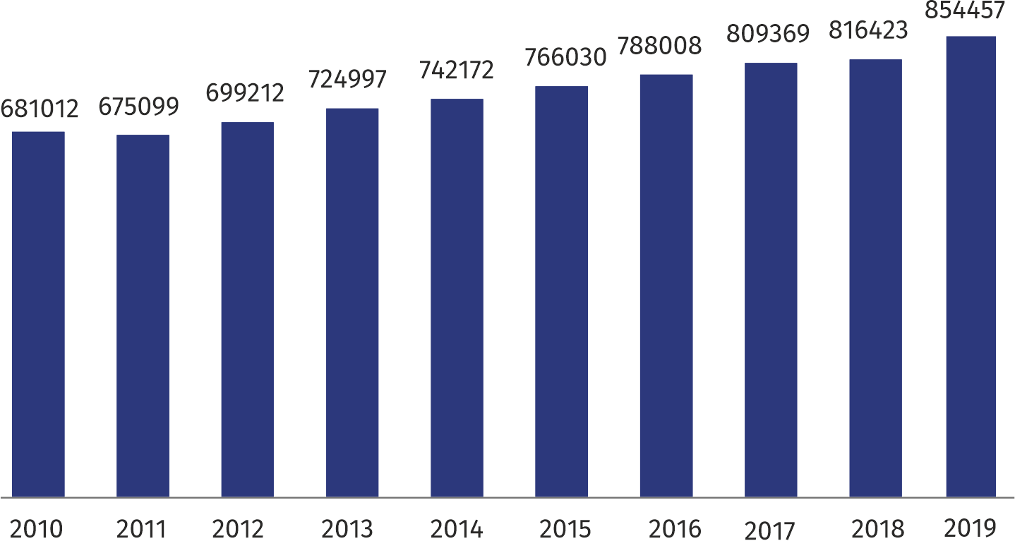

Among powiats and cities with powiat status, the largest number of newly registered entities (except for Warsaw capital city) were in the powiats: piaseczyński (36276) – 4.2%, wołomiński (33314) – 3.9%, pruszkowski (30010) ­– 3.5%, and in Radom (24626) – 2.9%. While the smallest number of registered entities was in the powiats: zwoleński (2403), łosicki (2424), lipski (2697), żuromiński (2807), białobrzeski (2864) and przysuski (2940) – by 0.3% each.

The largest increase in the number of entities was in wołomiński (by 5.8%), siedlecki, radomskiand ostrołęcki powiat – by 5.7% each. The highest drop was recorded only in Płock (by 1.0%).

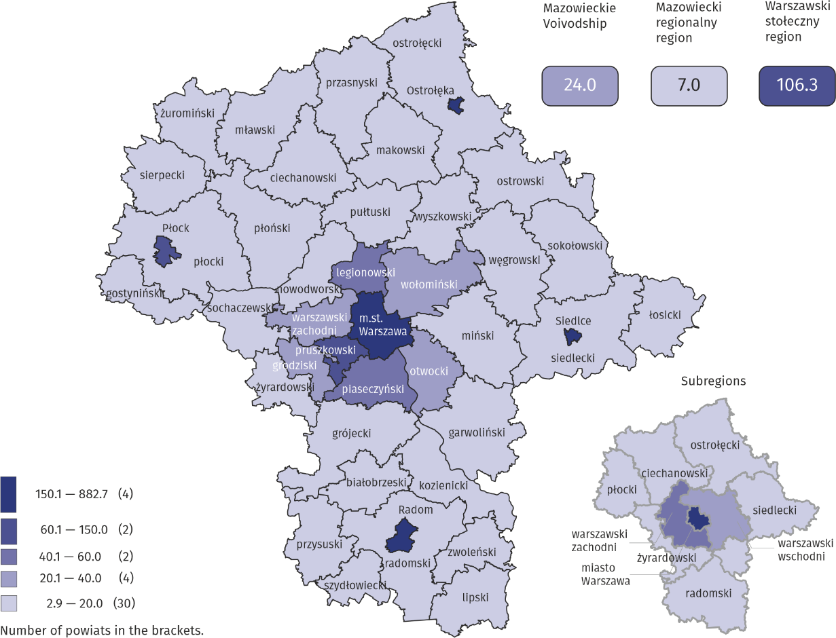**Map 1. Entities of the national economy per 1 km2 by powiats in 2019**

The number of registered units per 1 km2 was 15 times higher in warszawski stołeczny region than in mazowiecki regionalny

**Entities of the national economy by kind of conducted activity**

Every fourth entity conducted activity in the field of trade; repair of motor vehicles

In Mazowieckie Voivodship at the end of December 2019, the most numerous group of entities represented units conducting activity in the field of: trade; repair of motor vehicles – 186940, professional, scientific and technical activity – 128405, construction – 84668 and industry – 65566.

Compared to 2018, the number of entities increased, among others, in the following sections: information and communication (by 9.9%), administrative and support service activities (by 7.4%), construction (by 7.3%), other service activities (by 6.8%), arts, entertainment and recreation (by 6.5%). A decrease was recorded only in the agriculture, forestry and fishing section (by 0.2%).

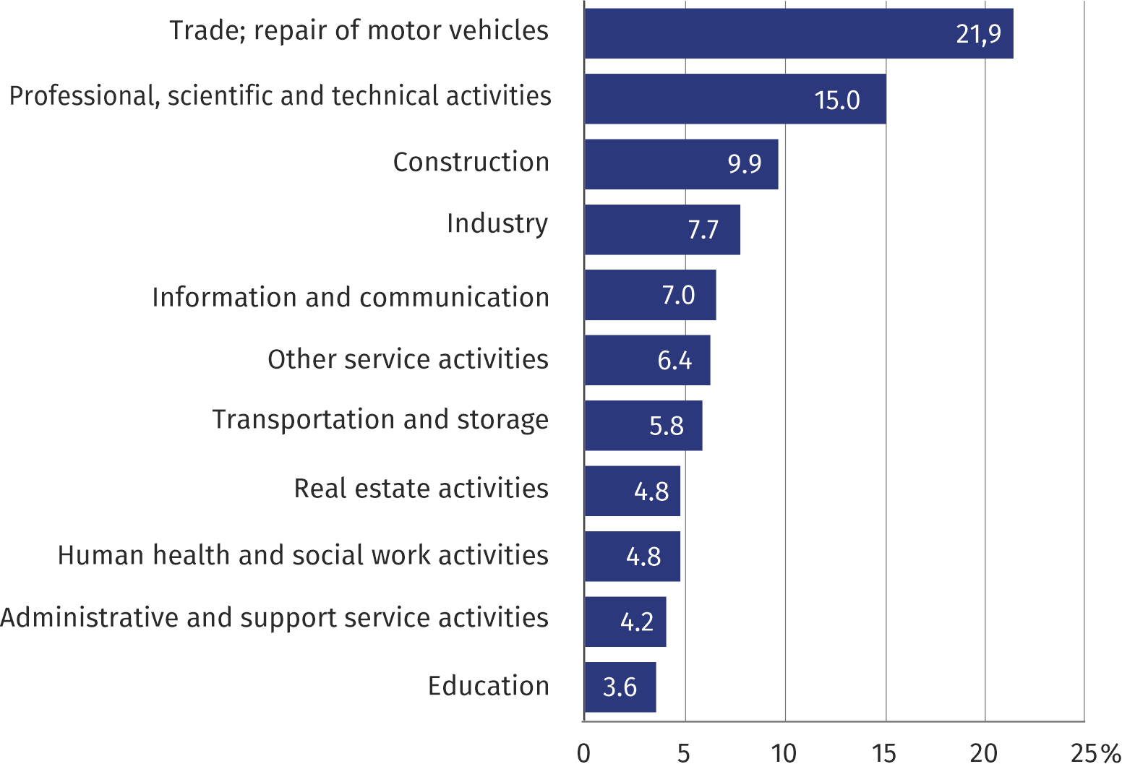**Chart 2. Share of entities of the national economy by selected sections of PKD (Nace Rev.) in 2019**

**Entities of the national economy by legal status**

Public sector entities accounted for only 1.4% of total units in the voivodship

As in 2018, the vast majority, that is 812195, i.e. 95.1% of the total number of entities were private sector entities. Among entities of this sector, 68.9% represented natural persons conducting economic activity, primarily: in trade; repair of motor vehicles (120035 entities), professional, scientific and technical activities (92226 entities) and in construction (62731 entities).

There were 12101 public sector entities registered in the REGON register, which belonged mainly to the education section (4739 entities) and real estate activities (2619 entities).

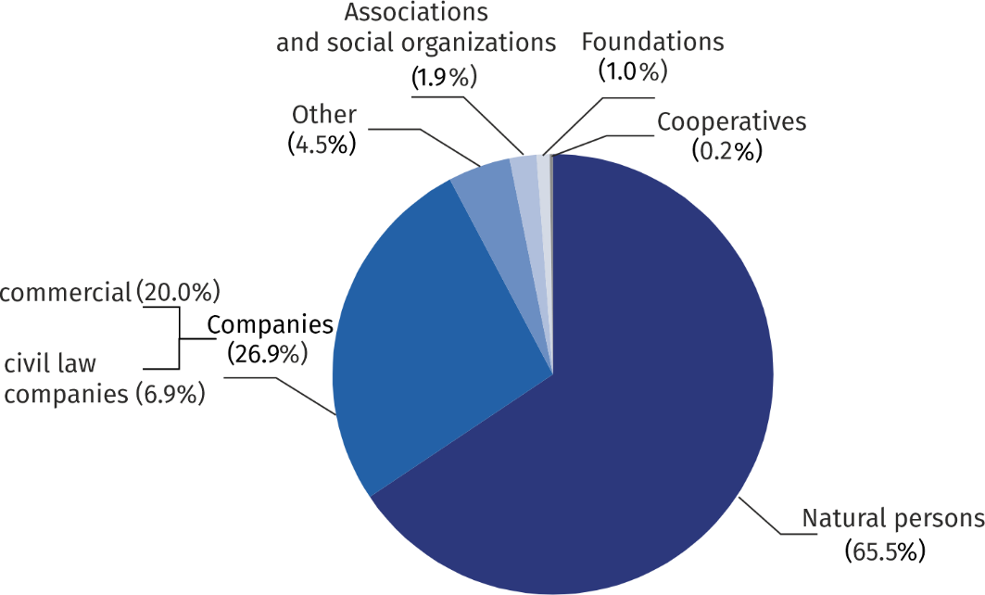**Chart 3. Structure of entities of the national economy by legal status in 2019**

At the end of December 2019, there were 559450 natural persons conducting economic activity registered in the REGON register, i.e. by 4.5% more than in the previous year. In the territorial cross-section, the highest increase took place in the following powiats: radomski (by 6.0%), piaseczyński and wołomiński (by 5.8% each), nowodworski, grodziski and warszawski zachodni (by 5.7% each). The decline was recorded in Płock (by 2.2%).

The highest share of natural persons in the total number of entities was in the powiats: zwoleński (83.7%) and radomski (83.6%), while the lowest in m.st. Warszawa (55.6%) and piaseczyński powiat (66.2%).

The number of registered commercial companies (170518) accounted for 32.7% of total commercial companies registered in the country. Over the year their number in the voivodship increased by 7.2%, and the largest decrease was recorded in the powiats: siedlecki and żyrardowski (by 14.5% each), sierpecki (by 10.4%), węgrowski and radomski (by 10.1% each). The decrease in the number of commercial companies (by 0.8%) was recorded in piaseczyński powiat.

The vast majority of commercial companies were capital commercial companies (88.4%) and they were mainly limited liability companies (86.1%). Out of partnerships (11.6%) the most popular legal status were limited partnerships (6.5% of total commercial companies) and unlimited partnerships (3.9%).

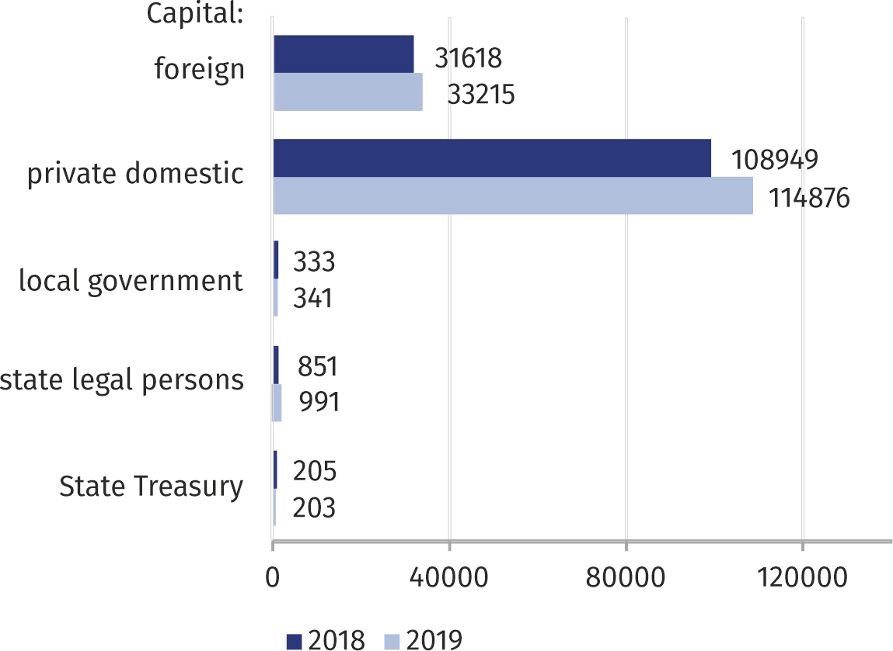Chart 4. Commercial companies by type of capital

Activity of commercial companies concentrated primarily in the sections: trade; repair of motor vehicles (24.7%), professional, scientific and technical activities (16.8%), construction (9.9%), industry and information and communication (9.2% each).

At the end of December 2019, the number of registered commercial companies amounted to 58621, i.e. by 0.8% more than a year before. The highest increase was recorded in the powiats: łosicki (by 4.1%), wołomiński (by 3.9%), przysuski (by 3.4%), płocki (by 3.0%), sokołowski (by 2.9%). Whereas the highest drop was recorded in miński powiat (by 2.0%). Commercial companies concentrated their activities primarily in the sections: trade; repair of motor vehicles (40.9%), industry (12.0%) and professional, scientific and technical activities (10.4%).

As of 31 December 2019, there were 16593 associations and social organizations registered, which means a decrease by 4.3% as compared to the previous year. The highest increase was recorded in the powiats: wołomiński (a 9.8% increase), lipski (8.9%), piaseczyński (by 7.8%), mławski (by 7.6%), szydłowiecki (7.1%), żuromiński (by 6.8%). Whereas the decrease in the number of associations and social organizations applies only to łosicki powiat where fewer such entities were noted (by 0.9%).

The decrease was also recorded in the number of registered foundations (6.1% in annual terms) and at the end of December 2019 it amounted to 8481. The highest increase was recorded in m.st. Warszawa by 379 foundations, in the powiats: wołomiński – by 22, piaseczyński – by 16, warszawski zachodni – by 11. On the other hand, no decline was recorded in any powiat or city with powiat status.

There were 1816 cooperatives registered in Mazowieckie Voivodship, i.e. less by 1.0% compared to the previous year. The highest decrease concerned the powiats: białobrzeski (by 16.7%), gostyniński (by 11.8%), sierpecki (by 10.5%), Siedlce (by 8.3%), ostrowski (by 6.9%). The largest increase was recorded in the powiats: grójecki (by 5.4%), przasnyski (by 4.8%) and łosicki (by 4.2%). The above legal status was usually chosen by units conducting activity in the field of real estate activities – they accounted for 49.8% of total cooperatives.

At the end of December 2019, there were 12 state owned enterprises registered in the REGON register, whose number decreased by 7.7% compared to the previous year. Out of these enterprises, the largest number of units dealt with industry (50.0%).

96.5% of total entities accounted for micro enterprises

**Entities of the national economy by the number of employed persons**

In Mazowieckie Voivodship, entities belonging to the group of micro enterprises (which at the moment of entering the REGON register provided for employment of up to 9 persons) prevailed, and accounted for 96.5% of total registered units. The share of small entities (with expected number of 10 to 49 employed persons) amounted to 2.8%, and medium-sized enterprises (expected number of 50 to 249 employed persons) and large (expected number of 250 and more employed persons) amounted to 0.6% and 0.1%, respectively.

Micro enterprises most often conducted activity in the following sections: trade; repair of motor vehicles, professional, scientific and technical activity and construction. In the group of small entities, except for trade; repair of motor vehicles dominated also units dealing with education and industry. Among medium entities, the following sections prevailed: education, industry and trade; repair of motor vehicles. In the case of large entities, the highest share concerned the following sections: industry, public administration and defence; compulsory social security and trade; repair of motor vehicles.

**Entities of the national economy newly registered and deregistered**

In 2019, there were 47 liquidated entities per every 100 newly registered entities, while this rate was higher in mazowieckie regionalny region than in warszawski stołeczny – it was respectively 56 and 44

In 2019, there were 70530 new entities of the national economy registered in the REGON register, i.e. by 2.5% less than in the previous year. Natural persons conducting economic activity accounted for 71.8% of total new entities, while the share of companies amounted to 23.3%. Most new units were created in Warszawa (36644) and in the following powiats: wołomiński (3025), piaseczyński (2911) and pruszkowski (2224). Whereas the fewest new units were created in the following powiats: białobrzeski (217), łosicki (221) and zwoleński (227).

**Chart 5. Entities of the national economy newly registered and deregistered in 2010–2019**

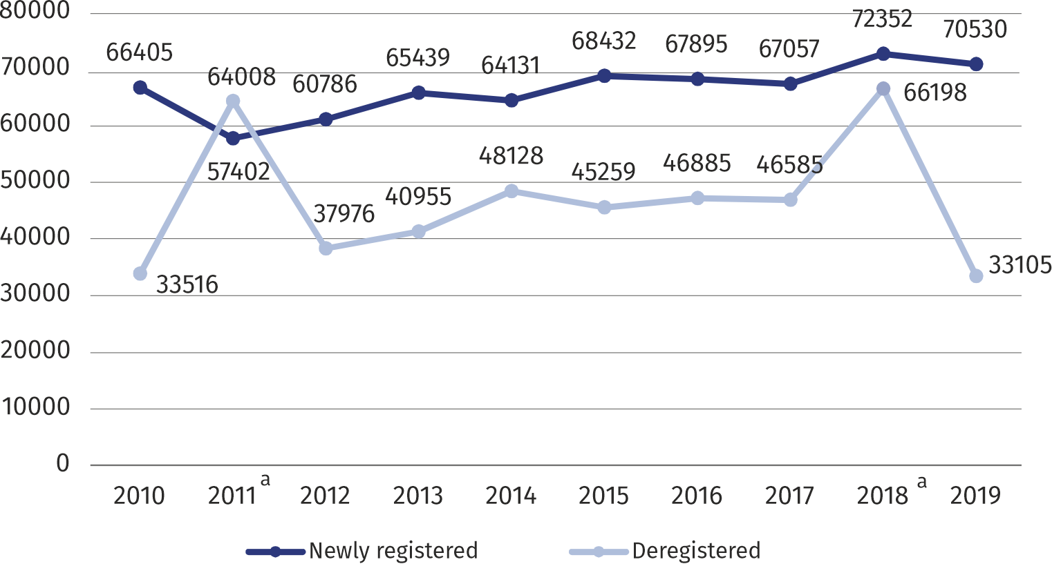

a The increase in the number of entities deregistered in 2011 and 2018 was affected by the update of the REGON register based on information about deceased persons obtained from the PESEL register and an update based on information from the National Court Register on entities deleted from the National Court Register.

During the year, 33105 entities were deregistered from the REGON register (by 50.0% less than throughout 2018) and they were mainly natural persons conducting economic activity (81.2%). Most units were deregistered in m.st Warszawa (14807), piaseczyński powiat (1466), wołomiński (1439), Radom (1312), pruszkowski powiat (1131). Whereas the fewest deregistrations were recorded in the following powiats: lipski and łosicki – by 99 each.

The number of entities with suspended activity at the end of December 2019 amounted to 77572, i.e. by 17.2% more than a year before. The vast majority of these entities (91.0%) accounted for natural persons conducting economic activity.

In 2019, the indicator measured by the ratio of the number of units removed from the register to the number of newly registered units in the voivodship amounted to 46.9%. The highest value of this indicator was recorded in Płock (104.9%), Radom (67.9%), żuromiński powiat (64.9%). The lowest value was recorded in m.st. Warszawa (40.4%), garwoliński powiat (41.3%), siedlecki powiat (42.0%), nowodworski (42.8%), sokołowski (43.7%), łosicki (44.8%).

**Entities of the national economy per 1000 population[1]**

The number of registered entities per 1000 residents was nearly 2.5 times higher in warszawski stołeczny region than in mazowiecki  
regionalny

In 2019, in Mazowieckie Voivodship there were 157.9 entities of the national economy registered in the REGON register per 1000 population. The highest values of this rate concerned m.st Warszawa (255.9) and the following powiats: piaseczyński (194.6), pruszkowski (181.8), warszawski zachodhi (176.1). While the lowest rates of intensity were recorded in the following powiats: zwoleński (66.3), ostrołęcki (68.1), sierpecki (69.7) and przysuski (70.5).

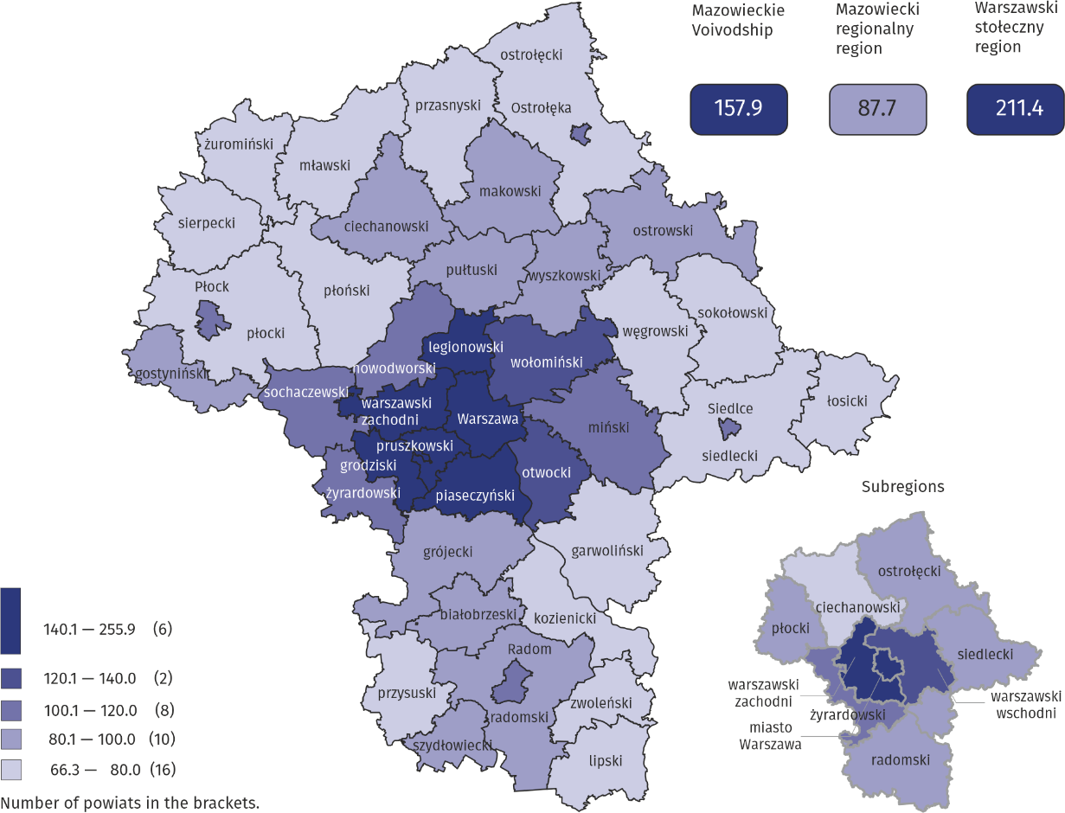**Map 2. Entities of the national economy per 1000 population in 2019**

|  |  |
| --- | --- |
| Prepared by:  **Statistical Office in Warszawa**  **Director Zofia Kozłowska** Tel.: (+48 22) 464 23 15 | Issued by: **Statistical Information Centre** **Marcin Kałuski**Tel: (+48 22) 464 20 91**e-mail:** [**m.kaluski@stat.gov.pl**](mailto:m.kaluski@stat.gov.pl) |

|  |  |  |
| --- | --- | --- |
|  |  |  |
| **Press office**  Tel.: (+4822) 464 20 91  **e-mail:** [**m.kaluski@stat.gov.pl**](mailto:m.kaluski@stat.gov.pl) |  |  |
|  | [warszawa.stat.gov.pl/en](https://warszawa.stat.gov.pl/en/)  [@Warszawa_STAT](https://twitter.com/Warszawa_STAT) |
|  |  |
|  |  |



**Related information**

[Structural changes of groups of entities of the national economy](https://stat.gov.pl/en/metainformations/glossary/terms-used-in-official-statistics/814,term.html)

**Data available in databases**

[Local Data Bank – Entities](https://bdl.stat.gov.pl/BDLS/dane/podgrup/temat)

[Number of entities in the REGON register (tables)](https://bip.stat.gov.pl/dzialalnosc-statystyki-publicznej/rejestr-regon/liczba-podmiotow-w-rejestrze-regon-tablice/)

**Terms used in official statistics**

[Entities of the national economy](http://stat.gov.pl/en/metainformations/glossary/terms-used-in-official-statistics/1406,term.html)

[Private sector](http://stat.gov.pl/en/metainformations/glossary/terms-used-in-official-statistics/2962,term.html)

[Public sector](https://stat.gov.pl/en/metainformations/glossary/terms-used-in-official-statistics/2961,term.html)

[Natural person](http://stat.gov.pl/en/metainformations/glossary/terms-used-in-official-statistics/817,term.html)

1. Population as of 30th June 2019