Out-patient health care in Mazowieckie Voivodship in 2019

At the end of 2019, out-patient health care was carried out by 3096 thousand out-patient departments and 273 thousand doctors and dentists practices providing services funded by public sources. In 2019, 49.8 milllion out-patient consultations were privided - 44.1 million doctors and 5.7 million dentists consultations.

2.3%



Increase in the number of out-patient consultations compared to 2018

# **Outpatient departments and doctors practices**

At the end of 2019, 18% of out-patient departments were funded by public sources

At the end of 2019, 3369 thousand providers of out-patient health care were operating (an increase by 0.9% compared to 2018), of whom 3096 outpatient departments[1] and 34 doctors practices and 239 dentists practices providing services funded by public sources. 20.4 thousand providers of ambulatory health care were located in urban areas, and 5.9 thousand in rural areas.

**Table 1. Out-patient health care providers**

As of 31st December

|  |  |  |  |
| --- | --- | --- | --- |
| SPECIFICATION | 2018 | 2019 | |
| in absolute numbers | | 2018=100 |
| **Total** | **3339** | **3369** | **100,9** |
| Departments | 3046 | 3096 | 101,6 |
| urban areas | 2449 | 2502 | 102,2 |
| rural areas | 597 | 594 | 99,5 |
| Practicesa , total | 293 | 273 | 93,2 |
| doctors | 37 | 34 | 91,9 |
| dentists | 256 | 239 | 93,4 |
| urban areas | 168 | 158 | 94,0 |
| rural areas | 125 | 115 | 92,0 |

a Data include practices that signed contracts with the National Health Fund or with departments.

In comparison with the previous year, the number of out-patient departments increased by 1.6%, while the number of both doctors and detists practices decreased by 8.1% and 6.6%, respectively.

In 2019, the number of doctors practices decreased, mainly in rural areas

At the end of 2019, there were 1610 persons per 1 out-patient health care provider (by 8 persons fewer than a year before).

In Mazowieckie Voivodship, 93.6% of out-patient health care providers were adapted to the needs of the disabled. 67.3% of entities were equipped with ramps or platforms facilitating the entrance to the building, 30.1% an elevator, 29.3% had non-slip floors, and 2.7% had facilities for the visually impaired and the blind.

# Out-patient consultations

On average, there were nearly 3.5-many times more out-patient consultations per urban than per rural inhabitant

In 2019, there were provided 49798.9 thousand out-patient consultations (by 2.3% more than in 2018). The vast majority of consultations (86.2%) were provided in urban areas. 44.1% of out-patient consultations were provided in primary health care, and 55.9% were specialized consultations, of which 11.4% were provided by dentists.

The average number of out-patient consultations per capita in 2019 was 9.2, with the indicator three times higher in urban than in rural areas and amounted to 12.3 and 3.6, respectively.

**Table 2.** **Consultations provideda** **in out-patient health care**

As of 31st December

|  |  |  |  |
| --- | --- | --- | --- |
| SPECIFICATION | 2018 | 2019 | |
| in thousands | | 2018=100 |
| **Consultations provided** | **48658,1** | **49798,9** | **102,3** |
| urban areas | 42024,3 | 42942,0 | 102,2 |
| rural areas | 6633,8 | 6856,9 | 103,4 |
| In primary health care | 21651,7 | 21945,0 | 101,4 |
| In specialized care | 27006,5 | 27853,9 | 103,1 |
| doctors | 21416,7 | 22180,1 | 103,6 |
| dentists | 5589,8 | 5673,7 | 101,5 |

aIncluding consultations paid by patients (non-public funds); excluding consultations provided in admission rooms of general hospitals.

59% of total out-patient health care consultations were provided to women

Out-patient consultations were more often provided to women. In the field of specialist care they constituted 60.4%, while in primary care — 57.3%.

In 2019, over half — 52.9% of consultations were provided to persons aged 18-64, in the age group 65 years and more — 27.9%, and at the age 0-17 years — 19.1%.

Children and youth in the age group 0-17 years were provided with 9,532.4 thousand consultations, of which 51.7% in primary health care (a decrease of 0.8 pp per year), 32.6% were specialized doctors consultations (an increase of 0.6 pp per year), and 15.7% dentists consultations (increase by 0.2 pp per year).

In the age group 65 and more, 13,915.8 thousand consultations were provided, the most in primary health care — 52.4% (increase by 0.1 pp per year), then 41.2% of specialized doctors care (as in the previous year) and 6.4% of dentists care (decrease by 0.2 pp per year).

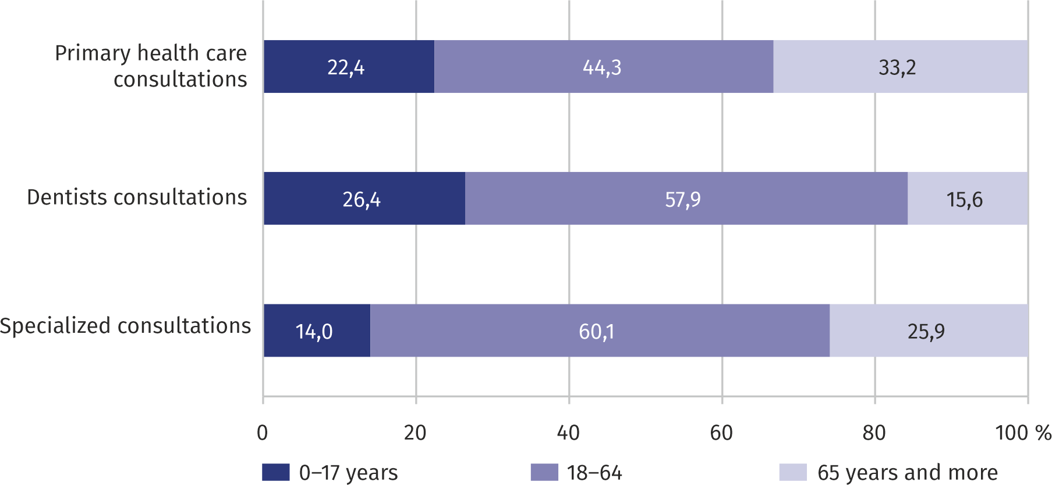**Chart 1.** **Structure of out-patient consultations by type of consultations and age of patients in 2019**

As in the previous year, every third primary health care consultation was provided to persons aged 65 and over

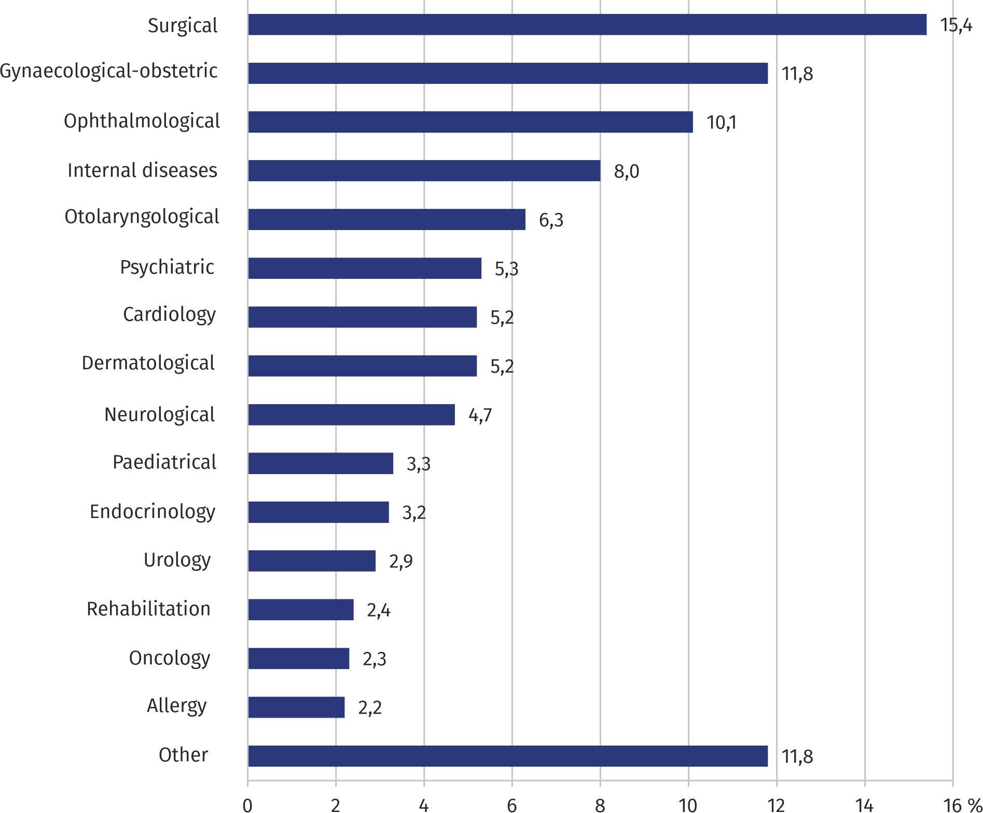**Chart 2. Structure of specialized doctors consultations by type of clinic in 2019**

As in the previous year, most (3.4 million) doctors consultations in specialized care were provided in surgical out-patient clinics

In 2019, the average number of outpatient consultations per capita was 8.5

In the case of quoting data from the Statistics Poland, please provide information: "Statis-tics Poland data source", and in the case of publishing calculations made on data published by the Statistics Poland, please provide information: "Own study based on Statistics Poland data".

|  |  |
| --- | --- |
| Prepared by:  **Statistical Office in Warszawa** **Director Zofia Kozłowska**Tel: (+ 48 22) 464 23 15 | Issued by: **Statistical Information Centre** **Marcin Kałuski**Tel: (+ 48 22) 464 20 91 |

|  |  |  |
| --- | --- | --- |
| **Press office**  Tel:(+ 48 22) 464 20 91  **e-mail:** [**m.kaluski@stat.** **gov.pl**](mailto:m.kaluski@stat.%20gov.pl) |  | [warszawa.stat.gov.pl](https://warszawa.stat.gov.pl/)/en/ |
|  | [@Warszawa_STAT](https://twitter.com/Warszawa_STAT) |
|  |  |



**Related information**

[Health care in Mazowieckie Voivodship in 2018](https://warszawa.stat.gov.pl/en/communiqus-and-announcements/brief-information/other/health-care-in-mazowieckie-voivodship-in-2018,6,6.html)

**Data available in databases**

[Local Data Bank -> Health care, social welfare and benefits to the family](https://bdl.stat.gov.pl/BDL/dane/podgrup/temat)

[Knowledge Databases -> Health and health care](http://swaid.stat.gov.pl/EN/SitePagesDBW/ZdrowieOchronaZdrowia.aspx)

**Terms used in official statistics**

[Specialized out-patient services](https://stat.gov.pl/en/metainformations/glossary/terms-used-in-official-statistics/3178,term.html)

[Out-patient health care services](https://stat.gov.pl/en/metainformations/glossary/terms-used-in-official-statistics/1946,term.html)

[Primary health care](https://stat.gov.pl/en/metainformations/glossary/terms-used-in-official-statistics/3158,term.html)

[Consultation](https://stat.gov.pl/en/metainformations/glossary/terms-used-in-official-statistics/3154,term.html)

[Medical practice](https://stat.gov.pl/en/metainformations/glossary/terms-used-in-official-statistics/1447,term.html)

[An out-patient department](https://stat.gov.pl/en/metainformations/glossary/terms-used-in-official-statistics/3164,term.html)

1. Including departments of the Ministry of National Defence and the Ministry of Internal Affairs and Administration.