Real estate sales in Mazowieckie Voivodship in 2024
In 2024, more real estate purchase/sale transactions were concluded than a year ago. The dominant form of real estate trade was the free market. The largest share in terms of quantity and value was held by transactions of residential premises. Compared to 2023, the average transaction price of residential premises per 1 m² on the free market increased.
9.9%
Increase in the number of real estate purchase/sale transactions y/y

Real estate purchase/sale transactions
Real estate purchase/sale transactions in Mazowieckie Voivodship accounted for over 17% of all transactions concluded in the country

In 2024, 95,235 real estate purchase/sale transactions were concluded in Mazowieckie Voivodship, which constituted 16.6% of transactions in the country. Compared to 2023, their number increased by 8,562 (by 9.9%). Most of them concerned real estate located within the boundaries of the Voivodship's cities – 65.3%. The vast majority of transactions were concluded on the free market – 99.0% (an increase of 1.6 pp compared to 2023), and only 1.0% in non-tender and tender sales.
Per 1,000 population, the number of real estate purchase/sale transactions in Mazowieckie Voivodship in 2024 was 17.3 compared to 15.7 in 2023.

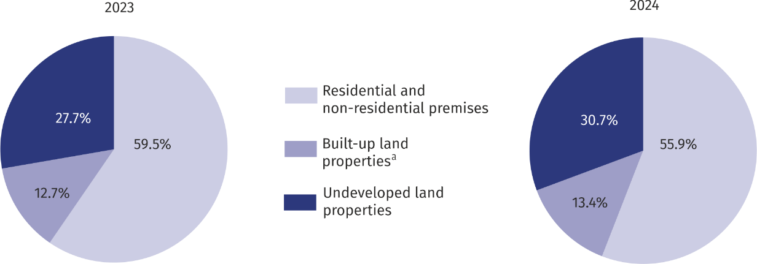
Chart 1. Structure of the number of purchase and sale transactions by type of real estate
a It includes properties built-up with residential buildings, built-up agricultural land, and building premises serving functions other than farm and residential.
In real estate trading in Mazowieckie Voivodship in 2024, the largest number of transactions concerned residential and non-residential premises (53.3 thousand), and the smallest number concerned built-up land properties (12.7 thousand).
Compared to 2023, there was an increase in the share of transactions in undeveloped land properties (by 3.0 pp), and in built-up properties (by 0.7 pp), while a decrease in residential and non-residential premises (by 3.6 pp).

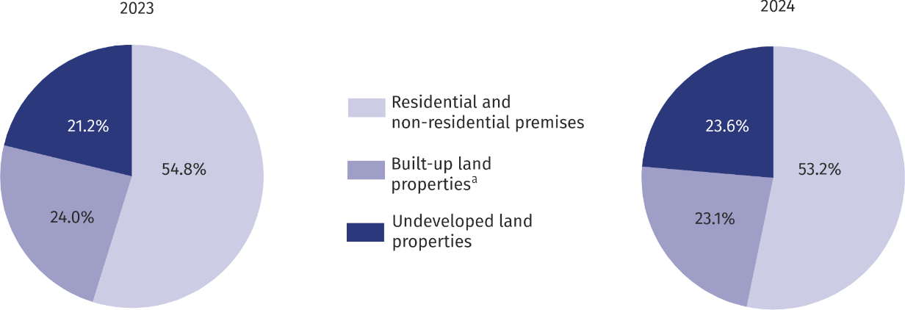
Chart 2. Structure of the value of purchase and sale transactions by type of real estate
a It includes properties built-up with residential buildings, built-up agricultural land, and building premises serving functions other than farm and residential.
In 2024, the value of all real estate transactions concluded in Mazowieckie Voivodship amounted to PLN 66.5 billion, which constituted 25.5% of the value of transactions concluded in the country. Compared to 2023, their value increased by 26.9%. The largest real estate turnover was recorded for residential and non-residential premises (PLN 35.4 billion), and the smallest for built-up land properties (15.4 billion). Compared to the previous year, there was an increase in the share of the value of transactions for undeveloped land properties (by 2.4 pp), while a decrease for residential properties (by 1.6 pp) and built-up land properties (by 0.9 pp).
The value of real estate transactions in Mazowieckie Voivodship constituted nearly 26% of the value of transactions concluded in the country

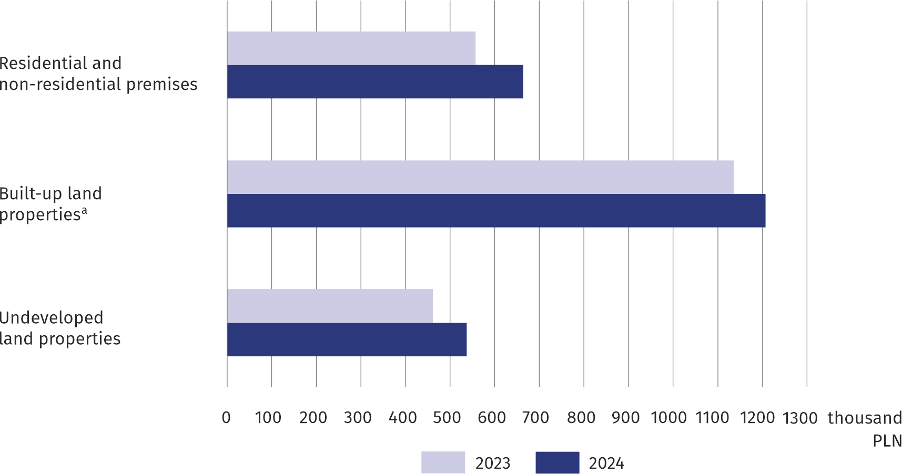
Chart 3. Average value of a single real estate purchase and sale transaction
a It includes properties built-up with residential buildings, built-up agricultural land, and building premises serving functions other than farm and residential.
The average value of a single transaction in Mazowieckie Voivodship for residential and non-residential premises was over 41% higher than the national average, for undeveloped properties by almost 96%, and for built-up properties by more than 55%.

Purchase/sale transactions of residential premises
In 2024, the turnover of residential premises in quantitative terms accounted for 83.2% of residential and non-residential premises turnover in Mazowieckie Voivodship and in value terms — 90.7%. Compared to 2023, the number of purchase/sale transactions of residential premises increased by 2.2% and their value by 21.8%. The vast majority of transactions in residential premises were concluded on the free market and in urban areas, respectively: 99.4% and 89.9% of all purchase/sale transactions of residential premises. As part of the transactions, 44585 residential premises were sold (the largest number accounted for 3-room premises — 34.8%). Compared to the previous year, the number of residential premises sold increased by 2.2%, while 2-room premises by 7.2%. However, sales of 3-room premises decreased by 0.7%.

Average transaction price of residential premises on the free market
In Mazowieckie Voivodship in 2024, the average transaction price for residential premises on the free market was PLN 12,229 m² and was by PLN 1,913 (18.5%) higher than in 2023. The most expensive were 1-room dwellings (PLN 15,682 m²), the least expensive were 4-room dwellings and larger (PLN 11,351 m²).
The average transaction price of residential premises on the free market was PLN 12,229 m²
Among the powiats of the Voivodship, the highest average transaction price of residential premises per 1 m² was in m.st. Warszawa (PLN 15,849) and in the following powiats: piaseczyński (PLN 9,496) and warszawski zachodni (PLN 9,231). On the other hand, the lowest prices were recorded in the powiats: lipski (PLN 3908) and radomski (PLN 4,392).

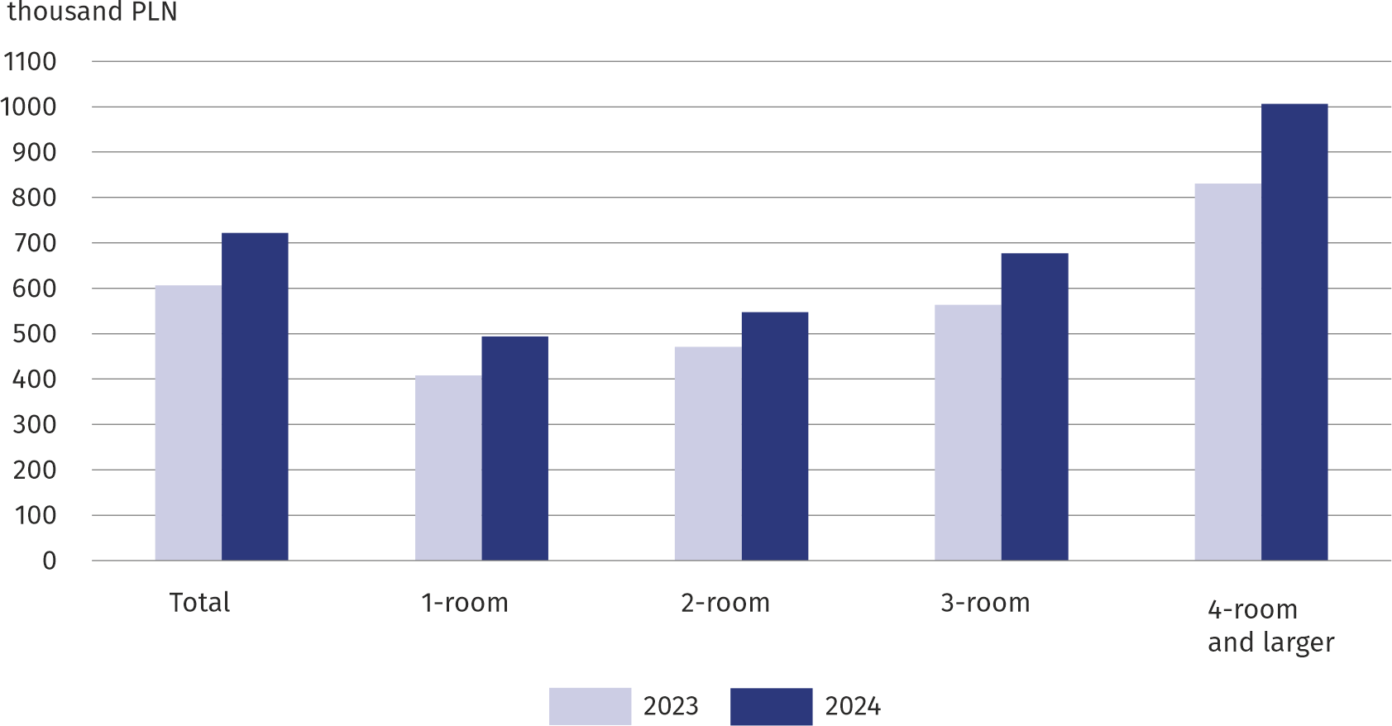
Chart 4. Average transaction price of residential premises on the free market

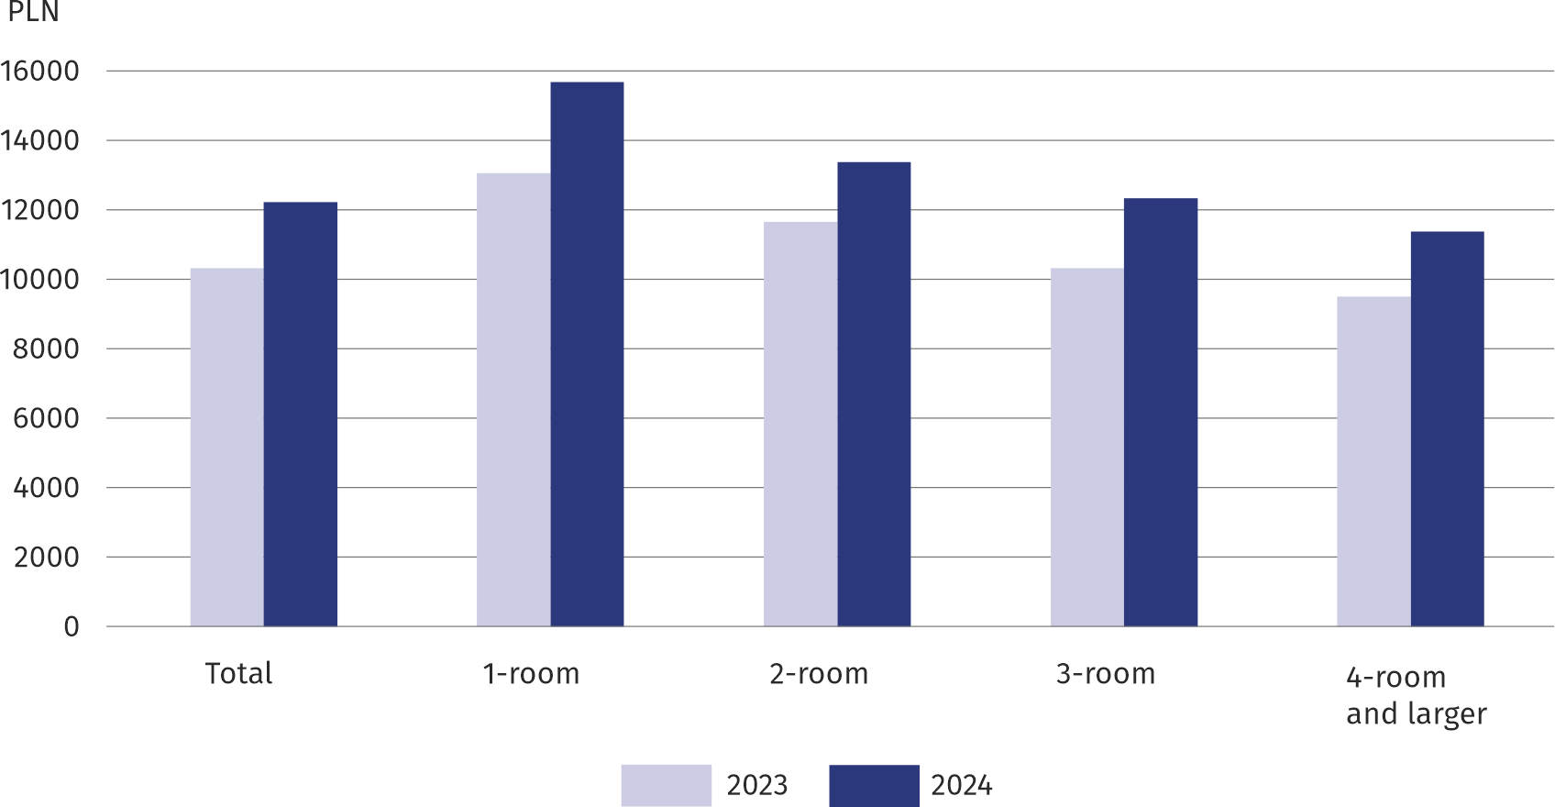
Chart 5. Average transaction price per 1 m² of residential premises on the free market
When quoting Statistics Poland data, please provide the information: “Source of data: Statistics Poland”, and when publishing calculations based on Statistics Poland data, please
include the following information: “Own work based on Statistics Poland data”.

Prepared by:  Statistical Office in Warszawa  Director Agnieszka Ajdyn  Phone: (+48 22) 464 23 15 | Issued by:  Statistical Information Centre  Mobile: (+48) 783 940 141  e-mail: m.kaluski@stat.gov.pl

www.warszawa.stat.gov.pl/en/

@Warszawa_STAT

@UrzadStatystycznywWarszawie

gus_stat

glownyurzadstatystycznygus

glownyurzadstatystyczny

Related information
Real estate sales in 2024
Price indices of residential premises by voivodships in the fourth quarter of 2024
Data available in databases
Local Data Bank (BDL) Real estate market
Knowledge Databases (DWB) Prices
Terms used in official statistics
Real estate turnover
Real estate Price Register
Premise
Real estate transaction

