Real estate sales in Mazowieckie Voivodship in 2018

In 2018, there were 64.1 thousand real estate purchase/sale transactions worth PLN 27.4 billion. The dominant form of real estate sales` was the free market. Transactions with residential premises had the largest share in terms of quantity. Compared to 2017, the average transaction price of residential premises per 1 m2 in the free market increased by almost 6%.

2.2%



Increase in the number of real estate purchase/sale transactions y/y

# Real estate purchase/sale transactions

Purchase/sale transactions of real estate in Mazowieckie Voivodship accounted for almost 14% of total  
domestic transactions

In 2018, 64125 real estate purchase/sale transactions were concluded in Mazowieckie Voivodship, which accounted for 13.6% of all transactions in the country. Compared to 2017, their number increased by 1387 (by 2.2%). The majority of purchase/sale transactions concerned real estate located within city borders — 68.6%. Most transactions were concluded on the free market — 98.6% (an increase of 0.4 pp compared to 2017), and only 1.4% in non-tender and tender sales.

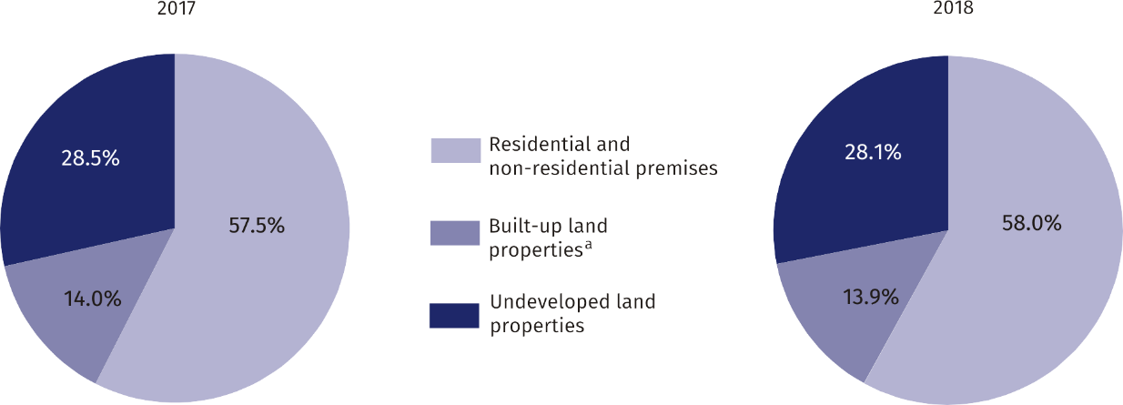Chart 1. Structure of the number purchase/sale transactions by type of property

a Include properties built-up with residential buildings, built-up agricultural land, other built-up properties and building premises.

In 2018, the most numerous transactions in real estate in Mazowieckie Voivodship were transactions in residential and non-residential premises (37.2 thousand), the least numerous in built-up land properties (8.9 thousand).

Compared to 2017, there was an increase in the share of transactions in residential and non-residential premises (by 0.5 pp), and a decrease in transactions in undeveloped land properties (by 0.4 pp) and built-up land properties (by 0.1 pp).

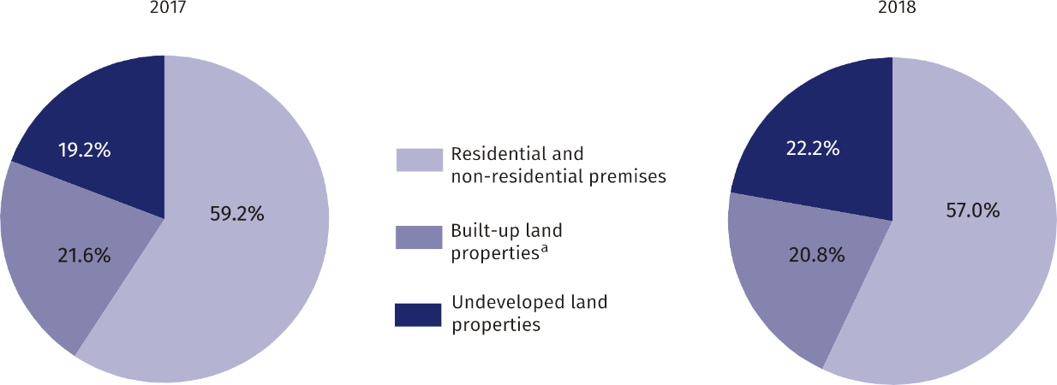**Chart 2. Value structure of purchase/sale transactions by type of property**

a Include properties built-up with residential buildings, built-up agricultural land, other built-up properties and building premises.

The value of real estate transactions in Mazowieckie Voivodship accounted for almost 23% of the value of transactions concluded in the country

In 2018, the value of total real estate transactions concluded in Mazowieckie Voivodship amounted to PLN 27.4 billion, which constituted 22.6% of the value of transactions concluded in the country. Compared to 2017, their value increased by 13.4%. The highest turnover in real estate in terms of value was recorded for residential and non-residential premises (PLN 15.6 billion), and the lowest for built-up land properties (PLN 5.7 billion). Compared to the previous year, there was an increase in the share of the value of transactions of undeveloped land properties (by 3.0 pp), while the decrease in premises (by 2.2 pp) and built-up land properties (by 0.8 pp).

**Chart 3. Average value of a single real estate purchase/sale transaction**

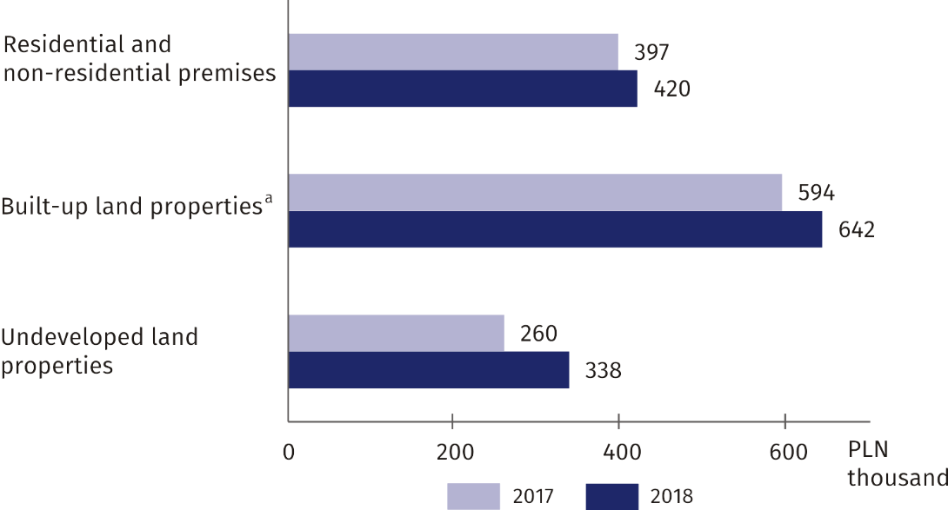

a Include properties built-up with residential buildings, built-up agricultural land, other built-up properties and building premises.

The highest average value of a single transaction in Mazowieckie Voivodship in 2018 was recorded for built-up land properties (PLN 64,1935.2), and the lowest for undeveloped land properties (PLN 33,718.2).

In quantitative terms, the largest real estate turnover was registered in Warsaw capital city (26695) and in the powiats: legionowski (2288), wołomiński (2285), warszawski zachodni (2239), and the smallest in the powiats: lipski (233) and łosicki (267). Number of transactions carried out in Warsaw capital city accounted for 41.6% of the total sum of transactions concluded in the voivodship.

Calculated per 1000 population, the number of real estate purchase/sale transactions in Mazowieckie Voivodship in 2018 was 11.9. The highest value of this indicator occurred in the powiats: legionowski (19.7), warszawski zachodni (19.3), and the lowest in garwoliński powiat (3.9).

On average, there were 12 transactions per 1000 population in Mazowieckie Voivodship

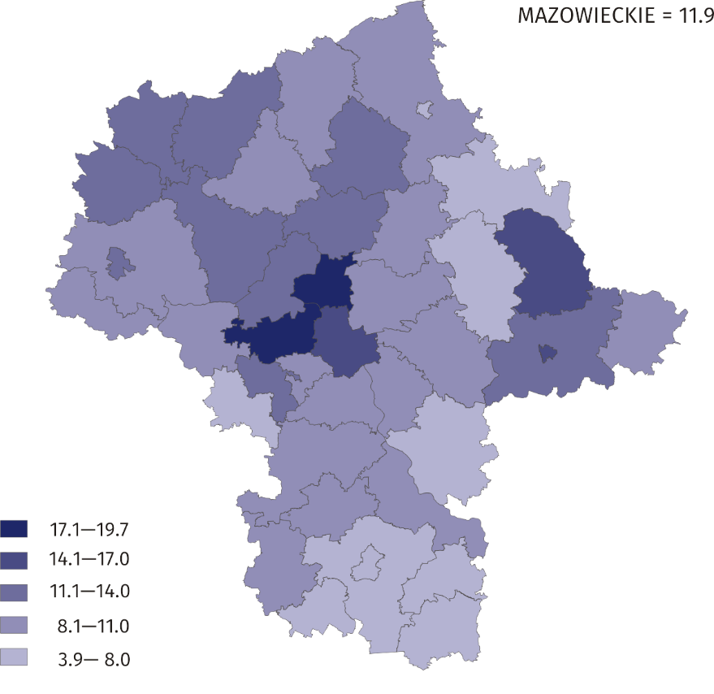**Map 1. Real estate purchase/sale transactions calculated per 1000 inhabitants in 2018**

The real estate market in Mazowieckie Voivodship in terms of the structure of real estate purchase/sale transactions was characterized by significant diversity. In cities with powiat status, the share of transactions with premises prevailed and amounted to 90.9% in Warsaw, 83.8% in Siedlce, 77.7% in Płock, 66.9% in Radom, 62.3% in Ostrołęka. In other powiats, transactions of land properties dominated. The exceptions were the powiats: wołomiński, pruszkowski and miński, where the share of land properties transactions amounted to respectively: 40.6%; 40.1% and 35.9%.

# Purchase/sale transactions of residential premises

In 2018, the turnover of residential premises in quantitative terms accounted for 93.5% of residential and non-residential premises turnover in Mazowieckie Voivodship and in value terms — 91.9%. Compared to 2017, the number of purchase/sale transactions of residential premises increased by 1.0% and their value by 8.6%. The vast majority of transactions in residential premises were concluded on the free market and in urban areas, respectively: 99.0% and 96.4% of all purchase/sale transactions of residential premises. As part of the transactions, 35083 residential premises were sold (the largest number accounted for 3-room premises — 36.6%). Compared to the previous year, the number of residential premises sold increased by 0.6%, while 3-room premises dropped by 1.7%.

# Average transaction price of residential premises on the free market

The average transaction price of residential premises on the free market was PLN 7252/m2

# In 2018, the average transaction price for residential premises on the free market in Mazowieckie Voivodship was PLN 7252/m2 and was by PLN 383 (5.6%) higher than in 2017. The most expensive were 1-room dwellings (PLN 8552)/m2), the least expensive 4- room dwellings and larger (PLN 7021/m2).

# Among the powiats, the highest average transaction price of residential premises per 1 m2 was in Warsaw capital city (PLN 8768) and in the following powiats: piaseczyński (PLN 5720) and pruszkowski (PLN 5305). On the other hand, the lowest prices were recorded in the powiats: radomski (PLN 1980) and makowski (PLN 2032).

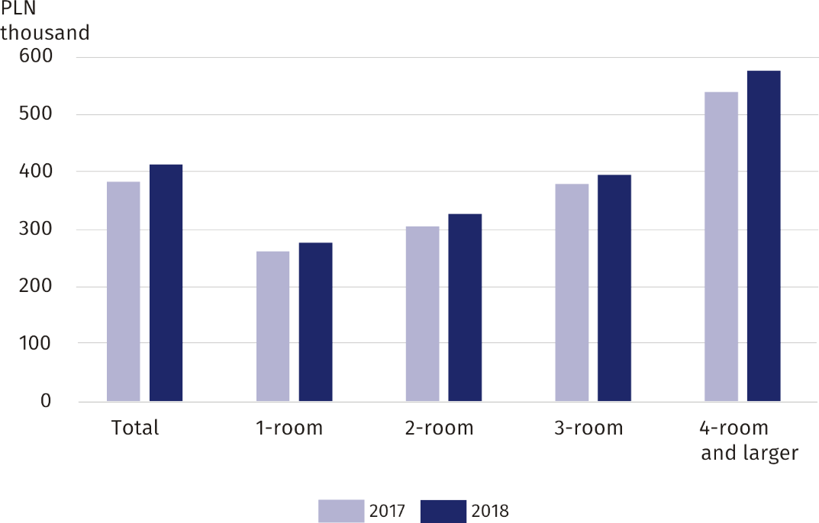**Chart 4. Average transaction price of residential premises on the free market**

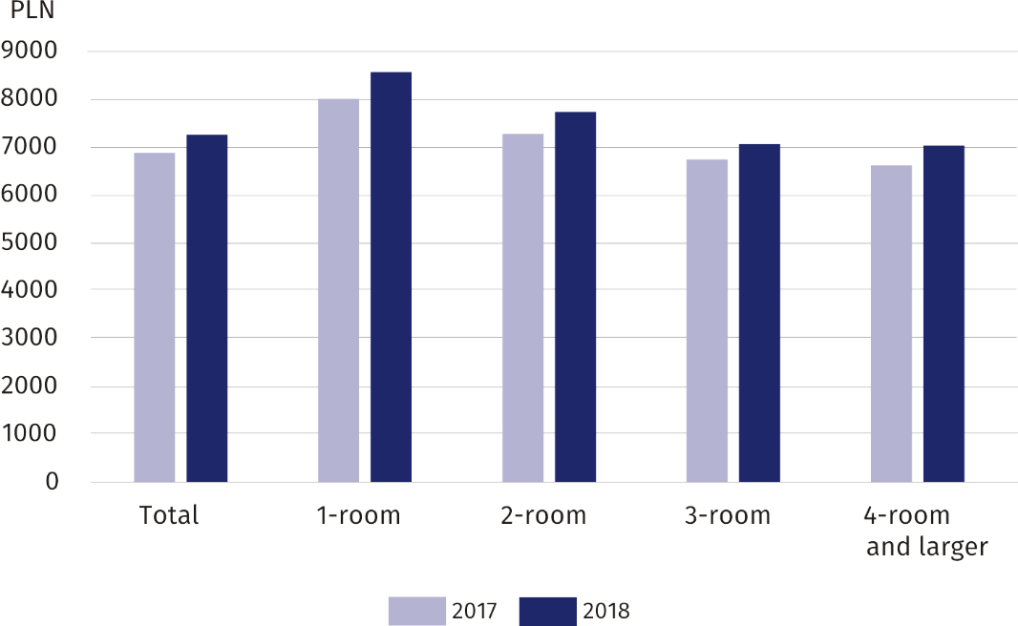**Chart 5. Average transaction price per 1 m2 of residential premises on the free market**

|  |  |
| --- | --- |
| Prepared by:  **Mazovian Centre for Reginal Surveys**  **Statistical Office in Warszawa** **Edyta Kaźmierczak**Tel: +48 24 366 50 37 w. 5055**e-mail:** [**e.kazmierczak@stat.gov.pl**](mailto:e.kazmierczak@stat.gov.pl) | Issued by: **Statistical Information Centre** **Marcin Kałuski**Tel: +48 22 464 20 91**e-mail:** [**m.kaluski@stat.gov.pl**](mailto:m.kaluski@stat.gov.pl) |

|  |  |  |
| --- | --- | --- |
| **Press office**  Tel.: +4822 464 20 91  **e-mail:** [**m.kaluski@stat.** **gov.pl**](mailto:m.kaluski@stat.%20gov.pl) |  | [warszawa.stat.gov.pl](https://warszawa.stat.gov.pl/)/en |
|  | [@Warszawa_STAT](https://twitter.com/Warszawa_STAT) |
|  |  |



**Related information**

[Real estate sales in 2018](https://stat.gov.pl/en/topics/municipal-infrastructure/municipal-infrastructure/real-estate-sales-in-2018,7,2.html)

[Announcement on price change indices for residential premises by voivodship](https://stat.gov.pl/en/latest-statistical-news/communications-and-announcements/)

**Data available in databases**

[Local Data Bank — Real estate market](https://bdl.stat.gov.pl/BDL/dane/podgrup/temat)

[Knowledge Database — Prices](http://swaid.stat.gov.pl/EN/SitePagesDBW/Ceny.aspx)

**Terms used in official statistics**

[Real estate turnover](https://stat.gov.pl/en/metainformations/glossary/terms-used-in-official-statistics/966,term.html)

[Register of real estate prices and values](https://stat.gov.pl/metainformacje/slownik-pojec/pojecia-stosowane-w-statystyce-publicznej/3015,pojecie.html)

[Premises](https://stat.gov.pl/en/metainformations/glossary/terms-used-in-official-statistics/1984,term.html)