Emergency medical care
in Mazowieckie Voivodsip in 2021
In 2021, emergency rescue teams provided health services in the place of occurrence to 423.5 thousand persons. In the admission rooms or hospital emergency wards, 530.6 thousand persons received out-patient medical services. In hospital emergency wards, 203.0 thousand persons were treated in stationary mode.
9.9%
Increase in the number of persons who were given medical help in the place of occurrence y/y

Units of emergency medical system and cooperating
At the end of 2021, there were 26.8 thousand persons on average per every emergency rescue team

Under the State Emergency Medical Systemª, in 2021, emergency medical services were provided by 202 emergency rescue teams (39 specialist and 163 basic, as well as 3 medical air rescue teams and 32 hospital emergency wards.
The rate of availability of medical services provided by emergency rescue teams, expressed as the number of teams (basic and specialist) per 100 thousand population in Mazowieckie Voivodship amounted to 3.7 and did not change compared to 2020 (in the country in 2020 – 4.1, in 2021 – 4.2).
Two trauma centres providing medical services to patients with multiple multi-organ injuries cooperated with the emergency medical system, including 1 newly created trauma centre for children and 10 admission rooms.

Emergency rescue teams, medical air rescue teams
As of 31 December 2021, the number of personnel included in emergency medical teams was 1797 employees^{b}. The most numerous group were paramedics – 1391. In addition, there were 120 system nurses, 100 system doctors, as well as 186 drivers and pilots.

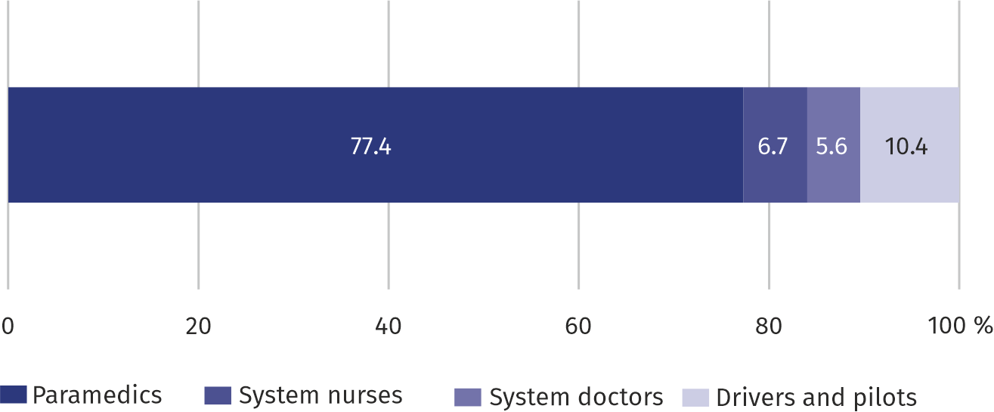
Chart 1. Structure of the compositionª of emergency rescue teams in 2021
As of 31 December

a Refers to the number of persons employed regardless of the form of employment for which this was the main workplace.
In 2021, 422.8 thousand (by 9.7% more compared to the previous year) of calls to the occurrence places were recorded, of which the vast majority (78.3%) were calls to the patient's home. Emergency rescue teams provided health care benefits to 423.5 thousand persons (by 9.9% more compared to the previous year), of which 47.2% were persons aged 65 and more, and 5.4% – children and youth up to 18 years of age. Men were provided with medical help more often (51.3%) than women. Before starting or during rescue operations, 9093 persons were found dead (by 6.1% more than in 2020), of which 84.5% at home, and 2.8% in the road traffic.
The number of trips of emergency medical teams to schools increased by nearly 1/3
There were on average 78 persons per 1000 inhabitants of Mazowieckie Voivodship provided with help from emergency rescue teams

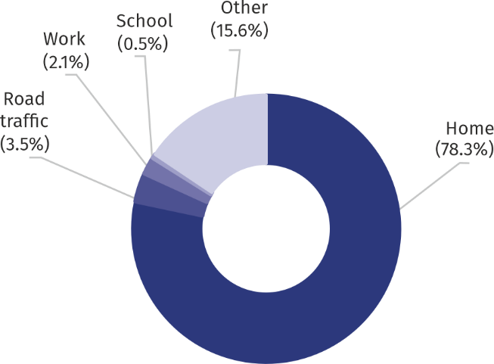
Chart 2. Structure of calls of emergency rescue teams by the occurrence place in 2021

Hospital emergency wards, admission rooms
In 2021, admission rooms and hospital emergency wards provided on average 103 out-patient health care services per 1000 population

Hospital emergency wards provided health services in two modes: outpatient (not finished with hospitalization) and stationary.
In 2021, in admission rooms or hospital emergency wards, outpatient emergency medical services were provided to 530.6 thousand persons, of which children and youth up to 18 years of age accounted for 20.5%, and persons aged 65 and more 24.4%. The number of patients treated in a stationary mode amounted to 203.0 thousand, of which 52.7% of patients were transferred to hospital treatment.
Every fifth outpatient treated in the admission room or hospital emergency ward was provided with trauma and orthopedic surgery services

Outpatients most often received medical services in the field of surgery (33.7%), internal diseases (14.6%).
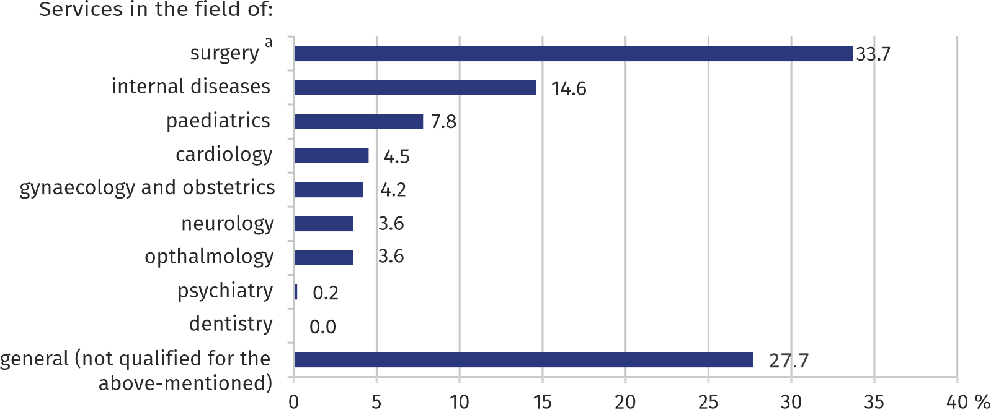
Chart 3. Structure of out-patient medical services provided in admission room or hospital emergency wards in 2021

a Including trauma and orthopedic surgery and neurosurgery.
Table 1. Emergency medical services and first aid
Specification | 2020 | 2021
 | In absolute numbers |  | 2020 = 100
Emergency rescue teamsª | 200 | 202 | 101,0
of which:
specialist | 41 | 39 | 95,1
basic | 159 | 163 | 102,5
Medical air rescue teamsª | 3 | 3 | 100,0
Hospital emergency wardsª | 31 | 32 | 103,2
Calls to the occurrence places^{b} | 385342 | 422770 | 109,7
of which occurrences:
in road traffic | 14900 | 14724 | 98,8
at work | 8944 | 8895 | 99,5
at school | 1656 | 2182 | 131,8
at home | 295916 | 331048 | 111,9
Persons who received health care benefits in the place of occurrence:
in absolute numbers | 385437 | 423521 | 109,9
per 1000 population | 71,0 | 78,1 | 110,0
Persons provided with out-patient health care services (in admission rooms or hospital emergency wards) | 535086 | 530641 | 99,2
a As of 31 December. b Excluding calls to illnesses.

In the case of quoting data from Statistics Poland, please provide information: "Source of data – Statistics Poland", and in the case of publishing calculations made on data published by Statistics Poland, please provide information: "Own study based on Statistics Poland data".

Prepared by:  Statistical Office in Warszawa  Director Zofia Kozłowska  Tel: (+48 22) 464 23 15 | Issued by:  Statistical Information Centre  Marcin Kałuski  Tel: (+48 22) 464 20 91
Press office  Tel: (+48 22) 464 20 91  e-mail: m.kaluski@stat. gov.pl | www.warszawa.stat.gov.pl/en/
 | @WARSZAWA_STAT
 | @UrzadStatystycznywWarszawie
 | gus_stat
 | glownyurzadstatystycznygus
 | glownyurzadstatystyczny
Related information
Out-patient health care in Mazowieckie Voivodship in 2020
Data available in databases
Local Data Bank -> Health care, social welfare and benefits to the family
Knowledge Databases -> Health and health care
Terms used in official statistics
Emergency medical services
Units of emergency medical services
Hospital emergency ward
Out-patient health care services
The place of occurrence
Trauma centre

