Dwelling stocks in Mazowieckie Voivodship in 2024
2024 was another year in which the number of dwellings increased. The average dwelling size was 74 m². Compared to 2023, the average number of persons per dwelling decreased. The number of housing allowances paid decreased, while their amount increased.
101.4
Indices of the number of dwellings y/y

Size of dwelling stocks and their location
Dwellings in Mazowieckie Voivodship accounted for almost 16% of national dwelling stocks

As of 31 December 2024, the dwelling stocks of Mazowieckie Voivodship amounted to 2,560.3 thousand dwellings, which accounted for 16.0% of national stocks. The size of dwellings stocks per 1,000 population was at the level of 464.8 (425.9 in the country). On an annual basis, it increased by 6.8 points and 6.6 points, respectively. Compared to 2023, there was an increase in the number of dwellings by 36.4 thousand (by 1.4%). In urban areas, the number of dwellings increased by 30.6 thousand (i.e. 1.7%), representing 84.0% of the increase in the number of dwellings in the Voivodship. The largest increase was recorded in the capital city — 14.5 thousand (39.8% of the increase in the Voivodship and 47.3% of the increase in dwellings in urban areas). The highest growth rate of dwellings, on an annual basis, was recorded in the powiats: pruszkowski (by 3.4%), followed by grodziski (by 3.2%), warszawski zachodni (2.6%). The lowest growth rate was noted in the łosicki powiat (by 0.3%), followed by: lipski, żuromiński (by 0.4% each). The useful floor area of dwellings amounted to 189,949.7 thousand m² and increased by 3,078.9 thousand m² (by 1.6%) compared to the previous year.
There were 465 dwellings per 1,000 population of the Voivodship (426 in the country)

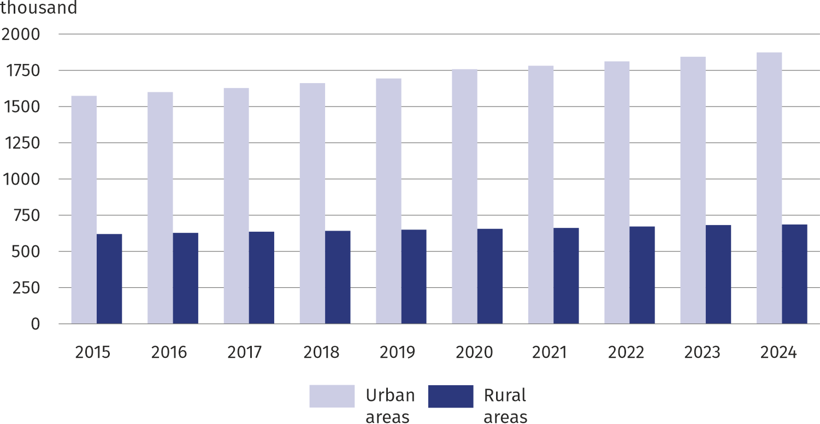
Chart 1. Dwelling stocks by location (as of 31 December)
The largest number of dwellings were owned by natural persons outside housing condominiums – 50.4%. Housing condominiums accounted for 30.4% of the dwellings, while housing cooperatives accounted for 13.4% and municipal housing – 4.7%. The smallest share of dwellings belonged to companies, constituting only 0.2% of the total number of dwellings.

Dwelling conditions
In 2024, in Mazowieckie Voivodship, the average number of rooms in a dwelling was 3.64 (in urban areas 3.34, in rural areas 4.48). The largest number of them was in ostrołęcki powiat (4.84), and the smallest in m.st. Warszawa (3.06). The average useful floor area of dwellings in Mazowieckie Voivodship increased by 0.2 m² and compared to the previous year and amounted to 74.2 m² (in urban areas 64.3 m², in rural areas 100.4 m²). Calculated per person, this gave an average of 33.9 m² (in urban areas 64.4 m², in rural areas 100.8 m²). The largest average useful floor area of a dwelling was recorded in warszawski zachodni powiat – 110.3 m², while the smallest in m.st. Warszawa – 58.9 m². The average number of persons per dwelling compared to 2023 decreased and amounted to 2.15. In urban areas this indicator reached the value of 1.90, and in rural areas – 2.82. The most populated dwellings were recorded in ostrołęcki powiat, where the average number of persons per dwelling was 3.33. Dwellings in m.st. Warszawa were the least populated – 1.71.
A dwelling in rural areas was on average 36.4 m² larger than in urban areas

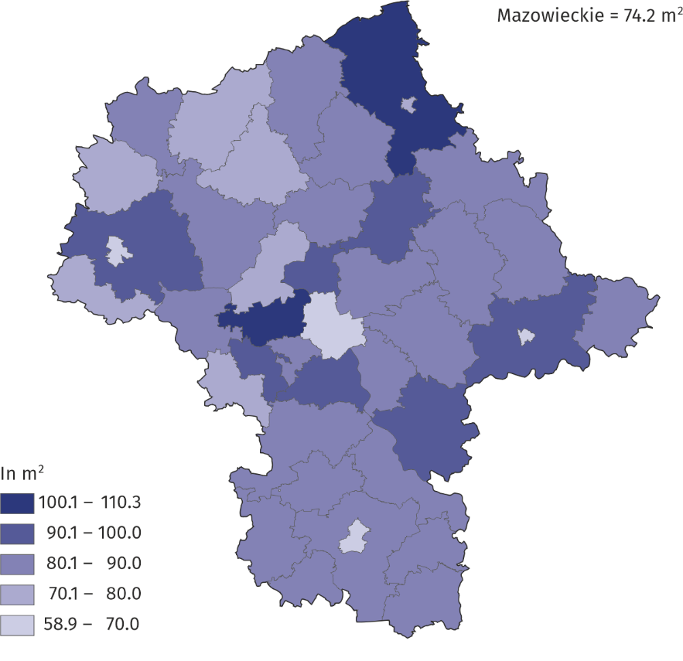
Map 1. Average useful floor area of dwellings in 2024 (as of 31 December)

Dwellings fitted with sanitary and technical installations ²
In 2024, 97.3% of total dwellings in the Voivodship were connected to the water supply system, 95.2% were fitted with lavatory; bathroom — 94.0%; central heating — 88.7%; gas from gas supply system — 59.4%. Among powiats, the highest indicators of dwellings equipped with sanitary and technical installations were recorded in Ostrołęka (99.8% of total dwellings were connected to the water supply system; 99.5% had lavatory, 99.2% a bathroom), and in m.st. Warszawa (96.5% of total dwellings were fitted with central heating). The smallest percentage of dwellings equipped with water supply was recorded in lipski powiat (90.7% of total dwellings). The smallest number of dwellings fitted with lavatory were in szydłowiecki powiat (81.5% of total dwellings), with a bathroom in przysuski powiat (77.6%), central heating in węgrowski powiat (68.8%). The largest number of dwellings fitted with gas from gas supply system were in warszawski zachodni powiat (83.2% of the total number of dwellings), and the least in żuromiński (0.5%), lipski and makowski (0.8% each) powiats.
97% of dwellings in the Voivodship were connected to the water supply system

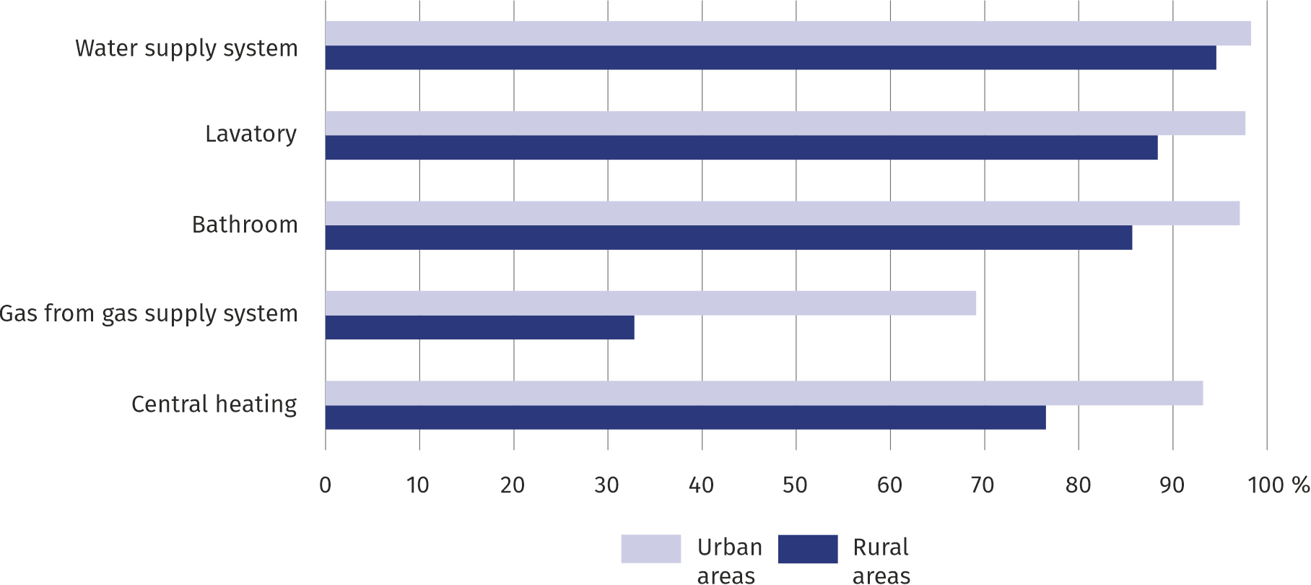
Chart 2. Dwellings fitted with technical and sanitary installations in 2024 (as of 31 December)

Ownership of dwelling stocks
Out of the total housing stocks, 1,269,9 thousand dwellings were located in buildings under management/administration. The acquisition of ownership of dwellings in multi-dwelling buildings by natural persons resulted in an increase in the dwelling stocks managed by housing condominiums. At the end of 2024, there were 777.2 thousand dwellings owned by natural persons in housing condominium buildings.
More than 777 thousand dwellings in buildings managed by housing condominiums belonged to natural persons

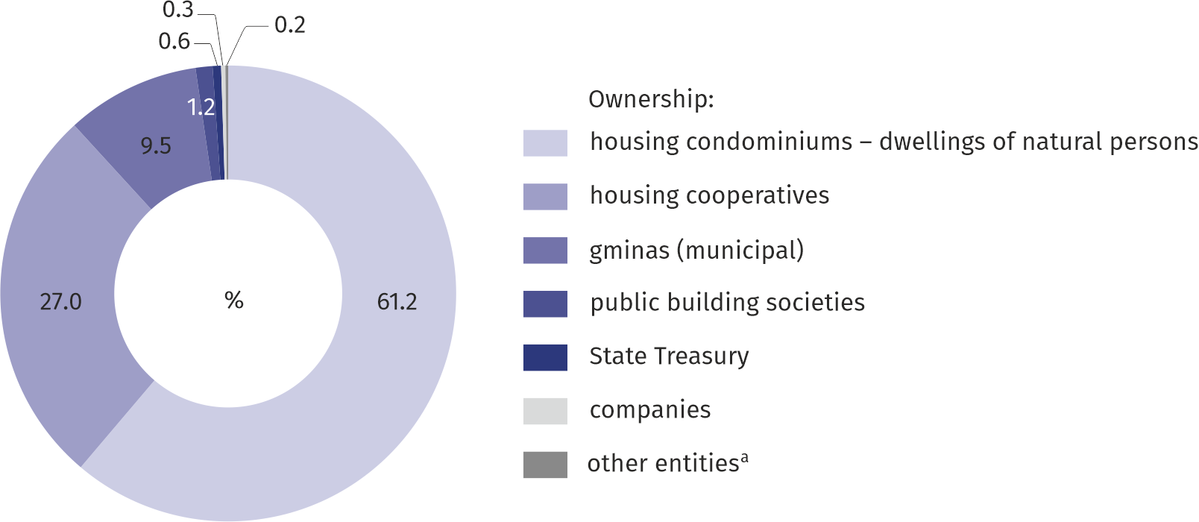
Chart 3. Structure of dwelling stocks by ownership form in 2024 (as of 31 December)
a Dwellings of other entities include the resources of: developers, trade unions, associations, foundations, political parties, professional and economic self-governments, the Catholic Church and religious associations, Catholic universities and church institutes, excluding dwellings owned by these entities in housing condominium buildings.
Dwellings belonging to housing cooperatives ranked second in terms of their share in the Voivodship's housing stocks (343.3 thousand). Of the 120.3 thousand municipal dwellings, 16.0 thousand were unoccupied, the vast majority of which – 76.2% – were located in Warszawa. There were also dwellings owned by companies, the State Treasury, public building societies, and other entities in Mazowieckie Voivodship. These dwellings accounted for 2.3% of the Voivodship's total housing stocks.

Arrears in housing payments
Nearly 58% of the amount of arrears in housing fees was attributable to tenants of municipal stocks
At the end of 2024, there were 392.4 thousand dwellings in the Voivodship whose tenants were in arrears. The total amount of arrears (including interest since the inception of the arrears) amounted to PLN 1,651.2 million. The largest share of dwellings with arrears was in municipal stocks – 41.2%. This percentage was 32.2% for public building societies, 27.4% for housing cooperatives, 21.6% for natural persons in housing condominiums, 13.2% for the State Treasury, 9.8% for companies, and 2.1% for other entities. Tenants of dwellings remaining in municipal stocks had the highest share in the total amount of arrears – 57.8%.

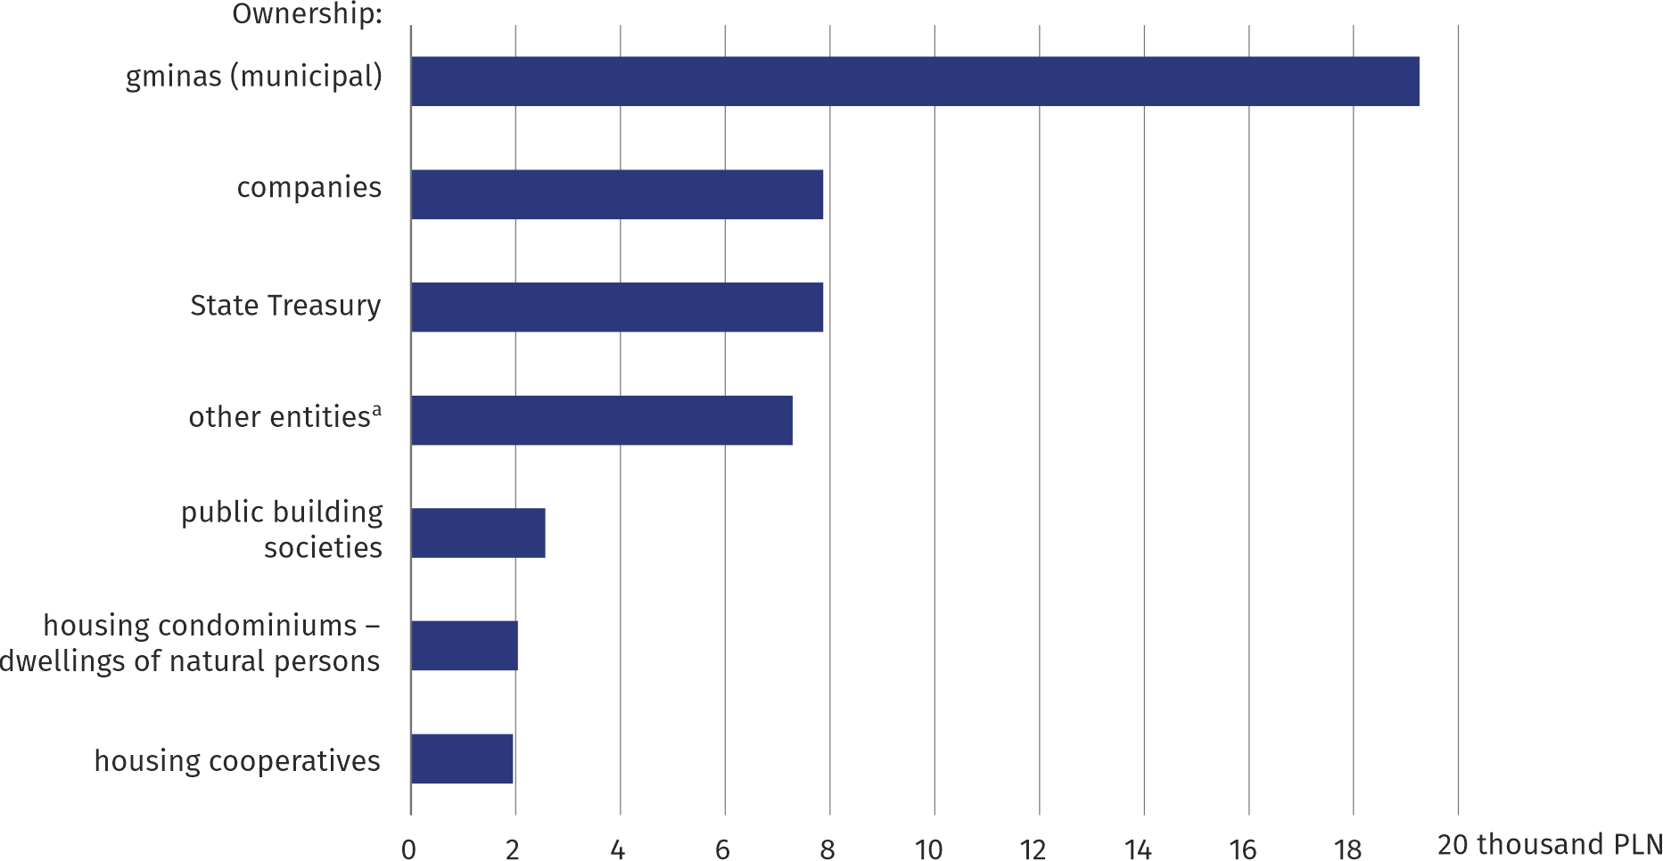
Chart 4. Average amount of arrears per dwelling by ownership form in 2024 (as of 31 December)
a See note below the chart on page 3.

Eviction actions
In Mazowieckie Voivodship, as of 31 December 2024, there were 3,368 eviction proceedings pending in court (a 7.9% increase compared to 2022), of which 2,847 were due to arrears in housing fees (a 5.4% increase). Of the total number of pending eviction proceedings due to arrears in fees, 81.1% concerned tenants in municipal stocks, 13.0% – natural persons in housing condominium buildings, 3.2% – housing cooperatives, 1.2% – public building societies, 0.9% – the State Treasury, 0.5% – companies, 0.1% – other entities. Of the 889 evictions ordered, 727 were carried out, of which 93.8% were due to arrears in housing fees.
More than 3 thousand eviction proceedings were pending in court

Renovations and modernisation of housing stocks
A total of 0.6 thousand dwellings were connected to the water, sewage and gas supply systems
In 2024, in Mazowieckie Voivodship, the number of dwellings undergoing renovations was 77.9 thousand. Of those undergoing renovations, 3.0% were dwellings with new technical and sanitary installations. 89 dwellings were connected to the water supply system, 400 to the gas supply system, and 100 to the sewage system. Hot water was provided to 1.8 thousand dwellings, and central heating was installed in 600 dwellings.

Housing maintenance costs
In 2024, the costs of maintaining housing stocks in Mazowieckie Voivodship amounted to PLN 12,851.3 million. Operating costs accounted for 46.6% of the total costs of maintaining housing stocks. Expenditure related to the technical maintenance of buildings and premises (maintenance and renovations) accounted for 35.3% of operating costs, and administrative expenses accounted for 30.4%. The annual costs of services provided in Mazowieckie Voivodship amounted to PLN 6,857.4 million. The share of costs related to central heating and hot water in the total services provided was the highest, at 63.6%.
Operating costs accounted for nearly 47% of the total costs of maintaining dwelling stocks

Among the entities managing dwelling stocks in Mazowieckie Voivodship, differences were observed in the level of maintenance costs of dwelling stocks. These costs per square meter of useful floor area ranged from PLN 298.83 in municipal stocks to PLN 140.28 in housing condominium buildings. Operating costs per square metre of useful floor area ranged from PLN 217.79 in municipal stocks to PLN 59.53 in housing condominium buildings. The highest costs of services provided per square metre of useful floor area were recorded by housing cooperatives at PLN 96.76, while the lowest costs were recorded by other entities at PLN 61.31.
The average monthly fees paid by tenants per 1 m² of useful floor area ranged from PLN 4.80 in housing condominium buildings to PLN 16.38 in public building society buildings.

Demand for renting premises from the gmina
As of 31 December 2024, the number of residential premises for which lease agreements were in force from the dwelling stocks of gminas (excluding replacement premises and temporary rooms) was 90.9 thousand with a total useful floor area of 3,741.5 thousand m². Compared to 2023, their number and useful floor area decreased (by 1.2% each). The average area of the rented premises from the gmina's residential stocks remained at the same level as in 2023, reaching 41.2 m². The number of residential premises for which social rental agreements were valid was 10.1 thousand, and their area was 324.8 thousand m².
Compared to 2023, the number of households waiting to rent residential premises from the gmina decreased

In 2024, 10.2 thousand households were waiting to rent residential premises from the gmina (excluding replacement premises and temporary rooms), including 5.0 thousand to rent social premises. Compared to 2023, the number of residential premises waiting to be rented decreased by 3.1%.
Urban areas accounted for 85.9% of all households waiting to rent residential premises from the gmina, in the case of social rent it was 87.7%.

Housing allowances
Most housing allowances were paid to users of municipal premises

One of the forms of assistance provided by the gmina is social assistance related to the expenses incurred by tenants for the dwelling they occupy. In 2024, PLN 281.1 thousand housing allowances for a total amount of PLN 91,433.2 thousand was paid in Mazowieckie Voivodship. The highest amount of allowances was paid to users of municipal premises (PLN 42,474.7 thousand) and cooperative premises (PLN 24,419.3 thousand), and the lowest in the stocks of public building societies (PLN 2,669.7 thousand).
Compared to 2023, the number of allowances paid to users of residential premises decreased by 3.3%, however their total amount increased by 2.2%. The average amount of housing allowances increased by 5.7%.

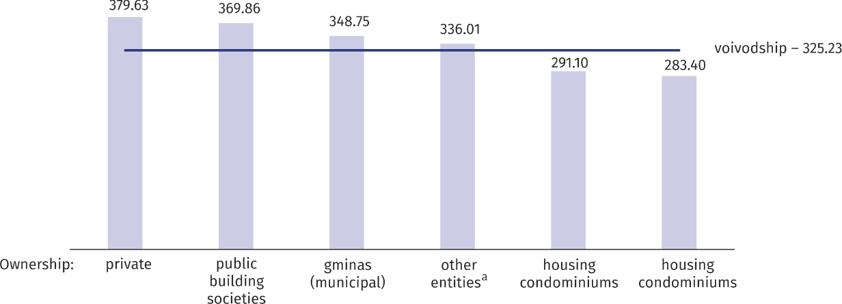
Chart 5. Average amount of housing allowances by type of housing ownership in 2024 (in PLN)
a Dwellings of other entities include the resources of: developers, trade unions, associations, foundations, political parties, professional and economic self-governments, the Catholic Church and religious associations, Catholic universities and church institutes, excluding dwellings owned by these entities in housing condominium buildings.

Land management for housing construction
As of 31 December 2024, gminas owned 1,402.9 ha of undeveloped land intended for housing construction, of which 70.6% of land was for single-family housing. Of the total land area intended for housing construction, 67.6% was located in urban areas. Compared to the previous year, there was an increase in the area of land for residential construction by 2.4%. In 2024, gminas transferred 40.9 hectares of land to investors for the construction of dwellings, including 73.6% for single-family housing. The transferred land in urban areas accounted for 55.5% of their total area.
Nearly 71% of the municipal land resources were designated for single-family housing
The majority of land from municipal resources transferred to investors for residential construction was allocated to investments by natural persons – 57.9%, followed by companies and other entities – 27.9%, and cooperatives – 11.0%. The share of land transferred for municipal construction was only 3.2%.
In case of quoting Statistics Poland data, please provide information: “Source of data: Statistics Poland”, and in case of publishing calculations made on data published by Statistics Poland, please include the following disclaimer: “Own study based on figures from Statistics Poland”.

Prepared by:  Statistical Office in Warszawa  Director Agnieszka Ajdyn  Phone: (+48 22) 464 23 15 | Issued by:  Statistical Information Centre  Mobile: (+48) 783 940 141  e-mail: m.kaluski@stat.gov.pl
 | www.warszawa.stat.gov.pl/en/
 | @WARSZAWA_STAT
 | @UrzadStatystycznywWarszawie
 | gus_stat
 | glownyurzadstatystycznygus
 | glownyurzadstatystyczny

Related information
Housing economy in 2024
Statistical Yearbook of Mazowieckie Voivodship 2024
Statistics of gminas and powiats of Mazowieckie Voivodship in 2015 and 2023
Report on the socio-economic situation of Mazowieckie Voivodship 2025
Data available in databases
Local Data Bank (BDL) Housing economy and municipal infrastructure
Knowledge Databases (DBW) Housing economy and municipal infrastructure
Ważniejsze pojęcia dostępne w słowniku
Dwelling
Useful floor area of a dwelling
Room
Arrears in payments for dwellings
Eviction
Costs of dwelling stock maintenance
Housing allowance

Excluding dwellings constituting a separate ownership, located in buildings owned by housing cooperatives.
Including dwellings constituting a separate ownership, located in buildings owned by housing cooperatives, in which housing condominiums have not been established and which are still managed by housing cooperatives.
Periodic survey carried out every 2 years.
Costs of operation and municipal services provided.
Including management, administrative and office costs, maintenance, and repairs.
Including heating and cold water supply, municipal waste collection, and elevator maintenance.

