Dwelling stocks in Mazowieckie Voivodship in 2019

2018 was the next year in which the number of dwellings increased. The average dwelling size was over 72 m2. The average number of persons per dwelling decreased. Compared to 2018, the number and amount of housing allowances paid decreased.

101.8



Dynamics of the number of dwellings y/y

# Size of dwelling stocks and their location

Dwellings in Mazowieckie Voivodship accounted for almost 16% of national dwelling stocks

As of 31 December 2019, the dwelling stocks of Mazowieckie Voivodship amounted to 2,344.4 thousand dwellings, which accounted for 15.8% of national stocks. The size of dwellings stocks per 1000 population was at the level of 432.3 (385.9 in the country). On an annual basis, it increased by 6.1 points and 5.4 points, respectively. Compared to 2018, there was an increase in the number of dwellings by 41.6 thousand (by 1.8%). The useful floor area of dwellings increased by 3,353.9 thousand m2 (by 2.0%). In urban areas, the number of dwellings increased by 33.0 thousand (i.e. 2.0%), representing 79.4% of the increase in the number of dwellings in the voivodship. The largest increase was recorded in the capital city — 21.3 thousand (51.3% of the increase in the voivodship and 64.6% of the increase in dwellings in urban areas). Whereas in rural areas the number of dwellings increased by 8.6 thousand (i.e. by 1.3%). The highest growth rate of dwellings, on an annual basis, was recorded in the powiats: legionowski (103.2), warszawski zachodni, wołomiński (by 103.0 each), piaseczyński (102.7), Siedlce (102.6), grodziski, pruszkowski and m.st. Warszawa (102.2 each). The lowest growth rate was noted in: żuromiński (0.3%), lipski, węgrowski (by 0.4% each), gostynińśki powiats (0.5%).

There were 432 dwellings per 1000 population of the voivodship (386 in the country)

Chart 1. Dwellings stocks by location (as of 31 December)

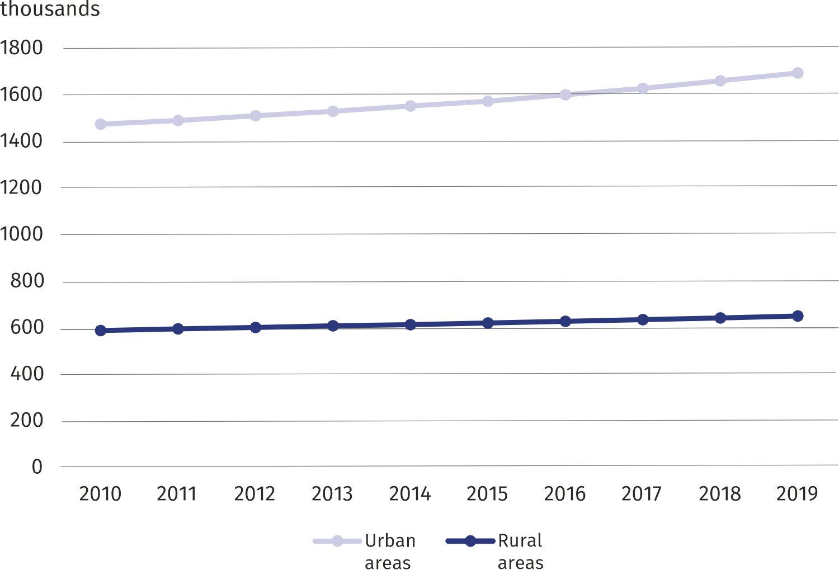

# Dwelling conditions

In 2019, in Mazowieckie Voivodship, the average number of rooms in a dwelling was 3.62 (in urban areas 3.38, in rural areas 4.24). The largest number of them was in ostrołęcki powiat (4.59), and the smallest in m.st. Warszawa (3.14).

The average useful floor area of dwellings in Mazowieckie Voivodship amounted to 72.4 m2 (in urban areas 63.7 m2, in rural areas 95.1 m2), which on average resulted in 31.3 m2 per person (in urban areas 30.9 m2, in rural areas 32.1 m2). The largest dwelling in terms of average useful floor area was located in warszawski zachodni powiat – 108.3 m2, while the smallest in m.st. Warszawa – 59.0 m2. The average number of persons per one dwelling compared to the previous year decreased and amounted to 2.31. In urban areas, this ratio reached 2.06, and in rural areas – 2.96. The most populated dwellings were recorded in ostrołęcki powiat, where the average number of persons per dwelling was 3.51. Dwellings in m.st. Warszawa were the least populated – 1.80.

A dwelling in rural areas was on average 31.4 m2 larger than in urban areas

**Map 1. Average useful floor area of dwellings in 2019 (as of 31 December)**

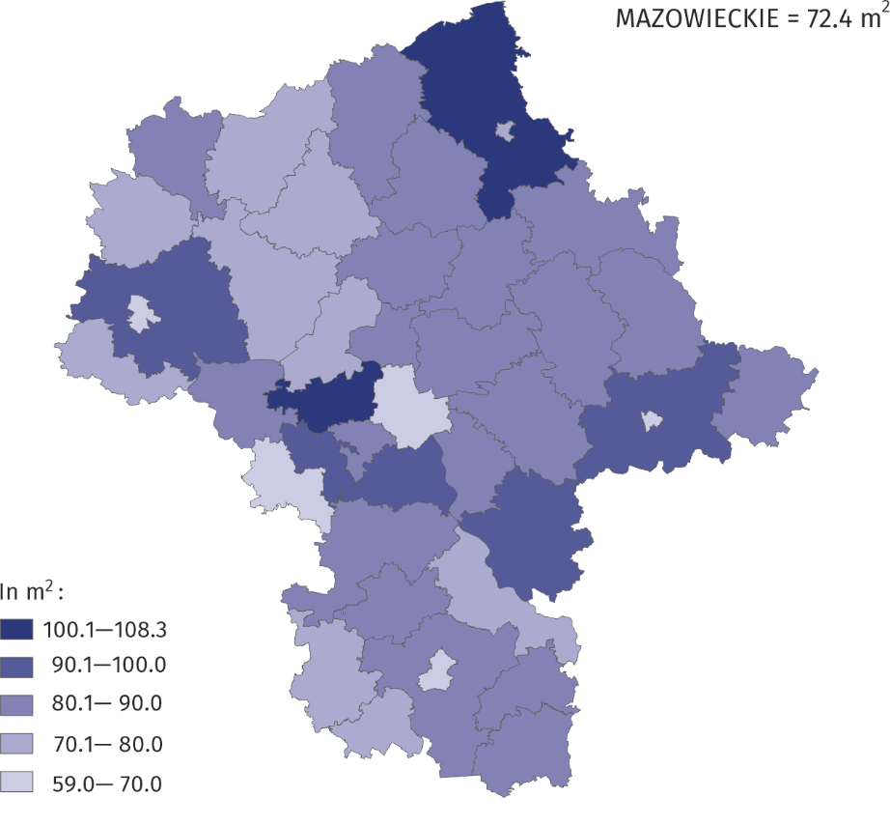

# Dwellings fitted with sanitary and technical installations

Almost 96% of dwellings in the voivodship were fitted with water supply system

At the end of 2019, 96.0% of total dwellings in the voivodship were fitted with water supply system, lavatory — 93.8%; bathroom — 91.8%; central heating — 87.0%; gas from gas supply system — 57.3%. Among powiats, the highest indicators of dwellings fitted with sanitary and technical installations were recorded in m.st. Warszawa (99.7% of total dwellings had water supply system; 99.3% lavatory), in Ostrołęka (98.5% of total dwellings had a lavatory; 96.3% central heating), in pruszkowski powiat (84.4% of dwellings had gas from gas supply system). The smallest percentage of dwellings fitted with water supply system, lavatory, central heating was in lipski powiat (respectively: 80.1%; 72.8%; 59.9%). Whereas in przysuski powiat the least dwellings were fitted with a bathroom (69.7% of total dwellings) and gas from gas supply system (0.1%).

Chart 2. Dwellings fitted with technical and sanitary installations in 2019

(as of 31 December)

# 

# Demand for renting premises from the gmina

Compared to 2018, the number of households waiting for the rental of dwellings from the gmina increased

As of 31 December 2019, the number of residential premises with lease contracts (excluding replacement premises and temporary premises) amounted to 90844 with a total useful area of 4,044,000 m2. The average area of a rented premises from the gminas’ dwelling stocks was 44.5 m2. The number of residential premises with social rental contracts[1] was 10334, and their area was 321.7 thousand m2. As at December 31, 2019, the number of residential premises with lease agreements (excluding replacement premises and temporary premises) amounted to 90,844 with a total usable area of 4,044,000.Na dzień 31 grudnia 2019 roku liczba lokali mieszkalnych z umowami najmu (z wyłączeniem lokali zamiennych i lokali tymczasowych) wyniosła 90.844 o łącznej powierzchni użytkowej 4.044.000.

As of December 31, 2019. Number of dwellings for which the lease agreements were (with the exception of parts of premises and temporary premises) amounted to 90,844, with a total usable area of 4044.0 thousand.

The most housing allowances were paid to users of municipal premises

Na dzień 31 grudnia 2019 r. Liczba mieszkań objętych umowami najmu (z wyłączeniem części lokali i lokali tymczasowych) wyniosła 90 844, o łącznej powierzchni użytkowej 4044,0 tys.

Nie mogę wczytać wszystkich wyników

Ponów próbę

Ponawianie próby

Ponawianie próby

m2.

...

Nie mogę wczytać wszystkich wyników

Ponów próbę

Ponawianie próby

Ponawianie próby

The average area of a rented premises from the commune's housing stock was 44.5 m2.

Średnia powierzchnia wynajmowanego lokalu z zasobu gminy wynosiła 44,5 m2.

The average size of incidental lease prereacted with residential premises resource Area amounted to 44.5 m2.

Średnia wielkość najmu incydentalnego wstępnie zrealizowanego zasobem lokali mieszkalnych Powierzchnia wyniosła 44,5 m2.

Nie mogę wczytać wszystkich wyników

Ponów próbę

Ponawianie próby

Ponawianie próby

In 2019, 14165 households awaited the rental of residential premises from the gmina (excluding spare premises and temporary premises), including 6904 for social premises1. In comparison with 2018, the number of residential premises awaiting rental increased by 0.3%.

In the cities of Mazowieckie Voivodship there were 86.2% of all households awaiting the rent of premises from the gmina, and for social premises1 — 87.3%.

# Housing allowances

One of the forms of assistance implemented by the gmina is social assistance related to expenses borne by tenants for a dwelling they occupy. In 2019, 298.5 thousand housing allowances for a total amount of PLN 60,080.1 thousand were paid in Mazowieckie Voivodship, of which in urban areas 95,7% and 96.2%, respectively. The highest amount of allowances was paid to users of municipal (gmina) premises (PLN 26,587.1 thousand) as well as cooperative premises (PLN 16,559.5 thousand), and the lowest to the users of stocks of public building societies (PLN 2,000.8 thousand) and other entities (PLN 2252.5 thousand).

Compared to 2018, both the number and the total amount of allowances paid to dwelling users decreased by 15.2% and 12.9%, respectively. The average amount of housing allowances increased by 2.5%.

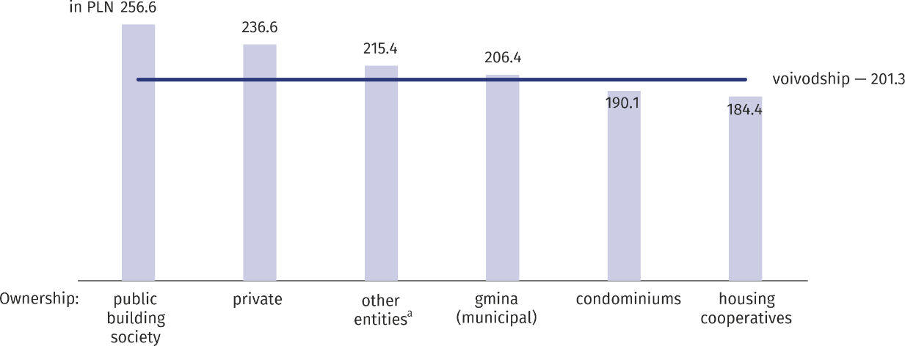In 2019, 298.5 thousand housing allowances for a total amount of PLN 60,080.1 thousand were paid in the Mazowieckie Voivodeship.

W 2019 roku w województwie mazowieckim wypłacono 298,5 tys. Dodatków mieszkaniowych na łączną kwotę 60080,1 tys. Zł.

In 2019. In the wo-jewództwa Mazowieckie paid 298,500 housing subsidies totaling 60,080.1 thousand.

W 2019 r. W województwie mazowieckim wypłacono 298 500 dopłat mieszkaniowych na łączną kwotę 60 080,1 tys.

Nie mogę wczytać wszystkich wyników

Ponów próbę

Ponawianie próby

Ponawianie próby

**Chart 3. Average amount of housing allowances by ownership form of dwellings stocks in 2019**

a Dwellings of other entities include the stocks of: developers, trade unions, associations, foundations, political parties, professional and economic self-governments, excluding dwellings owned by these entities in buildings of condominiums.

# Land management for housing construction

67% of the land in gmina resources was intended for single-family housing

As of 31 December 2018, the gminas owned 1,301.0 ha of undeveloped land for housing, of which 66.8% of land was for single-family housing. 66.1% of the total area of land intended for housing was located in urban areas. Compared to the previous year, a 2.4% increase in the area of land for housing construction was recorded. In 2019, gminas transferred 38.5 ha of land to investors for housing, including 69.4% for single-family housing. Transfers of land in urban areas constituted 69.6% of their total area.

In the case of quoting data from Statistics Poland, please provide information: "Source of data – Statistics Poland", and in the case of publishing calculations made on data published by Statistics Poland, please provide information: "Own study based on Statistics Poland data".

|  |  |
| --- | --- |
| Prepared by:  **Statistical Office in Warszawa** **Director Zofia Kozłowska**Tel: (+48 22) 464 23 15 | Issued by: **Statistical Information Centre** **Marcin Kałuski**Tel: (+48 22) 464 20 91 |

|  |  |  |
| --- | --- | --- |
| **Press office**  **tel.:** (+48 22) 464 20 91  **e-mail:** [**m.kaluski@stat.** **gov.pl**](mailto:m.kaluski@stat.%20gov.pl) |  | [warszawa.stat.gov.pl](https://warszawa.stat.gov.pl/)/en/ |
|  | [@Warszawa_STAT](https://twitter.com/Warszawa_STAT) |
|  |  |



**Related information**

[Housing economy in 2019](https://stat.gov.pl/en/topics/municipal-infrastructure/municipal-infrastructure/housing-economy-in-2019,10,3.html)

[Statistical Yearbook of Mazowieckie Voivodship 2019](https://warszawa.stat.gov.pl/publikacje-i-foldery/roczniki-statystyczne/rocznik-statystyczny-wojewodztwa-mazowieckiego-2019,4,19.html)

[Mazowieckie Voivodship — Subregions Powiats Gminas 2019](https://warszawa.stat.gov.pl/publikacje-i-foldery/roczniki-statystyczne/wojewodztwo-mazowieckie-podregiony-powiaty-gminy-2019,5,16.html)

**Data available in databases**

[Local Data Bank housing and municipal economy](https://bdl.stat.gov.pl/BDL/dane/podgrup/temat)

Knowledge Databases

**Terms used in official statistics**

[Dwelling](https://stat.gov.pl/en/metainformations/glossary/terms-used-in-official-statistics/202,term.html)

[Useful](http://stat.gov.pl/metainformacje/slownik-pojec/pojecia-stosowane-w-statystyce-publicznej/324,pojecie.html) floor area of dwellings

[Room](https://stat.gov.pl/metainformacje/slownik-pojec/pojecia-stosowane-w-statystyce-publicznej/133,pojecie.html)

[Dwelling allowance](https://stat.gov.pl/en/metainformations/glossary/terms-used-in-official-statistics/1481,term.html)

[Common land](https://stat.gov.pl/en/metainformations/glossary/terms-used-in-official-statistics/1375,term.html)

1. It applies to contracts for social housing and social rental contracts for premises concluded in 2019, both before and after the date of entry into force of Art. 2 of the Act of 22 March 2018 amending the Act on financial support for the creation of social housing, sheltered flats, night shelters and houses for the homeless, the Act on the protection of tenants' rights, municipal housing resources and amendment of the Civil Code and certain other acts.

   It applies to contracts for social housing and social rental contracts for premises concluded in 2019, both before and after the date of entry into force of Art.

   Dotyczy to umów o lokale socjalne i najmu lokali zawartych w 2019 r., Zarówno przed, jak i po wejściu w życie art.

   It applies to agreements on social housing and social premises lease agreements concluded in 2019. Both before and after the date of entry into force of Art.

   Dotyczy to umów o lokale socjalne i najmu lokali socjalnych zawartych w 2019 r. Zarówno przed, jak i po wejściu w życie art.

   Nie mogę wczytać wszystkich wyników

   Ponów próbę

   Ponawianie próby

   Ponawianie próby