Tourism in m.st. Warszawa in 2021
18 May 2022
53.4%
Y/y increase in the number of tourists in tourist accommodation establishments
In 2021, there were 2,029.8 thousand tourists using tourists accommodation establishmnets in Warszawa, who were provided with 3,479.6 thousand overnight stays. Compred to 2020, it was more by 53.4% and 48.9%, respectively. The occupancy rate of bed places amounted to 30.5% and increased during the year by 8.1 pp.

In 2021, restrictions on the operation of tourist accommodation establishments introduced from mid-March 2020 due to the COVID-19 pandemic were still in force. The scope of these restrictions was changed depending on the current epidemic situation.

Tourist accommodation establishments
At the end of July 2021, tourists visiting the capital city had 173 tourist accommodation establishments at their disposal

On 31 July 2021, there were 173 tourist accommodation facilities in m.st. Warszawa, of which 172 were open all year. During the year, the number of accommodation establishments increased by 12.
The tourist accommodation establishments consisted of 124 hotels and similar facilities (hotels, motels, boarding houses and other hotel facilities) as well as 52 other facilities. The largest group among hotels and similar facilities, as in previous years, were hotels – 100 facilities (by 15 more than in 2020). Among other facilities, the most numerous were hostels – 17 (by 2 fewer than in the previous year).

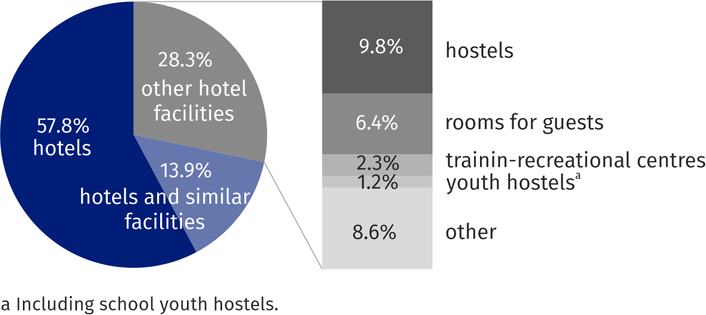
Chart 1. Structure of tourist accommodation establishments by type in 2021

At the end of July 2021, 37583 bed places were prepared in tourist accommodation facilities, that is by 18.3% more than in the corresponding period of 2020. According to the compiled data, there was an average of 217 bed places per one facility in the capital city (in 2020 – 197).
The largest number of bed places were offered by hotels (31372), i.e. 83.5% of all bed places in m.st. Warszawa. Compared to the corresponding period of the previous year, the number of bed places in hotels increased by 23.5%. There was an average of 314 bed places per one hotel (by 15 more than in the previous year).

Table 1. Tourist accommodation establishments at the end of july 2021
Specification | Number of establishments |  | Number of bed places
 | 2021 | 2020=100 | 2021 | 2020=100
Total | 173 | 107,5 | 37583 | 118,3
of which open all year | 172 | 108,2 | 37407 | 118,4
Hotels and similar facilities | 124 | 113,8 | 33386 | 122,2
of which hotels | 100 | 117,6 | 31372 | 123,5
Other facilities | 49 | 94,2 | 4197 | 94,3
The distribution of the tourist accommodation establishments in m.st. Warszawa is uneven. As of the end of July 2021, the largest number of tourist accommodation facilities were located in the Śródmieście district. 46 facilities were operating here, offering 12625 bed places (33.6% of total tourist accommodation facilities in the capital). Apart from Śródmieście, the following districts had the largest number of places: Włochy (5693 place in 21 facilities), Wola (5146 places in 17 facilities).
At the end of July 2021, tourist accommodation establishments in m.st. Warszawa offered 37.6 thousand bed places, of which the most in Śródmieście

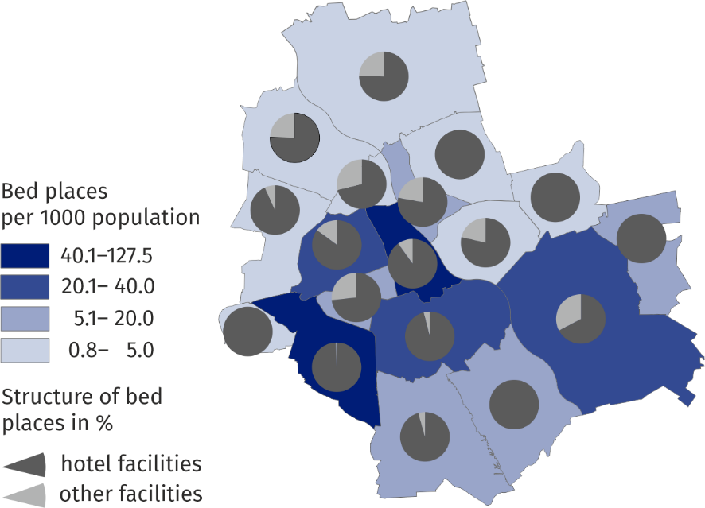
Map 1. Bed places in tourist accommodation establishments by districts in 2021

Equipment of tourist accommodation establishments
At the end of July 2021, there were 204 catering outlets operating in tourist accommodation establishments (29 more than in the previous year). The largest group were restaurants – 96 (47.1%), followed by bars and cafes – 66 (32.4%), catering outlets – 22 (10.8%) and canteens – 20 (9.8%).
The survey of tourist accommodation establishments once every four years also includes equipping tourist accommodation establishments with conference facilities, sports and recreation facilities and the availability of facilities for people with physical disabilities.
In 2021, 100 (57.8%) tourist accommodation establishments were prepared for conferences, and among hotels this percentage was 75.0% (75 establishments). Accommodation establishments offered a total of 33,719 places in 601 conference rooms. In 83.0% of establishments with conference facilities, apart from technical equipment, technical services were also provided. Wi-Fi network on the premises was available in 67.6% of tourist accommodation establishments, including 81.0% of hotels.
100 tourist accommodation establishments, including 75 hotels, had a conference room
Among sports and recreation facilities, tourist accommodation establishments most often had a gym – 41 (23.7%) and a sauna – 35 (20.2%). Spa treatments were offered in 18 (10.4%) establishments, as were rehabilitation treatments – 18 (10.4%). A playroom for children was located in 14 establishments (8.1%), an indoor swimming pool in 12 establishments (6.9%) and a pool table in 12 establishments (6.9%).
In 2021, the largest number of tourist accommodation establishments – 95 (54.9%) had lifts adapted for the disabled, and 86 (49.7%) car parks with designated spaces for the physically disabled. Automatic doors were located in 66 (38.2%) units, and ramps in 63 (36.4%) establishments.
Tourists staying in tourist accommodation establishments
In 2021, 2,029.8 thousand tourists stayed in tourist accommodation establishments, of which 327.6 thousand (i.e. 22.4%) foreign tourists. Compared to 2020, the number of tourists increased by a total of 53.4% and the number of foreign tourists by 38.8%.
As in the previous year, tourists most often stayed in hotels which hosted 1,771.5 thousand persons (i.e. 87.3% of the total number of tourists accommodated). There were 400.9 thousand foreign tourists among the hotel guests.

Table 2. Tourists accommodated and nights spent in tourist accommodation establishments
in 2021

Specification | Tourists accommodated |  | Nights spent
 | In thousands | 2020=100 | In thousands | 2020=100
TOTAL | 2029,8 | 153,4 | 3479,6 | 148,9
of which open all year | 454,6 | 138,8 | 865,5 | 136,7
Hotels and similar facilities | 1851,1 | 155,7 | 3015,7 | 153,4
of which hotels | 1771,5 | 156,6 | 2840,0 | 156,6
Other facilities | 178,7 | 133,3 | 463,9 | 124,9

Among foreign tourists, the largest number came from Germany – 54.0 thousand (11.9% of the total number of foreign tourists arriving in the capital), the United States – 46.0 thousand (10.1%) and Ukraine – 31.6 thousand. (6.9%).

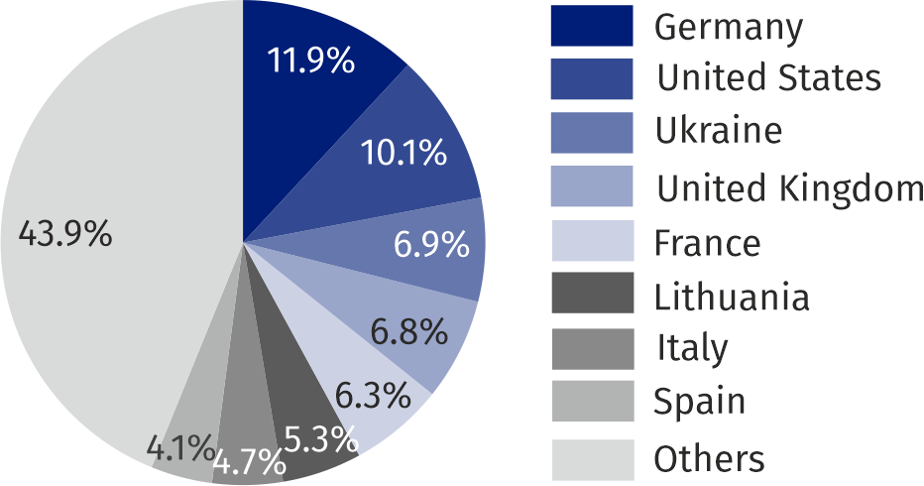
Chart 2. Structure of foreign tourists by country of permanent residence in 2021
454.6 thousand foreign tourists stayed in tourist accommodation establishments in the capital in 2021, the majority from Germany

Tourists, who visited m.st. Warszawa in 2020 were provided with 3,479.6 thousand overnight stays (a 48.9% increase compared to 2020), of which 865.5 thousand (24.9%) to foreign tourists (by 36.7% more than in the previous year). The largest number of overnight stays was recorded in hotels – 2,840.0 thousand (i.e. 81.6% of total nights spend in the capital).
In 2021, on average one tourist spent 1.7 nights in m.st. Warszawa and a foreign tourist 1.9 nights

On average, one tourist spent 1.7 nights in 2021 in m.st. Warszawa (1.8 nights the year before). The average length of a foreign tourist's stay remained unchanged and amounted to 1.9 nights.

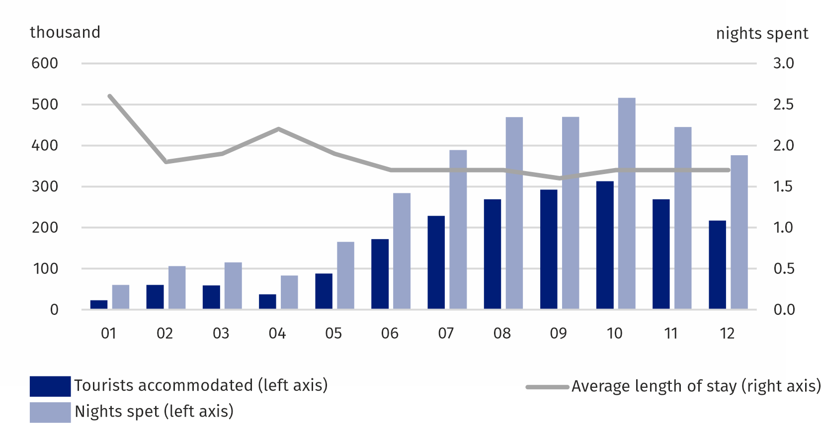
Chart 3. Tourists accommodated, nights spent and average length of stay in tourist accommodation establishments by months in 2021

The largest number of tourists visited the capital in October – 312.7 thousand, and the least in January – 23.2 thousand. The most overnight stays were also provided in October – 515.9 thousand, and the least in January – 60.7 thousand.
Occupancy rate of bed places in tourist accommodation facilities in total in 2021, amounted to 30.5% and increased by 8.1 pp than in the previous year. Occupancy rate of bed places in hotel facilities amounted to 30.0% (by 8.1 pp more than in the previous year), and in other facilities 33.9% (by 8.5 pp more).
In 2021, the highest occupancy rate of bed places was recorded in training-recreational centres (42.1%)

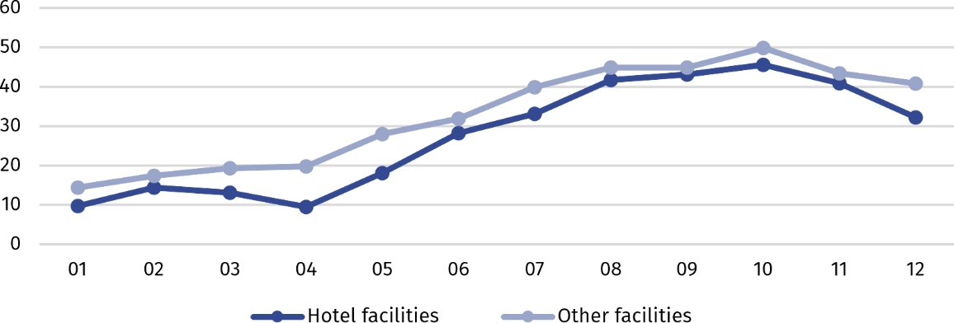
Chart 4. Occupancy rate of bed places in 2021 (in %)

In the capital city, 1,916.2 thousand rooms were rented to tourists in hotel facilities, including 500.6 thousand to foreign tourists. The occupancy of rooms in hotels, motels, boarding houses and other hotel facilities in 2021 amounted to 36.0% (by 8.3 pp more than in 2020). The highest occupancy rate of rooms was recorded in October (56.0%), and the lowest in April – 12.7%.
Warsaw is well-equipped with a high-standard tourist infrastructure. 39.7% of all hotels in Mazowieckie Voivodship were located in the capital city, including 15 5-star hotels out of 16 in the voivodship. 5-star hotels offered 3,506 rooms and 6,133 bed places. Occupancy rate of rooms in these hotels amounted to 32.1%, and of bed places – 27.6%. In 2021, 5-star hotels were used by 304.8 thousand, i.e. 17.2% of the total number of tourists staying in hotels in the capital city. The largest percentage were tourists staying in 4-star (32.5%) and 3-star (32.4%) hotels, and the smallest – staying in 1-star hotels (7.0%). Foreigners in hotels accounted for 22.6% of all guests, and in hotels of the highest standard (5-star) this share was the highest and amounted to 42.8%.
In 2021, tourists most often stayed in hotels, with every fifth choosing the offer of 5-star hotels

Table 3. Occupancy of hotels by category in 2021
Specification | Number of facilitiesª | Tourists | Nights spent | Rented rooms | Occupancy in % of
 |  | In thousands |  |  | places | rooms
Hotels | 100 | 1771,5 | 2840,0 | 1822,6 | 30,2 | 36,6
5-star | 15 | 304,8 | 526,8 | 346,2 | 27,6 | 32,1
4-star | 21 | 575,3 | 867,8 | 564,1 | 31,2 | 37,6
3-star | 39 | 573,6 | 903,4 | 586,1 | 31,0 | 36,3
2-star | 17 | 172,3 | 296,9 | 192,7 | 25,4 | 36,4
1-star | 6 | . | . | . | . | .
under categorisation | 2 | . | . | . | . | .
a As of the end of July.

When quoting the data from the Statistics Poland, please do include information: “Data source Statistics Poland”, while in case of publishing the calculations done with the use of the data published by Statistics Poland, please do include information: “Own elaboration based on the Statistics Poland data”.
Prepared by:  Statistical Office in Warszawa  Director Zofia Kozłowska  Tel.: (+ 48 22) 464 23 15 | Issued by:  Statistical Information Centre  Marcin Kałuski  Tel.: (+ 48 22) 464 20 91
Press office  Tel.: (+ 48 22) 464 20 91  e-mail: m.kaluski@stat. gov.pl | www.warszawa.stat.gov.pl/en/
 | @WARSZAWA_STAT
 | @UrzadStatystycznywWarszawie
 | gus_stat
 | glownyurzadstatystycznygus
 | glownyurzadstatystyczny
Related information
Tourism in 2020
Tourism in the European Union
Data available in databases
Local Data Bank
Terms used in official statistics
Tourism
Tourist accommodation establishment
Bed places in tourist accommodation establishments
Foreign tourists in tourist accommodation establishments
Nights spent in tourist accommodation establishments

Applies to tourist accommodation establishments with 10 or more beds.

