Tourism in m.st. Warszawa in 2020

Applies to tourist accommodation establishments with 10 or more beds

iApplies to tourist accommodation establishments with 10 or more beds

Dotyczy turystycznych obiektów noclegowych z 10 lub więcej miejscami noclegowymi

It applies to tourist accommodation establishments having 10 or more bed places

Dotyczy to turystycznych obiektów noclegowych posiadających 10 i więcej miejsc noclegowych

Nie mogę wczytać wszystkich wyników

Ponów próbę

Ponawianie próby

Ponawianie próby

**In 2020, there were 1,322.9 thousand tourists using tourists accommodation establishmnets in Warszawa, who were provided with 2,336.9 thousand overnight stays. Compred to 2019, it was less by 65.3% and 64.3%, respectively. The occupancy rate of bed places amounted to 22.4% and decreased during the year by 30.5 pp.**

65.3%

Decrease in the number of tourists in tourist accommodation establishments compared to 2019

Tourism is one of the sectors directly affected by the COVID-19 pandemic. The restrictions on the movement of people introduced in Poland in mid-March this year and the restriction of activities related to the provision of hotel services from the beginning of April and the renewed since November of the activities related to the provision of hotel services, resulted in a significant decrease in the number of persons staying in tourist accommodation establishments in 2020.

Tourism is one of the sectors directly affected by the COVID-19 pandemic.

Turystyka jest jednym z sektorów bezpośrednio dotkniętych pandemią COVID-19.

Tourism is one of the sectors directly affected by the pandemic COVID-19.

Turystyka jest jednym z sektorów bezpośrednio dotkniętych pandemią COVID-19.

Nie mogę wczytać wszystkich wyników

Ponów próbę

Ponawianie próby

Ponawianie próby

The restrictions on the movement of people introduced in Poland in mid-March this year and the restriction of activities related to the provision of hotel services from the beginning of April and the renewed since November of the activities related to the provision of hotel services, resulted in a significant decrease in the number of people using overnight stays in tourist accommodation establishments in 2020.

Ograniczenia w przemieszczaniu się osób wprowadzone w Polsce w połowie marca br. Oraz ograniczenie działalności związanej ze świadczeniem usług hotelarskich od początku kwietnia oraz wznowione od listopada czynności związane ze świadczeniem usług hotelarskich, spowodowały w znaczącym spadku liczby osób korzystających z noclegów w turystycznych obiektach noclegowych w 2020 r.

Introduced in Poland in mid-March., Restrictions on the movement of people and the reduction of early April and again from November activities related to the conduct of hotel services, caused a significant decrease in the number of people accommodated in tourist accommodation in 2020.

Wprowadzone w Polsce w połowie marca. Ograniczenia w przemieszczaniu się osób oraz zmniejszenie z początku kwietnia i ponownie od listopada br. Działalności związanej z prowadzeniem usług hotelarskich, spowodowały znaczny spadek liczby osób korzystających z bazy noclegowej w 2020 roku.

Nie mogę wczytać wszystkich wyników

Ponów próbę

Ponawianie próby

Ponawianie próby

**Tourist accommodation establishments**

At the end of July 2020, tourists visiting the capital city had 161 tourist accommodation establishments at their disposal

On 31 July 2020, there were 161 tourist accommodation facilities in m.st. Warszawa, of which 159 were open all year. During the year, the number of accommodation facilities decreased by 16.1% (by 31 facilities).

The tourist accommodation establishments consisted of 109 hotels and similar facilities (hotels, motels, boarding houses and other hotel facilities) as well as 52 other facilities[1]. The largest group among hotels and similar facilities, as in previous years, were hotels – 85 facilities (by 13 fewer than in 2019). Among other facilities, the most numerous were hostels – 19 (by 6 fewer than in the previous year).

**Chart 1. Structure of tourist accommodation establishments by type in 2020**

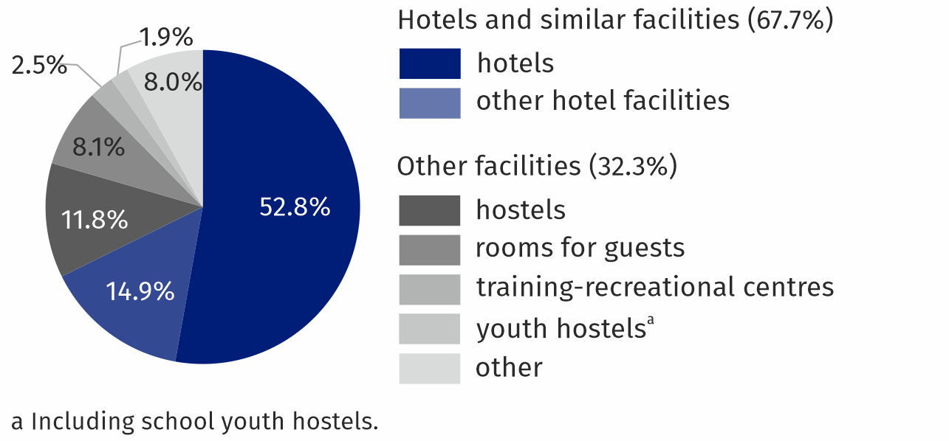**As of 31 July**

At the end of July 2020, 31769 bed places were prepared in tourist accommodation facilities, that is by 8.8% less than in the corresponding period of 2019. According to the compiled data, there was an average of 197 bed places per one facility in the capital city (in 2019 – 182).

The largest number of bed places were offered by hotels (25406), i.e. 80.0% of all bed places in m.st. Warszawa. Compared to the corresponding period of the previous year, the number of bed places in hotels decreased by 8.8%. There was an average of 299 bed places per one hotel (by 15 more than in the previous year).

**Table 1.** **Tourist accommodation establishments in 2020**

**As of 31 July**

|  |  |  |  |  |
| --- | --- | --- | --- | --- |
| Specification | Number of establishments | | Number of bed places | |
| 2020 | 2019=100 | 2020 | 2019=100 |
| **TOTAL** | **161** | **83,9** | **31769** | **91,2** |
| of which open all year | 159 | 83,7 | 31583 | 91,5 |
| Hotels and similar facilities | 109 | 87,9 | 27316 | 91,1 |
| of which hotels | 85 | 86,7 | 25406 | 91,2 |
| Other facilities | 52 | 76,5 | 4453 | 91,4 |

The distribution of the tourist accommodation establishments in m.st. Warszawa is uneven. As of the end of July 2020, the largest number of tourist accommodation facilities were located in the Śródmieście district. 41 facilities were operating here, offering 11139 bed places (35.1% of total tourist accommodation facilities in the capital). Apart from Śródmieście, the following districts had the largest number of places: Włochy (5027 place in 19 facilities), Wola (3525 places in 16 facilities) and Mokotów (3082 places in 18 facilities).

At the end of July 2020, tourist accommodation establishments in m.st. Warszawa offered 31.8 thousand bed places, of which the most in Śródmieście

**Map 1. Bed places in tourist accommodation establishments by districts in 2020**

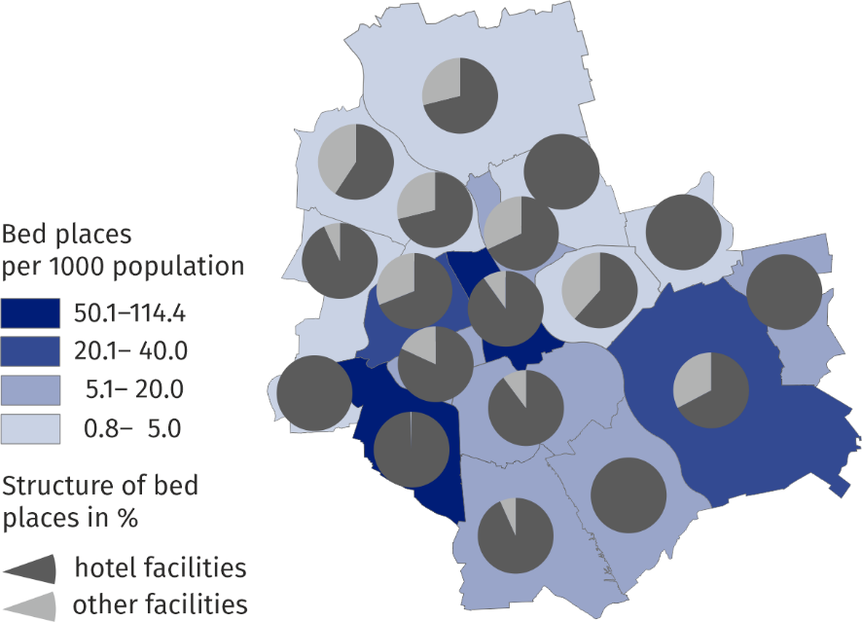**As of 31 July**

At the end of July 2020, 175 catering establishments operated in tourist accommodation facilities (by 34 fewer than in the previous year). The largest group represented restaurants – 84 (48.0%), followed by bars and cafes – 62 (35.4%), food stands – 15 (8.6%) and canteens – 14 (8.0%).

**Tourists staying in tourist accommodation establishments**

In 2020, 1322.9 thousand tourists stayed in tourist accommodation facilities, of which 327.6 thousand (i.e. 24.8%) foreign tourists. Compared to 2019, the number of tourists decreased by a total of 65.3% and the number of foreign tourists by 75.9%.

As in the previous year, tourists most often stayed in hotels which hosted 1,131.0 thousand persons (i.e. 85.5% of the total number of tourists accommodated). There were 285.1 thousand foreign tourists among the hotel guests.

As in the previous year, tourists most often stayed in hotels which hosted 1,131.0 thousand people (ie 85.5% of the total number of guests staying).

Podobnie jak w roku poprzednim turyści najczęściej zatrzymywali się w hotelach, które gościły 1 131,0 tys. Osób (tj. 85,5% ogółu przebywających gości).

Like last year stopped most tourists in hotels that have adopted 1131.0 thousand people (ie. 85.5% of the total using the accommodation).

Podobnie jak w ubiegłym roku większość turystów zatrzymała się w hotelach, które przyjęły 1131,0 tys. Osób (tj. 85,5% ogółu korzystających z noclegów).

Nie mogę wczytać wszystkich wyników

Ponów próbę

Ponawianie próby

Ponawianie próby

Among the hotel guests was

Wśród gości hotelowych był

Among the guests was

Wśród gości był

Nie mogę wczytać wszystkich wyników

Ponów próbę

Ponawianie próby

Ponawianie próby

Nie mogę wczytać wszystkich wyników

Ponów próbę

Ponawianie próby

Ponawianie próby

285.1 thousand foreign tourists.

285,1 tys. Turystów zagranicznych.

285,100 foreign tourists.

undefined

Nie mogę wczytać wszystkich wyników

Ponów próbę

Ponawianie próby

Ponawianie próby

**Table 2. Tourists accommodated and nights spent in tourist accommodation establishments**

**in 2020**

|  |  |  |  |  |
| --- | --- | --- | --- | --- |
| Specification | Tourists accommodated | | Nights spent | |
| In thousands | 2019=100 | In thousands | 2019=100 |
| **TOTAL** | **1322,9** | **34,7** | **2336,9** | **35,7** |
| of which open all year | 327,6 | 24,1 | 633,2 | 24,5 |
| Hotels and similar facilities | 1188,8 | 33,9 | 1965,6 | 33,8 |
| of which hotels | 1131,0 | 33,8 | 1813,0 | 33,0 |
| Other facilities | 134,1 | 44,0 | 371,4 | 51,0 |

Most foreign tourists visiting the capital came from Europe – 254.1 thousand (by 71.2% less than a year earlier). M.st. Warszawa was also visited by: 31.0 thousand tourists from Asia (by 86.5% less than in 2019); 26.5 thousand from North America (by 83.1% less); 2.2 thousand from South and Central America (by 85.3% less); 1.7 thousand from Africa (by 76.6% less) and 1.3 thousand from Australia and Oceania (by 89.0% less).

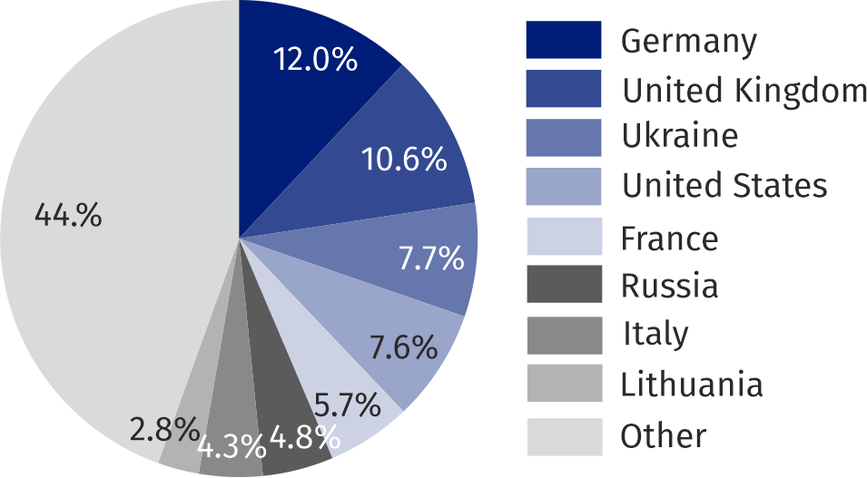**Chart 2. Structure of foreign tourists by country of permanent residence in 2020**

327.6 thousand foreign tourists stayed in tourist accommodation establishments in the capital in 2020, the majority from Germany, United Kingdom and Ukraine

Tourists, who visited Warsaw capital city in 2020 were provided with 2336.9 thousand overnight stays (a 64.3% decrease compared to 2019), of which 633.2 thousand (27.1%) to foreign tourists (by 75.5% less than in the previous year). The largest number of overnight stays was recorded in hotels – 1813.0 thousand (i.e. 77.6% of total nights spend in the capital).

On average, one tourist spent 1.8 nights in 2020 in m.st. Warszawa (1.7 nights the year before). The average length of a foreign tourist's stay remained unchanged and amounted to 1.9 nights.

On average, one tourist spent 1.8 nights in 2020 (1.7 nights the year before).

In 2020, on average one tourist spent 1.8 nights in m.st. Warszawa and a foreign tourist 1.9 nights

Średnio jeden turysta spędził w 2020 roku 1,8 nocy (1,7 nocy rok wcześniej).

On average, a tourist used in 2020. 1.8 of accommodation (accommodation 1.7 the year before).

Średnio turysta korzystał w 2020 r. 1,8 miejsca noclegowego (rok wcześniej 1,7 noclegu).

Nie mogę wczytać wszystkich wyników

Ponów próbę

Ponawianie próby

Ponawianie próby

The average duration of a foreign tourist's stay in the capital city of

Średni czas pobytu turysty zagranicznego w stolicy

The average length of stay of foreign tourists in the capital city

Średnia długość pobytu turystów zagranicznych w stolicy

Nie mogę wczytać wszystkich wyników

Ponów próbę

Ponawianie próby

Ponawianie próby

**Chart 3. Tourists accommodated, nights spent and average length of stay in tourist accommoda-**

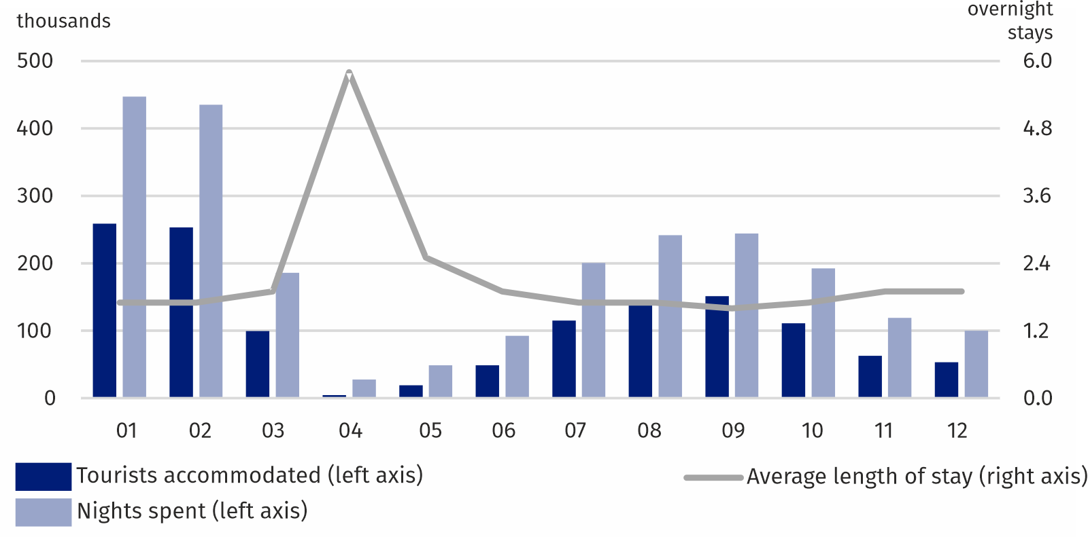**tion establishments by months in 2020**

Considering the number of tourists in individual months, it can be noticed that the greatest number of tourists visited m.st. Warszawa in January (258.7 thousand) and February (253.0 thousand). Starting in March, the number of tourists began to decline sharply, peaking in April (4,800), when most venues were suspended due to the COVID-19 pandemic. Since May, there has been an increase in the number of persons using overnight stays, and a further decline since October. The highest number of overnight stays was also provided in January (447.2 thousand) and February (435.0 thousand), the least in April (28.0 thousand).

Considering the number of tourists in individual months, it can be noticed that the greatest number of tourists visited the Capital City of

Biorąc pod uwagę liczbę turystów w poszczególnych miesiącach, można zauważyć, że najwięcej turystów odwiedziło miasto stołeczne

Considering the number of tourists in individual months it may be noted that most tourists visited the Capital City

Biorąc pod uwagę liczbę turystów w poszczególnych miesiącach można zauważyć, że najwięcej turystów odwiedziło stolicę

Nie mogę wczytać wszystkich wyników

Ponów próbę

Ponawianie próby

Ponawianie próby

Warsaw in January (258.7 thousand) and February (253.0 thousand).

Warszawa w styczniu (258,7 tys.) I lutym (253,0 tys.).

Warsaw in January (258.7 thous.) And February (253.0 thous.).

Warszawa w styczniu (258,7 tys.) I lutym (253,0 tys.).

Nie mogę wczytać wszystkich wyników

Ponów próbę

Ponawianie próby

Ponawianie próby

Starting in March, the number of tourists began to decline sharply, peaking in April (4,800), when most venues were suspended due to the COVID-19 pandemic.

Od marca liczba turystów zaczęła gwałtownie spadać, osiągając szczyt w kwietniu (4800), kiedy większość obiektów została zawieszona z powodu pandemii COVID-19.

Starting from March, the number of tourists started to rapidly decline, reaching its lowest level in April (4.8 thous.), When most of the objects suspended operations due to the pandemic COVID-19.

Od marca liczba turystów zaczęła gwałtownie spadać, osiągając najniższy poziom w kwietniu (4,8 tys.), Kiedy większość obiektów wstrzymała działalność z powodu pandemii COVID-19.

Nie mogę wczytać wszystkich wyników

Ponów próbę

Ponawianie próby

Ponawianie próby

Nie mogę wczytać wszystkich wyników

Ponów próbę

Ponawianie próby

Ponawianie próby

Since May, there has been an increase in the number of people using overnight stays, and a further decline since October.

Od maja obserwuje się wzrost liczby osób korzystających z noclegów, a od października dalszy spadek.

Since May, there has been an increase in the number of people using the accommodation, and since October noto-WANO renewed decline.

Od maja rośnie liczba osób korzystających z noclegu, a od października noto-WANO ponownie spada.

Nie mogę wczytać wszystkich wyników

Ponów próbę

Ponawianie próby

Ponawianie próby

The highest number of overnight stays was also provided in January (447.2 thousand) and February (435.0 thousand), the least in April (28.0 thousand).

Najwięcej noclegów udzielono także w styczniu (447,2 tys.) I lutym (435,0 tys.), Najmniej w kwietniu (28,0 tys.).

Most accommodation also granted in January (447.2 thous.) And February (435.0 thous.), The lowest in April (28.0 thous.).

Najwięcej noclegów udzielono także w styczniu (447,2 tys.) I lutym (435,0 tys.), Najniższe w kwietniu (28,0 tys.).

Nie mogę wczytać wszystkich wyników

Ponów próbę

Ponawianie próby

Ponawianie próby

Occupancy rate of bed places in tourist accommodation facilities in total in 2020, amounted to 22.4% and decreased by 30.5 pp than in the previous year. Occupancy rate of bed places in hotel facilities amounted to 21.9% (by 32.2 pp less than in the previous year), and in other facilities 25.4% (by 20.0 pp less).

In 2018, the highest occupancy rate of bed places was recorded in hostels (29,9%)

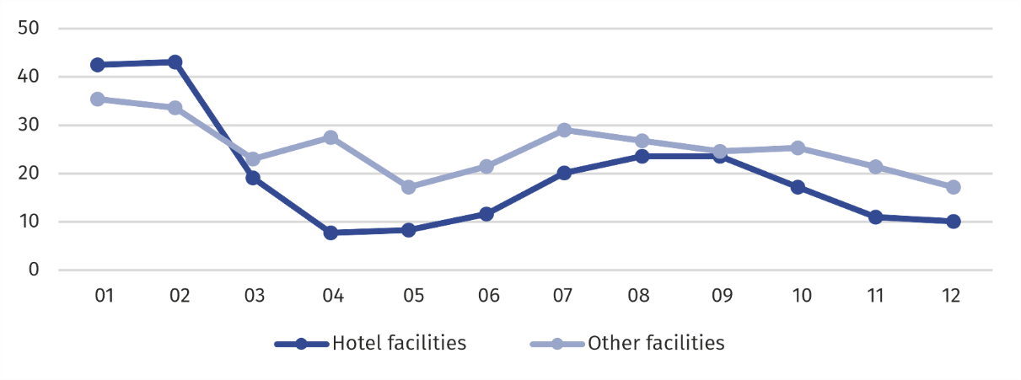**Chart 4. Occupancy rate of bed places in 2020 (in %)**

In the capital city, 1,298.0 thousand rooms were rented to tourists in hotel facilities, including 358.8 thousand to foreign tourists. The occupancy of rooms in hotels, motels, boarding houses and other hotel facilities in 2020 amounted to 27.7% (by 41.3 pp less than in 2019). The highest occupancy rate of rooms was recorded in February (57.7%) and January (54.7%), and the lowest in April - 9.3%.

Warsaw is well-equipped with a high-standard tourist infrastructure. 34.6% of all hotels in Mazowieckie Voivodship were located in the capital city, including 15 5-star hotels out of 16 in the voivodship. 5-star hotels offered 3,496 rooms and 6,100 bed places. Occupancy rate of rooms in these hotels amounted to 24.8%, and of bed places – 20.6%. In 2020, 5-star hotels were used by 217.3 thousand, i.e. 19.2% of the total number of tourists staying in hotels in the capital city. The largest percentage were tourists staying in 3-star (32.5%) and 4-star (30.7%) hotels, and the smallest – staying in 1-star hotels (7.0%). Foreigners in hotels accounted for 25.2% of all guests, and in hotels of the highest standard (5-star) this share was the highest and amounted to 44.8%. Warsaw is well-equipped with a high-standard tourist infrastructure.Warszawa jest dobrze wyposażona w infrastrukturę turystyczną o wysokim standardzie.Warsaw is well equipped with tourism infrastructure of a high standard.Warszawa jest dobrze wyposażona w infrastrukturę turystyczną o wysokim standardzie.Nie mogę wczytać wszystkich wyników

In 2020, tourists most often stayed in hotels, with every fifth choosing the offer of 5-star hotels

In 2020, tourists most often used hotels, with every fifth choosing the offer of 5-star hotels

W 2020 roku turyści najczęściej korzystali z hoteli, a co piąty wybierał ofertę hoteli 5-gwiazdkowych

In 2020. Tourists enjoyed most of the hotels, with one in five chose offer 5-star

W 2020 r. Większość hoteli cieszyła się największą popularnością wśród turystów, z czego co piąty wybrał ofertę pięciogwiazdkową

Nie mogę wczytać wszystkich wyników

Ponów próbę

Ponawianie próby

Ponawianie próby

Ponów próbę

Ponawianie próby

Ponawianie próby

34.6% of all hotels in the Mazowieckie voivodship were located in the capital city, including 15 5-star hotels out of 16 in the voivodship.

34,6% wszystkich hoteli województwa mazowieckiego znajdowało się w stolicy, w tym 15 hoteli 5-gwiazdkowych na 16 w województwie.

The capital was located 34.6% of the total Mazowieckie hotels, including 15 hotels 5-stars out of 16 in the province.

W stolicy zlokalizowane było 34,6% wszystkich hoteli mazowieckich, w tym 15 hoteli 5-gwiazdkowych na 16 w województwie.

Nie mogę wczytać wszystkich wyników

Ponów próbę

Ponawianie próby

Ponawianie próby

5-star hotels offered 3,496 rooms and 6,100 beds.

Hotele 5-gwiazdkowe oferowały 3496 pokoi i 6100 miejsc noclegowych.

5-star hotels offered 3496 rooms and 6100 beds.

Hotele 5-gwiazdkowe oferowały 3496 pokoi i 6100 miejsc noclegowych.

Nie mogę wczytać wszystkich wyników

Ponów próbę

Ponawianie próby

Ponawianie próby

Occupancy rate of rooms in these hotels amounted to 24.8%, and of bed places - 20.6%.

Stopień wykorzystania pokoi w tych hotelach wyniósł 24,8%, a miejsc noclegowych 20,6%.

The degree of utilization of rooms in these hotels was 24.8%, and the beds - 20.6%.

Stopień wykorzystania pokoi w tych hotelach wyniósł 24,8%, a łóżek - 20,6%.

Nie mogę wczytać wszystkich wyników

Ponów próbę

Ponawianie próby

Ponawianie próby

In 2020, 5-star hotels were used by 217.3 thousand, i.e. 19.2% of the total number of people staying in hotels in the capital city.

W 2020 roku z hoteli 5-gwiazdkowych korzystało 217,3 tys. Osób, tj. 19,2% ogólnej liczby osób przebywających w hotelach w stolicy.

In 2020. With a 5-star availed 217.3 thous., Ie. 19.2% of the total use of the hotels in the capital.

W 2020 r. Z 5-gwiazdkowym korzystało 217,3 tys., Tj. 19,2% całkowitego wykorzystania hoteli w stolicy.

Nie mogę wczytać wszystkich wyników

Ponów próbę

Ponawianie próby

Ponawianie próby

The largest percentage were tourists staying in 3-star (32.5%) and 4-star (30.7%) hotels, and the smallest - staying in 1-star hotels (7.0%).

Największy odsetek stanowili turyści przebywający w hotelach 3-gwiazdkowych (32,5%) i 4-gwiazdkowych (30,7%), a najmniejszy - korzystający z hoteli 1-gwiazdkowych (7,0%).

They represented the largest percentage-ryści using 3-stars hotels (32.5%) and 4-star hotels (30.7%) and the lowest - using 1-star hotels (7.0%).

Największy odsetek stanowili ryści korzystający z hoteli 3-gwiazdkowych (32,5%) i 4-gwiazdkowych (30,7%), a najniższy - korzystający z hoteli 1-gwiazdkowych (7,0%).

Nie mogę wczytać wszystkich wyników

Ponów próbę

Ponawianie próby

Ponawianie próby

Foreigners in hotels accounted for 25.2% of all guests, and in hotels of the highest standard (5-star) this share was the highest and amounted to 44.8%.

W hotelach obcokrajowcy stanowili 25,2% wszystkich gości, aw hotelach o najwyższym standardzie (5 gwiazdek) udział ten był najwyższy i wyniósł 44,8%.

Foreigners in hotels accounted for 25.2% of total visitors, and hotels of the highest standard (5-stars) share was the most-higher and amounted to 44.8%.

Obcokrajowcy w hotelach stanowili 25,2% ogółu odwiedzających, przy czym hotel o najwyższym standardzie (5 gwiazdek) był najwyższy i wyniósł 44,8%.

Nie mogę wczytać wszystkich wyników

Ponów próbę

Ponawianie próby

Ponawianie próby

**Table 3. Occupancy of hotels by category in 2020**

|  |  |  |  |  |  |  |
| --- | --- | --- | --- | --- | --- | --- |
| Specification | Number of facilitiesa | Tourists | Nights spent | Rented rooms | Occupancy in % of | |
| In thousands | | | places | rooms | |
| **Hotels** | **85** | **1131,0** | **1813,0** | **1213,0** | **21,8** | **27,8** | |
| 5-star | 15 | 217,3 | 365,3 | 252,8 | 20,6 | 24,8 | |
| 4-star | 17 | 346,9 | 545,4 | 374,3 | 20,9 | 27,3 | |
| 3-star | 32 | 368,0 | 530,7 | 363,2 | 21,7 | 27,7 | |
| 2-star | 15 | 105,5 | 172,4 | 117,6 | 19,4 | 28,4 | |
| 1-star | 4 | **.** | **.** | **.** | **.** | **.** | |
| under categorization | 2 | **.** | **.** | **.** | **.** | **.** | |

a As of 31 July.

Note: Due to the need to maintain statistical confidentiality within the meaning of the Law on official statistics, some data has been hidden (.).

Due to the need to maintain statistical confidentiality within the meaning of the Act on public statistics, some data has been hidden (.).

Ze względu na konieczność zachowania tajemnicy statystycznej w rozumieniu ustawy o statystyce publicznej część danych została ukryta (.).

Due to the necessity of maintaining statistical confidentiality within the meaning of the Act on Public Statistics part of the data was hidden (.).

Ze względu na konieczność zachowania tajemnicy statystycznej w rozumieniu ustawy o statystyce publicznej część danych została ukryta (.).

Nie mogę wczytać wszystkich wyników

Ponów próbę

Ponawianie próby

Ponawianie próby

**Table 4. Tourist accommodation establishments by districts in 2020**

|  |  |  |  |  |  |  |  |  |  |
| --- | --- | --- | --- | --- | --- | --- | --- | --- | --- |
| Specification | Establish-mentsa | Bed placesa | | Tourists accommodated | | Nights spent | | | |
| total | of which open all year | total | of which foreign tourists | total | of which to foreign tourists | |
| **M.st. Warszawa** | **161** | **31769** | **31583** | **1322926** | **327551** | **2336943** | | **633171** | |
| Bemowo | 5 | 412 | 412 | 22114 | 1540 | 35694 | | 3807 | |
| Białołęka | 8 | 647 | 622 | 20255 | 3691 | 59743 | | 25926 | |
| Bielany | 3 | 405 | 405 | 5780 | 574 | 12912 | | 1438 | |
| Mokotów | 18 | 3082 | 3082 | 120166 | 16890 | 301597 | | 37274 | |
| Ochota | 6 | 1599 | 1599 | 90562 | 28874 | 120039 | | 41089 | |
| Praga-Południe | 6 | 549 | 549 | 27673 | 1893 | 60535 | | 6162 | |
| Praga-Północ | 4 | 384 | 384 | 30783 | 3843 | 47443 | | 9098 | |
| Rembertów | 1 | 92 | 92 | **.** | **.** | **.** | | **.** | |
| Śródmieście | 41 | 11139 | 11139 | 486868 | 160938 | 822913 | 304998 | |
| Targówek | 1 | 99 | 99 | **.** | **.** | **.** | **.** | |

a As of 31 July.

Note: Due to statistical confidentiality within the meaning of the Act on official statistics, part of data for 5 districts has been hidden (#).

**Table 4. Tourist accommodation establishments by districts in 2020 (cont.)**

|  |  |  |  |  |  |  |  |  |
| --- | --- | --- | --- | --- | --- | --- | --- | --- |
| Specification | Establish-mentsa | Bed placesa | | Tourists accommodated | | Nights spent | | |
| total | of which open all year | total | of which foreign tourists | total | of which to foreign tourists |
| Ursus | 2 | 81 | 81 | **.** | **.** | **.** | **.** |
| Ursynów | 10 | 1544 | 1544 | 64407 | 5621 | 106891 | 9003 |
| Wawer | 14 | 2404 | 2404 | 74597 | 7032 | 174336 | 28689 |
| Wesoła | 2 | 337 | 337 | **.** | **.** | **.** | **.** |
| Wilanów | 3 | 370 | 370 | 14185 | 2013 | 24523 | 4029 |
| Włochy | 19 | 5027 | 4866 | 199041 | 50683 | 283137 | 73149 |
| Wola | 16 | 3525 | 3525 | 148007 | 42364 | 258065 | 85658 |
| Żoliborz | 2 | 73 | 73 | **.** | **.** | **.** | **.** |

a As of 31 July.

Note: Due to statistical confidentiality within the meaning of the Act on official statistics, part of data for 5 districts has been hidden (#).

|  |  |
| --- | --- |
| Prepared by:  **Statistical Office in Warszawa** **Director Zofia Kozłowska**Tel: (+ 48 22) 464 23 15 | Issued by: **Statistical Information Centre** **Marcin Kałuski**Tel: (+ 48 22) 464 20 91 |

**Related information**

[Tourism in 2019](https://stat.gov.pl/obszary-tematyczne/kultura-turystyka-sport/turystyka/turystyka-w-2019-roku,1,17.html)

[Tourism in the European Union](https://stat.gov.pl/en/topics/culture-tourism-sport/tourism/tourism-in-the-european-union-data-for-2019,4,6.html)

**Data available in databases**

[Local](https://bdl.stat.gov.pl/BDL/start) Data [Bank](https://bdl.stat.gov.pl/BDL/start)

**Terms used in official statistics**

[Tourist](https://stat.gov.pl/en/metainformation/glossary/terms-used-in-official-statistics/539,term.html)

[Tourist accommodation establishment](https://stat.gov.pl/en/metainformation/glossary/terms-used-in-official-statistics/245,term.html)

[Bed places in tourist accommodation establishments](https://stat.gov.pl/en/metainformation/glossary/terms-used-in-official-statistics/1231,term.html)

[Foreign tourists in tourist accommodation establishments](https://stat.gov.pl/en/metainformation/glossary/terms-used-in-official-statistics/3462,term.html)

[Nights spent (overnight stays) in tourist accommodation establishments](https://stat.gov.pl/en/metainformation/glossary/terms-used-in-official-statistics/1233,term.html)

|  |  |  |
| --- | --- | --- |
| **Press office**  Tel.:(+ 48 22) 464 20 91  e-mail:[**m.kaluski@stat. gov.pl**](mailto:m.kaluski@stat.%20gov.pl) |  | [warszawa.stat.gov.pl/en/](https://warszawa.stat.gov.pl/en/) |
|  | [@Warszawa_STAT](https://twitter.com/Warszawa_STAT) |
|  |  |



1. Excursion hostels, shelters, youth hostels, school youth hostels, holiday centres, holiday youth centres, training–recreational centres, creative arts centres, complexes of tourist cottages, camping sites, tent camp sites, hostels, health establishments, rooms for rent, agrotourism lodgings, other not classified establishments.