Functioning of foster care and day-support centres in Mazowieckie Voivodship in 2025
In Mazowieckie Voivodship, the number of foster families decreased compared to the previous year, while the number of family foster homes increased. There were more institutional foster care facilities, whereas the number of day-support centers also decreased.
0.2%
Decrease in the number of children in family foster care compared to 2024
Bringing up children and youth deprived of full or partial support from the natural family is provided by the family and institutional foster care system.

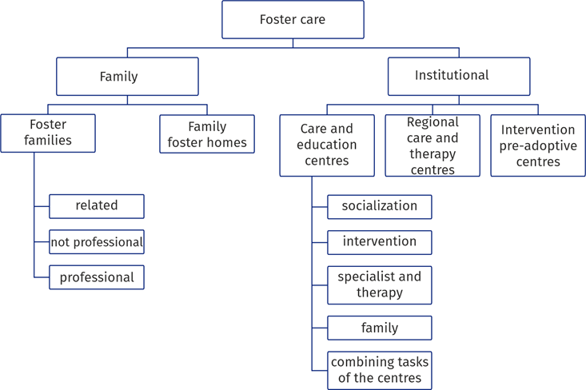
Forms of foster care

Family foster care
More than 53% of persons performing the role of a family foster care were in the 51–70 age group, and less than 12% of persons were in the age group over 70
In Mazowieckie Voivodship at the end of 2025, care for children was provided by 4043 foster families (by 20 more than in 2024) and 87 foster homes (by 2 more compared to 2024). Family foster care facilities accounted for 10.9% of all facilities of this type in Poland. Among foster families, related families constituted 64.1%, non-professional families – 31.4%, and professional families – 4.5%. Foster family care was made up of 1951 marriages and 2179 single persons, and also 44 foreigners. Most often the function of family foster care was taken by persons aged 51–70 (2199 persons, i.e. 53.2%), and the least frequently by persons up to 21 years of age (20 persons, i.e. 0.5%).

Table 1. Family foster care
As of 31 December
Specification |  | Grand total | Of which  In rural areas | Children in families
 |  | Grand total | Of which  In rural areas | total | of which girls
Family foster care | 2024 | 4148 | 1396 | 6443 | 3203
 | 2025 | 4130 | 1406 | 6429 | 3163
Foster families |  | 4043 | 1368 | 5749 | 2819
related |  | 2591 | 807 | 3418 | 1691
not-professional |  | 1271 | 464 | 1676 | 855
professional |  | 138 | 76 | 514 | 210
professional specialised |  | 16 | 5 | 32 | 8
professional that performs the function of a family emergency house |  | 27 | 16 | 109 | 55
Foster homes |  | 87 | 38 | 680 | 344

Chart 1. Persons providing family foster care by age groups in 2025

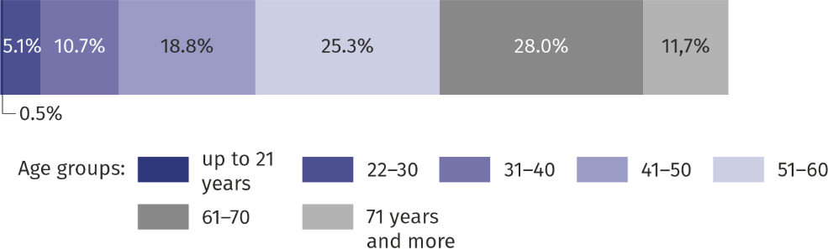
As of 31 December
There were 6429 children in family foster care on the last day of the year (of which 83.3% were persons up to 18 years of age). Their number decreased by 0.2% compared to the previous year. The most numerous group made up persons aged 7–13 and 14¬–17 (respectively 35.3% and 27.2%). Of all the persons in care, 721 had a disability certificate and 309 were orphans. For the first time in their lives, 1023 children were placed in family foster care.
Among children using family care forms, 721 had a disability certificate or degree of disability
Chart 2. Structure of children in family foster care by age groups in 2025

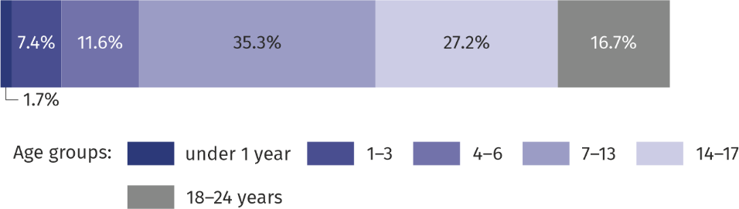
As of 31 December
Taking into account the number of children under the age of 18 staying in family foster care per 1,000 children of the same age, the highest rate was recorded in żyrardowski (13.5) and the lowest in szydłowiecki powiat (2.0).
Map 1. Children up to 18 years of age staying in family foster care per 1,000 children of the same age in 2025

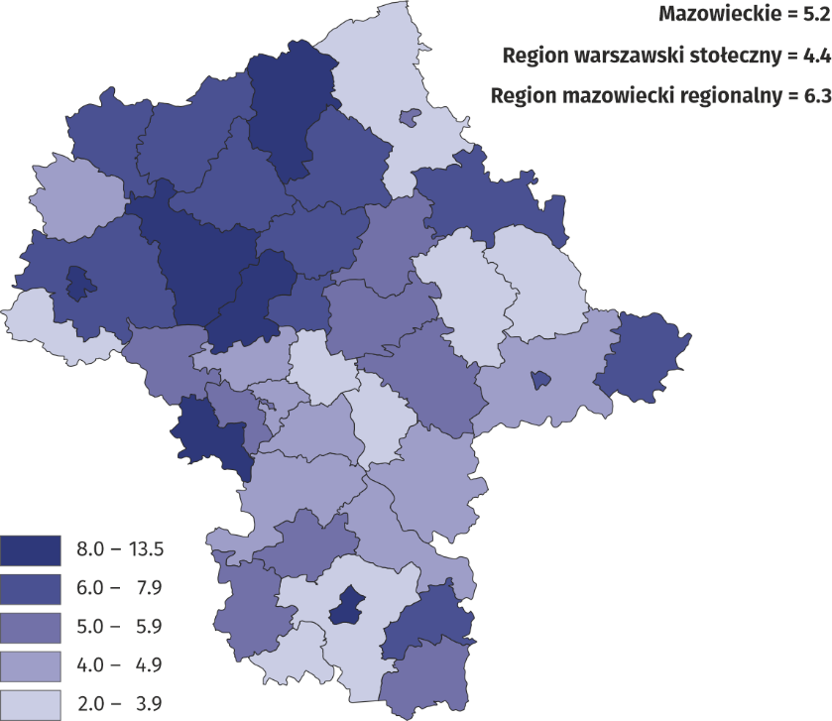
As of 31 December
During 2025, 844 children under the age of 18 left a family foster care, i.e. by 9.4% less than a year earlier, of which 31.3% of those who retuned to the natural family. Among those leaving family foster care, there were 455 adults, i.e. 3.9% more than in 2024. Of these, 377 became self-dependent, of which 312 set up their own household, and 19 returned to a natural family or relatives.

Institutional Foster care
In Mazowieckie Voivodship at the end of 2025, there were 140 facilities of institutional foster care, including 138 care and education centres (1 more than in 2024), 1 regional care and therapy centre and 1 pre-adoptive intervention centre.
Institutional foster care facilities accounted for 10.5% of all facilities of this type in Poland.
Among total care and educational centres, socialisation centers (70.3%) and family institu-tions (18.1%) prevailed.
Nearly 76% of all places in care and education cen-tres were places in socialisa-tion centres
The total number of places in institutional foster care amounted to 1707, and these were primarily places in care and educational centres (1655). Compared to the previous year, both the number of institutional foster care facilities and the number of places increased by 0.7% and 1.1%, respectively.

Table 2. Institutional foster care by type of facility

As of 31 December
Specification |  | Facilities | Places | Residents ª
 |  | Facilities | Places | total | of which orphans and half-orphans
Institutional foster care | 2024 | 139 | 1689 | 1798 | 315
 | 2025 | 140 | 1707 | 1809 | 310
Care and education centres |  | 138 | 1655 | 1751 | 307
socialisation |  | 97 | 1255 | 1318 | 223
intervention |  | 7 | 92 | 115 | 14
specialist and therapy |  | 2 | 27 | 28 | 8
family |  | 25 | 169 | 165 | 41
other ª |  | 7 | 112 | 125 | 21
Regional care and therapy centres |  | 1 | 32 | 32 | 3
pre-adoptive intervention centres |  | 1 | 20 | 26 | –
a Including students staying in boarding schools, dormitories, etc. b Combining the tasks of intervention, socialisation and specialist and therappy centres.
On the last day of the year, 1809 residents stayed in institutional foster care facilities, and 1751 in care and educational centres. Among the care and educational centres, the greatest number of residents – 75.3% stayed in socialisation centres, and the least – 1.6% in special-ist and therapeutic centres. As in previous years, more boys (942) than girls (867) were placed in institutional foster care facilities.

Chart 3. Structure of residents of care and education centres by age groups in 2025

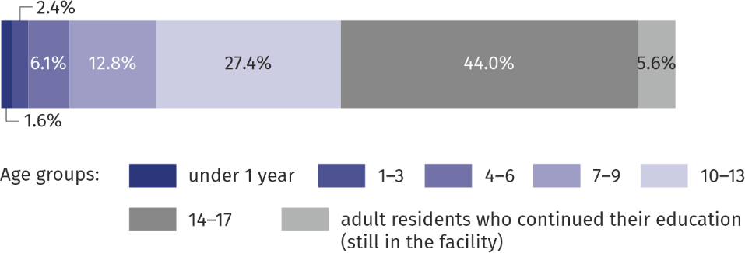
As of 31 December
The most numerous group (796 residents) made up persons aged 14–17, and the least numerous (29) were children under 1 year of age. In care and education centres there were also 102 adult residents continuing education.
The most numerous group of residents were children aged 14–17
Among residents of institutional foster care facilities – 82.9% of residents had both parents. Only 1.4% of children were orphans, and 15.8% half-orphans. Persons with disability certificate or degree of disability accounted for 13.2% of all residents, and 14.9% were chronically ill, whose illness lasted six months and longer.
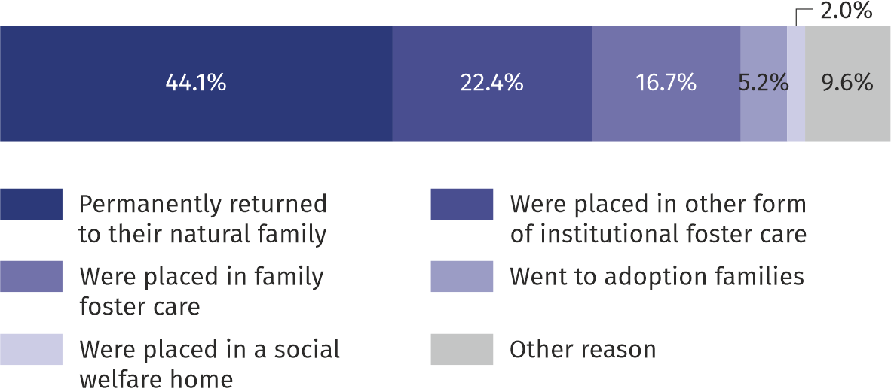
Chart 4. Structure of residents up to 18 years of age by reasons for leaving care and education centres in 2025

Among the 180 adult residents who left the facilities in 2025, 107 set up their own households and 60 returned to their natural families.
Institutional foster care facilities were supported in their activities by the work of 200 volun-teers, 175 of whom worked in care and educational centres.

Day-support centres
More than 57% of total places in day-support centres were places in general care centres
In Mazowieckie Voivodship at the end of 2025, the day care was provided by 213 day-support centres (19 fewer than in 2024) operating in the form of general care centre, specialised centre, street work or in a combination of the forms. They accounted for 7.8% of total day-support centres in the country.

Table 3. Day-support centres by type of facility

As of 31 December
Specification |  | Facilities | Places | Users
 |  | Facilities | Places | total | of which persons with disa-bilities
Total | 2024 | 232 | 6658 | 6299 | 280
 | 2025 | 213 | 6214 | 5644 | 305
General care |  | 128 | 3546 | 3095 | 92
Specialised |  | 31 | 917 | 799 | 87
Street work |  | 5 | 100 | 74 | –
Combining tasks of the centres |  | 49 | 1651 | 1676 | 126
These centres had 6214 places at their disposal, of which majority (57.1%) were in general care centres. During 2025, 8249 residents were provided with support from day-support cen-tres, of which 4503 (54.6% of total residents) from general care centres. Persons working with children in general care centres were supported by 219 volunteers 83 – in specialised cen-tres, 126 – in a combination of the forms.
In the case of quoting data from the Statistics Poland, please provide information: “Statis-tics Poland data source”, and in the case of publishing calculations made on data published by the Statistics Poland, please provide information: “Own study based on Statistics Poland data”.

Prepared by:  Statistical Office in Warszawa  Director Agnieszka Ajdyn  Phone: (+48 22) 464 23 15 | Issued by:  Statistical Information Centre  Marcin Kałuski  Mobile: (+48) 783 940 141
Press Office in the Statistical Office in Warszawa  Mobile: (+48) 783 940 141  e-mail: m.kaluski@stat.gov.pl |   www.warszawa.new.stat.gov.pl/en/

@WARSZAWA_STAT

@UrzadStatystycznywWarszawie

gus_stat

glownyurzadstatystycznygus

glownyurzadstatystyczny
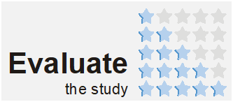
Related information
Social assistance, child and family services in 2024
Data available in databases
Local Data Bank -> Health care, social welfare and benefits to the family
Terms used in official statistics
Foster family
Family based assistance house
Intervention centre
Family centre
Socialisation centre
Specialist therapy centre
Centres combining tasks of the centres
Day support centre

