Agriculture in Mazowieckie Voivodship in 2019

15th June 2020

In June 2019, the total area of agricultural holdings in Mazowieckie Voivodship amounted to 2257.9 thousand ha. Compared with 2018, both the total area of agricultural holdings and the agricultural land area decreased. In December 2019, the number of cattle and poultry decreased and the number of pigs and sheep increased in annual terms.

8.8%

Decrease in the total area of agricultural holdings

A decrease by 1.3 pp of the share of agricultural holdings in the total area of agricultural holdings in the country

Land use

In 2019, the total area of agricultural holdings whose holders had a seat in Mazowieckie Voivodship, amounted to 2257.9 thousand ha and in comparison with 2018 was smaller by 216.6 thousand ha (by 8.8%). Private farms occupied 2221.8 thousand ha, i.e. over 98% of the total area of agricultural holdings.

Agricultural land in agricultural holdings occupied 1991.7 thousand ha, constituting 88.2% of the total area. In comparison with 2018, the area of this land increased by 156.5 thousand ha (by 7.3%). Agricultural land in a good agricultural condition occupied 1958.1 thousand ha, i.e. 98.3% of the agricultural land area, while the area of other agricultural land amounted to 33.6 thousand ha and accounted for 1.7%.

In the internal structure of agricultural land, the largest area accounted for sown area – 1293.5 thousand ha, followed by permanent grassland – 526.4 thousand ha, with permanent meadows cultivated on the area of 477.1 thousand ha, and permanent pastures on the area of 49.3 thousand ha. Permanent crops occupied 109.1 thousand ha. Fallow land area (including the crop area intended for ploughing of plants cultivated as major crops) amounted to 26.0 thousand ha. Kitchen gardens occupied 3.0 thousand ha.

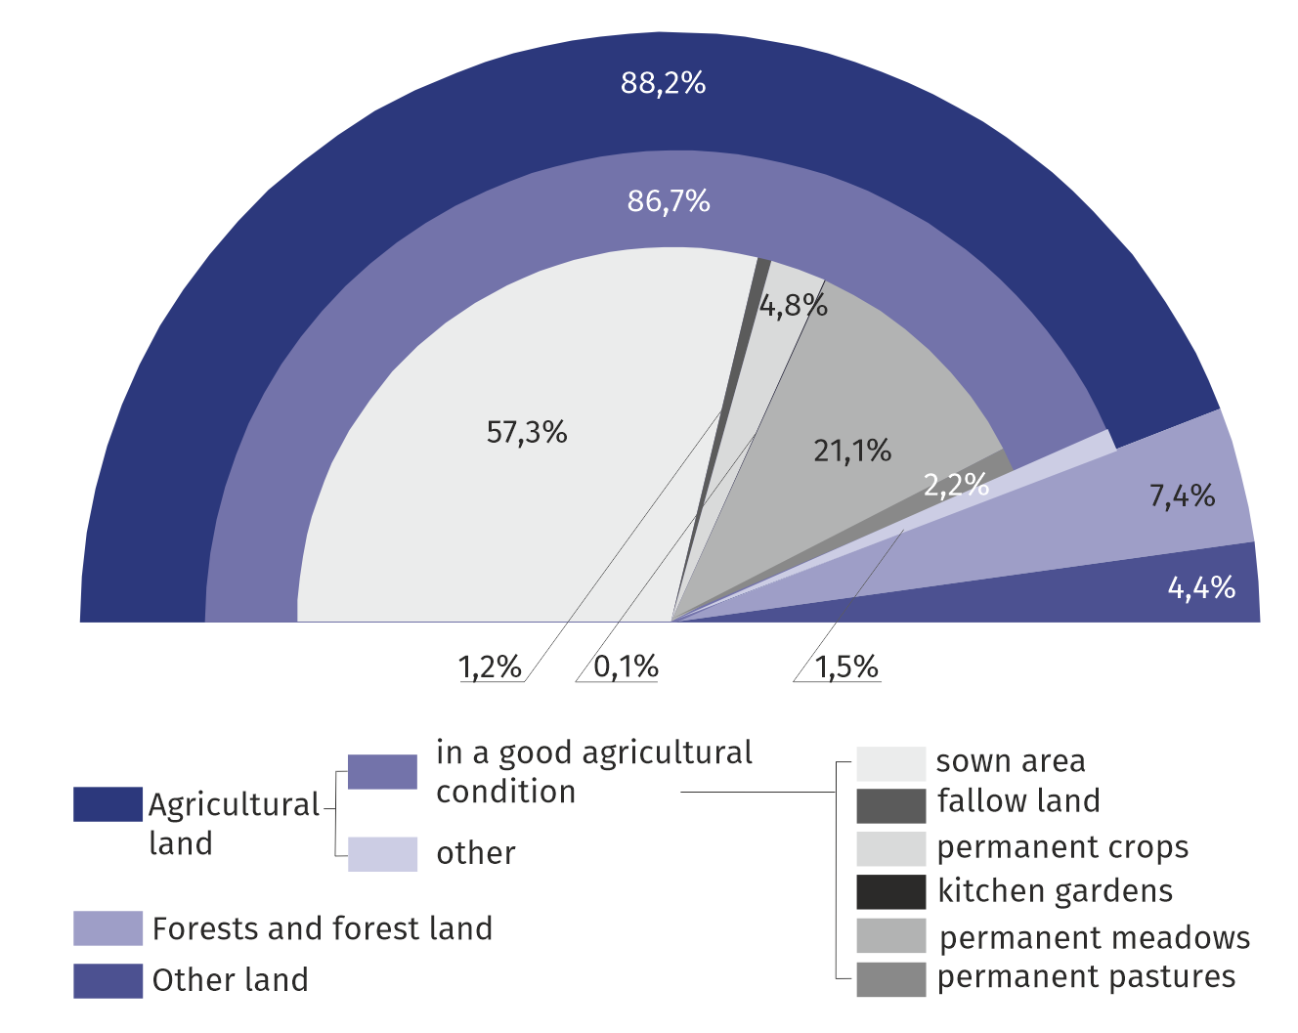**Chart 1. Structure of land use in agricultural holdings in 2019**

Crop output

Sown area occupied the largest part of agricultural land area

In 2019, the sown area amounted to 1293.5 thousand ha and accounted for almost two-thirds of the total area of agricultural land. In comparison with the previous year, it was smaller by 100.7 thousand ha. The crop structure was dominated by cereals, which occupied the area of 950.7 thousand ha, i.e. 73.5% of sown area. The area under cereals was smaller than in the previous year by 10.7%.

In comparison with 2018, there was an increase in the area under, among others, wheat (by 5.9%), and a decrease in: barley (by 37.2%), mixed cereals (by 14.5%), rye (by 12.6%) and triticale (by 12.1%), oat (by 7.7%) and maize for grain (by 7.5%). Among the other crops, there was an increase in the area under rape and turnip rape (by 34.8%), potatoes (by 16.3%) and sugar beets (by 2.8%); there was a significant decrease in the area of edible pulses (by 65.9%).

A decrease in the output of cereals, potatoes and sugar beets; an increase in the output of rape and turnip rape

Cereal yields (except maize) were higher than a year before, but production (except wheat) - lower. Potatoes, sugar beets, and rape and turnip rape yielded worse, with a decrease in production only recorded for potatoes and sugar beets.

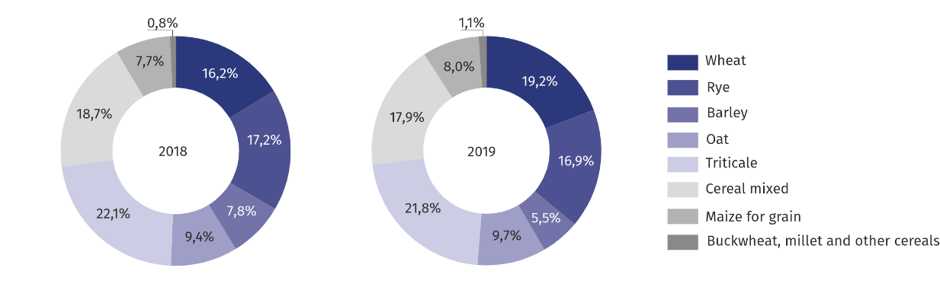**Chart 2. Structure of sown area under cereals**

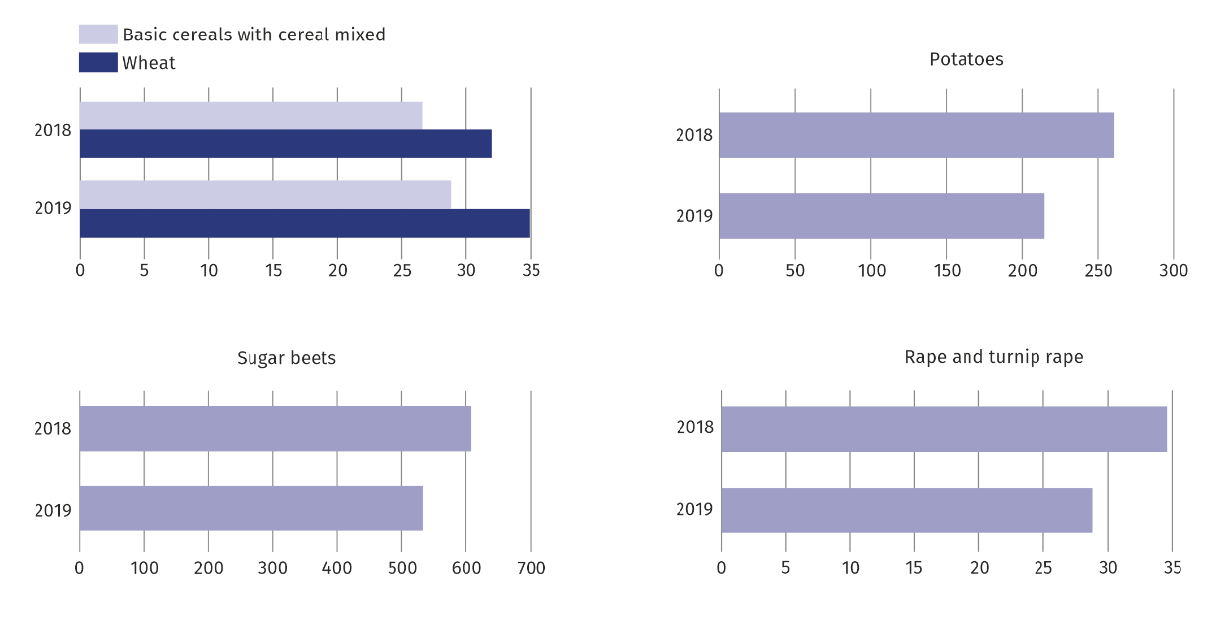**Chart 3. Yields of major crops (in dt/ha)**

In 2019, the total tree fruit production in orchards was estimated at 1522.5 thousand tonnes, i.e. at the level by 23.2% lower compared to the previous year, and the production of fruit from fruit-bearing trees and shrubs and berry plantations amounted to 99.8 thousand tonnes and were by 8.5% lower than in 2018. Apple production, which dominate orchard production (constituting over 92%), was lower by 22.8%. Production of pears and plums were about a quarter lower and cherries and sweet cherries by over 30%.

Mniejsze zbiory warzyw gruntowych oraz owoców z drzew, krzewów owocowych i plantacji jagodowych

In 2019, the total vegetable production amounted to 604.0 thousand tonnes and was by 13.0% lower than in the previous year.

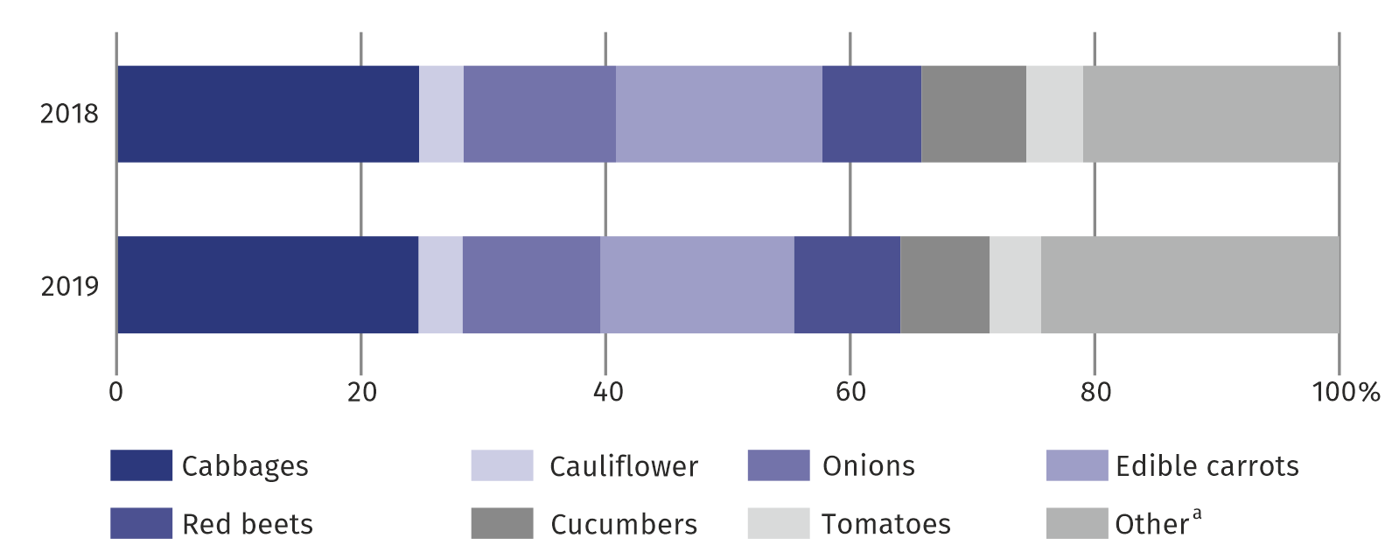**Chart 4. Structure of ground vegetable production**

a Parsley, leeks, celeries, radish, lettuce, rhubarb and other.

Means of production

In Mazowieckie Voivodship in the 2018/2019 farming year, the consumption of mineral fertilizers (NPK) amounted to 221.8 thousand tonnes and in comparison with the 2017/2018 farming year it was lower by 55.1 thousand tonnes (by 19.9%). Under the 2019 harvest, 113.2 thousand tonnes of nitrogenous fertilizers (51.0% of the total mineral fertilizers) were sown, 39.7 thousand tonnes phosphatic fertilizers (17.9%) and 68.9 thousand tonnes of potassic fertilizers (31.1%). In comparison with the previous period, the consumption of nitrogenous fertilizers decreased by 49.2 thousand tonnes (by 30.3%), potassic — by 3.3 thousand tonnes (by 4.5%), and phosphatic — by 2.6 thousand tonnes (by 6.2%).

Decrease in mineral fertilizer consumption by nearly 20%

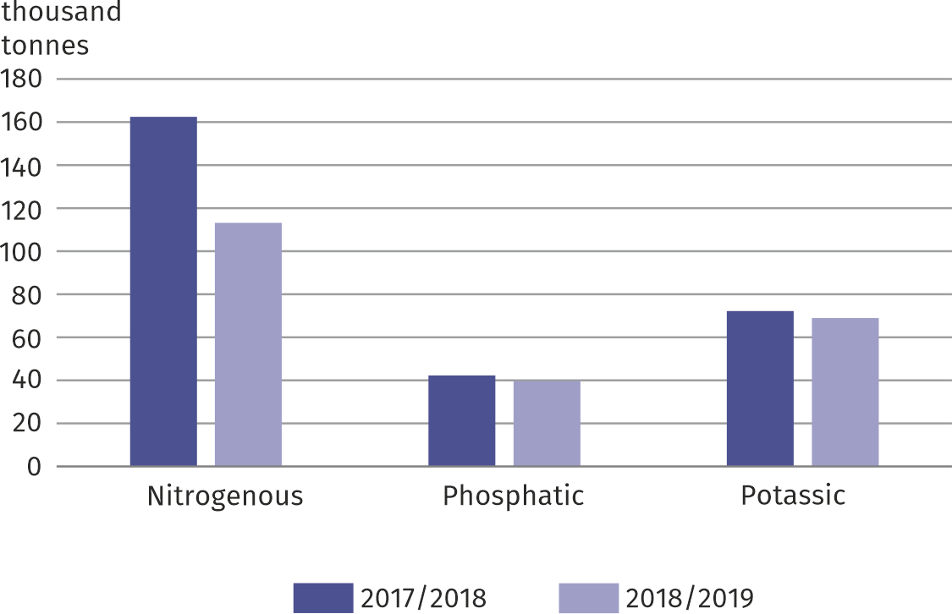**Chart 5. Mineral fertilizers consumption (NPK)**

Average consumption of mineral fertilizers per 1 ha of agricultural land amounted to 111.4 kg NPK, of which per 1 ha of agricultural land in good agricultural condition 113.3 kg (in the farming year 2017/2018, respectively 128.9 kg and 129.9 kg).

Consumption of lime fertilizers amounted to 232.5 thousand tonnes and was higher by 133.1% than in the farming year 2017/2018. In Mazowieckie Voivodship an average of 116.7 kg of lime fertilizers were used per 1 ha of agricultural land, of which per 1 ha of agricultural land in good agricultural condition — 118.7 kg (in then farming year 2017/2018, respectively 46.4 kg and 46.8 kg).

Livestock

Decrease in the number of cattle by 0.9%

In December 2019, the total number of cattle amounted to 1163.5 thousand heads and decreased by 10.8 thousand heads (by 0.9%) compared to 2018. The decrease in the number of cattle in total resulted from the decrease in the number of young cattle aged 1—2 years by 4.4% and calves by 2.4%. There were more (by 1.7%) adult cattle aged 2 and more. by 6.0%. Private farms maintained 99.5% of cattle in the voivodship.

In the structure of cattle, the share of calves decreased (by 0.4 pp) as well as the share of young cattle aged 1—2 (by 1.0 pp). Whereas, the share of adult cattle aged 2 and more increased by 1.3 pp each, of which cows by 0.2 pp.

The total number of cattle, of which cows, per 100 ha of agricultural land amounted to 58.4 and 26.1 heads, compared to 54.7 and 24.3 heads in December 2018.

**Chart 6. Structure of cattle stock by age and utility groups**

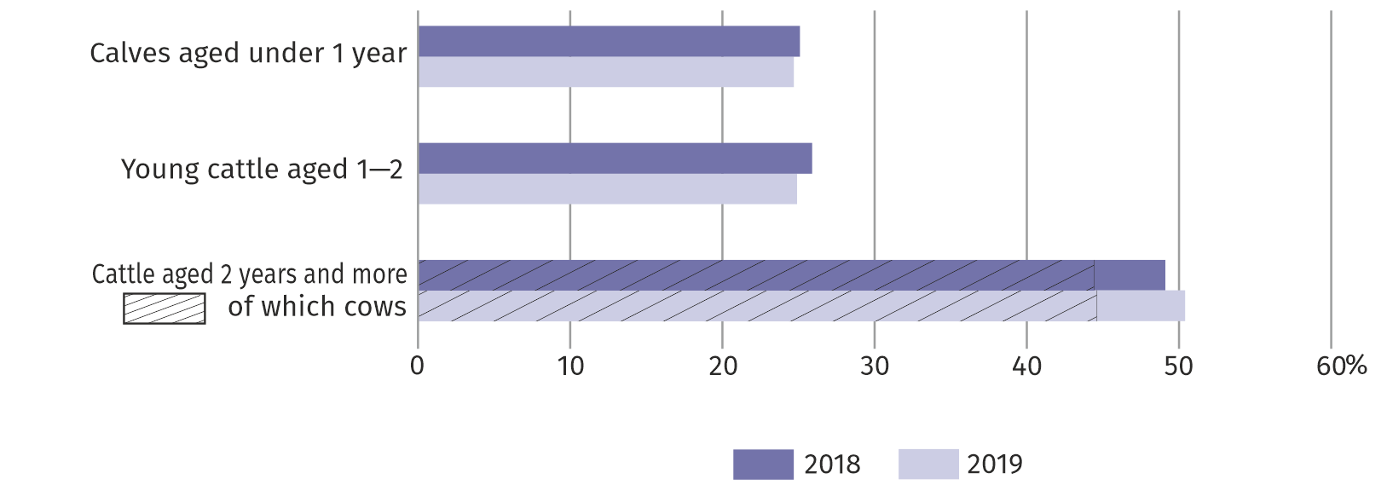 **As of 1st December**

The pig stock, as of December 2019, amounted to 1245.9 thousand heads and was larger by 82.9 thousand heads (by 7.1%) than a year before. The number of sows for breeding amounted to 52.2 thousand heads, i.e. less by 7.1%. Private farms maintained 99.2% of the voivodship pig stock.

In comparison with the structure of pig stock registered in December 2018, the share of animals for slaughter increased (by 3.2 pp), while the share of piglets and boars decreased (by 1.3 pp) as well as pigs for breeding (by 0.6 pp).

The total number of pigs, of which sows for breeding, per 100 ha of agricultural land amounted to 62.6 and 2.6 heads, respectively, and in December 2018 – 54.1 and 2.6 heads.

**Chart 7. Structure of pigs by production and utility groups**

Increase in the number of pigs and porkers and decrease in the number of sows for raising and piglets

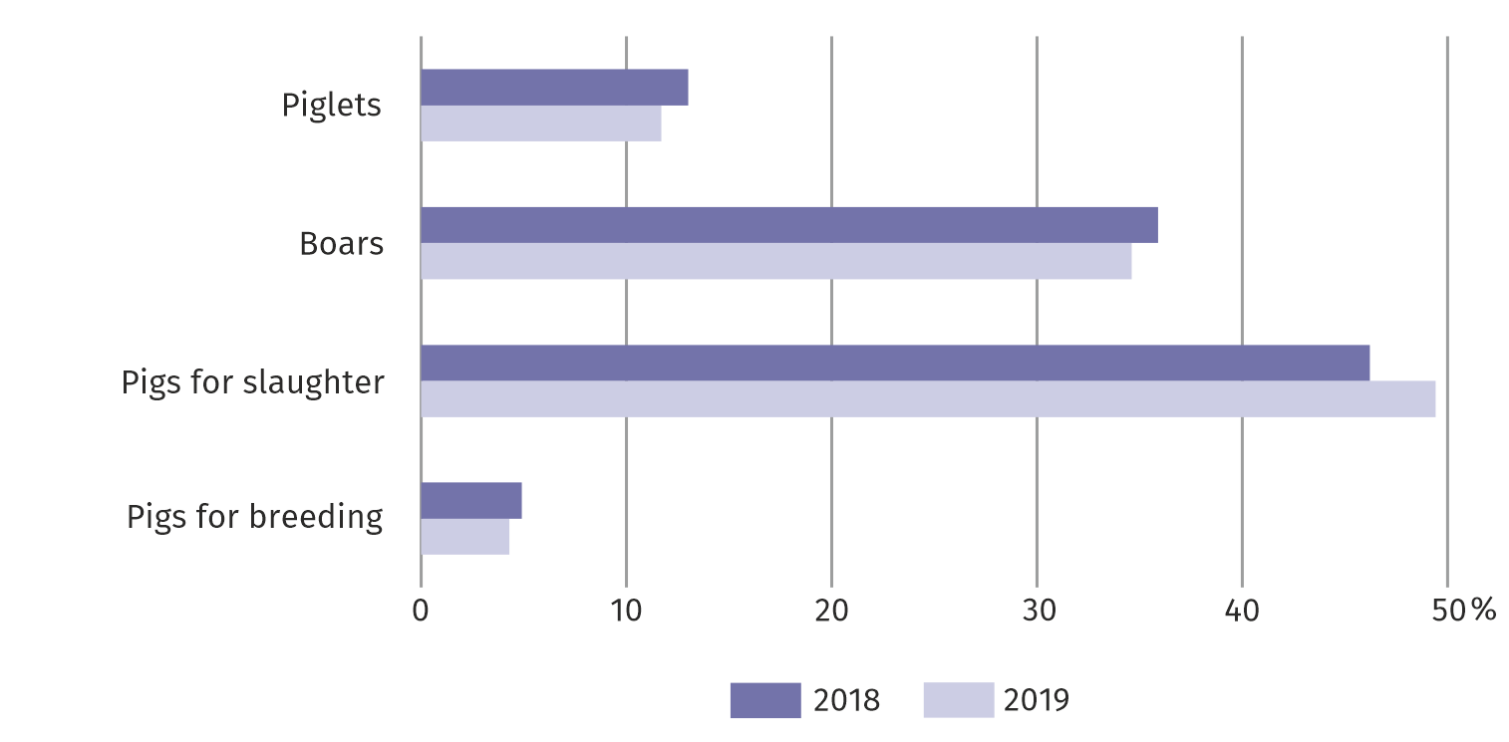**As of 1st December**

Sheep population in December 2019, amounted to 7.4 thousand heads and increased in comparison with the previous year by 4.0 thousand heads, i.e. by 6.4%. Private farms maintained 98.1% of the voivodship sheep population.

The sheep population per 100 ha of agricultural land, amounted to 0.4 heads, in the previous year – 0.3.

In December 2019, the total poultry population amounted to 35884.4 thousand heads and was smaller by 11915.6 thousand heads (by 24.9%) compared to 2018. Private farms maintained 94.6% of the voivodship poultry population. In the structure of total poultry, 92.8% accounted for poultry — hens, cocks and broilers (flaws), of which laying-hens — 23.1%.

The poultry population per 100 ha of agricultural land amounted to 1802 heads (in 2018 — 2225).

**Table 1.** **Land use in agricultural holdings by types of agricultural land in 2019**

|  |  |  |  |  |  |  |  |
| --- | --- | --- | --- | --- | --- | --- | --- |
| SPECIFICATION | Agricultural land | | | | | | |
| total | in good agricultural condition | | | | | other |
| Sown area | fallow land | permanent crops | permanent meadows and pastures | kitchen gardens |
| in hectares | | | | | | | |
| **Grand total** | **1991678** | **1293481** | **26028** | **109134** | **526403** | **3020** | **33612** |
| Of which private farms | 1962318 | 1273222 | 24946 | 108841 | 520026 | 3019 | 32264 |
| in percent | | | | | | | |
| **Grand total** | **100,0** | **64,9** | **1,3** | **5,5** | **26,4** | **0,2** | **1,7** |
| Of which private farms | 100,0 | 64,9 | 1,3 | 5,5 | 26,5 | 0,2 | 1,6 |

**Table 2.** **Cattle, sheep and poultry in 2019**

|  |  |  |  |  |
| --- | --- | --- | --- | --- |
| SPECIFICATION | June | | December | |
| in heads | previous year=100 | in heads | previous year=100 |
| **Cattle** | **1222774** | **106,1** | **1163456** | **99,1** |
| Calves aged under 1 year | 303288 | 107,3 | 287326 | 97,6 |
| Young cattle aged 1—2 years | 306105 | 105,5 | 290106 | 95,6 |
| Cattle aged 2 years and more | 613381 | 105,7 | 586024 | 101,7 |
| of which cows | 558778 | 108,1 | 519299 | 99,5 |

**Table 2.** **Cattle, sheep and poultry in 2019 (cont.)**

|  |  |  |  |  |
| --- | --- | --- | --- | --- |
| SPECIFICATION | June | | December | |
| in heads | previous year=100 | in heads | previous year=100 |
| **Sheep** | **8373** | **109,7** | **7363** | **106,4** |
| Of which ewes | 5373 | 139,5 | 4489 | 119,2 |
| **Poultry** | **37516682** | **90,2** | **35884412** | **75,1** |
| Of which poultry — hens, cocks and broilers (fowls) | 34578765 | 89,4 | 33296366 | 74,3 |

**Table 3.** **Pigs in 2019**

|  |  |  |  |  |
| --- | --- | --- | --- | --- |
| SPECIFICATION | June | | December | |
| in heads | previous year=100 | in heads | previous year=100 |
| **Total** | **1112156** | **88,5** | **1245855** | **107,1** |
| Piglets of weight up to 20 kg | 163365 | 76,0 | 145181 | 96,0 |
| Young pigs of weight from 20 kg up to 50 kg | 397334 | 96,2 | 431333 | 103,3 |
| Pigs for slaughter of weight 50 kg and more | 492450 | 88,4 | 615923 | 114,7 |
| Pigs for breeding of weight 50 kg and more | 59007 | 83,0 | 53418 | 93,2 |
| of which sows | 57842 | 83,1 | 52182 | 92,9 |

In the case of quoting data from Statistics Poland, please provide information: "Source of data – Statistics Poland", and in the case of publishing calculations made on data published by Statistics Poland, please provide information: "Own study based on Statistics Poland data".

|  |  |
| --- | --- |
| Prepared by: **Statistical Office in Warszawa****Director Zofia Kozłowska**Tel: (+48 22) 464 23 15 | Issued by: **Statistical Information Centre** **Marcin Kałuski**Tel: (+48 22) 464 20 91**e-mail:** [**m.kaluski@stat.gov.pl**](mailto:m.kaluski@stat.gov.pl) |

|  |  |  |
| --- | --- | --- |
| **Press office**  **tel.: (+48 22) 464 20 91**  **e-mail:** [**m.kaluski@stat. gov.pl**](mailto:m.kaluski@stat.%20gov.pl) |  | warszawa.stat.gov.pl/en/ |
|  | @Warszawa_STAT |
|  |  |



**Related information**

[**Agriculture of Mazowieckie Voivodship compared to the country and other voivodships in 2018**](https://warszawa.stat.gov.pl/publikacje-i-foldery/rolnictwo-lesnictwo/rolnictwo-wojewodztwa-mazowieckiego-na-tle-kraju-i-pozostalych-wojewodztw-w-2017-r-,2,11.html)

**Data available in databases**

[**Local Data Bank**](https://bdl.stat.gov.pl/BDL/dane/podgrup/temat)

**Terms used in official statistics**

[**agricultural**](https://stat.gov.pl/en/metainformations/glossary/terms-used-in-official-statistics/558,term.html) **land**

[**unutilised agricultural land**](https://stat.gov.pl/en/metainformations/glossary/terms-used-in-official-statistics/1404,term.html)

[**forests and forest land area**](https://stat.gov.pl/en/metainformations/glossary/terms-used-in-official-statistics/1243,term.html)

[**other land area**](https://stat.gov.pl/en/metainformations/glossary/terms-used-in-official-statistics/1244,term.html)

[**area of holding**](https://stat.gov.pl/en/metainformations/glossary/terms-used-in-official-statistics/1053,term.html)

[**livestock**](https://stat.gov.pl/en/metainformations/glossary/terms-used-in-official-statistics/1721,term.html)