Economic activity of population in Mazowieckie Voivodship in Q1 2022
31.1%
increase in the number of unemployed persons compared to the previous quarter

29 June 2022
In Q1 2022, there was an increase in the number of unemployed persons, decrease in the employed and economically inactive persons compared to Q4 2021. Unemployed women looked for a job shorter than men, and unemployed rural residents shorter than urban residents.

Preliminary results of the Labour Force Survey (LFS)

From Q1 2021, changes have been introduced in LFS resulting from the implementation of the framework regulation for social statistics, i.e. Regulation (EU) 2019/1700 of the European Parliament and of the Council of 10 October 2019 and its implementing acts, more information on this the topic is available in the methodological notes of this publication and on the website of the Statistics Poland: Information of the Statistics Poland regarding the changes introduced from 2021 onwards into the BAEL.

Due to the implementation of methodological changes in the survey, the LFS data from Q1 2021 cannot be compared with the previous periods (except for converted data). For the purposes of conducting comparative analyses for longer time series, the Statistics Poland prepared historical data from LFS for the years 2010-2020, compiled using the definitions changed from 2021 of the main categories of persons distinguished according to their status on the labour market, i.e. employed, unemployed and economically inactive. These data are available on the website of the Statistics Poland: recalculated LFS results for 2010-2020.

Economic activity of population aged 15–89 according to LFS
Almost 40% of population aged 15-89 did not work

In the first quarter of 2022, among the total population of Mazowieckie Voivodship aged 15-89, 60.3% represented employed persons, 1.9% – unemployed, and 37.9% – economically inactive persons. This means that less than half of the population aged 15-89 (39.7%) did not work. In urban and rural areas this structure looked similar. However, significant differences were visible in the structure of men and women. Without employment (economically inactive and unemployed) were 33.0% of men and 45.7% of women.
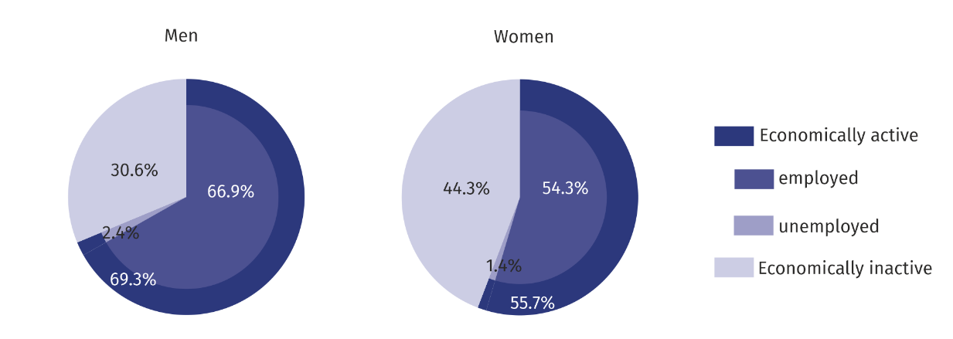
Chart 1. Structure of population aged 15-89 by sex in Q1 2022
There were 659 unemployed and economically inactive persons per 1000 employed persons

Compared to the fourth quarter of 2021, the number of unemployed persons increased by 31.1%. On the other hand, the number of employed persons (by 0.1%) and the number of economically inactive persons decreased (by 1.2%). In the first quarter of 2022, there were 659 unemployed and economically inactive persons per 1000 employed persons (the same in the fourth quarter of 2021).
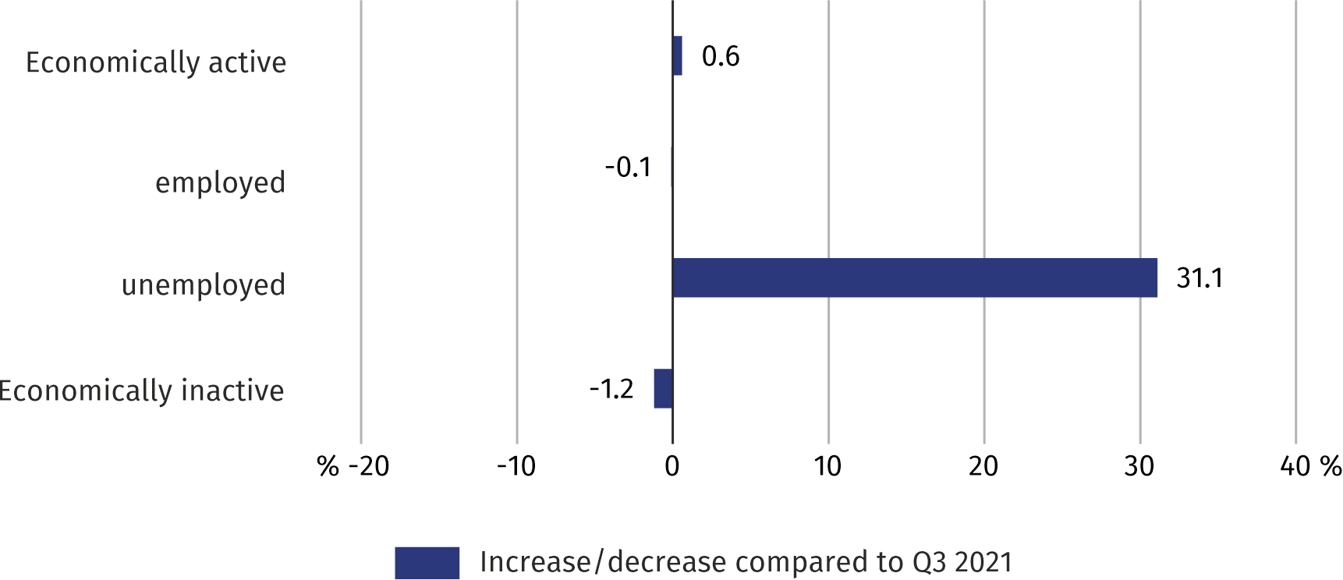
Chart 2. Changes compared to the fourth quarter of 2021
The number of unemployed persons increased by almost 31% compared to the previous quarter

The economic activity rate was 62.1% and increased by 0.4 pp compared to the previous quarter. There was an increase in the level of economic activity among women (by 1.1 pp) and a decrease among men (by 0.4 pp). This indicator increased both in rural (by 0.7 pp) and in urban areas (0.3 pp).
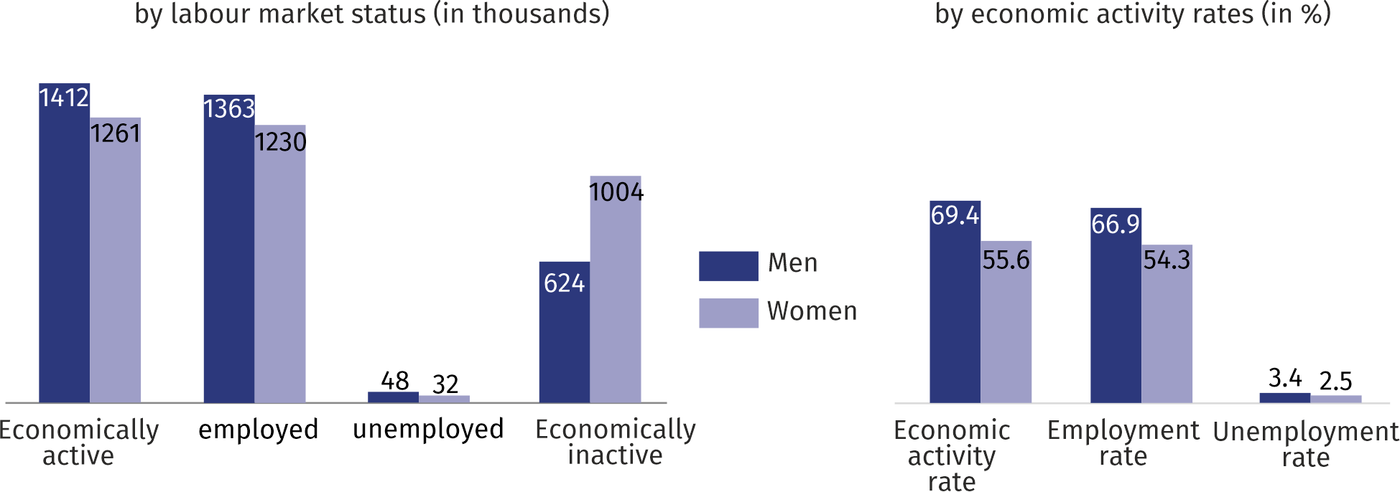
Chart 3. Economic activity of population in the first quarter of 2022

The highest value of the rate in terms of age was recorded for the age group 35–44, which amounted to 91.9%, while the lowest among persons aged 55-89 – 30.3%. For working age population, this rate was 84.4%.

Employed persons
In the first quarter of 2022, in Mazowieckie Voivodship, the population of employed persons counted 2593 thousand persons, and the employment rate was estimated at 60.3% (no changes compared to the previous quarter).
Compared to the fourth quarter of 2021, the number of employed persons decreased (by 2 thousand). There was a decrease among men (by 18 thousand), and an increase among women (by 16 thousand). The number of employed persons decreased in urban areas (by 9 thousand), and increased in rural areas (by 7 thousand).
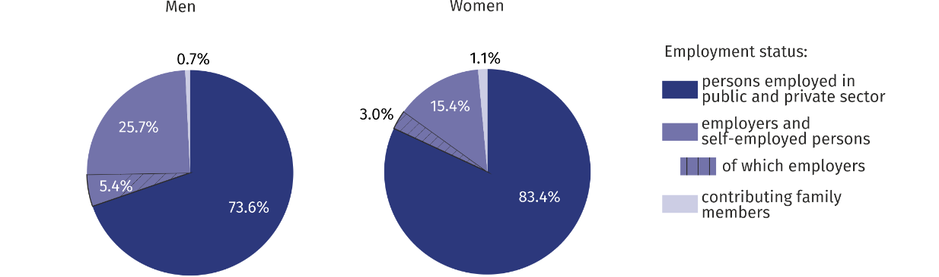
Chart 4. Structure of employed persons by age and education in the first quarter of 2022

In the first quarter of 2022, the highest employment rate was recorded among persons aged 35–44 (89.9%), and the lowest among persons aged 55–89 (29.7%). The highest increase of the rate was recorded among persons aged 25-34 (by 2.3 pp), and the highest decrease among persons aged 55-89 (by 0.9 pp).
For working age population, the employment rate reached 81.8% (a 0.4 pp increase compared to the fourth quarter 2021).
Among employed persons according to the level of education, the highest employment rate recorded persons with higher education – 81.8%, and the lowest among persons with lower secondary and less education – 16.8%. The highest increase in the employment rate occurred among persons with post-secondary and vocational secondary education (by 2.2 pp), and the largest decrease among persons with lower secondary and less education (by 0.7 pp).
Nearly 68% of total employed persons worked in the private

In the first quarter of 2022, there were 2029 thousand persons employed in the public and private sector (i.e. 78.2% of total employees), and their number decreased by 0.9% compared to the fourth quarter of 2021. There was an increase both among employers and self-employed persons (from 524 thousand to 540 thousand), as well as contributing family workers (from 24 thousand to 25 thousand). The vast majority of employed persons supported the private sector (67.8% of the total). Of these, the majority (56.6%) were men. The situation was different among persons employed in the public sector, where among 654 thousand employed persons predominated women (65.6%). There were 85.5% of employees employed for an indefinite period (a 1.2 pp decrease compared to the fourth quarter of 2021).
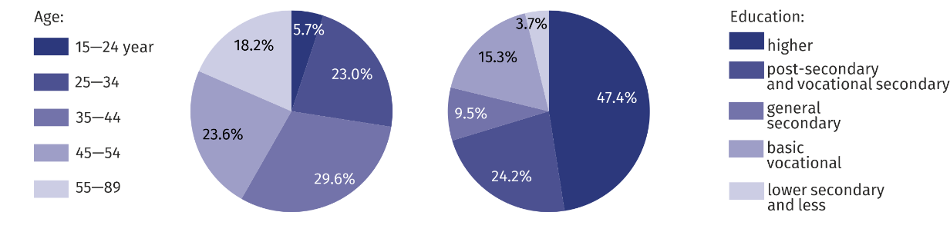
Chart 5. Structure of employed persons by employment status in the first quarter of 2022
26% of men and almost 15% of women worked as employers and self-employed persons

Unemployed persons
In the first quarter of 2022, the population of unemployed persons (aged 15-74) in Mazowieckie Voivodship amounted to 80 thousand persons and increased by 31.1% compared to the fourth quarter of 2021.
The number of unemployed women increased by more than 52%, and men by 20%

Compared to the previous quarter, the number of both unemployed women (by 52.4%) and men (by 20.0%) increased. There was also an increase among urban residents (by 47.4%), and among rural residents (by 4.3%).
The total unemployment rate in the Voivodship amounted to 3.0% and increased by 0.7 pp compared to the fourth quarter of 2021. In urban areas it was 3.2% (by 0.7 pp higher than in rural areas). For working age population the unemployment rate was 3.1%.
Compared to the fourth quarter of 2021, the unemployment rate increased both among women (by 0.8 pp), and among men (by 0.6 pp). There was an increase both in urban (by 1.0 pp), and in rural areas (by 0.1 pp).
Women looked for a job shorter than men, and rural residents shorter than urban residents

An average time of job seeking by unemployed persons amounted to 7.5 months. Women looked for a job for 7 months on average (by 0.8 months shorter than men), and rural residents for 6.3 months (by 1.7 months shorter than urban residents).
The population of long-term unemployed persons (13 months and more) accounted for 15.0% of the total unemployed (decrease by 3.0 pp compared to the fourth quarter of 2021).
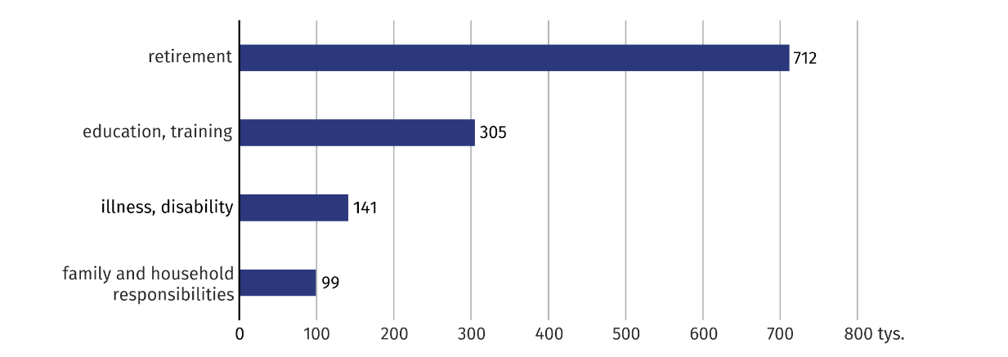
Chart 6. Structure of the unemployed by duration of job seeking in the first quarter of 2022

Economically inactive persons
Among the economically inactive women predominate – almost 62%
In the first quarter of 2022, in Mazowieckie Voivodship, 1629 thousand persons remained economically inactive, which accounted for 37.9% of total population aged 15-89 (in rural areas – 38.7% and in urban areas – 37.4%). Still, in this population women were the majority – 61.6%. Among economically inactive persons, as in previous periods, persons with lower secondary and less education predominated – 29.0%. Working age population made up 28.6% of total economically inactive persons.

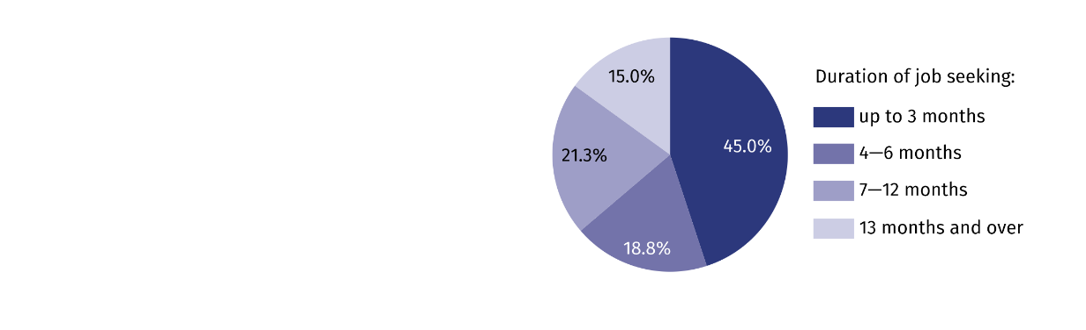
Chart 7. Economically inactive persons aged 15-74 by selected causes of economic inactivity*
in the first quarter of 2022

Compared to the fourth quarter of 2021, the population of economically inactive persons decreased by 1.2% (among women it decreased by 2.7%, and among men by 1.3 pp). Taking into account the place of residence, there was a decrease in the number of economically inactive persons both among rural (by 1.6%), and urban residents (0.9%).
Out of total economically inactive persons, 53.9% accounted for persons who did not seek work because of being retired. Other reasons for economic inactivity were: education and training – 23.1%, illness or disability – 10.7%, family and household responsibilities – 7.5%.

Table 1. Economic activity of population aged 15-89 by selected indicators
Specification | 2021 | 2022
 | Q4 | Q1
 | in % |  | increase/decrease  in pp compared to the previous period
ECONOMIC ACTIVITY RATE
TOTAL | 61,7 | 62,1 | 0,4
men | 69,8 | 69,4 | –0,4
women | 54,5 | 55,6 | 1,1
Urban areas | 62,3 | 62,6 | 0,3
Rural areas | 60,6 | 61,3 | 0,7
EMPLOYMENT RATE
TOTAL | 60,3 | 60,3 | –
men | 67,8 | 66,9 | –0,9
women | 53,6 | 54,3 | 0,7
Urban areas | 60,9 | 60,6 | –0,3
Rural areas | 59,2 | 59,7 | 0,5
UNEMPLOYMENT RATE
TOTAL | 2,3 | 3,0 | 0,7
men | 2,8 | 3,4 | 0,6
women | 1,7 | 2,5 | 0,8
Urban areas | 2,2 | 3,2 | 1,0
Rural areas | 2,4 | 2,5 | 0,1

Table 2. Economic activity of population aged 15-89 by labour market status

WyszczególnienieSpecification | 2021 | 2022
 | Q4 | Q1
 | in thousands |  | Q4 2021=100
EMPLOYED PERSONS

TOTAL | 2 595 | 2 593 | 99,9
men | 1 381 | 1 363 | 98,7
women | 1 214 | 1 230 | 101,3
Urban areas | 1 678 | 1 669 | 99,5
Rural areas | 917 | 924 | 100,8
UNEMPLOYED PERSONS
TOTAL | 61 | 80 | 131,1
men | 40 | 48 | 120,0
women | 21 | 32 | 152,4
Urban areas | 38 | 56 | 147,4
Rural areas | 23 | 24 | 104,3
ECONOMICALLY INACTIVE PERSONS

TOTAL | 1 648 | 1 629 | 98,8
men | 616 | 624 | 101,3
women | 1 032 | 1 004 | 97,3
Urban areas | 1 038 | 1 029 | 99,1
Rural areas | 609 | 599 | 98,4

Table 3. Employment rate and unemployment rate by age

Specification | 2021 | 2022
 | Q4 | Q1
 | in % |  | increase/decrease  in pp compared to the previous period
EMPLOYMENT RATE
TOTAL | 60,3 | 60,3 | –
15–24 years | 30,9 | 30,4 | –0,5
25–34 | 84,0 | 86,3 | 2,3
35–44 | 90,6 | 89,9 | –0,7
45–54 | 88,8 | 89,3 | 0,5
55–89 years | 30,6 | 29,7 | –0,9
UNEPMPLOYMENT RATE
TOTAL | 2,3 | 3,0 | 0,7
15–24 years | 9,1 | 11,0 | 1,9
25–34 | 3,0 | 3,1 | 0,1
35–44 | 1,8 | 2,2 | 0,4
45–54 | . | 2,6 | .
55–89 years | . | 2,1 | .

Table 4. Employment rate and unemployment rate by level of education

Specification | 2021 | 2022
 | Q4 | Q1
 | in % |  | increase/decrease  in pp compared to the previous period
EMPLOYMENT RATE
TOTAL | 60,3 | 60,3 | –
Higher | 82,0 | 81,8 | –0,2
Post-secondary and vocational secondary | 57,8 | 60,0 | 2,2
General secondary | 52,0 | 51,8 | –0,2
Basic vocational/sectoral | 56,9 | 56,5 | –0,4
Lower secondary, primary and incomplete primary | 17,5 | 16,8 | –0,7
UNEMPLOYMENT RATE
TOTAL | 2,3 | 3,0 | 0,7
Higher | 1,3 | 1,7 | 0,4
Post-secondary and vocational secondary | 2,0 | 2,5 | 0,5
General secondary | 5,7 | 5,4 | –0,3
Basic vocational/sectoral | 3,1 | 4,6 | 1,5
Lower secondary, primary and incomplete primary | . | . | .

Note. In the study, the sums of components may differ from the "total" value, which is the result of rounding made when generalising the survey results. Due to the representative survey method, caution is recommended in the use of data in those cases where more detailed divisions are used and there are low-order numbers (less than 20 thousand). Numbers which, after generalising the results from the sample, are below 10 thousand have been replaced with a dot ("·"), which means that a specific value cannot be shown due to a random sample error.

When quoting the data from the Statistics Poland, please do include information: “Data source Statistics Poland”, while in case of publishing the calculations done with the use of the data published by Statistics Poland, please do include information: “Own elaboration based on the Statistics Poland data”.

Prepared by:  Statistical Office in Warszawa  Director Zofia Kozłowska  Tel.: (+48 22) 464 23 15 | Issued by:  Statistical Information Centre  Marcin Kałuski  Tel.: (+48 22) 464 20 91
Press office  Tel.: (+48 22) 464 20 91  e-mail: m.kaluski@stat. gov.pl | warszawa.stat.gov.pl/en/
 | @Warszawa_STAT
 | @UrzadStatystycznywWarszawie
 | gus_stat
 | glownyurzadstatystycznygus
 | glownyurzadstatystyczny
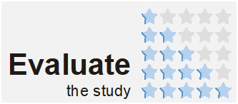
Related information
Methodological report. Labour force survey
Labour Force Survey in Poland
Employed, unemployed and economically inactive persons (preliminary LFS results) in the fourth quarter of 2021

Data available in databases
Local Data Bank → Labour market

Terms used in official statistics
Activity rate by LFS
Employment rate by LFS
Unemployment rate

