Economic activity of population in Mazowieckie Voivodship, II quarter 2020

28 September 2020

In Q2 2020, a decrease in the number of unemployed and employed persons and an increase in economically inactive persons compared to Q1 2020. An increase in the ratio of non-working age population to working age population was also observed.

 7.9%

Drop in the number on unemployed persons compared   
to the previous quarter

# **Economic activity of population aged 15 and more**

43% of population aged 15 and more did not work

In the second quarter of 2020, among the total population of Mazowieckie Voivodship aged 15 and more, 57.4% represented employed persons, 2.1% – unemployed persons, and 40.5% ­– economically inactive persons. This means that less than half of the population aged 15 and more (42.6%) did not work. In urban and rural areas this structure looked similar. However, significant differences were visible in the structure of men and women. Without employment (economically inactive and unemployed) were 35.1% of men and 49.3% of women.

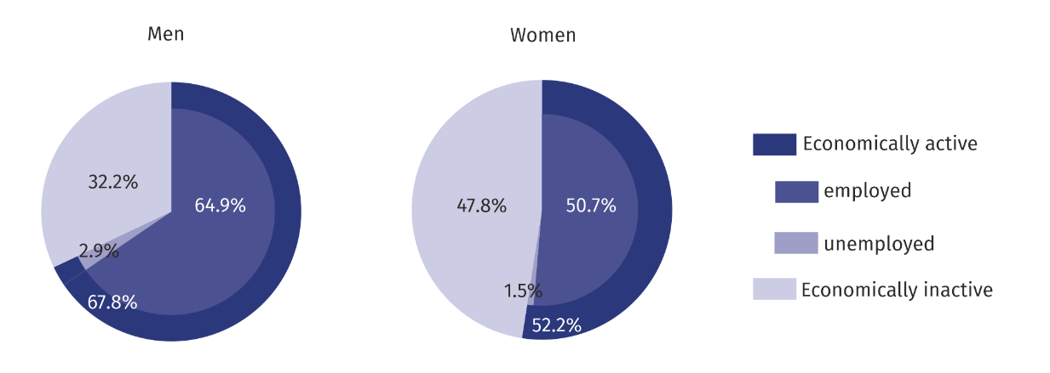**Chart 1. Structure of population aged 15 and more by sex, II quarter 2020**

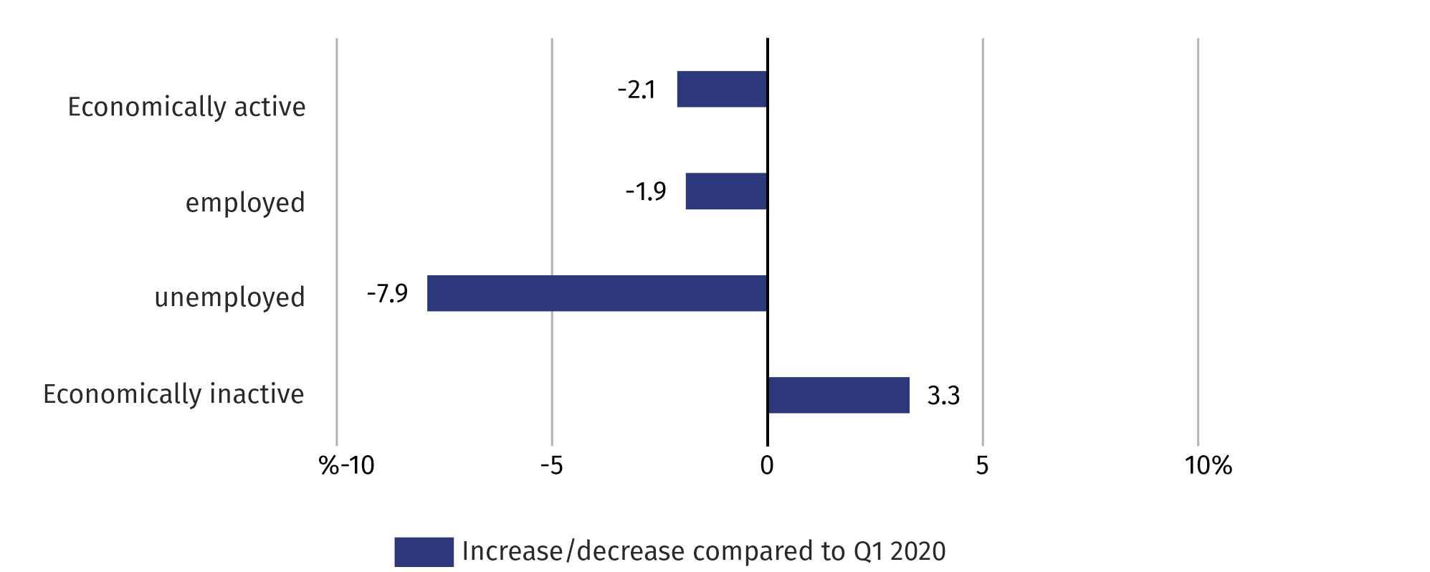**Chart 2. Changes compared to I quarter 2020**

decrease in unemployed persons by 8% compared to the previous quarter

In comparison with the first quarter of 2020, the number of economically inactive persons increased by 3.3%. However, there was a decrease in the number of unemployed and employed persons by 7.9% and 1.9%, respectively. There was an increase in the ratio of non-working to working population. In the second quarter of 2019, there were 742 unemployed and economically inactive persons per 1000 employed, while in the first quarter of 2020 – 709.

There were 742 unemployed and economically inactive persons per 1000 employed

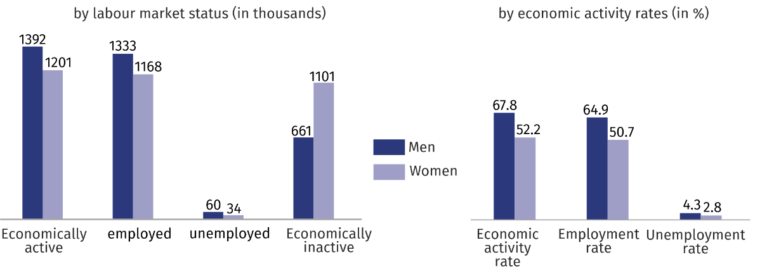**Chart 3. Economic activity of population in II quarter 2020**

The economic activity rate was 59.6% and decreased by 1.2 pp compared to the previous quarter. There was a decrease in the level of economic activity both in the female (by 1.7 pp) and in male population (by 0.8 pp). This rate decreased also in urban areas (by 2.0%) and in urban areas (by 0.1 pp).

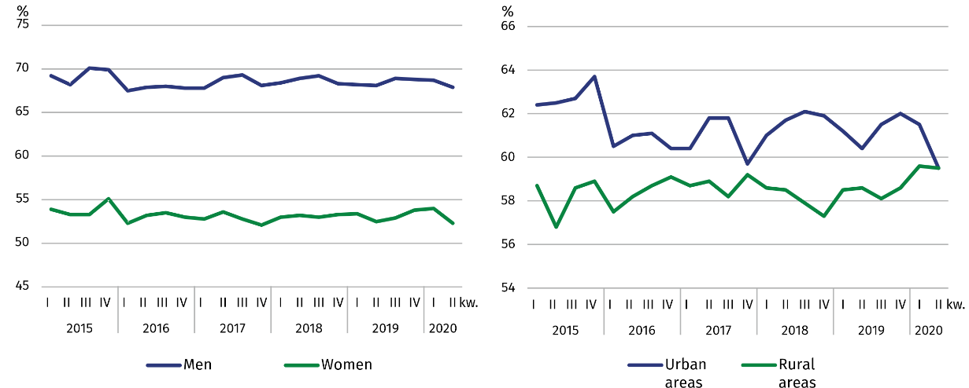**Chart 4. Economic activity rate by sex and place of residence**

The highest value of the rate in terms of age was recorded in the age group 45–54, which was 87.9%, and the lowest among persons aged 55 and more – 29.3%. For working age population, this rate was 80.6%.

**Employed persons**

In the second quarter of 2020, in Mazowieckie Voivodship, the population of employed persons counted 2500 thousand persons, and employment rate was estimated at 57.4% (a decrease by 1.1 pp compared to the previous quarter).

In comparison with I quarter 2020, the number of employed persons decreased by 1.9%. A decrease was recorded both in females (by 2.5%) and in males (by 1.3%). The number of employed persons decreased among urban (by 3.2%) and increased among rural residents (by 0.7%).

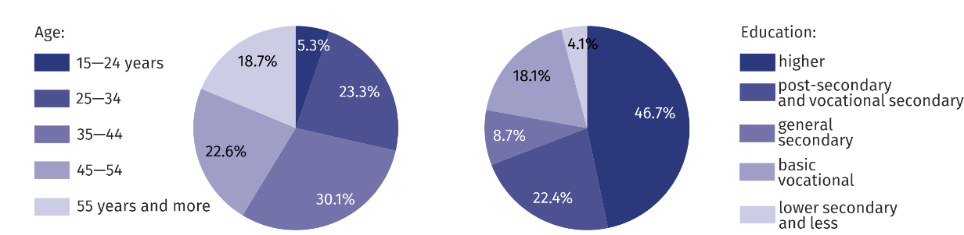**Chart 5. Structure of employed persons by age and education in II quarter 2020**

In II quarter 2020, the highest employment rate was recorded among persons aged 45–54 and 35-44 years (85.6%), and the lowest among persons aged 55 and more (28.8%).

The highest decrease in the employment rate was noted among persons aged 15–24 and 25-34 (by 3.4 pp each), and the increase only among persons aged 55 and more (by 0.1 pp).

For working age population, the employment rate was estimated at 77.5% (a decrease by 1.4 pp compared to I quarter 2020).

Among employed persons according to the level of education, the highest employment rate recorded persons with higher education – 77.9%, and the lowest among persons with lower secondary and less education – 16.0%.

The largest decrease in the employment rate recorded persons with basic vocational education (by 1.9 pp), and an increase only among persons with lower secondary and less education (0.3 pp).

**Chart 6. Employment rate by sex and place of residence** 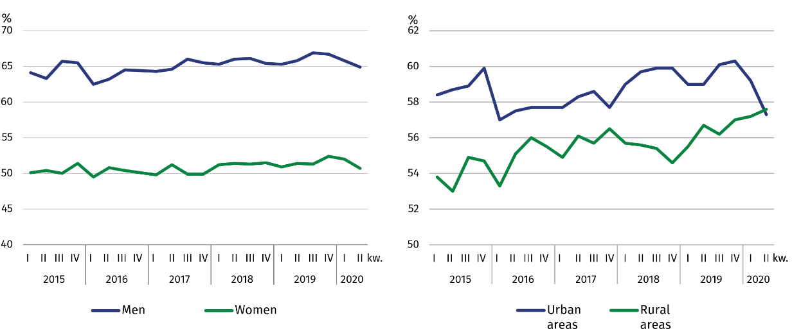

In II quarter 2020, 1927 thousand persons worked as paid employees (i.e. 77.1% of the total employed), and their number decreased compared to I quarter of 2020 (by 3.1%). The increase was recorded both among employers and own account workers (from 506 thousand to 513 thousand), as well as among contributing family workers (from 53 thousand to 60 thousand).

¾ of total employed persons worked in private sector

The vast majority of employed persons supported the private sector (75.1% of the total employed). Of these, the majority (58.4%) were men. The situation was different among paid employees in public sector, where among 623 thousand employed persons predominated women (62.1%). 81.3% of paid employees worked for an indefinite period (an increase by 0.8 pp compared to the first quarter of 2020).

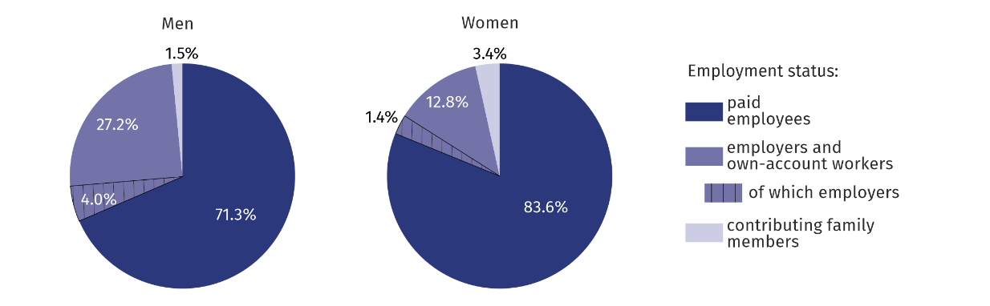**Chart 7. Structure of employed persons by employment status in II quarter 2020**

27% of men and 13% of women worked as employers and own-account workers

**Unemployed persons**

In II quarter 2020, the population of unemployed persons in Mazowieckie Voivodship amounted to 93 thousand persons and decreased by 7.9% compared to I quarter 2020.

decrease in the number of unemployed women by 21%, and an increase among men by 3%

Compared to the previous quarter, the number of unemployed women decreased (by 20.9%) and men increased (by 3.4%). There was a drop both among rural (by 18.9%), and urban population (by 1.6%).

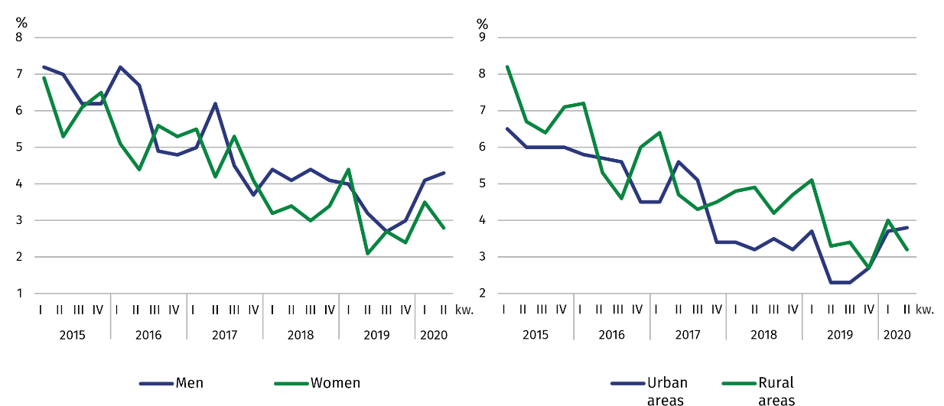**Chart 8. Unemployment rate by sex and place of residence**

The total unemployment rate in the voivodship amounted to 3.6% and decreased compared to I quarter 2020 by 0.2 pp. In urban areas it was 3.8% (by 0.6 pp higher than in rural areas). For working age population the unemployment rate was 3.8%.

In comparison with I quarter 2020, the unemployment rate decreased among women (by 0.7 pp), and increased among men (by 0.2 pp). The decrease in the unemployment rate was recorded in rural (by 0.8 pp), and the increase in urban areas (by 0.1 pp).

The highest unemployment rate was noted among persons with lower secondary and less education (by 11.3%), and the lowest among persons with higher education (2.0%).

The highest decrease was noted among persons with lower secondary and less education (by 3.2 pp), and the increase among persons with basic vocational education (by 1.0 pp).

The highest unemployment rate was among persons aged 15–24 years (by 10.7%), and the lowest among persons aged 55 and more (1.9%).

The largest decrease in the unemployment rate was noted among persons aged 15–24 (by 3.2 pp), and the increase among persons aged 25–34 (by 1.8 pp).

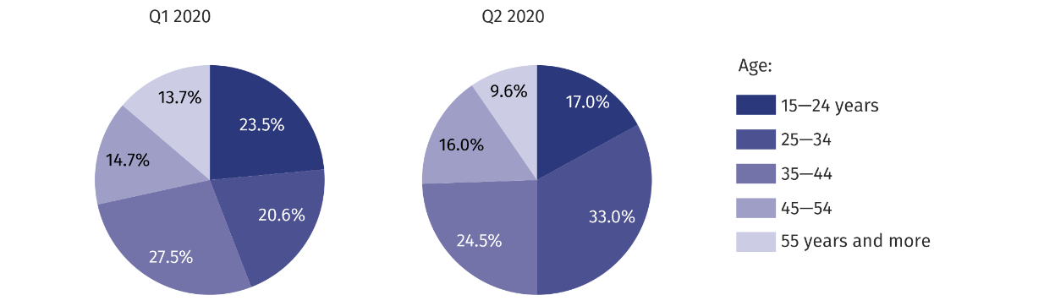**Chart 9. Structure of unemployed persons by age**

Men and urban residents looked for a job shorter than women and rural residents

An average time of job seeking by unemployed persons amounted to 6.7 months. Men and urban residents looked for a job shorter than women and rural residents. Men looked for a job for 6.6 months on average (by 0.2 months shorter than women), and urban residents for 6 months (by 1.6 months shorter than rural residents).

Long-term unemployment was more frequent among women than among men

The population of long-term unemployed persons (13 months and more) amounted to 10.8% of the total unemployed. Long-term unemployment was more frequent among women than men (11.8% compared to 10.0%) and more frequent among rural than urban residents (16.7% compared to 7.9%).

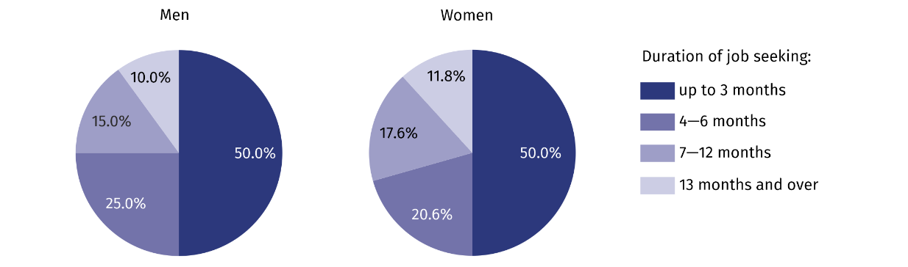**Chart 10. Structure of unemployed persons by duration of job seeking in II quarter 2020**

Economically inactive persons

Among the economically inactive women predominate – 63%

– 63%

In II quarter 2020, in Mazowieckie Voivodship, 1762 thousand persons remained economically inactive, which accounted for 40.5% of total population aged 15 and more (in rural areas the same as in urban areas). Still, in this population women were the majority – 62.5%. Among economically inactive persons, as in previous periods, persons with lower secondary and less education predominated – 29.6%. Working age population made up 33.6% of total economically inactive persons.

**Chart 11. Structure of economically inactive persons by causes of economic inactivity in II quarter  
 2020**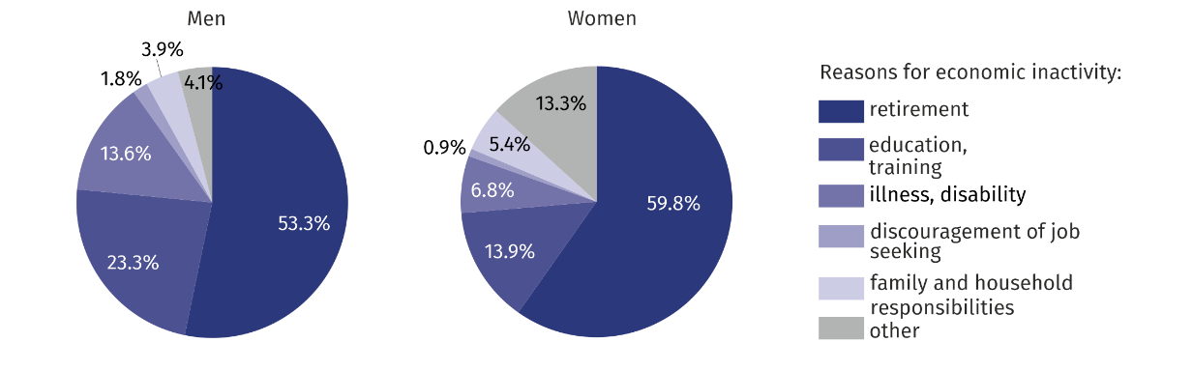

In relation to I quarter 2019, the population of economically inactive persons increased by 3.3%. The increase was recorded in the female population (by 3.8%) and in the male population (by 2.5%). Taking into account a place of residence, an increase in the number of economically inactive persons was noted among urban residents (by 5.3%), and no changes among rural residents (by 2.3%).

Out of total economically inactive persons, 57.3% accounted for persons who did not take up work because of being retired. Other reasons for economic inactivity were: education and training – 17.4%, illness or disability – 9.4%, family and household responsibilities – 4.8%. The population of persons discouraged by inefficiency of job seeking amounted to 22 thousand, i.e. 1.2% of total economically inactive persons.

**Table 1. Economic activity of population aged 15 years and more by selected indicators**

|  |  |  |  |  |
| --- | --- | --- | --- | --- |
| SPECIFICATION | 2020 | | | |
| Q1 | | Q2 | |
| in % | | | increase/decrease  in pp compared to the previous period |
| **ECONOMIC ACTIVITY RATE** | | | | |
| **TOTAL** | **60,8** | **59,6** | | **–1,2** |
| men | 68,6 | 67,8 | | –0,8 |
| women | 53,9 | 52,2 | | –1,7 |
| Urban areas | 61,5 | 59,5 | | –2,0 |
| Rural areas | 59,6 | 59,5 | | –0,1 |
| **EMPLOYMENT RATE** | | | | |
| **TOTAL** | **58,5** | **57,4** | | **–1,1** |
| men | 65,8 | 64,9 | | –0,9 |
| women | 52,0 | 50,7 | | –1,3 |
| Urban areas | 59,2 | 57,3 | | –1,9 |
| Rural areas | 57,2 | 57,6 | | 0,4 |
| **UNEMPLOYMENT RATE** | | | | |
| **TOTAL** | **3,8** | **3,6** | | **–0,2** |
| men | 4,1 | 4,3 | | 0,2 |
| women | 3,5 | 2,8 | | –0,7 |
| Urban areas | 3,7 | 3,8 | | 0,1 |
| Rural areas | 4,0 | 3,2 | | –0,8 |

**Table 2. Economic activity of population aged 15 and more by labour market status**

|  |  |  |  |
| --- | --- | --- | --- |
| SPECIFICATION | 2020 | | |
| Q1 | Q2 | |
| in thousands | | Q1 2020=100 |
| **EMPLOYED PERSONS** | | | |
| **TOTAL** | **2 548** | **2 500** | **98,1** |
| men | 1 350 | 1 333 | 98,7 |
| women | 1 198 | 1 168 | 97,5 |
| Urban areas | 1 654 | 1 601 | 96,8 |
| Rural areas | 894 | 900 | 100,7 |
| **UNEMPLOYED PERSONS** | | | |
| **TOTAL** | **101** | **93** | **92,1** |
| men | 58 | 60 | 103,4 |
| women | 43 | 34 | 79,1 |
| Urban areas | 64 | 63 | 98,4 |
| Rural areas | 37 | 30 | 81,1 |
| **ECONOMICALLY INACTIVE PERSONS** | | | |
| **TOTAL** | **1 706** | **1 762** | **103,3** |
| men | 645 | 661 | 102,5 |
| women | 1 061 | 1 101 | 103,8 |
| Urban areas | 1 073 | 1 130 | 105,3 |
| Rural areas | 632 | 632 | 100,0 |

**Table 3. Employment rate and unemployment rate by age**

|  |  |  |  |
| --- | --- | --- | --- |
| SPECIFICATION | 2020 | | |
| Q1 | Q2 | |
| in % | | increase/decrease  in pp compared to the previous period |
| **EMPLOYMENT RATE** | | | |
| **TOTAL** | **58,5** | **57,4** | **–1,1** |
| 15–24 years | 30,8 | 27,4 | –3,4 |
| 25–34 | 86,1 | 82,7 | –3,4 |
| 35–44 | 86,1 | 85,1 | –1,0 |
| 45–54 | 85,9 | 85,6 | –0,3 |
| 55 years and more | 28,7 | 28,8 | 0,1 |
| **UNEMPLOYMENT RATE** | | | |
| **TOTAL** | **3,8** | **3,6** | **–0,2** |
| 15–24 years | 13,9 | 10,7 | –3,2 |
| 25–34 | 3,3 | 5,1 | 1,8 |
| 35–44 | 3,5 | 3,0 | –0,5 |
| 45–54 | 2,6 | 2,6 | – |
| 55 years and more | 2,9 | 1,9 | –1,0 |

**Table 4. Employment rate and unemployment rate by level of education**

|  |  |  |  |
| --- | --- | --- | --- |
| SPECIFICATION | 2020 | | |
| Q1 | Q2 | |
| in % | | increase/decrease  in pp compared to the previous period |
| **EMPLOYMENT RATE** | | | |
| **TOTAL** | **58,5** | **57,4** | **–1,1** |
| Higher | 78,6 | 77,9 | –0,7 |
| Post-secondary and vocational secondary | 58,5 | 57,7 | –0,8 |
| General secondary | 52,1 | 51,2 | –0,9 |
| Basic vocational | 56,8 | 54,9 | –1,9 |
| Lower secondary, primary and incomplete primary | 15,7 | 16,0 | 0,3 |
| **Table 4. Employment rate and unemployment rate by level of education (cont.)**   |  |  |  |  | | --- | --- | --- | --- | | SPECIFICATION | 2020 | | | | Q1 | Q2 | | | in % | | increase/decrease  in pp compared to the previous period |   **UNEMPLOYMENT RATE** | | | |
| **TOTAL** | **3,8** | **3,6** | **–0,2** |
| Higher | 2,3 | 2,0 | –0,3 |
| Post-secondary and vocational secondary | 3,9 | 3,6 | –0,3 |
| General secondary | 7,8 | 6,4 | –1,4 |
| Basic vocational | 3,2 | 4,2 | 1,0 |
| Lower secondary, primary and incomplete primary | 14,5 | 11,3 | –3,2 |

Note. The sums of certain data may be different from the "total" item. This is due to rounding made when generalizing the results of the survey.

In the case of quoting data from Statistics Poland, please provide information: "Source of data – Statistics Poland", and in the case of publishing calculations made on data published by Statistics Poland, please provide information: "Own study based on Statistics Poland data".

|  |  |
| --- | --- |
| Prepared by:  **Statistical Office in Warszawa**  **Director Zofia Kozłowska**  Tel.: (+48 22) 464 23 15 | Issued by:  **Statistical Information Centre**  **Marcin Kałuski**  Tel.: (+48 22) 464 20 91 [**m.kaluski@stat.gov.pl**](mailto:m.kaluski@stat.gov.pl) |

|  |  |  |
| --- | --- | --- |
| **Press office**  Tel.: (+48 22) 464 20 91  **e-mail:** [**m.kaluski@stat. gov.pl**](mailto:m.kaluski@stat.%20gov.pl) |  | warszawa.stat.gov.pl/en/ |
|  | @Warszawa_STAT |
|  |  |

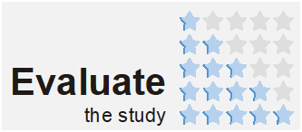

**Related information**

[Methodological report. Labour Force Survey](https://stat.gov.pl/obszary-tematyczne/rynek-pracy/zasady-metodyczne-rocznik-pracy/zeszyt-metodologiczny-badanie-aktywnosci-ekonomicznej-ludnosci,3,1.html)

[Labour force survey in Poland](https://stat.gov.pl/obszary-tematyczne/rynek-pracy/pracujacy-bezrobotni-bierni-zawodowo-wg-bael/aktywnosc-ekonomiczna-ludnosci-polski-iii-kwartal-2019-roku,4,35.html)

[Monitoring of the labour market](https://stat.gov.pl/obszary-tematyczne/rynek-pracy/pracujacy-bezrobotni-bierni-zawodowo-wg-bael/monitoring-rynku-pracy-kwartalna-informacja-o-rynku-pracy-w-pierwszym-kwartale-2019-r-,12,37.html)

**Data available in databases**

[Local Data Bank/Labour market](https://bdl.stat.gov.pl/BDL/dane/podgrup/temat)

**Terms used in official statistics**

[Activity rate](https://stat.gov.pl/en/metainformations/glossary/terms-used-in-official-statistics/591,term.html)

Employment rate

[Unemployment rate](https://stat.gov.pl/en/metainformations/glossary/terms-used-in-official-statistics/486,term.html)