Socio-economic situation of Mazowieckie Voivodship in December 2025
- In December this year, the average employment in the enterprise sector decreased on a yearly basis by 0.6%, and on a monthly basis increased by 0.3%. The registered unemployment rate amounted to 4.3% and increased on an annual basis (by 0.3 pp), and did not change compared to the previous month.
- Average monthly gross wages and salaries in the enterprise sector in December 2025 were higher by 10.1% compared to the previous year and by 6.3% than in the previous month.
- On the agricultural market in December 2025, the average procurement prices of cattle and poultry for slaughter were higher than in the previous year, while the prices of wheat, rye, potatoes and pigs for slaughter and milk were lower. On a monthly basis, more was paid for wheat, rye and potatoes, and less for cattle, pigs and poultry for slaughter as well as milk.
- In December this year, sold production of industry (at constant prices) increased on a yearly basis (by 2.2%), and on a monthly basis (by 9.2%). Construction and assembly production (at current prices) was higher by 11.0% than in the previous year and lower by 49.9% than a month earlier.
- The number of dwellings completed in December this year, was higher by 22.4% than a year before and by 50.4% compared to the previous month. Most dwellings were built for sale or rent.
- In December 2025, there was an increase in retail sales in annual terms (by 3.7%). Wholesale was higher than in the previous year (by 0.2%).
- In December 2025, the number of entities of the national economy registered in the REGON register was higher by 3.5% than in the previous year and by 0.2% than in the previous month.
- In January of this year, the general business climate indicator in most of the surveyed economic sectors indicated stabilisation or improvement in the economic climate compared to the previous month. The largest increase in the indicator (by 6.2) was recorded in construction. Compared to December 2025, a noticeable deterioration in the economic climate occurred only in accommodation and catering, with the indicator decreasing by 3.2. Despite this, entities in this section assess the economic climate most favourably, with the indicator value above the long-term average. Only retail entities express pessimistic opinions, with the indicator value below the long-term average.

Contents
Labour market 4
Wages and salaries 7
Agriculture 9
Industry and construction 12
Residential construction 14
Internal market 16
Entities of the national economy 17
Business tendency 19
Selected data on Mazowieckie Voivodship 25

General notes
Data presented in the news release:
- on employment, wages and salaries and sold production of industry and construction, construction and assembly production, as well as retail sales and wholesale concern economic entities employing more than 9 persons,
- on enterprise sector refer to entities conducting economic activity in the field of: forestry and logging; maritime fishing; mining and quarrying; manufacturing; electricity, gas, steam and air conditioning supply; water supply; sewerage, waste management and remediation activities; construction; wholesale and retail trade; repair of motor vehicles and motorcycles; transportation and storage; accommodation and food service activities; information and communication; real estate activities; legal and accounting activities; activities of head offices; management consultancy activities; architectural and engineering activities; technical testing and analysis; advertising and market research; other professional, scientific and technical activities; arts, entertainment and recreation; repair of computers and personal and household goods; other personal service activities,
- on retail prices of foodstuffs and non-foodstuffs as well as services that originate from quotations of prices conducted by interviewers at selected points of sale in selected regions of price surveys; prices of food are collected once a month, with the exception of fruit and vegetables, for which prices are collected twice a month,
- on procurement of agricultural products include procurement from producers from the voivodship; prices are given excluding VAT tax,
- on financial results of enterprises and investment outlays refer to economic entities keeping accounting ledgers (excluding entities whose activity is classified according to the NACE Rev. 2 in the sections “Agriculture, forestry and fishing” and “Financial and insurance activities” as well as higher education institutions) in which the number of employed persons exceeds 49.
Data in value terms are provided at current prices and form the basis for calculating the structure indicators. Dynamic indices are provided on the basis of value at current prices, except for industry, for which the dynamic indices are provided on the basis of value at constant prices (average current prices of 2015).
Relative numbers (indices, percentages) were calculated on the basis of absolute data expressed with higher precision than that presented in the text and tables.
Data have been presented in accordance with the Polish Classification of Activities – PKD 2007 (NACE Rev. 2).

Polish Classification of Activities 2007 (PKD 2007)
Abbreviation | Full name
sections
trade; repair of motor vehicles | wholesale and retail trade; repair of motor vehicles and motorcycles
accommodation and catering | accommodation and food service activities
divisions
trade; repair of motor vehicles | wholesale and retail trade; repair of motor vehicles and motorcycles

Symbols
Symbol | Description
(–) | – magnitude zero
(.) | – data not available, classified data (statistical confidentiality) or providing data impossible or purposeless
(*) | – data revised
∆ | – categories of applied classification are presented in abbreviated form
„Of which” | – indicates that not all elements of the sum are given
Data describing Mazowieckie Voivodship can also be found in statistical publications issued by the Statistical Office in Warszawa and in the publications of Statistics Poland.
The report „Economic situation in Mazowieckie Voivodship in January 2026” was published on the home page of the Statistical Office in Warszawa:: https://warszawa.stat.gov.pl/ on 30 January 2026.
When publishing Statistical Office data, please indicate the source.

Labour market
In December this year, the average employment in the enterprise sector was lower compared to the previous year and slightly higher compared to the previous month. The registered unemployment rate increased year-on-year and did not change month-on-month.
Average employment in the enterprise sector in December this year amounted to 1,575.1 thousand persons (full-time equivalent) and was by 0.6% lower in annual terms (in the previous month by 0.7%). The most significant decrease was recorded in accommodation and catering (by 7.0%), and also in trade; repair of motor vehicles (by 5.2%), transportation and storage (by 2.3%) and administrative and support service activities (by 0.7%). The highest increase was recorded in real estate activities (by 10.4%), followed by, among others, professional, scientific and technical activities (by 5.9%), electricity, gas, steam and air conditioning supply (by 2.7%), construction and manufacturing (by 1.8% each).
In comparison with November this year, average employment increased by 0.3%. The most in administrative and support service activities (by 2.9%), and also, among others, in construction and transportation and storage (by 0.2% each), and also in manufacturing and electricity, gas, steam and air conditioning supply (by 0.1% each). The decrease was recorded only in accommodation and catering (by 0.4%), real estate activities (by 0.3%) and professional, scientific and technical activities (by 0.2%).
Table 1. Average employment in the enterprise sector in December 2025
SPECIFICATION | 12 2025 |  | 01–12 2025
SPECIFICATION | in thousands | 12 2024=100 | in thousands | 01–12 2024=100
TOTAL | 1575,1 | 99,4 | 1579,4 | 99,1
of which:
Industry | 396,5 | 101,7 | 402,1 | 102,2
of which:
manufacturing | 355,2 | 101,8 | 361,0 | 102,4
electricity, gas, steam and air conditioning supply | 20,5 | 102,7 | 20,4 | 102,6
Construction | 94,8 | 101,8 | 94,1 | 100,8
Trade; repair of motor vehicles Δ | 323,8 | 94,8 | 325,6 | 95,1
Transportation and storage | 260,9 | 97,7 | 262,7 | 96,0
Accommodation and catering Δ | 34,3 | 93,0 | 35,0 | 94,7
Information and communication | 136,9 | 100,7 | 137,6 | 101,0
Real estate activities | 28,8 | 110,4 | 28,8 | 110,2
Professional, scientific and technical activities a | 116,5 | 105,9 | 117,7 | 105,0
Administrative and support service activities | 144,6 | 99,3 | 137,8 | 97,5
a Excluding divisions: Research and experimental development work and Veterinary activities.
In the period of January-December 2025, average employment in the enterprise sector amounted to 1,574.8 thousand persons and decreased by 1.1% compared to the same period of 2024 (a year ago, a slight increase of 17 persons was recorded).

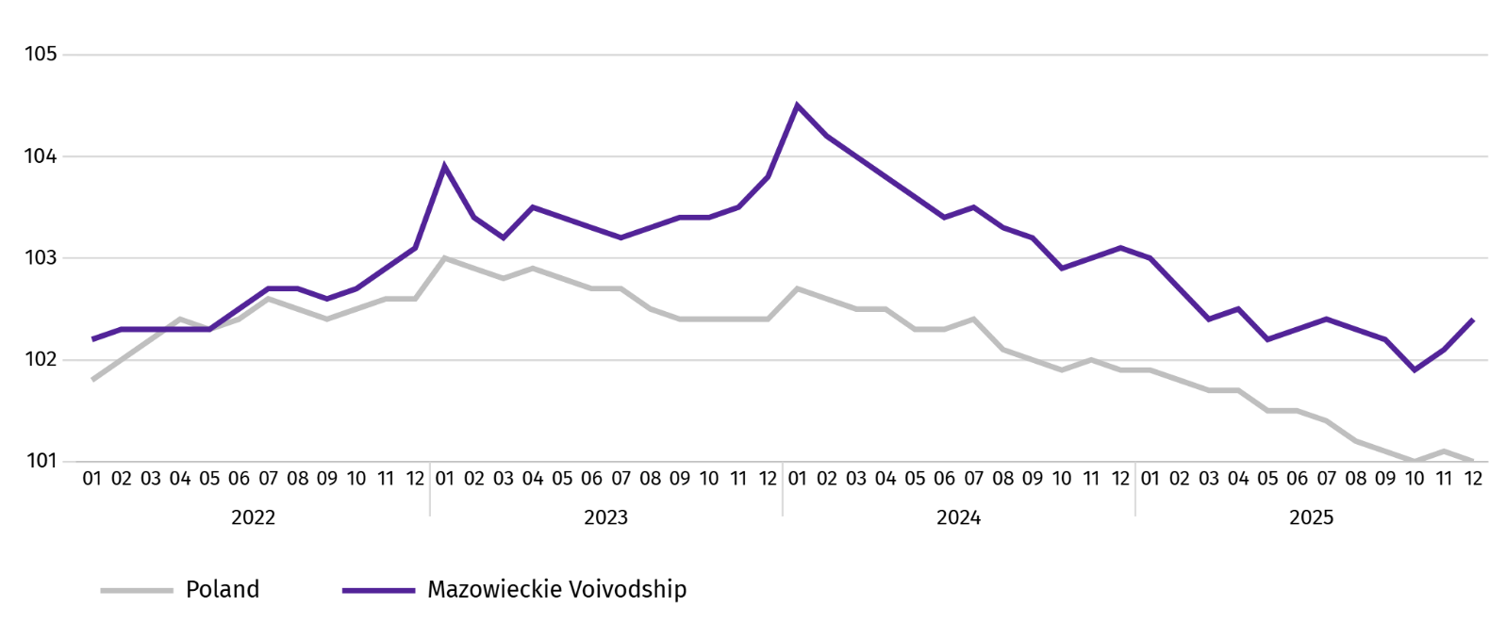
Chart 1. Average employment in the enterprise sector (monthly average 2021=100)

At the end of December 2025, the number of unemployed persons registered in labour offices amounted to 118.2 thousand persons and increased on a yearly basis by 9.2 thousand persons (i.e. by 8.4%), and on a monthly basis decreased by 40 persons (i.e. by 0.03%). Women accounted for 46.8% of total registered unemployed persons (a year before 48.3%).
Table 2. Number of unemployed persons and unemployment rate
SPECIFICATION | 2024 | 2025
SPECIFICATION | 12 | 11 | 12
Registered unemployed persons (as of end of month) in thousands | 109,0 | 118,1 | 118,2
Newly registered unemployed persons (during a month) in thousands | 11,1 | 11,3 | 11,5
Unemployed persons removed from unemployment rolls (during a month) in thousands | 10,5 | 11,9 | 11,4
Registered unemployment rate (as of end of month) in % | 4,0 | 4,3 | 4,3
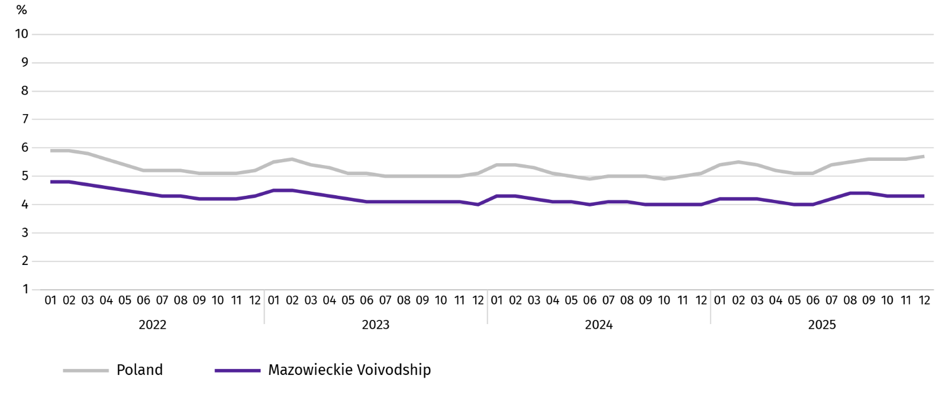
Chart 2. Registered unemployment rate (as of end of month)
Registered unemployment rate at the end of December 2025 amounted to 4.3% and was lower than the national average (5.7%). It increased on a yearly basis (0.3 pp), and did not change on a monthly basis.
The territorial differentiation of the unemployment rate continued in the Voivodship. Powiats with the highest unemployment rate were still szydłowiecki (22.1% against 23.5% in December 2024), przysuski (18.3% against 18.0%), and radomski (16.8% against 16.1%), and with the lowest – Warszawa (1.5% against 1.4%), warszawski zachodni (1.9% against 1.6%) and pruszkowski (2.6% against 2.1%).
Compared to December last year, the unemployment rate increased in 37 out of 42 powiats. The highest increase was recorded in the powiats: wołomiński (by 1.2 pp), pułtuski (by 1.1 pp) and gostyniński, legionowski, wyszkowski and żuromiński (by 1.0 pp each). The decrease was recorded in the szydłowiecki powiat (by 1.4 pp).
Compared to November 2025, the increase in unemployment rate of 0.1-0.6 pp took place in 24 powiats and an increase of 0.1-0.2 pp in 5 powiats.
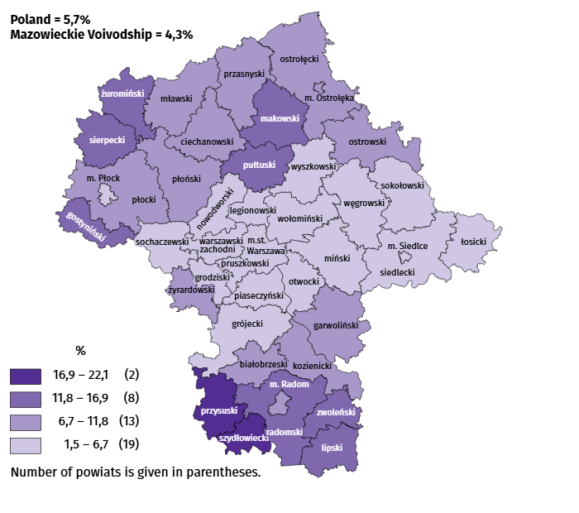
Map 1. Registered unemployment rate by powiats in 2025 (as of end of December)

In December this year, 11.5 thousand unemployed persons were registered in labour offices, i.e. more by 3.3% than a year before and by 1.2% than in the previous month. Among the newly registered, 75.5% were persons registering for the second time (80.0% in the previous year). Share of persons previously not employed amounted to 13.9% (a decrease of 0.4 pp year-on-year), persons terminated for company reasons 4.0% (a decrease of 0.1 pp). Among newly registered unemployed persons, 40.4% lived in rural areas (a decrease of 2.5 pp). Graduates accounted for 6.2% of newly registered unemployed persons (an increase of 0.4 pp).
In December 2025, 11.4 thousand persons were removed from unemployment rolls, i.e. more by 9.0% than a year before and by 3.7% less than a month before. 6.7 thousand persons (7.0% more than a year before) were removed from unemployment rolls due to undertaking employment. The share of this category of persons in the total number of persons removed from unemployment rolls decreased by 1.1 pp on a yearly basis and amounted to 58.4%. The percentage of persons who voluntarily gave up their status of the unemployed decreased as well (by 0.9 pp to 3.7%) and persons who started training and employer sponsored traineeships (by 0.1 pp to 2.0%). However there was an increase in the share of persons who obtained retirement or pension rights (by 0.1 pp to 0.6%).
At the end of December 2025, 101.7 thousand unemployed persons were not entitled to the unemployment benefit, and their share in the total number of the registered unemployed was 86.0% (a 1.8 pp increase in annual terms).
At the end of the surveyed month, 59.8 thousand, i.e. 50.6% out of registered unemployed persons were the long-term unemployed . The number of unemployed persons under the age of 30 amounted to 26.8 thousand, which accounted for 22.7% of the total unemployed (of which persons under the age of 25 constituted 12.2%). Persons aged over 50 amounted to 32.5 thousand (27.5%). 0.7 thousand of unemployed persons, i.e. 0.6% of their total number received social assistance benefits. There were 13.8 thousand persons (i.e. 11.7% of the total unemployed) with at least one child under the age of 6, and persons with a disabled child aged under 18 – 469 persons (0.4% respectively). The number of disabled unemployed persons amounted to 5.6 thousand (i.e. 4.7%).
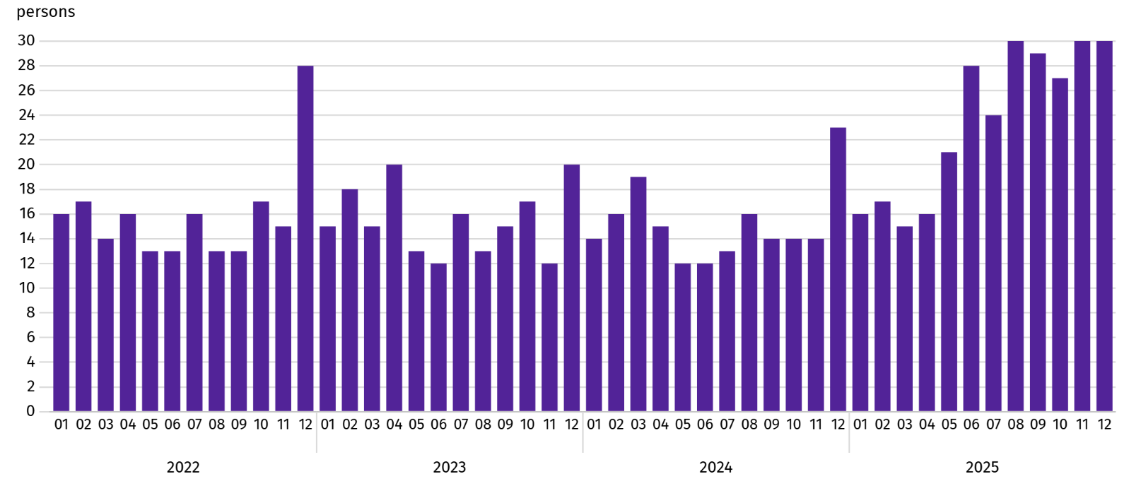
Chart 3. Registered unemployment rateª (as of end of month)

a From 1 June 2025, data on job offers are not fully comparable with earlier periods due to methodological changes resulting from the entry into force of the Act on the Labour Market and Employment Services (Journal of Laws of 2025, item 620).
In December 2025, 2.9 thousand job offers were submitted to labour offices, i.e. less by 20.4% than in the previous month. At the end of month, there were 42 unemployed persons per job offer (30 a month before).
According to the labour offices, as of the end of December 2025, 27 companies announced termination of 8.1 thousand employees in the near future (a year before, respectively 29 companies – 4.3 thousand employees).

Wages and salaries
In December 2025, the average monthly gross wages and salaries in the enterprise sector increased on a yearly and on a monthly basis.
Average monthly gross wages and salaries in the enterprise sector in December 2025 amounted to PLN 10,9333.28 and were higher than in the country (PLN 9,583.31). It increased by 10.1% on a yearly basis (by 8.5% in the previous month). The highest increase was recorded in transportation and storage (by 20.5%), and also, among others, in electricity, gas, steam and air conditioning supply (by 12.3%), manufacturing (by 11.4%) and information and communication (by 8.1%).
In comparison with November 2025, the average wages and salaries increased by 6.3%. The increase concerned all surveyed sections; the largest – real estate activities (by 15.3%), followed by transportation and storage (by 9.1%), professional, scientific and technical activities (by 7.1%), and trade; repair of motor vehicles (by 6.8%).
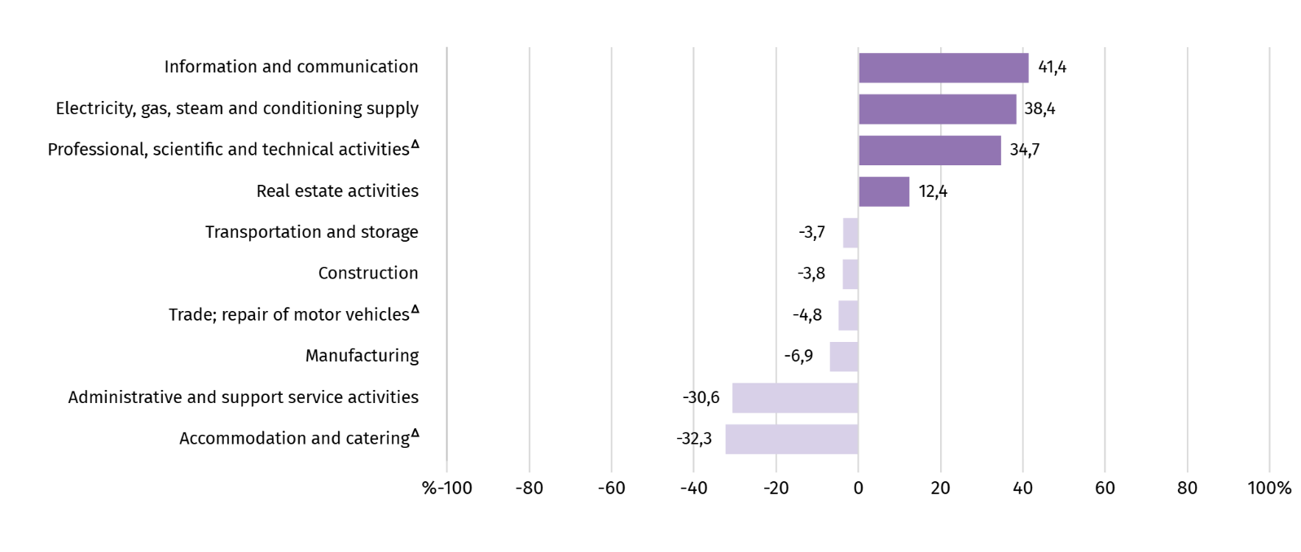
Chart 4. Relative deviations of average monthly gross wages and salaries in selected sections from average wages and salaries in the enterprise sector in December 2025

a Excluding divisions: Research and experimental development work and Veterinary activities.
Table 3. Average monthly gross wages and salaries in the enterprise sector in December 2025
SPECIFICATION | 12 2025 |  | 01–12 2025
SPECIFICATION | in PLN | 12 2024=100 | in PLN | 01–12 2024=100
TOTAL | 10933,28 | 110,1 | 10280,81 | 108,7
of which:
Industry | 10408,95 | 111,4 | 9876,49 | 110,1
of which:
manufacturing | 10179,18 | 111,4 | 9676,16 | 110,5
electricity, gas, steam and air conditioning supply | 15136,10 | 112,3 | 14580,37 | 106,1
Construction | 10516,86 | 104,3 | 10337,94 | 107,7
Trade; repair of motor vehicles Δ | 10409,04 | 105,4 | 9965,86 | 105,9
Transportation and storage | 10531,45 | 120,5 | 9035,91 | 109,9
Accommodation and catering Δ | 7397,45 | 103,9 | 7316,66 | 106,2
Information and communication | 15464,94 | 108,1 | 15098,90 | 108,5
Real estate activities | 12294,13 | 100,9 | 10682,54 | 102,9
Professional, scientific and technical activities a | 14726,66 | 107,7 | 13808,26 | 107,6
Administrative and support service activities | 7589,58 | 108,0 | 7582,25 | 108,4
a Excluding divisions: Research and experimental development work and Veterinary activities.
In the period of January-December 2025, the average monthly gross wages and salaries in the enterprise sector amounted to PLN 10,280.81 and was 8.7% higher than in the same period of 2024 (a year ago 10.6% higher).
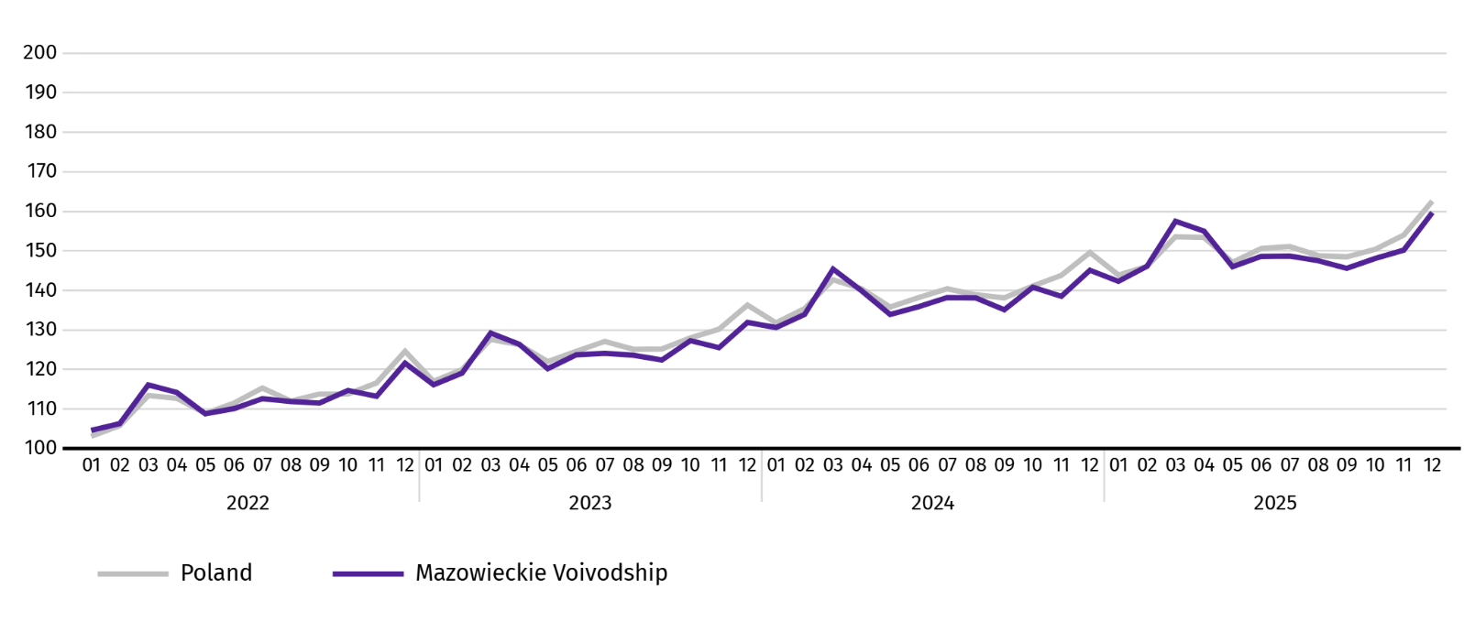
Chart 5. Average monthly gross wages and salaries in the enterprise sector (monthly average 2021=100)

Agriculture
On the agricultural market in December 2025, average procurement prices for cattle and poultry for slaughter were higher than a year ago, while prices for wheat, rye, potatoes, pigs for slaughter and milk were lower. On a monthly basis, more was paid for wheat, rye and potatoes, and less for cattle, pigs and poultry for slaughter as well as milk.
The average air temperature in Mazowieckie Voivodship in December 2025 amounted to 2.4°C and was by 2.6°C higher from the average from the years 1991–2020, while the maximum temperature reached 11.7°C in Płock and Warszawa, and the minimum amounted to minus 13.9°C in Kozienice. The average atmospheric precipitation (18.1 mm) accounted for 50% of the standard for the multi-year periods (ranging from 25% in Płock to 100% in Mława) . The number of days with precipitation, depending on the region, ranged from 9 to 11.
Table 4. Procurement of cereals ª
SPECIFICATION | 07–12 2025 |  | 12 2025
SPECIFICATION | in thousand tonnes | corresponding period of previous year=100 | in thousand tonnes | 12 2024=100 | 11 2025=100
Grain of basic cereals b | 262,7 | 103,2 | 52,5 | 191,3 | 184,7
of which:
wheat | 200,2 | 107,6 | 39,4 | 189,0 | 166,9
rye | 24,2 | 88,0 | 4,6 | 152,0 | 467,6
a Excluding procurement by natural persons. b Includes: wheat, rye, barley, oat, triticale; including cereal mixed, excluding sowing seed.
In July-December 2025, the procurement of basic cereals (with cereal mixed, without sowing seed) was by 3.2% larger than in the same period of 2024, with procurement of wheat larger by 12.0%. In December 2025, deliveries of cereal to procurement were 91.3% higher than a year ago and by 84.7% than in the previous month.
Table 5. Procurement of basic animal products ª
SPECIFICATION | 01–12 2025 |  | 12 2025
SPECIFICATION | in thousand tonnes | 01–12 2024=100 | in thousand tonnes | 12 2024=100 | 11 2025=100
Animals for slaughter b | 1166,4 | 93,8 | 83,1 | 89,8 | 84,5
of which:
cattle (including calves) | 56,2 | 103,0 | 2,2 | 59,4 | 96,3
pigs | 314,1 | 112,4 | 21,7 | 98,2 | 108,7
poultry | 795,2 | 87,5 | 59,1 | 88,6 | 77,7
Milk c | 2857,9 | 103,8 | 239,1 | 105,3 | 106,3
a In July-December, excluding procurement by natural persons. b Including cattle, calves, pigs, sheep, horses and poultry; in terms of meat including fats in post-slaughter warm weight. c In million litres.
In 2025, producers from Mazowieckie Voivodship delivered 1166.4 thousand tonnes of animals for slaughter (in warm weight), i.e. by 6.2% less than in the previous year. The decrease in procurement concerned poultry for slaughter (by 12.5%), while an increase concerned pigs (by 12.4%) and cattle for slaughter (by 3.0%). In December 2025, the total supply of animals for slaughter (83.1 thousand tonnes) was lower by 15.5% than in the previous month, and by 10.2% than in the previous year.
Deliveries of milk in 2025 (2,857.9 million litres) were by 3.8% larger than in 2024. In December 2025, the procurement of milk was larger by 5.3% than in the previous year and by 6.3% than in the previous month.
Table 6. Przeciętne ceny skupu podstawowych produktów rolnych
SPECIFICATION | 12 2025 |  |  | 01–12 2025
SPECIFICATION | PLN | 12 2024=100 | 11 2025=100 | PLN | 01–12 2024=100
Wheat ª per dt | 76,73 | 83,1 | 101,9 | 85,70 | 100,0
Rye ª per dt | 62,87 | 92,8 | 103,0 | 67,52 | 117,2
Potatoes per dt | 72,07 | 59,5 | 174,0 | 64,36 | 74,7
Animals for slaughter per kg of live weight:
cattle (excluding calves) | 19,28 | 125,6 | 99,8 | 15,59 | 136,0
pigs | 5,49 | 83,0 | 94,5 | 6,68 | 89,8
poultry | 5,59 | 103,0 | 96,2 | 5,95 | 115,6
Milk per 1 hl | 197,28 | 77,0 | 92,5 | 221,23 | 105,7
a Excluding sowing seed..
In December 2025, PLN 76.73 was paid for 1 dt of wheat at procurement, i.e. 1.9% more than last month and 16.9% more than last year. The average price of wheat at marketplaces was PLN 103.53 and was smaller by 0.2% than in November 2025, and by 6.6% than in December 2024. The procurement price of rye increased by 3.0% (to PLN 62.87) compared to the previous month, and the marketplace price decreased by 2.4% (to PLN 71.10). Compared to December 2024, procurement prices for rye were 7.2% lower, and marketplace prices by 16.1%.
Table 7. Average marketplace prices of wheat and potatoes
SPECIFICATION | 12 2025 |  |  | 01–12 2025
SPECIFICATION | PLN | 12 2024=100 | 11 2025=100 | PLN | 01–12 2024=100
Wheat per dt | 103,53 | 93,4 | 99,8 | 111,05 | 103,5
Rye per dt | 71,10 | 83,9 | 97,6 | 76,98 | 102,9
Potatoes b per dt | 172,44 | 77,4 | 95,0 | 203,53 | 87,0
a Edible late.
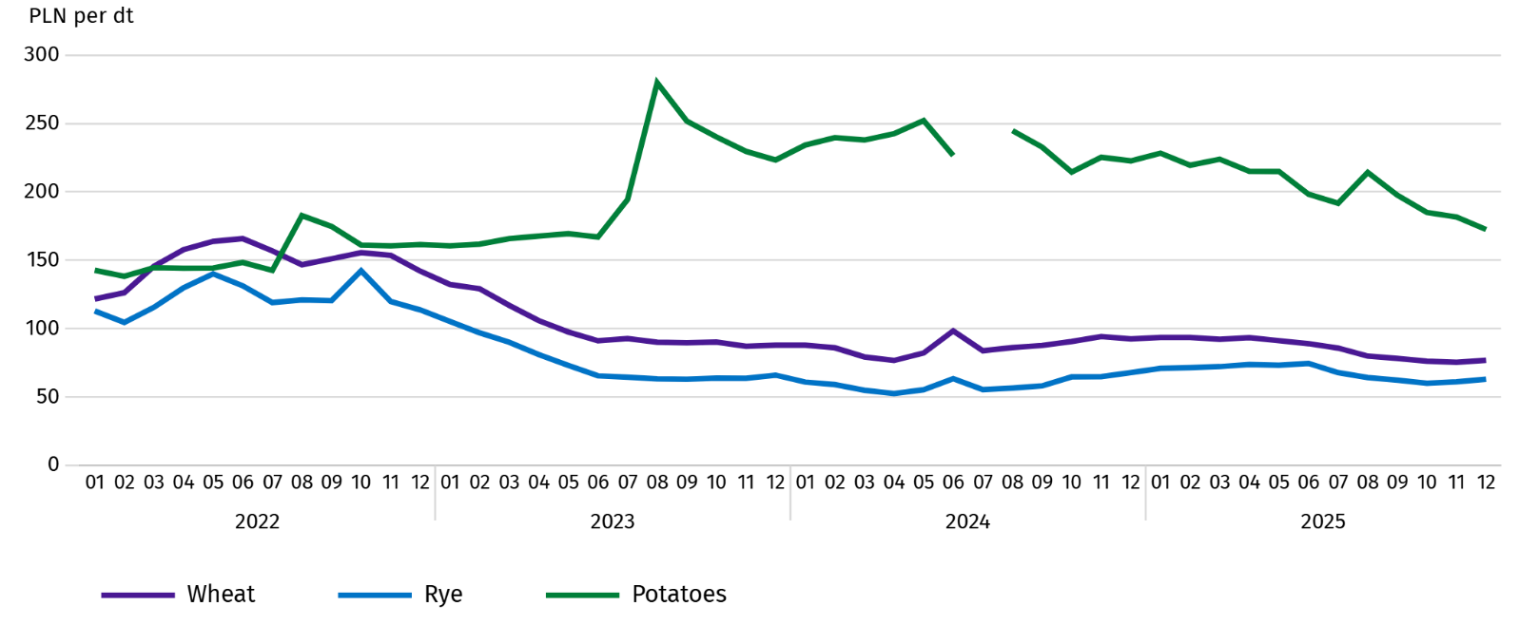
Chart 6. Average marketplace prices of cereals and potatoes ª

a In July 2024, the price of late edible potatoes was not recorded due to their absence at the time of observations.
In December 2025, the average procurement price of potatoes was PLN 72.07/dt, i.e. more by 74.0% than in the previous month and by 40.5% than last year. At marketplaces, the average price of 1 dt of potatoes was PLN 172.44 and was 5.0% lower than in the previous month, and by 22.6% than in the previous year.
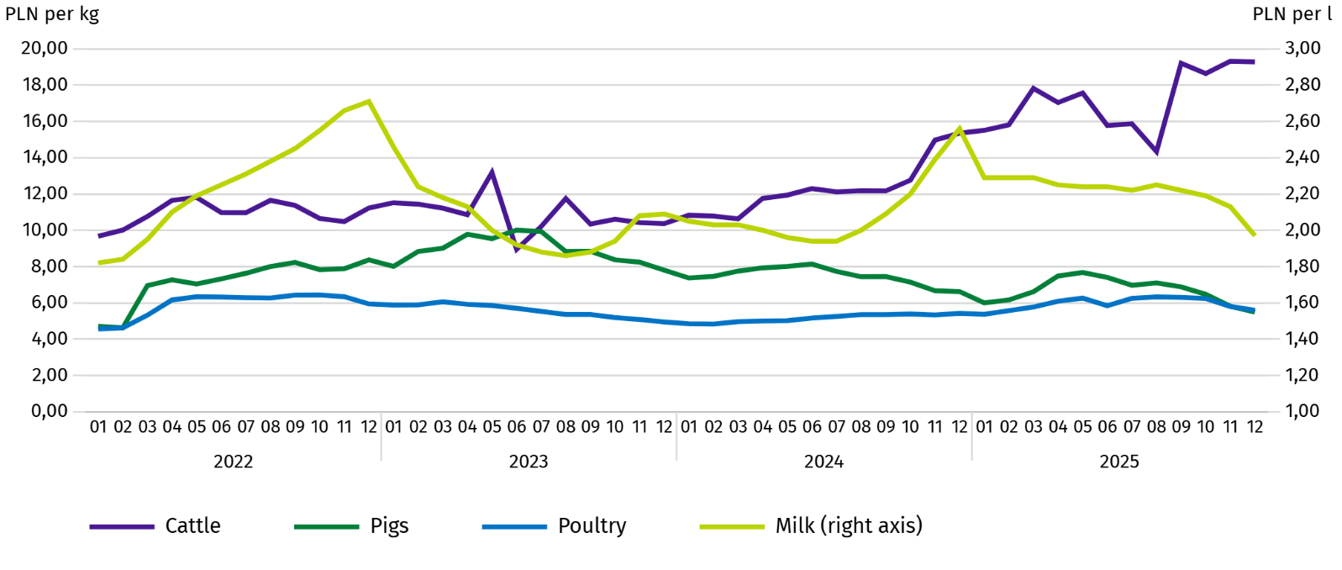
Chart 7. Average procurement prices of animals for slaughter and milk

In December 2025, the average procurement price of pigs for slaughter was lower by 5.5% than in the previous month, and by 17.0% than In the previous year.
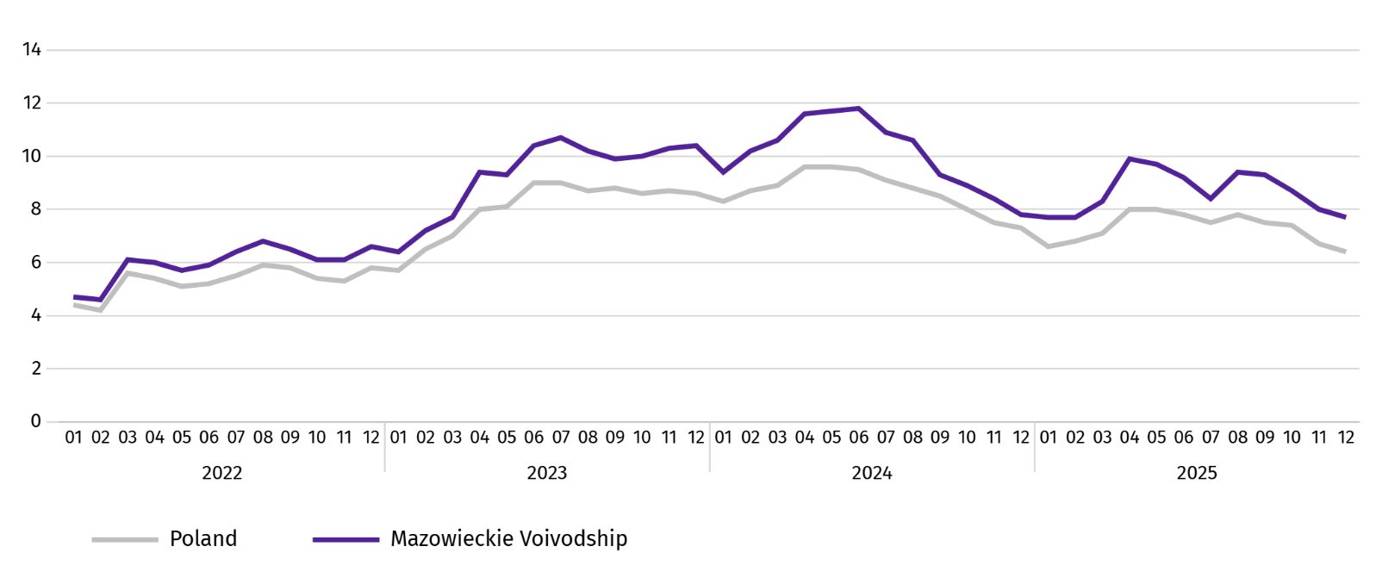
Chart 8. Ratio of the average procurement prices of pigs for slaughter to the average marketplace prices of rye
The procurement price of cattle for slaughter was lower by 0.2% than a month ago and hgher by 25.6% than a year ago.
In December 2025, suppliers were paid an average of PLN 5.59 per 1 kg of poultry for slaughter, i.e. 3.8% less than in November 2025 and 3.0% more than in December 2024.
Procurement prices of milk in December 2025 were by 7.5% lower than in the previous month and by 23.0% than in the previous year.

Industry and construction
Sold production of industry in December this year, reached the value (at current prices) of PLN 47,073.5 million and was (at constant prices) by 2.2% higher than a year before (compared to a 6.1% decrease in November 2025); as compared to the previous month it increased by 9.2%.
Sold production in manufacturing (constituting 85.7% of sold production of industry) compared to December 2024 increased (at constant prices) by 2.3%. However there was a decrease (by 2.9%) in sold production in the section of electricity, gas, steam and air conditioning supply (the share of this section represents 12.1% of industrial production).
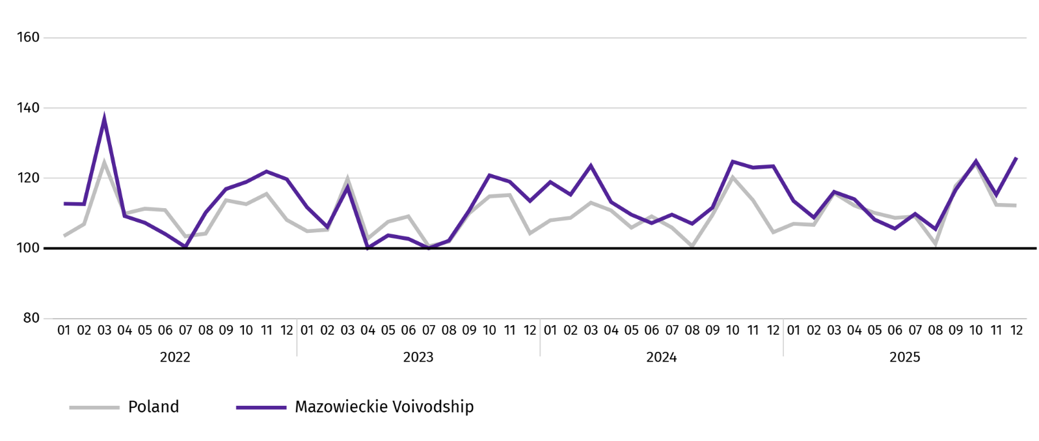
Chart 9. Sold production of industry (monthly average 2021=100; constant prices)
In December 2025, theinecrease in sold production in annual terms was recorded in 23 (out of 32 in the Voivodship) divisions of industry, among others, in: manufacture of beverages (by 35.4%), manufacture of machinery and equipment n.e.c. (by 31.1%), manufacture of other non-metallic mineral products (by 27.9%), manufacture of metal products (by 25.0%), rubber and plastic products (by 16.3%), food products (by 13.9%), computer, electronic and optical equipment (by 2.7%). However, there was a decrease in sold production of, among others, electrical equipment (by 20.5%), paper and paper products (by 3.6%), chemicals and chemical products (by 1.5%).
Table 8. Indices (constant prices) and structure (current prices) of sold production of industry in December 2025
SPECIFICATION | 12 2025 | 01–12 2025
SPECIFICATION | corresponding period of previous year=100 |  | In percent
TOTAL | 102,2 | 101,7 | 100,0
of which:
Manufacturing | 102,3 | 101,9 | 87,0
of which manufacture of:
food products | 113,9 | 106,1 | 22,4
beverages | 135,4 | 100,0 | 1,8
paper and paper products | 96,4 | 98,0 | 2,0
chemicals and chemical products | 98,5 | 101,8 | 4,0
manufacture of rubber and plastic products | 116,3 | 109,2 | 3,0
other non-metallic mineral products | 127,9 | 105,0 | 2,5
metal products ^{Δ} | 125,0 | 111,6 | 3,8
computer, electronic and optical equipment | 102,7 | 99,2 | 5,2
electrical equipment | 79,5 | 102,4 | 4,3
machinery and equipment n.e.c. | 131,1 | 108,6 | 2,0
Electricity, gas, steam and air conditioning supply ^{Δ} | 97,1 | 98,2 | 10,5
Labour productivity in industry measured by sold production per employed person, in December 2025 amounted (at current prices) to PLN 118.7 thousand and was (at constant prices) by 0.5% higher than a year before, with an increase in average paid employment by 1.7% and average monthly gross wages and salaries by 11.4%.
Sold production of industry in January–December 2025, reached the value of PLN 530,075.8 million (at current prices) and was by 1.7% higher than in the corresponding period of 2024.
Sold production of construction (at current prices) in December 2025, reached the value of PLN 14,077.9 million and was by 6.7% higher than in the previous year (compared to a 17.9% increase in November 2025). In January-December 2025, sold production of construction amounted to PLN 128,594.4 million and was by 6.7% higher compared to the corresponding period of 2024.
Labour productivity in construction, measured by revenue from the sale of goods and services per employed person in December 2025 amounted to PLN 148.5 thousand (at current prices) and was by 4.8% higher compared to the corresponding month of the previous year, with an increase in average employment in construction by 1.8% and in average monthly gross wages and salaries by 4.3%.
Construction and assembly production (at current prices) in December 2025, amounted to PLN 4,340.2 million and was by 11.0% higher than a year before (as compared to 3.7% increase in November 2025). The increase in production was recorded in entities whose basic activity is the construction of buildings (by 36.9%) and in enterprises mainly performing specialised construction activities (by 24.0%). The decrease was recorded in units specialising in civil engineering (by 1.6%). In January-December 2025, construction and assembly production was PLN 34,562.3 million and was 15.5% higher compared to the corresponding period of 2024.
Table 9. Indices and structure (current prices) of construction and assembly production December 2025
SPECIFICATION | 12 2025 | 01–12 2025
SPECIFICATION | corresponding period of previous year=100 |  | In percent
TOTAL | 111,0 | 115,5 | 100,0
Construction of buildings ^{Δ} | 136,9 | 150,8 | 28,0
Civil engineering | 98,4 | 96,3 | 47,6
Specialised construction activities | 124,0 | 131,3 | 24,4

Residential construction
In December 2025, the number of dwellings completed increased by 22.4% compared to the corresponding month in 2024. The number of dwellings for which permits have been granted or which have been registered with a construction project increased by 18.2%, and dwellings in which construction has begun by 12.7%.
According to preliminary data in December 2025, there were 5868 dwellings completed, i.e. by 1075 more (by 22.4%) than in the previous year and by 1966 (by 50.4%) than in the previous month. There were 4487 dwellings built for sale or rent (76.5% of their total number), followed by private dwellings 1011 (17.2%). Compared to December 2024, there were more dwellings for sale or rent by 17.5%, and private dwellings by 10.5%.
The effects of housing construction obtained in Mazowieckie Voivodship in the surveyed month constituted 23.8% of national effects.
Table 10. Number of dwellings completed in January-December 2025
SPECIFICATION | Dwellings completed |  |  | Average useful floor area of a dwelling in m²
SPECIFICATION | In absolute numbers | in percent | 01–12 2024=100 | Average useful floor area of a dwelling in m²
Private | 45227 | 100,0 | 117,4 | 82,1
Cooperative | 10102 | 22,3 | 100,2 | 145,9
For sale or rent | 607 | 1,3 | 333,5 | 52,4
Municipal | 33741 | 74,6 | 121,8 | 64,3
Public building society | 338 | 0,7 | 84,7 | 42,4
Private | 379 | 0,8 | 261,4 | 50,4
Company | 60 | 0,1 | 60 razy | 67,4

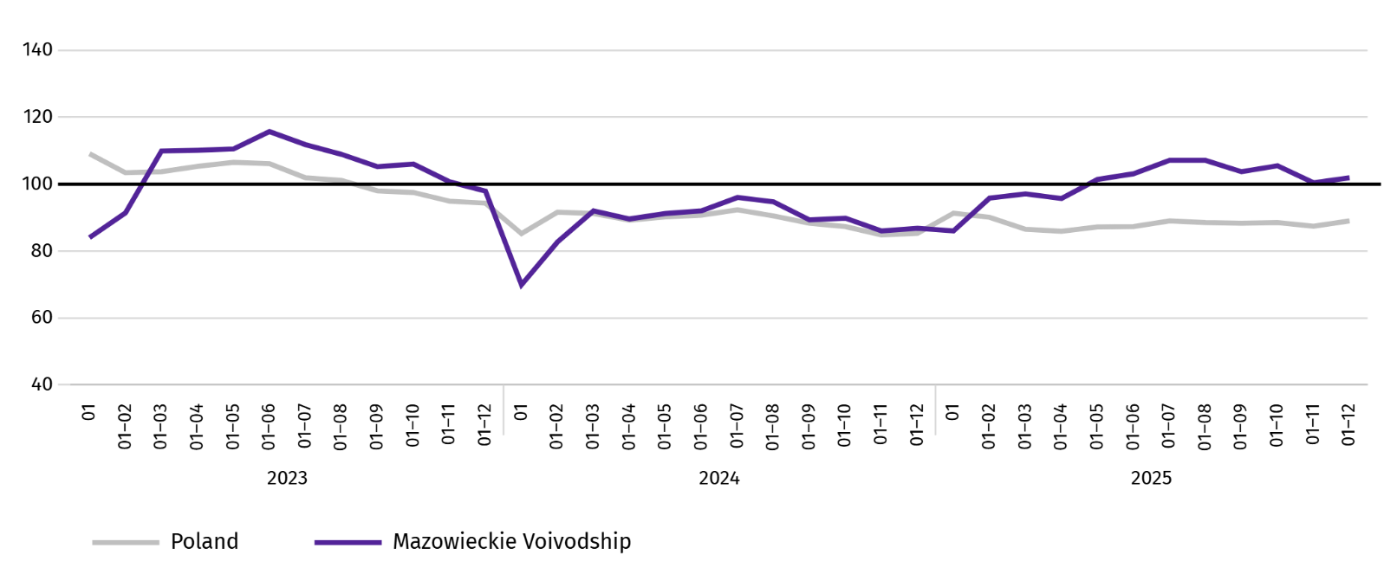
Chart 10. Dwellings completed (corresponding period 2021=100)

In the period January–December 2025, most dwellings were completed in Warszawa (20038), and then in piaseczyński (3327), and wołomiński (2884) powiats, and the least in lipski (51), lipski (45), makowski (68) and szydłowiecki (96).
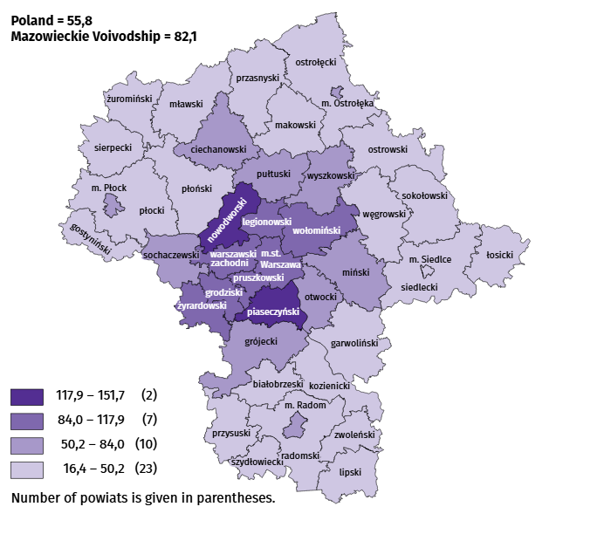
Map 2. Dwellings completed per 10 thousand populationª by powiats in January-December 2025

a Population as of 30 June 2025.
The average useful floor area of dwellings completed in December 2025 amounted to 76.2 m² and was smaller than a year earlier by 0.9 m2 than a year earlier. The largest dwellings were completed in sokołowski powiat (165.3 m²), siedlecki (162.3 m²) and wyszkowski powiat (160.2 m²). The smallest were built in Płock (47.1 m²), and żyrardowski (52.9 m²) and łosicki powiat (53.5 m²).
In December 2025, the number of dwellings for which permits have been granted or which have been registered with a construction project amounted to 7349, i.e. larger by 1131 (by 18.2%) than a year earlier and by 3105 (by 73.2%) than in the previous month. Of the total number of dwellings, 82.1% were dwellings for sale or rent, and 16.7% private.
In the surveyed month, the construction began in 2871 dwellings, which means an increase by 324 (by 12.7%) in annual terms and by 60 (by 2.0%) in monthly terms. Dwellings for sale or rent accounted for 75.5% of their total number, and private 24.5%.
Table 11. Number of dwellings for which permits have been granted or which have been registered with a construction project as well as dwelling in which construction has begun January–December 2025
SPECIFICATION | Dwellings for which permits have been granted or which have been registered with a construction project |  |  | Dwellings in which construction has begun
SPECIFICATION | in absolute numbers | in percent | 01–12 2024=100 | in absolute numbers | in percent | 01–12 2024=100
TOTAL | 52588 | 100,0 | 88,5 | 44139 | 100,0 | 97,7
Private | 14148 | 26,9 | 115,3 | 12056 | 27,3 | 102,2
Cooperative | 30 | 0,1 | 22,6 | – | – | .
For sale or rent | 38018 | 72,3 | 82,1 | 32006 | 72,5 | 97,1
Municipal | 112 | 0,2 | 72,3 | – | – | .
Public building society | 280 | 0,5 | 49,6 | 77 | 0,2 | 35,6

Internal market
In December 2025, both retail and wholesale sales were higher than in the previous year.
Retail sales (at current prices) in trade and non-trade enterprises in December 2025, increased by 3.7% compared to the year before. The largest increase in sales was recorded in units from the group: “newspapers, books, other sales in specialised stores” (by 23.8%), followed by „others” (by 15.0%), “pharmaceuticals, cosmetics, orthopedic equipment” (by 11.7%), “furniture, electronics and household appliances” (by 5.8%), “other retail sales in non-specialised stores” (by 5.3%), “food, beverages and tobacco” (by 4.3%), “motor vehicles, motorcycles, parts” (by 1.3%), “textiles, clothing and footwear” (by 1.2%).
Compared to November 2025, retail sales increased by 17.2%. The largest increase in retail sales was recorded in the following groups: “newspapers, books, other sales in specialised stores” (by 52.9%), “food, beverages and tobacco” (by 36.4%), „pharmaceuticals, cosmetics, orthopedic equipment” (by 31.8%), followed by “textiles, clothing and footwear” (by 18.8%), “others” (by 17.4%), “other retail sales in non-specialised stores” (by 14.6%), “motor vehicles, motorcycles, parts” (by 11.7%), “furniture, electronics and household appliances” (by 10.7%). No decrease in sales was recorded in any group.
Table 12. Indices and structure (at current prices) of retail sales in December 2025
SPECIFICATION | 12 2025 | 01–12 2025
SPECIFICATION | corresponding period of previous year=100 |  | in percent
TOTAL ª | 103,7 | 99,9 | 100,0
of which:
Motor vehicles, motorcycles, parts | 101,3 | 96,9 | 6,9
Food, beverages and tobacco | 104,3 | 102,2 | 14,5
Other retail sales in non-specialised stores | 105,3 | 114,9 | 3,7
Pharmaceuticals, cosmetics and orthopedic equipment | 111,7 | 100,9 | 5,0
Textiles, clothing and footwear | 101,2 | 97,5 | 5,9
a The grouping of enterprises was made on the basis of the Polish Classification of Activities - PKD 2007, including the enterprise to a specific category according to the type of predominant activity, in accordance with the organizational status in the period under consideration. The recorded changes (increase/decrease) in retail sales in particular groups of activity of enterprises may also result from changes in the type of predominant economic activity and organisational changes (e.g. mergers of enterprises). This does not affect the dynamics of retail sales in general.
Table 12. Indices and structure (at current prices) of retail sales in December 2025 (cont.)
SPECIFICATION | 12 2025 | 01–12 2025
SPECIFICATION | corresponding period of previous year=100 |  | in percent
Furniture, electronics and household appliances | 105,8 | 102,0 | 17,8
Press, books and other sales in specialised stores | 123,8 | 118,7 | 7,5
Other | 115,0 | 106,3 | 9,5
In the period January-December 2025, retail sales decreased by 0.1% year-on-year. The decrease in sales was recorded by enterprises from the group “motor vehicles, motorcycles, parts” (by 3.1%), “textiles, clothing and footwear” (by 2.5%). While the increase in sales recorded enterprises from the group "press, books, other sales in specialised stores" (by 18.7%), “other retail sales in non-specialised stores” (by 14.9%), “others” (by 6.3%), “food, beverages and tobacco” (by 2.2%), “furtniture, electronics and household appliances” (by 2.0%), „pharmaceuticals, cosmetics, orthopedic equipment” (by 0.9%).
Wholesale (at current prices) in trade enterprises in December 2025 was by 4.1% higher as compared to the previous month and by 0.2% higher compared to December 2024. In wholesale enterprises it was higher by 4.8% and 2.2%, respectively.
In January-December 2025, wholesale in trade enterprises was 4.1% higher than in the previous year, and in wholesale enterprises lower by 5.4%.

Entities of the national economy
In December 2025, the number of entities of the national economy registered in the REGON register increased by 0.2% compared to the previous month. There were more entities removed from the REGON register by 50.4% and entities with suspended activity by 0.8%. While the number of newly registered entities decreased by 1.6%.
As of the end of December 2025, the number of entities of the national economy registered in the REGON register amounted to 1089830, which means an increase of 3.5% year-on-year and 0.2% compared to the previous month.
In the total number of registered entities, the greatest number is natural persons conducting economic activity. At the end of December 2025, there were 702202 of them, i.e. more by 3.5% than in the previous year. The number of companies which were registered in the REGON register amounted to 306899, including 247076 commercial companies (an annual increase by 3.7% and 4.7%, respectively). There were 59364 civil partnerships i.e. less 0.2% compared to the previous year.
According to the expected number of employed persons, entities that declared employment of up to 9 persons prevailed upon entry in the REGON register; they constituted 97.3% of all registered units. The share of entities with an estimated number of 10-49 employed persons was 2.1%, and of entities employing more than 49 persons – 0.5%. Over the year, the increase in the number of entities occurred among the smallest entities (up to 9 persons) – by 3.6%.
Compared to December 2024, the largest increase in the number of entities was recorded in the sections: professional, scientific and technical activities – more by 6990 units (in percentage terms, a 4.3% increase), administrative and support service activities by 6171 units (an increase of 12.2%), information and communication by 5395 units (5.4%).
Compared to November 2025, the largest percentage increase in the number of entities was recorded in the sections: electricity, gas, steam and air conditioning supply (by 1.0%), administrative and support service activities (by 0.6%), financial and insurance activities and human health and social work activities (by 0.4% each).

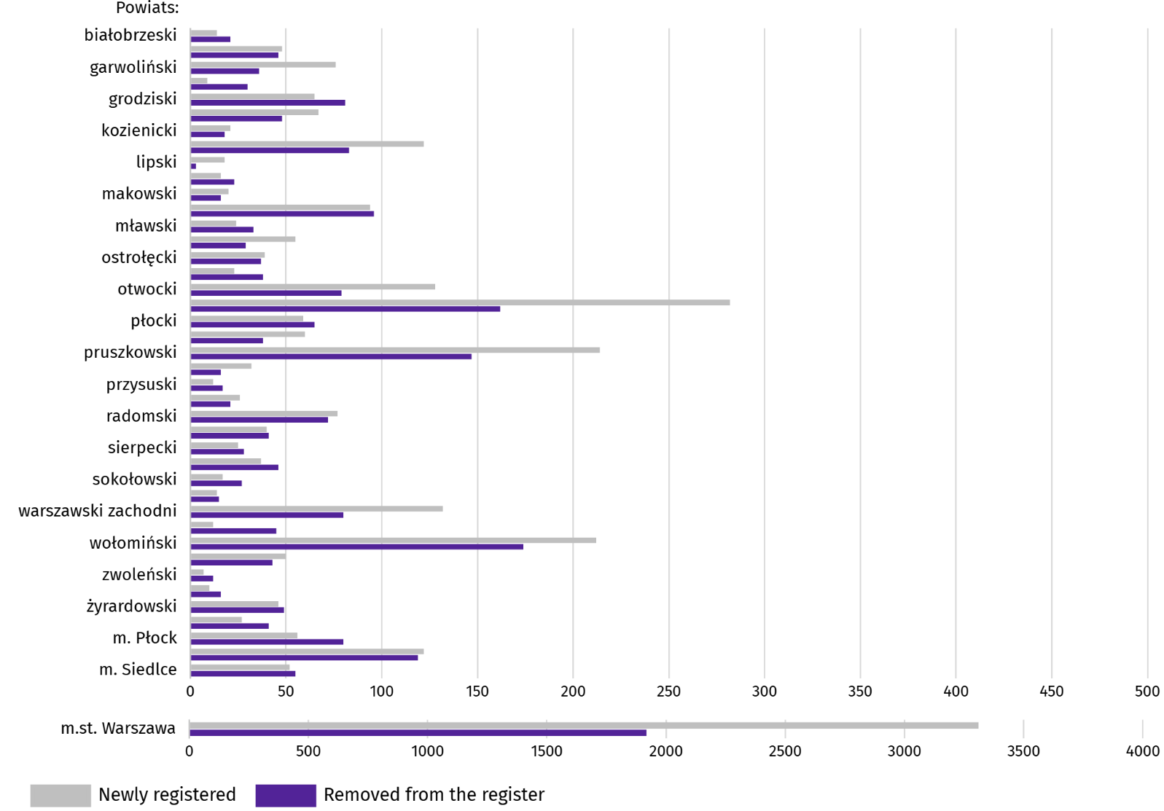
Chart 11. Entities of the national economy newly registered and removed from the register in December 2025

In December 2025, 5771 new entities were registered in the REGON register, i.e. by 1.6% less than in the previous month. The newly registered units were dominated by natural persons conducting economic activity, 3855 of whom were registered (by 7.0% less than in the previous month). The number of newly registered commercial companies was larger by 7.2%, including companies with limited liability by 7.5%.
In the surveyed month, 4044 entities were removed from the REGON register (by 50.4% more than a month ago), including 3381 natural persons conducting economic activity (by 61.7% more).
As of the end of December 2025, there were 148029 entities in the REGON with suspended activity (by 0.8% more than a month ago). The vast majority were natural persons conducting economic activity (94.1%, in the previous month).

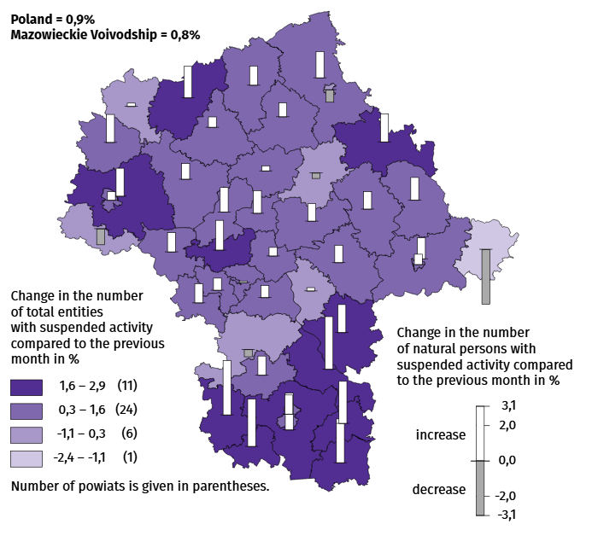
Map 3. Entities of the national economy with suspended activity in December 2025

Business tendency
In January of this year, the general business climate indicator in most of the surveyed economic sectors signaled stabilisation or improvement in the economic climate compared to the previous month. The largest increase in the indicator (by 6.2) was recorded in construction. Compared to December 2025, a noticeable deterioration in the economic climate occurred only in accommodation and catering, with the indicator decreasing by 3.2. Despite this, entities in this section assess the economic climate most favourably (plus 23.8), and the indicator value is above the long-term average (plus 0.6). However, only retail entities express pessimistic opinions (minus 0.9), with the indicator value below the long-term average (plus 0.5).

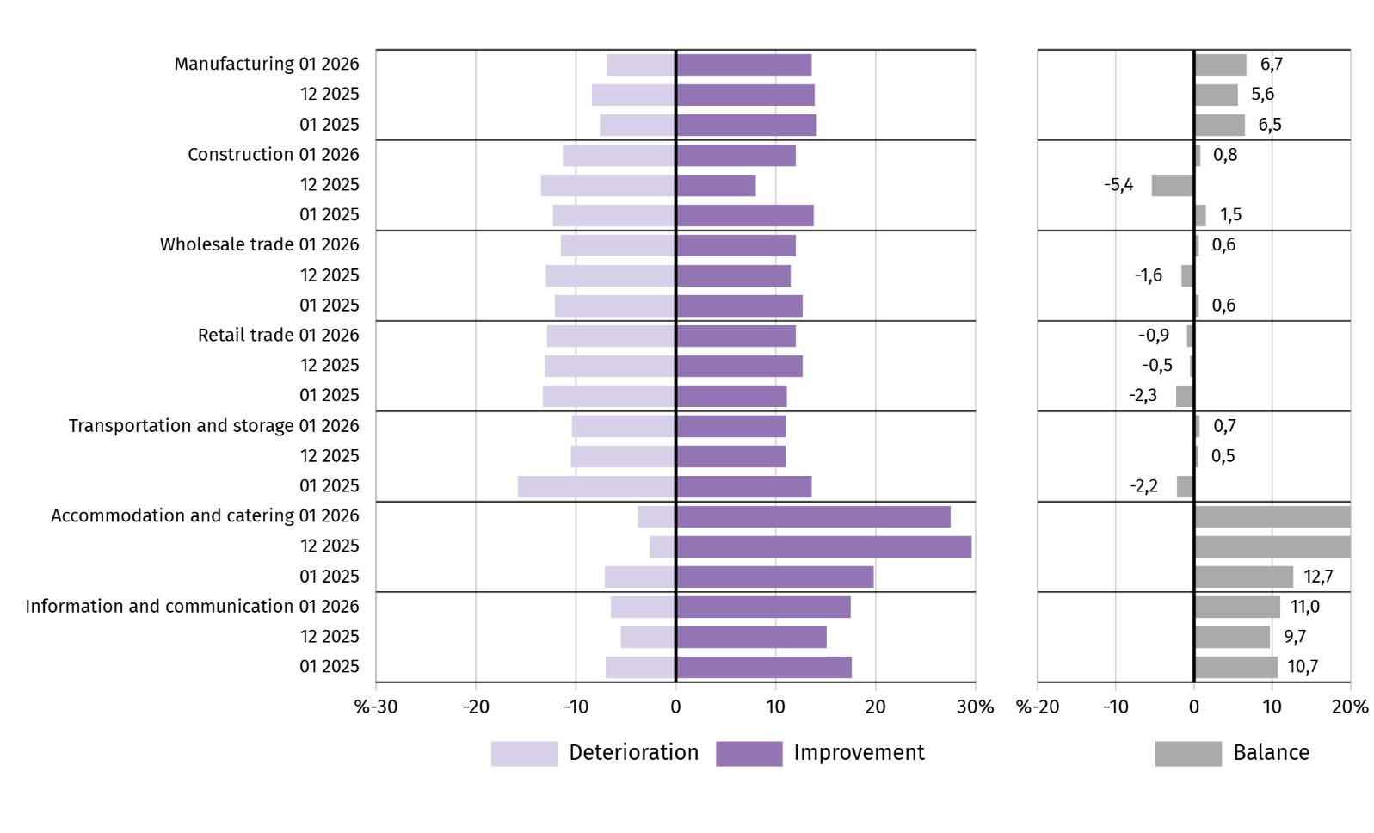
Chart 12. Indices of the general business climate by type of activity (sections and divisions of NACE Rev. 2)

Questions about the impact of the war in Ukraine
Question 1. The negative effects of the war in Ukraine and its consequences for the business activities of your company will be this month:
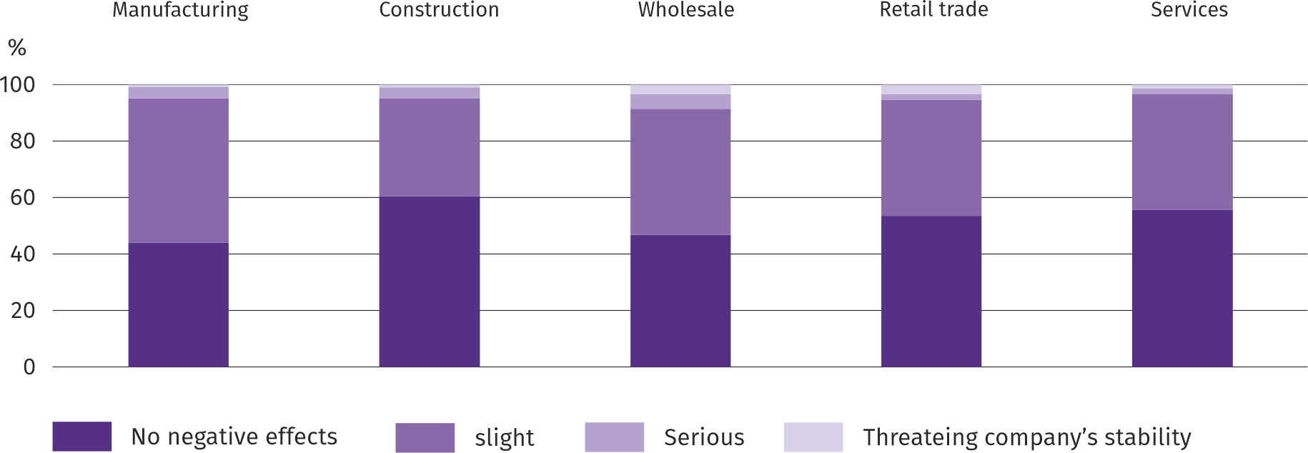
In all sectors of the economy surveyed, entrepreneurs dominated the survey, reporting that the ongoing war had caused no negative impact or posed only a minor threat to their businesses in January of this year. Entrepreneurs operating in wholesale trade were most likely to experience the war's serious effects, threatening the stability of their businesses, while those operating in services were least likely to experience them.
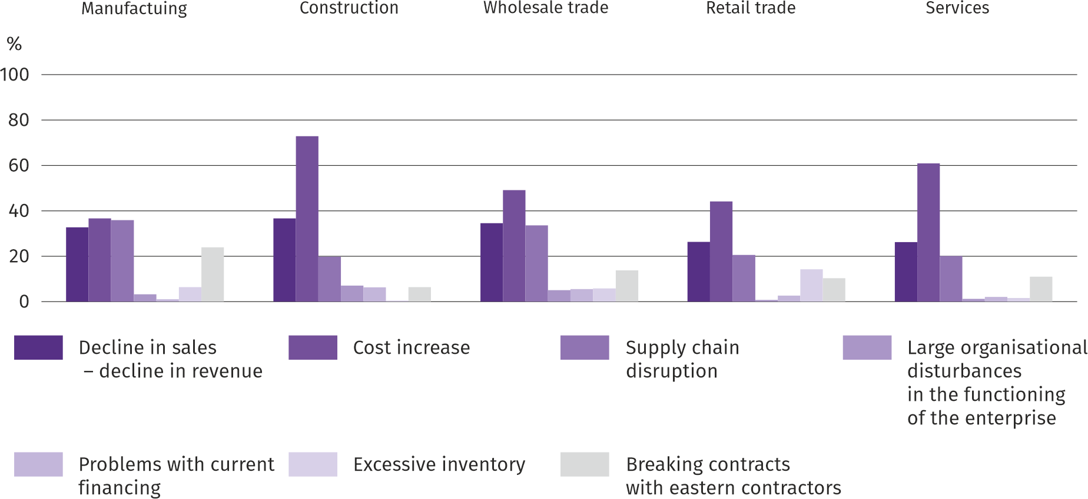
Question 2. Of the negative effects of the war in Ukraine observed last month, your companies are most concerned about:

Regardless of the type of economic activity, entrepreneurs considered the most significant negative effect of the war in Ukraine to be an increase in costs, followed by a decline in sales/revenue and disruptions in the supply chain.
Question 3. If your company employs employees from Ukraine, did you observe any changes last month due to the war in Ukraine?:
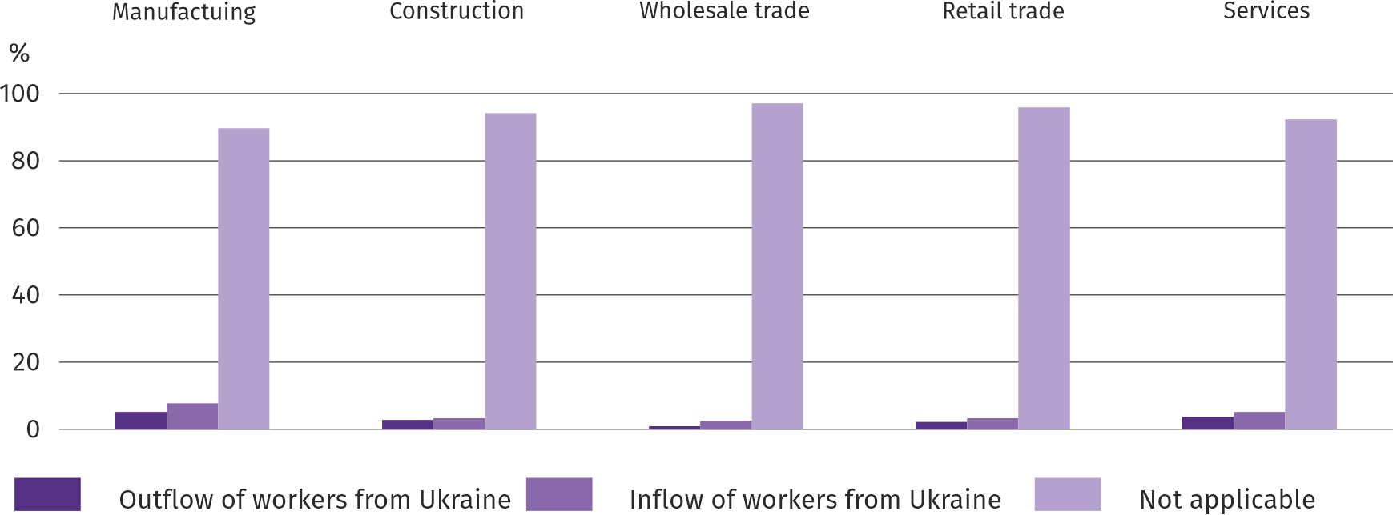
In January of this year, all surveyed types of economic activities saw an outflow and inflow of workers from Ukraine due to the ongoing war. Both outflow and inflow of workers were most frequently reported in manufacturing, and least frequently in wholesale. The vast majority of companies are not affected by this phenomenon.

Questions about pricing processes
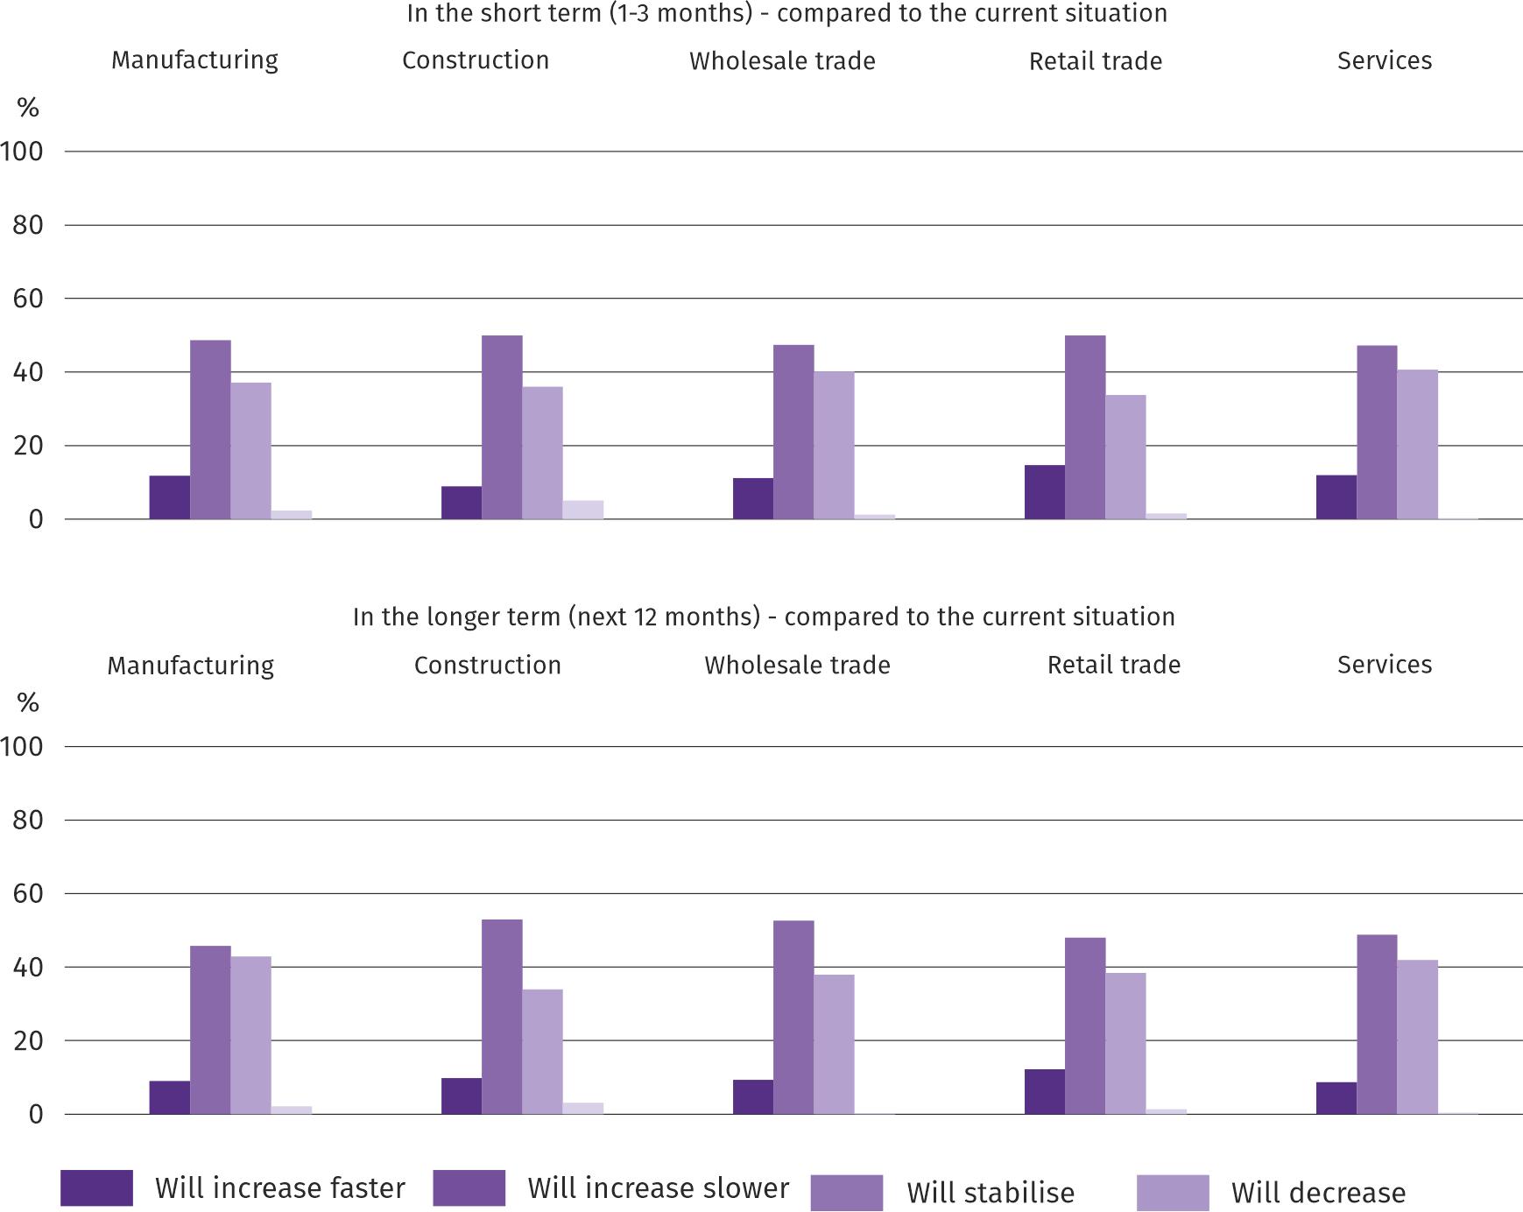
Question 4. In your opinion, what will be the prices of services/materials/raw materials used by your company as part of its business activities?:
Regardless of the type of economic activity, most entrepreneurs believed that price increases would be slower than currently observed in both the short term (1-3 months) and the long term (the next 12 months). Over a third of entrepreneurs expressed the opinion that prices would stabilise. The smallest percentage predicted price declines.

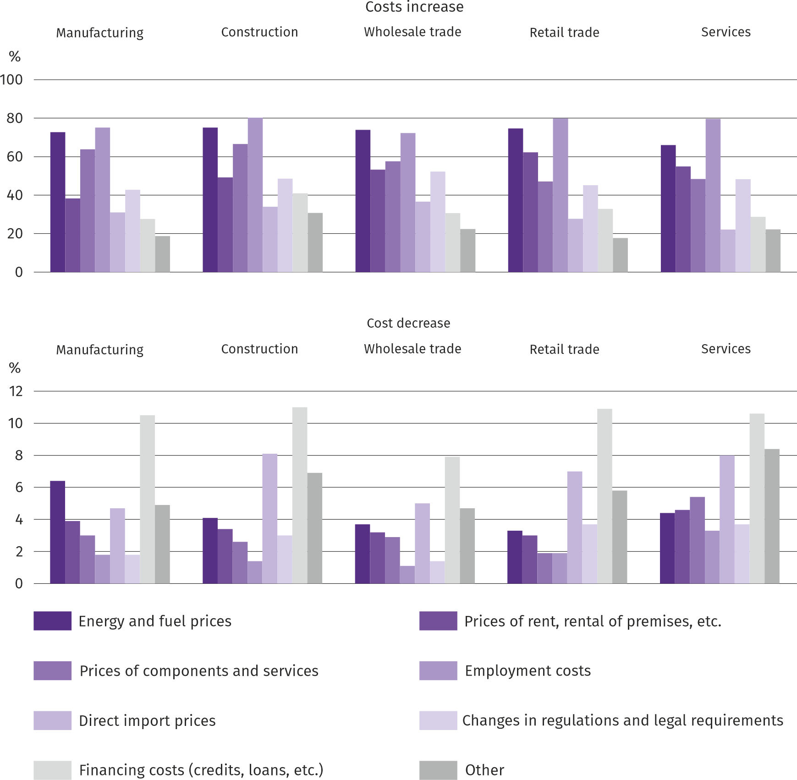
Question 5. Which of the following factors will have the greatest impact on the operating costs of your company in the next quarter:

Entrepreneurs across all surveyed economic activity types identified employment costs and energy and fuel prices as the factors with the greatest impact on the increase in company operating costs. Among these factors, direct import prices and financing costs (credits, loans, etc.) were considered the least significant. Among the factors with the greatest impact on cost reductions across all industries, financing costs (credits, loans, etc.) were most frequently cited. Employment costs were considered the factor with the least impact on the decrease in company operating costs.

Question 6. Will the observed and predicted changes in the financing conditions of the enterprise (costs of bank loans and their availability, trade credit, deferred payments, etc.) cause, in the next 12 months, in the case of:
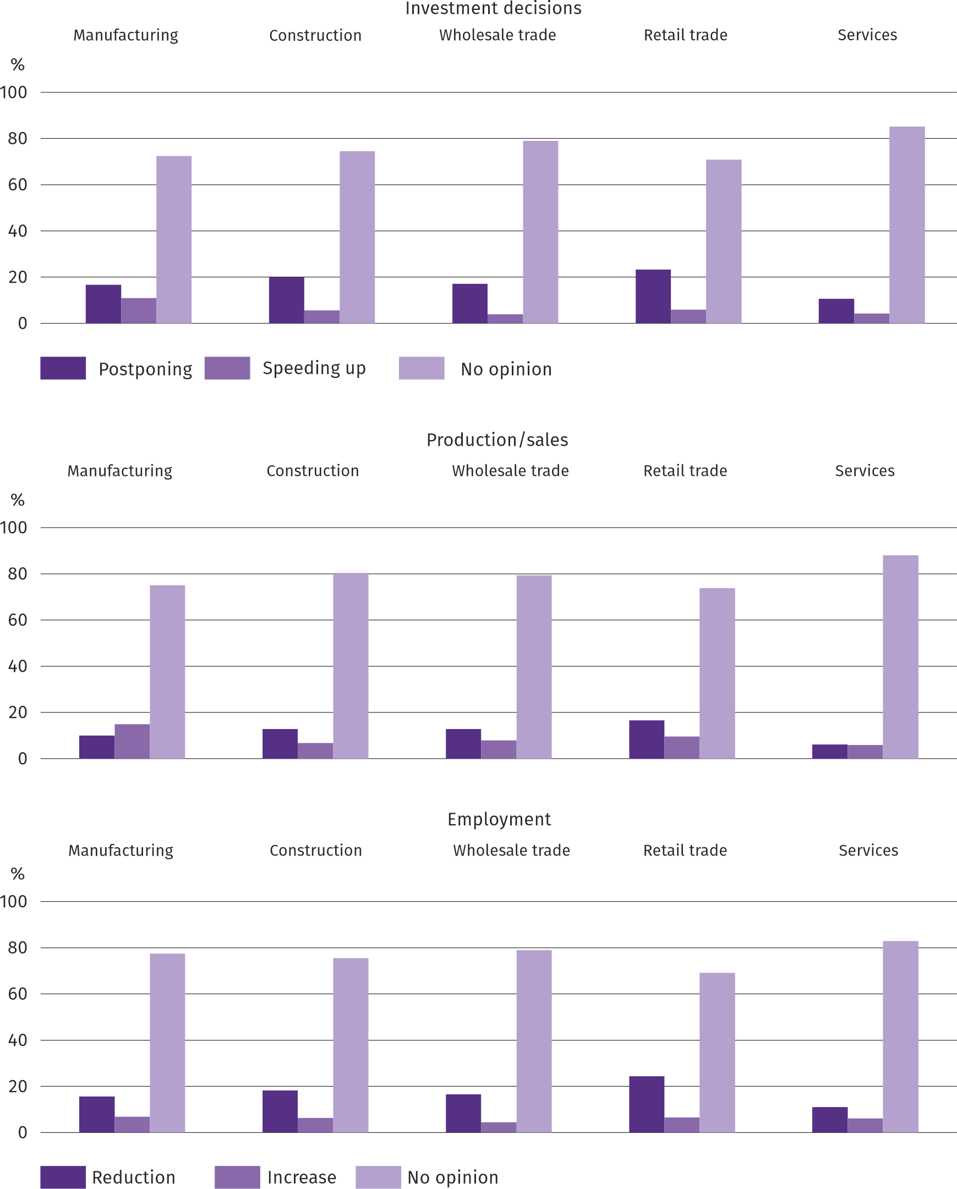
Responses to questions about how observed and anticipated changes in corporate financing conditions over the next 12 months will affect investment decisions, production/sales, and employment indicate that entrepreneurs found it difficult to assess this impact – the vast majority of respondents always expressed no opinion on the matter. Those who expressed an opinion on the matter were more likely to expect postponement of investments, reductions in production/sales, and employment than growth in these areas of activity.
More information on the results of the business climate survey can be found on the website of the Statistical Office in Zielona Góra https://zielonagora.stat.gov.pl/osrodki/osrodek-badan-koniunktury/obk-dane/.

Table 13. Selected data on Mazowieckie Voivodship
SPECIFICATION  A – 2024  B – 2025 |  | 01 | 02 | 03 | 04 | 05 | 06 | 07 | 08 | 09 | 10 | 11 | 12
Average employment in the enterprise sector ª  (in thousand persons) | A | 1607,0 | 1601,8 | 1598,1 | 1594,4 | 1591,7 | 1588,1 | 1589,5 | 1586,0 | 1584,4 | 1580,1 | 1582,0 | 1583,9
 | B | 1582,5 | 1577,9 | 1572,7 | 1574,8 | 1570,6 | 1572,8 | 1574,1 | 1572,8 | 1571,5 | 1567,2 | 1570,8 | 1575,1
previous month=100 | A | 100,7 | 99,7 | 99,8 | 99,8 | 99,8 | 99,8 | 100,1 | 99,8 | 99,9 | 99,7 | 100,1 | 100,1
previous month=100 | B | 99,9 | 99,7 | 99,7 | 100,1 | 99,7 | 100,1 | 100,1 | 99,9 | 99,9 | 99,7 | 100,2 | 100,3
corresponding period of previous year=100 | A | 100,7 | 100,8 | 100,8 | 100,3 | 100,3 | 100,1 | 100,3 | 100,0 | 99,8 | 99,5 | 99,4 | 99,3
corresponding period of previous year=100 | B | 98,5 | 98,5 | 98,4 | 98,8 | 98,7 | 99,0 | 99,0 | 99,2 | 99,2 | 99,2 | 99,3 | 99,4
Registered unemployed persons (in thousand persons; as of end of period) | A | 117,1 | 117,7 | 114,8 | 111,9 | 110,0 | 108,5 | 109,9 | 110,6 | 109,6 | 108,3 | 108,4 | 109,0
 | B | 114,7 | 115,9 | 113,9 | 111,3 | 108,7 | 111,0 | 116,0 | 120,2 | 119,6 | 118,7 | 118,1 | 118,2
Unemployment rate ^{b} (in %; as of end of period) | A | 4,3 | 4,3 | 4,2 | 4,1 | 4,1 | 4,0 | 4,1 | 4,1 | 4,0 | 4,0 | 4,0 | 4,0
Unemployment rate ^{b} (in %; as of end of period) | B | 4,2 | 4,2 | 4,2 | 4,1 | 4,0 | 4,0* | 4,2* | 4,4 | 4,4 | 4,3* | 4,3 | 4,3
Job offers ^{c} (submitted during a month) | A | 17944 | 17639 | 14928 | 16475 | 16584 | 17271 | 17764 | 12910 | 13202 | 16551 | 13455 | 10874
Job offers ^{c} (submitted during a month) | B | 15760 | 13938 | 14768 | 13164 | 11459 | 4235 | 5656 | 4432 | 5028 | 4975 | 3612 | 2876
Unemployed persons per 1 job offer ^{c} (as of end of period) | A | 14 | 16 | 19 | 15 | 12 | 12 | 13 | 16 | 14 | 14 | 14 | 23
 | B | 16 | 17 | 15 | 16 | 21 | 28 | 24 | 30 | 29 | 27 | 30 | 42
Average monthly gross wages and salaries in the enterprise sector ª (in PLN) | A | 8943,42 | 9165,69 | 9949,91 | 9568,24 | 9156,63 | 9296,77 | 9459,07 | 9445,98 | 9239,16 | 9629,96 | 9480,33 | 9931,44
 | B | 9739,87 | 10004,89 | 10785,77 | 10612,28 | 9995,20 | 10173,45 | 10185,77 | 10100,98 | 9974,07 | 10141,45 | 10285,58 | 10933,28
previous month=100 | A | 99,0 | 102,5 | 108,6 | 96,2 | 95,7 | 101,5 | 101,7 | 99,9 | 97,8 | 104,2 | 98,4 | 104,8
previous month=100 | B | 98,1 | 102,7 | 107,8 | 98,4 | 94,2 | 101,8 | 100,1 | 99,2 | 98,7 | 101,7 | 101,4 | 106,3
corresponding period of previous year=100 | A | 112,4 | 112,3 | 112,3 | 110,5 | 111,1 | 109,7 | 111,2 | 111,6 | 110,3 | 110,5 | 110,4 | 110,0
corresponding period of previous year=100 | B | 108,9 | 109,2 | 108,4 | 110,9 | 109,2 | 109,4 | 107,7 | 106,9 | 108,0 | 105,3 | 108,5 | 110,1
Price indices:
consumer goods and services ^{d}:
corresponding period of previous year=100 | A | . | . | 103,4 | . | . | 102,6 | . | . | 104,4 | . | . | 104,7
corresponding period of previous year=100 | B | . | . | 104,7 | . | . | 103,7 | . | . | 102,6 | . | . | .
a In enterprises employing more than 9 persons. b Share of registered unemployed persons in civilian economically active population, estimated at the end of each month. C Since 1 June 2025, data on job offers are not fully comparable with earlier periods due to methodological changes resulting from the entry into force of the Act on theLlabour Market and Employment Services (Journal of Laws of 2025, item 620). d In the quarter.
Table 13. Selected data on Mazowieckie Voivodship (cont.)
SPECIFICATION  A – 2024  B – 2025 |  | 01 | 02 | 03 | 04 | 05 | 06 | 07 | 08 | 09 | 10 | 11 | 12
Price indices (cont.):
Procurement of cereal grain:
previous month=100 | A | 106,0 | 97,7 | 92,9 | 94,5 | 106,7 | 119,5 | 82,0 | 107,3 | 100,4 | 105,7 | 104,7 | 97,5
previous month=100 | B | 102,5 | 100,3 | 98,5 | 102,4 | 98,1 | 97,1 | 94,2 | 93,1 | 99,4 | 97,5 | 100,0 | 101,6
corresponding month of previous year=100 | A | 65,8 | 66,0 | 68,4 | 70,6 | 83,3 | 105,9 | 88,3 | 96,9 | 96,1 | 99,5 | 107,1 | 110,3
corresponding month of previous year=100 | B | 106,6 | 109,4 | 116,0 | 125,8 | 115,7 | 94,0 | 108,0 | 93,8 | 92,9 | 85,7 | 81,9 | 85,4
procurement of cattle for slaughter (excluding calves):
previous month=100 | A | 104,4 | 99,6 | 98,6 | 110,6 | 101,6 | 103,0 | 98,6 | 100,4 | 100,0 | 104,8 | 117,3 | 102,5
previous month=100 | B | 101,0 | 102,0 | 112,7 | 95,6 | 103,1 | 89,8 | 100,6 | 90,3 | 134,0 | 97,0 | 103,7 | 99,8
corresponding month of previous year=100 | A | 93,9 | 94,2 | 94,8 | 108,2 | 90,6 | 137,3 | 118,8 | 103,6 | 117,7 | 120,3 | 143,7 | 148,0
corresponding month of previous year=100 | B | 143,3 | 146,7 | 167,6 | 144,9 | 147,2 | 128,3 | 130,9 | 117,7 | 157,8 | 146,1 | 129,1 | 125,6
procurement of pigs for slaughter:
previous month=100 | A | 94,5 | 101,2 | 103,9 | 102,4 | 101,0 | 101,6 | 95,0 | 96,2 | 100,1 | 95,9 | 93,4 | 99,2
previous month=100 | B | 90,7 | 102,7 | 107,4 | 113,0 | 102,6 | 96,4 | 94,3 | 101,8 | 96,9 | 94,0 | 89,8 | 94,5
corresponding month of previous year=100 | A | 91,9 | 84,4 | 86,0 | 81,1 | 83,9 | 81,3 | 77,8 | 84,2 | 84,2 | 85,3 | 81,0 | 84,8
corresponding month of previous year=100 | B | 81,4 | 82,6 | 85,4 | 94,3 | 95,8 | 90,9 | 90,2 | 95,5 | 92,4 | 90,6 | 87,1 | 83,0
Ratio of procurement prices ª of pigs for slaughter to marketplace prices of rye | A | 9,4 | 10,2 | 10,6 | 11,6 | 11,7 | 11,8 | 10,9 | 10,6 | 9,3 | 8,9 | 8,4 | 7,8
 | B | 7,7 | 7,7 | 8,3 | 9,9 | 9,7 | 9,2 | 8,4 | 9,4 | 9,3 | 8,7 | 8,0 | 7,7
Sold production of industry ^{b} (at constant prices):
previous month=100 | A | 104,8 | 97,0 | 107,1 | 91,7 | 96,8 | 97,8 | 102,2 | 97,6 | 104,3 | 111,7 | 98,6 | 100,3
previous month=100 | B | 92,0 | 95,9 | 106,7 | 98,2 | 94,9 | 97,6 | 104,0 | 96,1 | 110,6 | 106,9 | 92,4* | 109,2
corresponding month of previous year=100 | A | 109,2 | 111,4 | 108,4 | 114,0 | 108,3 | 108,0 | 113,1 | 107,1 | 103,3 | 105,6 | 104,4 | 108,7
corresponding month of previous year=100 | B | 95,4 | 94,3 | 93,9 | 100,6 | 98,6 | 98,4 | 100,2 | 98,6 | 104,6 | 100,2 | 93,9* | 102,2
Construction and assembly production b (at current prices):
previous month=100 | A | 34,4 | 123,4 | 111,9 | 125,7 | 101,6 | 107,2 | 98,7 | 95,1 | 113,8 | 103,6 | 102,1 | 140,0
previous month=100 | B | 47,2 | 107,8 | 118,8 | 106,2 | 100,8 | 106,8 | 104,8 | 89,5 | 116,9 | 104,2 | 93,7 | 149,9
corresponding month of previous year=100 | A | 95,7 | 107,3 | 88,7 | 117,5 | 109,0 | 106,0 | 117,3 | 98,9 | 98,8 | 112,0 | 101,3 | 103,0
corresponding month of previous year=100 | B | 141,1 | 123,2 | 130,9 | 110,6 | 109,7 | 109,3 | 116,1 | 109,4 | 112,4 | 113,0 | 103,7 | 111,0
a Current prices excluding VAT. b In enterprises employing more than 9 persons.

Table 13. Selected data on Mazowieckie Voivodship (cont.)
SPECIFICATION  A – 2024  B – 2025 |  | 01 | 02 | 03 | 04 | 05 | 06 | 07 | 08 | 09 | 10 | 11 | 12
Dwellings completed (from the beginning of the year) | A | 2723 | 5939 | 9232 | 11738 | 14595 | 17553 | 21339 | 24190 | 26662 | 30180 | 33728 | 38521
Dwellings completed (from the beginning of the year) | B | 3349 | 6885 | 9739 | 12532 | 16228 | 19683 | 23803 | 27368 | 30948 | 35457 | 39359 | 45227
corresponding month of previous year=100 | A | 83,2 | 90,5 | 83,7 | 81,4 | 82,6 | 79,5 | 85,9 | 86,9 | 84,9 | 84,7 | 85,4 | 88,6
corresponding month of previous year=100 | B | 123,0 | 115,9 | 105,5 | 106,8 | 111,2 | 112,1 | 111,5 | 113,1 | 116,1 | 117,5 | 116,7 | 117,4
Retail sales of goods ª (at current prices):
previous month=100 | A | 75,5 | 100,0 | 112,7 | 101,6 | 99,0 | 99,3 | 105,6 | 98,9 | 91,9 | 106,4 | 101,2 | 111,9
previous month=100 | B | 78,0 | 94,8 | 113,7 | 104,7 | 97,6 | 98,8 | 104,6 | 98,9 | 95,6 | 105,7 | 99,6 | 117,2
corresponding month of previous year=100 | A | 100,3 | 103,6 | 101,9 | 103,4 | 105,1 | 102,7 | 105,9 | 99,1 | 93,0 | 94,3 | 97,2 | 98,4
corresponding month of previous year=100 | B | 101,6 | 96,3 | 97,2 | 100,1 | 98,7 | 98,2 | 97,3 | 97,3 | 101,3 | 100,6 | 99,0 | 103,7
Turnover profitability indicator in enterprises ^{b}:
gross ^{c} (in %) | A | . | . | 4,0 | . | . | 4,4 | . | . | 4,6 | . | . | 4,9
gross ^{c} (in %) | B | . | . | 4,6 | . | . | 4,9 | . | . | 4,9 | . | . | .
net ^{d} (in %) | A | . | . | 3,0 | . | . | 3,6 | . | . | 3,8 | . | . | 3,9
net ^{d} (in %) | B | . | . | 3,6 | . | . | 3,9 | . | . | 4,0 | . | . | .
Investment outlays of enterprises ^{b} – from the begin-ning of the year (in million PLN; current prices) | A | . | . | 13513,2 | . | . | 29901,6 | . | . | 48420,6 | . | . | 75782,3
 | B | . | . | 13471,2 | . | . | 31921,6 | . | . | 51529,6 | . | . | .
corresponding month of previous year=100 (current prices) | A | . | . | 97,0 | . | . | 95,7 | . | . | 92,6 | . | . | 93,7
corresponding month of previous year=100 (current prices) | B | . | . | 99,7 | . | . | 106,8 | . | . | 106,4 | . | . | .
Entities of the national economy ^{e} in the REGON regis-ter (as of end of period) | A | 1013945 | 1018833 | 1022367 | 1026106 | 1029355 | 1032369 | 1035867 | 1039428 | 1043211 | 1047123 | 1050447 | 1052760
 | B | 1055182 | 1057965 | 1061558 | 1064898 | 1068064 | 1071074 | 1074082 | 1077325 | 1080871 | 1084899 | 1088107 | 1089830
of which commercial companies | A | 224121 | 225458 | 226664 | 227868 | 228837 | 229562 | 230815 | 231886 | 232883 | 234115 | 234950 | 236043
of which commercial companies | B | 237041 | 237949 | 239071 | 240155 | 240700 | 241451 | 242422 | 243409 | 696939 | 245130 | 246088 | 247076
of which with foreign capital participation | A | 40492 | 40647 | 40808 | 41008 | 41245 | 41356 | 41550 | 41689 | 41873 | 42067 | 42226 | 42385
of which with foreign capital participation | B | 42461 | 42567 | 42726 | 42857 | 42903 | 43009 | 43119 | 43266 | 43348 | 43446 | 43570 | 43665
a In enterprises employing more than 9 persons. b In enterprises employing more than 49 persons. c Relation of gross financial result to revenues from total activity. d Relation of net financial result to revenues from total activity. e Excluding persons tending private farms in agriculture.
Prepared by:  Statistical Office in Warszawa  Director Agnieszka Ajdyn  Phone: (+48 22) 464 23 15 | Issued by:  Statistical Information Centre  Phone: (+48) 783 940 141  e-mail: m.kaluski@stat.gov.pl

www.warszawa.stat.gov.pl/en/

@WARSZAWA_STAT

@UrzadStatystycznywWarszawie

gus_stat

glownyurzadstatystycznygus

glownyurzadstatystyczny

In the case of quoting data from the Statistics Poland, please provide information “Statistics Poland data source”, and in the case of publishing calculations made on data published by the Statistics Poland, provide information: “Own study based on Statistics Poland data”.
Related information
Statistical Bulletin of Mazowieckie Voivodship
Report on the socio-economic situation of Mazowieckie Voivodship 2025
Socio-economic situation of voivodships No. 3/2025
Data available in databases
Local Data Bank (BDL)
Knowledge Databases (DBW)
Terms used in official statistics
Average paid employment
Registered unemployed persons
Registered unemployment rate
Monthly gross wages and salaries
Retail prices
Price index of consumer goods and services
Procurement of agricultural products
Procurement prices
Marketplace prices
Pigs
Cattle
Sold production of industry
Construction and assembly production
Dwellings completed
Retail sales of goods (including VAT)
Wholesale (including VAT)
Financial results of enterprises
Investment outlays
Entities of the national economy
Business tendency

The long-term unemployed include persons remaining in the register of the powiat labour office for a total period of more than 12 months in the last 2 years, excluding periods of internship and vocational preparation.
Refers to vacancies and places of occupational activation.
The average values of temperature and precipitation were calculated as arithmetic averages of the average monthly values from five hydrological and meteorological stations of the Institute of Meteorology and Water Management located in Kozienice, Mława, Płock, Siedlce and Warszawa.
Applies to legal persons, organisational units without legal personality and natural persons conducting economic activity (excluding natural persons tending private farms in agriculture).
The survey was conducted from the 1st to the 10th of the current month on a sample of industrial, construction, commercial, and service entities. Responses to the entire additional block of questions are provided on a voluntary basis. All questions present a weighted percentage of respondents' responses to a given option. Data were aggregated according to the aggregation (weighting) methodology standardly used in economic climate surveys.
It was possible to select one answer for each variant ("outflow" and "inflow") at the same time, therefore the sum of the variants may exceed 100%. The answer "not applicable" was marked if the company did not employ employees from Ukraine or did not observe their "outflow" or "inflow" last month”.

