Socio-economic situation of Mazowieckie Voivodship in November 2025
- In November this year, the average employment in the enterprise sector decreased on a yearly basis by 0.7%, and on a monthly basis increased by 0.2%. The registered unemployment rate amounted to 4.3% and increased on an annual basis (by 0.3 pp), and decreased (by 0.1 pp) compared to the previous month.
- Average monthly gross wages and salaries in the enterprise sector in November this year were higher by 8.5% compared to the previous year and by 1.4% than in the previous month.
- Prices of consumer goods and services in the third quarter of 2025 increased by 2.6% year-on-year (compared to an increase of 3.7% in the second quarter of 2025).
- On the agricultural market in November 2025, the average procurement prices of cattle and poultry for slaughter were higher than in the previous year, while the prices of wheat, rye, potatoes and pigs for slaughter and milk were lower. On a monthly basis, more was paid for rye and cattle for slaughter, and less for wheat, potatoes, pigs and poultry for slaughter as well as milk.
- In November this year, sold production of industry (at constant prices) decreased on a yearly basis (by 6.5%), and on a monthly basis (by 8.0%). Construction and assembly production (at current prices) was higher by 3.7% than in the previous year and lower by 6.3% than a month earlier.
- The number of dwellings completed in November this year, was higher by 10.0% than a year before and lower by 13.5% compared to the previous month. Most dwellings were built for sale or rent.
- In November this year, there was an decrease in retail sales in annual terms (by 1.0%). Wholesale was lower than in the previous year (by 10.1%).
- In November this year, the number of entities of the national economy registered in the REGON register was higher by 3.6% than in the previous year and by 0.3% than in the previous month.
- In December of this year, only the information and communication section saw no change in the assessment of the economic climate compared to the previous month. The greatest improvement occurred in the accommodation and catering section (an increase in the general business climate indicator by 12.5 compared to November of this year). In retail trade, entrepreneurs' opinions remained at a similar level to last month. However, the largest decline (by 4.0) was recorded in wholesale trade. Accommodation and catering entities assess the economic climate most favourably (plus 27.0), and the indicator value is above the long-term average. Construction entities express the most pessimistic assessments (minus 5.4), and the indicator value is below the long-term average.

Contents
Labour market 4
Wages and salaries 7
Retail prices 9
Agriculture 10
Industry and construction 13
Residential construction 15
Internal market 17
Entities of the national economy 18
Business tendency 20
Selected data on Mazowieckie Voivodship 24

General notes
Data presented in the news release:
- on employment, wages and salaries and sold production of industry and construction, construction and assembly production, as well as retail sales and wholesale concern economic entities employing more than 9 persons,
- on enterprise sector refer to entities conducting economic activity in the field of: forestry and logging; maritime fishing; mining and quarrying; manufacturing; electricity, gas, steam and air conditioning supply; water supply; sewerage, waste management and remediation activities; construction; wholesale and retail trade; repair of motor vehicles and motorcycles; transportation and storage; accommodation and food service activities; information and communication; real estate activities; legal and accounting activities; activities of head offices; management consultancy activities; architectural and engineering activities; technical testing and analysis; advertising and market research; other professional, scientific and technical activities; arts, entertainment and recreation; repair of computers and personal and household goods; other personal service activities,
- on retail prices of foodstuffs and non-foodstuffs as well as services that originate from quotations of prices conducted by interviewers at selected points of sale in selected regions of price surveys; prices of food are collected once a month, with the exception of fruit and vegetables, for which prices are collected twice a month,
- on procurement of agricultural products include procurement from producers from the voivodship; prices are given excluding VAT tax,
- on financial results of enterprises and investment outlays refer to economic entities keeping accounting ledgers (excluding entities whose activity is classified according to the NACE Rev. 2 in the sections “Agriculture, forestry and fishing” and “Financial and insurance activities” as well as higher education institutions) in which the number of employed persons exceeds 49.
Data in value terms are provided at current prices and form the basis for calculating the structure indicators. Dynamic indices are provided on the basis of value at current prices, except for industry, for which the dynamic indices are provided on the basis of value at constant prices (average current prices of 2015).
Relative numbers (indices, percentages) were calculated on the basis of absolute data expressed with higher precision than that presented in the text and tables.
Data have been presented in accordance with the Polish Classification of Activities – PKD 2007 (NACE Rev. 2).

Polish Classification of Activities 2007 (PKD 2007)
Abbreviation | Full name
sections
trade; repair of motor vehicles | wholesale and retail trade; repair of motor vehicles and motorcycles
accommodation and catering | accommodation and food service activities
divisions
trade; repair of motor vehicles | wholesale and retail trade; repair of motor vehicles and motorcycles

Symbols
Symbol | Description
(–) | – magnitude zero
(.) | – data not available, classified data (statistical confidentiality) or providing data impossible or purposeless
(*) | – data revised
∆ | – categories of applied classification are presented in abbreviated form
„Of which” | – indicates that not all elements of the sum are given
Data describing Mazowieckie Voivodship can also be found in statistical publications issued by the Statistical Office in Warszawa and in the publications of Statistics Poland.
The report „Economic situation in Mazowieckie Voivodship in November 2025” was published on the home page of the Statistical Office in Warszawa:: https://warszawa.stat.gov.pl/ on 30 December 2025.
When publishing Statistical Office data, please indicate the source.

Labour market
In November this year, the average employment in the enterprise sector was lower compared to the previous year and slightly higher compared to the previous month. The registered unemployment rate increased year-on-year but decreased month-on-month.
Average employment in the enterprise sector in November this year amounted to 1,570.8 thousand persons (full-time equivalent) and was by 0.7% lower in annual terms (in the previous month by 0.8%). The most significant decrease was recorded in accommodation and catering (by 6.7%), and also in trade; repair of motor vehicles (by 5.1%), transportation and storage (by 2.6%) and administrative and support service activities (by 1.8%). The highest increase was recorded in real estate activities (by 10.9%), followed by, among others, professional, scientific and technical activities (by 6.8%), electricity, gas, steam and air conditioning supply (by 2.7%), and construction (by 1.7%).
In comparison with October this year, average employment increased by 0.2%. The most in administrative and support service activities (by 2.0%), and also, among others, in construction and electricity, gas, steam and air conditioning supply (by 0.6% each), and also in professional, scientific and technical activities (by 0.2%). The decrease was recorded only in information and communication (by 0.4%).
Table 1. Average employment in the enterprise sector in November 2025
SPECIFICATION | 11 2025 |  | 01–11 2025
SPECIFICATION | In thousands | 11 2024=100 | In thousands | 01–11 2024=100
TOTAL | 1570,8 | 99,3 | 1574,8 | 98,9
of which:
Industry | 396,1 | 101,4 | 400,6 | 101,8
of which:
manufacturing | 354,7 | 101,4 | 359,5 | 101,9
electricity, gas, steam and air conditioning supply | 20,5 | 102,7 | 20,4 | 102,6
Construction | 94,6 | 101,7 | 93,7 | 100,6
Trade; repair of motor vehicles ^{Δ} | 324,1 | 94,9 | 325,8 | 95,2
Transportation and storage | 260,4 | 97,4 | 262,4 | 95,9
Accommodation and catering ^{Δ} | 34,4 | 93,3 | 35,0 | 95,0
Information and communication | 136,8 | 100,4 | 137,6 | 100,8
Real estate activities | 28,9 | 110,9 | 28,9 | 110,5
Professional, scientific and technical activities ª | 116,8 | 106,8 | 115,8 | 103,7
Administrative and support service activities | 140,5 | 98,2 | 137,1 | 97,4
a Excluding divisions: Research and experimental development work and Veterinary activities.
In the period of January-November this year, average employment in the enterprise sector amounted to 1,574.8 thousand persons and decreased by 1.1% compared to the same period of 2024 (a year ago, an increase of 0.1% was recorded).
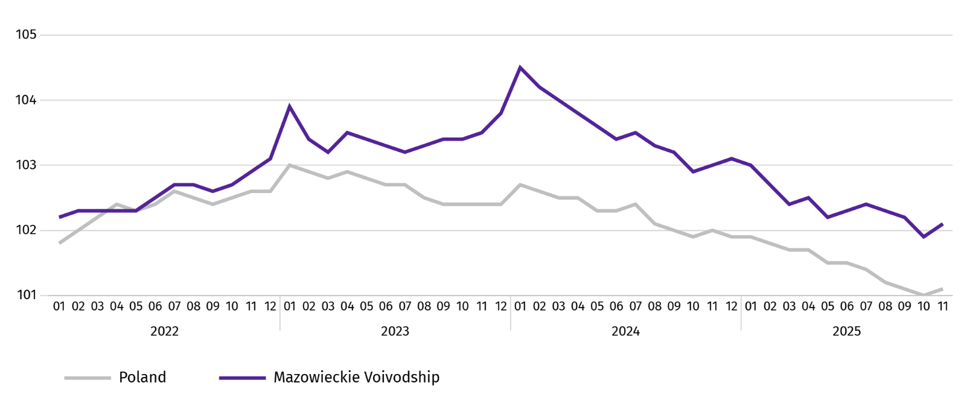
Chart 1. Average employment in the enterprise sector (monthly average 2021=100)

At the end of November this year, the number of unemployed persons registered in labour offices amounted to 118.1 thousand persons and increased on a yearly basis by 9.7 thousand persons (i.e. by 9.0%), and on a monthly basis decreased by 0.5 thousand persons (i.e. by 0.5%). Women accounted for 47.2% of total registered unemployed persons (a year before 48.8%).
Table 2. Number of unemployed persons and unemployment rate
SPECIFICATION | 2024 | 2025
SPECIFICATION | 11 | 10 | 11
Registered unemployed persons (as of end of month) in thousands | 108,4 | 118,7 | 118,1
Newly registered unemployed persons (during a month) in thousands | 12,0 | 13,9 | 11,3
Unemployed persons removed from unemployment rolls (during a month) in thousands | 11,9 | 14,8 | 11,9
Registered unemployment rate (as of end of month) in % | 4,0 | 4,4 | 4,3
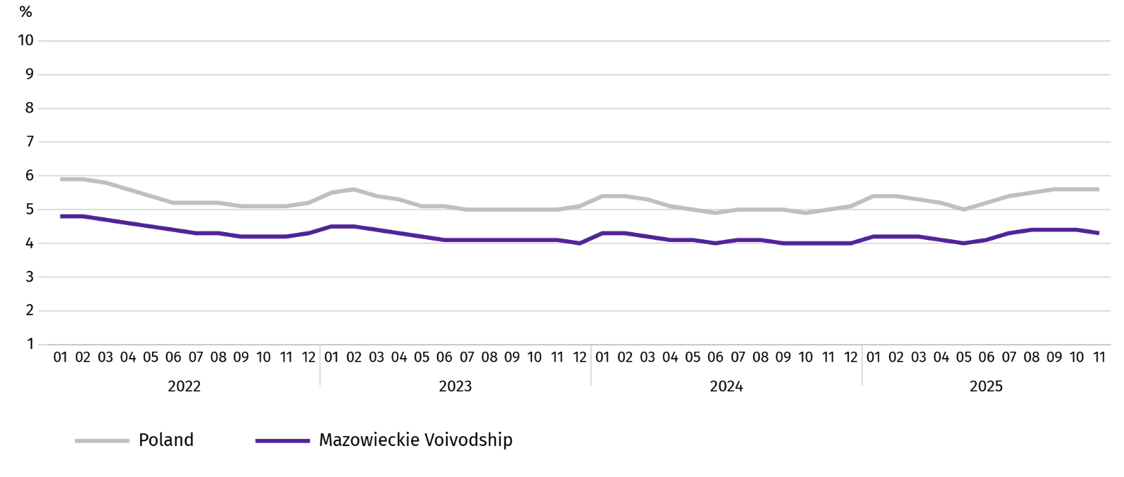
Chart 2. Registered unemployment rate (as of end of month)
Registered unemployment rate at the end of November this year amounted to 4.3% and was lower than the national average (5.6%). It increased on a yearly basis (0.3 pp), and a monthly basis decreased (by 0.1 pp).
The territorial differentiation of the unemployment rate continued in the Voivodship. Powiats with the highest unemployment rate were still szydłowiecki (21.4% against 23.1% in November last year), przysuski (17.8% against 17.5%), and radomski (16.7% against 15.9%), and with the lowest – Warszawa (1.6% against 1.4%), warszawski zachodni (1.8% against 1.6%) and pruszkowski (2.6% against 2.1%).
Compared to November last year, the unemployment rate increased in 41 out of 42 powiats. The highest increase was recorded in the powiats: żuromiński (by 1.4 pp), wyszkowski (by 1.2 pp), pułtuski and wołomiński (by 1.1 pp each). The decrease was recorded in the szydłowiecki powiat (by 1.7 pp).
Compared to October this year, the decrease in unemployment rate of 0.1-0.3 pp took place in 22 powiats and an increase of 0.1-0.2 pp in 7 powiats.
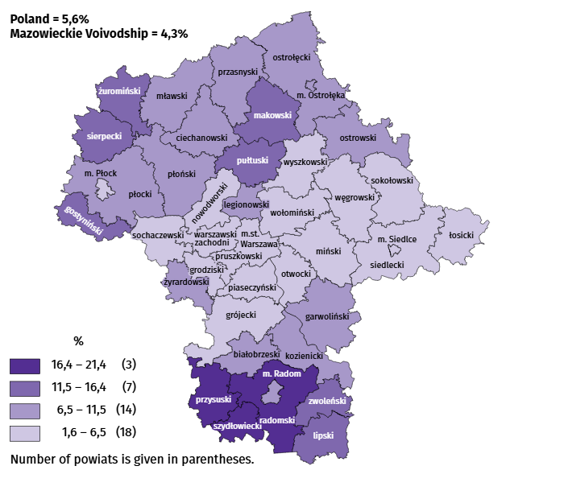
Map 1. Registered unemployment rate by powiats in 2025 (as of end of November)

In November this year, 11.3 thousand unemployed persons were registered in labour offices, i.e. less by 5.5% than a year before and by 18.7% than in the previous month. Among the newly registered, 71.2% were persons registering for the second time (76.1% in the previous year). Share of persons previously not employed amounted to 14.8% (a decrease of 0.5 pp year-on-year), persons terminated for company reasons 4.7% (an increase of 0.7 pp). Among newly registered unemployed persons, 39.6% lived in rural areas (a decrease of 2.2 pp). Graduates accounted for 8.2% of newly registered unemployed persons (an increase of 0.7 pp).
In October this year, 14.8 thousand persons were removed from unemployment rolls, i.e. less by 0.3% than a year before and by 20.0% than a month before. 7.1 thousand persons (2.9% more than a year before) were removed from unemployment rolls due to undertaking employment. The share of this category of persons in the total number of persons removed from unemployment rolls increased by 1.8 pp on a yearly basis and amounted to 59.5%. The share of persons who started training and employer sponsored traineeships increased as well (by 0.7 pp to 5.5%). However the percentage of persons who voluntarily gave up their status of the unemployed decreased (by 0.5 pp to 4.2%). The share of persons who obtained retirement or pension rights did not change and amounted to 0.6%.
At the end of November this year, 101.6 thousand unemployed persons were not entitled to the unemployment benefit, and their share in the total number of the registered unemployed was 86.0% (a 1.5 pp increase in annual terms).
At the end of the surveyed month, 59.1 thousand, i.e. 50.0% out of registered unemployed persons were the long-term unemployed. The number of unemployed persons under the age of 30 amounted to 27.4 thousand, which accounted for 23.2% of the total unemployed (of which persons under the age of 25 constituted 12.5%). Persons aged over 50 amounted to 31.8 thousand (26.9%). 0.6 thousand of unemployed persons, i.e. 0.5% of their total number received social assistance benefits. There were 14.0 thousand persons (i.e. 11.8% of the total unemployed) with at least one child under the age of 6, and persons with a disabled child aged under 18 – 447 persons (0.4% respectively). The number of disabled unemployed persons amounted to 5.5 thousand (i.e. 4.7%).
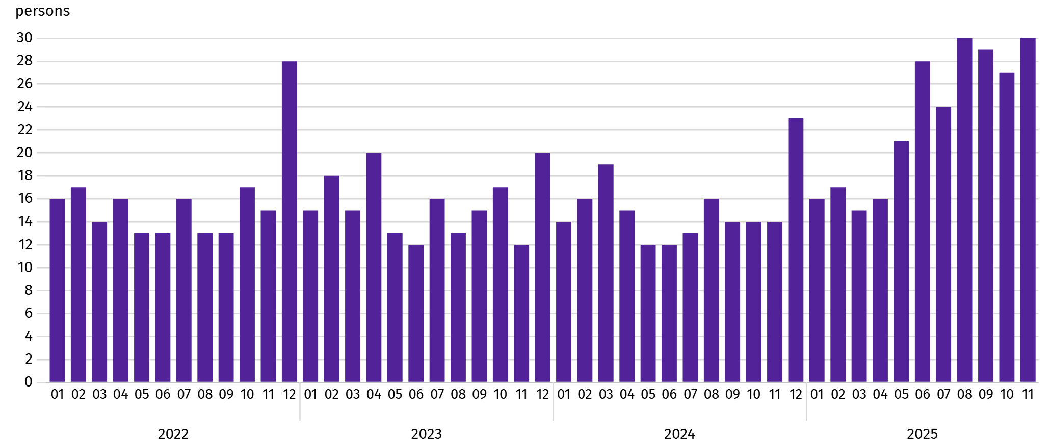
Chart 3. Registered unemployment rateª (as of end of month)

a From 1 June 2025, data on job offers are not fully comparable with earlier periods due to methodological changes resulting from the entry into force of the Act on the Labour Market and Employment Services (Journal of Laws of 2025, item 620).
In November this year, 3.6 thousand job offers were submitted to labour offices, i.e. less by 27.4% than in the previous month. At the end of month, there were 30 unemployed persons per job offer (27 a month before).
According to the labour offices, as of the end of November this year, 33 companies announced termination of 8.4 thousand employees in the near future (a year before, respectively 37 companies – 6.4 thousand employees).

Wages and salaries
In November this year, the average monthly gross wages and salaries in the enterprise sector increased on a yearly and on a monthly basis.
Average monthly gross wages and salaries in the enterprise sector in November this year amounted to PLN 10,285.58 and were higher than in the country (PLN 9,078.16). It increased by 8.5% on a yearly basis (by 5.3% in the previous month). The highest increase was recorded in transportation and storage (by 14.0%), followed by among others in construction (by 8.9%), and manufacturing (by 8.6%), professional, scientific and technical activities (by 8.1%). The decrease was recorded only in electricity, gas, steam and air conditioning supply (by 4.3%).
In comparison with October this year, the average wages and salaries increased by 1.4%. The largest increase concerned electricity, gas, steam and air conditioning supply (by 15.6%), followed by, among others, transportation and storage (by 7.3%), real estate activities (by 2.5%), professional, scientific and technical activities (by 2.3%), and in manufacturing (by 1.7%). The decrease was recorded, among others, in construction(by 3.1%), and trade; repair of motor vehicles (by 0.1%).
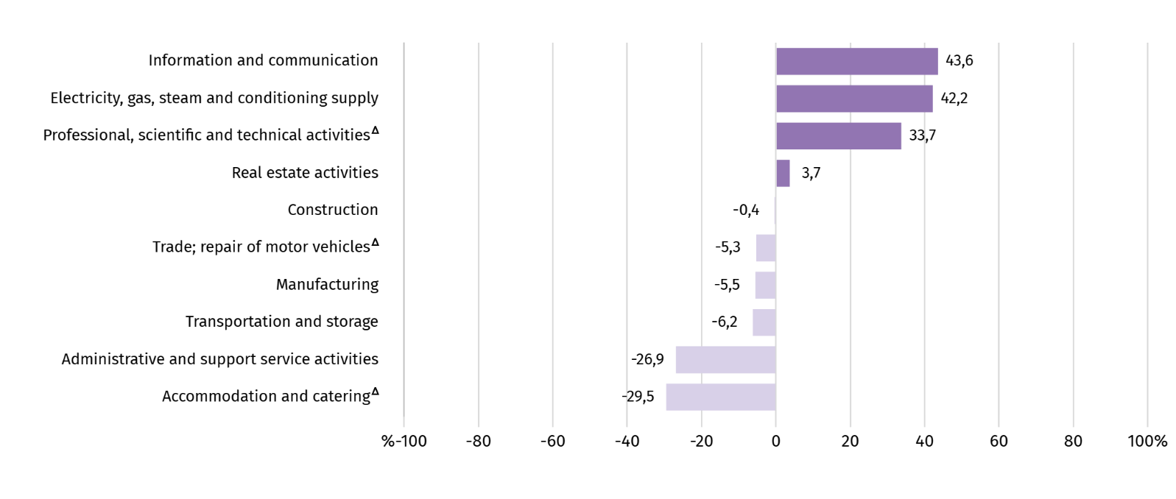
Chart 4. Relative deviations of average monthly gross wages and salaries in selected sections from average wages and salaries in the enterprise sector in November 2025

a Excluding divisions: Research and experimental development work and Veterinary activities.
Table 3. Average monthly gross wages and salaries in the enterprise sector in November 2025
SPECIFICATION | 11 2025 |  | 01–11 2025
SPECIFICATION | w zł | 11 2024=100 | w zł | 01–11 2024=100
TOTAL | 10285,58 | 108,5 | 10227,81 | 108,5
of which:
Industry | 9914,40 | 107,5 | 9832,38 | 110,0
of which:
manufacturing | 9716,36 | 108,6 | 9632,09 | 110,4
electricity, gas, steam and air conditioning supply | 14630,63 | 95,7 | 14524,07 | 105,5
Construction | 10245,75 | 108,9 | 10308,39 | 107,4
Trade; repair of motor vehicles ^{Δ} | 9742,43 | 105,3 | 9939,41 | 105,8
Transportation and storage | 9649,00 | 114,0 | 8873,30 | 108,7
Accommodation and catering ^{Δ} | 7246,84 | 105,2 | 7287,40 | 105,9
Information and communication | 14774,24 | 108,1 | 15085,61 | 108,7
Real estate activities | 10661,57 | 103,4 | 10577,85 | 103,6
Professional, scientific and technical activities ª | 13747,01 | 108,1 | 13816,03 | 107,7
Administrative and support service activities | 7515,14 | 107,2 | 7595,64 | 108,6
a Excluding divisions: Research and experimental development work and Veterinary activities.
In the period of January-November this year, the average monthly gross wages and salaries in the enterprise sector amounted to PLN 10,227.81 and was 8.5% higher than in the same period of 2024 (a year ago 11.0% higher).
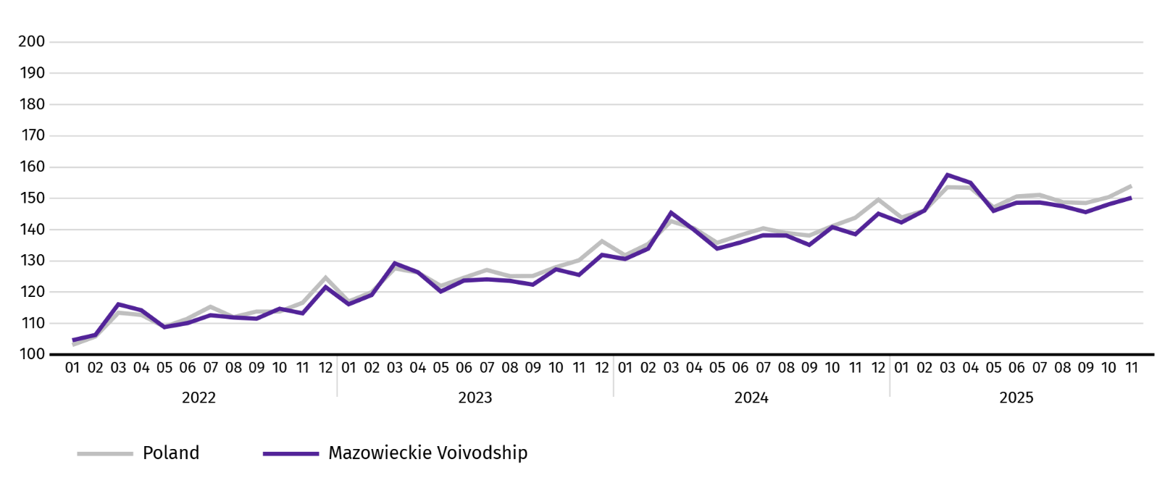
Chart 5. Average monthly gross wages and salaries in the enterprise sector (monthly average 2021=100)

Retail prices
In the third quarter of 2025, in Mazowieckie Voivodship, the prices of consumer goods and services increased by 2.6% on a yearly basis (by 3.0% in the country; in the third quarter of 2024, the price increase was 4.4%.
The largest price increase compared to the third quarter of 2024 concerned education – it amounted to 7.9%. Alcoholic beverages and tobacco increased in price by 6.2%, health-related prices increased by 5.0%, prices of food and non-alcoholic beverages were higher by 4.4% than in the previous year, prices related to recreation and culture by 2.8%, and housing costs were up to 2.3%. Prices dropped for goods and services in transport by 4.0% and for clothing and footwear by 0.9%.
Table 4. Price indices of consumer goods and services
SPECIFICATION | 2024 |  | 2025
SPECIFICATION | Q2 | Q3 | Q2 | Q3
SPECIFICATION | corresponding period of previous year=100
TOTAL | 102,6 | 104,4 | 103,7 | 102,6
Food and non-alcoholic beverages | 102,5 | 104,5 | 104,7 | 104,4
Alcoholic beverages and tobacco | 103,3 | 103,9 | 106,0 | 106,2
Clothing and footwear | 99,6 | 98,2 | 98,6 | 99,1
Housing | 101,6 | 107,1 | 107,3 | 102,3
Health | 104,3 | 104,8 | 105,2 | 105,0
Transport | 99,8 | 98,9 | 94,9 | 96,0
Recreation and culture | 104,3 | 105,3 | 103,3 | 102,8
Education | 109,8 | 109,6 | 107,5 | 107,9
In the third quarter of 2025, the increase in prices of consumer goods and services in Mazowieckie Voivodship was slightly lower than in the country (2.6% compared to 3.0%).

Agriculture
On the agricultural market in November 2025, average procurement prices for cattle and poultry for slaughter were higher than a year ago, while prices for wheat, rye, potatoes, pigs for slaughter and milk were lower. On a monthly basis, more was paid for rye and cattle for slaughter, and less for wheat, potatoes, pigs and poultry for slaughter as well as milk.
The average air temperature in Mazowieckie Voivodship in November 2025 amounted to 4.0°C and was by 0.4°C higher from the average from the years 1991–2020, while the maximum temperature reached 17.8°C in Kozienice, and the minimum amounted to minus 7.7°C in Mława. The average atmospheric precipitation (36.1 mm) accounted for 103% of the standard for the multi-year periods (ranging from 81% in Warszawa to 130% in Kozienice) . The number of days with precipitation, depending on the region, ranged from 10 to 13.
Table 5. Procurement of cereals ª
SPECIFICATION | 07–11 2025 |  | 11 2025
SPECIFICATION | in thousand tonnes | corresponding period of previous year=100 | in thousand tonnes | 11 2024=100 | 10 2025=100
Grain of basic cereals ^{b} | 210,2 | 92,6 | 28,4 | 61,2 | 93,0
of which:
wheat | 160,8 | 97,3 | 23,6 | 62,8 | 99,5
rye | 19,6 | 80,2 | 1,0 | 31,2 | 78,9
a Excluding procurement by natural persons. b Includes: wheat, rye, barley, oat, triticale; including cereal mixed, excluding sowing seed.
In July-November, the procurement of basic cereals (with cereal mixed, without sowing seed) amounted to 210.2 thousand tonnes and was by 7.4% smaller than in the same period last year. Procurement of wheat during this period was 2.7% lower, and procurement of rye 19.8% lower. In November of this year, deliveries of cereal to procurement were 38.8% lower than a year ago and by 7.0% than in the previous month.
Table 6. Procurement of basic animal products ª
SPECIFICATION | 01–11 2025 |  | 11 2025
SPECIFICATION | in thousand tonnes | 01–11 2024=100 | in thousand tonnes | 11 2024=100 | 10 2025=100
Animals for slaughter ^{b} | 1083,3 | 94,1 | 98,4 | 100,3 | 115,6
of which:
cattle (including calves) | 54,0 | 106,2 | 2,3 | 63,5 | 92,3
pigs | 292,4 | 113,6 | 20,0 | 97,2 | 88,5
poultry | 736,1 | 87,4 | 76,1 | 103,0 | 126,8
Milk ^{c} | 2618,9 | 103,6 | 224,9 | 107,2 | 96,8
a Excluding procurement by natural persons. b Including cattle, calves, pigs, sheep, horses and poultry; in terms of meat including fats in post-slaughter warm weight. c In million litres.
From the beginning of this year, producers from Mazowieckie Voivodship delivered 1083.0 thousand tonnes of animals for slaughter (in warm weight), i.e. by 5.9% less than in the previous year. The decrease in procurement concerned poultry for slaughter (by 12.6%), while an increase concerned pigs (by 13.6%) and cattle for slaughter (by 6.2%). In November this year, the total supply of animals for slaughter (98.4 thousand tonnes) was higher by 15.6% than in the previous year, and by 0.3% than in the previous month.
Deliveries of milk in January-November 2025 (2,618.9 million litres) were by 3.6% larger than in the previous year. In November this year, the procurement of milk amounted to 224.9 million litres and was smaller by 3.2% than in the previous month and by 7.2% than in the previous year.
Table 7. Average prices of basic agricultural products
SPECIFICATION | 11 2025 |  |  | 01–11 2025
SPECIFICATION | PLN | 11 2024=100 | 10 2025=100 | PLN | 01–11 2024=100
Wheat ª per dt | 75,33 | 80,0 | 99,0 | 86,60 | 101,4
Rye ª per dt | 61,03 | 94,2 | 101,8 | 68,05 | 119,4
Potatoes per dt | 41,43 | 67,6 | 88,5 | 63,84 | 75,1
Animals for slaughter per kg of live weight:
cattle (excluding calves) | 19,32 | 129,1 | 103,7 | 15,44 | 138,1
pigs | 5,81 | 87,1 | 89,8 | 6,77 | 90,1
poultry | 5,80 | 108,9 | 93,0 | 5,98 | 116,6
Milk per 1 hl | 213,17 | 89,3 | 97,4 | 223,42 | 108,9
a Excluding sowing seed.
In November 2025, PLN 75.33 was paid for 1 dt of wheat at procurement, i.e. 0.1% less than last month and 20.0% than last year. The average price of wheat at marketplaces was PLN 103.71 and was smaller by 1.6% than in October 2025, and by 5.8% than in November 2024. The procurement price of rye decreased by 1.8% (to PLN 61.03) compared to the previous month, and the marketplace price by 1.8% (to PLN 72.87). Compared to November 2024, procurement prices for rye were 5.8% lower, and marketplace prices by 8.7%.
Table 8. Average marketplace prices of wheat and potatoes
SPECIFICATION | 11 2025 |  |  | 01–11 2025
SPECIFICATION | PLN | 11 2024=100 | 10 2025=100 | PLN | 01–11 2024=100
Wheat per dt | 103,71 | 94,2 | 98,4 | 111,73 | 104,5
Rye per dt | 72,87 | 91,3 | 98,2 | 77,52 | 104,9
Potatoes ^{b} per dt | 181,59 | 80,6 | 98,2 | 206,35 | 87,8
a Edible late.

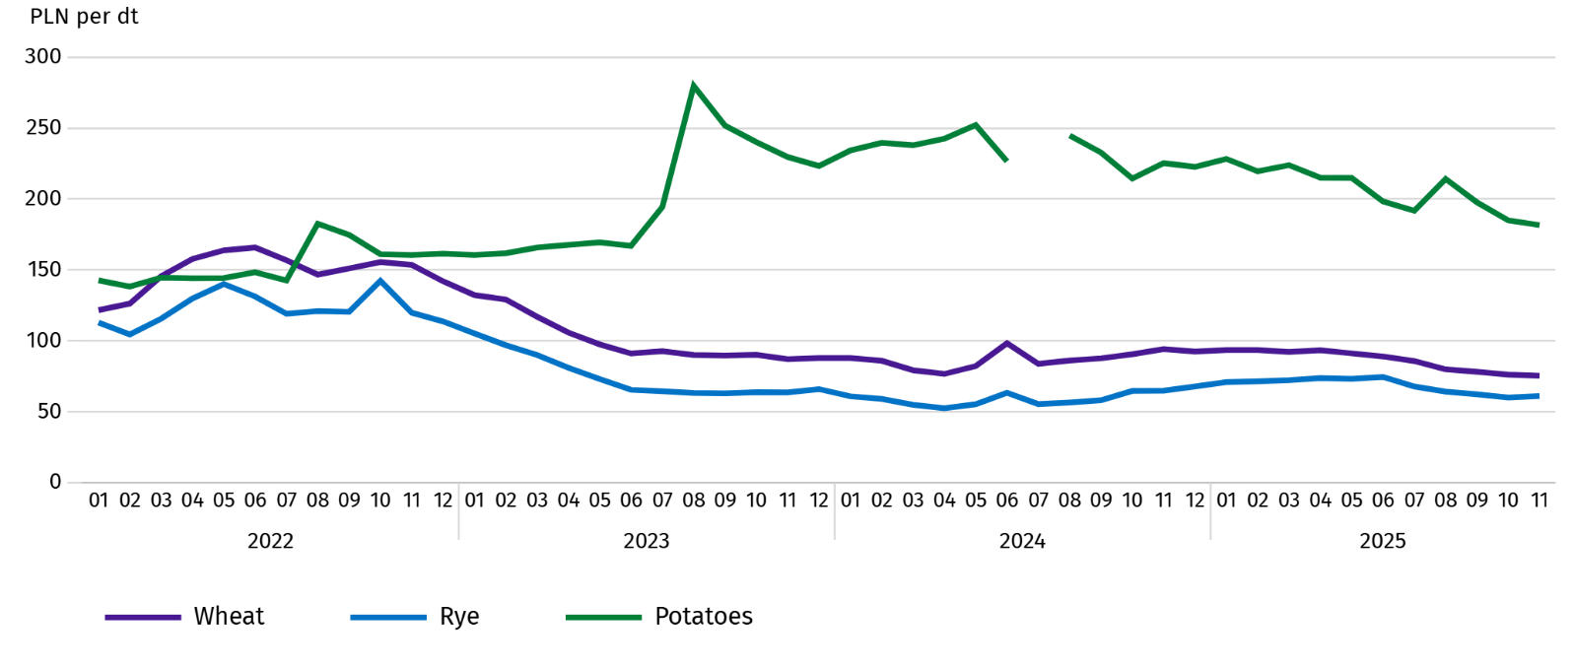
Chart 6. Average marketplace prices of cereals and potatoes ª

a In July 2024, the price of late edible potatoes was not recorded due to their absence at the time of observations.
In November 2025, the average procurement price of potatoes was PLN 41.43/dt, i.e. less by 11.5% than in the previous month and by 32.4% than last year. At marketplaces, the average price of 1 dt of potatoes was PLN 181.59 and was 1.8% lower than in the previous month, and by 19.4% than in the previous year.
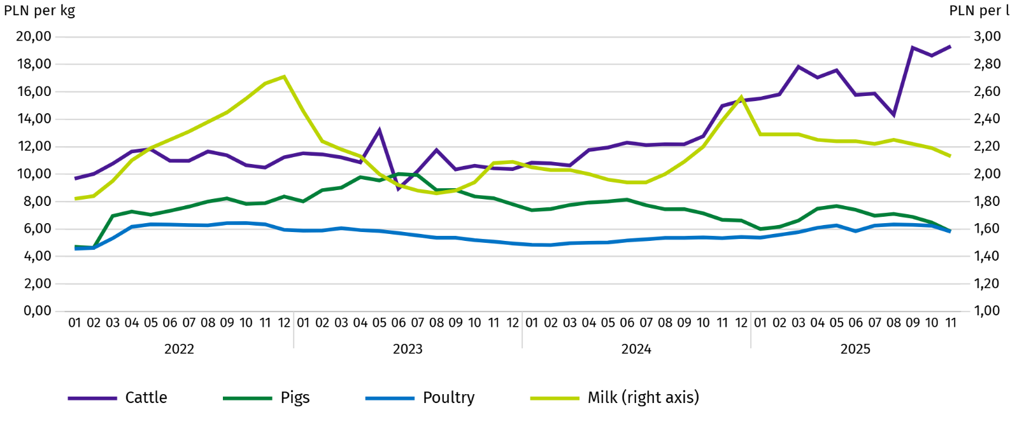
Chart 7. Average procurement prices of animals for slaughter and milk

In November 2025, the average procurement price of pigs for slaughter was lower by 10.2% than in the previous year, and by 12.9% than In the previous month.
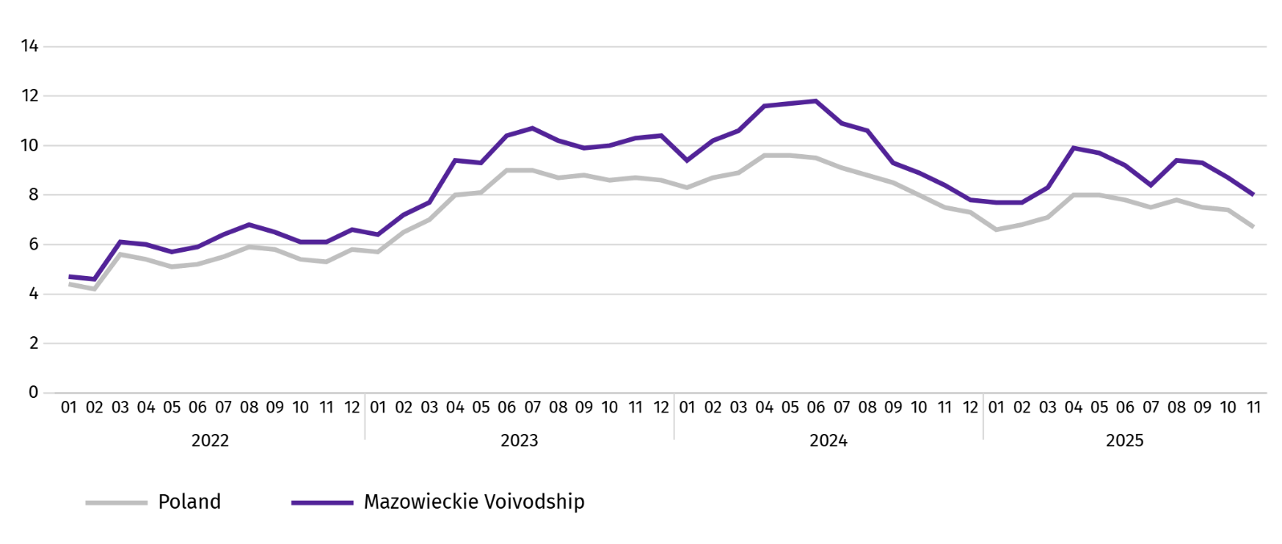
Chart 8. Ratio of the average procurement prices of pigs for slaughter to the average marketplace prices of rye

The procurement price of cattle for slaughter was higher by 3.7% than a month ago and by 29.1% than a year ago.
In October 2025, suppliers were paid an average of PLN 5.80 per 1 kg of poultry for slaughter, i.e. 7.0% less than in October 2025 and 8.9% more than in November 2024.
Procurement prices of milk in November 2025 were by 2.6% lower than in the previous year and by 10.7% than in the previous month.

Industry and construction
Sold production of industry in November this year, reached the value (at current prices) of PLN 43,712.3 million and was (at constant prices) by 6.5% lower than a year before (with an unchanged level in September this year); as compared to the previous month it decreased by 8.0%.
Sold production in manufacturing (constituting 85.9% of sold production of industry) compared to November last year increased (at constant prices) by 6.8%. However there was a decrease (by 4.7%) in sold production in the section of electricity, gas, steam and air conditioning supply (the share of this section represents 11.8% of industrial production).
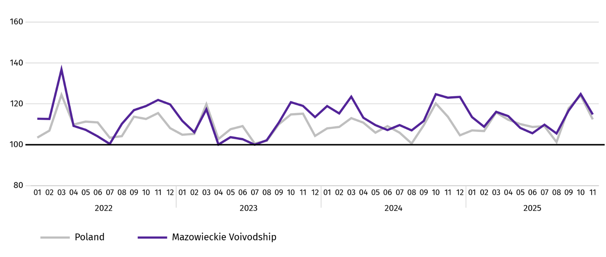
Chart 9. Sold production of industry (monthly average 2021=100; constant prices)

In November this year, the decrease in sold production in annual terms was recorded in 19 (out of 32 in the Voivodship) divisions of industry, among others, in: manufacture of electrical equipment (by 23.0%), computer, electronic and optical equipment (by 17.6%), chemicals and chemical products (by 7.1%), other non-metallic mineral products (by 6.5%), paper and paper products (by 3.7%), beverages (by 3.4%). However, there was an increase in sold production of, among others, rubber and plastic products (by 10.1%), food products (by 7.4%), machinery and equipment n.e.c. (by 4.4%), metal products (by 2.3%).
Table 9. Indices (constant prices) and structure (current prices) of sold production of industry in November 2025
SPECIFICATION | 11 2025 | 01–11 2025
SPECIFICATION | corresponding period of previous year=100 |  | In percent
TOTAL | 93,5 | 101,2 | 100,0
of which:
Manufacturing | 93,2 | 101,4 | 87,2
of which manufacture of:
food products | 107,4 | 104,1 | 22,3
beverages | 96,6 | 97,1 | 1,8
paper and paper products | 96,3 | 97,5 | 2,0
chemicals and chemical products | 92,9 | 101,6 | 4,1
manufacture of rubber and plastic products | 110,1 | 110,4 | 3,1
other non-metallic mineral products | 93,5 | 103,8 | 2,5
metal products ^{Δ} | 102,3 | 110,4 | 3,8
computer, electronic and optical equipment | 82,4 | 99,0 | 5,2
electrical equipment | 77,0 | 105,1 | 4,4
machinery and equipment n.e.c. | 104,4 | 105,9 | 1,9
Electricity, gas, steam and air conditioning supply ^{Δ} | 95,3 | 98,3 | 10,4
Labour productivity in industry measured by sold production per employed person, in November this year amounted (at current prices) to PLN 110.4 thousand and was (at constant prices) by 7.8% lower than a year before, with an increase in average paid employment by 1.4% and average monthly gross wages and salaries by 7.5%.
Sold production of industry in January–November this year, reached the value of PLN 482,118.2 million (at current prices) and was by 1.2% higher than in the corresponding period of previous year.
Sold production of construction (at current prices) in November this year, reached the value of PLN 10,143.8 million and was by 17.9% lower than in the previous year (compared to a 4.1% increase in October this year). In January-November this year, sold production of construction amounted to PLN 112,976.9 million and was by 4.9% higher compared to the corresponding period of last year.
Labour productivity in construction, measured by revenue from the sale of goods and services per employed person in November this year amounted to PLN 107.2 thousand (at current prices) and was by 19.2% lower compared to the corresponding month of the previous year, with an increase in average employment in construction by 1.7% and in average monthly gross wages and salaries by 8.9%.
Construction and assembly production (at current prices) in November this year, amounted to PLN 2,895.7 million and was by 3.7% higher than a year before (as compared to 13.0% increase in October this year). The increase in production was recorded in entities whose basic activity is the construction of buildings (by 33.4%) and in enterprises mainly performing specialised construction activities (by 33.2%). The decrease was recorded in units specialising in civil engineering (by 33.2%). In January-November this year, construction and assembly production was PLN 29,926.1 million and was 15.8% higher compared to the corresponding period of last year.
Table 10. Indices and structure (current prices) of construction and assembly production in November 2025
SPECIFICATION | 11 2025 | 01–11 2025
SPECIFICATION | corresponding period of previous year=100 |  | In percent
TOTAL | 103,7 | 115,8 | 100,0
Construction of buildings ^{Δ} | 133,4 | 150,8 | 28,2
Civil engineering | 80,8 | 95,2 | 46,3
Specialised construction activities | 133,2 | 133,9 | 25,5

Residential construction
In November this year, the number of dwellings completed increased by 10.0% compared to the corresponding month in 2024. The number of dwellings for which permits have been granted or which have been registered with a construction project increased by 17.9%, and dwellings in which construction has begun decreased by 14.7%.
According to preliminary data in November this year, there were 3902 dwellings completed, i.e. by 354 more (by 10.0%) than in the previous year and by 607 (by 13.5%) than in the previous month. There were 3025 dwellings built for sale or rent (77.5% of their total number), followed by private dwellings 877 (22.5%). Compared to November last year, there were more dwellings for sale or rent by 13.0%, and private dwellings by 11.3%.
The effects of housing construction obtained in Mazowieckie Voivodship in the surveyed month constituted 20.2% of national effects.
Table 11. Number of dwellings completed in January-November 2025
SPECIFICATION | Dwellings comleted |  |  | Average useful floor area of a dwelling in m²
SPECIFICATION | In absolute numbers | In percent | 01–11 2024=100 | Average useful floor area of a dwelling in m²
TOTAL | 39359 | 100,0 | 116,7 | 83,0
Private | 9091 | 23,1 | 99,1 | 146,2
Cooperative | 335 | 0,9 | 184,1 | 51,9
For sale or rent | 29254 | 74,3 | 122,4 | 64,4
Municipal | 240 | 0,6 | 70,6 | 42,9
Public building society | 379 | 1,0 | 261,4 | 50,4
Company | 60 | 0,2 | . | 67,4

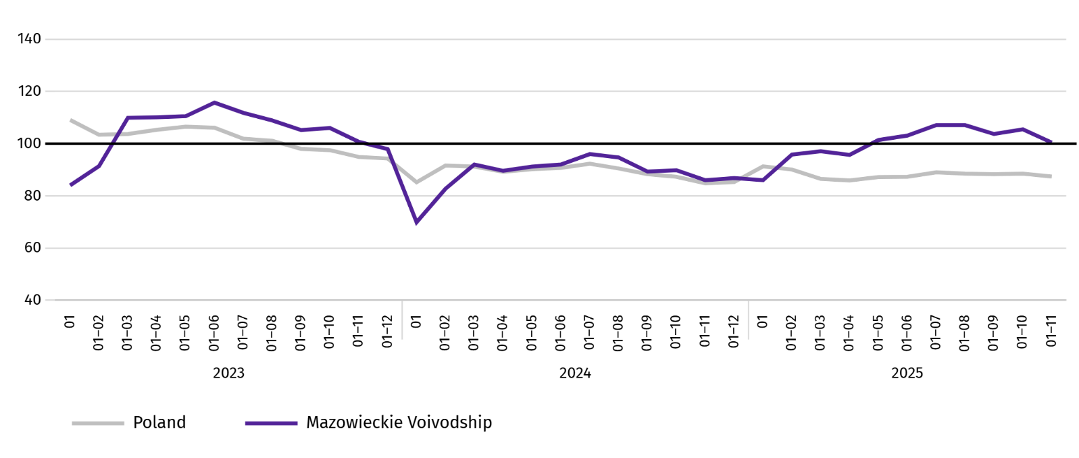
Chart 10. Dwellings completed (corresponding period 2021=100)

In the period January–November this year, most dwellings were completed in m.st. Warszawa (17129), and then in piaseczyński powiat (2857), and wołomiński (2456), and the least in lipski and łosicki (47 each) and makowski (63).
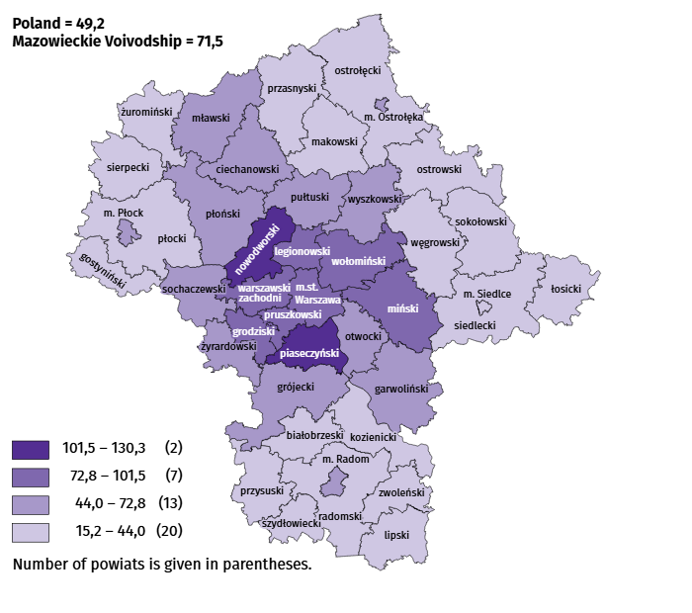
Map 2. Dwellings completed per 10 thousand populationª by powiats in January-November 2025

a Population as of 30 June 2025.
The average useful floor area of dwellings completed in November this year amounted to 77.6 m² and was smaller than a year earlier by 5.4 m² than a year earlier. The largest dwellings were completed in żuromiński powiat (189.0 m²), sokołowski (170.2 m²) and łosicki powiat (166.7 m²). The smallest were built in Warszawa (51.8 m²), Płock (52.1 m²), as well as ciechanowski powiat (55.0 m²).
In November this year, the number of dwellings for which permits have been granted or which have been registered with a construction project amounted to 4244, i.e. larger by 643 (by 17.9%) than a year earlier and by 787 (by 15.6%) than in the previous month. Of the total number of dwellings, 73.5% were dwellings for sale or rent, and 26.0% private.
In the surveyed month, the construction began in 2931 dwellings, which means a decrease by 505 (by 14.7%) in annual terms and by 1765 (by 37.6%) in monthly terms. Dwellings for sale or rent accounted for 71.4% of their total number, and private 28.6%.
Table 12. Number of dwellings for which permits have been granted or which have been registered with a construction project as well as dwelling in which construction has begun January–November 2025
SPECIFICATION | Dwellings for which permits have been granted or which have been registered with a construction project |  |  | Dwellings in which construction has begun
SPECIFICATION | in absolute numbers | in percent | 01–11 2024=100 | in absolute numbers | in percent | 01–11 2024=100
TOTAL | 45239 | 100,0 | 85,0 | 41268 | 100,0 | 96,8
Private | 12921 | 28,6 | 113,9 | 11354 | 27,5 | 101,8
Cooperative | 30 | 0,1 | 22,6 | – | – | .
For sale or rent | 31988 | 70,7 | 78,0 | 29837 | 72,3 | 96,1
Municipal | 72 | 0,2 | 46,5 | – | – | .
Public building society | 228 | 0,5 | 41,9 | 77 | 0,2 | 35,6

Internal market
In November this year, both retail and wholesale sales were lower compared to the previous year.
Retail sales (at current prices) in trade and non-trade enterprises in November this year, decreased by 0.1% compared to the year before. The decrease in sales was recorded in units from the group: “pharmaceuticals, cosmetics, orthopedic equipment” (by 8.9%),“motor vehicles, motorcycles, parts” (by 5.6%), and “food, beverages and tobacco” (by 1.0%). The largest increase in retail sales recorded units from the group: “press, books, other sales in specialised stores” (by 17.2%), followed by “other retail sales in non-specialised stores” (by 7.5%), “textiles, clothing and footwear” (by 2.8%), “furniture, electronics and household appliances” (by 1.8%), ”others” (by 1.4%).
Compared to October this year, retail sales decreased by 0.4%. The largest decrease in retail sales was recorded in the following groups: “food, beverages and tobacco” (by 9.0%), followed by “other retail sales in non-specialised stores” (by 4.0%), “motor vehicles, motorcycles, parts” (by 3.3%), “others” (by 0.6%). The increase in sales was recorded in the groups: “furniture, electronics and household appliances” (by 11.4%), “pharmaceutical, cosmetics, orthopedic equipment” (by 6.3%), “press, books, other retail sales in specialized stores” (by 4.3%), “textiles, clothing and footwear” (by 1.1%).
Table 13. Indices and structure (at current prices) of retail sales in November 2025
SPECIFICATION | 11 2025 | 01–11 2025
SPECIFICATION | corresponding period of previous year=100 |  | in percent
TOTAL ª | 99,0 | 99,6 | 100,0
of which:
Motor vehicles, motorcycles, parts | 94,4 | 96,8 | 6,9
Food, beverages and tobacco | 99,0 | 102,9 | 14,4
Other retail sales in non-specialised stores | 107,5 | 112,4 | 3,7
Pharmaceuticals, cosmetics and orthopedic equipment | 91,1 | 98,2 | 4,8
Textiles, clothing and footwear | 102,8 | 97,4 | 5,8
a The grouping of enterprises was made on the basis of the Polish Classification of Activities - PKD 2007, including the enterprise to a specific category according to the type of predominant activity, in accordance with the organizational status in the period under consideration. The recorded changes (increase/decrease) in retail sales in particular groups of activity of enterprises may also result from changes in the type of predominant economic activity and organisational changes (e.g. mergers of enterprises). This does not affect the dynamics of retail sales in general.
Table 13. Indices and structure (at current prices) of retail sales in November 2025 (cont.)
SPECIFICATION | 11 2025 | 01–11 2025
SPECIFICATION | corresponding period of previous year=100 |  | in percent
Furniture, electronics and household appliances | 101,8 | 102,0 | 17,8
Press, books and other sales in specialised stores | 117,2 | 118,1 | 7,3
Other | 101,4 | 103,8 | 9,5
In the period January-November 2025, retail sales decreased by 0.4% year-on-year. The decrease in sales was recorded by enterprises from the group “motor vehicles, motorcycles, parts” (by 3.2%), “textiles, clothing and footwear” (by 2.6%), “pharmaceuticals, cosmetics, orthopedic equipment” (by 1.8%), while sales increased in enterprises from the group "press, books, other sales in specialised stores" (by 18.1%), “other retail sales in non-specialised stores” (by 12.4%), “others” (by 3.8%), “food, beverages and tobacco” (by 2.9%), “furniture, electronics and household appliances” (by 2.0%).
Wholesale (at current prices) in trade enterprises in November this year was by 9.6% lower as compared to the previous month and by 10.1% lower compared to November 2024. In wholesale enterprises it was lower by 7.3% and 8.9%, respectively.
In January-November 2025, wholesale in trade enterprises was 7.2% lower than in the previous year, and in wholesale enterprises lower by 6.4%.

Entities of the national economy
In November of this year, the number of entities of the national economy registered in the REGON register increased by 0.3% compared to the previous month. There were more entities with suspended activity. While the number of newly registered entities and entities removed from the REGON register decreased (by 17.5% and 13.5%, respectively).
As of the end of November this year, the number of entities of the national economy registered in the REGON register amounted to 1088107, which means an increase of 3.6% year-on-year and 0.3% compared to the previous month.
In the total number of registered entities, the greatest number is natural persons conducting economic activity. At the end of November this year, there were 701754 of them, i.e. more by 3.5% than in the previous year. The number of companies which were registered in the REGON register amounted to 305940, including 246088 commercial companies (an annual increase by 3.8% and 4.7%, respectively). There were 59393 civil partnerships i.e. more 0.2% compared to the previous year.
According to the expected number of employed persons, entities that declared employment of up to 9 persons prevailed upon entry in the REGON register; they constituted 97.3% of all registered units. The share of entities with an estimated number of 10-49 employed persons was 2.1%, and of entities employing more than 49 persons – 0.5%. Over the year, the increase in the number of entities occurred among the smallest entities (up to 9 persons) – by 3.7%.
Compared to October 2024, the largest increase in the number of entities was recorded in the sections: professional, scientific and technical activities – more by 7302 units (in percentage terms, a 4.5% increase), administrative and support service activities by 6123 units (an increase of 12.3%), information and communication by 5620 units (5.7%).
Compared to November 2024, the largest numerical increase in the number of entities was recorded in the sections: professional, scientific and technical activities – more by 7199 units (in percentage terms, an increase by 4.4%), administrative and support service activities by 6198 units (a 12.4% increase), information and communication – by 5545 units (by 5.6%).
Compared to October 2025, the largest percentage increase in the number of entities occurred in the following sections: electricity, gas and air conditioning supply (by 0.8%), administrative and support service activities, and human health and social work activities (0.7% each).
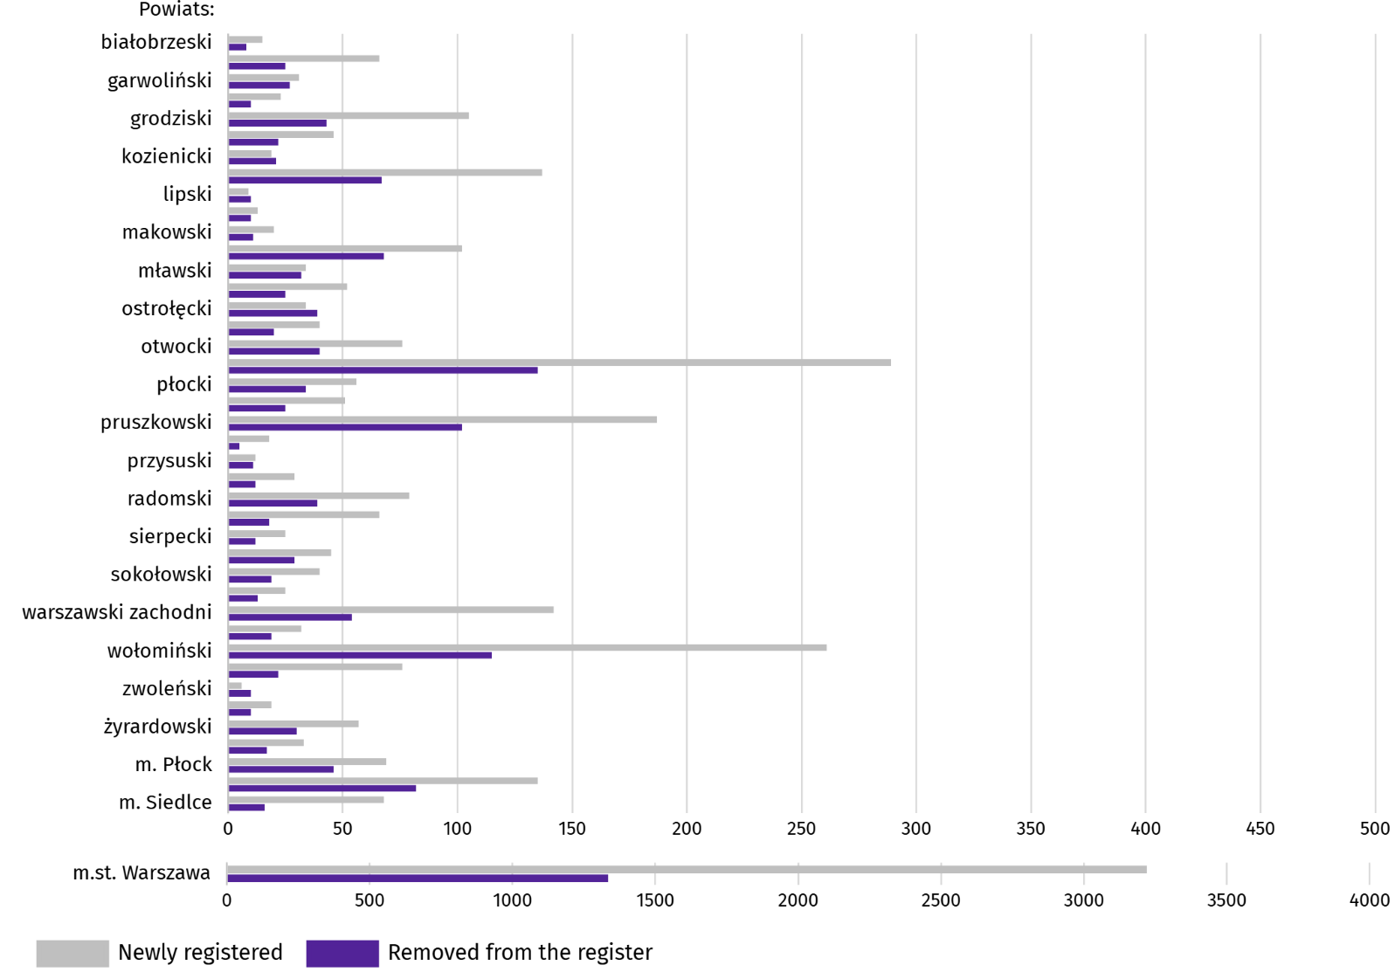
Chart 11. Entities of the national economy newly registered and removed from the register in November 2025

In November this year, 5862 new entities were registered in the REGON register, i.e. by 17.5% less than in the previous month. The newly registered units were dominated by natural persons conducting economic activity, 4143 of whom were registered (by 19.6% less than in the previous month). The number of newly registered commercial companies was smaller by 12.0%, including companies with limited liability by 11.3%.
In the surveyed month, 2688 entities were removed from the REGON register (by 13.5% less than a month ago), including 2091 natural persons conducting economic activity (by 13.7% less).
As of the end of November this year, there were 146903 entities in the REGON with suspended activity (by 0.6% more than a month ago). The vast majority were natural persons conducting economic activity (94.1%; 94.2% in the previous month).
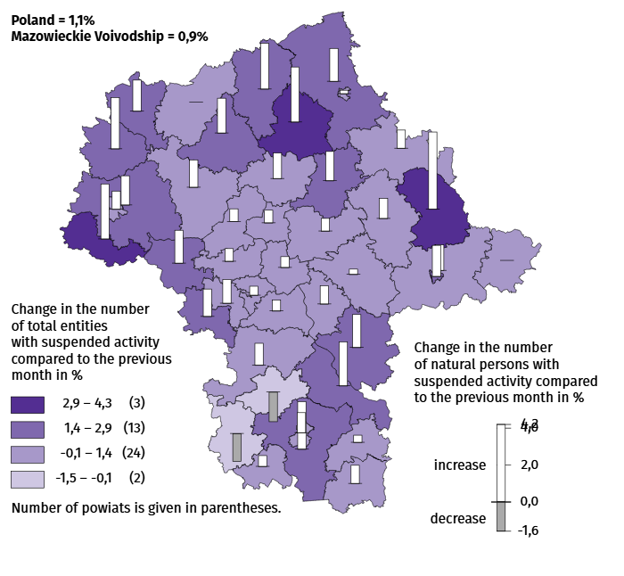
Map 3. Entities of the national economy with suspended activity in November 2025

Business tendency
In December of this year, only the information and communication sector saw no change in the assessment of the economic climate compared to the previous month. The greatest improvement occurred in the accommodation and catering section (an increase in the general business climate indicator by 12.5 compared to November of this year). In retail trade, entrepreneurs' opinions remained at a similar level to last month. However, the largest decline (by 4.0) was recorded in wholesale trade. Accommodation and catering entities assess the economic climate most favourably (plus 27.0), and the indicator value is above the long-term average (plus 0.5). The most pessimistic assessments are expressed by entities operating in the construction section (minus 5.4), with the indicator value below the long-term average (minus 4.8).

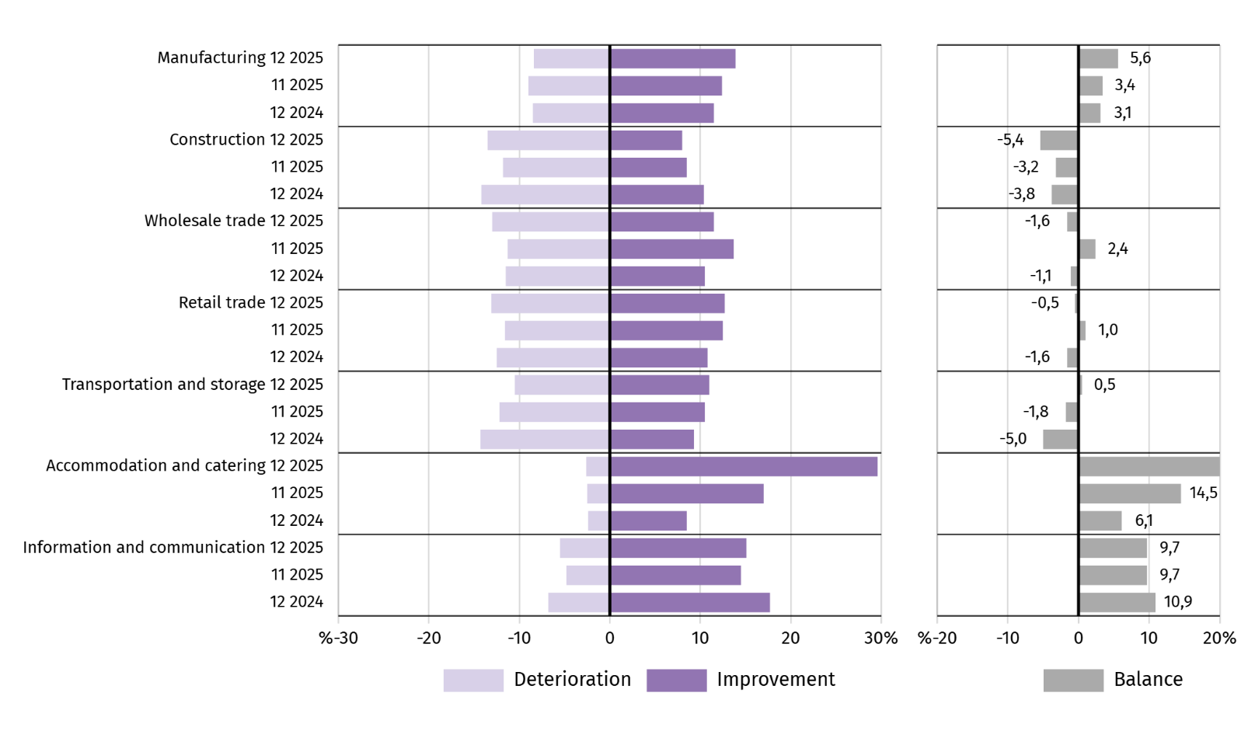
Chart 12. Indices of the general business climate by type of activity (sections and divisions of NACE Rev. 2)

Questions about labour market
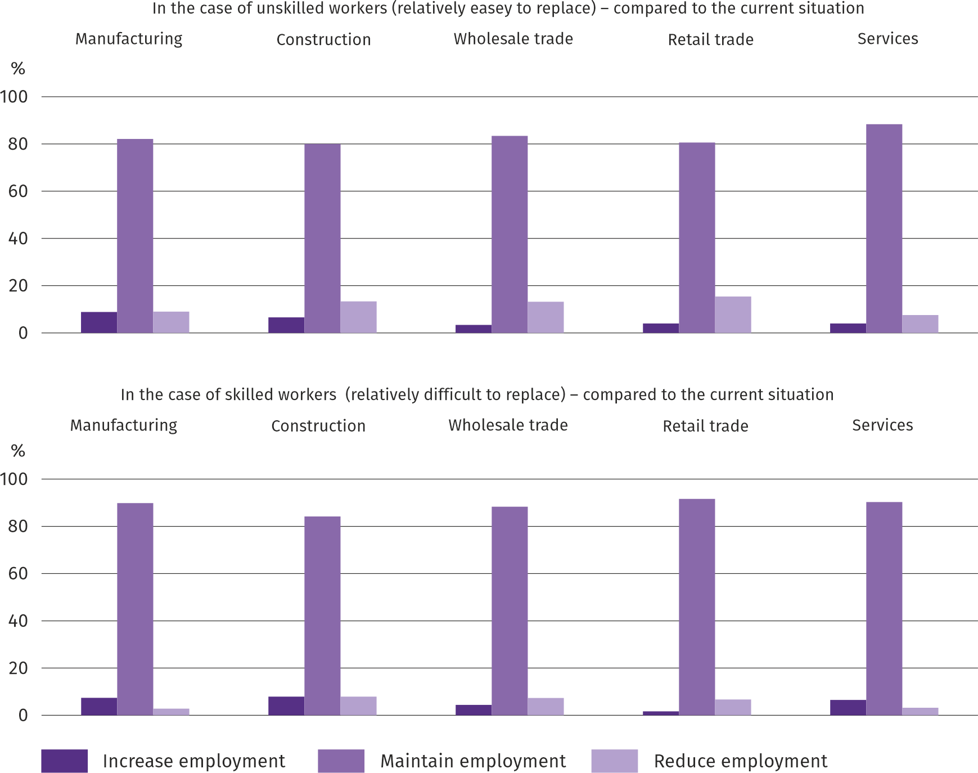
Question 1. In the next three months, do you intend to:

Across all the surveyed business types, entrepreneurs predominate in their intention to maintain their current employment levels over the next three months. Such declarations apply to both relatively easy and relatively difficult-to-replace employees, with a higher percentage of such responses observed for relatively difficult-to-replace employees across all surveyed economic entities.
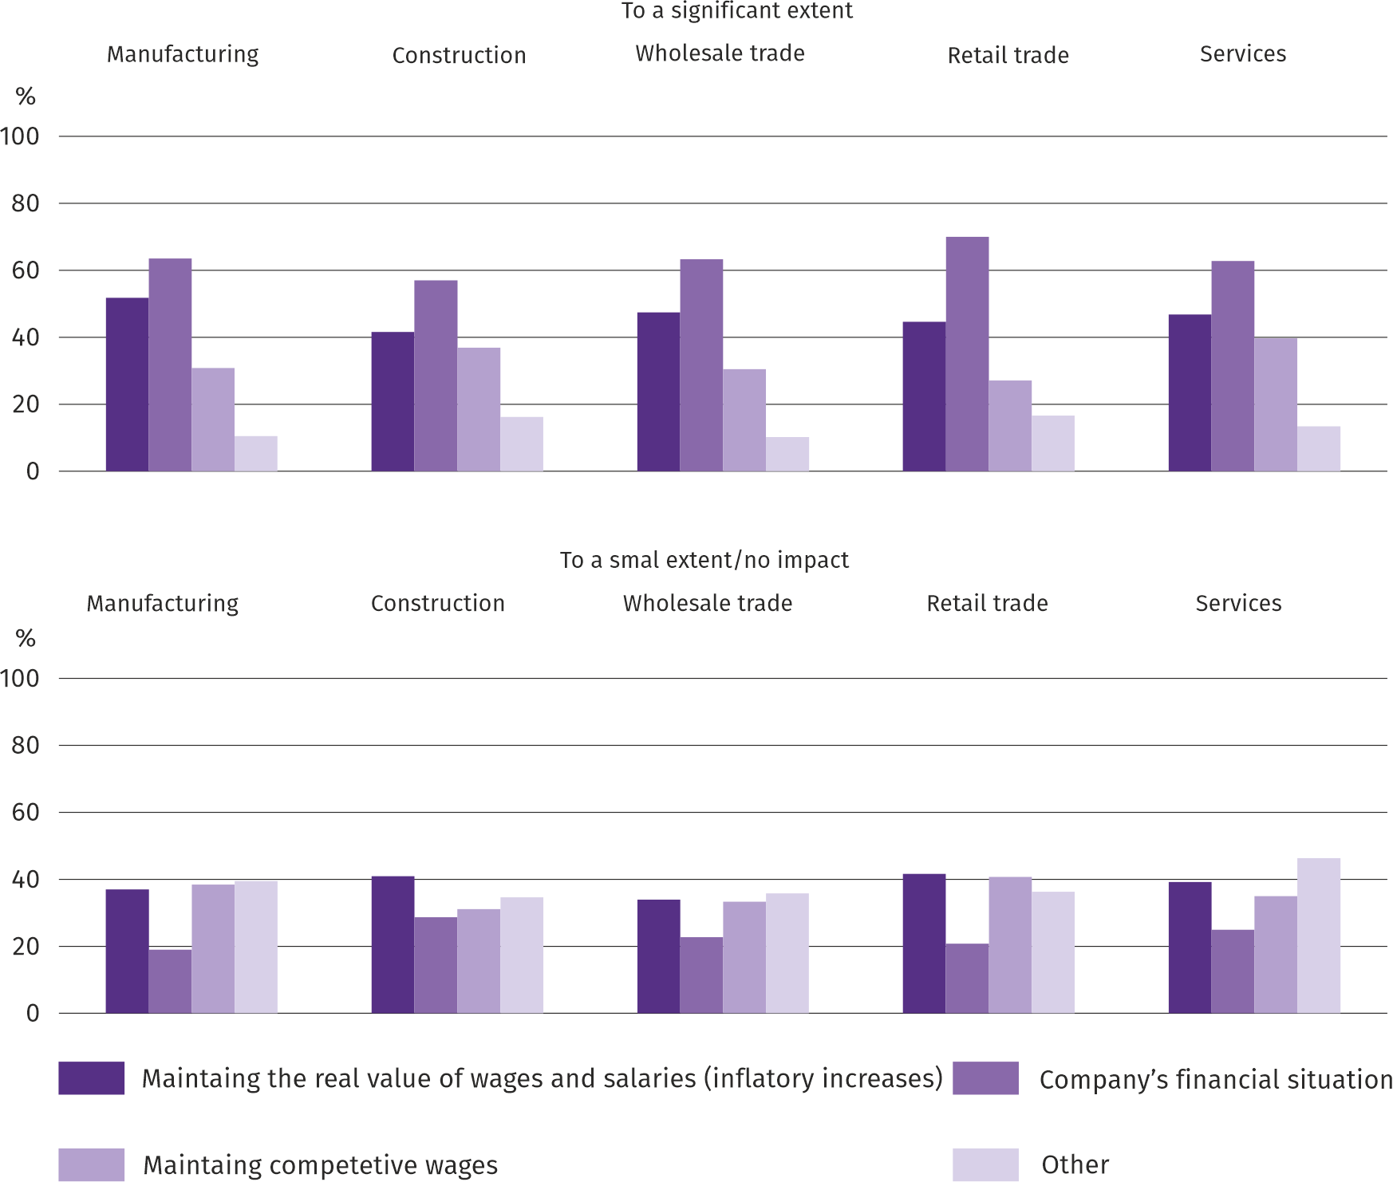
Question 2. Which of the following factors and to what extent will affect the level of remuneration of employees in your company in the next three months:

Regardless of the type of economic entities, most entrepreneurs expressed the opinion that the company's financial situation would significantly impact employee remuneration levels in the next three months. The factors cited in the survey as having a small impact on remuneration most frequently included maintaining the real value of remuneration (inflationary increases), and in the manufacturing sector, maintaining competitive wages.
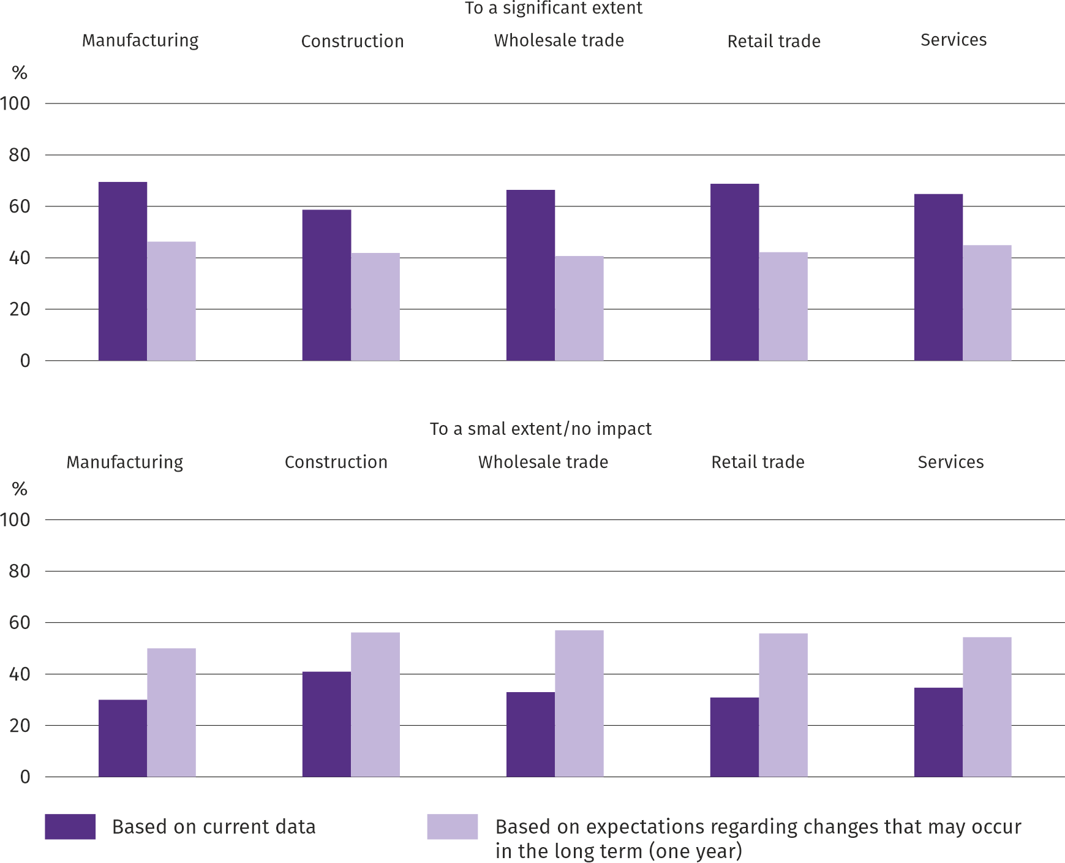
Question 3. To what extent are your decisions regarding employment and remuneration in the next three months based on:

In all areas of the economy covered by the business climate survey, the majority of entrepreneurs stated that decisions regarding employment and remuneration in the next three months depend to a large extent on current data, and to a lesser extent are more often made on the basis of expectations regarding changes that may occur in the long term (one year).
More information on the results of the business climate survey can be found on the website of the Statistical Office in Zielona Góra https://zielonagora.stat.gov.pl/osrodki/osrodek-badan-koniunktury/obk-dane/.

Table 14. Selected data on Mazowieckie Voivodship
SPECIFICATION  A – 2024  B – 2025 |  | 01 | 02 | 03 | 04 | 05 | 06 | 07 | 08 | 09 | 10 | 11 | 12
Average employment in the enterprise sector ª  (in thousand persons) | A | 1607,0 | 1601,8 | 1598,1 | 1594,4 | 1591,7 | 1588,1 | 1589,5 | 1586,0 | 1584,4 | 1580,1 | 1582,0 | 1583,9
 | B | 1582,5 | 1577,9 | 1572,7 | 1574,8 | 1570,6 | 1572,8 | 1574,1 | 1572,8 | 1571,5 | 1567,2 | 1570,8
previous month=100 | A | 100,7 | 99,7 | 99,8 | 99,8 | 99,8 | 99,8 | 100,1 | 99,8 | 99,9 | 99,7 | 100,1 | 100,1
previous month=100 | B | 99,9 | 99,7 | 99,7 | 100,1 | 99,7 | 100,1 | 100,1 | 99,9 | 99,9 | 99,7 | 100,2
corresponding month of previous year=100 | A | 100,7 | 100,8 | 100,8 | 100,3 | 100,3 | 100,1 | 100,3 | 100,0 | 99,8 | 99,5 | 99,4 | 99,3
corresponding month of previous year=100 | B | 98,5 | 98,5 | 98,4 | 98,8 | 98,7 | 99,0 | 99,0 | 99,2 | 99,2 | 99,2 | 99,3
Registered unemployed persons (in thousand persons; as of end of period) | A | 117,1 | 117,7 | 114,8 | 111,9 | 110,0 | 108,5 | 109,9 | 110,6 | 109,6 | 108,3 | 108,4 | 109,0
 | B | 114,7 | 115,9 | 113,9 | 111,3 | 108,7 | 111,0 | 116,0 | 120,2 | 119,6 | 118,7 | 118,1
Unemployment rate b (in %; as of end of period) | A | 4,3 | 4,3 | 4,2 | 4,1 | 4,1 | 4,0 | 4,1 | 4,1 | 4,0 | 4,0 | 4,0 | 4,0
Unemployment rate b (in %; as of end of period) | B | 4,2 | 4,2 | 4,2 | 4,1 | 4,0 | 4,1 | 4,3 | 4,4 | 4,4 | 4,4 | 4,3
Job offers (submitted during a month) | A | 17944 | 17639 | 14928 | 16475 | 16584 | 17271 | 17764 | 12910 | 13202 | 16551 | 13455 | 10874
Job offers (submitted during a month) | B | 15760 | 13938 | 14768 | 13164 | 11459 | 4235 | 5656 | 4432 | 5028 | 4975 | 3612
Unemployed persons per 1 job offer (as of end of period) | A | 14 | 16 | 19 | 15 | 12 | 12 | 13 | 16 | 14 | 14 | 14 | 23
Unemployed persons per 1 job offer (as of end of period) | B | 16 | 17 | 15 | 16 | 21 | 28 | 24 | 30 | 29 | 27 | 30
Average monthly gross wages and salaries in the en-terprise sector ª (in PLN) | A | 8943,42 | 9165,69 | 9949,91 | 9568,24 | 9156,63 | 9296,77 | 9459,07 | 9445,98 | 9239,16 | 9629,96 | 9480,33 | 9931,44
 | B | 9739,87 | 10004,89 | 10785,77 | 10612,28 | 9995,20 | 10173,45 | 10185,77 | 10100,98 | 9974,07 | 10141,45 | 10285,58
previous month=100 | A | 99,0 | 102,5 | 108,6 | 96,2 | 95,7 | 101,5 | 101,7 | 99,9 | 97,8 | 104,2 | 98,4 | 104,8
previous month=100 | B | 98,1 | 102,7 | 107,8 | 98,4 | 94,2 | 101,8 | 100,1 | 99,2 | 98,7 | 101,7 | 101,4
corresponding month of previous year=100 | A | 112,4 | 112,3 | 112,3 | 110,5 | 111,1 | 109,7 | 111,2 | 111,6 | 110,3 | 110,5 | 110,4 | 110,0
corresponding month of previous year=100 | B | 108,9 | 109,2 | 108,4 | 110,9 | 109,2 | 109,4 | 107,7 | 106,9 | 108,0 | 105,3 | 108,5
Price indices:
consumer goods and services ^{c}:
corresponding month of previous year=100 | A | . | . | 103,4 | . | . | 102,6 | . | . | 104,4 | . | . | 104,7
corresponding month of previous year=100 | B | . | . | 104,7 | . | . | 103,7 | . | . | 102,6 | . | .
a In enterprises employing more than 9 persons. b Share of registered unemployed persons in civilian economically active population, estimated at the end of each month. c From 1 June 2025, data on job offers are not fully comparable with earlier periods due to methodological changes resulting from the entry into force of the Act on the Labour Market and Employment Services (Journal of Laws of 2025, item 620). d In the quarter.
Table 14. Selected data on Mazowieckie Voivodship (cont.)
SPECIFICATION  A – 2024  B – 2025 |  | 01 | 02 | 03 | 04 | 05 | 06 | 07 | 08 | 09 | 10 | 11 | 12
Price indices (cont.):
Procurement of cereal grain:
previous month=100 | A | 106,0 | 97,7 | 92,9 | 94,5 | 106,7 | 119,5 | 82,0 | 107,3 | 100,4 | 105,7 | 104,7 | 97,5
previous month=100 | B | 102,5 | 100,3 | 98,5 | 102,4 | 98,1 | 97,1 | 94,2 | 93,1 | 99,4 | 97,5 | 100,0
corresponding month of previous year=100 | A | 65,8 | 66,0 | 68,4 | 70,6 | 83,3 | 105,9 | 88,3 | 96,9 | 96,1 | 99,5 | 107,1 | 110,3
corresponding month of previous year=100 | B | 106,6 | 109,4 | 116,0 | 125,8 | 115,7 | 94,0 | 108,0 | 93,8 | 92,9 | 85,7 | 81,9
procurement of cattle for slaughter (excluding calves):
previous month=100 | A | 104,4 | 99,6 | 98,6 | 110,6 | 101,6 | 103,0 | 98,6 | 100,4 | 100,0 | 104,8 | 117,3 | 102,5
previous month=100 | B | 101,0 | 102,0 | 112,7 | 95,6 | 103,1 | 89,8 | 100,6 | 90,3 | 134,0 | 97,0 | 103,7
corresponding month of previous year=100 | A | 93,9 | 94,2 | 94,8 | 108,2 | 90,6 | 137,3 | 118,8 | 103,6 | 117,7 | 120,3 | 143,7 | 148,0
corresponding month of previous year=100 | B | 143,3 | 146,7 | 167,6 | 144,9 | 147,2 | 128,3 | 130,9 | 117,7 | 157,8 | 146,1 | 129,1
procurement of pigs for slaughter:
previous month=100 | A | 94,5 | 101,2 | 103,9 | 102,4 | 101,0 | 101,6 | 95,0 | 96,2 | 100,1 | 95,9 | 93,4 | 99,2
previous month=100 | B | 90,7 | 102,7 | 107,4 | 113,0 | 102,6 | 96,4 | 94,3 | 101,8 | 96,9 | 94,0 | 89,8
corresponding month of previous year=100 | A | 91,9 | 84,4 | 86,0 | 81,1 | 83,9 | 81,3 | 77,8 | 84,2 | 84,2 | 85,3 | 81,0 | 84,8
corresponding month of previous year=100 | B | 81,4 | 82,6 | 85,4 | 94,3 | 95,8 | 90,9 | 90,2 | 95,5 | 92,4 | 90,6 | 87,1
Ratio of procurement prices ª of pigs for slaughter to marketplace prices of rye | A | 9,4 | 10,2 | 10,6 | 11,6 | 11,7 | 11,8 | 10,9 | 10,6 | 9,3 | 8,9 | 8,4 | 7,8
 | B | 7,7 | 7,7 | 8,3 | 9,9 | 9,7 | 9,2 | 8,4 | 9,4 | 9,3 | 8,7 | 8,0
Sold production of industry ^{b} (at constant prices):
previous month=100 | A | 104,8 | 97,0 | 107,1 | 91,7 | 96,8 | 97,8 | 102,2 | 97,6 | 104,3 | 111,7 | 98,6 | 100,3
previous month=100 | B | 92,0 | 95,9 | 106,7 | 98,2 | 94,9 | 97,6 | 104,0 | 96,1 | 110,6 | 106,9* | 92,0
corresponding month of previous year=100 | A | 109,2 | 111,4 | 108,4 | 114,0 | 108,3 | 108,0 | 113,1 | 107,1 | 103,3 | 105,6 | 104,4 | 108,7
corresponding month of previous year=100 | B | 95,4 | 94,3 | 93,9 | 100,6 | 98,6 | 98,4 | 100,2 | 98,6 | 104,6 | 100,2* | 93,5
Construction and assembly production b (at current prices):
previous month=100 | A | 34,4 | 123,4 | 111,9 | 125,7 | 101,6 | 107,2 | 98,7 | 95,1 | 113,8 | 103,6 | 102,1 | 140,0
previous month=100 | B | 47,2 | 107,8 | 118,8 | 106,2 | 100,8 | 106,8 | 104,8 | 89,5 | 116,9 | 104,2 | 93,7
corresponding month of previous year=100 | A | 95,7 | 107,3 | 88,7 | 117,5 | 109,0 | 106,0 | 117,3 | 98,9 | 98,8 | 112,0 | 101,3 | 103,0
corresponding month of previous year=100 | B | 141,1 | 123,2 | 130,9 | 110,6 | 109,7 | 109,3 | 116,1 | 109,4 | 112,4 | 113,0 | 103,7
a Current prices excluding VAT. b In enterprises employing more than 9 persons.

Table 14. Selected data on Mazowieckie Voivodship (cont.)
SPECIFICATION  A – 2024  B – 2025 |  | 01 | 02 | 03 | 04 | 05 | 06 | 07 | 08 | 09 | 10 | 11 | 12
Dwellings completed (from the beginning of the year) | A | 2723 | 5939 | 9232 | 11738 | 14595 | 17553 | 21339 | 24190 | 26662 | 30180 | 33728 | 38521
Dwellings completed (from the beginning of the year) | B | 3349 | 6885 | 9739 | 12532 | 16228 | 19683 | 23803* | 27368* | 30948* | 35457* | 39359
corresponding month of previous year=100 | A | 83,2 | 90,5 | 83,7 | 81,4 | 82,6 | 79,5 | 85,9 | 86,9 | 84,9 | 84,7 | 85,4 | 88,6
corresponding month of previous year=100 | B | 123,0 | 115,9 | 105,5 | 106,8 | 111,2 | 112,1 | 111,5* | 113,1* | 116,1* | 117,5* | 116,7
Retail sales of goods ª (at current prices):
previous month=100 | A | 75,5 | 100,0 | 112,7 | 101,6 | 99,0 | 99,3 | 105,6 | 98,9 | 91,9 | 106,4 | 101,2 | 111,9
previous month=100 | B | 78,0 | 94,8 | 113,7 | 104,7 | 97,6 | 98,8 | 104,6 | 98,9 | 95,6 | 105,7 | 99,6
corresponding month of previous year=100 | A | 100,3 | 103,6 | 101,9 | 103,4 | 105,1 | 102,7 | 105,9 | 99,1 | 93,0 | 94,3 | 97,2 | 98,4
corresponding month of previous year=100 | B | 101,6 | 96,3 | 97,2 | 100,1 | 98,7 | 98,2 | 97,3 | 97,3 | 101,3 | 100,6 | 99,0
Turnover profitability indicator in enterprises ^{b}:
gross ^{c} (in %) | A | . | . | 4,0 | . | . | 4,4 | . | . | 4,6 | . | . | 4,9
gross ^{c} (in %) | B | . | . | 4,6 | . | . | 4,9 | . | . | 4,9 | . | .
net ^{d} (in %) | A | . | . | 3,0 | . | . | 3,6 | . | . | 3,8 | . | . | 3,9
net ^{d} (in %) | B | . | . | 3,6 | . | . | 3,9 | . | . | 4,0 | . | .
Investment outlays of enterprises ^{b} – from the begin-ning of the year (in million PLN; current prices) | A | . | . | 13513,2 | . | . | 29901,6 | . | . | 48420,6 | . | . | 75782,3
 | B | . | . | 13471,2 | . | . | 31921,6 | . | . | 51529,6 | . | .
corresponding month of previous year=100 (current prices) | A | . | . | 97,0 | . | . | 95,7 | . | . | 92,6 | . | . | 93,7
corresponding month of previous year=100 (current prices) | B | . | . | 99,7 | . | . | 106,8 | . | . | 106,4 | . | .
Entities of the national economy ^{e} in the REGON regis-ter (as of end of period) | A | 1013945 | 1018833 | 1022367 | 1026106 | 1029355 | 1032369 | 1035867 | 1039428 | 1043211 | 1047123 | 1050447 | 1052760
 | B | 1055182 | 1057965 | 1061558 | 1064898 | 1068064 | 1071074 | 1074082 | 1077325 | 1080871 | 1084899 | 1088107
of which commercial companies | A | 224121 | 225458 | 226664 | 227868 | 228837 | 229562 | 230815 | 231886 | 232883 | 234115 | 234950 | 236043
of which commercial companies | B | 237041 | 237949 | 239071 | 240155 | 240700 | 241451 | 242422 | 243409 | 696939 | 245130 | 246088
of which with foreign capital participation | A | 40492 | 40647 | 40808 | 41008 | 41245 | 41356 | 41550 | 41689 | 41873 | 42067 | 42226 | 42385
of which with foreign capital participation | B | 42461 | 42567 | 42726 | 42857 | 42903 | 43009 | 43119 | 43266 | 43348 | 43446 | 43570
a In enterprises employing more than 9 persons. b In enterprises employing more than 49 persons. c Relation of gross financial result to revenues from total activity. d Relation of net financial result to revenues from total activity. e Excluding persons tending private farms in agriculture.
Prepared by:  Statistical Office in Warszawa  Director Agnieszka Ajdyn  Phone: (+48 22) 464 23 15 | Issued by:  Statistical Information Centre  Mobile: (+48) 783 940 141  e-mail: m.kaluski@stat.gov.pl

www.warszawa.stat.gov.pl/en/

@WARSZAWA_STAT

@UrzadStatystycznywWarszawie

gus_stat

glownyurzadstatystycznygus

glownyurzadstatystyczny

In the case of quoting data from the Statistics Poland, please provide information “Statistics Poland data source”, and in the case of publishing calculations made on data published by the Statistics Poland, provide information: “Own study based on Statistics Poland data”.
Related information
Statistical Bulletin of Mazowieckie Voivodship
Report of the socio-economic situation of Mazowieckie Voivodship in 2024
Socio-economic situation of voivodships No. 3/2025
Data available in databases
Local Data Bank (BDL)
Knowledge Databases (DBW)
Terms used in official statistics
Average paid employment
Registered unemployed persons
Registered unemployment rate
Monthly gross wages and salaries
Retail prices
Price index of consumer goods and services
Procurement of agricultural products
Procurement prices
Marketplace prices
Pigs
Cattle
Sold production of industry
Construction and assembly production
Dwellings completed
Retail sales of goods (including VAT)
Wholesale (including VAT)
Financial results of enterprises
Investment outlays
Entities of the national economy
Business tendency

The long-term unemployed include persons remaining in the register of the powiat labour office for a total period of more than 12 months in the last 2 years, excluding periods of internship and vocational preparation.
Refers to vacancies and places of occupational activation.
The average values of temperature and precipitation were calculated as arithmetic averages of the average monthly values from five hydrological and meteorological stations of the Institute of Meteorology and Water Management located in Kozienice, Mława, Płock, Siedlce and Warszawa.
Reporting data – may change after preparing quarterly report.
Dotyczy osób prawnych, jednostek organizacyjnych niemających osobowości prawnej oraz osób fizycznych prowadzących działalność gospodarczą (bez osób fizycznych prowadzących gospodarstwa indywidualne w rolnictwie).
The survey was conducted from the 1st to the 10th of the current month on a sample of industrial, construction, commercial, and service entities. Responses to the entire additional block of questions are provided on a voluntary basis. All questions present a weighted percentage of respondents' responses to a given option. Data were aggregated according to the aggregation (weighting) methodology standardly used in economic climate surveys.

