Socio-economic situation in Mazowieckie Voivodship in October 2025
- In October this year, the average employment in the enterprise sector decreased on a yearly basis by 0.8%, and on a monthly basis by 0.3%. The registered unemployment rate amounted to 4.4% and increased on an annual basis (by 0.4 pp), and did not change compared to the previous month.
- Average monthly gross wages and salaries in the enterprise sector in October this year were higher by 5.3% compared to the previous year and by 1.7% than in the previous month.
- On the agricultural market in October 2025, the average procurement prices of cattle and poultry for slaughter were higher than in the previous year, while the prices of wheat, rye, potatoes and pigs for slaughter and milk were lower. On a monthly basis, prices for all agricultural products discussed decreased.
- In October this year, sold production of industry (at constant prices) remained at the same level as in the previous year, but increased on a monthly basis (by 6.8%). Construction and assembly production (at current prices) was higher by 13.0% than in the previous year and by 4.2% than a month earlier.
- The number of dwellings completed in October this year, was higher by 28.2% than a year before and by 21.4% compared to the previous month. Most dwellings were built for sale or rent.
- In October this year, there was an increase in retail sales in annual terms (by 0.6%). Wholesale was lower than in the previous year (by 2.8%).
- In January–September 2025, gross and net financial results of enterprises were higher than those achieved a year earlier. Gross and net turnover profitability indicators improved.
- Investment expenditure incurred by enterprises in January–September this year was (at current prices) 6.4% higher than a year ago. The estimated value of newly started investments was also higher than during the same period of the previous year (by 55.9%).
- In October this year, the number of entities of the national economy registered in the REGON register was higher by 3.6% than in the previous year and by 0.4% than in the previous month.
- In November this year, the general business climate indicator in most of the surveyed economic sectors indicated a stabilisation of the economic climate compared to the previous month. A noticeable deterioration in the economic climate occurred only in construction, as well as in transportation and storage (the indicator in each of these sectors dropped by 3.2 compared to October of this year). Entities conducting economic activities in accommodation and catering assess the economic climate most favourably (plus 14.5), and the indicator value is above the long-term average. Construction companies express the most pessimistic assessments (minus 3.2), but the indicator value is above the long-term average.

Contents
Labour market 4
Wages and salaries 7
Agriculture 9
Industry and construction 12
Residential construction 14
Internal market 16
Financial results of enterprises 17
Investment outlays 19
Entities of the national economy 20
Business tendency 22
Selected data on Mazowieckie Voivodship 26

General notes
Data presented in the news release:
- on employment, wages and salaries and sold production of industry and construction, construction and assembly production, as well as retail sales and wholesale concern economic entities employing more than 9 persons,
- on enterprise sector refer to entities conducting economic activity in the field of: forestry and logging; maritime fishing; mining and quarrying; manufacturing; electricity, gas, steam and air conditioning supply; water supply; sewerage, waste management and remediation activities; construction; wholesale and retail trade; repair of motor vehicles and motorcycles; transportation and storage; accommodation and food service activities; information and communication; real estate activities; legal and accounting activities; activities of head offices; management consultancy activities; architectural and engineering activities; technical testing and analysis; advertising and market research; other professional, scientific and technical activities; arts, entertainment and recreation; repair of computers and personal and household goods; other personal service activities,
- on retail prices of foodstuffs and non-foodstuffs as well as services that originate from quotations of prices conducted by interviewers at selected points of sale in selected regions of price surveys; prices of food are collected once a month, with the exception of fruit and vegetables, for which prices are collected twice a month,
- on procurement of agricultural products include procurement from producers from the voivodship; prices are given excluding VAT tax,
- on financial results of enterprises and investment outlays refer to economic entities keeping accounting ledgers (excluding entities whose activity is classified according to the NACE Rev. 2 in the sections “Agriculture, forestry and fishing” and “Financial and insurance activities” as well as higher education institutions) in which the number of employed persons exceeds 49.
Data in value terms are provided at current prices and form the basis for calculating the structure indicators. Dynamic indices are provided on the basis of value at current prices, except for industry, for which the dynamic indices are provided on the basis of value at constant prices (average current prices of 2015).
Relative numbers (indices, percentages) were calculated on the basis of absolute data expressed with higher precision than that presented in the text and tables.
Data have been presented in accordance with the Polish Classification of Activities – PKD 2007 (NACE Rev. 2).

Polish Classification of Activities 2007 (PKD 2007)
Abbreviation | Full name
sections
trade; repair of motor vehicles | wholesale and retail trade; repair of motor vehicles and motorcycles
accommodation and catering | accommodation and food service activities
divisions
trade; repair of motor vehicles | wholesale and retail trade; repair of motor vehicles and motorcycles

Symbols
Symbol | Description
(–) | – magnitude zero
(.) | – data not available, classified data (statistical confidentiality) or providing data impossible or purposeless
(*) | – data revised
∆ | – categories of applied classification are presented in abbreviated form
„Of which” | – indicates that not all elements of the sum are given
Data describing Mazowieckie Voivodship can also be found in statistical publications issued by the Statistical Office in Warszawa and in the publications of Statistics Poland.
The report „Economic situation in Mazowieckie Voivodship in November 2025” will be published on the home page of the Statistical Office in Warszawa: https://warszawa.stat.gov.pl/en on 27 November 2025.
When publishing Statistical Office data, please indicate the source.

Labour market
In October this year, the average employment in the enterprise sector was lower compared to the previous year and compared to the previous month. The registered unemployment rate increased year-on-year and remained unchanged month-on-month.
Average employment in the enterprise sector in October this year amounted to 1,567.2 thousand persons (full-time equivalent) and was by 0.8% lower in annual terms (in the previous month by 0.8%). The decrease was recorded in trade; repair of motor vehicles (by 5.0%) and in transportation and storage (by 3.6%). The highest increase was recorded in real estate activities (by 10.8%), followed by, among others, in professional, scientific and technical activities (by 6.6%), electricity, gas, steam and air conditioning supply (by 2.2%), and manufacturing (by 1.5%).
In comparison with September this year, average employment decreased by 0.3%. The decrease was recorded in, among others, manufacturing (by 1.0%), and electricity, gas, steam and air conditioning supply (by 0.3%). The increase was recorded in professional, scientific and technical activities (by 0.4%) and construction (by 0.2%).
Table 1. Average employment in the enterprise sector in October 2025
SPECIFICATION | 10 2025 |  | 01–10 2025
SPECIFICATION | In thousands | 10 2024=100 | In thousands | 01–10 2024=100
TOTAL | 1567,2 | 99,2 | 1576,5 | 98,9
of which:
Industry | 396,0 | 101,4 | 401,5 | 101,9
of which:
manufacturing | 354,8 | 101,5 | 360,4 | 102,1
electricity, gas, steam and air conditioning supply | 20,4 | 102,2 | 20,4 | 102,5
Construction | 94,1 | 101,1 | 93,7 | 100,7
Trade; repair of motor vehicles ^{Δ} | 323,9 | 95,0 | 326,1 | 95,1
Transportation and storage | 260,3 | 96,4 | 262,6 | 95,6
Accommodation and catering ^{Δ} | . | . | . | .
Information and communication | 137,4 | 100,9 | 137,7 | 100,9
Real estate activities | 28,9 | 110,8 | 28,9 | 111,2
Professional, scientific and technical activities ª | 116,5 | 106,6 | 115,8 | 103,4
Administrative and support service activities | 137,7 | . | 137,1 | .
a Excluding divisions: Research and experimental development work and Veterinary activities.
In the period of January-October this year, average employment in the enterprise sector amounted to 1,576.5 thousand persons and decreased by 1.1% compared to the same period of 2024 (a year ago, an increase of 0.3% was recorded).

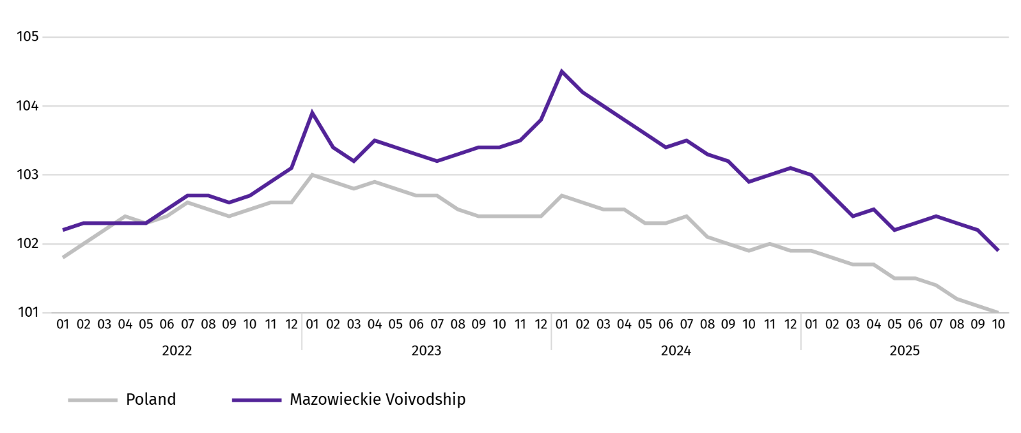
Chart 1. Average employment in the enterprise sector (monthly average 2021=100)

At the end of October this year, the number of unemployed persons registered in labour offices amounted to 118.7 thousand persons and increased on a yearly basis by 10.4 thousand persons (i.e. by 9.6%), and on a monthly basis decreased by 0.9 thousand persons (i.e. by 0.8%). Women accounted for 47.3% of total registered unemployed persons (a year before 49.0%).
Table 2. Number of unemployed persons and unemployment rate
SPECIFICATION | 2024 | 2025
SPECIFICATION | 10 | 09 | 10
Registered unemployed persons (as of end of month) in thousands | 108,3 | 119,6 | 118,7
Newly registered unemployed persons (during a month) in thousands | 13,6 | 14,8 | 13,9
Unemployed persons removed from unemployment rolls (during a month) in thousands | 14,9 | 15,3 | 14,8
Registered unemployment rate (as of end of month) in % | 4,0 | 4,4 | 4,4
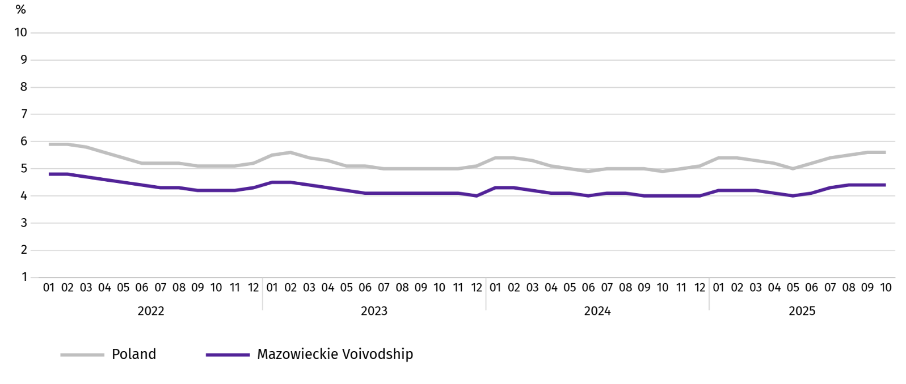
Chart 2. Registered unemployment rate (as of end of month)
Registered unemployment rate at the end of October this year amounted to 4.4% and was lower than the national average (5.6%). It increased on a yearly basis (0.4 pp), and a monthly basis remained unchanged.
The territorial differentiation of the unemployment rate continued in the Voivodship. Powiats with the highest unemployment rate were still szydłowiecki (21.7% against 23.1% in October last year), przysuski (17.7%; no changes on a yearly basis), and radomski (16.8% against 16.0%), and with the lowest – Warszawa (1.6% against 1.4%), warszawski zachodni (1.9% against 1.6%) and pruszkowski (2.6% against 2.1%).
Compared to October last year, the unemployment rate increased in 38 out of 42 powiats. The highest increase was recorded in the powiats: żuromiński (by 1.3 pp), wyszkowski (by 1.2 pp), legionowski and wołomiński (by 1.1 pp each). The decrease was recorded in the szydłowiecki powiat (by 1.4 pp).
Compared to September this year, the increase in unemployment rate of 0.1-0.4 pp took place in 8 powiats and a decrease of 0.1-0.5 pp in 18 powiats.
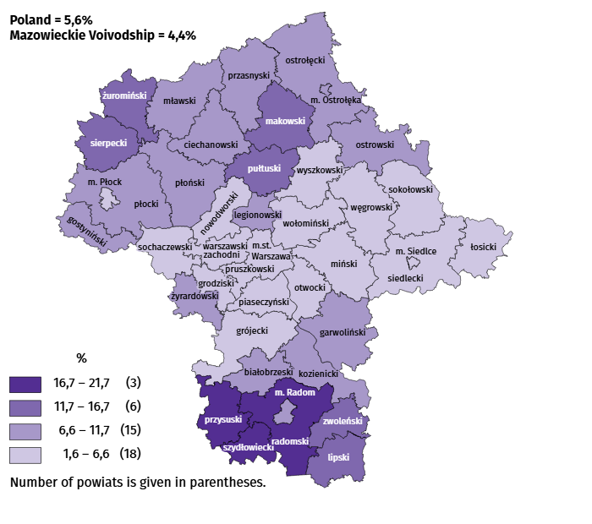
Map 1. Registered unemployment rate by powiats in 2025 (as of end of October)

In October this year, 13.9 thousand unemployed persons were registered in labour offices, i.e. more by 2.2% than a year before and by 5.7% than in the previous month. Among the newly registered, 67.1% were persons registering for the second time (72.9% in the previous year). Share of persons previously not employed amounted to 18.8% (an increase of 0.8 pp year-on-year), persons terminated for company reasons 3.8% (a decrease of 0.6 pp). Among newly registered unemployed persons, 40.7% lived in rural areas (a decrease of 0.8 pp). Graduates accounted for 11.6% of newly registered unemployed persons (an increase of 1.1 pp).
In October this year, 14.8 thousand persons were removed from unemployment rolls, i.e. less by 0.5% than a year before and by 3.2% than a month before. 9.0 thousand persons (5.6% more than a year before) were removed from unemployment rolls due to undertaking employment. The share of this category of persons in the total number of persons removed from unemployment rolls increased by 3.5 pp on a yearly basis and amounted to 60.5%. The share of persons who started training and employer sponsored traineeships increased as well (by 0.3 pp to 8.0%). However the percentage of persons who voluntarily gave up their status of the unemployed decreased (by 1.2 pp to 4.9%), and persons who obtained retirement or pension rights (by 0.1 pp and 0.5%).
At the end of October this year, 101.9 thousand unemployed persons were not entitled to the unemployment benefit, and their share in the total number of the registered unemployed was 85.9% (a 1.4 pp increase in annual terms).
At the end of the surveyed month, 58.5 thousand, i.e. 49.3% out of registered unemployed persons were the long-term unemployed. The number of unemployed persons under the age of 30 amounted to 27.8 thousand, which accounted for 23.4% of the total unemployed (of which persons under the age of 25 constituted 12.8%). Persons aged over 50 amounted to 31.8 thousand (26.8%). 0.5 thousand of unemployed persons, i.e. 0.4% of their total number received social assistance benefits. There were 14.2 thousand persons (i.e. 11.9% of the total unemployed) had at least one child under the age of 6, and persons with a disabled child aged under 18 – 430 persons (0.4% respectively). The number of disabled unemployed persons amounted to 5.5 thousand (i.e. 4.7%).
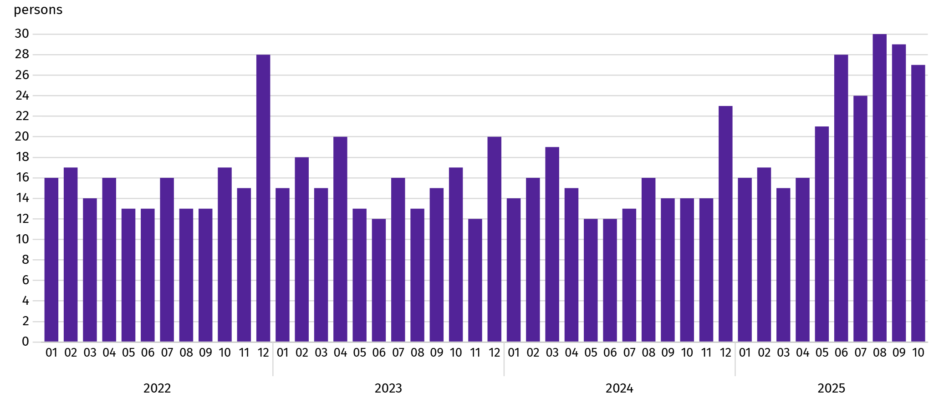
Chart 3. Registered unemployment rateª (as of end of month)

a From 1 June 2025, data on job offers are not fully comparable with earlier periods due to methodological changes resulting from the entry into force of the Act on the Labour Market and Employment Services (Journal of Laws of 2025, item 620).
In October this year, 5.0 thousand job offers were submitted to labour offices, i.e. less by 1.1% than in the previous month. At the end of month, there were 27 unemployed persons per job offer (29 a month before).
According to the labour offices, as of the end of October this year, 38 companies announced termination of 61.8 thousand employees in the near future (a year before, respectively 38 companies – 7.2 thousand employees).

Wages and salaries
In October this year, the average monthly gross wages and salaries in the enterprise sector increased on a yearly and on a monthly basis.
Average monthly gross wages and salaries in the enterprise sector in October this year amounted to PLN 10,141.45 and were higher than in the country (PLN 8,865.12). It increased by 5.3% on a yearly basis (by 8.0% in the previous month). The highest increase was recorded in manufacturing (by 9.3%), followed by among others in information and communication (by 8.3%), professional, scientific and technical activities (by 7.1%) and construction (by 6.7%). The decrease was recorded in transportation and storage (by 4.8%) and electricity, gas, steam and air conditioning supply (by 3.4%).
In comparison with September this year, the average wages and salaries increased by 1.7%. The largest increase concerned construction (by 7.2%), followed by, among others, real estate activities (by 2.5%), trade; repair of motor vehicles (by 2.2%), and transportation and storage (by 1.7%). The decrease was recorded only in professional, scientific and technical activities (by 3.1%).
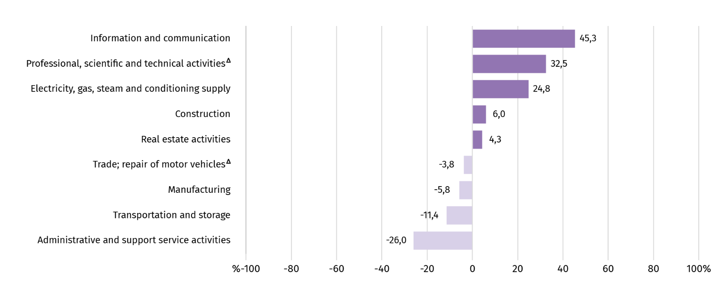
Chart 4. Relative deviations of average monthly gross wages and salaries in selected sections from average wages and salaries in the enterprise sector in October 2025

a Excluding divisions: Research and experimental development work and Veterinary activities.
Table 3. Average monthly gross wages and salaries in the enterprise sector in October 2025
SPECIFICATION | 10 2025 |  | 01–10 2025
SPECIFICATION | In PLN | 10 2024=100 | In PLN | 01–10 2024=100
TOTAL | 10141,45 | 105,3 | 10213,84 | 108,4
of which:
Industry | 9679,29 | 108,4 | 9820,88 | 110,4
of which:
manufacturing | 9551,33 | 109,3 | 9620,46 | 110,7
electricity, gas, steam and air conditioning supply | 12652,26 | 96,6 | 14510,10 | 106,6
Construction | 10752,62 | 106,7 | 10320,97 | 106,8
Trade; repair of motor vehicles ^{Δ} | 9756,15 | 104,4 | 9942,09 | 105,4
Transportation and storage | 8990,02 | 95,2 | 8794,85 | 108,3
Accommodation and catering ^{Δ} | . | . | . | .
Information and communication | 14732,90 | 108,3 | 15123,15 | 108,6
Real estate activities | 10581,42 | 102,1 | 10529,92 | 102,5
Professional, scientific and technical activities ª | 13437,91 | 107,1 | 13817,47 | 107,6
Administrative and support service activities | 7504,58 | . | 7568,79 | .
a Excluding divisions: Research and experimental development work and Veterinary activities.
In the period of January-October this year, the average monthly gross wages and salaries in the enterprise sector amounted to PLN 10,213.84 and was 8.4% higher than in the same period of 2024 (a year ago 10.9% higher).
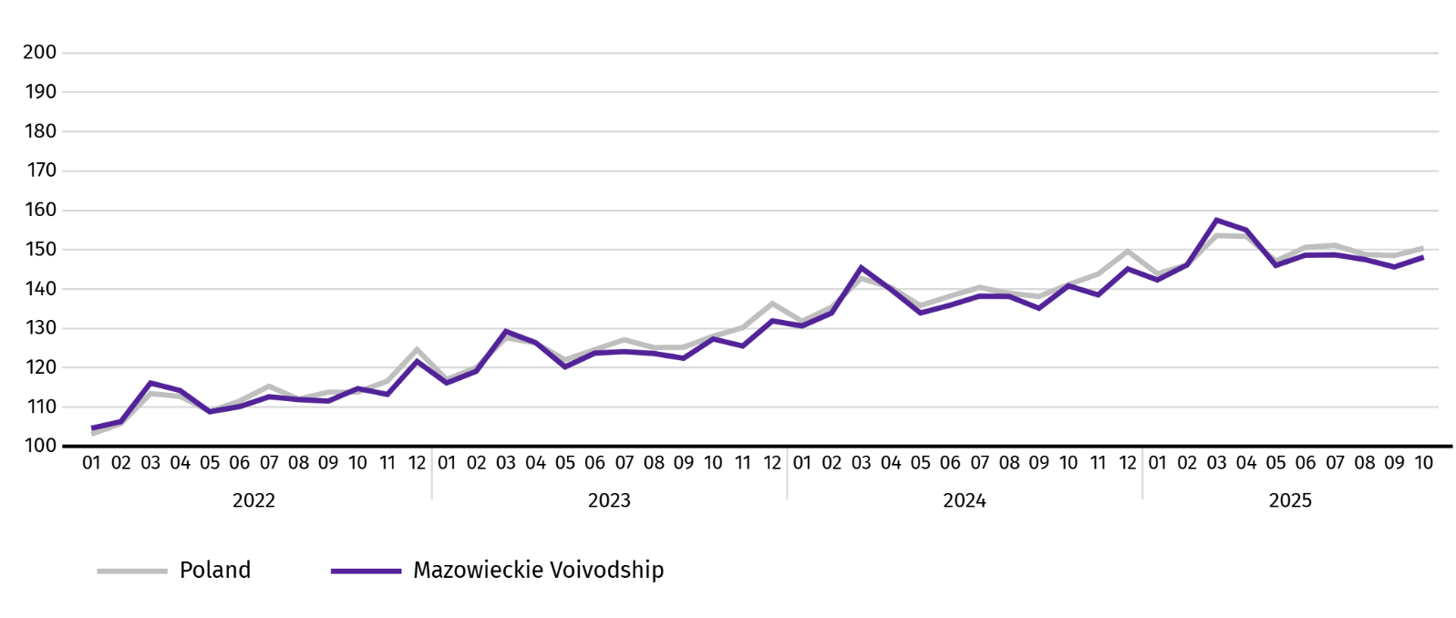
Chart 5. Average monthly gross wages and salaries in the enterprise sector (monthly average 2021=100)

Agriculture
On the agricultural market in October 2025, average procurement prices for cattle and poultry for slaughter were higher than a year ago, while prices for wheat, rye, potatoes, pigs for slaughter and milk were lower. On a monthly basis, lower prices were paid for all these agricultural products.
The average air temperature in Mazowieckie Voivodship in October 2025 amounted to 8.4°C and was by 0.04°C lower from the average from the years 1991–2020, while the maximum temperature reached 19.5°C, and the minimum amounted to minus 4.9°C (both values registered in Kozienice). The average atmospheric precipitation (59.1 mm) accounted for 148% of the standard for the multi-year periods (ranging from 99% in Kozienice to 173% in Mława) . The number of days with precipitation, depending on the region, ranged from 14 to 20.
Table 4. Skup zbóż ª
SPECIFICATION | 07–10 2025 |  | 10 2025
SPECIFICATION | in thousand tonnes | corresponding period of previous year=100 | in thousand tonnes | 10 2024=100 | 09 2025=100
Grain of basic cereals ^{b} | 181,7 | 100,7 | 30,6 | 80,6 | 67,9
of which:
wheat | 137,1 | 107,5 | 23,8 | 82,0 | 65,1
rye | 18,7 | 87,4 | 1,2 | 43,0 | 33,8
a Excluding procurement by natural persons. b Includes: wheat, rye, barley, oat, triticale; including cereal mixed, excluding sowing seed.
In July-October, the procurement of basic cereals (with cereal mixed, without sowing seed) amounted to 181.7 thousand tonnes and was by 0.7% higher than in the same period last year. Procurement of wheat during this period was 7.5% higher, and procurement of rye was 12.6% lower. In October of this year, deliveries of cereal to procurement were 19.4% lower than a year ago and by 32.1% than in the previous month.
Table 5. Procurement of basic animal products ª
SPECIFICATION | 01–10 2025 |  | 10 2025
SPECIFICATION | in thousand tonnes | 01–10 2024=100 | in thousand tonnes | 10 2024=100 | 09 2025=100
Animals for slaughter ^{b} | 985,0 | 93,5 | 85,1 | 79,4 | 106,9
of which:
cattle (including calves) | 51,7 | 109,4 | 2,5 | 76,0 | 90,3
pigs | 272,4 | 115,0 | 22,6 | 101,2 | 104,9
poultry | 660,1 | 85,9 | 60,0 | 73,6 | 108,4
Milk ^{c} | 2394,0 | 103,3 | 232,4 | 105,5 | 101,2
a In July-October excluding procurement by natural persons. b Including cattle, calves, pigs, sheep, horses and poultry; in terms of meat including fats in post-slaughter warm weight. c In million litres.
From the beginning of this year, producers from Mazowieckie Voivodship delivered 985.0 thousand tonnes of animals for slaughter (in warm weight), i.e. by 6.5% less than in the previous year. The decrease in procurement concerned poultry for slaughter (by 14.1%), while an increase concerned pigs (by 15.0%) and cattle for slaughter (by 9.4%). In October this year, the total supply of animals for slaughter (85.1 thousand tonnes) was higher by 6.9% than in the previous year, and by 20.6% lower than in the previous month.
Deliveries of milk in July-October 2025 (2,394.0 million litres) were by 3.3% larger than in the previous year. In October this year, the procurement of milk amounted to 232.4 million litres and was larger by 1.2% than in the previous month and by 5.5% than in the previous year.
Table 6. Average prices of basic agricultural products
SPECIFICATION | 10 2025 |  |  | 01–10 2025
SPECIFICATION | PLN | 10 2024=100 | 09 2025=100 | PLN | 01–10 2024=100
Wheat ª per dt | 76,12 | 84,1 | 97,5 | 87,32 | 103,3
Rye ª per dt | 59,94 | 92,8 | 96,3 | 68,22 | 120,8
Potatoes per dt | 46,84 | 88,6 | 95,5 | 68,99 | 79,0
Animals for slaughter per kg of live weight:
cattle (excluding calves) | 18,64 | 146,1 | 97,0 | 15,27 | 140,1
pigs | 6,47 | 90,6 | 94,0 | 6,84 | 90,2
poultry | 6,24 | 115,7 | 99,0 | 6,00 | 117,5
Milk per 1 hl | 218,81 | 99,3 | 98,7 | 224,38 | 111,0
a Excluding sowing seed.
In October 2025, PLN 76.12 was paid for 1 dt of wheat at procurement, i.e. 2.5% less than last month and 15.9% than last year. The average price of wheat at marketplaces was PLN 105.37 and was smaller by 2.9% than in September 2025, and by 2.7% than in October 2024. The procurement price of rye decreased by 3.7% (to PLN 59.94) compared to the previous month, and the marketplace price by 0.1% (to PLN 74.17). Compared to October 2024, procurement prices for rye were 7.2% lower, and marketplace prices by 7.3%.
Tablica 7. Average marketplace prices of wheat and potatoes
SPECIFICATION | 10 2025 |  |  | 01–10 2025
SPECIFICATION | PLN | 10 2024=100 | 09 2025=100 | PLN | 01–10 2024=100
Wheat per dt | 105,37 | 97,3 | 97,1 | 112,54 | 105,5
Rye per dt | 74,17 | 92,7 | 99,9 | 77,98 | 106,4
Potatoes ^{b} per dt | 184,89 | 86,2 | 93,6 | 208,83 | 88,4
a Edible late.
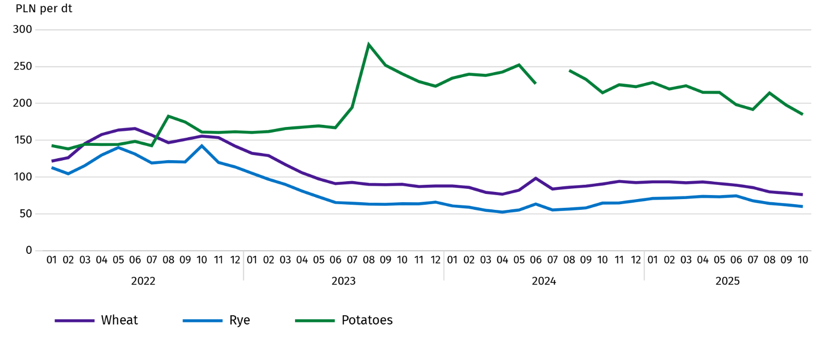
Chart 6. Average marketplace prices of cereals and potatoes ª

a In July 2024, the price of late edible potatoes was not recorded due to their absence at the time of observations.
In October 2025, the average procurement price of potatoes was PLN 46.84/dt, i.e. less by 4.5% than in the previous month and by 11.4% than last year. At marketplaces, the average price of 1 dt of potatoes was PLN 184.89 and was 6.4% lower than in the previous month, and by 13.8% than in the previous year.
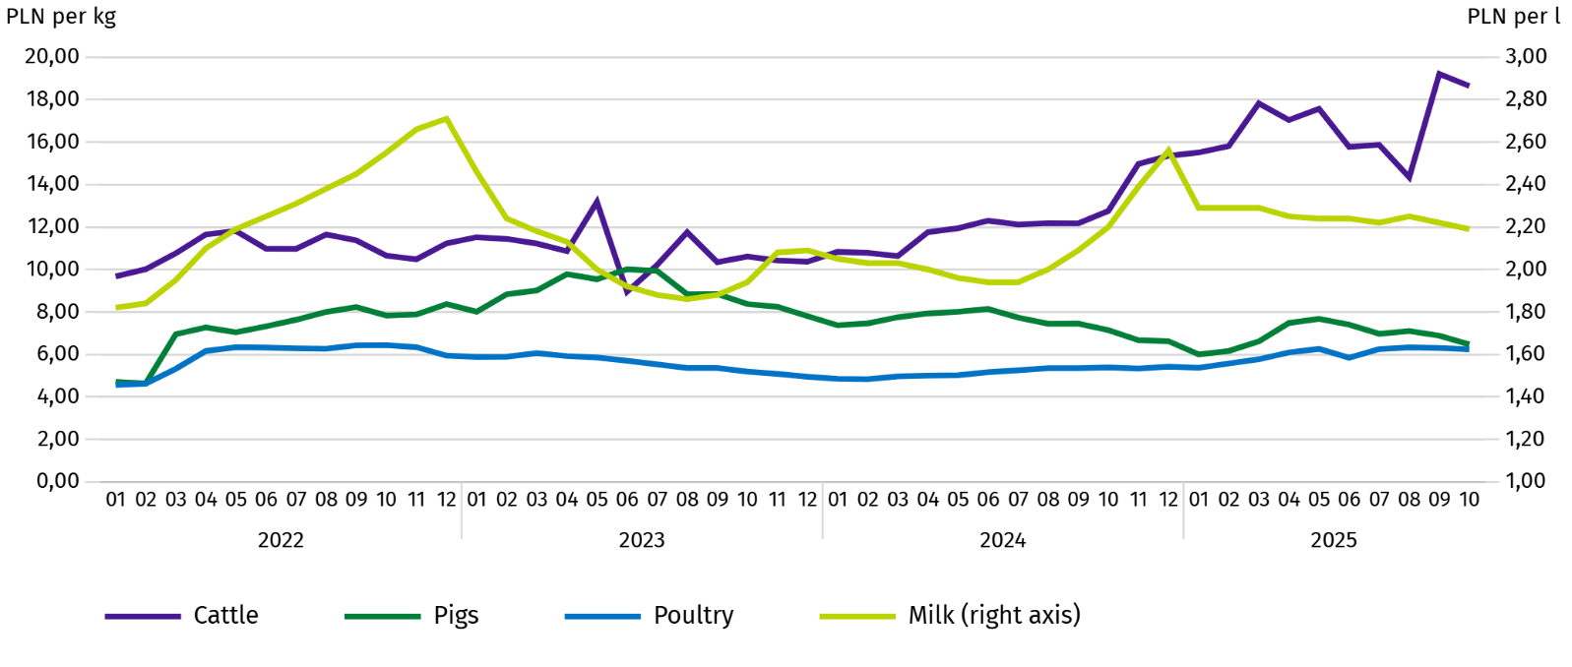
Chart 7. Average procurement prices of animals for slaughter and milk

In October 2025, the average procurement price of pigs for slaughter was lower by 6.0% than in the previous year, and by 9.4% than In the previous month.
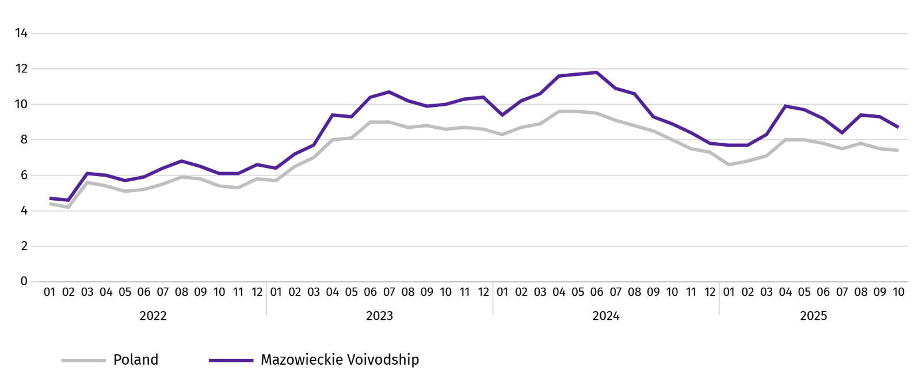
Chart 8. Ratio of the average procurement prices of pigs for slaughter to the average marketplace prices of rye

The procurement price of cattle for slaughter was lower by 3.0% than a month ago and by 46.1% lower than a year ago.
In October 2025, suppliers were paid an average of PLN 6.24 per 1 kg of poultry for slaughter, i.e. 1.0% less than in September 2025 and 15.7% more than in October 2024.
Procurement prices of milk in October 2025 were by 1.3% lower than in the previous year and by 0.7% than in the previous month.

Industry and construction
Sold production of industry in October this year, reached the value (at current prices) of PLN 46,974.1 million and was (at constant prices) at the same level as a year before (compared to a 4.6% increase in September this year); as compared to the previous month it increased by 6.8%.
Sold production in manufacturing (constituting 87.5% of sold production of industry) compared to October last year increased (at constant prices) by 0.1%. However there was an increase (by 1.3%) in sold production in the section of electricity, gas, steam and air conditioning supply (the share of this section represents 10.3% of industrial production).
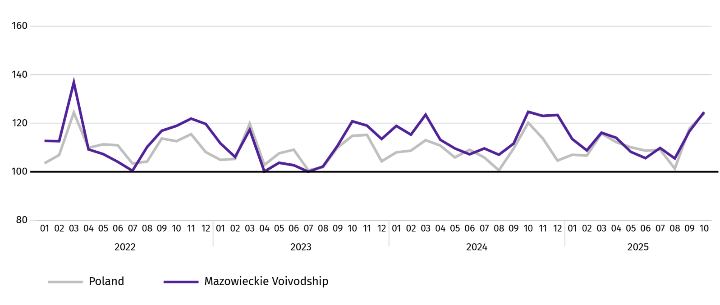
Chart 9. Sold production of industry (monthly average 2021=100; constant prices)
In October this year, the decrease in sold production in annual terms was recorded in 21 (out of 32 in the Voivodship) divisions of industry, among others, in: manufacture of beverages (by 29.5%), rubber and plastic products (by 8.6%), food products (by 6.8%), machinery and equipment n.e.c. (by 4.4%), other non-metallic mineral products (by 3.3%), computer, electronic and optical equipment (by 2.5%), metal products (by 1.1%), electrical equipment (by 0.9%). However, there was a decrease in sold production of, among others, paper and paper products (by 1.8%), and chemicals and chemical products (by 0.6%).
Table 8. Indices (constant prices) and structure (current prices) of sold production of industry in October 2025
SPECIFICATION | 10 2025 | 01–10 2025
SPECIFICATION | corresponding period of previous year=100 |  | In percent
TOTAL | 100,0 | 101,8 | 100,0
of which:
Manufacturing | 100,1 | 102,1 | 87,4
of which manufacture of:
food products | 106,8 | 104,1 | 22,4
beverages | 129,5 | 99,0 | 1,9
paper and paper products | 91,7 | 97,5 | 2,0
chemicals and chemical products | 99,4 | 102,4 | 4,2
manufacture of rubber and plastic products | 108,6 | 109,7 | 3,1
other non-metallic mineral products | 103,3 | 105,0 | 2,5
metal products ^{Δ} | 101,1 | 110,7 | 3,8
computer, electronic and optical equipment | 102,5 | 101,1 | 5,1
electrical equipment | 100,9 | 108,6 | 4,5
machinery and equipment n.e.c. | 104,4 | 106,0 | 1,9
Electricity, gas, steam and air conditioning supply ^{Δ} | 98,7 | 98,3 | 10,1
Labour productivity in industry measured by sold production per employed person, in October this year amounted (at current prices) to PLN 118.6 thousand and was (at constant prices) by 1.4% lower than a year before, with an increase in average paid employment by 1.4% and average monthly gross wages and salaries by 8.4%.
Sold production of industry in January–October this year, reached the value of PLN 438,331.4 million (at current prices) and was by 1.8% higher than in the corresponding period of previous year.
Sold production of construction (at current prices) in October this year, reached the value of PLN 10,696.9 million and was by 4.1% higher than in the previous year (compared to a 18.6% increase in September this year). In January-October this year, sold production of construction amounted to PLN 101,917.3 million and was by 7.5% higher compared to the corresponding period of last year.
Labour productivity in construction, measured by revenue from the sale of goods and services per employed person in October this year amounted to PLN 113.7 thousand (at current prices) and was by 3.0% higher compared to the corresponding month of the previous year, with an increase in average employment in construction by 1.1% and in average monthly gross wages and salaries by 6.7%.
Construction and assembly production (at current prices) in October this year, amounted to PLN 3,089.1 million and was by 13.0% higher than a year before (as compared to 12.4% increase in September this year). The increase in production was recorded in entities whose basic activity is the construction of buildings (by 52.7%) and in enterprises mainly performing specialised construction activities (by 8.7%). The decrease was recorded in units specialising in civil engineering (by 1.0%). In January-October this year, construction and assembly production was PLN 26,881.2 million and was 16.8% higher compared to the corresponding period of last year.
Table 9. Indices and structure (current prices) of construction and assembly production in October 2025
SPECIFICATION | 10 2025 | 01–10 2025
SPECIFICATION | corresponding period of previous year=100 |  | In percent
TOTAL | 113,0 | 116,8 | 100,0
Construction of buildings | 152,7 | 153,2 | 28,5
Civil engineering | 99,0 | 96,0 | 45,9
Specialised construction activities | 108,7 | 133,3 | 25,6

Residential construction
In October this year, the number of dwellings completed increased by 28.2% compared to the corresponding month in 2024. The number of dwellings for which permits have been granted or which have been registered with a construction project increased by 13.7%, and dwellings in which construction has begun by 12.1%.
According to preliminary data in October this year, there were 4509 dwellings completed, i.e. by 991 more (by 28.2%) than in the previous year and by 794 (by 13.3%) than in the previous month. There were 3500 dwellings built for sale or rent (77.6% of their total number), followed by private dwellings 895 (19.8%). Compared to October last year, there were more dwellings for sale or rent by 36.6%, and private dwellings by 2.3%.
The effects of housing construction obtained in Mazowieckie Voivodship in the surveyed month constituted 22.7% of national effects.
Table 10. Number of dwellings completed in January-October 2025
SPECIFICATION | Dwellings completed |  |  | Average useful floor area of a dwelling in m²
SPECIFICATION | In absolute numbers | In percent | 01–10 2024=100 | Average useful floor area of a dwelling in m²
TOTAL | 35079 | 100,0 | 116,2 | 83,8
Private | 8235 | 23,5 | 98,2 | 147,4
Cooperative | 339 | 1,0 | 186,3 | 51,3
For sale or rent | 25884 | 73,8 | 122,0 | 64,9
Municipal | 240 | 0,7 | 77,9 | 41,8
Public building society | 381 | 1,1 | 401,1 | 50,2

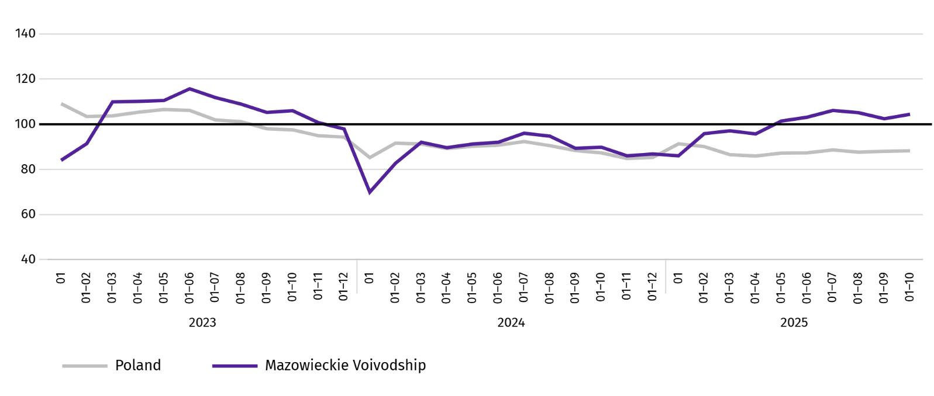
Chart 10. Dwellings completed (corresponding period 2021=100)

In the period January–October this year, most dwellings were completed in m.st. Warszawa (14901), and then in piaseczyński powiat (2589), and wołomiński (2309), and the least in łosicki (44), lipski (45) and makowski (59).
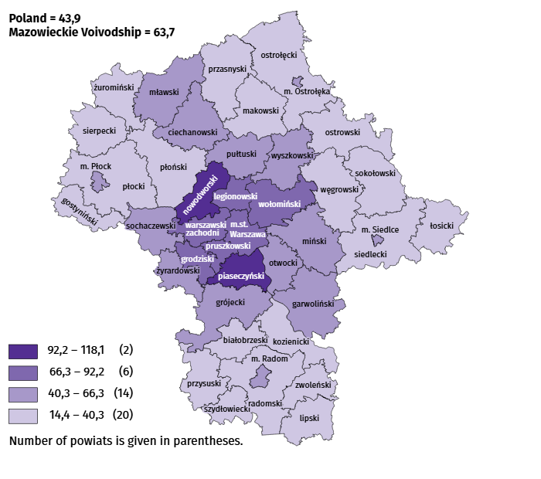
Map 2. Dwellings completed per 10 thousand populationª by powiats in January-October 2025

a Population as of 30 June 2025.
The average useful floor area of dwellings completed in October this year amounted to 79.9 m² and was larger than a year earlier by 6.5 m² than a year earlier. The largest dwellings were completed in żuromiński powiat (199.2 m²), Siedlce (176.2 m²) and siedlecki powiat (174.0 m²). The smallest were built in mławski powiat (54.4 m²), Płock (58.0 m²), Warszawa (59.5 m²) as well as Radom (61.8 m²).
In October this year, the number of dwellings for which permits have been granted or which have been registered with a construction project amounted to 5031, i.e. larger by 608 (by 13.7%) than a year earlier and by 203 (by 3.9%) than in the previous month. Of the total number of dwellings, 72.9% were dwellings for sale or rent, and 26.9% private.
In the surveyed month, the construction began in 4696 dwellings, which means an increase by 508 (by 12.1%) in annual terms and by 23 (by 0.5%) in monthly terms. Dwellings for sale or rent accounted for 75.0% of their total number, and private 25.0%.
Table 11. Number of dwellings for which permits have been granted or which have been registered with a construction project as well as dwelling in which construction has begun January–October 2025
SPECIFICATION | Dwellings for which permits have been granted or which have been registered with a construction project |  |  | Dwellings in which construction has begun
SPECIFICATION | in absolute numbers | in percent | 01–10 2024=100 | in absolute numbers | in percent | 01–10 2024=100
TOTAL | 40853 | 100,0 | 82,4 | 38337 | 100,0 | 97,8
Private | 11827 | 29,0 | 114,1 | 10516 | 27,4 | 101,9
Cooperative | 30 | 0,1 | 22,6 | – | – | .
For sale or rent | 28716 | 70,3 | 74,8 | 27744 | 72,4 | 97,3
Municipal | 52 | 0,1 | 33,5 | – | – | .
Public building society | 228 | 0,6 | 41,9 | 77 | 0,2 | 44,8

Internal market
In October this year, there was an increase in retail sales, while a decrease in wholesale compared to the previous year.
Retail sales (at current prices) in trade and non-trade enterprises in October this year, increased by 0.6% compared to the year before. The largest increase in sales was recorded in units from the group: “press, books, other sales in specialised stores” (by 23.2%), followed by “other retail sales in non-specialised stores” and “textiles, clothing and footwear” (by 5.7% each), “others” (by 5.3%), “food, beverages and tobacco” (by 3.5%). The decrease in retail sales recorded units from the group: “pharmaceuticals, cosmetics, orthopedic equipment” (by 4.8%), “motor vehicles, motorcycles, parts” (by 2.5%), “furniture, electronics and household appliances” (by 1.0%).
Compared to September this year, retail sales increased by 5.7%. The largest decrease in retail sales was recorded in the following groups: “textiles, clothing and footwear” (by 19.7%), “others” (by 10.7%), “food, beverages and tobacco” (by 10.5%). The decrease in sales was recorded in the groups of “motor vehicles, motorcycles, parts” (by 1.3%).
Table 12. Indices and structure (at current prices) of retail sales in October 2025
SPECIFICATION | 10 2025 | 01–10 2025
SPECIFICATION | corresponding period of previous year=100 |  | in percent
TOTAL ª | 100,6 | 99,5 | 100,0
of which:
Motor vehicles, motorcycles, parts | 97,5 | 97,1 | 7,0
Food, beverages and tobacco | 103,5 | 102,5 | 14,4
Other retail sales in non-specialised stores | 105,7 | 114,0 | 3,7
Pharmaceuticals, cosmetics and orthopedic equipment | 95,2 | 97,3 | 4,7
Textiles, clothing and footwear | 105,7 | 97,7 | 5,8
a The grouping of enterprises was made on the basis of the Polish Classification of Activities - PKD 2007, including the enterprise to a specific category according to the type of predominant activity, in accordance with the organizational status in the period under consideration. The recorded changes (increase/decrease) in retail sales in particular groups of activity of enterprises may also result from changes in the type of predominant economic activity and organisational changes (e.g. mergers of enterprises). This does not affect the dynamics of retail sales in general.
Table 12. Indices and structure (at current prices) of retail sales in September 2025 (cont.)
SPECIFICATION | 10 2025 | 01–10 2025
SPECIFICATION | corresponding period of previous year=100 |  | in percent
Furniture, electronics and household appliances | 99,0 | 101,8 | 17,7
Press, books and other sales in specialised stores | 123,2 | 118,1 | 7,3
Other | 105,3 | 104,5 | 9,5
In the period January-October 2025, retail sales decreased by 0.5% year-on-year. The decrease in sales was recorded by enterprises from the group “motor vehicles, motorcycles, parts” (by 2.7%), “textiles, clothing and footwear” (by 2.3%), while the increase in sales recorded enterprises from the group "press, books, other sales in specialised stores" (by 18.1%), “other retail sales in non-specialised stores” (by 14.0%), “others” (by 4.5%), “food, beverages and tobacco” (by 2.5%), “furtniture, electronics and household appliances” (by 1.8%).
Wholesale (at current prices) in trade enterprises in October this year was by 6.7% higher as compared to the previous month and by 2.8% lower compared to October 2024. In wholesale enterprises it was higher by 2.8% and lower by 6.4%, respectively.
In January-October 2025, wholesale in trade enterprises was 6.9% lower than in the previous year, and in wholesale enterprises lower by 6.3%.

Finanical results of enterprises
In the January–September 2025, the financial results of the surveyed enterprises were higher than those achieved a year earlier. Basic economic and financial indicators were also more favourable.
In the January–September 2025, the financial results of the surveyed enterprises were more favourable than in the previous year. Cost level indicators and gross and net turnover profitability indicators improved.
Table 13. Revenue, costs and financial results of enterprises
SPECIFICATION | 01–09 2024 | 01–09 2025
SPECIFICATION | In milion PLN
Total revenue (revenue from total activity) | 1311385,2 | 1350384,8
of which revenue from sale of products, goods and materials | 1263010,2 | 1296127,1
Costs of obtaining revenue from total activity | 1250832,0 | 1283803,2
of which of cost of products, goods and materials sold | 1208157,9 | 1235696,1
Result on sale of products, goods and materials | 54852,4 | 60431,0
Result on other operational activity | 5014,8 | 5461,7
Result of financial operations | 686,0 | 688,9
Gross financial result | 60553,2 | 66581,6
Net financial result | 49727,1 | 54288,8
net profit | 60047,6 | 64259,7
net loss | 10320,5 | 9970,8
Revenue from total activity in the first half of 2025, were by 3.1% higher than in the previous year, while costs of obtaining this revenue increased by 2.6%, which resulted in the improvement of cost level indicator. Net revenue from sale of products, goods and materials as well as costs of this activity were higher than in the previous year by 2.6% and 2.3%, respectively. In terms of value, the highest increase in net revenue from the sale of products, goods and materials was recorded, among others, in information and communication, professional, scientific and technical activities and transportation and storage.
Financial result from sale of products, goods and materials was by 10.2% higher than a year before and amounted to PLN 60,431.0 million. The result on other operational activity was estimated at PLN 5,461.7 million compared to PLN 5,014.8 million. Worse than a year before, was the result on financial operations (PLN 688.9 million against PLN 686.0 million). Financial revenue increased by 7.0%, and financial costs by 7.2%.
As a result, the gross financial result reached PLN 66,581.6 million and was higher by PLN 6,028.4 million (by 10.0%) from the result obtained in the corresponding period of 2024. Encumbrances on gross financial result increased in annual terms by 13.5% to PLN 12,292.8 million. The net financial result was estimated at PLN 54,288.8 million and was higher by PLN 4,561.8 million (by 9.2%) compared to the result obtained a year earlier; net profit increased by 7.0%, and net loss by 3.4%.
In the analysed period, 75.7% of the surveyed enterprises showed a net profit (74.6% a year before). The share of revenue of enterprises showing net profit in the total amount of revenue from total activity increased from 84.5% to 85.4%. In manufacturing, 75.4% of enterprises showed a net profit (a year before – 76.4%), and the share of revenue generated by these enterprises in the revenue of total entities of this section accounted for 90.1% (91.3% a year earlier).
On an annual basis, the cost level indicator and gross turnover profitability indicator improved by 0.3 pp each, gross sales profitability indicator increased by 0.4 pp, and gross net turnover profitability indicator by 0.2 pp. The first degree financial liquidity indicator was higher by 7.2 pp, and the second degree financial liquidity indicator – by 1.5 pp.
Table 14. Economic relations in enterprises
SPECIFICATION | 01–09 2024 | 01–09 2025
SPECIFICATION | in %
Cost level indicator | 95,4 | 95,1
Gross sales profitability indicator | 4,3 | 4,7
Gross turnover profitability indicator | 4,6 | 4,9
Net turnover profitability indicator | 3,8 | 4,0
First degree financial liquidity indicator | 45,7 | 52,9
Second degree financial liquidity indicator | 123,3 | 124,8
Out of 16 sections, the most profitable types of activity were, among others, accommodation and catering (net turnover profitability indicator 14.8%), education (indicator 13.6%) and water supply; sewerage, waste management and remediation activities (indicator 10.6%). Compared to January-September of the previous year, the improvement in net turnover profitability was recorded in 10 sections.
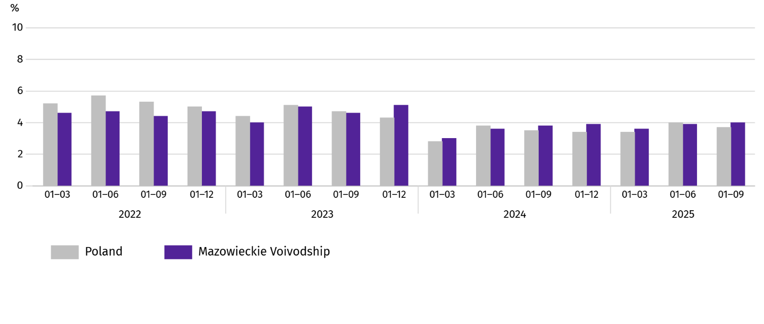
Chart 11. Net turnover profitability indicator

The value of current assets of the surveyed enterprises at the end of September 2025 amounted to PLN 673,407.3 million and was by 3.0% higher than a year before, with short-term inter-period settlements were higher by 19.2%, and short-term investments by 17.3%, stocks by 2.2%, while short-term dues were lower by 6.1%. In the material structure of current assets, the share of short-term investments (from 27.6% to 31.4%), and short-term inter-period settlements (from 3.3% to 3.9%), however the share of short-term dues decreased (from 46.8% to 42.7%), and stocks (from 22.3% to 22.1%). In the structure of stocks, the share of goods increased (from 42.8% to 44.6%), however the share of materials decreased (from 28.5% to 23.6%), finished products (from 12.6% to 9.7%) as well as semi-finished products and products in progress (from 13.0% to 12.3%).
Financial current assets were mainly short-term liabilities – the ratio of short-term liabilities to current assets amounted to 59.3% against 60.3% a year earlier.
Long- and short-term liabilities (excluding special funds) at the end of September 2025 amounted to PLN 656,277.3 million and were by 3.9% higher than a year before. Long-term liabilities accounted for 39.1% of total liabilities (at 37.6% in September 2024), and their value amounted to PLN 256,909.3 million and was by 8.3% higher than a year earlier. Short-term liabilities of surveyed enterprises amounted to PLN 399,368.0 million and were higher by 1.3% per year, of which liabilities for taxes, duties, insurance and other benefits were higher by 9.6%, and for deliveries and services by 4.9%, and– by 8.1%.

Investment outlays
In January-September 2025, the investment outlays of the surveyed enterprises were higher than last year. The estimated value of newly started investments was higher as well.
Investment outlays carried out in January-September of this year by enterprises based in Mazowieckie Voivodship reached the value of PLN 51,529.6 million and were (at current prices) by 6.4% higher than in the corresponding period of previous year. Outlays on buildings and structures increased by 3.5%, while on purchases by 8.6%, with outlays on machinery, technical equipment and tools were higher by 7.7%, and outlays on transport equipment – by 10.3%. The share of purchases in total outlays amounted to 59.8% (58.6% a year before).
Chart 12. Investment outlays (current prices; increase/decrease compared to the previous year)
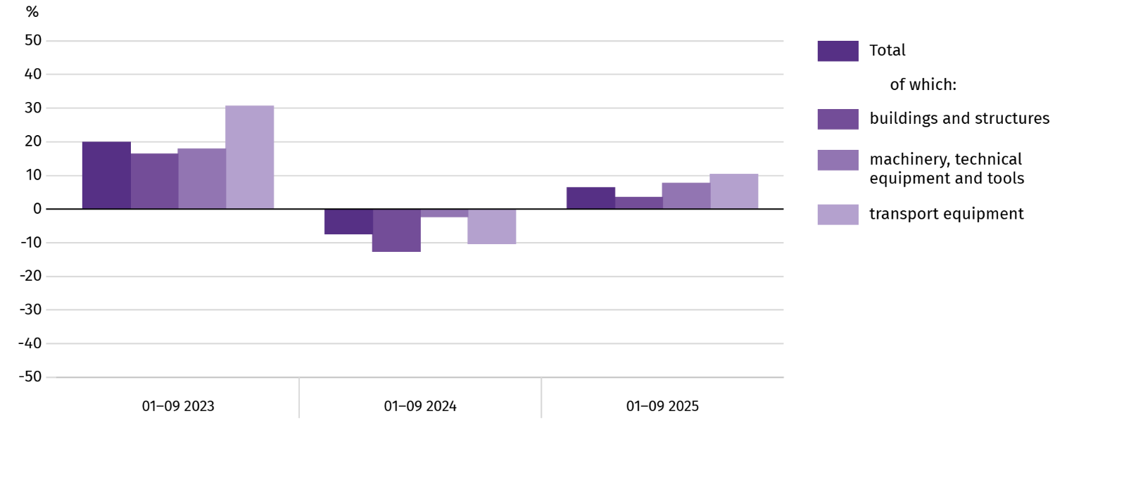
The increase in investment outlays was observed, among others, in construction (by 35.1%) and in real estate activities (by 31.2%). The decrease in outlays was recorded, among others, in water supply; sewerage, waste management and remediation activities (by 31.3%) and in accommodation and catering (by 24.7%).
In January-September of this year, investments were primarily made by enterprises operating in manufacturing (which accounted for 27.0% of total expenditure), and in transportation and storage (21.8%). In the structure of outlays by section, compared to the same period of the previous year, the share of expenditure incurred by enterprises operating in manufacturing decreased the most (by 3.0 pp).
Since the beginning of the year, 27,341 investments were started, which is 2.0% less than a year ago. The total estimated value of newly started investments amounted to PLN 32,410.5 million, which was 55.9% higher than in the first half of the previous year. Improvements (i.e., reconstruction, expansion, or modernisation) of existing fixed assets accounted for 66.5% of the estimated value of all initiated investments (compared to 54.6% a year ago). The estimated value of investments initiated by enterprises operating in professional, scientific and technical activities increased the most (over two and a half times).

Entities of the national economy
In October of this year, the number of entities of the national economy registered in the REGON register increased by 0.4% compared to the previous month. There were more newly registered entities and entities with suspended activity (by 1.4% and 0.6%, respectively). While the number of entities removed from the REGON register decreased by 1.1%.
As of the end of October this year, the number of entities of the national economy registered in the REGON register amounted to 1084899, which means an increase of 3.6% year-on-year and 0.4% compared to the previous month.
In the total number of registered entities, the greatest number is natural persons conducting economic activity. At the end of October this year, there were 699715 of them, i.e. more by 3.6% than in the previous year. The number of companies which were registered in the REGON register amounted to 304989, including 245130 commercial companies (an annual increase by 3.8% and 4.7%, respectively). There were 59400 civil partnerships i.e. more 0.3% compared to the previous year.
According to the expected number of employed persons, entities that declared employment of up to 9 persons prevailed upon entry in the REGON register; they constituted 97.3% of all registered units. The share of entities with an estimated number of 10-49 employed persons was 2.1%, and of entities employing more than 49 persons – 0.5%. Over the year, the increase in the number of entities occurred among the smallest entities (up to 9 persons) – by 3.7%.
Compared to October 2024, the largest increase in the number of entities was recorded in the sections: professional, scientific and technical activities – more by 7302 units (in percentage terms, a 4.5% increase), administrative and support service activities by 6123 units (an increase of 12.3%), information and communication by 5620 units (5.7%).
Compared to September 2025, the largest percentage increase in the number of entities was recorded in the sections: administrative and support service activities (by 0.9%), human health and social work activities (by 0.8%), education (by 0.7%).
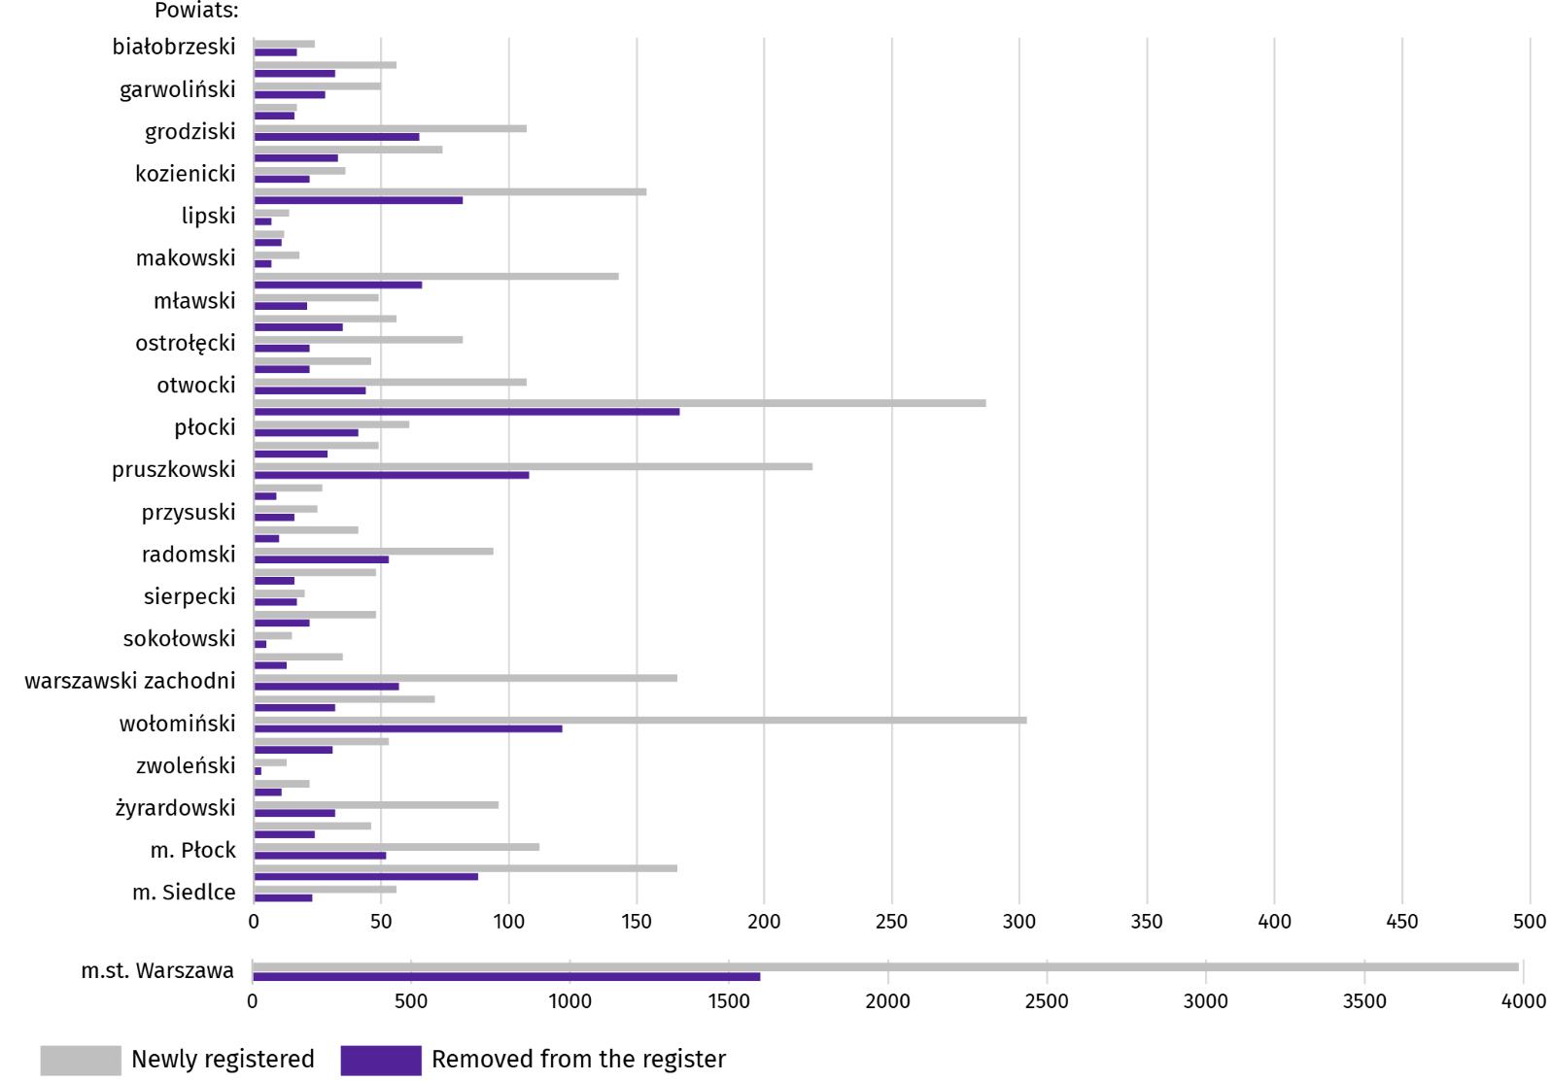
Chart 13. Entities of the national economy newly registered and removed from the register in October 2025

In October this year, 7102 new entities were registered in the REGON register, i.e. by 1.4% more than in the previous month. The newly registered units were dominated by natural persons conducting economic activity, 5152 of whom were registered (by 2.4% more than in the previous month). The number of newly registered commercial companies was larger by 0.4%, including companies with limited liability by 1.1%.
In the surveyed month, 3109 entities were removed from the REGON register (by 8.6% less than a month ago), including 2423 natural persons conducting economic activity (by 3.4% less).
As of the end of October this year, there were 145588 entities in the REGON with suspended activity (by 0.6% more than a month ago). The vast majority were natural persons conducting economic activity (94.2%; 94.3% in the previous month).
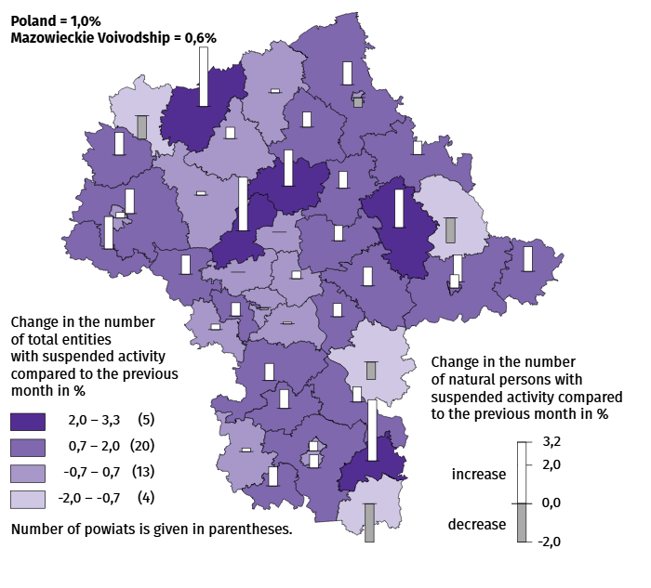
Map 3. Entities of the national economy with suspended activity in October 2025

Business tendency
In November of this year, the general business climate indicator in most of the surveyed economic sectors indicated a stabilisation of the economic climate compared to the previous month. A noticeable deterioration in business conditions occurred only in construction, as well as in transportation and storage (the indicator in each of these sections dropped by 3.2 compared to October of this year). Economic entities conducting activity in accommodation and catering assess the economic climate most favourably (plus 14.5), and the indicator value is above the long-term average (plus 0.4). Construction companies express the most pessimistic assessments (minus 3.2), but the indicator value is above the long-term average (minus 4.8).

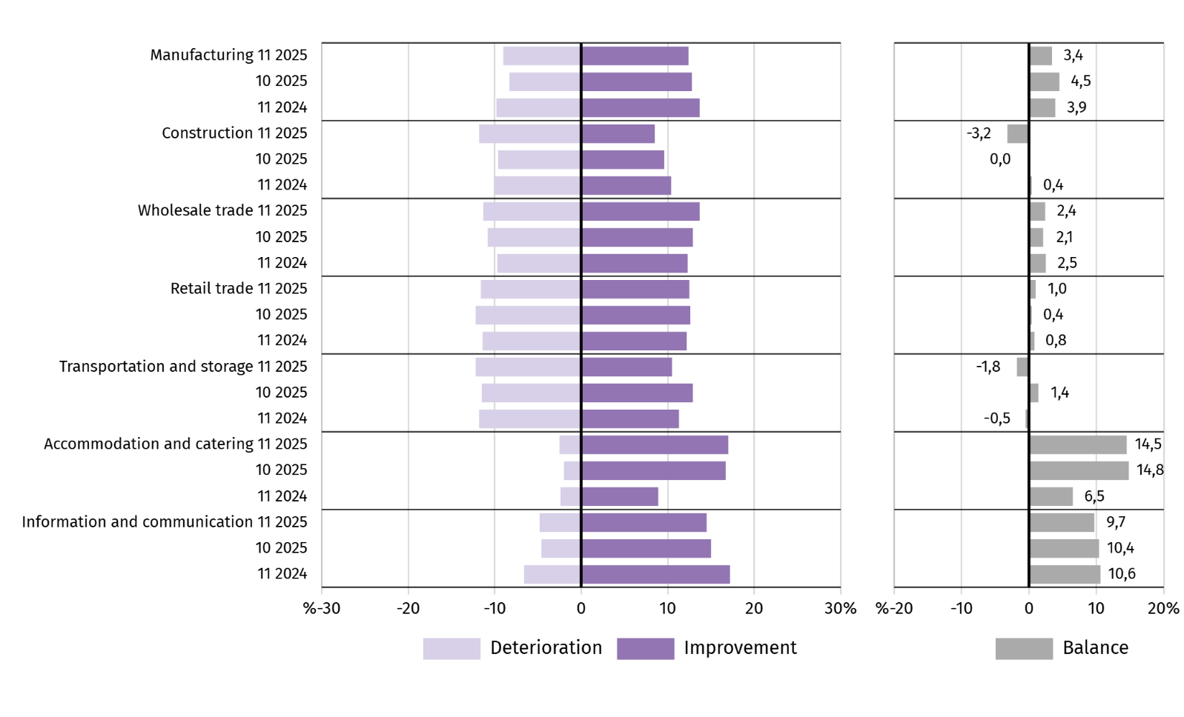
Chart 14. Indices of the general business climate by type of activity (sections and divisions of NACE Rev. 2)

Questions about investments
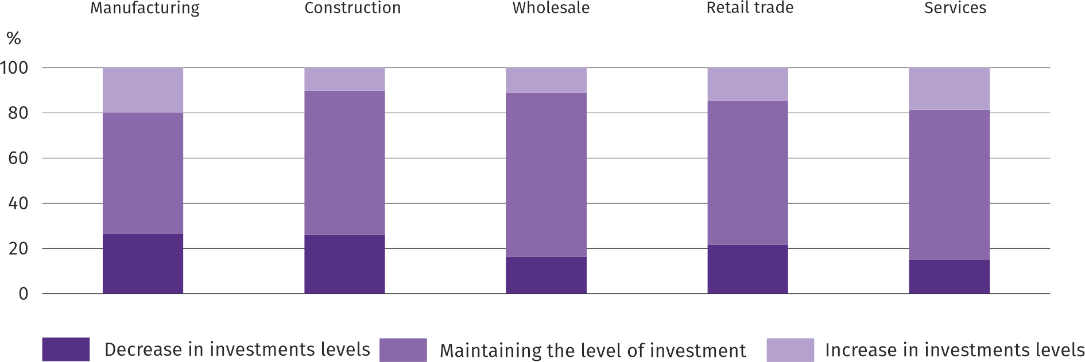
Question 1. What are your current projections for your company's investment level in 2025, relative to investments made in 2024?:

In all sectors of the economy surveyed, the majority of entrepreneurs predicted that investment in 2025 would remain at the previous year's level. Both a decline and an increase in investment were most often expected in manufacturing.
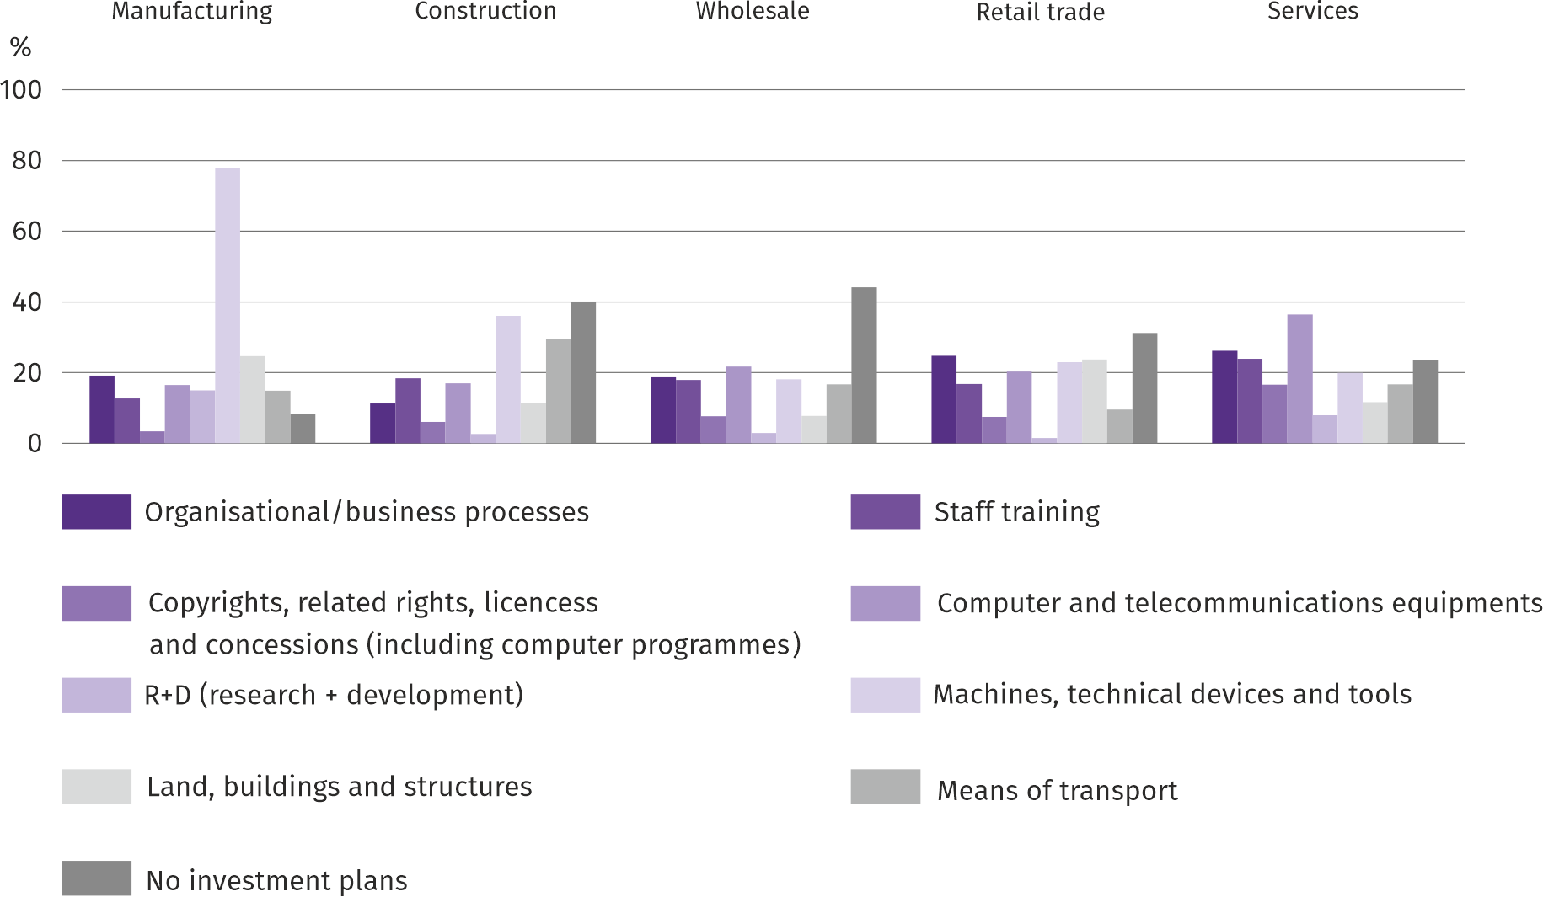
Question 2. What are your company's main investment directions this year?:

Entrepreneurs operating in the manufacturing and construction sections indicated machinery, technical equipment, and tools as their primary investment focus. In wholesale and services, the most frequently mentioned investments were computer and telecommunications equipment, and in retail, organisational/business processes.
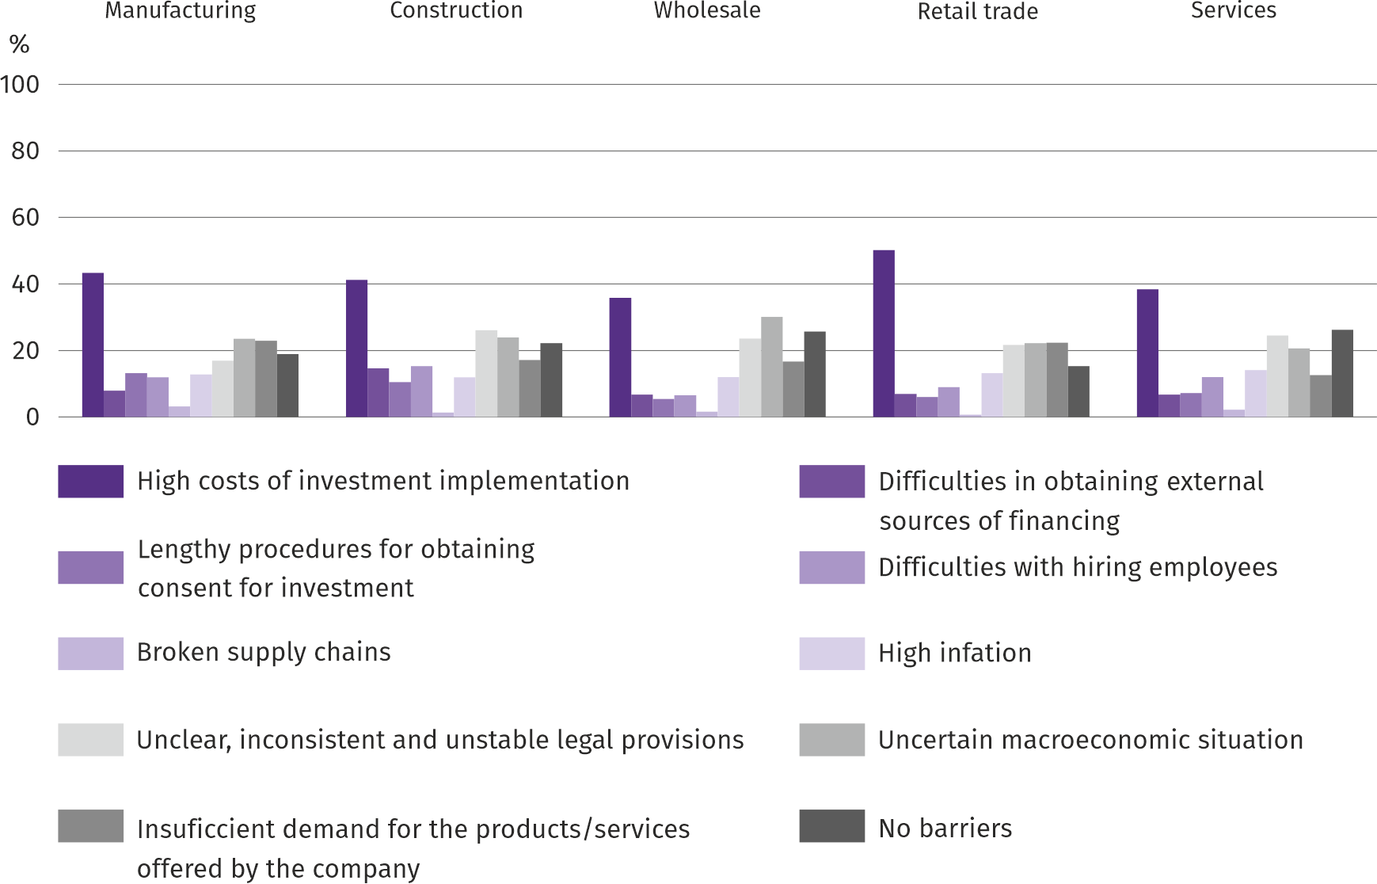
Question 3. Which of the following barriers have the greatest impact on the scale of your company's investments this year?

Regardless of the type of economic activity, entrepreneurs identified high investment costs as the main barrier to investment. Other barriers cited included unclear, inconsistent, and unstable legal regulations, an uncertain macroeconomic situation, and insufficient demand for the company's products and services. Broken supply chains were considered the least significant barrier.

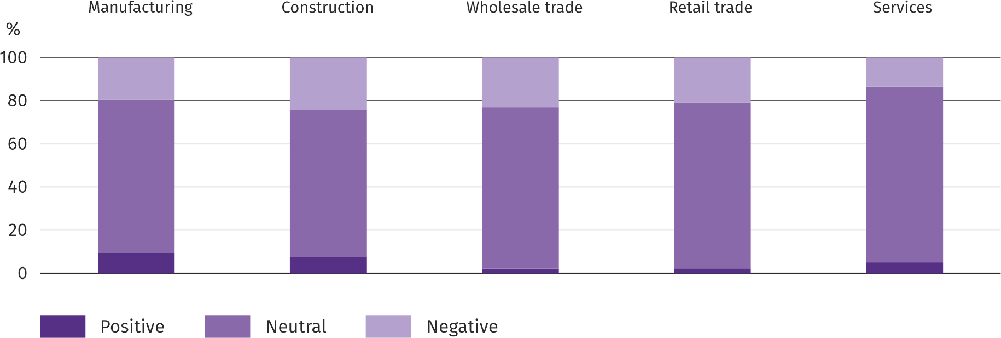
Question 4. How do current changes in your company's situation and market environment affect your willingness to invest?:

Across all surveyed economic activity sectors, the vast majority of entrepreneurs believed that changes in the company's situation and the market environment had a neutral impact on their willingness to invest. The highest percentage of entrepreneurs perceiving a positive impact of these factors on their willingness to invest was recorded in manufacturing, and the lowest in wholesale trade.
More information on the results of the business climate survey can be found on the website of the Statistical Office in Zielona Góra https://zielonagora.stat.gov.pl/osrodki/osrodek-badan-koniunktury/obk-dane/.

Table 15. Selected data on Mazowieckie Voivodship
SPECIFICATION  A – 2024  B – 2025 |  | 01 | 02 | 03 | 04 | 05 | 06 | 07 | 08 | 09 | 10 | 11 | 12
Average employment in the enterprise sector ª  (in thousand persons) | A | 1607,0 | 1601,8 | 1598,1 | 1594,4 | 1591,7 | 1588,1 | 1589,5 | 1586,0 | 1584,4 | 1580,1 | 1582,0 | 1583,9
 | B | 1582,5 | 1577,9 | 1572,7 | 1574,8 | 1570,6 | 1572,8 | 1574,1 | 1572,8 | 1571,5 | 1567,2
previous month=100 | A | 100,7 | 99,7 | 99,8 | 99,8 | 99,8 | 99,8 | 100,1 | 99,8 | 99,9 | 99,7 | 100,1 | 100,1
previous month=100 | B | 99,9 | 99,7 | 99,7 | 100,1 | 99,7 | 100,1 | 100,1 | 99,9 | 99,9 | 99,7
corresponding month of previous year=100 | A | 100,7 | 100,8 | 100,8 | 100,3 | 100,3 | 100,1 | 100,3 | 100,0 | 99,8 | 99,5 | 99,4 | 99,3
corresponding month of previous year=100 | B | 98,5 | 98,5 | 98,4 | 98,8 | 98,7 | 99,0 | 99,0 | 99,2 | 99,2 | 99,2
Registered unemployed persons (in thousand persons; as of end of period) | A | 117,1 | 117,7 | 114,8 | 111,9 | 110,0 | 108,5 | 109,9 | 110,6 | 109,6 | 108,3 | 108,4 | 109,0
 | B | 114,7 | 115,9 | 113,9 | 111,3 | 108,7 | 111,0 | 116,0 | 120,2 | 119,6 | 118,7
Unemployment rate b (in %; as of end of period) | A | 4,3 | 4,3 | 4,2 | 4,1 | 4,1 | 4,0 | 4,1 | 4,1 | 4,0 | 4,0 | 4,0 | 4,0
Unemployment rate b (in %; as of end of period) | B | 4,2 | 4,2 | 4,2 | 4,1 | 4,0 | 4,1 | 4,3 | 4,4 | 4,4 | 4,4
Job offers (submitted during a month) | A | 17944 | 17639 | 14928 | 16475 | 16584 | 17271 | 17764 | 12910 | 13202 | 16551 | 13455 | 10874
Job offers (submitted during a month) | B | 15760 | 13938 | 14768 | 13164 | 11459 | 4235 | 5656 | 4432 | 5028 | 4975
Unemployed persons per 1 job offer (as of end of period) | A | 14 | 16 | 19 | 15 | 12 | 12 | 13 | 16 | 14 | 14 | 14 | 23
Unemployed persons per 1 job offer (as of end of period) | B | 16 | 17 | 15 | 16 | 21 | 28 | 24 | 30 | 29 | 27
Average monthly gross wages and salaries in the en-terprise sector ª (in PLN) | A | 8943,42 | 9165,69 | 9949,91 | 9568,24 | 9156,63 | 9296,77 | 9459,07 | 9445,98 | 9239,16 | 9629,96 | 9480,33 | 9931,44
 | B | 9739,87 | 10004,89 | 10785,77 | 10612,28 | 9995,20 | 10173,45 | 10185,77 | 10100,98 | 9974,07 | 10141,45
previous month=100 | A | 99,0 | 102,5 | 108,6 | 96,2 | 95,7 | 101,5 | 101,7 | 99,9 | 97,8 | 104,2 | 98,4 | 104,8
previous month=100 | B | 98,1 | 102,7 | 107,8 | 98,4 | 94,2 | 101,8 | 100,1 | 99,2 | 98,7 | 101,7
corresponding month of previous year=100 | A | 112,4 | 112,3 | 112,3 | 110,5 | 111,1 | 109,7 | 111,2 | 111,6 | 110,3 | 110,5 | 110,4 | 110,0
corresponding month of previous year=100 | B | 108,9 | 109,2 | 108,4 | 110,9 | 109,2 | 109,4 | 107,7 | 106,9 | 108,0 | 105,3
Price indices:
consumer goods and services ^{c}:
corresponding month of previous year=100 | A | . | . | 103,4 | . | . | 102,6 | . | . | 104,4 | . | . | 104,7
corresponding month of previous year=100 | B | . | . | 104,7 | . | . | 103,7 | . | . | . | .
a In enterprises employing more than 9 persons. b Share of registered unemployed persons in civilian economically active population, estimated at the end of each month. c From 1 June 2025, data on job offers are not fully comparable with earlier periods due to methodological changes resulting from the entry into force of the Act on the Labour Market and Employment Services (Journal of Laws of 2025, item 620). d In the quarter.
Table 15. Selected data on Mazowieckie Voivodship (cont.)
SPECIFICATION  A – 2024  B – 2025 |  | 01 | 02 | 03 | 04 | 05 | 06 | 07 | 08 | 09 | 10 | 11 | 12
Price indices (cont.):
Procurement of cereal grain:
previous month=100 | A | 106,0 | 97,7 | 92,9 | 94,5 | 106,7 | 119,5 | 82,0 | 107,3 | 100,4 | 105,7 | 104,7 | 97,5
previous month=100 | B | 102,5 | 100,3 | 98,5 | 102,4 | 98,1 | 97,1 | 94,2 | 93,1 | 99,4 | 97,5
corresponding month of previous year=100 | A | 65,8 | 66,0 | 68,4 | 70,6 | 83,3 | 105,9 | 88,3 | 96,9 | 96,1 | 99,5 | 107,1 | 110,3
corresponding month of previous year=100 | B | 106,6 | 109,4 | 116,0 | 125,8 | 115,7 | 94,0 | 108,0 | 93,8 | 92,9 | 85,7
procurement of cattle for slaughter (excluding calves):
previous month=100 | A | 104,4 | 99,6 | 98,6 | 110,6 | 101,6 | 103,0 | 98,6 | 100,4 | 100,0 | 104,8 | 117,3 | 102,5
previous month=100 | B | 101,0 | 102,0 | 112,7 | 95,6 | 103,1 | 89,8 | 100,6 | 90,3 | 134,0 | 97,0
corresponding month of previous year=100 | A | 93,9 | 94,2 | 94,8 | 108,2 | 90,6 | 137,3 | 118,8 | 103,6 | 117,7 | 120,3 | 143,7 | 148,0
corresponding month of previous year=100 | B | 143,3 | 146,7 | 167,6 | 144,9 | 147,2 | 128,3 | 130,9 | 117,7 | 157,8 | 146,1
procurement of pigs for slaughter:
previous month=100 | A | 94,5 | 101,2 | 103,9 | 102,4 | 101,0 | 101,6 | 95,0 | 96,2 | 100,1 | 95,9 | 93,4 | 99,2
previous month=100 | B | 90,7 | 102,7 | 107,4 | 113,0 | 102,6 | 96,4 | 94,3 | 101,8 | 96,9 | 94,0
corresponding month of previous year=100 | A | 91,9 | 84,4 | 86,0 | 81,1 | 83,9 | 81,3 | 77,8 | 84,2 | 84,2 | 85,3 | 81,0 | 84,8
corresponding month of previous year=100 | B | 81,4 | 82,6 | 85,4 | 94,3 | 95,8 | 90,9 | 90,2 | 95,5 | 92,4 | 90,6
Ratio of procurement prices ª of pigs for slaughter to marketplace prices of rye | A | 9,4 | 10,2 | 10,6 | 11,6 | 11,7 | 11,8 | 10,9 | 10,6 | 9,3 | 8,9 | 8,4 | 7,8
 | B | 7,7 | 7,7 | 8,3 | 9,9 | 9,7 | 9,2 | 8,4 | 9,4 | 9,3 | 8,7
Sold production of industry ^{b} (at constant prices):
previous month=100 | A | 104,8 | 97,0 | 107,1 | 91,7 | 96,8 | 97,8 | 102,2 | 97,6 | 104,3 | 111,7 | 98,6 | 100,3
previous month=100 | B | 92,0 | 95,9 | 106,7 | 98,2 | 94,9 | 97,6 | 104,0 | 96,1 | 110,6* | 106,8
corresponding month of previous year=100 | A | 109,2 | 111,4 | 108,4 | 114,0 | 108,3 | 108,0 | 113,1 | 107,1 | 103,3 | 105,6 | 104,4 | 108,7
corresponding month of previous year=100 | B | 95,4 | 94,3 | 93,9 | 100,6 | 98,6 | 98,4 | 100,2 | 98,6 | 104,6* | 100,0
Construction and assembly production b (at current prices):
previous month=100 | A | 34,4 | 123,4 | 111,9 | 125,7 | 101,6 | 107,2 | 98,7 | 95,1 | 113,8 | 103,6 | 102,1 | 140,0
previous month=100 | B | 47,2 | 107,8 | 118,8 | 106,2 | 100,8 | 106,8 | 104,8 | 89,5 | 116,9 | 104,2
corresponding month of previous year=100 | A | 95,7 | 107,3 | 88,7 | 117,5 | 109,0 | 106,0 | 117,3 | 98,9 | 98,8 | 112,0 | 101,3 | 103,0
corresponding month of previous year=100 | B | 141,1 | 123,2 | 130,9 | 110,6 | 109,7 | 109,3 | 116,1 | 109,4 | 112,4 | 113,0
a Current prices excluding VAT. b In enterprises employing more than 9 persons.

Table 15. Selected data on Mazowieckie Voivodship (cont.)
SPECIFICATION  A – 2024  B – 2025 |  | 01 | 02 | 03 | 04 | 05 | 06 | 07 | 08 | 09 | 10 | 11 | 12
Dwellings completed (from the beginning of the year) | A | 2723 | 5939 | 9232 | 11738 | 14595 | 17553 | 21339 | 24190 | 26662 | 30180 | 33728 | 38521
Dwellings completed (from the beginning of the year) | B | 3349 | 6885 | 9739 | 12532 | 16228 | 19683 | 23575 | 26855 | 30570 | 35079
corresponding month of previous year=100 | A | 83,2 | 90,5 | 83,7 | 81,4 | 82,6 | 79,5 | 85,9 | 86,9 | 84,9 | 84,7 | 85,4 | 88,6
corresponding month of previous year=100 | B | 123,0 | 115,9 | 105,5 | 106,8 | 111,2 | 112,1 | 110,5 | 111,0 | 114,7 | 116,2
Retail sales of goods ª (at current prices):
previous month=100 | A | 75,5 | 100,0 | 112,7 | 101,6 | 99,0 | 99,3 | 105,6 | 98,9 | 91,9 | 106,4 | 101,2 | 111,9
previous month=100 | B | 78,0 | 94,8 | 113,7 | 104,7 | 97,6 | 98,8 | 104,6 | 98,9 | 95,6 | 105,7
corresponding month of previous year=100 | A | 100,3 | 103,6 | 101,9 | 103,4 | 105,1 | 102,7 | 105,9 | 99,1 | 93,0 | 94,3 | 97,2 | 98,4
corresponding month of previous year=100 | B | 101,6 | 96,3 | 97,2 | 100,1 | 98,7 | 98,2 | 97,3 | 97,3 | 101,3 | 100,6
Turnover profitability indicator in enterprises ^{b}:
gross ^{c} (in %) | A | . | . | 4,0 | . | . | 4,4 | . | . | 4,6 | . | . | 4,9
gross ^{c} (in %) | B | . | . | 4,6 | . | . | 4,9 | . | . | 4,9 | .
net ^{d} (in %) | A | . | . | 3,0 | . | . | 3,6 | . | . | 3,8 | . | . | 3,9
net ^{d} (in %) | B | . | . | 3,6 | . | . | 3,9 | . | . | 4,0 | .
Investment outlays of enterprises ^{b} – from the begin-ning of the year (in million PLN; current prices) | A | . | . | 13513,2 | . | . | 29901,6 | . | . | 48420,6 | . | . | 75782,3
 | B | . | . | 13471,2 | . | . | 31921,6 | . | . | 51529,6 | .
corresponding month of previous year=100 (current prices) | A | . | . | 97,0 | . | . | 95,7 | . | . | 92,6 | . | . | 93,7
corresponding month of previous year=100 (current prices) | B | . | . | 99,7 | . | . | 106,8 | . | . | 106,4 | .
Entities of the national economy ^{e} in the REGON regis-ter (as of end of period) | A | 1013945 | 1018833 | 1022367 | 1026106 | 1029355 | 1032369 | 1035867 | 1039428 | 1043211 | 1047123 | 1050447 | 1052760
 | B | 1055182 | 1057965 | 1061558 | 1064898 | 1068064 | 1071074 | 1074082 | 1077325 | 1080871 | 1084899
of which commercial companies | A | 224121 | 225458 | 226664 | 227868 | 228837 | 229562 | 230815 | 231886 | 232883 | 234115 | 234950 | 236043
of which commercial companies | B | 237041 | 237949 | 239071 | 240155 | 240700 | 241451 | 242422 | 243409 | 696939 | 245130
of which with foreign capital participation | A | 40492 | 40647 | 40808 | 41008 | 41245 | 41356 | 41550 | 41689 | 41873 | 42067 | 42226 | 42385
of which with foreign capital participation | B | 42461 | 42567 | 42726 | 42857 | 42903 | 43009 | 43119 | 43266 | 43348 | 43446
a In enterprises employing more than 9 persons. b In enterprises employing more than 49 persons. c Relation of gross financial result to revenues from total activity. d Relation of net financial result to revenues from total activity. e Excluding persons tending private farms in agriculture.
Prepared by:  Statistical Office in Warszawa  Director Agnieszka Ajdyn  Phone: (+48 22) 464 23 15 | Issued by:  Statistical Information Centre  Mobile: (+48) 783 940 141  e-mail: m.kaluski@stat.gov.pl

warszawa.stat.gov.pl/en/

@Warszawa_STAT

@UrzadStatystycznywWarszawie

gus_stat

glownyurzadstatystycznygus

glownyurzadstatystyczny

In the case of quoting data from the Statistics Poland, please provide information “Statistics Poland data source”, and in the case of publishing calculations made on data published by the Statistics Poland, provide information: “Own study based on Statistics Poland data”.
Related information
Statistical Bulletin of Mazowieckie Voivodship
Report of the socio-economic situation of Mazowieckie Voivodship in 2024
Socio-economic situation of voivodships No. 2/2025
Data available in databases
Local Data Bank (BDL)
Knowledge Databases (DBW)
Terms used in official statistics
Average paid employment
Registered unemployed persons
Registered unemployment rate
Monthly gross wages and salaries
Retail prices
Price index of consumer goods and services
Procurement of agricultural products
Procurement prices
Marketplace prices
Pigs
Cattle
Sold production of industry
Construction and assembly production
Dwellings completed
Retail sales of goods (including VAT)
Wholesale (including VAT)
Financial results of enterprises
Investment outlays
Entities of the national economy
Business tendency

The long-term unemployed include persons remaining in the register of the powiat labour office for a total period of more than 12 months in the last 2 years, excluding periods of internship and vocational preparation.
Refers to vacancies and places of occupational activation.
The average values of temperature and precipitation were calculated as arithmetic averages of the average monthly values from five hydrological and meteorological stations of the Institute of Meteorology and Water Management located in Kozienice, Mława, Płock, Siedlce and Warszawa.
Reporting data – may change after preparing quarterly report.
Applies to legal persons, organisational units without legal personality and natural persons conducting economic activity (excluding natural persons tending private farms in agriculture).
The survey was conducted from the 1st to the 10th of the current month on a sample of industrial, construction, commercial, and service entities. Responses to the entire additional block of questions are provided on a voluntary basis. All questions present a weighted percentage of respondents' responses to a given option. Data were aggregated according to the aggregation (weighting) methodology standardly used in economic climate surveys.

