Socio-economic situatin of Mazowieckie Voivodship in September 2025
- In September this year, the average employment in the enterprise sector decreased on a yearly basis by 0.8%, and on a monthly basis by 0.1%. The registered unemployment rate amounted to 4.4% and increased on an annual basis (by 0.4 pp), and did not change compared to the previous month.
- Average monthly gross wages and salaries in the enterprise sector in September this year were higher by 8.0% compared to the previous year and lower by 1.3% than in the previous month.
- On the agricultural market in September 2025, the average procurement prices of rye, cattle and poultry for slaughter and milk were higher than in the previous year, while the prices of wheat, potatoes and pigs for slaughter were lower. On a monthly basis, more was paid for pigs and poultry for slaughter, and less for wheat, rye, potatoes pigs and poultry for slaughter as well as milk.
- In September this year, sold production of industry (at constant prices) increased on a yearly (by 4.0%) and on a monthly basis (by 9.9%). Construction and assembly production (at current prices) was higher by 12.4% than in the previous year and by 16.9% than a month earlier.
- The number of dwellings completed in September this year, was higher by 50.3% than a year before and by 13.3% compared to the previous month. Most dwellings were built for sale or rent.
- In September this year, there was an increase in retail sales in annual terms (by 1.3%). Wholesale was higher than in the previous year (by 0.8%).
- In September this year, the number of entities of the national economy registered in the REGON register was higher by 3.6% than in the previous year and by 0.3% than in the previous month.
- In October of this year, the general business climate indicator in most of the surveyed economic sectors indicated a stabilisation of the economic climate compared to the previous month. A noticeable deterioration in the economic climate occurred only in the transportation and storage sector (the indicator dropped by 5.8 points compared to September of this year). In other sectors, business opinions remained similar to those of the previous month. The most optimistic assessments were expressed by entities in the accommodation and catering sector, with the indicator value above the long-term average. Only entities involved in construction assessed the economic climate at a neutral level, with the indicator value above the long-term average.

Contents
Labour market 4
Wages and salaries 7
Agriculture 9
Industry and construction 12
Residential construction 14
Internal market 16
Entities of the national economy 17
Business tendency 19
Selected data on Mazowieckie Voivodship 25

General notes
Data presented in the news release:
- on employment, wages and salaries and sold production of industry and construction, construction and assembly production, as well as retail sales and wholesale concern economic entities employing more than 9 persons,
- on enterprise sector refer to entities conducting economic activity in the field of: forestry and logging; maritime fishing; mining and quarrying; manufacturing; electricity, gas, steam and air conditioning supply; water supply; sewerage, waste management and remediation activities; construction; wholesale and retail trade; repair of motor vehicles and motorcycles; transportation and storage; accommodation and food service activities; information and communication; real estate activities; legal and accounting activities; activities of head offices; management consultancy activities; architectural and engineering activities; technical testing and analysis; advertising and market research; other professional, scientific and technical activities; arts, entertainment and recreation; repair of computers and personal and household goods; other personal service activities,
- on retail prices of foodstuffs and non-foodstuffs as well as services that originate from quotations of prices conducted by interviewers at selected points of sale in selected regions of price surveys; prices of food are collected once a month, with the exception of fruit and vegetables, for which prices are collected twice a month,
- on procurement of agricultural products include procurement from producers from the voivodship; prices are given excluding VAT tax,
- on financial results of enterprises and investment outlays refer to economic entities keeping accounting ledgers (excluding entities whose activity is classified according to the NACE Rev. 2 in the sections “Agriculture, forestry and fishing” and “Financial and insurance activities” as well as higher education institutions) in which the number of employed persons exceeds 49.
Data in value terms are provided at current prices and form the basis for calculating the structure indicators. Dynamic indices are provided on the basis of value at current prices, except for industry, for which the dynamic indices are provided on the basis of value at constant prices (average current prices of 2015).
Relative numbers (indices, percentages) were calculated on the basis of absolute data expressed with higher precision than that presented in the text and tables.
Data have been presented in accordance with the Polish Classification of Activities – PKD 2007 (NACE Rev. 2).

Polish Classification of Activities 2007 (PKD 2007)
Abbreviation | Full name
sections
trade; repair of motor vehicles | wholesale and retail trade; repair of motor vehicles and motorcycles
accommodation and catering | accommodation and food service activities
divisions
trade; repair of motor vehicles | wholesale and retail trade; repair of motor vehicles and motorcycles

Symbols
Symbol | Description
(–) | – magnitude zero
(.) | – data not available, classified data (statistical confidentiality) or providing data impossible or purposeless
(*) | – data revised
∆ | – categories of applied classification are presented in abbreviated form
„Of which” | – indicates that not all elements of the sum are given
Data describing Mazowieckie Voivodship can also be found in statistical publications issued by the Statistical Office in Warszawa and in the publications of Statistics Poland.
The report „Economic situation in Mazowieckie Voivodship in October 2025” will be published on the home page of the Statistical Office in Warszawa: https://warszawa.stat.gov.pl/en on 30 October 2025.
When publishing Statistical Office data, please indicate the source.

Labour market
In September this year, the average employment in the enterprise sector was lower compared to the previous year and compared to the previous month. The registered unemployment rate increased year-on-year and remained unchanged month-on-month.
Average employment in the enterprise sector in September this year amounted to 1,571.5 thousand persons (full-time equivalent) and was by 0.8% lower in annual terms (in the previous month by 0.8%). The most significant decrease was recorded in accommodation and catering (by 6.0%), followed by trade; repair of motor vehicles (by 5.1%) and transportation and storage (by 4.0%). The highest increase was recorded in real estate activities (by 11.1%), followed by, among others, in professional, scientific and technical activities (by 3.5%), electricity, gas, steam and air conditioning supply (by 2.6%), and manufacturing (by 2.4%).
In comparison with August this year, average employment decreased by 0.1%; the most in accommodation and catering (by 1.5%), followed by trade; repair of motor vehicles (by 0.3%) and in construction, manufacturing, transportation and storage as well as electricity, gas, steam and air conditioning supply (by 0.1% each). The increase was recorded in real estate activities (by 0.2%) and also in professional, scientific and technical activities and information and communication (by 0.1% each).
Table 1. Average employment in the enterprise sector in August 2025
SPECIFICATION | 09 2025 |  | 01–09 2025
SPECIFICATION | In thousands | 09 2024=100 | In thousands | 01–09 2024=100
TOTAL | 1571,5 | 99,2 | 1576,7 | 98,8
of which:
Industry | 399,5 | 102,2 | 401,8 | 101,9
of which:
manufacturing | 358,4 | 102,4 | 360,7 | 102,1
electricity, gas, steam and air conditioning supply | 20,4 | 102,6 | 20,4 | 102,8
Construction | 93,9 | 100,9 | 93,5 | 100,5
Trade; repair of motor vehicles ^{Δ} | 324,2 | 94,9 | 326,0 | 94,9
Transportation and storage | 260,6 | 96,0 | 263,0 | 95,6
Accommodation and catering ^{Δ} | 34,9 | 94,0 | 34,9 | 94,7
Information and communication | 137,4 | 101,2 | 138,0 | 101,3
Real estate activities | 28,9 | 111,1 | 29,0 | 111,3
Professional, scientific and technical activities ª | 116,1 | 103,5 | 115,4 | 103,1
Administrative and support service activities | . | . | . | .
a Excluding divisions: Research and experimental development work and Veterinary activities.
In the period of January-September this year, average employment in the enterprise sector amounted to 1,576.7 thousand persons and decreased by 1.2% compared to the same period of 2024 (a year ago, an increase of 0.5% was recorded).
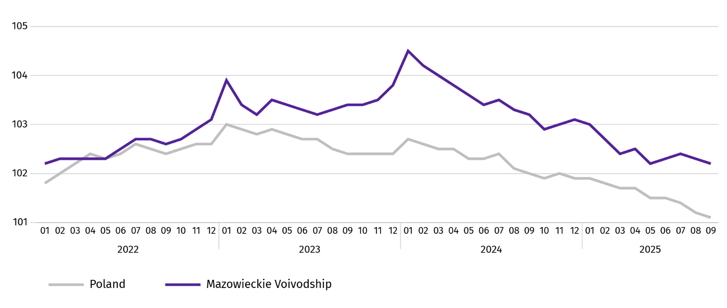
Chart 1. Average employment in the enterprise sector (monthly average 2021=100)

At the end of September this year, the number of unemployed persons registered in labour offices amounted to 119.6 thousand persons and increased on a yearly basis by 10.0 thousand persons (i.e. by 9.1%), and on a monthly basis by 0.6 thousand persons (i.e. by 0.5%). Women accounted for 47.5% of total registered unemployed persons (a year before 49.3%).
Table 2. Number of unemployed persons and unemployment rate
SPECIFICATION | 2024 | 2025
SPECIFICATION | 09 | 08 | 09
Registered unemployed persons (as of end of month) in thousands | 109,6 | 120,2 | 119,6
Newly registered unemployed persons (during a month) in thousands | 14,2 | 12,2 | 14,8
Unemployed persons removed from unemployment rolls (during a month) in thousands | 15,2 | 8,1 | 15,3
Registered unemployment rate (as of end of month) in % | 4,0 | 4,4 | 4,4
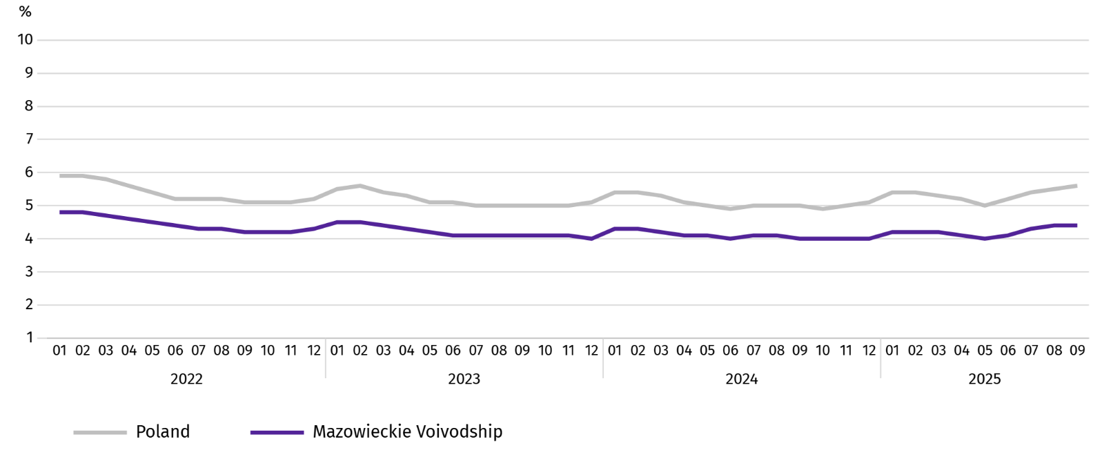
Chart 2. Registered unemployment rate (as of end of month)
Registered unemployment rate at the end of September this year amounted to 4.4% and was lower than the national average (5.6%). It increased on a yearly basis (0.4 pp), and a monthly basis remained unchanged.
The territorial differentiation of the unemployment rate continued in the Voivodship. Powiats with the highest unemployment rate were still szydłowiecki (21.7% against 23.3% in September last year), przysuski (18.2% against 18.0%), and radomski (16.8% against 16.2%), and with the lowest – Warszawa (1.6% against 1.4%), warszawski zachodni (1.9% against 1.6%) and pruszkowski (2.6% against 2.2%).
Compared to September last year, the unemployment rate increased in 38 out of 42 powiats. The highest increase was recorded in the powiats: wyszkowski (by 1.2 pp), wołomiński and żuromiński (by 1.0 pp each), and in Siedlce (by 0.9 pp). The decrease was recorded in the szydłowiecki powiat (by 1.6 pp).
Compared to August this year, the increase in unemployment rate of 0.1-0.4 pp took place in 20 powiats and a decrease of 0.1-08 pp in 10 powiats.
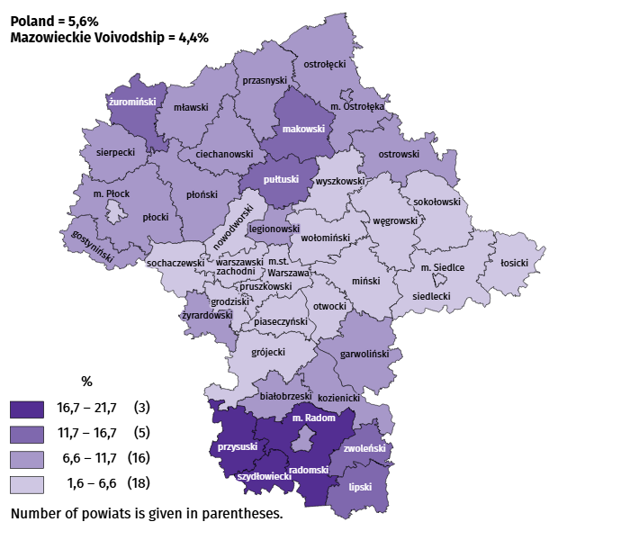
Map 1. Registered unemployment rate by powiats in 2025 (as of end of September)

In September this year, 14.8 thousand unemployed persons were registered in labour offices, i.e. more by 3.7% than a year before and by 20.5% than in the previous month. Among the newly registered, 65.9% were persons registering for the second time (71.5% in the previous year). Share of persons previously not employed amounted to 20.7% (an increase of 1.7 pp year-on-year), persons terminated for company reasons 3.8% (a decrease of 0.2 pp). Among newly registered unemployed persons, 42.0% lived in rural areas (a decrease of 2.5 pp). Graduates accounted for 13.0% of newly registered unemployed persons (an increase of 0.8 pp).
In September this year, 15.3 thousand persons were removed from unemployment rolls, i.e. more by 0.7% than a year before and by 89.8% than a month before. 9.1 thousand persons (0.5% more than a year before) were removed from unemployment rolls due to undertaking employment. The share of this category of persons in the total number of persons removed from unemployment rolls decreased by 0.2 pp on a yearly basis and amounted to 59.5%. The share of persons who started training and employer sponsored traineeships decreased as well (by 0.6 pp to 7.2%) and persons who voluntarily gave up their status of the unemployed (by 0.6 pp to 5.2%). However the percentage of persons who obtained retirement or pension rights increased (by 0.1 pp and 0.4%).
At the end of September this year, 102.4 thousand unemployed persons were not entitled to the unemployment benefit, and their share in the total number of the registered unemployed was 85.6% (a 0.9 pp increase in annual terms).
At the end of the surveyed month, 58.2 thousand, i.e. 48.7% out of registered unemployed persons were the long-term unemployed. The number of unemployed persons under the age of 30 amounted to 28.1 thousand, which accounted for 23.5% of the total unemployed (of which persons under the age of 25 constituted 12.7%). Persons aged over 50 amounted to 31.8 thousand (26.6%). 0.5 thousand of unemployed persons, i.e. 0.4% of their total number received social assistance benefits. There were 14.4 thousand persons (i.e. 12.0% of the total unemployed) had at least one child under the age of 6, and persons with a disabled child aged under 18 – 427 persons (0.4% respectively). The number of disabled unemployed persons amounted to 5.6 thousand (i.e. 4.6%).
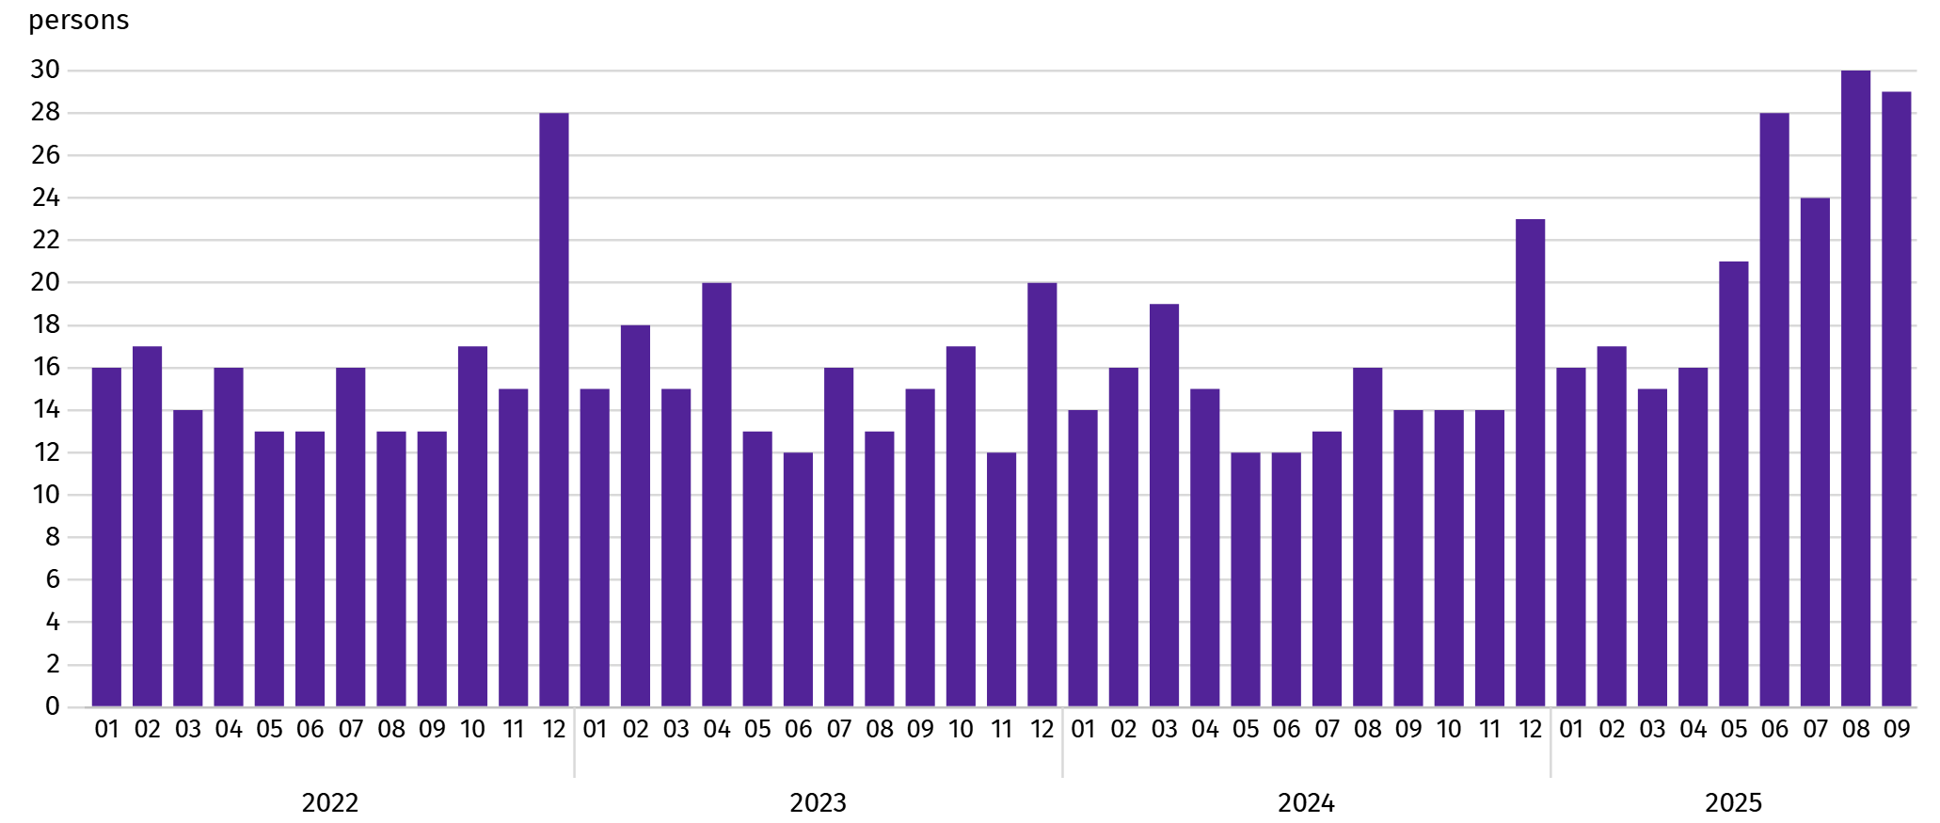
Chart 3. Registered unemployment rateª (as of end of month)

a From 1 June 2025, data on job offers are not fully comparable with earlier periods due to methodological changes resulting from the entry into force of the Act on the Labour Market and Employment Services (Journal of Laws of 2025, item 620).
In September this year, 5.0 thousand job offers were submitted to labour offices, i.e. more by 13.4% than in the previous month. At the end of month, there were 29 unemployed persons per job offer (30 a month before).
According to the labour offices, as of the end of September this year, 31 companies announced termination of 61.6 thousand employees in the near future (a year before, respectively 38 companies – 7.5 thousand employees).

Wages and salaries
In September this year, the average monthly gross wages and salaries in the enterprise sector increased on a yearly basis, but decreased on a monthly basis.
Average monthly gross wages and salaries in the enterprise sector in September this year amounted to PLN 9,974.07 and were higher than in the country (PLN 8,750.34). It increased by 8.0% on a yearly basis (by 6.9% in the previous month). The increase was recorded in all surveyed sections; the largest – in manufacturing (by 9.4%), followed by, among others, professional, scientific and technical activities (by 9.0%), transportation and storage (by 8.5%) and construction (by 8.1%).
In comparison with August this year, the average wages and salaries decreased by 1.3%. The largest decrease concerned electricity, gas, steam and air conditioning supply (by 16.2%), followed by, among others, construction (by 3.8%), trade; repair of motor vehicles and accommodation and catering (by 1.8%), and also in information and communication (by 1.4%). The increase was recorded in professional, scientific and technical activities (by 3.3%) and manufacturing (by 0.6%).
Chart 4. Relative deviations of average monthly gross wages and salaries in selected sections from average wages and salaries in the enterprise sector in September 2025
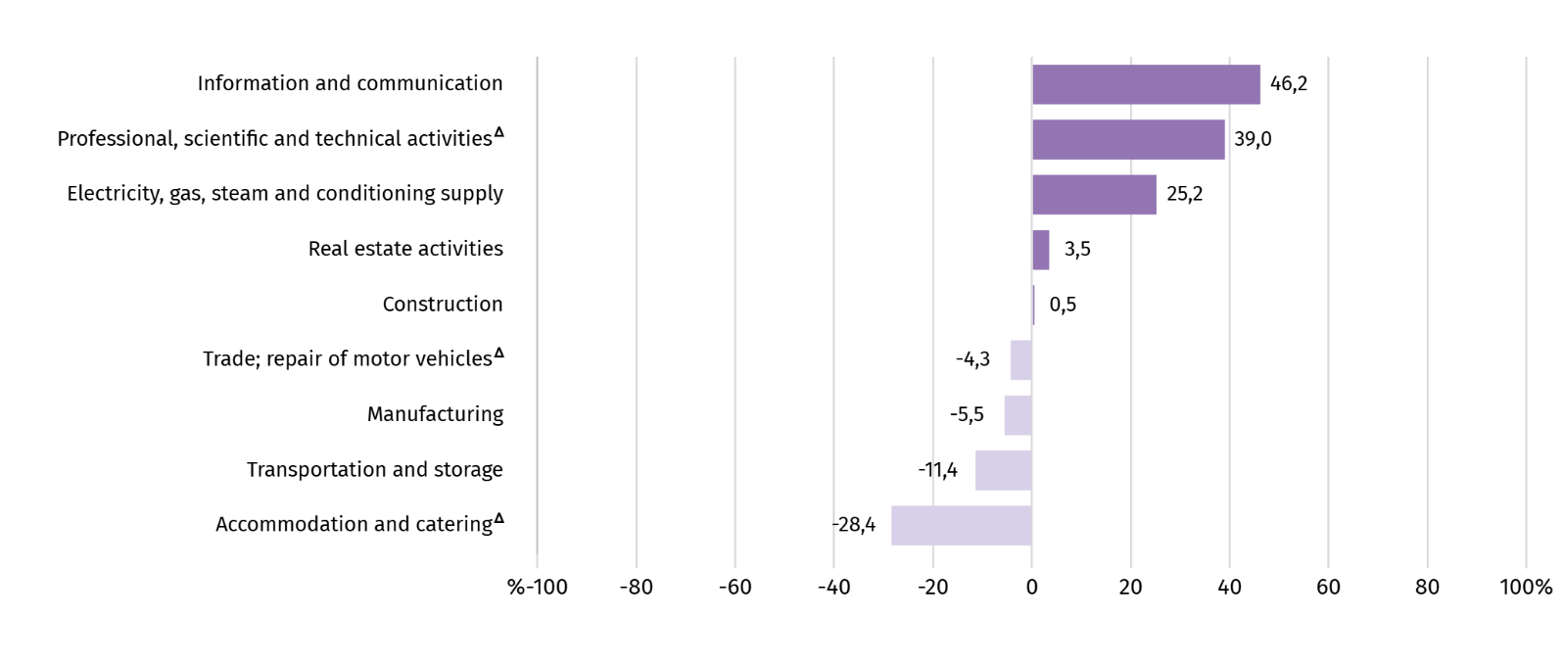
a Excluding divisions: Research and experimental development work and Veterinary activities..
Table 3. Average monthly gross wages and salaries in the enterprise sector in September 2025
SPECIFICATION | 09 2025 |  | 01–09 2025
SPECIFICATION | In PLN | 09 2024=100 | In PLN | 01–09 2024=100
TOTAL | 9974,07 | 108,0 | 10213,36 | 108,7
of which:
Industry | 9543,44 | 108,9 | 9811,23 | 110,4
of which:
manufacturing | 9428,25 | 109,4 | 9599,93 | 110,6
electricity, gas, steam and air conditioning supply | 12483,51 | 101,8 | 14701,70 | 107,7
Construction | 10026,57 | 108,1 | 10257,52 | 107,2
Trade; repair of motor vehicles ^{Δ} | 9542,23 | 105,5 | 9959,72 | 105,5
Transportation and storage | 8837,46 | 108,5 | 8767,36 | 110,0
Accommodation and catering ^{Δ} | 7140,07 | 105,1 | 7258,65 | 105,8
Information and communication | 14583,11 | 107,4 | 15166,12 | 108,7
Real estate activities | 10319,02 | 102,5 | 10520,59 | 102,5
Professional, scientific and technical activities ª | 13861,26 | 109,0 | 13859,51 | 106,9
Administrative and support service activities | . | . | . | .
a Excluding divisions: Research and experimental development work and Veterinary activities.
In the period of January-September this year, the average monthly gross wages and salaries in the enterprise sector amounted to PLN 10,213.36 and was 8.7% higher than in the same period of 2024 (a year ago 11.1% higher).
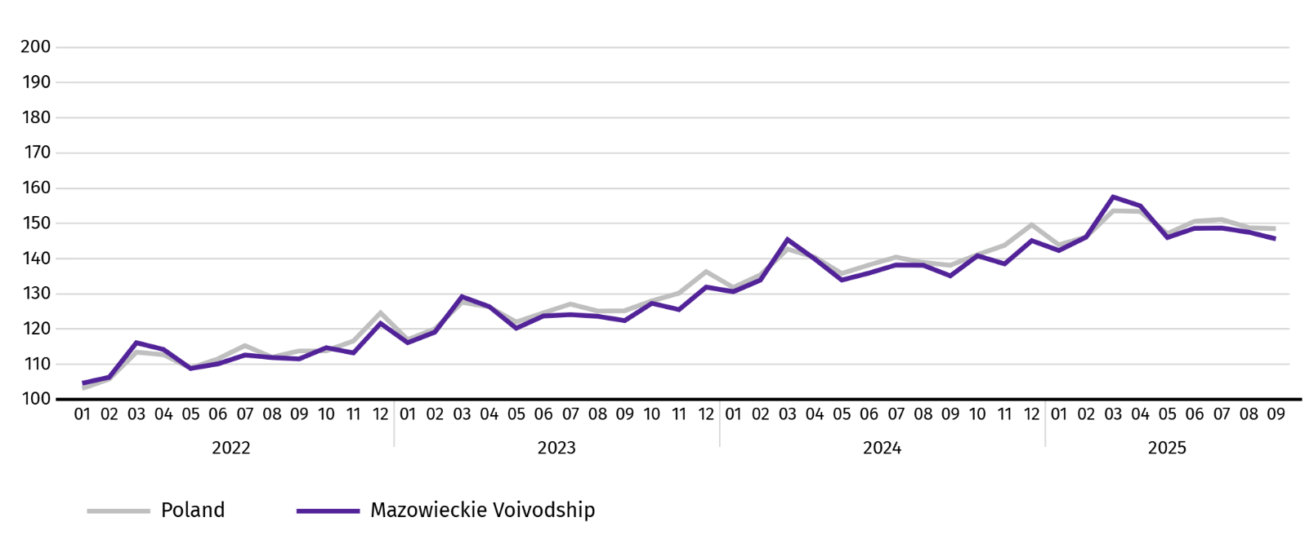
Chart 5. Average monthly gross wages and salaries in the enterprise sector (monthly average 2021=100)

Agriculture
On the agricultural market in September 2025, average procurement prices for rye, cattle, poultry for slaughter and milk were higher than a year ago, while prices for wheat, potatoes, and pigs for slaughter were lower. On a monthly basis, more was paid for cattle for slaughter as well as wheat, rye, potatoes, pigs and poultry for slaughter and milk.
The average air temperature in Mazowieckie Voivodship in September 2025 amounted to 15.8°C and was by 2.1°C higher from the average from the years 1991–2020, while the maximum temperature reached 31.7°C, and the minimum amounted to minus 1.2°C (both values registered in Kozienice). The average atmospheric precipitation (56.2 mm) accounted for 108% of the standard for the multi-year periods (ranging from 42% in Warszawa to 169% in Płock) . The number of days with precipitation, depending on the region, ranged from 8 to 17.
Table 4. Procurement of cereals ª
SPECIFICATION | 07–09 2025 |  | 09 2025
SPECIFICATION | in thousand tonnes | corresponding period of previous year=100 | in thousand tonnes | 09 2024=100 | 08 2025=100
Grain of basic cereals ^{b} | 151,2 | 106,0 | 45,0 | 117,9 | 63,0
of which:
wheat | 113,4 | 114,9 | 36,5 | 136,6 | 71,2
rye | 17,4 | 94,3 | 3,7 | 105,5 | 38,8
a Excluding procurement by natural persons. b Includes: wheat, rye, barley, oat, triticale; including cereal mixed, excluding sowing seed.

In July-September, the procurement of basic cereals (with cereal mixed, without sowing seed) amounted to 151.2 thousand tonnes and was by 6.0% higher than in the same period last year. Procurement of wheat during this period was 14.9% higher, and procurement of rye was 5.7% lower. In September of this year, deliveries of cereal to procurement were 17.9% higher than a year ago and by 37.0% lower than in the previous month.
Table 5. Procurement of basic animal products ª
SPECIFICATION | 01–09 2025 |  | 09 2025
SPECIFICATION | in thousand tonnes | 01–09 2024=100 | in thousand tonnes | 09 2024=100 | 08 2025=100
Animals for slaughter ^{b} | 899,9 | 95,1 | 79,6 | 87,4 | 100,6
of which:
cattle (including calves) | 49,3 | 111,8 | 2,7 | 105,2 | 103,0
pigs | 249,8 | 116,4 | 21,5 | 116,6 | 111,0
poultry | 600,1 | 87,4 | 55,3 | 79,0 | 97,0
Milk ^{c} | 2161,6 | 103,1 | 229,6 | 105,8 | 94,0
a In July-September excluding procurement by natural persons. b Including cattle, calves, pigs, sheep, horses and poultry; in terms of meat including fats in post-slaughter warm weight. c In million litres.
From the beginning of this year, producers from Mazowieckie Voivodship delivered 899.9 thousand tonnes of animals for slaughter (in warm weight), i.e. by 4.9% less than in the previous year. The decrease in procurement concerned poultry for slaughter (by 12.6%), while an increase concerned pigs (by 16.4%) and poultry for slaughter (by 11.8%). In September this year, the total supply of animals for slaughter (79.6 thousand tonnes) was lower by 12.6% than in the previous year, and by 0.6% than in the previous month.
Deliveries of milk in July-September 2025 (2161.6 million litres) were by 3.1% larger than in the previous year. In September this year, the procurement of milk amounted to 229.6 million litres and was by 6.0% lower than in the previous month and larger by 5.8% than in the previous year.
Table 6. Average prices of basic agricultural products
SPECIFICATION | 09 2025 |  |  | 01–09 2025
SPECIFICATION | PLN | 09 2024=100 | 08 2025=100 | PLN | 01–09 2024=100
Wheat ª per dt | 78,05 | 89,1 | 97,8 | 88,09 | 104,8
Rye ª per dt | 62,23 | 107,3 | 97,1 | 68,49 | 122,5
Potatoes per dt | 49,07 | 94,6 | 74,3 | 82,62 | 77,8
Animals for slaughter per kg of live weight:
cattle (excluding calves) | 19,21 | 157,8 | 134,0 | 15,10 | 140,3
pigs | 6,88 | 92,4 | 96,9 | 6,88 | 90,1
poultry | 6,30 | 117,8 | 99,6 | 5,98 | 117,9
Milk per 1 hl | 221,67 | 106,3 | 98,6 | 225,00 | 112,4
a Excluding sowing seed.
In September 2025, PLN 78.05 was paid for 1 dt of wheat at procurement, i.e. 2.2% less than last month and 10.9% than last year. The average price of wheat at marketplaces was PLN 108.54 and was smaller by 2.0% than in August 2025, and by 1.8% higher than in September 2024. The procurement price of rye decreased by 2.9% (to PLN 62.23) compared to the previous month, and the marketplace price by 1.3% (to PLN 74.23). Compared to September 2024, procurement prices for rye were 7.3% higher, and marketplace prices 7.5% lower.
Table 7. Average marketplace prices of wheat and potatoes
SPECIFICATION | 09 2025 |  |  | 01–09 2025
SPECIFICATION | PLN | 09 2024=100 | 08 2025=100 | PLN | 01–09 2024=100
Wheat per dt | 108,54 | 98,2 | 98,0 | 113,33 | 106,5
Rye per dt | 74,23 | 92,5 | 98,7 | 78,40 | 108,1
Potatoes ^{b} per dt | 197,60 | 84,9 | 92,3 | 211,49 | 88,6
a Edible late.
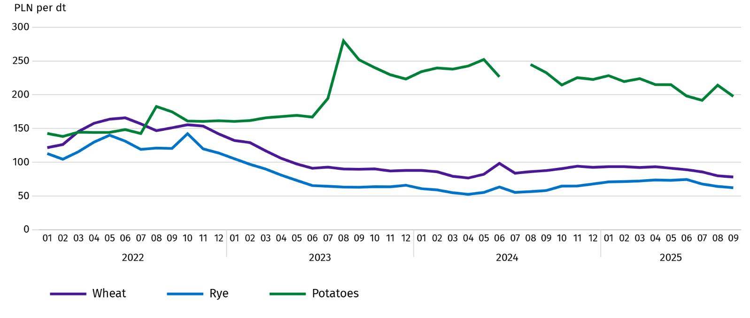
Chart 6. Average marketplace prices of cereals and potatoes ª

a In July 2024, the price of late edible potatoes was not recorded due to their absence at the time of observations.
In September 2025, the average procurement price of potatoes was PLN 49.07/dt, i.e. less by 25.7% than in the previous month and by 5.4% than last year. At marketplaces, the average price of 1 dt of potatoes was PLN 197.60 and was 7.7% lower than in the previous month, and by 15.1% than in the previous year.
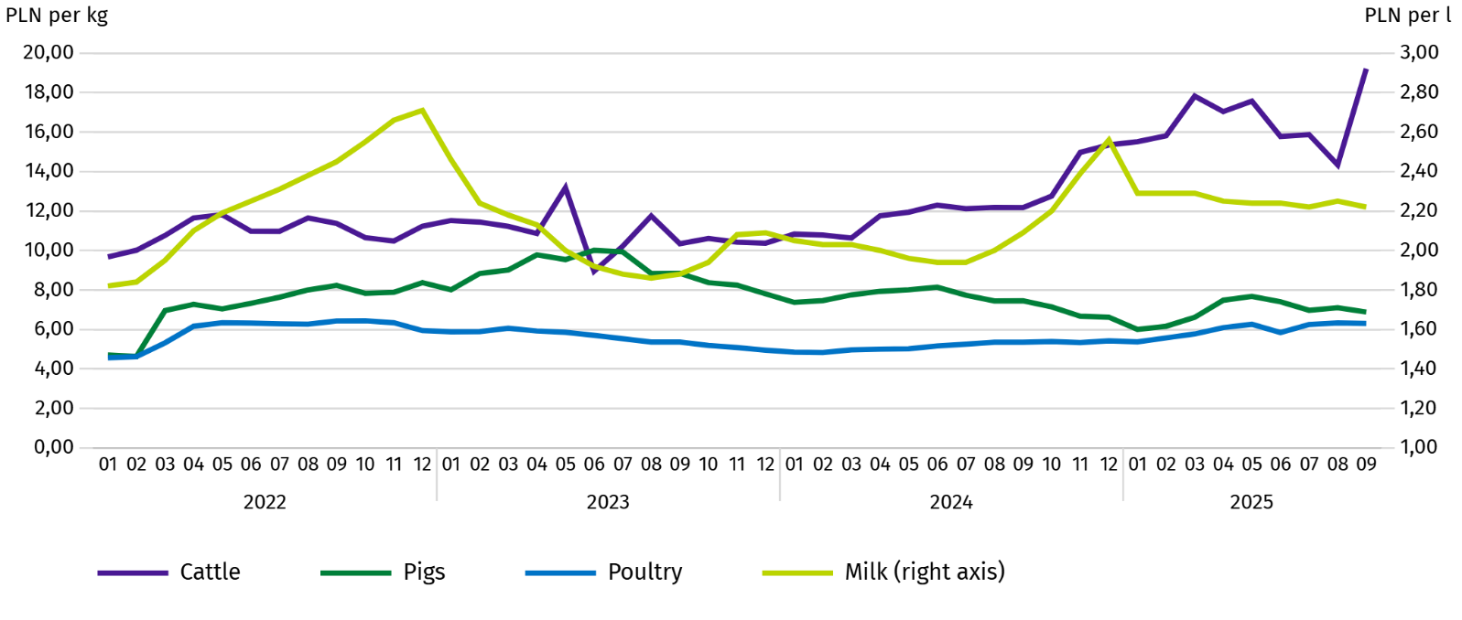
Chart 7. Average procurement prices of animals for slaughter and milk

In September 2025, the average procurement price of pigs for slaughter was lower by 7.6% than in the previous year, and by 3.1% than In the previous month.
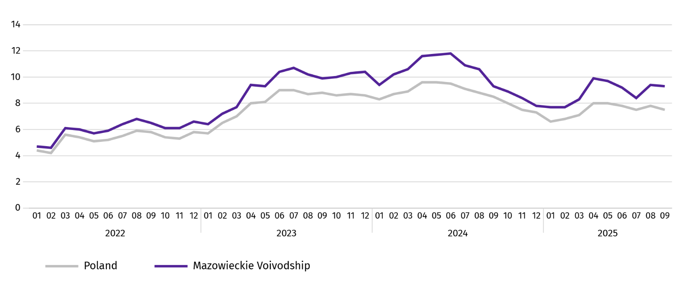
Chart 8. Ratio of the average procurement prices of pigs for slaughter to the average marketplace prices of rye

The procurement price of cattle for slaughter was higher by 34.0% than a month ago and by 57.8% than a year ago.
In September 2025, suppliers were paid an average of PLN 6.30 per 1 kg of poultry for slaughter, i.e. 0.4% less than in August 2025 and 17.8% more than in September 2024.
Procurement prices of milk in September 2025 were by 6.3% higher than in the previous year and by 1.4% than in the previous month.

Industry and construction
Sold production of industry in September this year, reached the value (at current prices) of PLN 43,879.0 million and was (at constant prices) by 4.0% higher than a year before (compared to a 1.4% decrease in August this year); as compared to the previous month it increased by 9.9%.
Sold production in manufacturing (constituting 88.7% of sold production of industry) compared to September last year increased (at constant prices) by 4.7%. However there was a decrease (by 9.4%) in sold production in the section of electricity, gas, steam and air conditioning supply (the share of this section represents 9.0% of industrial production).
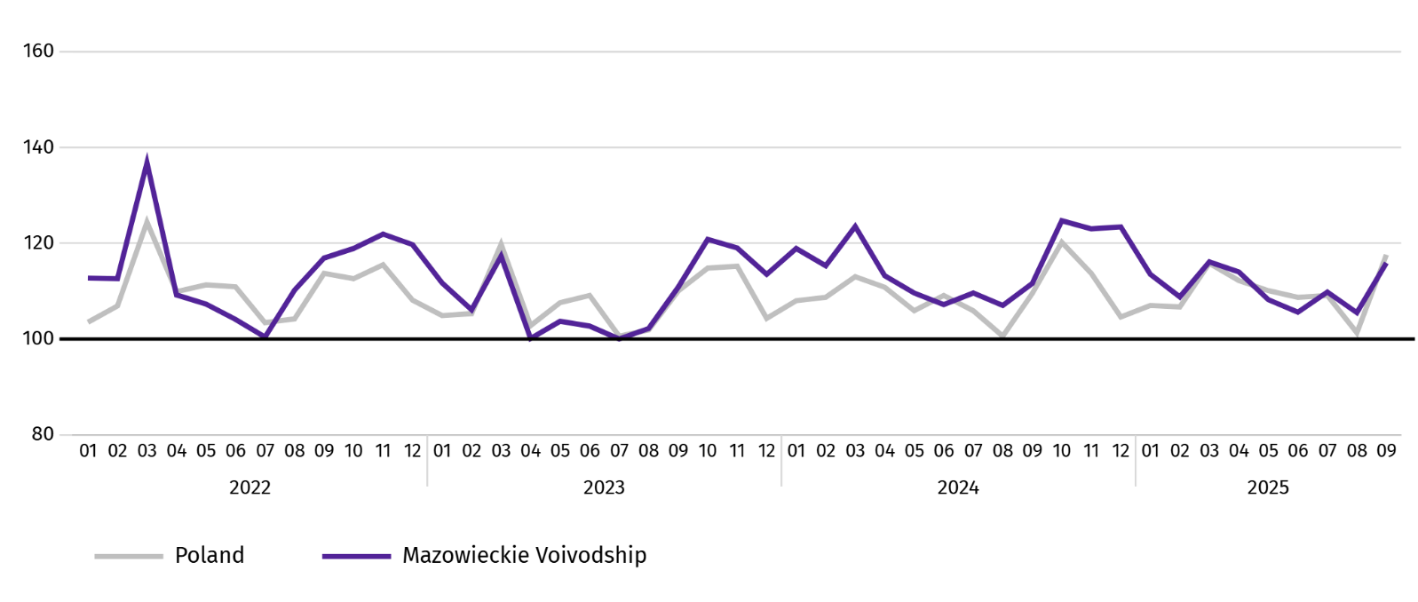
Chart 9. Sold production of industry (monthly average 2021=100; constant prices)

In September this year, the decrease in sold production in annual terms was recorded in 20 (out of 32 in the Voivodship) divisions of industry, among others, in: manufacture of electrical equipment (by 15.3%), rubber and plastic products (by 14.6%), metal products (by 12.3%), other non-metallic mineral products (by 10.1%), beverages (by 13.3%), machinery and equipment n.e.c. (by 9.9%), chemicals and chemical products (by 7.7%), computer, electronic and optical equipment (by 5.3%), food products (by 5.0%). However, there was an decrease in sold production of, among others, beverages (by 7.4%), paper and paper products (by 1.8%).
Table 8. Indices (constant prices) and structure (current prices) of sold production of industry in September 2025
SPECIFICATION | 09 2025 | 01–09 2025
SPECIFICATION | corresponding period of previous year=100 |  | In percent
TOTAL | 104,0 | 102,0 | 100,0
of which:
Manufacturing | 104,7 | 102,2 | 87,4
of which manufacture of:
food products | 105,0 | 103,3 | 22,3
beverages | 92,6 | 99,6 | 1,9
paper and paper products | 98,2 | 98,0 | 2,0
chemicals and chemical products | 107,7 | 102,9 | 4,2
manufacture of rubber and plastic products | 114,6 | 110,1 | 3,1
other non-metallic mineral products | 110,1 | 105,4 | 2,5
metal products ^{Δ} | 112,3 | 111,2 | 3,8
computer, electronic and optical equipment | 105,3 | 100,1 | 4,9
electrical equipment | 115,3 | 108,6 | 4,4
machinery and equipment n.e.c. | 109,9 | 104,8 | 1,9
Electricity, gas, steam and air conditioning supply ^{Δ} | 90,6 | 97,8 | 10,2
Labour productivity in industry measured by sold production per employed person, in September this year amounted (at current prices) to PLN 109.8 thousand and was (at constant prices) by 1.7% lower than a year before, with an increase in average paid employment by 2.2% and average monthly gross wages and salaries by 8.9%.
Sold production of industry in January–September this year, reached the value of PLN 389,952.3 million (at current prices) and was by 2.0% higher than in the corresponding period of previous year.
Sold production of construction (at current prices) in September this year, reached the value of PLN 11,445.5 million and was by 18.6% higher than in the previous year (compared to a 7.2% decrease in August this year). In January-September this year, sold production of construction amounted to PLN 88,862.3 million and was by 7.4% higher compared to the corresponding period of last year.
Labour productivity in construction, measured by revenue from the sale of goods and services per employed person in September this year amounted to PLN 121.9 thousand (at current prices) and was by 17.5% higher compared to the corresponding month of the previous year, with an increase in average employment in construction by 0.9% and in average monthly gross wages and salaries by 8.1%.
Construction and assembly production (at current prices) in September this year, amounted to PLN 2,964.7 million and was by 12.4% higher than a year before (as compared to 9.4% increase in August this year). The increase in production was recorded in entities whose basic activity is the construction of buildings (by 74.7%) and in enterprises mainly performing specialised construction activities (by 32.6%). The decrease was recorded in units specialising in civil engineering (by 17.1%). In January-September this year, construction and assembly production was PLN 23,444.7 million and was 17.5% higher compared to the corresponding period of last year.
Table 9. Indices and structure (current prices) of construction and assembly production in September 2025
SPECIFICATION | 09 2025 | 01–09 2025
SPECIFICATION | corresponding period of previous year=100 |  | In percent
TOTAL | 112,4 | 117,5 | 100,0
Construction of buildings | 174,7 | 145,7 | 28,6
Civil engineering | 82,9 | 97,6 | 45,7
Specialised construction activities | 132,6 | 137,9 | 25,6

Residential construction
In September this year, the number of dwellings completed increased by 50.3% compared to the corresponding month in 2024. The number of dwellings for which permits have been granted or which have been registered with a construction project increased by 7.1%, and dwellings in which construction has begun by 44.8%.
According to preliminary data in September this year, there were 3715 dwellings completed, i.e. by 1243 more (by 50.3%) than in the previous year and by 435 (by 13.3%) than in the previous month. There were 2535 dwellings built for sale or rent (68.2% of their total number), followed by private dwellings 805 (21.7%). Compared to September last year, there were more dwellings for sale or rent by 49.2%, and private dwellings by 6.2%.
The effects of housing construction obtained in Mazowieckie Voivodship in the surveyed month constituted 19.5% of national effects.
Table 10. Number of dwellings completed in January-September 2025
SPECIFICATION | Dwellings completed |  |  | Average useful floor area of a dwelling in m²
SPECIFICATION | In absolute numbers | In percent | 01–09 2024=100 | Average useful floor area of a dwelling in m²
TOTAL | 30570 | 100,0 | 114,7 | 84,4
Private | 7340 | 24,0 | 98,3 | 147,9
Cooperative | 339 | 1,1 | 186,3 | 51,3
For sale or rent | 22384 | 73,2 | 120,0 | 64,9
Municipal | 226 | 0,7 | 84,0 | 41,3
Public building society | 281 | 0,9 | 295,8 | 48,8

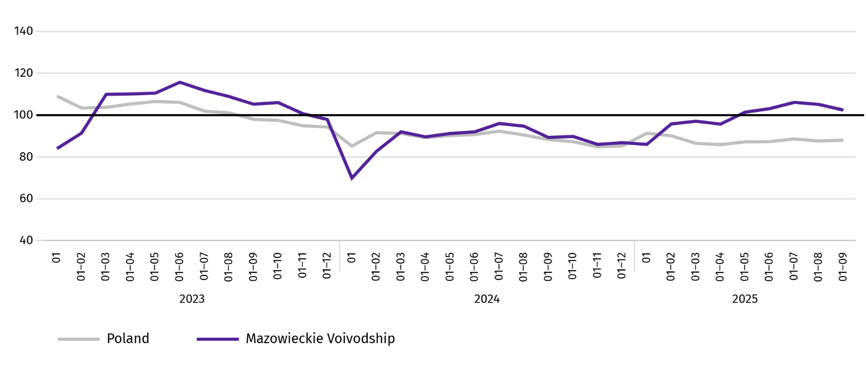
Chart 10. Dwellings completed (corresponding period 2021=100)

In the period January–September this year, most dwellings were completed in m.st. Warszawa (12688), and then in piaseczyński powiat (2235), and wołomiński (2177), and the least in lipski and łosicki (41 each), makowski (49) and gostyniński (51).
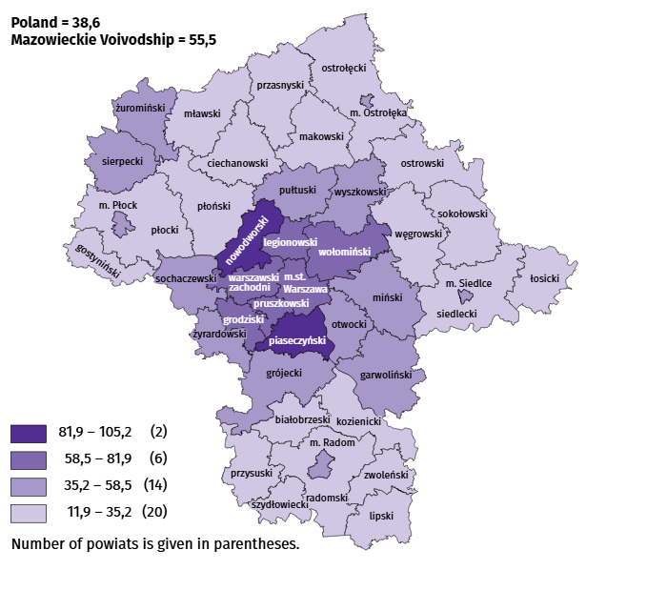
Map 2. Dwellings completed per 10 thousand populationª by powiats in January-September 2025

a Population as of 31 December 2024.
The average useful floor area of dwellings completed in September this year amounted to 82.8 m² and was smaller than a year earlier by 9.6 m² than a year earlier. The largest dwellings were completed in ciechanowski powiat (199.7 m²), ostrołęcki (180.3 m²) and przasnyski powiat (172.5 m²). The smallest were built in Płock (48.2 m²), Warszawa (58.1 m²), as well as in mławski powiat (59.7 m²).
In September this year, the number of dwellings for which permits have been granted or which have been registered with a construction project amounted to 5234, i.e. larger by 349 (by 7.1%) than a year earlier and by 1871 (by 55.6%) than in the previous month. Of the total number of dwellings, 75.6% were dwellings for sale or rent, and 24.4% private.
In the surveyed month, the construction began in 4719 dwellings, which means an increase by 1459 (by 44.8%) in annual terms and by 1581 (by 50.4%) in monthly terms. Dwellings for sale or rent accounted for 76.3% of their total number, and private 23.7%.
Table 11. Number of dwellings for which permits have been granted or which have been registered with a construction project as well as dwelling in which construction has begun January–September 2025
SPECIFICATION | Dwellings for which permits have been granted or which have been registered with a construction project |  |  | Dwellings in which construction has begun
SPECIFICATION | in absolute numbers | in percent | 01–09 2024=100 | in absolute numbers | in percent | 01–09 2024=100
TOTAL | 35822 | 100,0 | 79,3 | 33641 | 100,0 | 96,1
Private | 10472 | 29,2 | 114,9 | 9342 | 27,8 | 101,8
Cooperative | 30 | 0,1 | 22,6 | – | – | .
For sale or rent | 25048 | 69,9 | 71,1 | 24222 | 72 | 94,6
Municipal | 44 | 0,1 | 28,4 | – | – | .
Public building society | 228 | 0,6 | 41,9 | 77 | 0,2 | 183,3

Internal market
In September this year, there was an increase in retail sales and in wholesale compared to the previous year.
Retail sales (at current prices) in trade and non-trade enterprises in September this year, increased by 1.3% compared to the year before. The largest decrease in sales was recorded in units from the group: “press, books, other sales in specialised stores” (by 22.0%), “other retail sales in non-specialised stores” (by 13.5%), followed by “motor vehicles, motorcycles, parts” (by 7.0%), “others” (by 4.1%), “food, beverages and tobacco” (by 3.2%), “textiles, clothing and footwear” (by 2.4%), “furniture, electronics and household appliances” (by 1.6%). The largest increase in retail sales recorded units from the group: “pharmaceuticals, cosmetics, orthopedic equipment” (by 3.8%).
Compared to August this year, retail sales decreased by 4.4%. The largest decrease in retail sales was recorded in the following groups: “food, beverages and tobacco” and “press, books, other sales in specialised stores” (by 8.2% and 7.7%, respectively). The largest increase in sales was recorded in the groups: “motor vehicles, motorcycles, parts” (by 16.1%) and “other retail sales in non-specialised stores” (7.0%).
Table 12. Indices and structure (at current prices) of retail sales in September 2025
SPECIFICATION | 09 2025 | 01–09 2025
SPECIFICATION | corresponding period of previous year=100 |  | in percent
TOTAL ª | 101,3 | 98,8 | 100,0
of which:
Motor vehicles, motorcycles, parts | 107,0 | 97,5 | 7,0
Food, beverages and tobacco | 103,2 | 103,6 | 14,6
Other retail sales in non-specialised stores | 113,5 | 115,5 | 3,7
a The grouping of enterprises was made on the basis of the Polish Classification of Activities - PKD 2007, including the enterprise to a specific category according to the type of predominant activity, in accordance with the organizational status in the period under consideration. The recorded changes (increase/decrease) in retail sales in particular groups of activity of enterprises may also result from changes in the type of predominant economic activity and organisational changes (e.g. mergers of enterprises). This does not affect the dynamics of retail sales in general.
Table 12. Indices and structure (at current prices) of retail sales in September 2025 (cont.)
SPECIFICATION | 09 2025 | 01–09 2025
SPECIFICATION | corresponding period of previous year=100 |  | in percent
Pharmaceuticals, cosmetics and orthopedic equipment | 96,2 | 96,0 | 4,7
Textiles, clothing and footwear | 102,4 | 95,5 | 5,7
Furniture, electronics and household appliances | 101,6 | 102,4 | 17,9
Press, books and other sales in specialized stores | 122,0 | 118,1 | 7,4
Other | 104,1 | 100,0 | 9,1
In the period January-September 2025, retail sales decreased by 1.2% year-on-year. The largest decrease in sales was recorded by enterprises from the group “textiles, clothing and footwear” (by 4.5%), while the largest increase in sales recorded enterprises from the group "press, books, other sales in specialised stores" (by 18.1%).
Wholesale (at current prices) in trade enterprises in September this year was by 20.0% higher as compared to the previous month and by 0.8% higher compared to September 2024. In wholesale enterprises it was higher by 15.7% and by 0.2%, respectively.
In January-September 2025, wholesale in trade enterprises was 7.5% lower than in the previous year, and in wholesale enterprises lower by 6.3%.

Entities of the national economy
In September of this year, the number of entities of the national economy registered in the REGON register increased by 0.3% compared to the previous month. There were more entities removed from the REGON register and newly registered entities (by 24.1% and 18.1%, respectively). While the number of entities with suspended activity decreased by 1.1%.
As of the end of September this year, the number of entities of the national economy registered in the REGON register amounted to 1080871, which means an increase of 3.6% year-on-year and 0.3% compared to the previous month.
In the total number of registered entities, the greatest number is natural persons conducting economic activity. At the end of September this year, there were 696939of them, i.e. more by 3.5% than in the previous year. The number of companies which were registered in the REGON register amounted to 304053, including 244200 commercial companies (an annual increase by 3.9% and 4.9%, respectively). There were 59395 civil partnerships i.e. more 0.3% compared to the previous year.
According to the expected number of employed persons, entities that declared employment of up to 9 persons prevailed upon entry in the REGON register; they constituted 97.3% of all registered units. The share of entities with an estimated number of 10-49 employed persons was 2.1%, and of entities employing more than 49 persons – 0.5%. Over the year, the increase in the number of entities occurred among the smallest entities (up to 9 persons) – by 3.7%.
Compared to September 2024, the largest increase in the number of entities was recorded in the sections: professional, scientific and technical activities – more by 7299 units (in percentage terms, a 4.5% increase), administrative and support service activities by 5935 units (an increase of 12.0%), information and communication by 5512 units (by 5.6%).
Compared to August 2024, the largest percentage increase in the number of entities was recorded in the sections: administrative and support service activities (by 0.9%), electricity, gas, steam and air conditioning supply (by 0.7%).
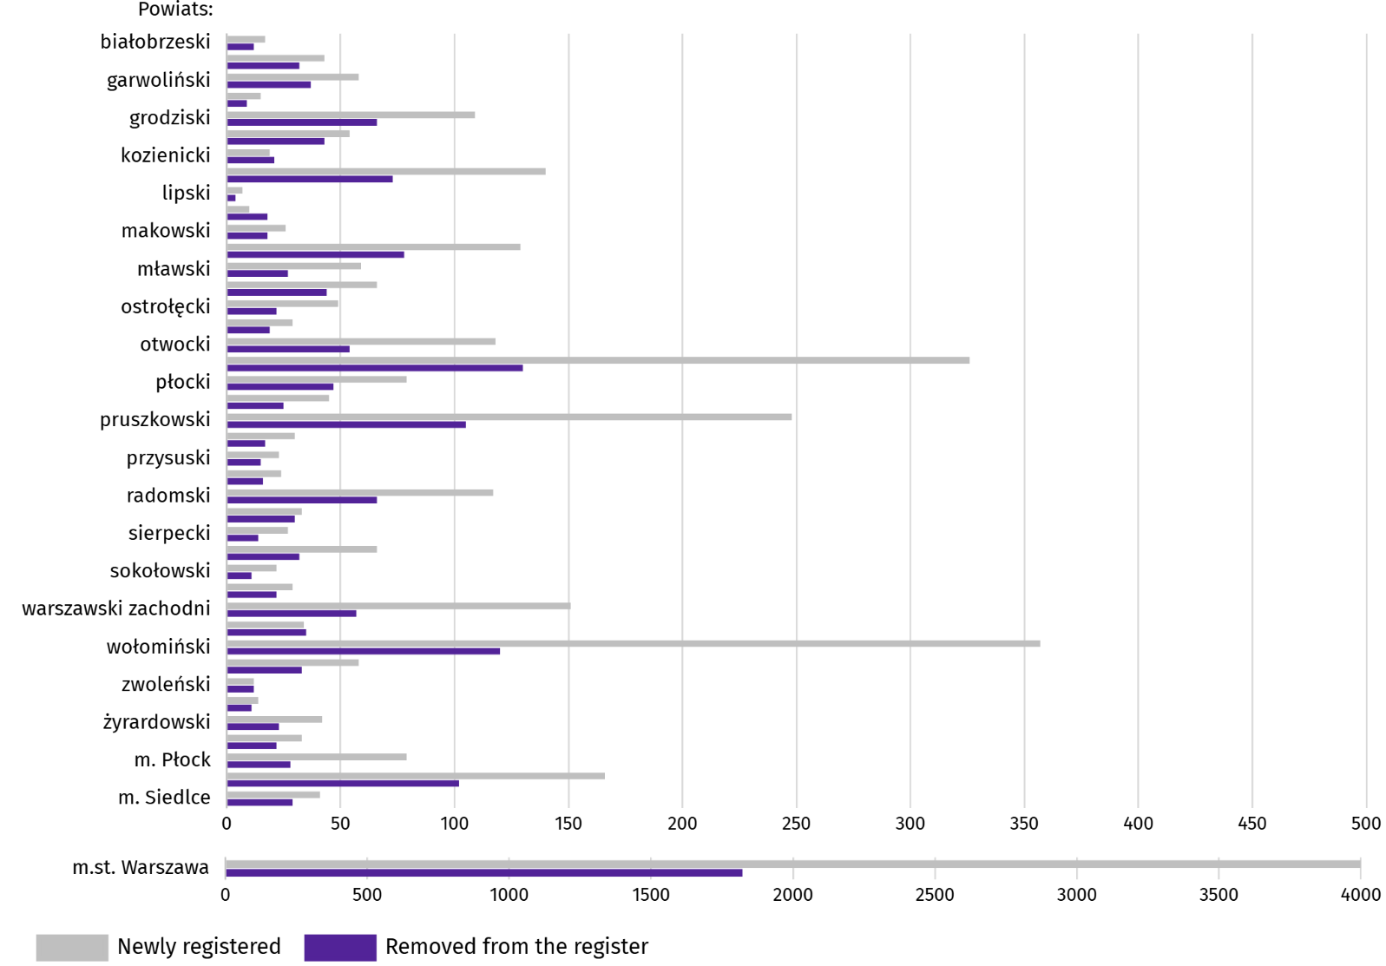
Chart 11. Entities of the national economy newly registered and removed from the register in September 2025

In September this year, 7004 new entities were registered in the REGON register, i.e. by 18.1% more than in the previous month. The newly registered units were dominated by natural persons conducting economic activity, 5029 of whom were registered (by 19.5% more than in the previous month). The number of newly registered commercial companies was larger by 9.3%, including companies with limited liability by 9.3%.
In the surveyed month, 3401 entities were removed from the REGON register (by 24.1% more than a month ago), including 2508 natural persons conducting economic activity (by 14.9% more).
As of the end of September this year, there were 144731 entities in the REGON with suspended activity (by 1.1% less than a month ago). The vast majority were natural persons conducting economic activity (94.3%; 94.4% in the previous month).
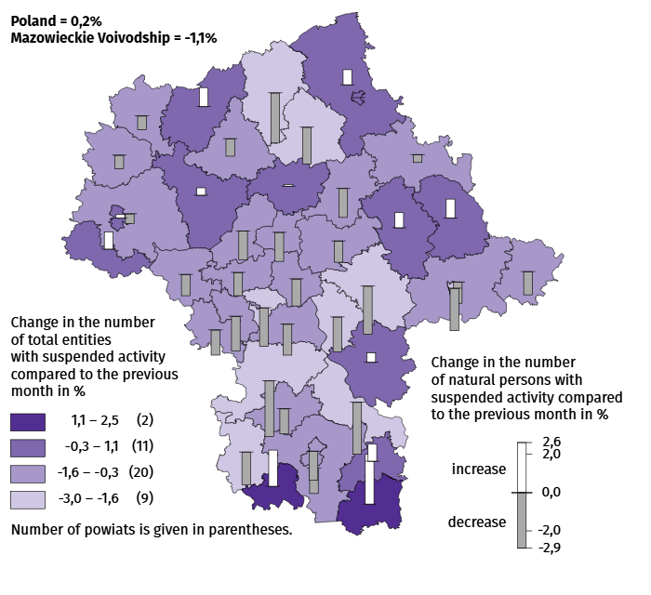
Map 3. Entities of the national economy with suspended activity in September 2025

Business tendency
In October of this year, the general business climate indicator in most of the surveyed economic sectors indicated a stabilisation of the economic climate compared to the previous month. A noticeable deterioration in business conditions occurred only in transportation and storage (the indicator dropped by 5.8 compared to September of this year). In other sectors, business opinions remained similar to last month. The most optimistic assessments were expressed by entities in the accommodation and catering section (plus 14.8), and the indicator value was above the long-term average (plus 0.3). Only entities involved in construction assessed the economic climate at a neutral level (0.0), with the indicator value above the long-term average (minus 4.8).

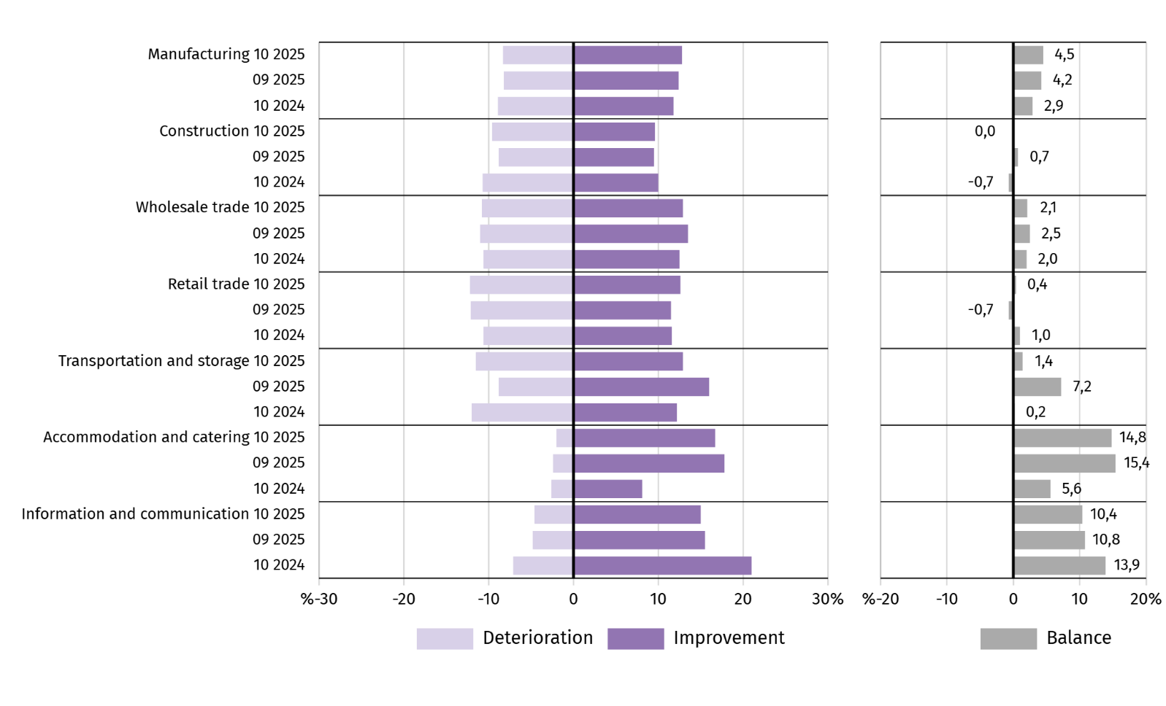
Chart 12. Indices of the general business climate by type of activity (sections and divisions of NACE Rev. 2)

Questions about the impact of the war in Ukraine
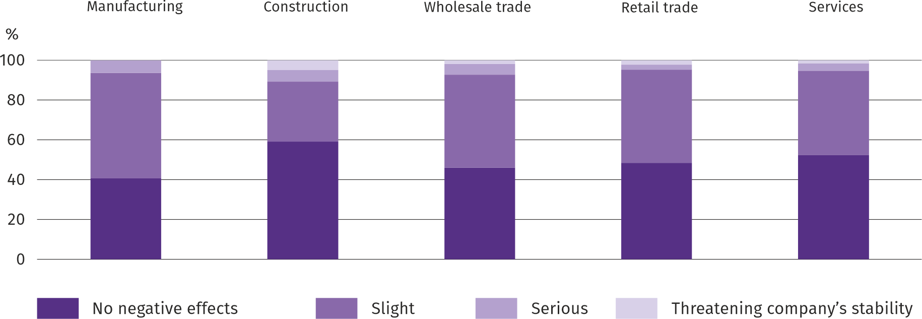
Question 1. The negative effects of the war in Ukraine and its consequences for your company's business operations this month will be:

Across all sectors of the economy surveyed, entrepreneurs dominated in the survey who reported that the ongoing war had no negative impact or posed only a minor threat to their businesses in October of this year. The war's serious effects, threatening the stability of their businesses, were felt most often by entrepreneurs operating in the construction section, and least often by those in retail trade.
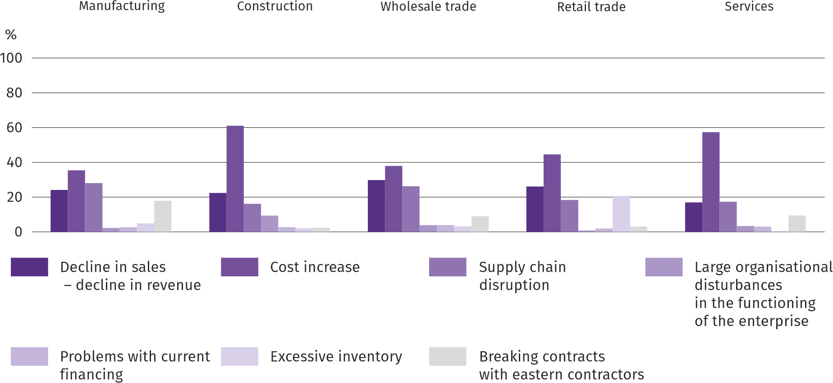
Q2. Of the negative effects of the war in Ukraine observed over the past month, the following are most relevant to your company:

Regardless of the type of economic activity, entrepreneurs considered the most significant negative effect of the war in Ukraine to be an increase in costs, followed by a decline in sales/revenues or disruptions in the supply chain.
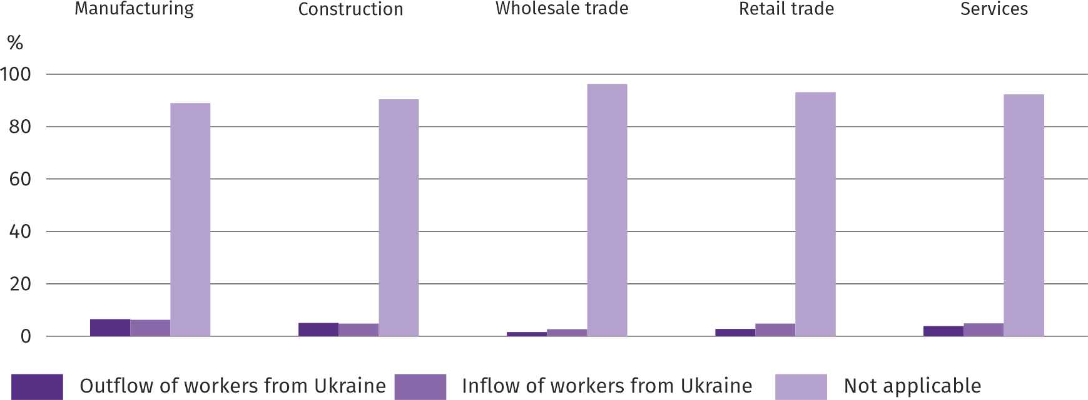
Q3. If your company employs workers from Ukraine, have you observed any changes in the last month due to the war in Ukraine?:

In October of this year, all surveyed sections saw an outflow and inflow of workers from Ukraine due to the ongoing war. Both outflow and inflow of workers were most frequently reported in manufacturing, and least frequently in wholesale trade. However, most companies were not affected by this phenomenon.

Questions about pricing processes
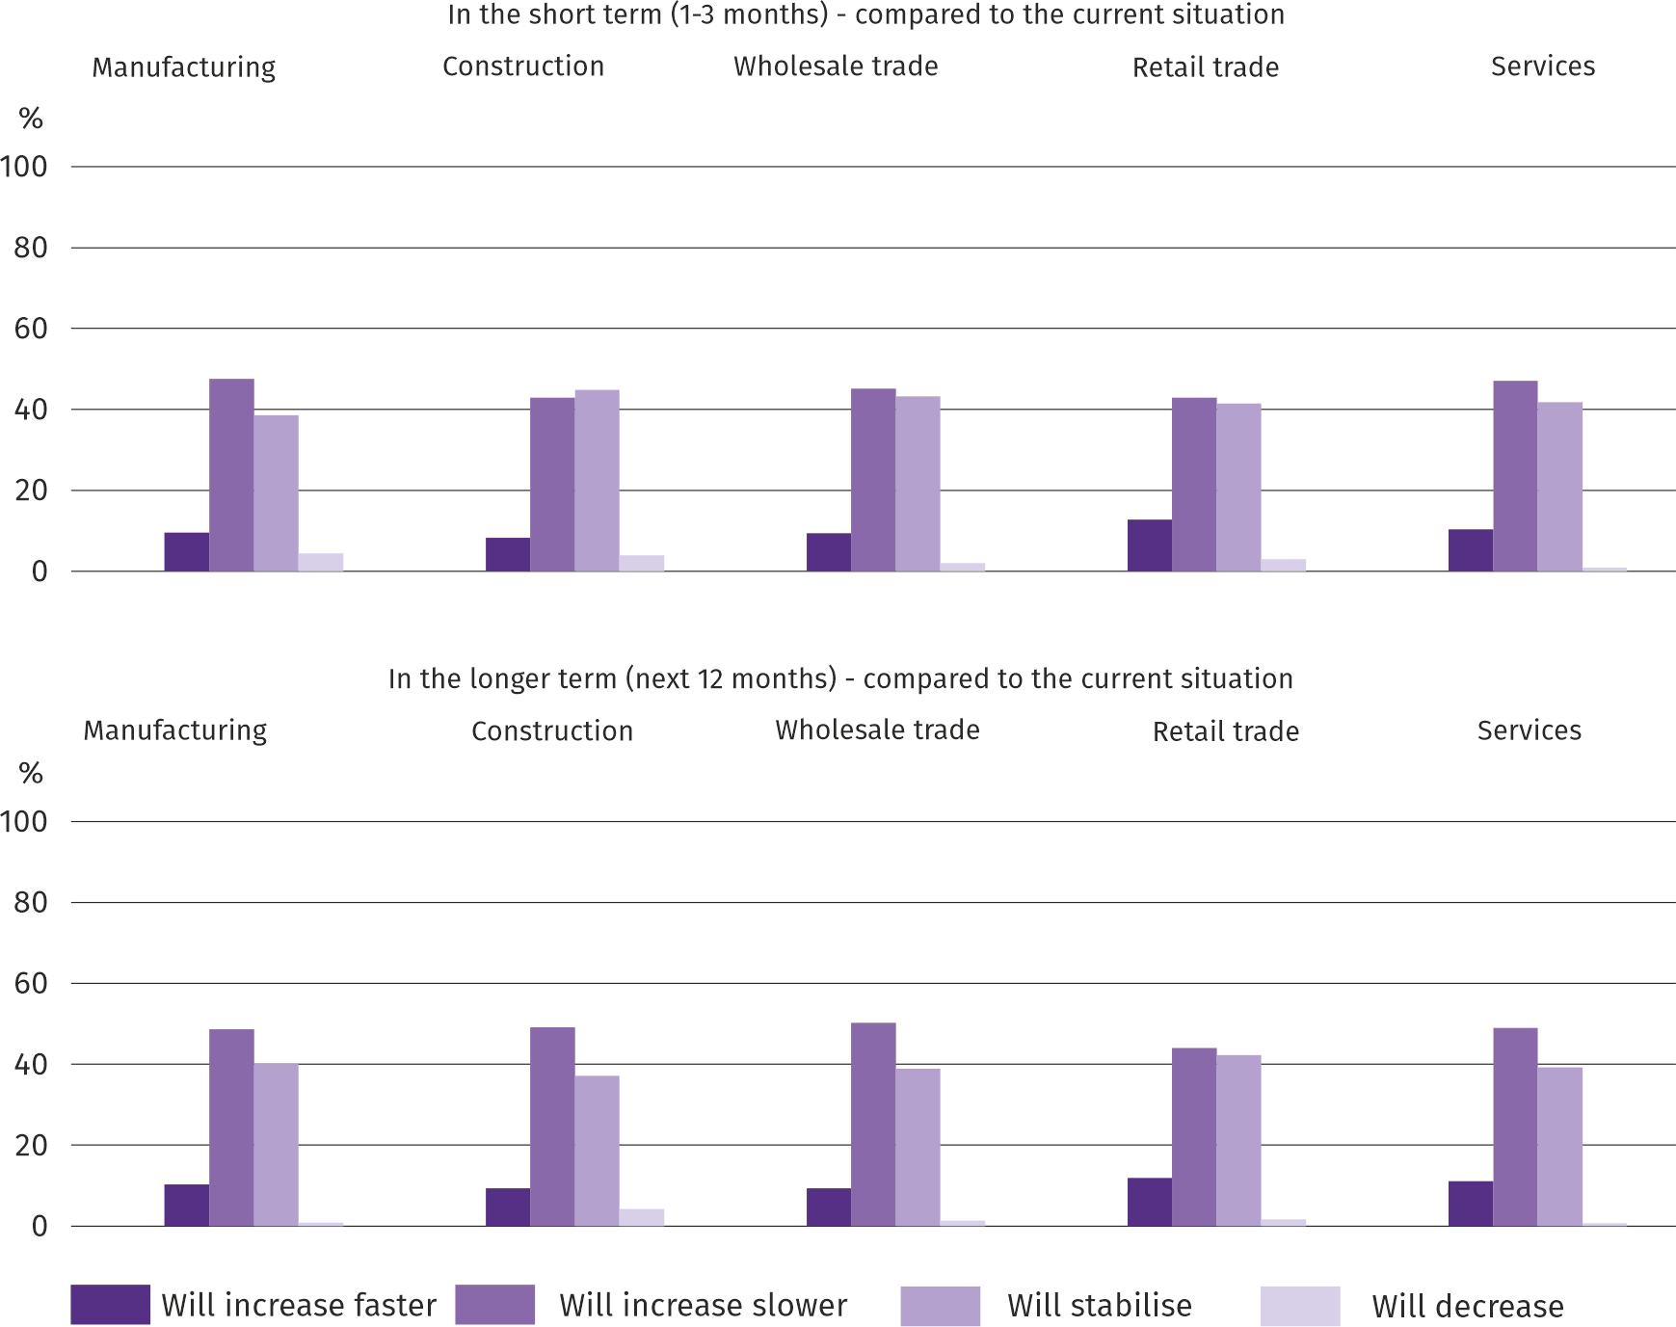
Question 4. What do you think the prices of services/materials/raw materials used by your company in its economic activities will be like?:

In most of the surveyed business types, the majority of entrepreneurs believed that price growth would be slower than currently in the short term (1-3 months). Only in the construction section did more entrepreneurs express the opinion that prices would stabilise. In the long term (the next 12 months), regardless of the type of economic activity, the majority of respondents believed that price growth would be slower compared to the current situation.
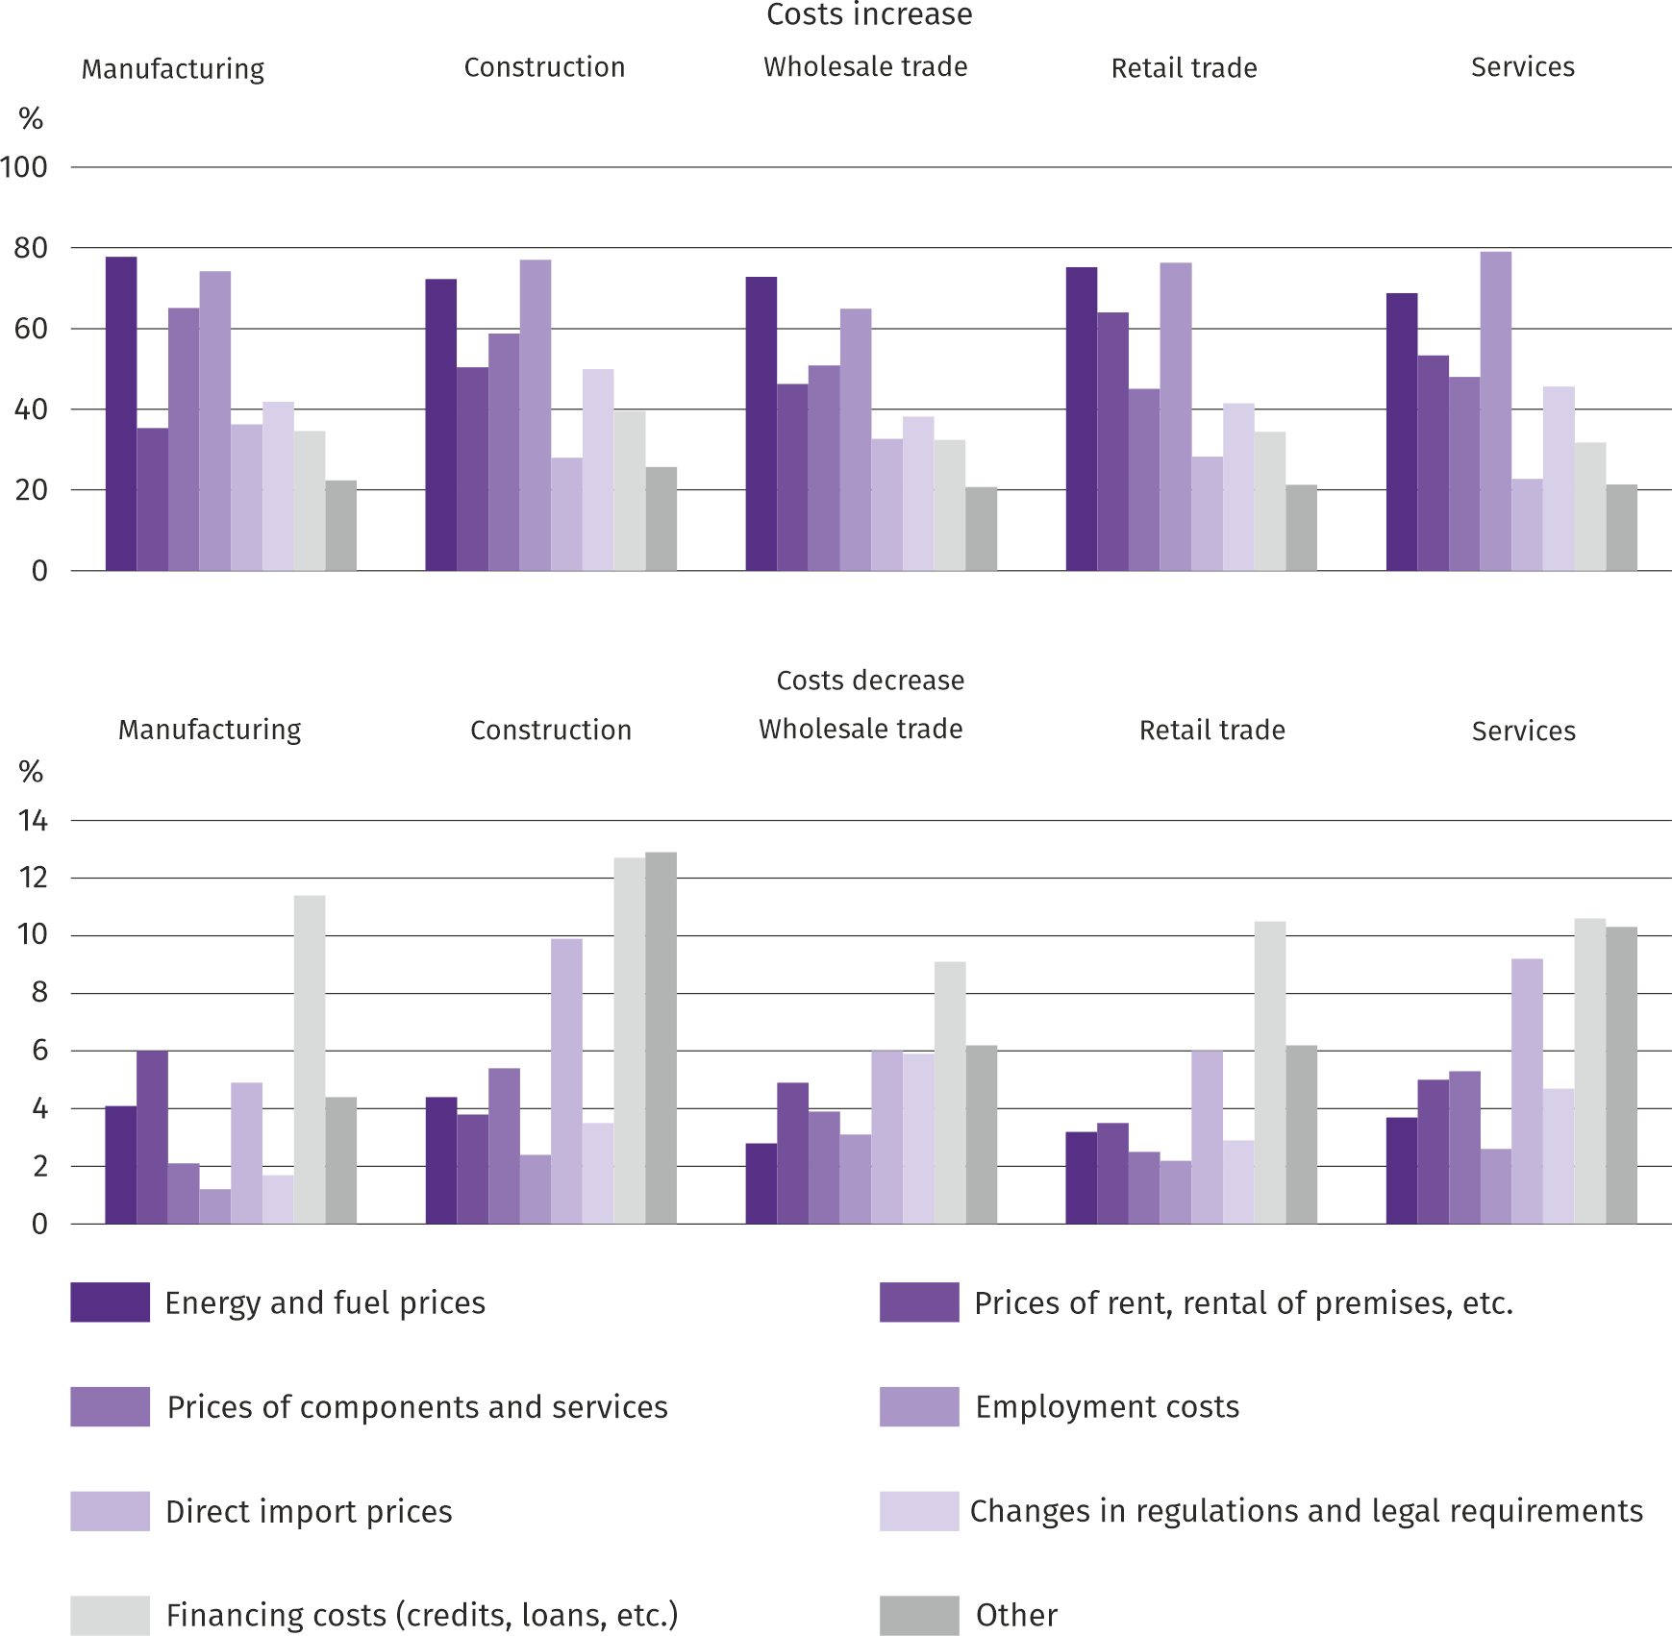
Question 5. Which of the following factors will have the greatest impact on your company's operating costs in the next quarter:
Entrepreneurs in all surveyed business types identified energy and fuel prices, as well as employment costs, as the factors with the greatest impact on the increase in company operating costs. Among these factors, direct import prices or financing costs (credits, loans, etc.) were cited as the least significant. Among the factors with the greatest impact on cost reductions across all industries, financing costs (credits, loans, etc.) and direct import prices, rent, and premises lease prices were most frequently cited.

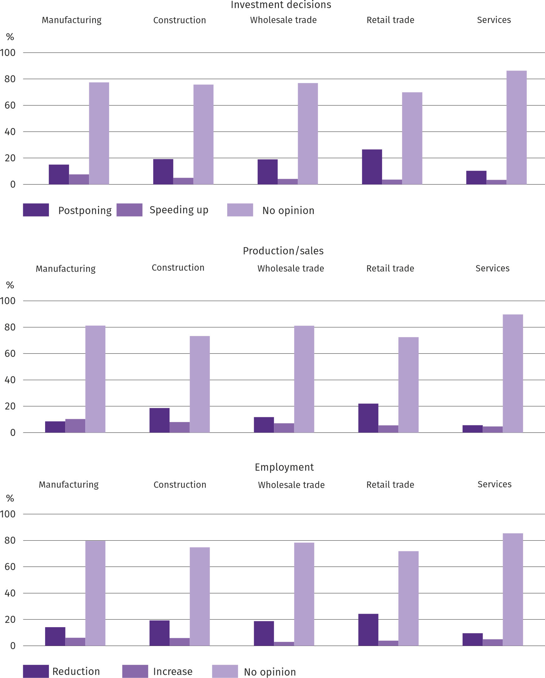
Question 6. Will the observed and predicted changes in the financing conditions of the enterprise (costs of bank loans and their availability, trade credit, deferred payments, etc.) cause, in the next 12 months, in the case of:

The responses to questions about how observed and anticipated changes in enterprise financing conditions over the next 12 months will affect investment decisions, production/sales, and employment indicate that entrepreneurs found it difficult to assess this impact – the vast majority of respondents always expressed no opinion on the matter. Those who expressed an opinion rarely expected an acceleration in investment or an increase in production/sales and employment. They more often believed that the impact of changes in the enterprise's operating conditions would be negative, forcing the postponement of investments and reductions in production/sales and employment. Only in the manufacturing sector were there more responses that the anticipated changes would increase production/sales than reduce them.
More information on the results of the business climate survey can be found on the website of the Statistical Office in Zielona Góra https://zielonagora.stat.gov.pl/osrodki/osrodek-badan-koniunktury/obk-dane/.

Table 13. Selected data on Mazowieckie Voivodship
SPECIFICATION  A – 2024  B – 2025 |  | 01 | 02 | 03 | 04 | 05 | 06 | 07 | 08 | 09 | 10 | 11 | 12
Average employment in the enterprise sector ª  (in thousand persons) | A | 1607,0 | 1601,8 | 1598,1 | 1594,4 | 1591,7 | 1588,1 | 1589,5 | 1586,0 | 1584,4 | 1580,1 | 1582,0 | 1583,9
 | B | 1582,5 | 1577,9 | 1572,7 | 1574,8 | 1570,6 | 1572,8 | 1574,1 | 1572,8 | 1571,5
previous month=100 | A | 100,7 | 99,7 | 99,8 | 99,8 | 99,8 | 99,8 | 100,1 | 99,8 | 99,9 | 99,7 | 100,1 | 100,1
previous month=100 | B | 99,9 | 99,7 | 99,7 | 100,1 | 99,7 | 100,1 | 100,1 | 99,9 | 99,9
corresponding month of previous year=100 | A | 100,7 | 100,8 | 100,8 | 100,3 | 100,3 | 100,1 | 100,3 | 100,0 | 99,8 | 99,5 | 99,4 | 99,3
corresponding month of previous year=100 | B | 98,5 | 98,5 | 98,4 | 98,8 | 98,7 | 99,0 | 99,0 | 99,2 | 99,2
Registered unemployed persons (in thousand persons; as of end of period) | A | 117,1 | 117,7 | 114,8 | 111,9 | 110,0 | 108,5 | 109,9 | 110,6 | 109,6 | 108,3 | 108,4 | 109,0
 | B | 114,7 | 115,9 | 113,9 | 111,3 | 108,7 | 111,0 | 116,0 | 120,2 | 119,6
Unemployment rate b (in %; as of end of period) | A | 4,3 | 4,3 | 4,2 | 4,1 | 4,1 | 4,0 | 4,1 | 4,1 | 4,0 | 4,0 | 4,0 | 4,0
Unemployment rate b (in %; as of end of period) | B | 4,2 | 4,2 | 4,2 | 4,1 | 4,0 | 4,1 | 4,3 | 4,4 | 4,4
Job offers (submitted during a month) | A | 17944 | 17639 | 14928 | 16475 | 16584 | 17271 | 17764 | 12910 | 13202 | 16551 | 13455 | 10874
Job offers (submitted during a month) | B | 15760 | 13938 | 14768 | 13164 | 11459 | 4235 | 5656 | 4432 | 5028
Unemployed persons per 1 job offer (as of end of period) | A | 14 | 16 | 19 | 15 | 12 | 12 | 13 | 16 | 14 | 14 | 14 | 23
Unemployed persons per 1 job offer (as of end of period) | B | 16 | 17 | 15 | 16 | 21 | 28 | 24 | 30 | 29
Average monthly gross wages and salaries in the en-terprise sector ª (in PLN) | A | 8943,42 | 9165,69 | 9949,91 | 9568,24 | 9156,63 | 9296,77 | 9459,07 | 9445,98 | 9239,16 | 9629,96 | 9480,33 | 9931,44
 | B | 9739,87 | 10004,89 | 10785,77 | 10612,28 | 9995,20 | 10173,45 | 10185,77 | 10100,98 | 9974,07
previous month=100 | A | 99,0 | 102,5 | 108,6 | 96,2 | 95,7 | 101,5 | 101,7 | 99,9 | 97,8 | 104,2 | 98,4 | 104,8
previous month=100 | B | 98,1 | 102,7 | 107,8 | 98,4 | 94,2 | 101,8 | 100,1 | 99,2 | 98,7
corresponding month of previous year=100 | A | 112,4 | 112,3 | 112,3 | 110,5 | 111,1 | 109,7 | 111,2 | 111,6 | 110,3 | 110,5 | 110,4 | 110,0
corresponding month of previous year=100 | B | 108,9 | 109,2 | 108,4 | 110,9 | 109,2 | 109,4 | 107,7 | 106,9 | 108,0
Price indices:
consumer goods and services ^{c}:
corresponding month of previous year=100 | A | . | . | 103,4 | . | . | 102,6 | . | . | 104,4 | . | . | 104,7
corresponding month of previous year=100 | B | . | . | 104,7 | . | . | 103,7 | . | . | .
a In enterprises employing more than 9 persons. b Share of registered unemployed persons in civilian economically active population, estimated at the end of each month. c From 1 June 2025, data on job offers are not fully comparable with earlier periods due to methodological changes resulting from the entry into force of the Act on the Labour Market and Employment Services (Journal of Laws of 2025, item 620). d In the quarter.
Table 13. Selected data on Mazowieckie Voivodship (cont.)
SPECIFICATION  A – 2024  B – 2025 |  | 01 | 02 | 03 | 04 | 05 | 06 | 07 | 08 | 09 | 10 | 11 | 12
Price indices (cont.):
Procurement of cereal grain:
previous month=100 | A | 106,0 | 97,7 | 92,9 | 94,5 | 106,7 | 119,5 | 82,0 | 107,3 | 100,4 | 105,7 | 104,7 | 97,5
previous month=100 | B | 102,5 | 100,3 | 98,5 | 102,4 | 98,1 | 97,1 | 94,2 | 93,1 | 99,4
corresponding month of previous year=100 | A | 65,8 | 66,0 | 68,4 | 70,6 | 83,3 | 105,9 | 88,3 | 96,9 | 96,1 | 99,5 | 107,1 | 110,3
corresponding month of previous year=100 | B | 106,6 | 109,4 | 116,0 | 125,8 | 115,7 | 94,0 | 108,0 | 93,8 | 92,9
procurement of cattle for slaughter (excluding calves):
previous month=100 | A | 104,4 | 99,6 | 98,6 | 110,6 | 101,6 | 103,0 | 98,6 | 100,4 | 100,0 | 104,8 | 117,3 | 102,5
previous month=100 | B | 101,0 | 102,0 | 112,7 | 95,6 | 103,1 | 89,8 | 100,6 | 90,3 | 134,0
corresponding month of previous year=100 | A | 93,9 | 94,2 | 94,8 | 108,2 | 90,6 | 137,3 | 118,8 | 103,6 | 117,7 | 120,3 | 143,7 | 148,0
corresponding month of previous year=100 | B | 143,3 | 146,7 | 167,6 | 144,9 | 147,2 | 128,3 | 130,9 | 117,7 | 157,8
procurement of pigs for slaughter:
previous month=100 | A | 94,5 | 101,2 | 103,9 | 102,4 | 101,0 | 101,6 | 95,0 | 96,2 | 100,1 | 95,9 | 93,4 | 99,2
previous month=100 | B | 90,7 | 102,7 | 107,4 | 113,0 | 102,6 | 96,4 | 94,3 | 101,8 | 96,9
corresponding month of previous year=100 | A | 91,9 | 84,4 | 86,0 | 81,1 | 83,9 | 81,3 | 77,8 | 84,2 | 84,2 | 85,3 | 81,0 | 84,8
corresponding month of previous year=100 | B | 81,4 | 82,6 | 85,4 | 94,3 | 95,8 | 90,9 | 90,2 | 95,5 | 92,4
Ratio of procurement prices ª of pigs for slaughter to marketplace prices of rye | A | 9,4 | 10,2 | 10,6 | 11,6 | 11,7 | 11,8 | 10,9 | 10,6 | 9,3 | 8,9 | 8,4 | 7,8
 | B | 7,7 | 7,7 | 8,3 | 9,9 | 9,7 | 9,2 | 8,4 | 9,4 | 9,3
Sold production of industry ^{b} (at constant prices):
previous month=100 | A | 104,8 | 97,0 | 107,1 | 91,7 | 96,8 | 97,8 | 102,2 | 97,6 | 104,3 | 111,7 | 98,6 | 100,3
previous month=100 | B | 92,0 | 95,9 | 106,7 | 98,2 | 94,9 | 97,6 | 104,0 | 96,1* | 109,9
corresponding month of previous year=100 | A | 109,2 | 111,4 | 108,4 | 114,0 | 108,3 | 108,0 | 113,1 | 107,1 | 103,3 | 105,6 | 104,4 | 108,7
corresponding month of previous year=100 | B | 95,4 | 94,3 | 93,9 | 100,6 | 98,6 | 98,4 | 100,2 | 98,6* | 104,0
Construction and assembly production b (at current prices):
previous month=100 | A | 34,4 | 123,4 | 111,9 | 125,7 | 101,6 | 107,2 | 98,7 | 95,1 | 113,8 | 103,6 | 102,1 | 140,0
previous month=100 | B | 47,2 | 107,8 | 118,8 | 106,2 | 100,8 | 106,8 | 104,8 | 89,5 | 116,9
corresponding month of previous year=100 | A | 95,7 | 107,3 | 88,7 | 117,5 | 109,0 | 106,0 | 117,3 | 98,9 | 98,8 | 112,0 | 101,3 | 103,0
corresponding month of previous year=100 | B | 141,1 | 123,2 | 130,9 | 110,6 | 109,7 | 109,3 | 116,1 | 109,4 | 112,4
a Current prices excluding VAT. b In enterprises employing more than 9 persons.

Table 13. Selected data on Mazowieckie Voivodship (cont.)
SPECIFICATION  A – 2024  B – 2025 |  | 01 | 02 | 03 | 04 | 05 | 06 | 07 | 08 | 09 | 10 | 11 | 12
Dwellings completed (from the beginning of the year) | A | 2723 | 5939 | 9232 | 11738 | 14595 | 17553 | 21339 | 24190 | 26662 | 30180 | 33728 | 38521
Dwellings completed (from the beginning of the year) | B | 3349 | 6885 | 9739 | 12532 | 16228 | 19683 | 23575 | 26855 | 30570
corresponding month of previous year=100 | A | 83,2 | 90,5 | 83,7 | 81,4 | 82,6 | 79,5 | 85,9 | 86,9 | 84,9 | 84,7 | 85,4 | 88,6
corresponding month of previous year=100 | B | 123,0 | 115,9 | 105,5 | 106,8 | 111,2 | 112,1 | 110,5 | 111,0 | 114,7
Retail sales of goods ª (at current prices):
previous month=100 | A | 75,5 | 100,0 | 112,7 | 101,6 | 99,0 | 99,3 | 105,6 | 98,9 | 91,9 | 106,4 | 101,2 | 111,9
previous month=100 | B | 78,0 | 94,8 | 113,7 | 104,7 | 97,6 | 98,8 | 104,6 | 98,9 | 95,6
corresponding month of previous year=100 | A | 100,3 | 103,6 | 101,9 | 103,4 | 105,1 | 102,7 | 105,9 | 99,1 | 93,0 | 94,3 | 97,2 | 98,4
corresponding month of previous year=100 | B | 101,6 | 96,3 | 97,2 | 100,1 | 98,7 | 98,2 | 97,3 | 97,3 | 101,3
Turnover profitability indicator in enterprises ^{b}:
gross ^{c} (in %) | A | . | . | 4,0 | . | . | 4,4 | . | . | 4,6 | . | . | 4,9
gross ^{c} (in %) | B | . | . | 4,6 | . | . | 4,9 | . | . | .
net ^{d} (in %) | A | . | . | 3,0 | . | . | 3,6 | . | . | 3,8 | . | . | 3,9
net ^{d} (in %) | B | . | . | 3,6 | . | . | 3,9 | . | . | .
Investment outlays of enterprises ^{b} – from the begin-ning of the year (in million PLN; current prices) | A | . | . | 13513,2 | . | . | 29901,6 | . | . | 48420,6 | . | . | 75782,3
 | B | . | . | 13471,2 | . | . | 31921,6 | . | . | .
corresponding month of previous year=100 (current prices) | A | . | . | 97,0 | . | . | 95,7 | . | . | 92,6 | . | . | 93,7
corresponding month of previous year=100 (current prices) | B | . | . | 99,7 | . | . | 106,8 | . | . | .
Entities of the national economy ^{e} in the REGON regis-ter (as of end of period) | A | 1013945 | 1018833 | 1022367 | 1026106 | 1029355 | 1032369 | 1035867 | 1039428 | 1043211 | 1047123 | 1050447 | 1052760
 | B | 1055182 | 1057965 | 1061558 | 1064898 | 1068064 | 1071074 | 1074082 | 1077325 | 1080871
of which commercial companies | A | 224121 | 225458 | 226664 | 227868 | 228837 | 229562 | 230815 | 231886 | 232883 | 234115 | 234950 | 236043
of which commercial companies | B | 237041 | 237949 | 239071 | 240155 | 240700 | 241451 | 242422 | 243409 | 696939
of which with foreign capital participation | A | 40492 | 40647 | 40808 | 41008 | 41245 | 41356 | 41550 | 41689 | 41873 | 42067 | 42226 | 42385
of which with foreign capital participation | B | 42461 | 42567 | 42726 | 42857 | 42903 | 43009 | 43119 | 43266 | 43348
a In enterprises employing more than 9 persons. b In enterprises employing more than 49 persons. c Relation of gross financial result to revenues from total activity. d Relation of net financial result to revenues from total activity. e Excluding persons tending private farms in agriculture.
Prepared by:  Statistical Office in Warszawa  Director Agnieszka Ajdyn  Phone: (+48 22) 464 23 15 | Issued by:  Statistical Information Centre  Mobile: (+48) 783 940 141  e-mail: m.kaluski@stat.gov.pl

warszawa.stat.gov.pl/en/

@Warszawa_STAT

@UrzadStatystycznywWarszawie

gus_stat

glownyurzadstatystycznygus

glownyurzadstatystyczny

In the case of quoting data from the Statistics Poland, please provide information “Statistics Poland data source”, and in the case of publishing calculations made on data published by the Statistics Poland, provide information: “Own study based on Statistics Poland data”.
Related information
Statistical Bulletin of Mazowieckie Voivodship
Report of the socio-economic situation of Mazowieckie Voivodship in 2024
Socio-economic situation of voivodships No. 2/2025
Data available in databases
Local Data Bank (BDL)
Knowledge Databases (DBW)
Terms used in official statistics
Average paid employment
Registered unemployed persons
Registered unemployment rate
Monthly gross wages and salaries
Retail prices
Price index of consumer goods and services
Procurement of agricultural products
Procurement prices
Marketplace prices
Pigs
Cattle
Sold production of industry
Construction and assembly production
Dwellings completed
Retail sales of goods (including VAT)
Wholesale (including VAT)
Financial results of enterprises
Investment outlays
Entities of the national economy
Business tendency

The long-term unemployed include persons remaining in the register of the powiat labour office for a total period of more than 12 months in the last 2 years, excluding periods of internship and vocational preparation.
Refers to vacancies and places of occupational activation.
The average values of temperature and precipitation were calculated as arithmetic averages of the average monthly values from five hydrological and meteorological stations of the Institute of Meteorology and Water Management located in Kozienice, Mława, Płock, Siedlce and Warszawa.
Reporting data – may change after preparing quarterly report.
Applies to legal persons, organisational units without legal personality and natural persons conducting economic activity (excluding natural persons tending private farms in agriculture).
The survey was conducted from the 1st to the 10th of the current month on a sample of industrial, construction, commercial, and service entities. Responses to the entire additional block of questions are provided on a voluntary basis. All questions present a weighted percentage of respondents' responses to a given option. Data were aggregated according to the aggregation (weighting) methodology standardly used in economic climate surveys.
It was permissible to select one answer for each option ("outflow" and "inflow") simultaneously, therefore the sum of the options may exceed 100%. The answer "not applicable" was selected if the company did not employ workers from Ukraine or had not observed any outflow or inflow of workers in the previous month.

