Socio-economic situation of Mazowieckie Voivodship in September 2022
- In August this year, the average employment in the enterprise sector increased by 2.5% on a yearly basis and decreased by 0.1% compared to the previous month. The registered unemployment rate amounted to 4.2% and decreased by 0.6 pp on an annual basis and by 0.1 pp on a monthly basis.
- Average monthly gross wages and salaries in the enterprise sector in September this year were higher by 13.3% compared to the previous year and by 0.4% lower than in the previous month.
- On the agricultural market in September 2022, the average procurement prices of the discussed agricultural products were higher than in the previous year. On a monthly basis, prices of wheat, pigs and poultry for slaughter and milk were higher, while less was paid for rye, potatoes and cattle for slaughter.
- In September this year, sold production of industry (at constant prices) increased on a yearly basis (by 17.0%) and on a monthly basis (by 6.7%). Construction and assembly production (at current prices) was higher by 7.4% than in the previous year and by 4.5% than a month earlier.
- The number of dwellings completed in September this year was higher by 5.7% than a year before and by 14.6% compared to the previous month. Most dwellings were built for sale or rent.
- In September this year, there was an increase in wholesale in annual terms (by 31.6%). There was also an increase in retail sales (by 16.9%).
- In September this year, the number of entities of the national economy registered in the REGON register was higher by 4.3% than in the previous year and by 0.5% than in August this year.
- In most of the analysed areas, entrepreneurs in October this year assessed the economic situation similarly or worse than in August this year.

Contents
Labour market 4
Wages and salaries 7
Agriculture 9
Industry and construction 12
Housing construction 14
Domestic market 17
Entities of the national economy 18
Business tendency 20
Selected data on Mazowieckie Voivodship 25

General notes
Data presented in the news release:
- on employment, wages and salaries and sold production of industry and construction, construction and assembly production, as well as retail sales and wholesale concern economic entities employing more than 9 persons,
- on enterprise sector refer to entities conducting economic activity in the field of: forestry and logging; maritime fishing; mining and quarrying; manufacturing; electricity, gas, steam and air conditioning supply; water supply; sewerage, waste management and remediation activities; construction; wholesale and retail trade; repair of motor vehicles and motorcycles; transportation and storage; accommodation and food service activities; information and communication; real estate activities; legal and accounting activities; activities of head offices; management consultancy activities; architectural and engineering activities; technical testing and analysis; advertising and market research; other professional, scientific and technical activities; arts, entertainment and recreation; repair of computers and personal and household goods; other personal service activities,
- on retail prices of foodstuffs and non-foodstuffs as well as services that originate from quotations of prices conducted by interviewers at selected points of sale in selected regions of price surveys; prices of food are collected once a month, with the exception of fruit and vegetables, for which prices are collected twice a month,
- on procurement of agricultural products include procurement from producers from the voivodship; prices are given excluding VAT tax,
- on financial results of enterprises and investment outlays refer to economic entities keeping accounting ledgers (excluding entities whose activity is classified according to the NACE Rev. 2 in the sections “Agriculture, forestry and fishing” and “Financial and insurance activities” as well as higher education institutions) in which the number of employed persons exceeds 49.
Data in value terms are provided at current prices and form the basis for calculating the structure indicators. Dynamic indices are provided on the basis of value at current prices, except for industry, for which the dynamic indices are provided on the basis of value at constant prices (average current prices of 2015).
Relative numbers (indices, percentages) were calculated on the basis of absolute data expressed with higher precision than that presented in the text and tables.
Data have been presented in accordance with the Polish Classification of Activities – PKD 2007 (NACE Rev. 2).

Polish Classification of Activities 2007 – PKD 2007 (NACE Rev. 2)
Abbreviation | Full name
sections
trade; repair of motor vehicles | wholesale and retail trade; repair of motor vehicles and motorcycles
accommodation and catering | accommodation and food service activities
divisions
trade; repair of motor vehicles | wholesale and retail trade; repair of motor vehicles and motorcycles

Symbols
Symbol | Description
(–) | – magnitude zero
(.) | – data not available, classified data (statistical confidentiality) or providing data impossible or purposeless
(*) | – data revised
∆ | – categories of applied classification are presented in abbreviated form
„Of which” | – indicates that not all elements of the sum are given
Data describing Mazowieckie Voivodship can also be found in statistical publications issued by the Statistical Office in Warszawa and in the publications of Statistics Poland.
The report „Economic situation in Mazowieckie Voivodship in October 2022” will be published on the home page of the Statistical Office in Warszawa: https://warszawa.stat.gov.pl/en on 31 October 2022.
When publishing Statistical Office data – please indicate the source.

Labour market
In September this year, the average employment in the enterprise sector was higher compared to the previous year and slightly decreased compared to the previous month. The registered unemployment rate decreased in annual and in monthly terms.
Average employment in the enterprise sector in September this year amounted to 1,576.7 thousand persons and was by 2.5% higher in annual terms (2.7% in the previous month). The largest increase occurred in accommodation and catering (by 9.7%), and also, among others, in information and communication (by 7.8%), and in professional, scientific and technical activities (by 6.9%). The decrease was recorded in electricity, gas, steam and air conditioning supply (by 2.9%) and real estate activities (by 2.3%).
In comparison with August this year, average employment decreased by 0.1%; the most in accommodation and catering (by 1.7%), and also in professional, scientific and technical activities (by 0.5%), trade; repair of motor vehicles (by 0.3%), construction and in transportation and storage (by 0.1% each). The increase was recorded in administrative and support service activities and in information and communication (by 0.5% each).
Table 1. Average employment in the enterprise sector in September 2022
SPECIFICATION | 09 2022 |  | 01–09 2022
 | in thousands | 09 2021=100 | in thousands | 01–09 2021=100
TOTAL | 1576,7 | 102,5 | 1571,2 | 102,3
of which:
Industry | 389,9 | 100,4 | 391,2 | 100,6
of which:
manufacturing | 344,6 | 100,7 | 345,7 | 100,8
electricity, gas, steam and air conditioning supply | 23,9 | 97,1 | 24,0 | 96,7
Construction | 91,5 | 102,2 | 91,5 | 102,4
Trade; repair of motor vehicles ^{Δ} | 347,7 | 102,2 | 347,2 | 102,3
Transportation and storage | 276,1 | 101,8 | 276,2 | 101,5
Accommodation and catering ^{Δ} | 33,4 | 109,7 | 32,4 | 108,8
Information and communication | 129,4 | 107,8 | 127,1 | 108,4
Real estate activities | 22,6 | 97,7 | 22,6 | 97,9
Professional, scientific and technical activities ª | 104,9 | 106,9 | 102,6 | 106,1
Administrative and support service activities | 145,7 | 102,2 | 145,4 | 100,1
a Excluding divisions: Research and experimental development work and Veterinary activities.
In the period of January–September this year, average employment in the enterprise sector amounted to 1,571.2 thousand persons and increased by 2.3% compared to the corresponding period of 2021 (it increased by 0.1% the year before).

Chart 1. Average employment in the enterprise sector (monthly average 2015=100)
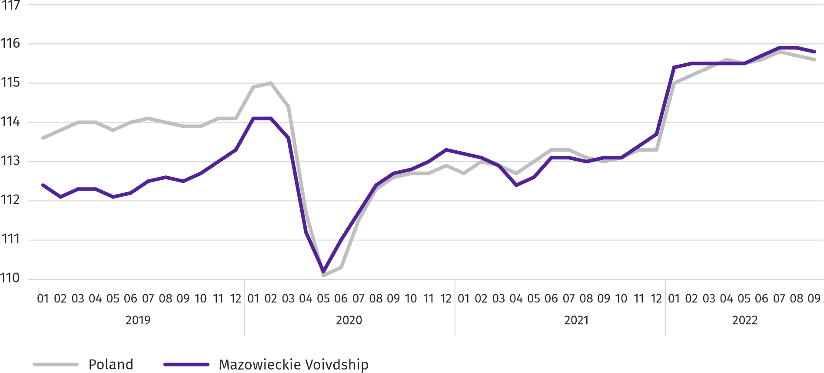
At the end of September this year, the number of unemployed persons registered in labour offices amounted to 118.3 thousand persons and decreased on a yearly basis by 16.6 thousand persons (i.e. by 12.3%), and on a monthly basis by 1.7 thousand persons (i.e. by 1.4%). Women accounted for 51.6% of total registered unemployed persons (a year before 51.1%).
Table 2. Number of unemployed persons and unemployment rate
SPECIFICATION | 2021 | 2022
 | 09 | 08 | 09
Registered unemployed persons (as of end of month) in thousands | 134,9 | 119,9 | 118,3
Newly registered unemployed persons (during a month) in thousands | 13,4 | 13,3 | 16,1
Unemployed persons removed from unemployment rolls (during a month) in thousands | 16,7 | 14,0 | 17,8
Registered unemployment rate (as of end of month) in % | 4,8 | 4,3* | 4,2
Chart 2. Registered unemployment rate (as of end of month)
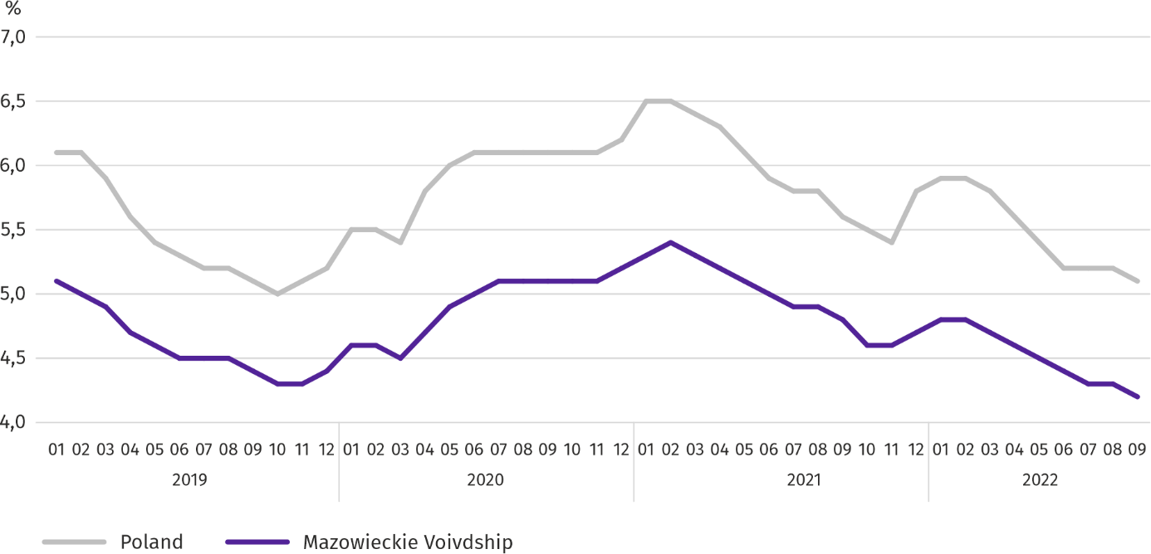

Registered unemployment rate at the end of September this year amounted to 4.2% and was lower than the national average (5.1%). It decreased by 0.6 pp on a yearly basis, and by 0.1% on a monthly basis.
The territorial differentiation of the unemployment rate continued in the Voivodship. Powiats with the highest unemployment rate were still szydłowiecki (24.9% compared to 22.6% in Sepetember last year), przysuski (17.6% compared to 15.3%), radomski (17.3% compared to 15.7%), and with the lowest – m.st. Warszawa (1.5% compared to 1.9%), warszawski zachodni (1.6% compared to 2.1%), grójecki (2.3% compared to 2.4%), and pruszkowski (2.3% compared to 3.3%).
Compared to September last year, the unemployment rate decreased in 23 out of 42 powiats. The highest decrease was recorded in the powiats: legionowski (by 1.8 pp), Radom and sochaczewski (by 1.3 pp) and płoński and pruszkowski (by 1.0 pp). The highest increase was recorded in the powiats: pułtuski and żuromiński (by 2.8 pp each), lipski (by 2.4 pp) and in przysuski and szydłowiecki (by 2.3 pp each).
Compared to August this year, the unemployment rate decrease by 0.1–0.6 pp took place in 19 powiats. Increase in the range of 0.1-0.3 pp took place in 7 powiats. There were no changes in 16 powiats.
Map 1. Registered unemployment rate by powiats in 2022 (as of end of September)
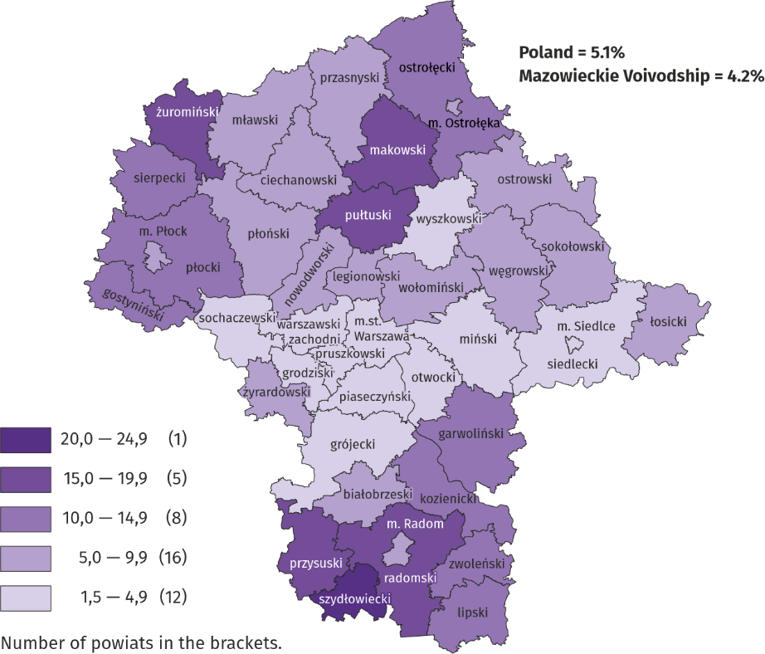
In September this year, 16.1 thousand unemployed persons were registered in labour offices, i.e. more by 20.6% than a year before and by 21.4% than in the previous month. Among the newly registered, 67.9% were persons registered once again (71.7% a year before). The share of persons previously not employed amounted to 23.4% (increase by 4.0 pp on a yearly basis), persons terminated due to company reasons 2.8% (a 1.1 pp decrease). Out of newly registered unemployed persons, 44.4% were rural residents (a decrease by 2.0 pp). Graduates accounted for 14.4% of newly registered unemployed persons (increase by 1.3%).
In September this year, 17.8 thousand persons were removed from unemployment rolls, i.e. more by 6.7% than a year before and by 26.9% than a month before. 9.6 thousand persons (8.0% less than a year before) were removed from unemployment rolls due to undertaking employment. The share of this category of persons in the total number of persons removed from unemployment rolls decreased by 8.6 pp on a yearly basis and amounted to 54.1%. However there was an increase in the share of persons who lost their status of the unemployed as a result of not confirming readiness to take up work (by 5.6 pp to 20.1%), persons who started training or traineeship with employer (by 2.4 pp to 9.8%), and persons who voluntarily gave up their status of the unemployed (by 1.4 pp to 6.5%). The percentage of persons who obtained retirement or pension rights did not change and amounted to 0.4%.
At the end of September this year, 102.6 thousand unemployed persons were not entitled to the unemployment benefit, and their share in the total number of the registered unemployed was 86.7% (no changes in annual terms).
At the end of the surveyed month, 64.8 thousand, i.e. 54.8% out of registered unemployed persons were the long-term unemployed. The number of unemployed persons under the age of 30 amounted to 26.1 thousand, which accounted for 22.0% of the total unemployed (of which persons under the age of 25 constituted 11.1%). Persons aged over 50 amounted to 32.1 thousand (27.1%). 0.6 thousand of unemployed persons, i.e. 0.5% of their total number received social assistance benefits. There were 18.2 thousand persons (i.e. 15.4% of the total unemployed) had at least one child under the age of 6, and persons with a disabled child aged under 18 – 241 persons (0.2% respectively). The number of disabled unemployed persons amounted to 6.5 thousand (i.e. 5.5%).
Chart 3. Registered unemployed persons per job offer (as of end of month)
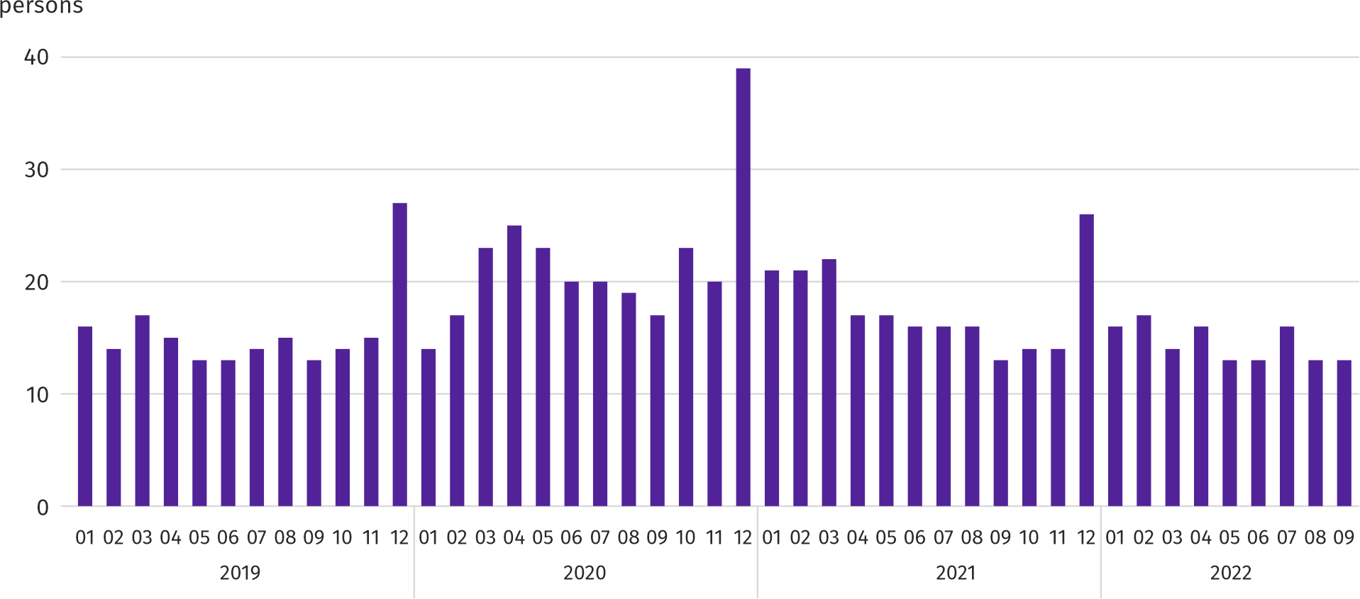
In September this year, 15.9 thousand job offers, i.e. less than a year before by 3.5% and by 3.9% more on a monthly basis were submitted to labour offices. At the end of month, there were 13 unemployed persons (as in the previous year) per job offer.
According to the labour offices, as of the end of September this year, 42 companies announced termination of 8.7 thousand employees in the near future (a year before, respectively 58 companies – 13.6 thousand employees).

Wages and salaries
In September this year, the average monthly gross wages and salaries in the enterprise sector increased on a yearly but decreased on a monthly basis.
Average monthly gross wages and salaries in the enterprise sector in September this year amounted to PLN 7,640.75 and were higher than in the country (PLN 6,687.81). The increase was recorded in all analysed sections, the largest in electricity, gas, steam and air conditioning supply (by 20.0%), and also, among others, in transportation and storage (by 17.1%), construction (by 16.4%) and real estate activities (by 13.7%).
In comparison with August this year, average wages and salaries decreased by 0.4%. It decreased the most in professional, scientific and technical activities (by 4.6%), and also in electricity, gas, steam and air conditioning supply (by 4.1%), construction (by 2.4%) and in trade; repair of motor vehicles (by 2.2%). The largest increase was noted in manufacturing (by 3.2%), and also to a lesser extent, among others, in transportation and storage and accommodation and catering (by 1.0% each) and in information and communication (by 0.4%).

Chart 4. Relative deviations of average monthly gross wages and salaries in selected sections from average wages and salaries in the enterprise sector in September 2022
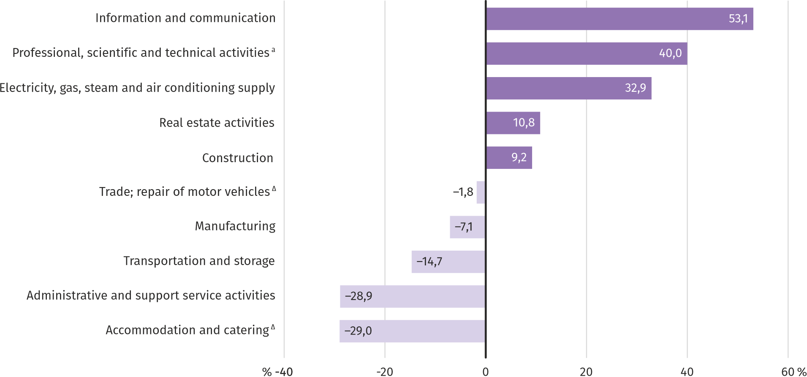
a Excluding divisions: Research and experimental development work and Veterinary activities.
In September this year, the highest average monthly gross wages and salaries were noted in information and communication – it exceeded the average wages and salaries in the enterprise sector in the Voivodship by 53.1%.
Table 3. Average monthly gross wages and salaries in the enterprise sector in September 2022
SPECIFICATION | 09 2022 |  | 01–09 2022
 | in PLN | 09 2021=100 | in PLN | 01–09 2021=100
TOTAL | 7640,75 | 113,3 | 7618,21 | 112,8
of which:
Industry | 7252,77 | 113,5 | 7156,58 | 110,2
of which:
manufacturing | 7098,91 | 113,2 | 6961,41 | 110,6
electricity, gas, steam and air conditioning supply | 10154,16 | 120,0 | 10626,00 | 108,4
Construction | 8344,52 | 116,4 | 8510,31 | 117,3
Trade; repair of motor vehicles ^{Δ} | 7503,18 | 111,9 | 7740,22 | 113,0
Transportation and storage | 6517,33 | 117,1 | 6267,70 | 117,6
Accommodation and catering ^{Δ} | 5428,06 | 107,7 | 5398,90 | 114,4
Information and communication | 11698,75 | 110,3 | 11582,92 | 108,3
Real estate activities | 8466,52 | 113,7 | 8629,14 | 112,3
Professional, scientific and technical activities ª | 10695,71 | 113,3 | 10874,19 | 112,2
Administrative and support service activities | 5432,27 | 107,9 | 5375,37 | 109,7
a Excluding divisions: Research and experimental development work and Veterinary activities.
In the period of January–September this year, the average monthly gross wages and salaries in the enterprise sector amounted to PLN 7,618.21 and was 12.8% higher than in the corresponding period of 2021 (7.1% higher a year before).
Chart 5. Average monthly gross wages and salaries in the enterprise sector (monthly average 2015=100)
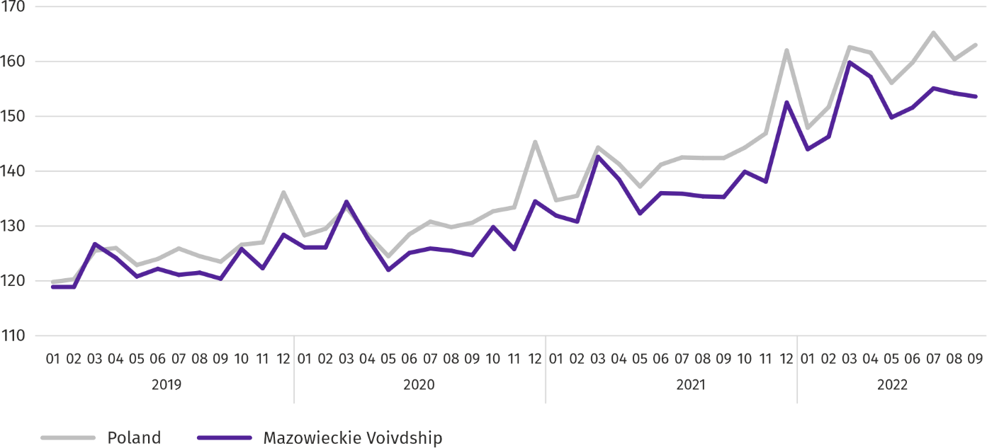

Agriculture
On the agricultural market in September 2022, the average procurement prices of the surveyed agricultural products were higher than in the previous year. On a monthly basis, procurement prices of wheat, pigs and poultry for slaughter and milk were higher, and prices of rye, potatoes and cattle for slaughter lower.
The average air temperature in Mazowieckie Voivodship in September 2022 amounted to 11.7°C and was by 1.9°C lower from the average from the years 1991–2020, while the maximum temperature reached 23.3°C, and the minimum amounted to minus 1.3°C both registered at the meteorological station in Kozienice. The average atmospheric precipitation (49.8 mm) accounted for 94% of the standard for the multi-year periods (ranging from 42% in Płock to 105% in Kozienice). The number of days with precipitation, depending on the region, ranged from 11 to 17.
Table 4. Procurement of cereals ª
SPECIFICATION | 07–09 2022 |  | 09 2022
 | in thousand tonnes | corresponding period of the previous year=100 | in thousand tonnes | 09 2021=100 | 08 2022=100
Grain of basic cereals ^{b} | 175,1 | 105,7 | 50,4 | 73,0 | 60,9
of which:
wheat | 117,3 | 105,7 | 36,1 | 74,5 | 67,7
rye | 26,0 | 98,5 | 5,1 | 51,5 | 36,6
a Excluding procurement by natural persons. b Includes: wheat, rye, barley, oat, triticale; including cereal mixed, excluding sowing seed.
In September 2022, deliveries of basic cereals (with cereal mixed, without sowing seed) to the procurement amounted to 50.4 thousand tonnes and were by 27.0% smaller than in the corresponding period of the previous year, with wheat deliveries smaller by 25.5%, and rye by 48.5%. On a monthly basis, the procurement of these types of cereals was smaller by 32.3% and 63.4%, respectively).

Table 5. Procurement of basic animal productsª
SPECIFICATION | 01–09 2022 |  | 09 2022
 | in thousand tonnes | 01–09 2021=100 | in thousand tonnes | 09 2021=100 | 08 2022=100
Animals for slaughter ^{b} | 879,6 | 111,6 | 87,8 | 101,2 | 96,8
of which:
cattle (including calves) | 53,0 | 133,3 | 2,9 | 99,3 | 95,5
pigs | 221,8 | 98,9 | 19,0 | 80,9 | 102,2
poultry | 604,1 | 115,4 | 65,8 | 109,2 | 95,4
Milk ^{c} | 2009,1 | 101,9 | 209,6 | 101,2 | 94,2
a In July-September excluding procurement by natural persons. b Including cattle, calves, pigs, sheep, horses and poultry; in terms of meat including fats in post-slaughter warm weight. c In million litres.
From the beginning of this year, producers from Mazowieckie Voivodship delivered 791.9 thousand tonnes of animals for slaughter (in warm weight), i.e. 11.6% more than in the previous year. The increase in procurement concerned cattle (by 33.3%) and poultry (by 15.4%), and a decrease pigs for slaughter (by 1.1%). In September this year, the total supply of animals for slaughter (87.8 thousand tonnes) was higher by 1.2% on an annual basis, and by 3.2% lower on a monthly basis.
Deliveries of milk to procurement in January–September 2022 (2,009.1 million litres) were by 1.9% larger than in the corresponding period of 2021. In September this year, procurement of milk amounted to 209.6 million litres and was smaller by 5.8% than in the previous month and by 1.2% larger than in the previous year.
Tablie 6. Average prices of basic agricultural products
SPECIFICATION | 09 2022 |  |  | 01–09 2022
 | PLN | 09 2021=100 | 08 2022=100 | PLN | 01–09 2021=100
Wheat ª per dt | 151,03 | 146,3 | 103,0 | 147,62 | 155,7
Rye ª per dt | 120,44 | 146,8 | 99,6 | 118,01 | 168,4
Potatoes per dt | 38,59 | 153,1 | 45,7 | 55,35 | 144,9
Animals for slaughter per kg of live weight:
cattle (excluding calves) | 11,37 | 138,7 | 97,7 | 10,07 | 139,6
pigs | 8,23 | 179,4 | 102,8 | 6,63 | 128,7
poultry | 6,43 | 158,6 | 102,5 | 5,86 | 152,7
Milk per 1 hl | 245,14 | 157,8 | 103,0 | 216,64 | 143,8
a Excluding sowing seed.
In September this year, PLN 151.03 was paid for 1 dt of wheat at procurement, i.e. 3.0% more than last month and 46.3% more than last year. The average price of wheat at marketplaces was similar to that in August 2022 (PLN 171.58) and was higher by 57.8% than a year before. The procurement price of rye decreased by 0.4% (to PLN 120.44) compared to the previous month, and the marketplace price increased by 7.1% (to PLN 126.32). Compared to September 2021, procurement prices for rye were 46.8% higher, and marketplace prices 66.36% higher.

Table 7. Average marketplace prices of cereals and potatoes
SPECIFICATION | 09 2022
 | PLN | 09 2021=100 | 08 2022=100
Wheat per dt | 171,58 | 157,8 | 100,0
Rye per dt | 126,32 | 166,6 | 107,1
Potatoes ^{b} per dt | 174,71 | 112,0 | 95,7
a Edible late.
Chart 6. Average marketplace prices of cereals and potatoes ª
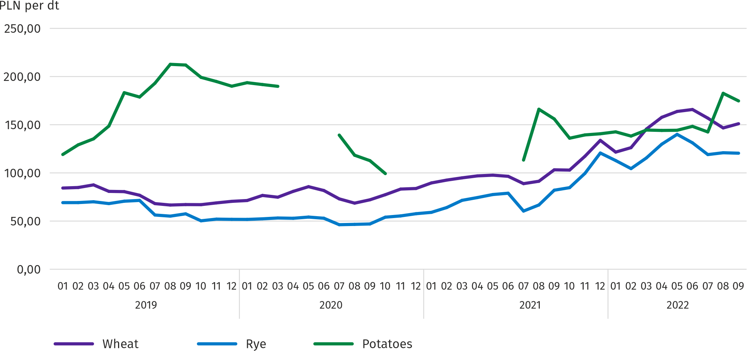
a No data in the period April-June 2020 and November 2020-June 2021 due to the current decision to close marketplaces due to the COVID-19 threat; it was not possible to collect data on prices of agricultural products at marketplaces.
In September this year, the average procurement price of potatoes was PLN 38.59/dt, i.e. 54.3% less than in the previous month and 53.1% more than last year. At marketplaces, the average price of 1 dt of potatoes was PLN 174.71 and was 4.3% lower than in the previous month and by 12.0% higher than in the previous year.
Chart 7. Average procurement prices of animals for slaughter and milk
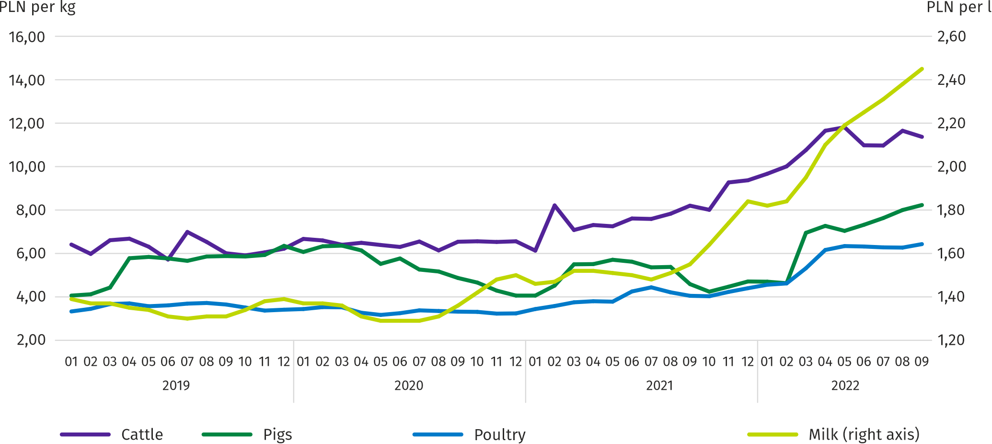
In September this year, the average procurement price of pigs for slaughter was by 79.4% higher than in the previous year, and higher than In the previous month by 2.8%.
Chart 8. Ratio of the average procurement prices of pigs for slaughter to the average marketplace prices of rye ª
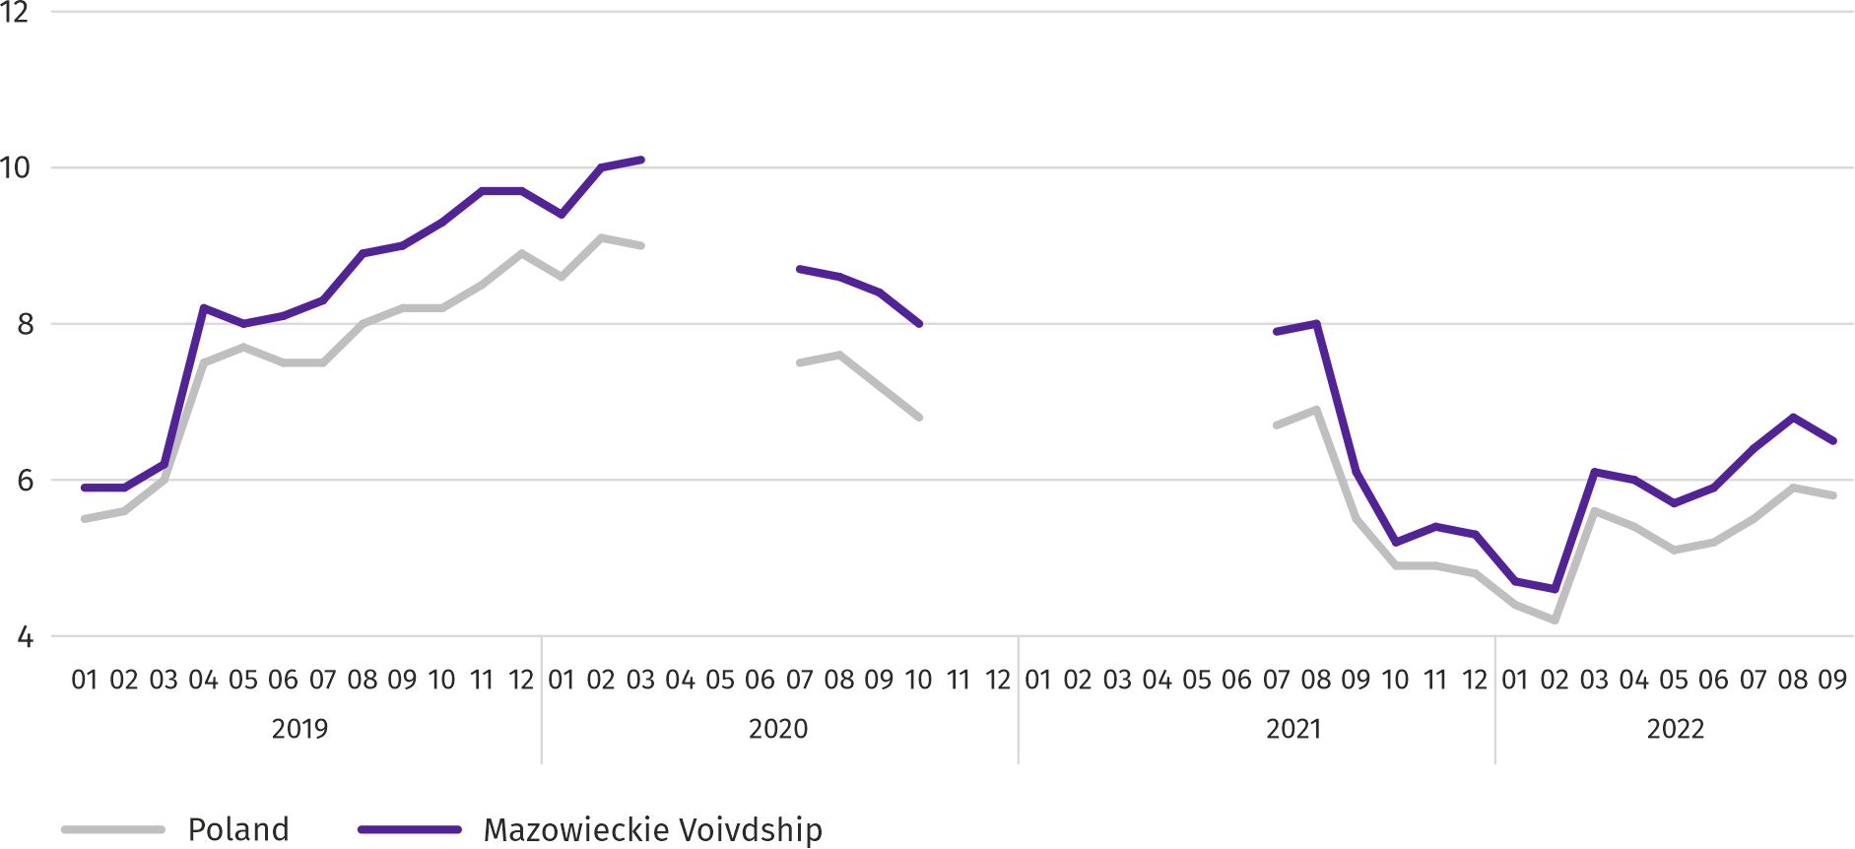
a No data in the period April-June 2020 and November 2020-June 2021 due to the current decision to close marketplaces due to the COVID-19 threat; it was not possible to collect data on prices of agricultural products at marketplaces.
In September 2022, suppliers were paid an average of PLN 6.43 per 1 kg of poultry for slaughter, i.e. 2.5% more than in August 2022 and 58.6% more than in September last year.
In the period of nine months of this year, the average procurement price of cattle for slaughter was 39.6% higher than in the corresponding period of the previous year. In September this year, 2.3% less was paid for cattle for slaughter than a month before and by 38.7% more than in the previous year.
Procurement prices of milk in September 2022 were 57.8% higher than a year ago and by 3.0% higher than a month ago.

Industry and construction
Sold production of industry in September this year, reached the value (at current prices) of PLN 50,900.4 million and was (at constant prices) by 17.0% higher than a year before (compared to a 18.3% increase in August this year); as compared to the previous month it increased by 6.7%.
Sold production in manufacturing (constituting 82.1% of sold production of industry) compared to September last year increased (at constant prices) by 16.1%. There was also an increase (by 23.5%) in sold production in the section of electricity, gas, steam and air conditioning supply (the share of this section represents 16.1% of industrial production).

Chart 9. Sold production of industry (monthly average 2015=100; constant prices)
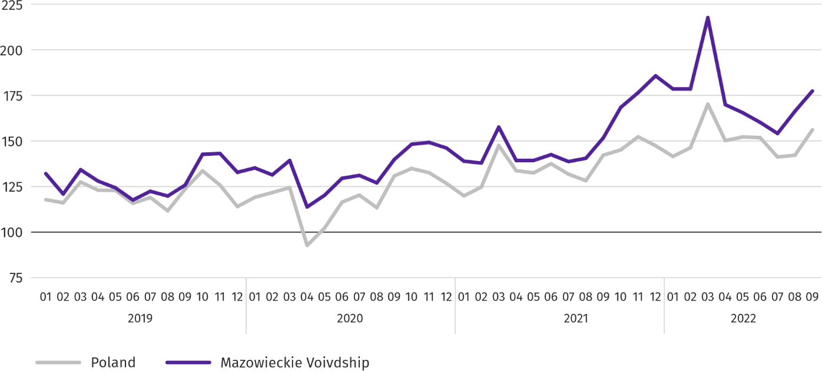
In September this year, the increase in sold production in annual terms was recorded in 23 (out of 32 in the Voivodship) divisions of industry, among others, in: manufacture of food products (by 15.4%), manufacture of rubber and plastic products (by 11.8%), electrical equipment (by 10.1%), chemicals and chemical products (by 6.9%), beverages (by 5.6%). However, there was a decrease in sold production of, among others, other non-metallic mineral products (by 9.4%), machinery and equipment n.e.c. (by 7.8%), computers, electronic and optical products (by 2.1%), metal products (by 1.3%), paper and paper products (by 0.3%).
Table 8. Indices (constant prices) and structure (current prices) of sold production of industry in September 2022
SPECIFICATION | 09 2022 | 01–09 2022
 | corresponding period of previous year =100 |  | In percent
TOTAL | 117,0 | 118,3 | 100,0
of which:
Manufacturing | 116,1 | 114,0 | 75,7
of which manufacture of:
food products | 115,4 | 117,0 | 17,3
beverages | 105,6 | 112,1 | 1,8
paper and paper products | 99,7 | 95,8 | 2,2
chemicals and chemical products | 106,9 | 123,6 | 4,5
manufacture of rubber and plastic products | 111,8 | 117,0 | 3,3
other non-metallic mineral products | 90,6 | 105,8 | 2,3
metal products ^{Δ} | 98,7 | 112,9 | 3,9
computer, electronic and optical equipment | 97,9 | 95,6 | 4,7
electrical equipment | 110,1 | 102,5 | 4,2
machinery and equipment n.e.c. | 92,2 | 104,7 | 1,7
Electricity, gas, steam and air conditioning supply | 123,5 | 136,7 | 22,3
Labour productivity in industry measured by sold production per employed person, in September this year amounted (at current prices) to PLN 130.6 thousand and was (at constant prices) by 16.5% higher than a year before, with higher by 0.4% average paid employment and higher average monthly gross wages and salaries by 13.5%.
In the period January–September this year, sold production of industry (at current prices), reached the value of PLN 418,997.2 million (at constant prices) was by 18.3% higher than in the corresponding period of the previous year. In manufacturing sold production increased by 14.0%, and in electricity, gas, steam and air conditioning supply by 36.7%.
Sold production of construction (at current prices) in September this year, reached the value of PLN 9,793.1 million and was by 30.4% higher than in the previous year (compared to a 22.6% increase in August this year). In the period of January–September this year, sold production of the construction amounted to PLN 77,439.3 million and was 25.7% higher than in the corresponding period of the previous year.
Labour productivity in construction, measured by revenue from the sale of goods and services per employed person in September this year amounted to PLN 107.0 thousand (at current prices) and was by 27.7% higher compared to the corresponding month of last year, with an increase in average employment by 2.2% and the average monthly gross wages and salaries by 16.4%.
Construction and assembly production (at current prices) in September this year, amounted to PLN 2,188.6 million and was by 7.4% higher than a year before (as compared to 11.0% increase in August this year). The increase in production was recorded in enterprises performing specialised construction activities (by 9.7%), in units specialising in civil engineering (by 8.3%), in entities whose basic activity is the construction of buildings (by 3.6%). In the period of January–September this year, construction and assembly production amounted to PLN 17,965.1 million and was by 14.6% higher compared to the corresponding period of the previous year.
Table 9. Indices and structure (at current prices) of construction and assembly production in September 2022
SPECIFICATION | 09 2022 | 01–09 2022
 | corresponding period of previous year =100 |  | In percent
TOTAL | 107,4 | 114,6 | 100,0
Construction of buildings | 103,6 | 122,5 | 22,4
Civil engineering | 108,3 | 107,8 | 49,0
Specialized construction activities | 109,7 | 121,9 | 28,6

Housing construction
In September this year, number of dwellings completed decreased by 5.7% compared to the corresponding month in 2021. The number of dwellings for which permits have been granted or which have been registered with a construction project decreased by 19.4%, and dwellings in which construction has begun by 29.7%.
According to preliminary data in September this year, there were 4055 dwellings completed, i.e. by 244 more (by 5.7%) than in the previous year and by 517 (by 14.6%) than in the previous month. Majority of dwellings were built for sale or rent 2964 (73.1% of their total number), followed by private dwellings 1051 (25.9%). Compared to September last year, there were more dwellings for sale or rent by 11.4%, and private dwellings by 10.3% less.
The effects of housing construction obtained in Mazowieckie Voivodship in the surveyed month constituted 18.9% of national effects.
Table 10. Number of dwellings completed in January-September 2022
SPECIFICATION | Dwellings completed |  |  | Average useful floor area per dwelling in m²
 | In absolute numbers | In percent | 01–09 2021=100
TOTAL | 29604 | 100,0 | 99,2 | 91,5
Private | 9221 | 31,1 | 96,6 | 147,0
Cooperative | 423 | 1,4 | ok. 18 razy | 59,2
For sale or rent | 19813 | 66,9 | 98,9 | 66,8
Municipal | 15 | 0,1 | 7,4 | 46,7
Public building society | 102 | 0,3 | 237,2 | 42,5
Company | 30 | 0,1 | 375,0 | 68,0
Chart 10. Dwellings completed (corresponding period 2015=100)
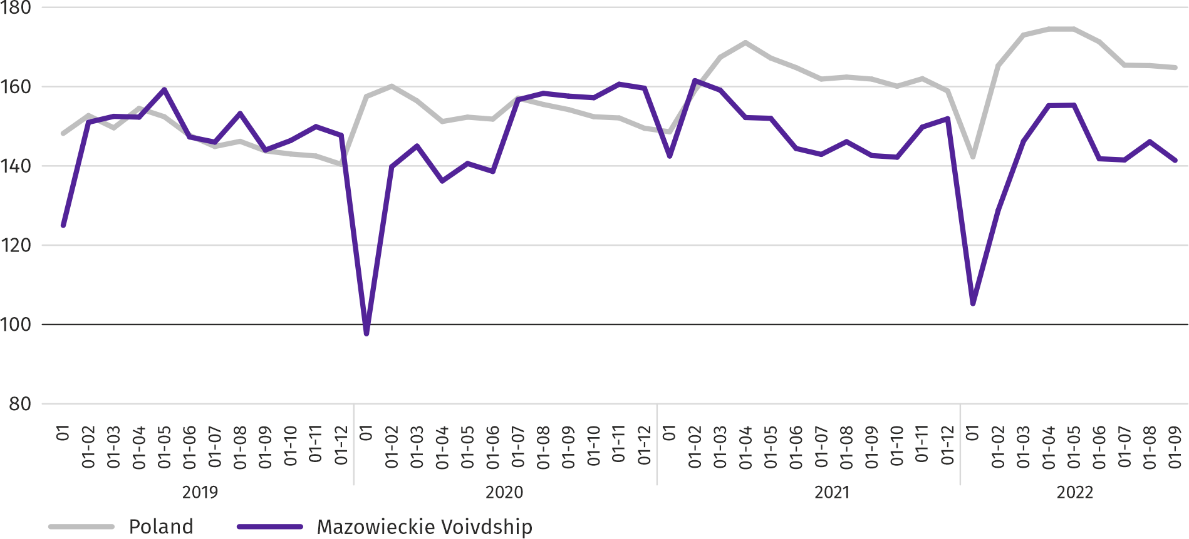
In the period of January–September this year, 29604 dwellings were completed, i.e. fewer than in the corresponding period of the previous year by 247. Most dwellings were completed in m.st. Warszawa (9846), followed by wołomiński (2455) and piaseczyński (2057), and the least in żuromiński (40), zwoleński (74) and gostyniński (76).

Map 2. Dwellings completed per 10 thousand population ª by powiats in January–September 2022
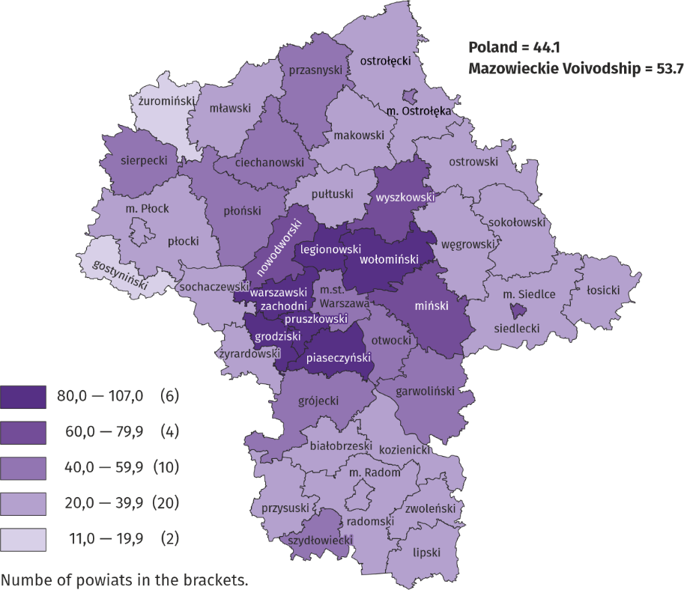
a Population as of 31 December 2021.
The average useful floor area of dwellings completed in the period of eight months of this year amounted to 91.5 m² and was smaller than a year earlier by 2.3 m² than a year earlier. The largest dwellings were completed in siedlecki (151.0 m²), ostrołęcki (142.9 m²) and żuromiński (by 137.4 m2) The smallest were built in Ostrołęka (64.6 m²), m.st. Warszawa (64.7 m²) and Siedlce (65.7 m²).
In September this year, the number of dwellings for which permits have been granted or which have been registered with a construction project amounted to 4589, that is by 1105 (by 19.4%) fewer than a year earlier and by 1844 (by 67.2%) than in the previous month. Of the total number of dwellings, 76.3% were dwellings for sale or rent, and 21.4% private.
In the surveyed month, the construction began in 3093 dwellings, which means a decrease by 1307 (by 29.7%) in annual terms and by 1494 (by 93.4%) in monthly terms. Dwellings for sale or rent accounted for 67.3% of their total number, and private 32.7%.
Table 11. Number of dwellings for which permits have been granted or which have been registered with a construction project as well as dwelling in which construction has begun in January–September 2022
SPECIFICATION | Dwellings for which permits have been granted or which have been registered with a construction project |  |  | Dwellings in which construction has begun
 | in absolute numbers | in percent | 01–09 2021=100 | in absolute numbers | in percent | 01–09 2021=100
TOTAL | 43273 | 100,0 | 94,4 | 29193 | 100,0 | 73,3
Private | 10025 | 23,2 | 71,2 | 9178 | 31,4 | 77,8
Cooperative | 121 | 0,3 | 55,3 | 260 | 0,9 | 70,3
For sale or rent | 32786 | 75,8 | 104,4 | 19569 | 67,0 | 70,9
Municipal | 341 | 0,8 | 315,7 | 155 | 0,5 | ok. 12 razy
Company | – | – | . | 31 | 0,1 | .

Domestic market
In September this year, there was an increase both in retail sales and in wholesale compared to the previous year.
Retail sales (at current prices) in trade and non-trade enterprises in September this year, increased by 16.9% compared to the year before. The increase in sales was recorded in units from the group: “textiles, clothing and footwear” (by 31.1%), “solid, liquid and gas fuels” (by 30.8%), “other retail sales in non-specialised stores” (by 20.8%), “food, beverages and tobacco” (by 14.2%), „pharmaceuticals, cosmetics, orthopedic equipment” (by 12.5%), “others” (by 11.6%), “furniture, electronics and household appliances” (by 9.2%). The decrease occurred units from the group “motor vehicles, motorcycles, parts” (by 2.2%) and “press, books, other sales in specialized stores” (by 0.7%).
Compared to August 2022, retail sales decreased by 3.7%. The decrease in retail sales was recorded in the following groups: “solid, liquid and gas fuels” (by 10.8%), “press, books, other sales in specialized stores” (by 8.6%), “food, beverages and tobacco” (by 3.7%), „furniture, electronics and household appliances” (by 0.8%), „pharmaceuticals, cosmetics, orthopedic equipment” (by 0.1%). The increase in sales was recorded in the groups: “motor vehicles, motorcycles, parts” (by 8.6%), “textiles, clothing and footwear” (by 8.2%), “other retail sales in non-specialized stores” (by 5.3%), and “others” (by 1.6%).
In the period January–September 2022, retail sales increased by 20.0% annually. The highest increase in sales was achieved by enterprises from the group of "solid, liquid and gas fuels" (by 45.9%), while a decrease in sales was recorded only by enterprises from the group of "motor vehicles, motorcycles, parts" (by 10.1%) .
Table 12. Indices and structure (at current prices) of retail sales in September 2022
SPECIFICATION | 09 2022 | 01–09 2022
 | corresponding period of previous year =100 |  | In percent
TOTAL ª | 116,9 | 120,0 | 100,0
of which:
Motor vehicles, motorcycles, parts | 97,8 | 89,9 | 5,7
Solid, liquid and gas fuels | 130,8 | 145,9 | 31,5
Food, beverages and tobacco | 114,2 | 109,5 | 14,4
Other retail sales in non-specialized stores | 120,8 | 119,0 | 2,8
Pharmaceuticals, cosmetics and orthopedic equipment | 112,5 | 119,3 | 3,4
Textiles, clothing and footwear | 131,1 | 133,5 | 5,0
Furniture, electronics and household appliances | 109,2 | 110,6 | 19,3
Press, books and other sales in specialized stores | 99,3 | 102,1 | 6,5
Other | 111,6 | 114,5 | 8,3
a The grouping of enterprises was made on the basis of the Polish Classification of Activities - PKD 2007, including the enterprise to a specific category according to the type of predominant activity, in accordance with the organizational status in the period under consideration. The recorded changes (increase/decrease) in retail sales in particular groups of activity of enterprises may also result from changes in the type of predominant economic activity and organizational changes (e.g. mergers of enterprises). This does not affect the dynamics of retail sales in general.

Wholesale (at current prices) in trade enterprises in September 2022 was by 11.7% higher as compared to the previous month, and by 31.6% higher compared to September 2021. In wholesale enterprises it was higher by 11.2% and by 32.9%, respectively.
In the period of January–September 2022, trade enterprises realised wholesale sales by 30.6% higher than in the previous year, and wholesale enterprises higher by 39.4%.

Entities of the national economy
In September this year, the number of national economy entities entered into the REGON register increased by 0.5% compared to the previous month. More than a month ago there were newly registered entities as well as entities removed 9by 20.2% and 18.0%, respectively), whereas less suspended entities (by 0.6%).
As at the end of September this year, 958012 entities of the national economy were registered in the REGON register, i.e. by 4.3% more than last year and by 0.5% than in the previous month.
In the total number of registered entities, the greatest number is natural persons conducting economic activity. At the end of September this year, there were 620728 of them, i.e. more by 3.7% than in the previous year. The number of companies which were registered in the REGON register amounted to 266538, including 206951 commercial companies and 59165 civil partnerships (annual increase by 6.1%, 8.0% and 0.2%, respectively).
According to the expected number of employees, entities that declared employment of up to 9 persons prevailed upon entry in the REGON register; they constituted 96.9% of all registered units. The share of entities with an estimated number of 10-49 employed persons was 2.5%, and of entities employing more than 49 persons – 0.6%. Over the year, the increase in the number of entities occurred among the smallest entities (up to 9 persons) – by 4.5% and the largest (more than 49 persons) – 0.02%.
Compared to September 2021, the largest increase in the number of entities was recorded in the sections: electricity, gas, steam and air conditioning supply (by 17.5%), information and communication (by 15.8%) and administrative and support service activities (by 7.4%).
Compared to August this year, the number of entities increased, among others, in the sections: information and communication (by 1.3%), electricity, gas, steam and air conditioning supply as well as education (by 1.1% each).
In September this year, 7389 new entities were entered in the REGON register, i.e. by 20.2% more than in the previous month. The newly registered units were dominated by natural persons conducting economic activity, 5337 of whom were registered (by 20.7% more than in August this year). The number of newly registered commercial companies was higher by 11.2%, including companies with limited liability by 13.1%.
In the surveyed month, 2814 entities were removed from the REGON register (by 18.0% more than a month ago), including 2187 natural persons conducting economic activity (by 10.9% more).

Chart 11. Entities of the national economy newly registered and removed from the register in September 2022
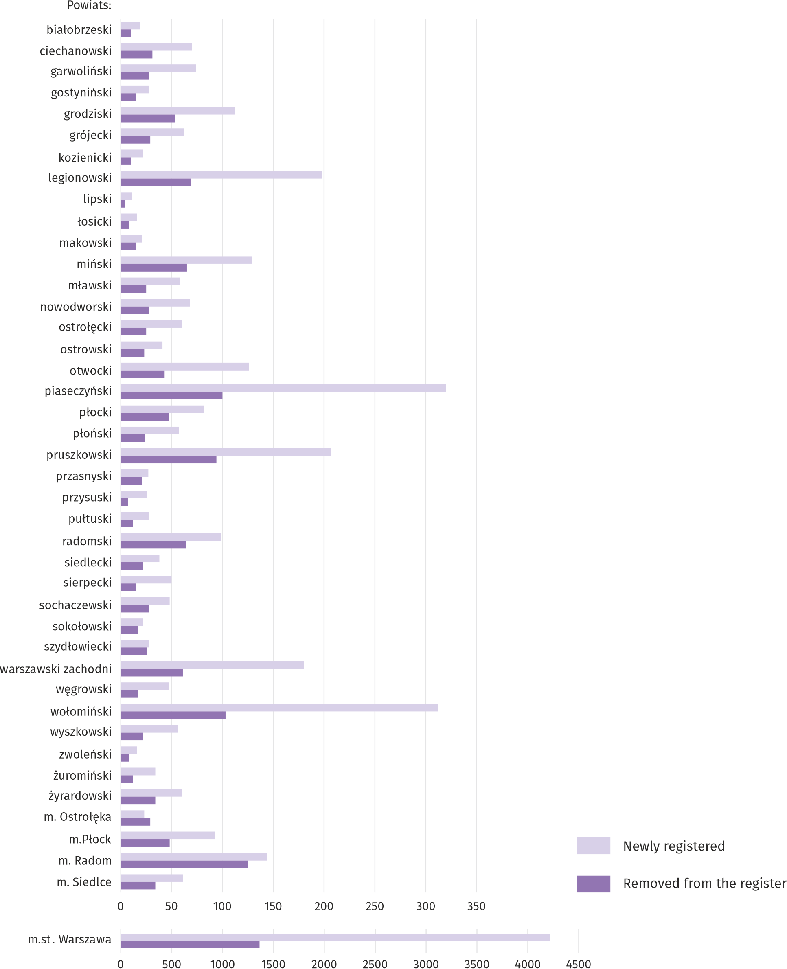
As at the end of September 2022, there were 112721 entities in the REGON with suspended activity (by 0.6% less than a month ago). The vast majority were natural persons conducting economic activity (90.5% compared to 90.6% in the previous month).

Map 3. Entities of the national economy with suspended activity in September 2022
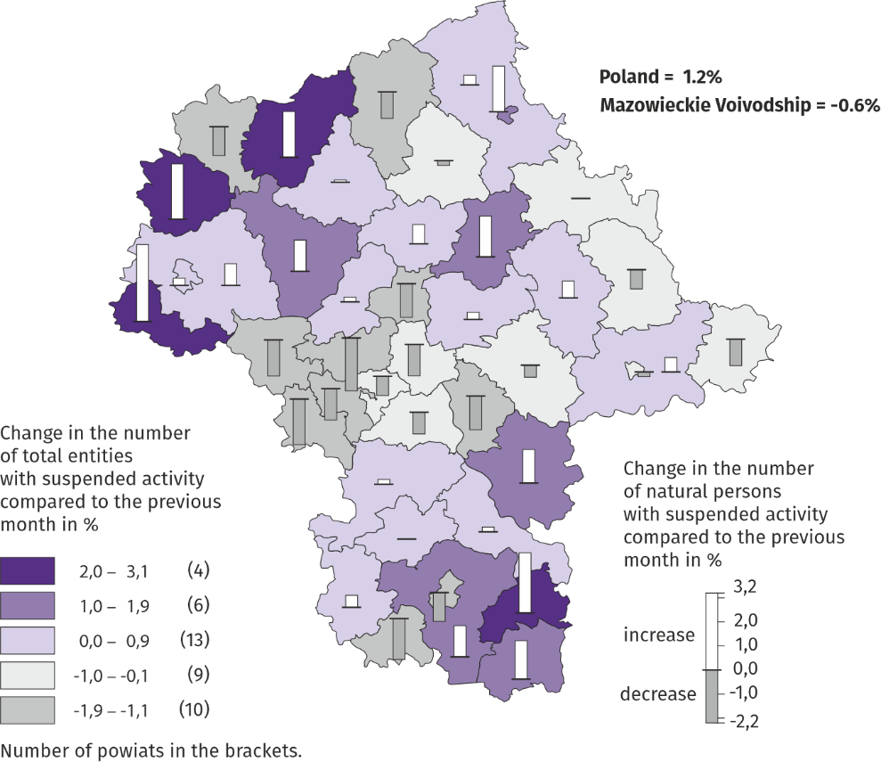

Business tendency
In most of the analysed areas, entrepreneurs in October this year, assessed the economic situation similarly or worse than in September. Only in information and communication the indicator of the general economic climate is positive. The manufacturing section is an exception, where the general economic climate indicator increased.
Chart 12. Indices of the general business climate by type of activity (sections and divisions of NACE Rev.2)
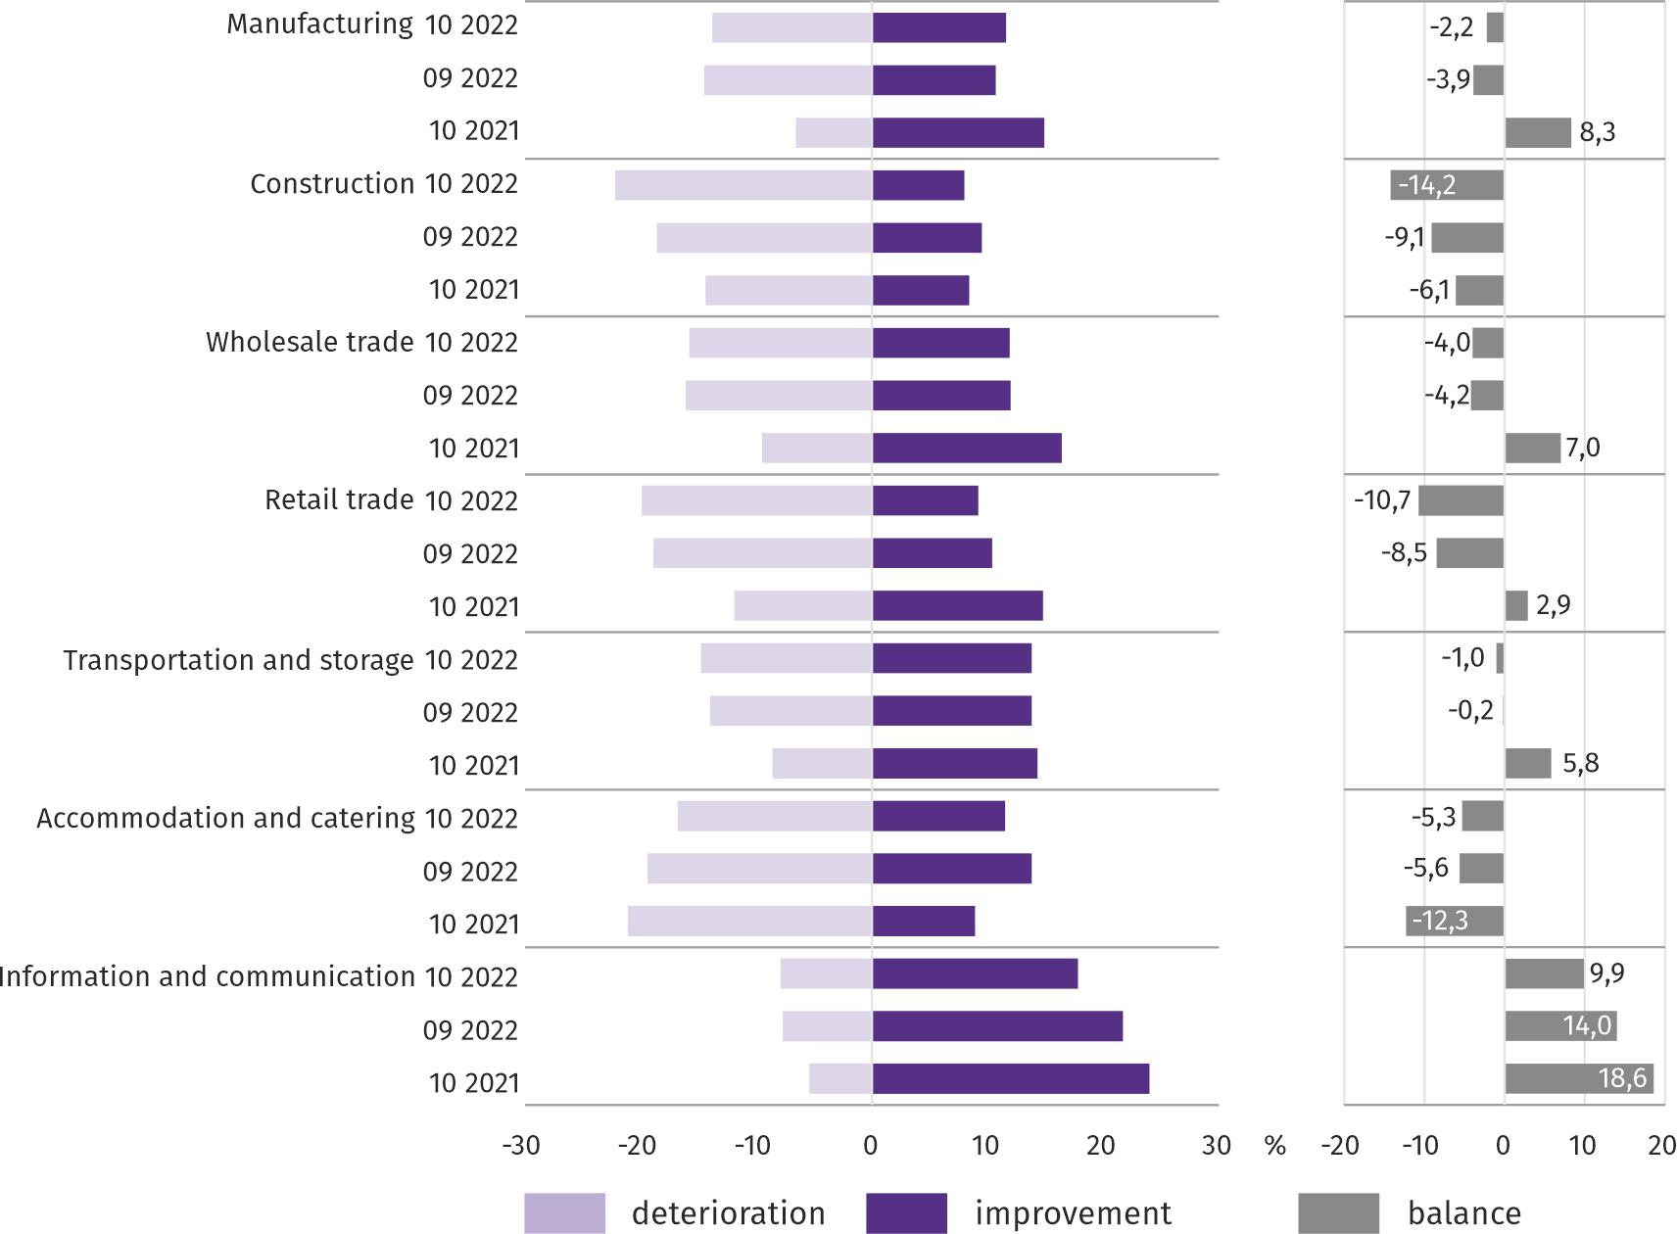
Survey results on the impact of the war in Ukraine on the economic situation
Questions about the impact of the war in Ukraine
Q1. The negative effects of the war in Ukraine and its consequences for the economic activity conducted by your company will be this month:
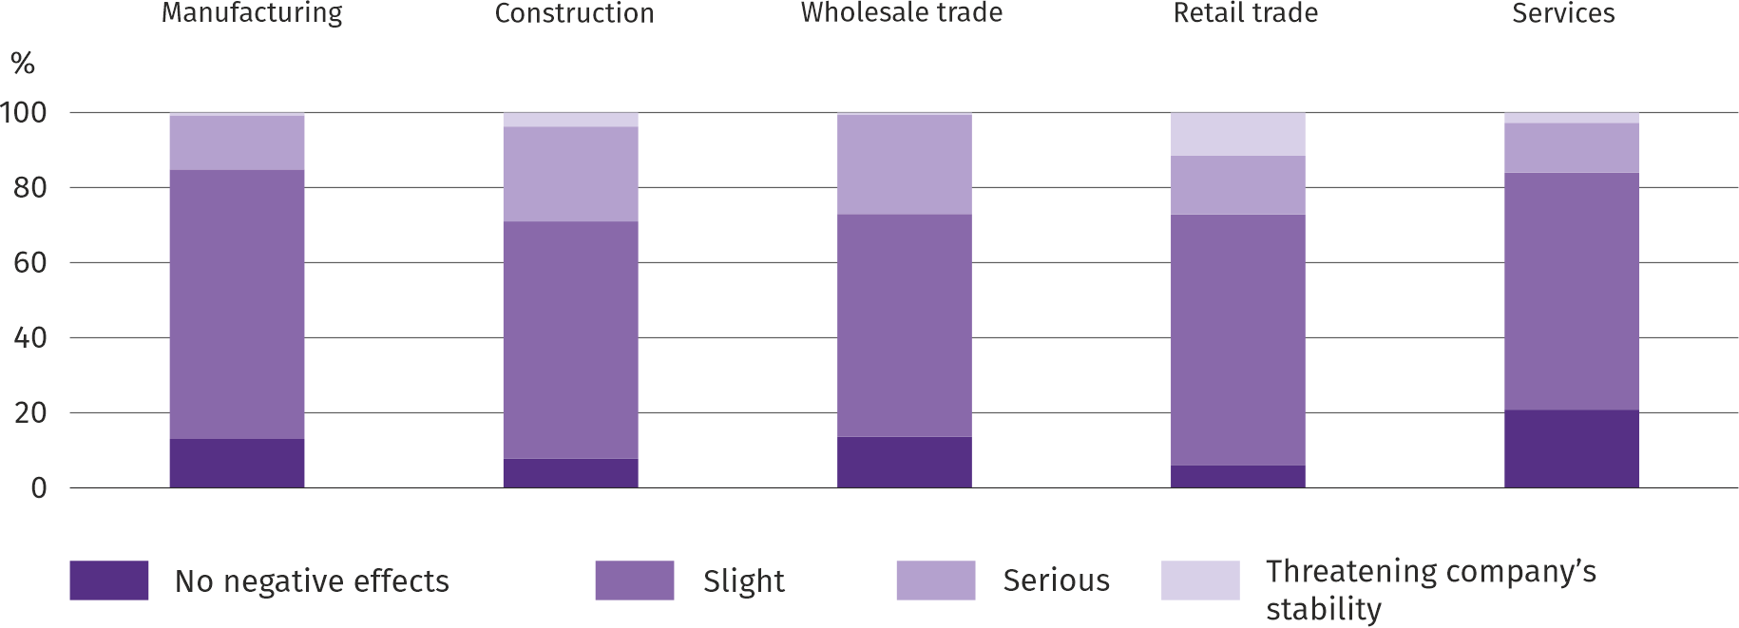
Among the entrepreneurs who answered the survey, the most frequent opinions were that the ongoing war was in October this year insignificant threat to the conduct of business in their companies. The consequences of the war, serious and threatening the stability of the company, were most often felt by entrepreneurs operating in the construction industry.
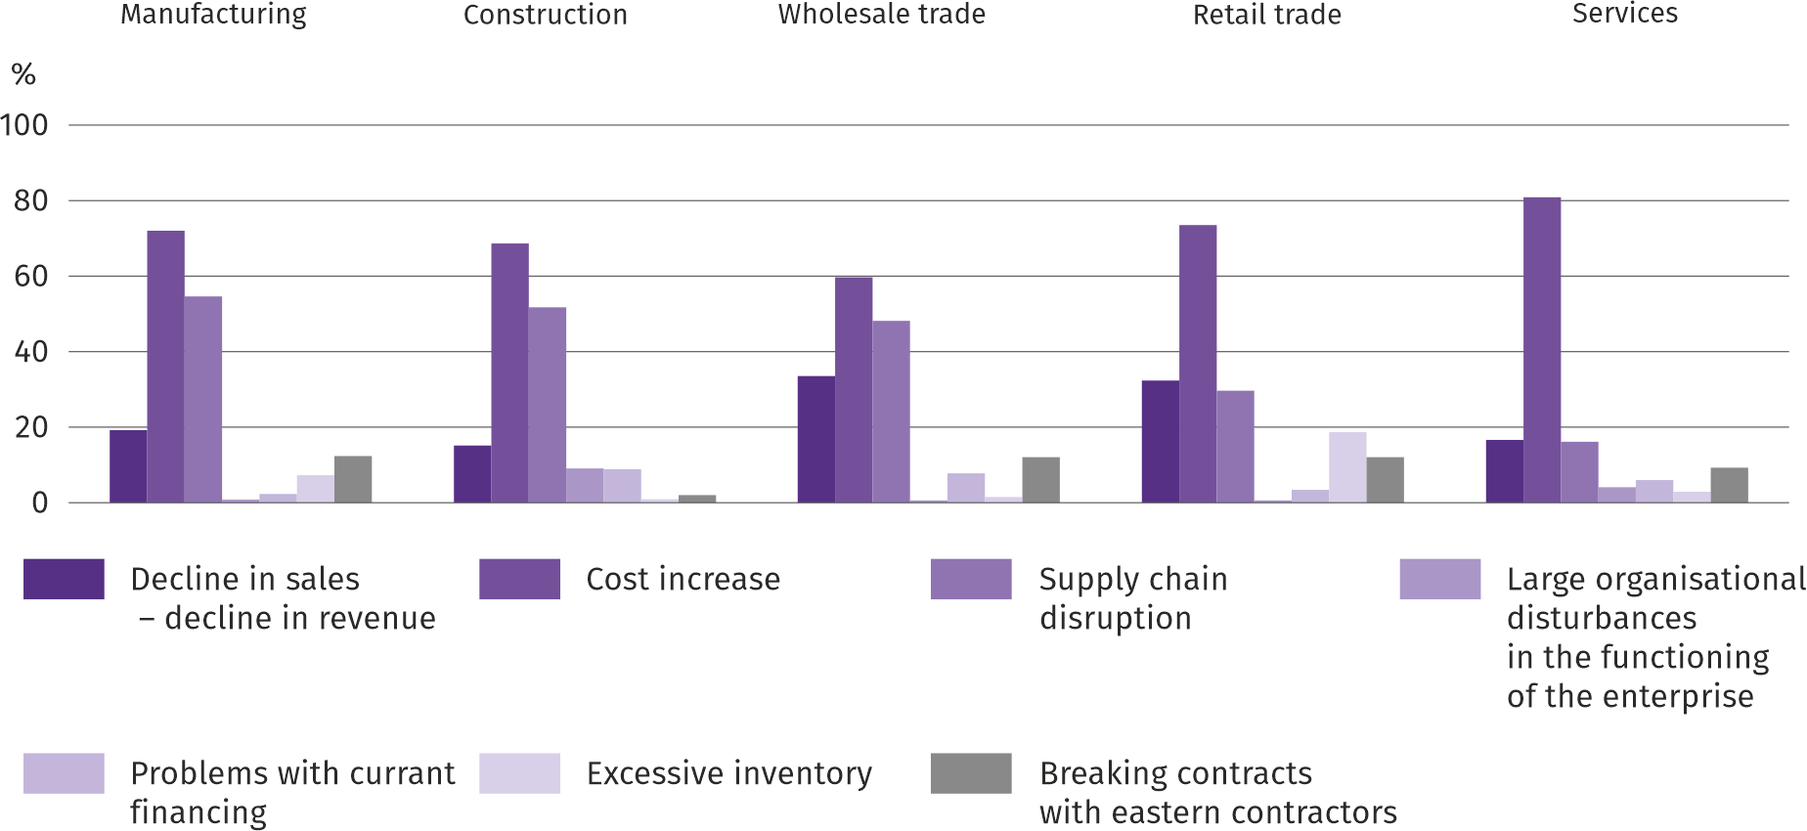
Q2. From the negative effects of the war in Ukraine observed in the last month, the ones that most refer to your company are:

The most common negative consequences of the war in Ukraine were the increase in costs, followed by disruptions in the supply chain and a decrease in sales/decrease in revenue.

Q3. If your company employs employees from Ukraine, did you observe last month in connection with the war in Ukraine:
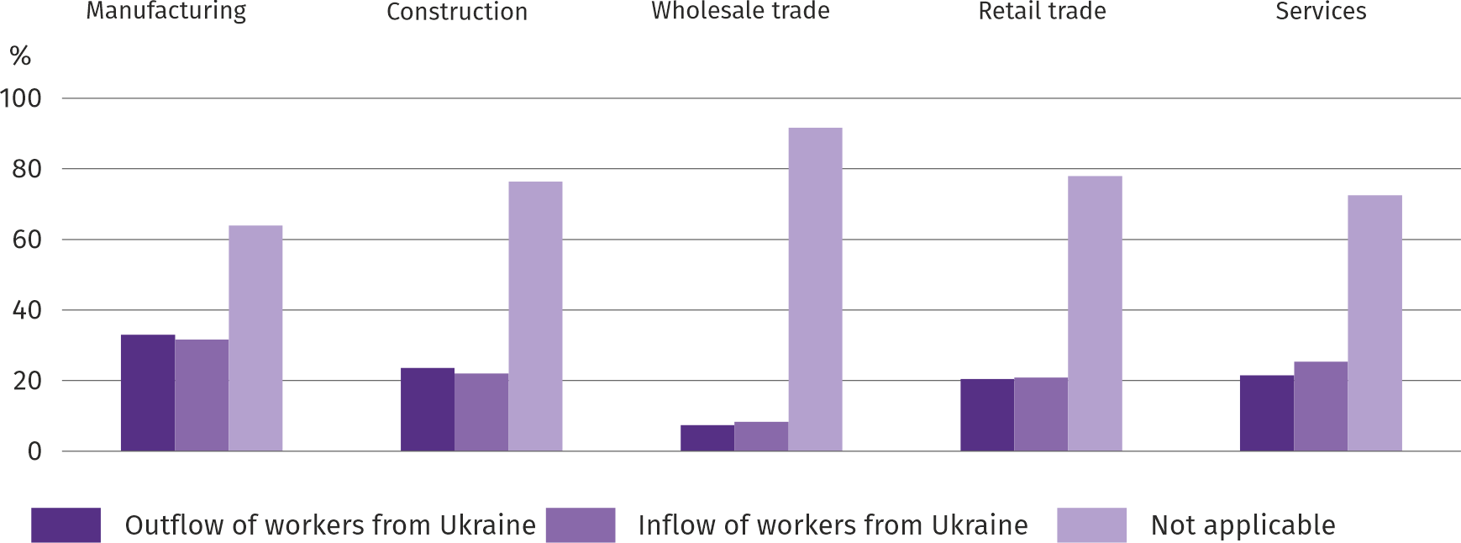
In October this year. In all the analysed types of activity, an outflow and an inflow of workers from Ukraine was observed in connection with the ongoing war (the vast majority was a minor move). Both the outflow and the inflow of workers were most often indicated in manufacturing.
Questions about pricing processes
Q4. How do you think the prices of services materials raw materials used by your company in the course of your business will develop?
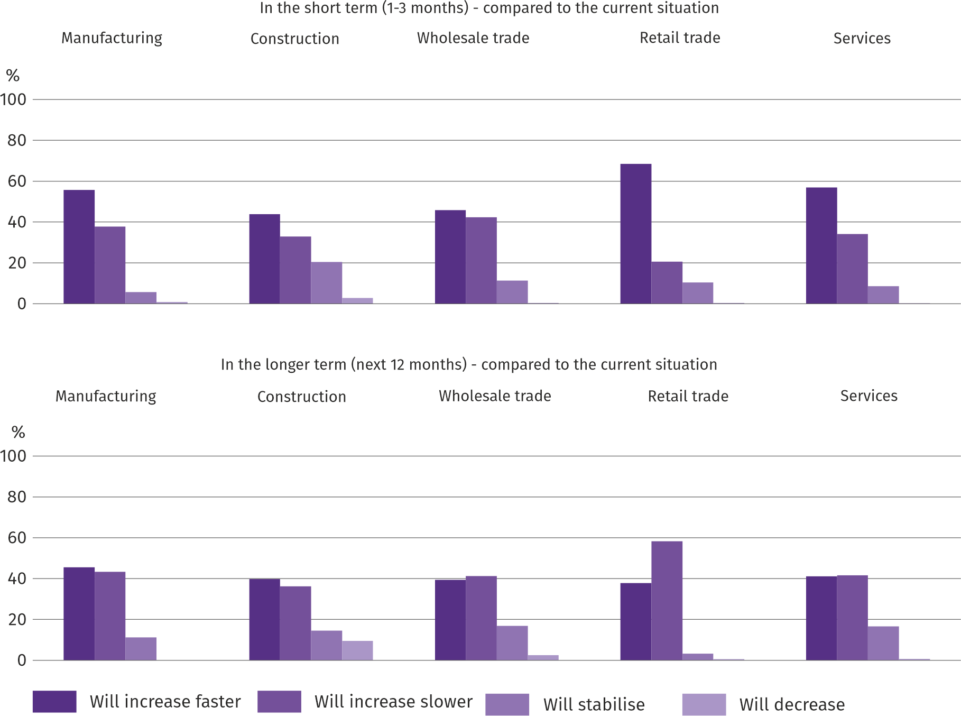
In all the analysed types of activity, the greatest number of entrepreneurs was of the opinion that in a short period of time (1-3 months) the prices of services/materials/raw materials would increase faster than at present. In the longer term (the next 12 months), entrepreneurs expect that the price growth will be slower than at present; only in manufacturing and construction they thought that prices would rise faster.
Q5. Which of the following factors will have the greatest impact on the operating costs of your company in the next quarter?:
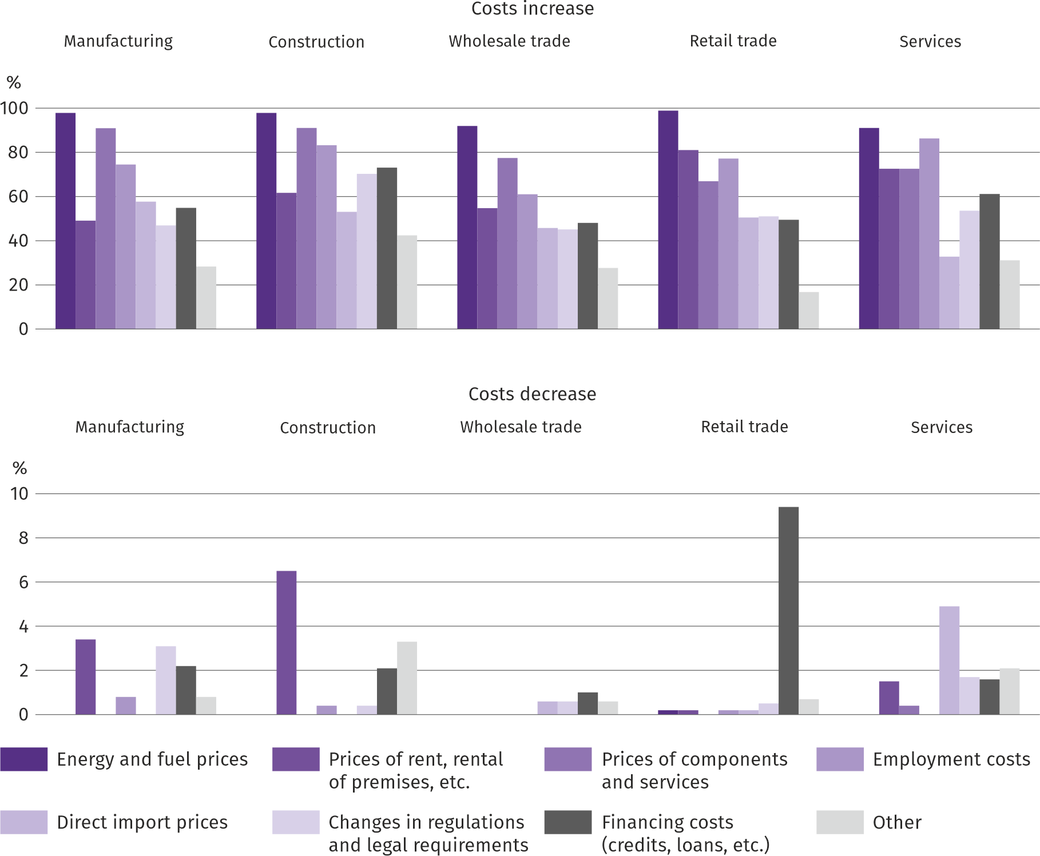
Entrepreneurs, in all analysed types of activities, considered energy and fuel prices and employment costs to be the factors having the greatest impact on the increase in the company's operating costs. Moreover, in manufacturing, construction and wholesale, prices of components and services were often indicated, and in retail and services – the prices of rent and lease of premises. The factors that had the greatest impact on the decline in costs in most of the analysed activities included financing costs (credits, loans, etc.) as well as changes in regulations and legal requirements. In enterprises operating in manufacturing and construction, the prices of rent, premises, etc. were also indicated, and in services – prices of direct import.

Q6. Will the observed and expected changes in the conditions of financing the enterprise (costs of bank loans and their availability, trade credit, deferred payments, etc.) cause, in the next 12 months, in the case of:
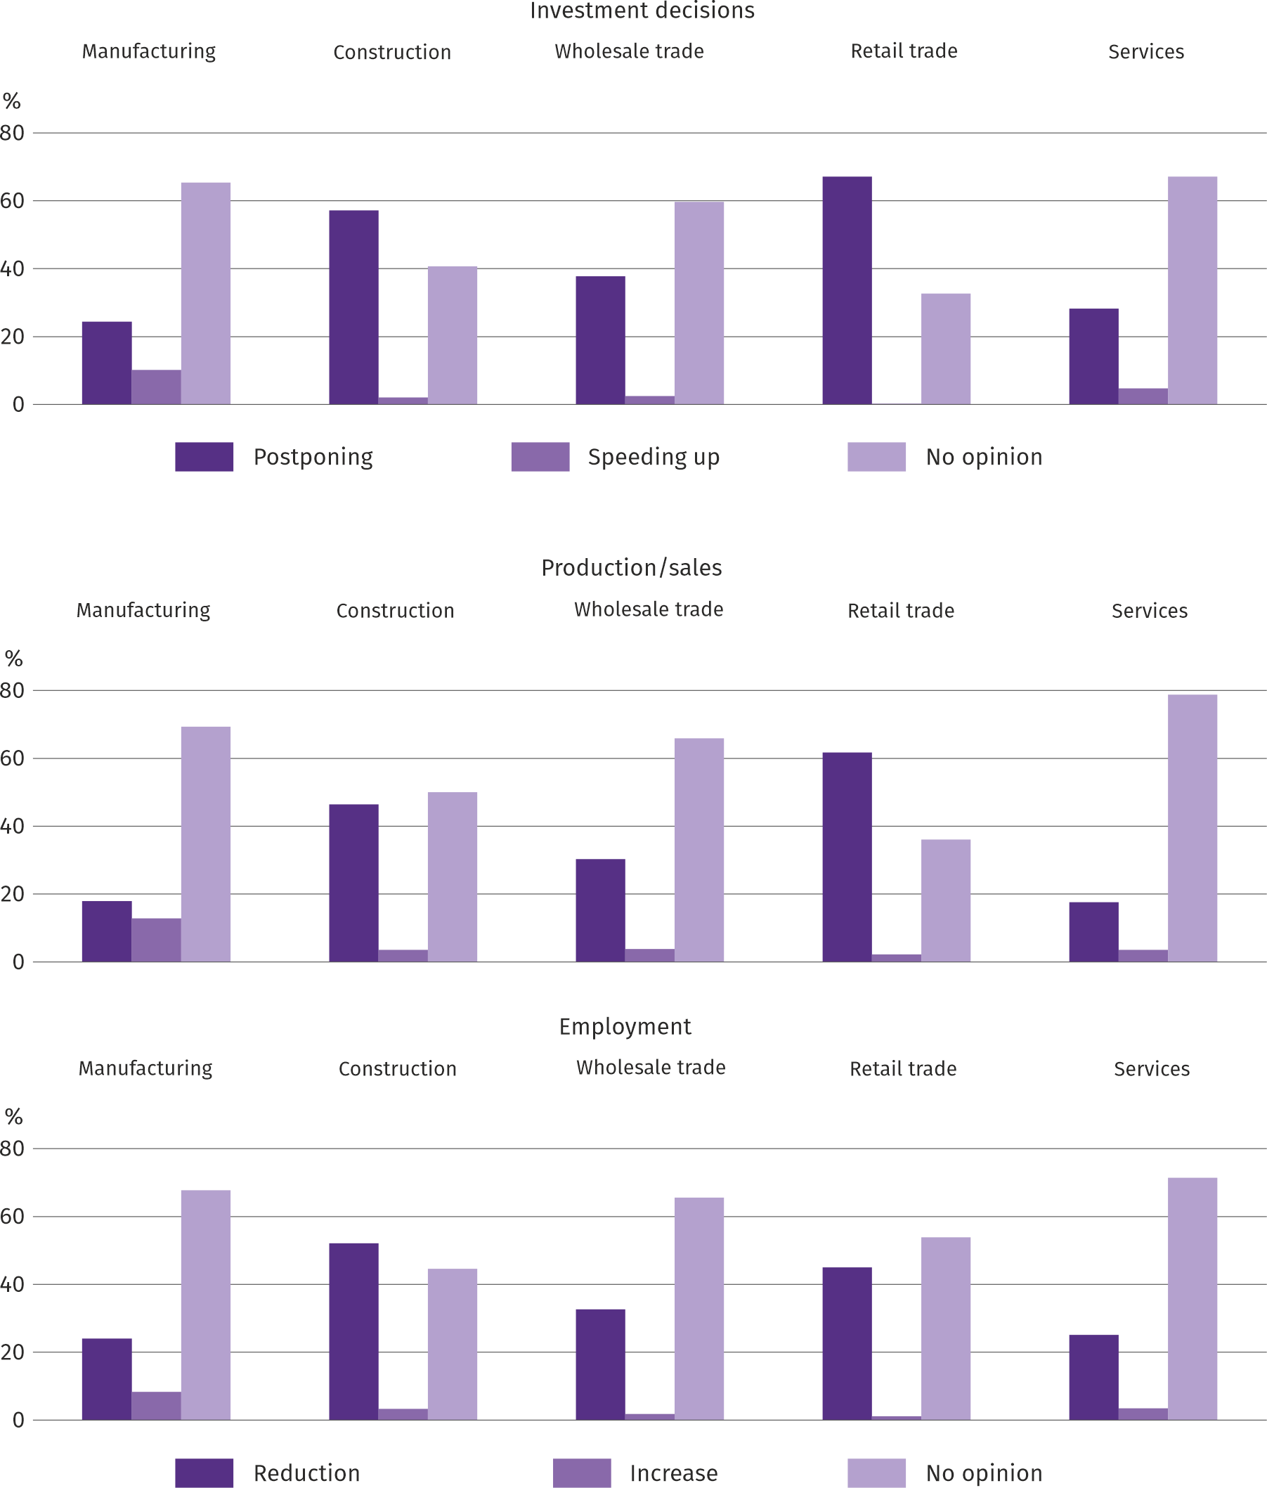
The answers to the questions on how the observed and expected changes in the conditions of financing the enterprise in the next 12 months will affect investment decisions, production/sales and employment indicate that it was difficult for entrepreneurs to assess this impact – almost always most of the respondents did not have an opinion on this subject . Those who expressed their opinion on the above-mentioned topic rarely expected an acceleration of investments and an increase in production/sales and employment. They decided much more often that the impact of changes in the operating conditions of the enterprise would be negative, i.e. it would force the necessity to postpone investments, as well as limit production/sales and employment.
More information on the results of the business climate survey can be found on the website of the Statistical Office in Zielona Góra https://zielonagora.stat.gov.pl/osrodki/osrodek-badan-koniunktury/obk-dane/.

Table 13. Selected data on Mazowieckie Voivodship
SPECIFCIATION  A – 2021  B – 2022 |  | 01 | 02 | 03 | 04 | 05 | 06 | 07 | 08 | 09 | 10 | 11 | 12
Average employment in the enterprise sector ª  (in thousand persons) | A | 1540,2 | 1538,3 | 1534,8 | 1528,8 | 1532,2 | 1537,7 | 1537,8 | 1536,4 | 1537,6 | 1537,9 | 1541,8 | 1546,6
 | B | 1569,9 | 1571,8 | 1572,5 | 1572,8 | 1572,2 | 1574,9 | 1577,9 | 1577,8 | 1576,7
previous month=100 | A | 99,9 | 99,9 | 99,8 | 99,6 | 100,2 | 100,4 | 100,0 | 99,9 | 100,1 | 100,0 | 100,3 | 100,3
 | B | 101,5 | 100,1 | 100,0 | 100,0 | 100,0 | 100,2 | 100,2 | 100,0 | 99,9
corresponding month of previous year=100 | A | 99,2 | 99,2 | 99,3 | 101,0 | 102,2 | 101,8 | 101,2 | 100,5 | 100,3 | 100,2 | 100,3 | 100,3
 | B | 101,9 | 102,2 | 102,5 | 102,9 | 102,6 | 102,4 | 102,6 | 102,7 | 102,5
Registered unemployed persons (in thousand persons; as of end of period) | A | 151,1 | 152,5 | 149,9 | 147,7 | 144,6 | 141,4 | 139,6 | 138,2 | 134,9 | 131,2 | 129,9 | 129,2
 | B | 133,5 | 132,7 | 130,4 | 128,0 | 125,3 | 121,7 | 120,7 | 119,9 | 118,3
Unemployment rate b (in %; as of end of period) | A | 5,3 | 5,4 | 5,3 | 5,2 | 5,1 | 5,0 | 4,9 | 4,9 | 4,8 | 4,6 | 4,6 | 4,7*
 | B | 4,8* | 4,8* | 4,7* | 4,6* | 4,5* | 4,4* | 4,3* | 4,3* | 4,2
Job offers (submitted during a month) | A | 13732 | 14151 | 15040 | 15041 | 14658 | 14339 | 15485 | 14674 | 16427 | 18125 | 17141 | 13252
 | B | 16533 | 15627 | 18846 | 14296 | 14943 | 14081 | 12893 | 15270 | 15858
Unemployed persons per 1 job offer (as of end of period) | A | 21 | 21 | 22 | 17 | 17 | 16 | 16 | 16 | 13 | 14 | 14 | 26
 | B | 16 | 17 | 14 | 16 | 13 | 13 | 16 | 13 | 13
Average monthly gross wages and salaries in the en-terprise sector ª (in PLN) | A | 6570,77 | 6519,70 | 7109,13 | 6904,91 | 6594,12 | 6777,25 | 6772,44 | 6746,93 | 6742,14 | 6968,53 | 6875,56 | 7590,74
 | B | 7163,58 | 7275,06 | 7947,19 | 7819,34 | 7450,43 | 7539,43 | 7716,38 | 7671,21 | 7640,75
previous month=100 | A | 98,1 | 99,2 | 109,0 | 97,1 | 95,5 | 102,8 | 99,9 | 99,6 | 99,9 | 103,4 | 98,7 | 110,4
 | B | 94,4 | 101,6 | 109,2 | 98,4 | 95,3 | 101,2 | 102,3 | 99,4 | 99,6
corresponding month of previous year=100 | A | 104,5 | 103,7 | 106,1 | 108,4 | 108,4 | 108,7 | 108,0 | 107,9 | 108,4 | 107,7 | 109,7 | 113,3
 | B | 109,0 | 111,6 | 111,8 | 113,2 | 113,0 | 111,2 | 113,9 | 113,7 | 113,3
Price indices:
consumer goods and services ^{c}:
corresponding month of previous year=100 | A | . | . | 102,9 | . | . | 104,3 | . | . | 105,2 | . | . | 107,3
 | B | . | . | 109,5 | . | . | 113,1 | . | . | .
a In enterprises employing more than 9 persons. b Share of registered unemployed persons in civilian economically active population, estimated at the end of each month. c In the quarter.
Table 13. Selected data on Mazowieckie Voivodship (cont.)
SPECIFICATION  A – 2021  B – 2022 |  | 01 | 02 | 03 | 04 | 05 | 06 | 07 | 08 | 09 | 10 | 11 | 12
Price indices (cont.):
Procurement of cereal grain:
previous month=100 | A | 109,5 | 102,4 | 102,9 | 100,7 | 104,6 | 98,5 | 86,4 | 107,3 | 113,8 | 100,2 | 110,9 | 116,5
 | B | 91,0 | 105,6 | 116,2 | 108,1 | 104,0 | 100,2 | 91,3 | 95,3 | 104,3
corresponding month of previous year=100 | A | 122,8 | 117,9 | 124,4 | 117,2 | 116,3 | 122,8 | 126,0 | 136,8 | 146,1 | 136,9 | 139,8 | 163,7
 | B | 136,0 | 140,2 | 158,3 | 169,9 | 168,9 | 171,7 | 181,4 | 161,2 | 147,8
procurement of cattle for slaughter (excluding calves):
previous month=100 | A | 93,5 | 133,9 | 86,2 | 103,4 | 99,2 | 104,9 | 99,7 | 103,1 | 104,8 | 97,7 | 115,7 | 101,1
 | B | 103,2 | 103,4 | 107,5 | 108,3 | 101,4 | 93,0 | 100,0 | 106,1 | 97,7
corresponding month of previous year=100 | A | 92,0 | 124,4 | 110,5 | 112,7 | 113,5 | 120,7 | 115,8 | 127,4 | 125,3 | 122,1 | 141,9 | 142,9
 | B | 157,8 | 121,9 | 152,0 | 159,3 | 162,8 | 144,3 | 144,6 | 148,8 | 138,7
procurement of pigs for slaughter:
previous month=100 | A | 100,2 | 111,1 | 121,7 | 100,2 | 103,5 | 98,5 | 95,4 | 100,4 | 85,2 | 92,5 | 105,3 | 105,5
 | B | 99,8 | 98,4 | 150,1 | 104,6 | 96,8 | 104,0 | 104,1 | 105,0 | 102,8
corresponding month of previous year=100 | A | 67,0 | 71,3 | 86,4 | 89,7 | 103,3 | 97,3 | 101,9 | 104,1 | 94,2 | 91,0 | 104,2 | 116,2
 | B | 115,7 | 102,5 | 126,4 | 132,0 | 123,4 | 130,3 | 142,2 | 148,7 | 179,4
Ratio of procurement prices ª of pigs for slaughter to marketplace prices of rye | A | . | . | . | . | . | . | 7,9 | 8,0 | 6,1 | 5,2 | 5,4 | 5,3
 | B | 4,7 | 4,6 | 6,1 | 6,0 | 5,7 | 5,9 | 6,4 | 6,8 | 6,5
Sold production of industry ^{b} (at constant prices):
previous month=100 | A | 95,1 | 99,3 | 114,3 | 88,4 | 100,0 | 102,3 | 97,3 | 101,3 | 108,0 | 111,0 | 104,8 | 105,2
 | B | 96,1 | 100,0 | 121,9 | 78,1 | 97,4 | 96,8 | 96,2 | 107,9* | 106,7
corresponding month of previous year=100 | A | 102,7 | 104,9 | 113,2 | 122,4 | 115,9 | 110,2 | 105,9 | 110,6 | 108,5 | 113,6 | 118,3 | 127,1
 | B | 128,4 | 129,2 | 137,8 | 121,8 | 118,6 | 112,2 | 111,0 | 118,3* | 117,0
Construction and assembly production b (at current prices):
previous month=100 | A | 37,4 | 108,5 | 139,6 | 101,3 | 115,2 | 104,5 | 95,1 | 109,0 | 108,0 | 103,0 | 112,7 | 109,1
 | B | 48,5 | 115,8 | 126,5 | 99,8 | 113,8 | 99,0 | 99,8 | 101,9 | 104,5
corresponding month of previous year=100 | A | 87,0 | 77,2 | 89,4 | 90,7 | 104,5 | 100,2 | 100,0 | 108,9 | 107,3 | 105,6 | 120,1 | 98,0
 | B | 127,0 | 135,7 | 122,9 | 121,1 | 119,5 | 113,3 | 118,9 | 111,0 | 107,4
a Current prices excluding VAT. b In enterprises employing more than 9 persons.
Table 13. Selected data on Mazowieckie Voivodship (cont.)
SPECIFICATION  A – 2021  B – 2022 |  | 01 | 02 | 03 | 04 | 05 | 06 | 07 | 08 | 09 | 10 | 11 | 12
Dwellings completed (from the beginning of the year) | A | 3895 | 7185 | 10030 | 13097 | 16000 | 19084 | 22224 | 25552 | 29851 | 33607 | 39200 | 44385
 | B | 2877 | 5732 | 9220 | 13358 | 16353 | 18743 | 22011 | 25549 | 29604
corresponding month of previous year=100 | A | 145,8 | 115,5 | 109,7 | 111,7 | 108,1 | 104,2 | 91,2 | 92,3 | 90,5 | 90,5 | 93,3 | 95,2
 | B | 73,9 | 79,8 | 91,9 | 102,0 | 102,2 | 98,2 | 99,0 | 100,0 | 99,2
Retail sales of goods ª (at current prices):
previous month=100 | A | 70,1 | 106,4 | 114,3 | 87,7 | 121,4 | 103,0 | 102,9 | 98,8 | 97,9 | 103,9 | 102,5 | 116,9
 | B | 73,9 | 102,5 | 122,9 | 99,4 | 100,4 | 102,6 | 101,3 | 100,9 | 96,3
corresponding month of previous year=100 | A | 88,2 | 97,3 | 122,2 | 127,0 | 121,8 | 113,9 | 110,9 | 110,3 | 112,3 | 115,6 | 125,5 | 115,9
 | B | 122,2 | 117,7 | 126,6 | 143,5 | 118,7 | 118,3 | 116,4 | 118,9 | 116,9
Turnover profitability indicator in enterprises ^{b}:
gross ^{c} (in %) | A | . | . | 7,7 | . | . | 7,1 | . | . | 7,3 | . | . | 6,9
 | B | . | . | 5,6 | . | . | 5,7 | . | . | .
net ^{d} (in %) | A | . | . | 6,4 | . | . | 5,9 | . | . | 6,1 | . | . | 5,7
 | B | . | . | 4,6 | . | . | 4,7 | . | . | .
Investment outlays of enterprises ^{b} – from the begin-ning of the year (in million PLN; current prices) | A | . | . | 10470,0 | . | . | 23370,2 | . | . | 38358,4 | . | . | 60121,2
 | B | . | . | 12067,3 | . | . | 26485,4 | . | . | .
corresponding month of previous year=100 (current prices) | A | . | . | 125,1 | . | . | 124,4 | . | . | 122,3 | . | . | 116,2
 | B | . | . | 115,3 | . | . | 113,3 | . | . | .
Entities of the national economy ^{e} in the REGON regis-ter (as of end of period) | A | 889125 | 892337 | 895928 | 899078 | 903365 | 907151 | 910555 | 913994 | 918286 | 921713 | 924634 | 927669
 | B | 929689 | 933084 | 936946 | 938904 | 942577 | 946216 | 949552 | 953378 | 958012
of which commercial companies | A | 182507 | 183477 | 184442 | 185508 | 186906 | 188142 | 189104 | 190318 | 191708 | 193476 | 194760 | 196493
 | B | 197912 | 199278 | 200876 | 201826 | 202713 | 203559 | 204672 | 205824 | 206951
of which with foreign capital participation | A | 34386 | 34481 | 34550 | 34665 | 34826 | 34968 | 35089 | 35354 | 35579 | 35854 | 36017 | 36305
 | B | 36402 | 36555 | 36649 | 36790 | 36954 | 37154 | 37405 | 37566 | 37738
a In enterprises employing more than 9 persons. b In enterprises employing more than 49 persons. c Relation of gross financial result to revenues from total activity. d Relation of net financial result to revenues from total activity. e Excluding persons tending private farms in agriculture. .
Prepared by:  Statistical Office in Warszawa  Director Zofia Kozłowska  Tel: (+48 22) 464 23 15 | Issued by:  Statistical Information Centre  Marcin Kałuski  Tel: (+48 22) 464 20 91
Press office  Tel: (+48 22) 464 20 91  e-mail: m.kaluski@stat.gov.pl | warszawa.stat.gov.pl/en/
 | @Warszawa_STAT
 | @UrzadStatystycznywWarszawie
 | gus_stat
 | glownyurzadstatystycznygus
 | glownyurzadstatystyczny
In the case of quoting data from the Statistics Poland, please provide information “Statistics Poland data source”, and in the case of publishing calculations made on data published by the Statistics Poland, provide information: “Own study on Statistics Poland data”.
Related information
Statistical Bulletin of Mazowieckie Voivodship
Raport on the socio-economic situation of Mazowieckie Voivodship 2022
Socio-economic situation of voivodships No. 2/2022
Data available in databases
Local Data Bank (BDL)
Knowledge Databases (DBW)
Terms used in official statistics
Average paid employment
Registered unemployed persons
Registered unemployment rate
Monthly gross wages and salaries
Retail prices
Price index of consumer goods and services
Procurement of agricultural products
Procurement prices
Marketplace prices
Pigs
Cattle
Sold production of industry
Construction and assembly production
Dwellings completed
Retail sales of goods (including VAT)
Wholesale (including VAT)
Financial results of enterprises
Investment outlays
Entities of the national economy
Business tendency

The long-term unemployed include persons remaining in the register of the powiat labour office for a total period of more than 12 months in the last 2 years, excluding periods of internship and vocational preparation.
Refers to vacancies and places of occupational activation.
Reporting data – may change after preparing quarterly report.
It applies to legal persons, organizational units without legal personality and natural persons conducting economic activity (excluding natural per-sons tending private farms in agriculture).
The survey was conducted from 1 to 10 August this year, on a sample of industrial, construction, commercial and service units. The questions were di-vided into two sections - questions about the impact of the war in Ukraine on the economic situation and questions about price processes. An-swers to the entire additional block of questions are provided on a voluntary basis. In all questions, the percentage of respondents' answers to a given variant is presented. The data has been aggregated in accordance with the aggregation (weighting) methodology used as standard in the study of the economic situation.
It was allowed to select one answer for each option ("outflow" and "inflow") at the same time, therefore the sum of the options may exceed 100%. The answer "not applicable" was marked when the company does not employ employees from Ukraine or did not observe their "outflow" or "inflow" last month.

