Socio-economic situation of Mazowieckie Voivodship in August 2022
- In August this year, the average employment in the enterprise sector increased by 2.7% on a yearly basis and decreased by 0.01% compared to the previous month. The registered unemployment rate amounted to 4.2% and decreased by 0.7 pp on an annual basis and did not change on a monthly basis.
- Average monthly gross wages and salaries in the enterprise sector in August this year were higher by 13.7% compared to the previous year and by 0.6% lower than in the previous month.
- Prices of consumer goods and services in the second quarter of this year they increased by 13.1% compared to the same period last year; for comparison, in the first quarter of this year, the year-on-year increase in prices was 9.5%.
- On the agricultural market in August 2022, the average procurement prices of the discussed agricultural products were higher than in the previous year. On a monthly basis, procurement prices of rye, cattle and pigs for slaughter and milk were higher, while less was paid for wheat, potatoes and poultry for slaughter.
- In August this year, sold production of industry (at constant prices) increased on a yearly basis (by 16.9%) and on a monthly basis (by 6.6%). Construction and assembly production (at current prices) was higher by 11.0% than in the previous year and by 1.9% than a month earlier.
- The number of dwellings completed in August this year was higher by 6.3% than a year before and by 8.3% compared to the previous month. Most dwellings were built for sale or rent.
- In August this year, there was an increase in wholesale in annual terms (by 35.6%). There was also an increase in retail sales (by 18.9%).
- In August this year, the number of entities of the national economy registered in the REGON register was higher by 4.3% than in the previous year and by 0.4% than in July this year.
- In most of the analysed areas, entrepreneurs assessed the economic situation negatively in September this year.

Contents
Labour market 4
Wages and salaries 7
Retail prices 9
Agriculture 10
Industry and construction 15
Housing construction 17
Domestic market 19
Entities of the national economy 20
Business tendency 22
Selected data on Mazowieckie Voivodship 26

General notes
Data presented in the news release:
- on employment, wages and salaries and sold production of industry and construction, construction and assembly production, as well as retail sales and wholesale concern economic entities employing more than 9 persons,
- on enterprise sector refer to entities conducting economic activity in the field of: forestry and logging; maritime fishing; mining and quarrying; manufacturing; electricity, gas, steam and air conditioning supply; water supply; sewerage, waste management and remediation activities; construction; wholesale and retail trade; repair of motor vehicles and motorcycles; transportation and storage; accommodation and food service activities; information and communication; real estate activities; legal and accounting activities; activities of head offices; management consultancy activities; architectural and engineering activities; technical testing and analysis; advertising and market research; other professional, scientific and technical activities; arts, entertainment and recreation; repair of computers and personal and household goods; other personal service activities,
- on retail prices of foodstuffs and non-foodstuffs as well as services that originate from quotations of prices conducted by interviewers at selected points of sale in selected regions of price surveys; prices of food are collected once a month, with the exception of fruit and vegetables, for which prices are collected twice a month,
- on procurement of agricultural products include procurement from producers from the voivodship; prices are given excluding VAT tax,
- on financial results of enterprises and investment outlays refer to economic entities keeping accounting ledgers (excluding entities whose activity is classified according to the NACE Rev. 2 in the sections “Agriculture, forestry and fishing” and “Financial and insurance activities” as well as higher education institutions) in which the number of employed persons exceeds 49.
Data in value terms are provided at current prices and form the basis for calculating the structure indicators. Dynamic indices are provided on the basis of value at current prices, except for industry, for which the dynamic indices are provided on the basis of value at constant prices (average current prices of 2015).
Relative numbers (indices, percentages) were calculated on the basis of absolute data expressed with higher precision than that presented in the text and tables.
Data have been presented in accordance with the Polish Classification of Activities – PKD 2007 (NACE Rev. 2).

Polish Classification of Activities 2007 – PKD 2007 (NACE Rev. 2)
Abbreviation | Full name
sections
trade; repair of motor vehicles | wholesale and retail trade; repair of motor vehicles and motorcycles
accommodation and catering | accommodation and food service activities
divisions
trade; repair of motor vehicles | wholesale and retail trade; repair of motor vehicles and motorcycles

Symbols
Symbol | Description
(–) | – magnitude zero
(.) | – data not available, classified data (statistical confidentiality) or providing data impossible or purposeless
(*) | – data revised
∆ | – categories of applied classification are presented in abbreviated form
„Of which” | – indicates that not all elements of the sum are given
Data describing Mazowieckie Voivodship can also be found in statistical publications issued by the Statistical Office in Warszawa and in the publications of Statistics Poland.
The report „Economic situation in Mazowieckie Voivodship in September 2022” will be published on the home page of the Statistical Office in Warszawa: https://warszawa.stat.gov.pl/en on 30 September 2022.
When publishing Statistical Office data – please indicate the source.

Labour market
In August this year, the average employment in the enterprise sector was higher compared to the previous year and slightly decreased compared to the previous month. The registered unemployment rate decreased in annual terms and did not change in monthly terms.
Average employment in the enterprise sector in August this year amounted to 1,577.8 thousand persons and was by 2.7% higher in annual terms (2.6% in the previous month). The largest increase occurred in accommodation and catering (by 9.7%), and also, among others, in professional, scientific and technical activities (by 9.5%), information and communication (by 8.6%), and also in trade; repair of motor vehicles (by 2.5%). The decrease was recorded in electricity, gas, steam and air conditioning supply (by 3.2%) and real estate activities (by 2.3%).
In comparison with July this year, average employment decreased by 0.01%; the most in electricity, gas, steam and air conditioning supply (by 2.9%), followed by trade; repair of motor vehicles (by 0.3%) and in transportation and storage (by 0.1%). The largest increase was recorded in accommodation and catering as well as in administrative and support service activities (by 0.7% each), and, among others, in construction (by 0.3%), in information and communication and real estate activities (by 0.2%).
Table 1. Average employment in the enterprise sector in August 2022
SPECIFICATION | 08 2022 |  | 01–08 2022
 | in thousands | 08 2021=100 | in thousands | 01–08 2021=100
TOTAL | 1577,8 | 102,7 | 1572,0 | 102,4
of which:
Industry | 389,7 | 100,2 | 390,8 | 100,3
of which:
manufacturing | 344,4 | 100,5 | 345,3 | 100,5
electricity, gas, steam and air conditioning supply | 23,9 | 96,8 | 24,0 | 96,7
Construction | 91,5 | 102,1 | 91,7 | 102,7
Trade; repair of motor vehicles ^{Δ} | 348,9 | 102,5 | 347,2 | 102,2
Transportation and storage | 276,5 | 101,7 | 276,7 | 101,4
Accommodation and catering ^{Δ} | 33,9 | 109,7 | 32,1 | 108,1
Information and communication | 128,8 | 108,6 | 126,8 | 108,8
Real estate activities | 22,6 | 97,7 | 22,5 | 97,7
Professional, scientific and technical activities ª | 105,4 | 109,5 | 103,8 | 108,5
Administrative and support service activities | 145,0 | 101,4 | 145,4 | 100,3
a Excluding divisions: Research and experimental development work and Veterinary activities.
In the period of January–August this year, average employment in the enterprise sector amounted to 1,572.0 thousand persons and increased by 2.4% compared to the corresponding period of 2021 (it increased by 0.01% the year before).

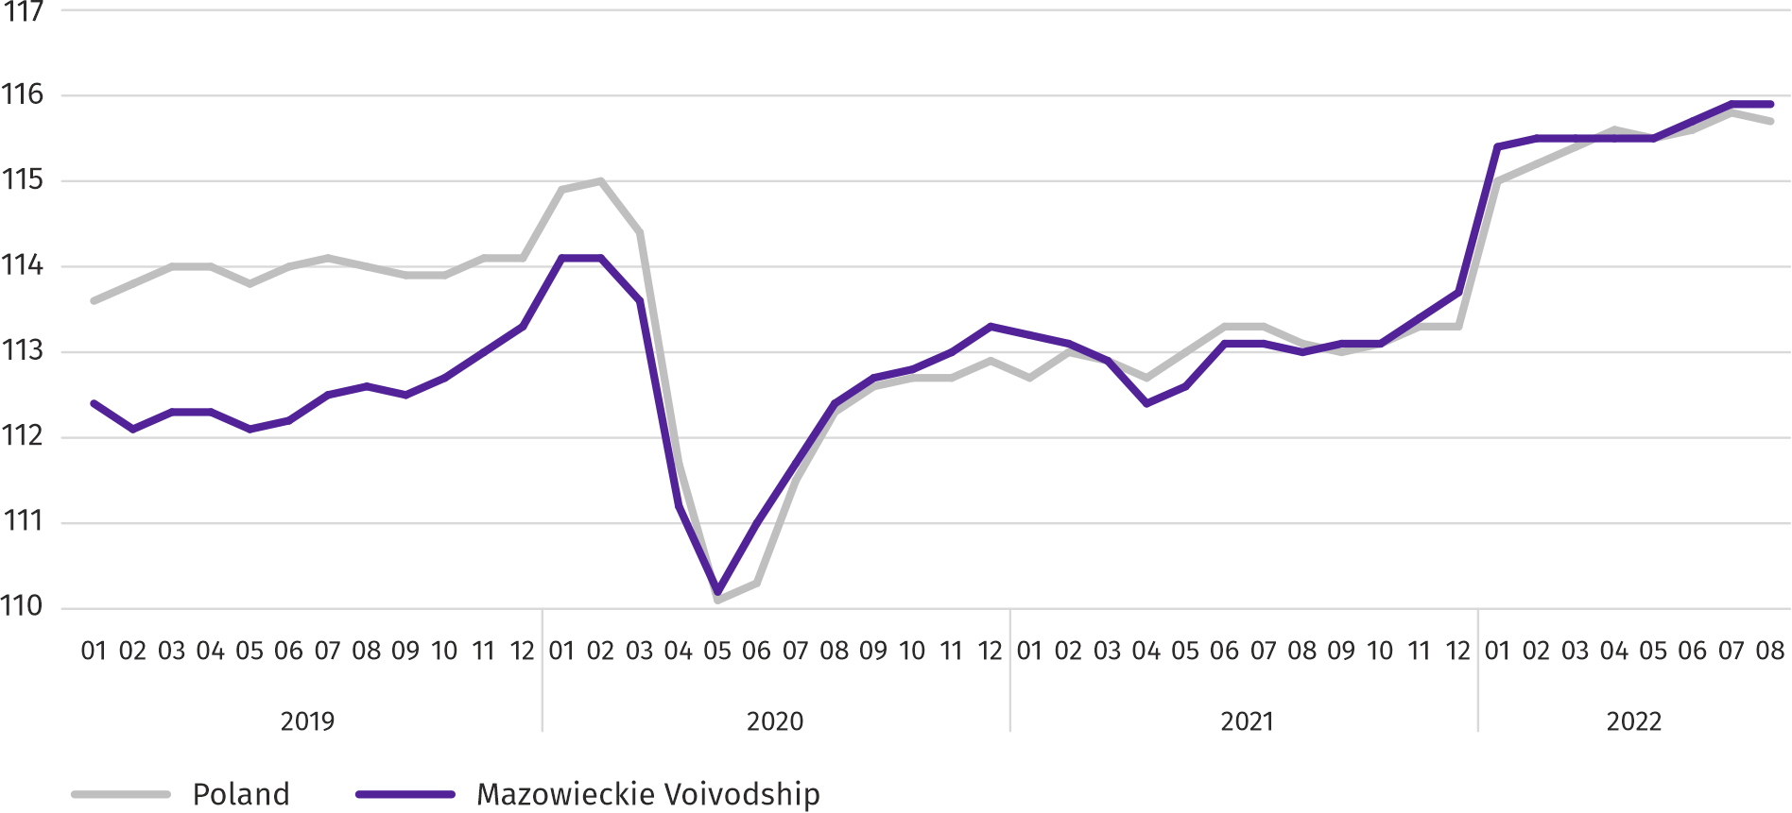
Chart 1. Average employment in the enterprise sector (monthly average 2015=100)

At the end of August this year, the number of unemployed persons registered in labour offices amounted to 119.9 thousand persons and decreased on a yearly basis by 18.3 thousand persons (i.e. by 13.2%), and on a monthly basis by 0.7 thousand persons (i.e. by 0.6%). Women accounted for 52.3% of total registered unemployed persons (a year before 51.1%).
Table 2. Number of unemployed persons and unemployment rate
SPECIFICATION | 2021 | 2022
 | 08 | 07 | 08
Registered unemployed persons (as of end of month) in thousands | 138,2 | 120,7 | 119,9
Newly registered unemployed persons (during a month) in thousands | 11,7 | 13,2 | 13,3
Unemployed persons removed from unemployment rolls (during a month) in thousands | 13,2 | 14,2 | 14,0
Registered unemployment rate (as of end of month) in % | 4,9 | 4,2 | 4,2
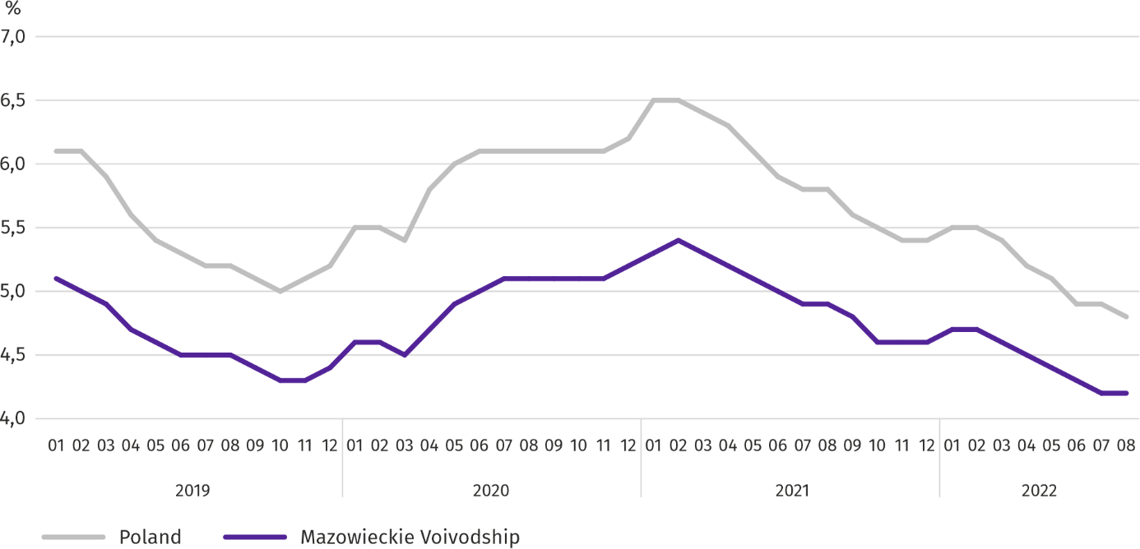
Chart 2. Registered unemployment rate (as of end of month)
Registered unemployment rate at the end of August this year amounted to 4.2% and was lower than the national average (4.8%). It decreased by 0.7 pp on a yearly basis, and did not change on a monthly basis.
The territorial differentiation of the unemployment rate continued in the Voivodship. Powiats with the highest unemployment rate were still szydłowiecki (21.4% compared to 22.8% in August last year), przysuski (14.4% compared to 15.9%), radomski (14.1% compared to 16.2%), and with the lowest – m.st. Warszawa (1.7% compared to 1.9%), warszawski zachodni (1.7% compared to 2.2%), grójecki (2.1% compared to 2.4%), pruszkowski (2.3% compared to 3.4%).
Compared to August last year, the unemployment rate decreased in 41 out of 41 powiats. The highest decrease was recorded in the powiats: gostyniński (by 2.2 pp), legionowski and radomski (by 2.1 pp each) and sochachewski (by 2.0 pp). Only pułtuski powiat recorded an increase (by 0.2 pp).
Compared to July this year, the unemployment rate decrease by 0.1–0.2 pp took place in 14 powiats. Decrease in the range of 0.1-0.6 pp took place in 13 powiats. There were no changes in 15 powiats.
Map 1. Registered unemployment rate by powiats in 2022 (as of end of August)
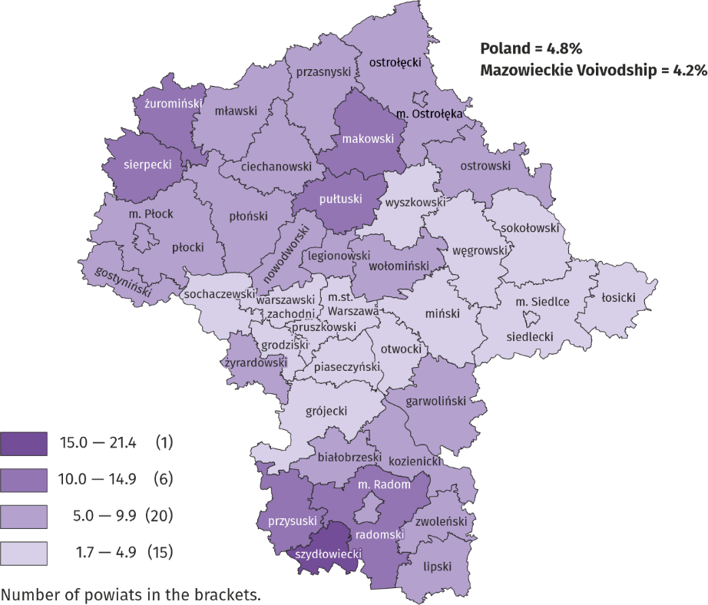
In August this year, 13.3 thousand unemployed persons were registered in labour offices, i.e. more by 13.1% than a year before and by 1.0% than in the previous month. Among the newly registered, 72.3% were persons registered once again (76.1% a year before). The share of persons previously not employed amounted to 21.9% (increase by 4.5 pp on a yearly basis), persons terminated due to company reasons 3.3% (a 0.9 pp decrease). Out of newly registered unemployed persons, 43.2% were rural residents (a decrease by 1.2 pp). Graduates accounted for 8.1% of newly registered unemployed persons (decrease by 0.5%).
In August this year, 14.0 thousand persons were removed from unemployment rolls, i.e. more by 6.6% than a year before and less by 1.2% than a month before. 6.3 thousand persons (15.1 thousand less than a year before) were removed from unemployment rolls due to undertaking employment. The share of this category of persons in the total number of persons removed from unemployment rolls decreased by 11.4 pp on a yearly basis and amounted to 44.8%. There was also a decrease in the share of persons who obtained retirement or pension rights (by 0.1 pp to 0.5%). However there was an increase in the share of persons who lost their status of the unemployed as a result of not confirming readiness to take up work (by 8.3 pp to 26.6%), persons who voluntarily gave up their status of the unemployed (by 2.1pp to 7.1%) as well as persons who started training or traineeship with employer (by 1.6 pp to 8.9%).
At the end of August this year, 103.3 thousand unemployed persons were not entitled to the unemployment benefit, and their share in the total number of the registered unemployed was 86.2% (a 0.4 pp increase in annual terms).
At the end of the surveyed month, 66.6 thousand, i.e. 55.5% out of registered unemployed persons were the long-term unemployed. The number of unemployed persons under the age of 30 amounted to 25.4 thousand, which accounted for 21.1% of the total unemployed (of which persons under the age of 25 constituted 10.0%). Persons aged over 50 amounted to 32.7 thousand (27.3%). 0.5 thousand of unemployed persons, i.e. 0.4% of their total number received social assistance benefits. There were 18.8 thousand persons (i.e. 15.7% of the total unemployed) had at least one child under the age of 6, and persons with a disabled child aged under 18 – 236 persons (0.2% respectively). The number of disabled unemployed persons amounted to 6.6 thousand (i.e. 5.5%).
Chart 3. Registered unemployed persons per job offer (as of end of month)
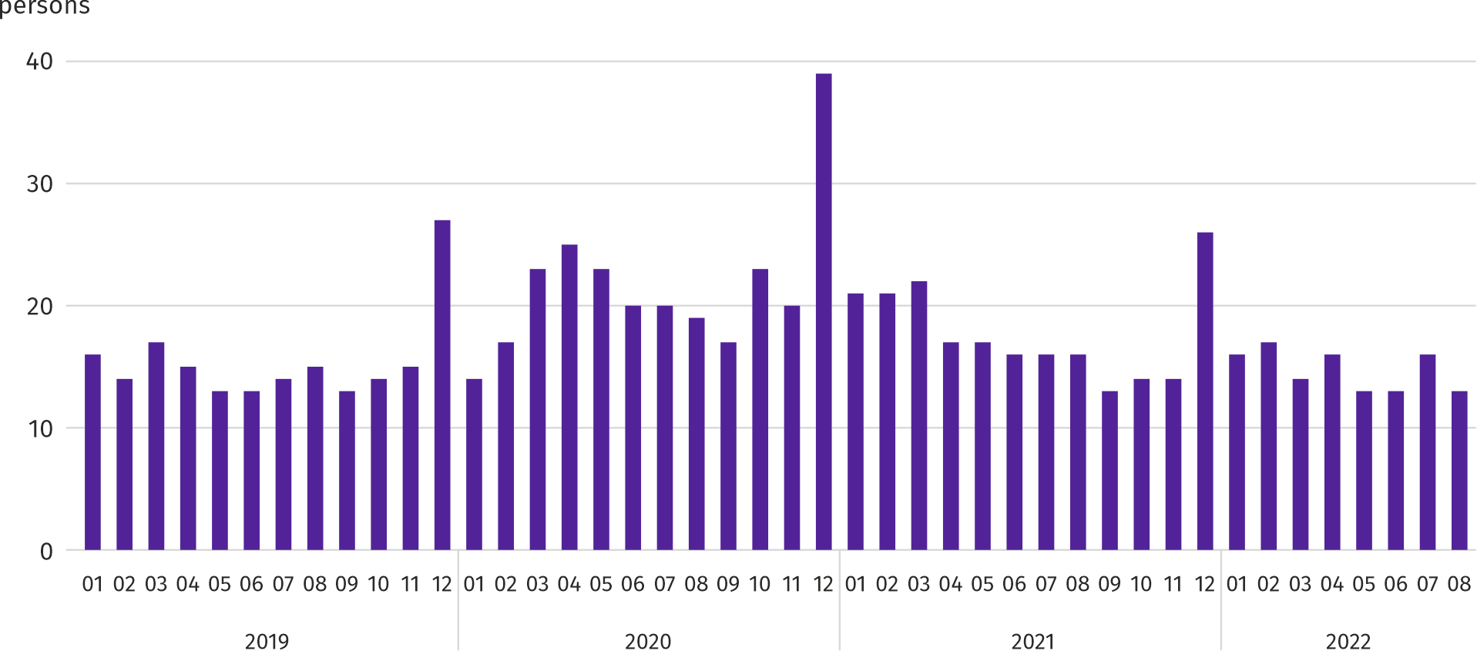
In August this year, 15.3 thousand job offers, i.e. more than a year before by 4.1% and by 18.4% on a monthly basis were submitted to labour offices. At the end of month, there were 13 unemployed persons (16 in the previous year) per job offer.
According to the labour offices, as of the end of August this year, 43 companies announced termination of 9.2 thousand employees in the near future (a year before, respectively 59 companies – 14.6 thousand employees).

Wages and salaries
In August this year, the average monthly gross wages and salaries in the enterprise sector increased on a yearly but decreased on a monthly basis.
Average monthly gross wages and salaries in the enterprise sector in August this year amounted to PLN 7,671.21 and were higher than in the country (PLN 6,583.03). In annual terms it increased by 13.7% (13.9% in the previous month). The highest increase was recorded in transportation and storage (by 18.6%), followed by, among others, professional, scientific and technical activities (by 17.3%), real estate activities (by 16.4%) and construction (by 14.9%).
In comparison with July this year, average wages and salaries decreased by 0.6%. It decreased the most in accommodation and catering (by 4.7%), and also in manufacturing (by 3.4%), transportation and storage (by 2.1%) and real estate activities (by 1.1%). The largest increase was noted in electricity, gas, steam and air conditioning supply (by 3.9%), and also in professional, scientific and technical activities (by 1.5%), trade; repair of motor vehicles (by 1.3%) and construction (by 1.1%).

Chart 4. Relative deviations of average monthly gross wages and salaries in selected sections from average wages and salaries in the enterprise sector in August 2022
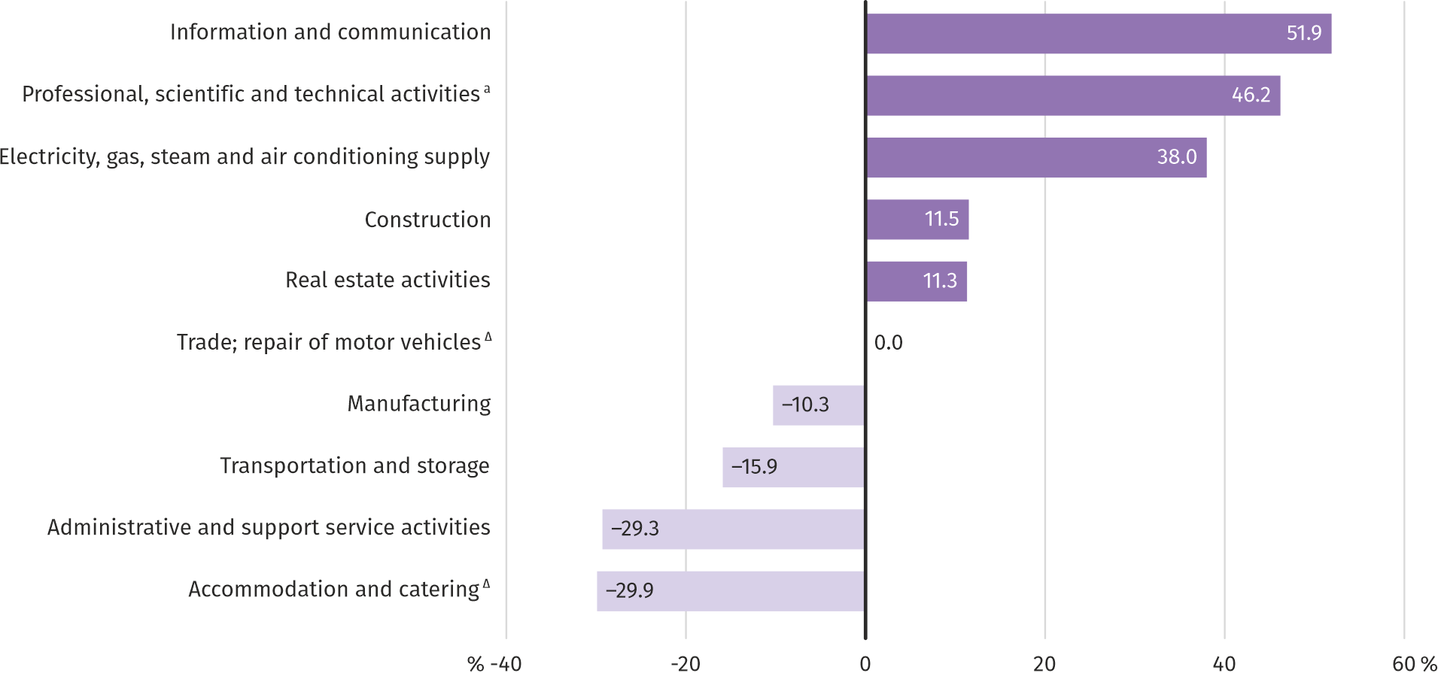
a Excluding divisions: Research and experimental development work and Veterinary activities.
In August this year, the highest average monthly gross wages and salaries were noted in information and communication – it exceeded the average wages and salaries in the enterprise sector in the Voivodship by 51.9%.
Table 3. Average monthly gross wages and salaries in the enterprise sector in August 2022
SPECIFICATION | 08 2022 |  | 01–08 2022
 | In PLN | 08 2021=100 | In PLN | 01–08 2021=100
TOTAL | 7671,21 | 113,7 | 7600,99 | 112,6
of which:
Industry | 7081,77 | 110,0 | 7148,62 | 109,8
of which:
manufacturing | 6878,65 | 110,6 | 6951,41 | 110,3
electricity, gas, steam and air conditioning supply | 10587,04 | 105,5 | 10661,88 | 107,0
Construction | 8553,50 | 114,9 | 8551,34 | 117,8
Trade; repair of motor vehicles ^{Δ} | 7672,66 | 113,7 | 7711,75 | 112,3
Transportation and storage | 6453,72 | 118,6 | 6191,01 | 117,0
Accommodation and catering ^{Δ} | 5373,93 | 107,3 | 5396,48 | 115,6
Information and communication | 11650,44 | 109,4 | 11563,50 | 108,0
Real estate activities | 8540,98 | 116,4 | 8654,41 | 112,2
Professional, scientific and technical activities ª | 11214,85 | 117,3 | 10905,52 | 112,1
Administrative and support service activities | 5422,11 | 111,9 | 5366,73 | 110,2
a Excluding divisions: Research and experimental development work and Veterinary activities.

In the period of January–August this year, the average monthly gross wages and salaries in the enterprise sector amounted to PLN 7,600.99 and was 12.2% higher than in the corresponding period of 2021 (6.8% higher a year before).
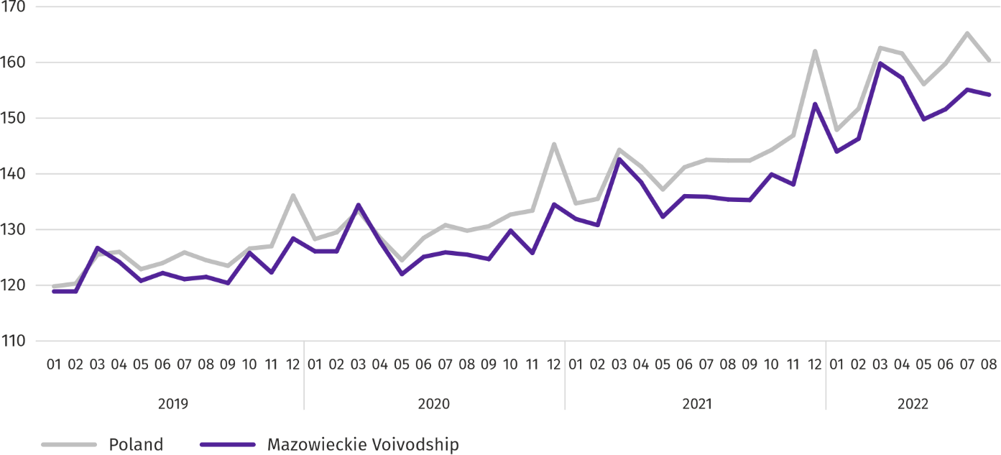
Chart 5. Average monthly gross wages and salaries in the enterprise sector (monthly average 2015=100)

Retail prices
In the second quarter of this year, in Mazowieckie Voivodship, the prices of consumer goods and services increased by 13.1% on a yearly basis; in the second quarter of 2021, the increase was 4.3%.
In the second quarter of this year, an increase in prices was recorded in all researched groups of consumer goods and services. Transportation prices grew the fastest; their increase compared to the second quarter of the previous year was 25.6%. At the same time, prices related to the maintenance of housing increased by 15.8%, the prices of food and non-alcoholic beverages by 13.3%, and those related to recreation and culture by 11.1%. The increase in the prices of health-related goods and services amounted to 9.1%, alcoholic beverages and tobacco products - 6.3%, and prices related to education - 5.9%. The relatively lowest price increase of 5.0% concerned clothing and footwear.
Table 4. Price indices of consumer goods and services
SPECIFICATION | 2021 |  | 2022
 | Q1 | Q2 | Q1 | Q2
 | corresponding period of previous year=100
TOTAL | 102,9 | 104,3 | 109,5 | 113,1
Food and non-alcoholic beverages | 100,7 | 101,7 | 108,8 | 113,3
Alcoholic beverages and tobacco | 103,0 | 101,8 | 104,2 | 106,3
Clothing and footwear | 98,4 | 100,5 | 105,1 | 105,0
Housing | 105,0 | 105,1 | 112,9 | 115,8
Health | 105,2 | 103,2 | 106,5 | 109,1
Transport | 100,4 | 112,7 | 116,1 | 125,6
Recreation and culture | 104,6 | 105,1 | 107,6 | 111,1
Education | 104,5 | 103,9 | 105,1 | 105,9
In the second quarter of this year the increase in the prices of consumer goods and services in Mazowieckie Voivodship was lower than the national average (13.1% compared to 13.9%).

Agriculture
On the agricultural market in August 2022, the average procurement prices of the surveyed agricultural products were higher than in the previous year. On a monthly basis, procurement prices of rye, cattle and pigs for slaughter and milk were higher, and prices of wheat, potatoes and poultry for slaughter lower.
The average air temperature in Mazowieckie Voivodship in August 2022 amounted to 21.1°C and was by 2.4°C higher from the average from the years 1991–2020, while the maximum temperature reached 32.7°C, and the minimum amounted to 6.8°C both registered at the meteorological station in Kozienice. The average atmospheric precipitation (35.6 mm) accounted for 59.4% of the standard for the multi-year periods (ranging from 49% in Warszawa and Siedlce to 75% in Mława). The number of days with precipitation, depending on the region, ranged from 6 to 11.
Table 5. Procurement of cereals ª
SPECIFICATION | 07–08 2022 |  | 08 2022
 | in thousand tonnes | corresponding period of the previous year=100 | in thousand tonnes | 08 2021=100 | 07 2022=100
Grain of basic cereals ^{b} | 124,7 | 129,0 | 82,7 | 138,8 | 197,2
of which:
wheat | 81,2 | 129,9 | 53,3 | 127,3 | 190,9
rye | 20,8 | 127,1 | 14,0 | 171,3 | 205,4
a Excluding procurement by natural persons. b Includes: wheat, rye, barley, oat, triticale; including cereal mixed, excluding sowing seed.
In August 2022, deliveries of basic cereals (with cereal mixed, without sowing seed) to the procurement amounted to 82.7 thousand tonnes and were by 38.8% higher than in the corresponding period of the previous year, with wheat deliveries larger by 27.3%, and rye by 71.3%. On a monthly basis, the procurement of these types of cereals was higher by 90.9% and 105.4%, respectively).
Table 6. Procurement of basic animal productsª
SPECIFICATION | 01–08 2022 |  | 08 2022
 | in thousand tonnes | 01–08 2021=100 | in thousand tonnes | 08 2021=100 | 07 2022=100
Animals for slaughter ^{b} | 791,9 | 112,9 | 90,6 | 123,7 | 111,4
of which:
cattle (including calves) | 50,1 | 135,9 | 3,0 | 116,5 | 117,3
pigs | 202,8 | 101,0 | 18,6 | 96,4 | 112,1
poultry | 538,3 | 116,2 | 68,9 | 134,3 | 111,0
Milk ^{c} | 1799,5 | 102,0 | 222,4 | 104,9 | 97,6
a In July-August excluding procurement by natural persons. b Including cattle, calves, pigs, sheep, horses and poultry; in terms of meat including fats in post-slaughter warm weight. c In million litres.
From the beginning of this year, producers from Mazowieckie Voivodship delivered 791.9 thousand tonnes of animals for slaughter (in warm weight), i.e. 12.9% more than in the previous year. The increase in procurement concerned cattle (by 35.9%), poultry (by 16.2%) and pigs for slaughter (by 1.0%). In August this year, the total supply of animals for slaughter (90.6 thousand tonnes) was higher by 23.7% on an annual basis, and by 11.4% on a monthly basis.
Deliveries of milk to procurement in January–August 2022 (1,799.5 million litres) were by 2.0% larger than in the corresponding period of 2021. In August this year, procurement of milk amounted to 222.4 million litres and was smaller by 2.4% than in the previous month and by 4.9% larger than in the previous year.
Table 7. Average prices of basic agricultural products
SPECIFICATION | 08 2022 |  |  | 01–08 2022
 | PLN | 08 2021=100 | 07 2022=100 | PLN | 01–08 2021=100
Wheat ª per dt | 146,65 | 160,6 | 93,5 | 147,16 | 158,1
Rye ª per dt | 120,92 | 181,3 | 101,6 | 117,71 | 174,7
Potatoes per dt | 84,35 | 214,6 | 94,5 | 82,73 | 139,0
Animals for slaughter per kg of live weight:
cattle (excluding calves) | 11,65 | 148,8 | 106,1 | 9,99 | 140,1
pigs | 8,00 | 148,7 | 105,0 | 6,48 | 124,2
poultry | 6,27 | 149,1 | 99,9 | 5,79 | 152,0
Milk per 1 hl | 238,03 | 158,0 | 102,9 | 213,33 | 142,1
a Excluding sowing seed.
In August this year, PLN 146.65 was paid for 1 dt of wheat at procurement, i.e. 6.5% less than last month and 60.6% more than last year. The average price of wheat at marketplaces was PLN 171.63 and was lower by 2.7% than in July 2022 and higher by 66.1% than a year before. The procurement price of rye increased by 1.6% (to PLN 120.92) compared to the previous month, and the marketplace price decreased by 1.2% (to PLN 119.41). Compared to August 2021, procurement prices for rye were 81.3% higher, and marketplace prices 76.3% higher.
Table 8. Average marketplace prices of cereals and potatoes
SPECIFICATION | 08 2022
 | PLN | 08 2021=100 | 07 2022=100
Wheat per dt | 171,63 | 166,1 | 97,3
Rye per dt | 117,95 | 176,3 | 98,8
Potatoes ^{b} per dt | 182,59 | 110,0 | 128,1
a Edible late.

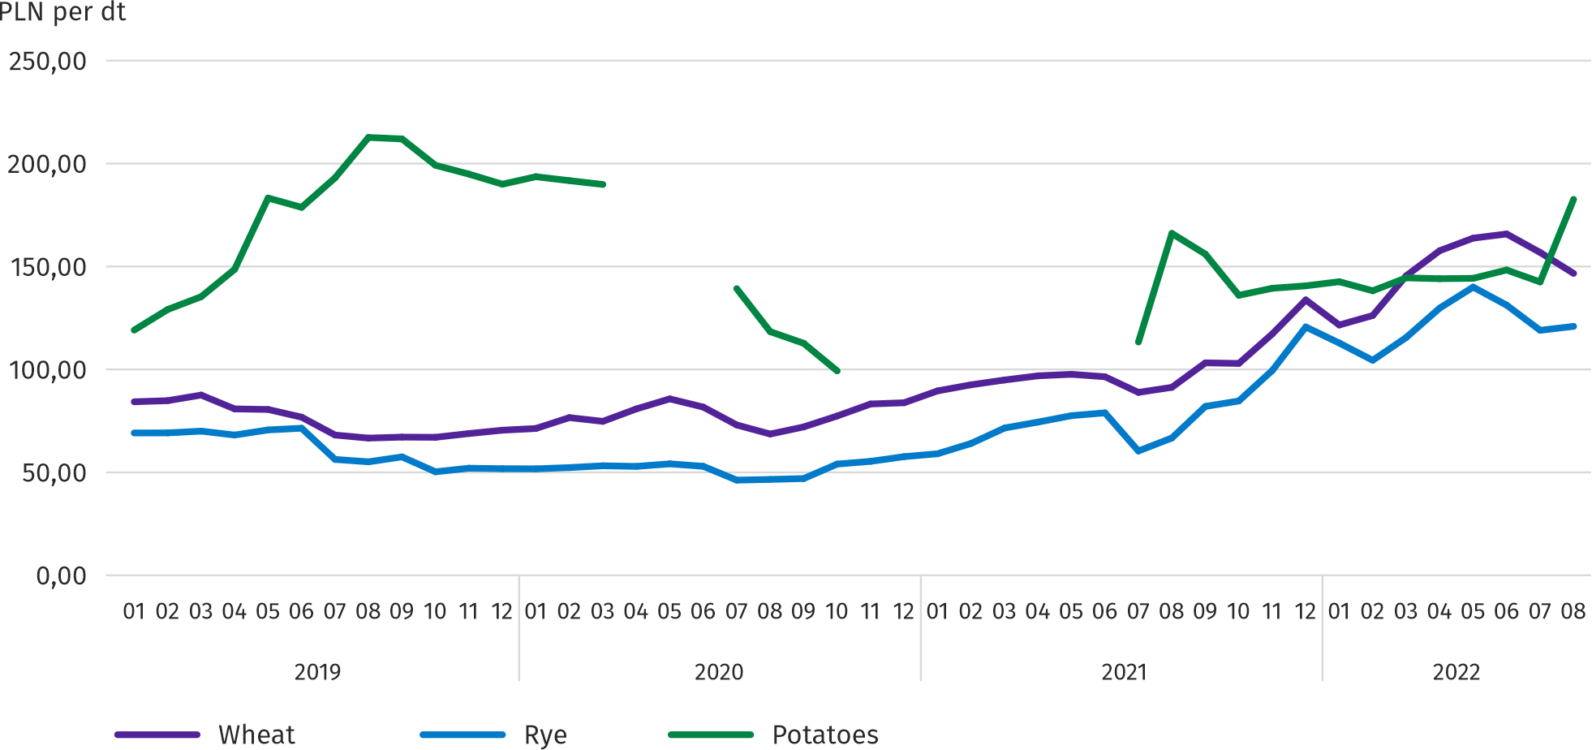
Chart 6. Average marketplace prices of cereals and potatoes ª

a No data in the period April-June 2020 and November 2020-June 2021 due to the current decision to close marketplaces due to the COVID-19 threat; it was not possible to collect data on prices of agricultural products at marketplaces.
In August this year, the average procurement price of potatoes was PLN 84.35/dt, i.e. 5.5% less than in the previous month and 114.6% more than last year. At marketplaces, the average price of 1 dt of potatoes was PLN 182.59 and was 28.1% higher than in the previous month and by 10.0% higher than in the previous year.
Chart 7. Average procurement prices of animals for slaughter and milk
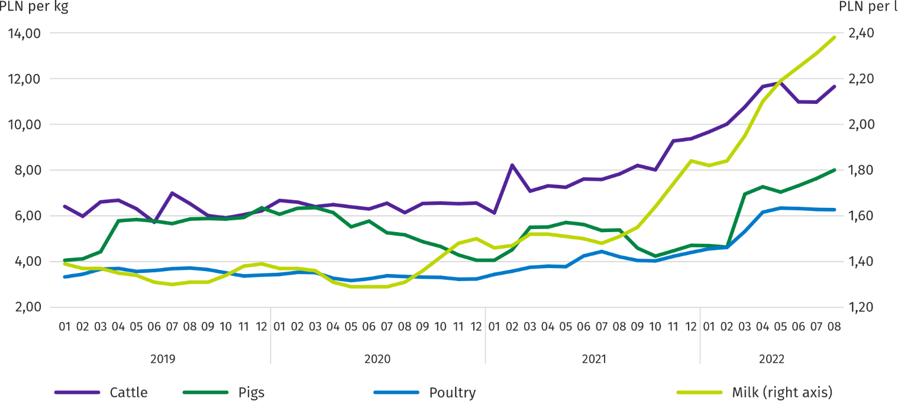
In August this year, the average procurement price of pigs for slaughter was by 48.7% higher than in the previous year, and higher than In the previous month by 5.0%.

Chart 8. Ratio of the average procurement prices of pigs for slaughter to the average marketplace prices of ryeª
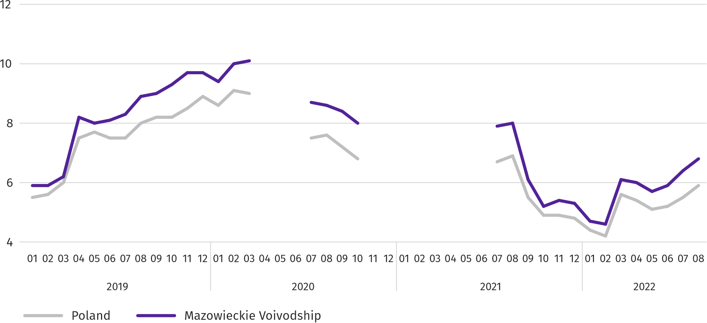
a No data in the period April-June 2020 and November 2020-June 2021 due to the current decision to close marketplaces due to the COVID-19 threat; it was not possible to collect data on prices of agricultural products at marketplaces.
Table 9. Population of pigs in June 2022
SPECIFICATION | In heads | In percent | 06 2021=100
TOTAL ª | 1223778 | 100,0 | 96,3
Piglets weighing less than 20 kg | 159794 | 13,1 | 108,5
Pigs weighing from 20 kg to 50 kg | 398664 | 32,6 | 86,6
Pigs weighing 50 kg and more:
for slaughter | 613282 | 50,1 | 100,6
for breeding | 52039 | 4,3 | 97,9
of which sows | 50996 | 4,2 | 97,9
of which mated | 36340 | 3,0 | 101,3
a Preliminary data.
According to preliminary data, the pig population in June 2021 was 1,223.8 thousand heads and compared to the corresponding period of previous year it was 3.7% lower. The decrease in the number of pigs was the result of a decrease in the size of a herd of pigs weighing from 20 kg to 50 kg by 13.4% and a herd of pigs weighing 50 kg and more for breeding by 2.1%. The share of Mazowieckie Voivodship in the total domestic pig population was 12.7%, compared to 11.5% in the previous year.

Chart 9. Population of pigs
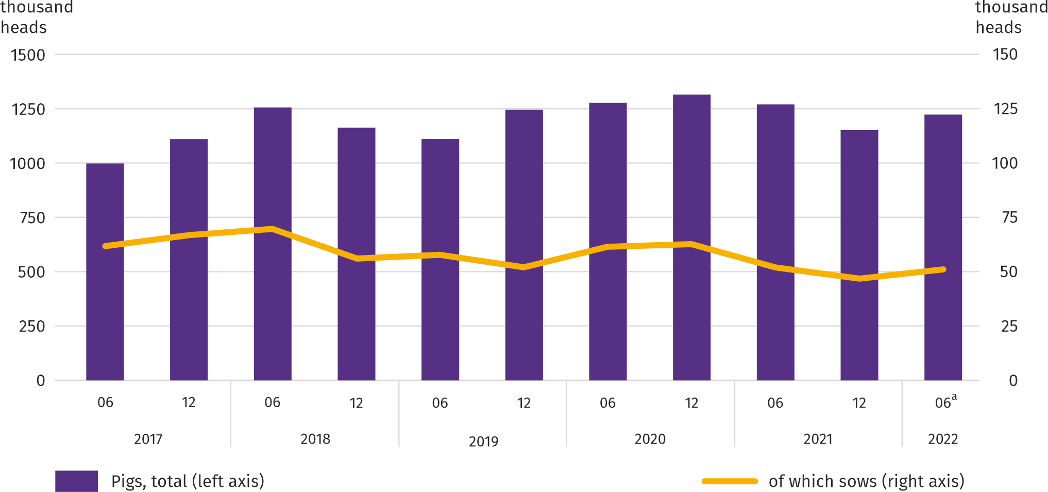
a Preliminary data.
In August 2022, the average procurement price of cattle for slaughter amounted to PLN 11.65 and was 6.1% higher than a month ago, and compared to August 2021 it was by 48.8% higher.
Table 10. Cattle population in June 2022
SPECIFICATION | In heads | In percent | 06 2021=100
TOTAL ª | 1210653 | 100,0 | 103,9
Calves under 1 year of age | 316080 | 26,1 | 107,8
Young cattle aged 1 to 2 years | 278664 | 23,0 | 89,5
Cattle over the age of 2 years | 615909 | 50,9 | 109,8
of which cows | 454923 | 37,6 | 89,8
of which milk cows | 411088 | 34,0 | 86,7
a Preliminary data.
According to the results of the survey conducted in June this year, the total cattle population was higher by 3.9% than in June 2021. The relatively highest increase (by 9.8%) concerned the herd of 2-year-old and older cattle. The share of the Mazowieckie Voivodship in the total cattle population amounted to 18.8%, as compared to 18.2% in the previous year.

Chart 10. Cattle population
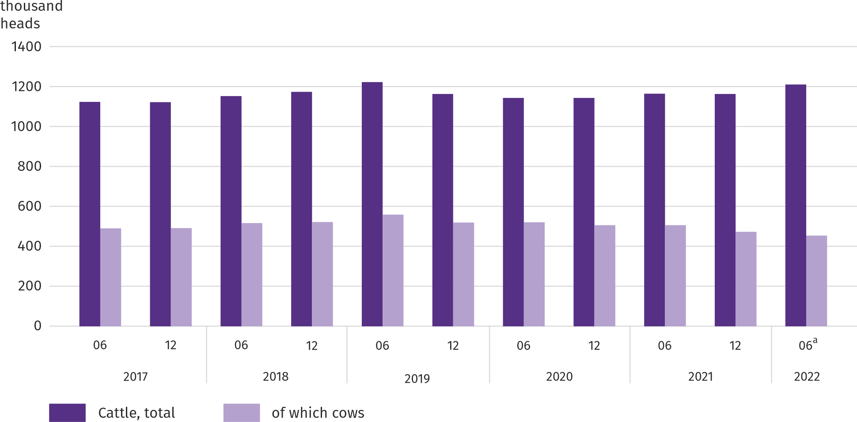
a Preliminary data.
In August 2022, suppliers were paid an average of PLN 6.27 per 1 kg of poultry for slaughter, i.e. 0.1% less than in July 2022 and 49.1% more than in August last year.
Procurement prices of milk in August 2022 were 58.0% higher than a year ago and by 2.9% higher than a month ago.

Industry and construction
Sold production of industry in August this year, reached the value (at current prices) of PLN 49,749.2 million and was (at constant prices) by 16.9% higher than a year before (compared to a 11.0% increase in July this year); as compared to the previous month it increased by 6.6%.
Sold production in manufacturing (constituting 78.8% of sold production of industry) compared to August last year increased (at constant prices) by 15.6%. There was also an increase (by 25.3%) in sold production in the section of electricity, gas, steam and air conditioning supply (the share of this section represents 19.4% of industrial production).
Chart 11. Sold production of industry (monthly average 2015=100; constant prices)
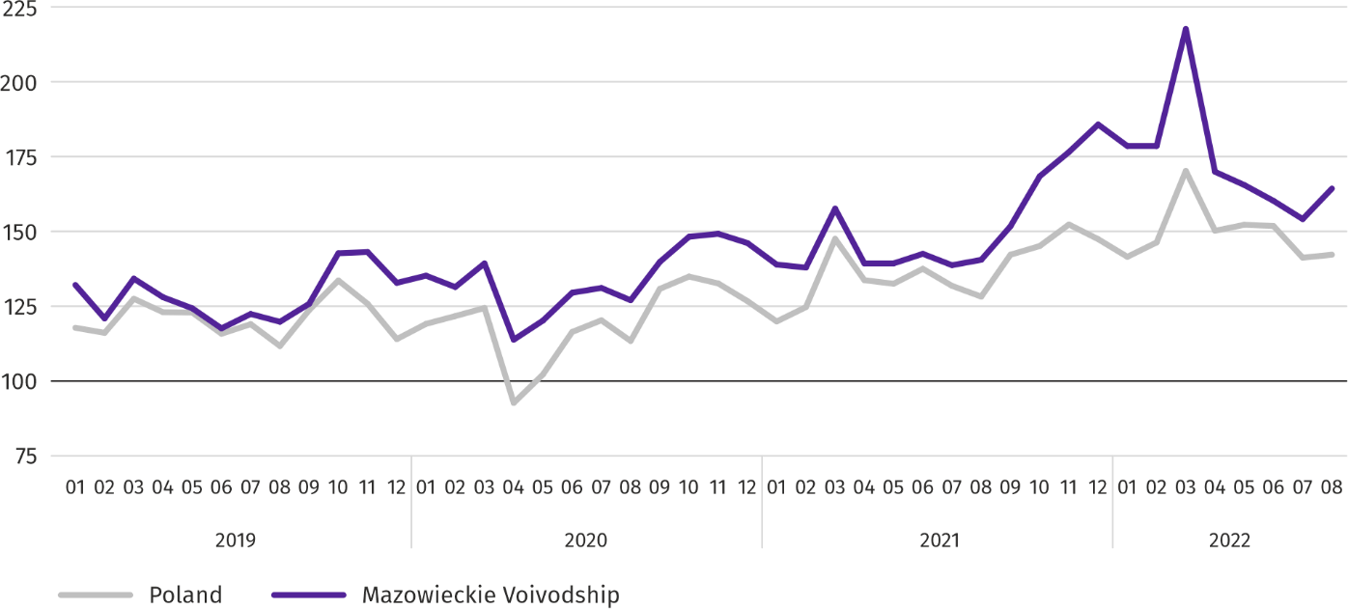
In August this year, the increase in sold production in annual terms was recorded in 21 (out of 32 in the Voivodship) divisions of industry, among others, in: manufacture of food products (by 21.4%), electrical equipment (by 14.4%), manufacture of rubber and plastic products (by 9.0%), chemicals and chemical products (by 8.8%), beverages (by 0.1%). However, there was a decrease in sold production of, among others, machinery and equipment n.e.c. (by 17.4%), computers, electronic and optical products (by 12.6%), paper and paper products (by 7.5%), other non-metallic mineral products (by 4.9%), metal products (by 1.2%).
Table 11. Dynamics (constant prices) and structure (current prices) of sold production of industry in August 2022
SPECIFICATION | 08 2022 | 01–08 2022
 | corresponding period of previous year =100 |  | In percent
TOTAL | 116,9 | 119,1 | 100,0
of which:
Manufacturing | 115,6 | 113,6 | 74,6
of which manufacture of:
food products | 121,4 | 117,5 | 17,3
beverages | 100,1 | 111,6 | 1,8
paper and paper products | 92,5 | 96,4 | 2,2
chemicals and chemical products | 108,8 | 125,7 | 4,5
manufacture of rubber and plastic products | 109,0 | 117,5 | 3,4
other non-metallic mineral products | 95,1 | 107,3 | 2,2
metal products ^{Δ} | 98,8 | 114,5 | 3,9
computer, electronic and optical equipment | 87,4 | 94,9 | 4,6
electrical equipment | 114,4 | 101,6 | 4,1
machinery and equipment n.e.c. | 82,6 | 106,1 | 1,7
Electricity, gas, steam and air conditioning supply | 125,3 | 142,3 | 23,3
Labour productivity in industry measured by sold production per employed person, in August this year amounted (at current prices) to PLN 127.7 thousand and was (at constant prices) by 16.6% higher than a year before, with higher by 0.2% average paid employment and higher average monthly gross wages and salaries by 10.0%.
In the period January–August this year, sold production of industry (at current prices), reached the value of PLN 368,666.3 million (at constant prices) was by 19.1% higher than in the corresponding period of the previous year.
Sold production of construction (at current prices) in August this year, reached the value of PLN 8,579.0 million and was by 22.6% higher than in the previous year (compared to a 22.7% increase in July this year). In the period of January–August this year, sold production of the construction amounted to PLN 66,904.7 million and was 24.8% higher than in the corresponding period of the previous year.
Labour productivity in construction, measured by revenue from the sale of goods and services per employed person in August this year amounted to PLN 93.7 thousand (at current prices) and was by 20.0% higher compared to the corresponding month of last year, with an increase in average employment by 2.1% and the average monthly gross wages and salaries by 14.9%.
Construction and assembly production (at current prices) in August this year, amounted to PLN 2,095.1 million and was by 11.0% higher than a year before (as compared to 18.9% increase in July this year). The increase in production was recorded in entities whose basic activity is the construction of buildings (by 31.3%), in enterprises performing specialised construction activities (by 27.8%). Whereas the decrease occurred in units specialising in civil engineering (by 2.6%). In the period of January–August this year, construction and assembly production amounted to PLN 15,402.1 million and was by 15.6% higher compared to the corresponding period of the previous year.
Tabls 12. Dynamics and structure (at current prices) of construction and assembly production in August 2022

SPECIFICATION | 08 2022 | 01–08 2022
 | corresponding period of previous year =100 |  | In percent
TOTAL | 111,0 | 115,6 | 100,0
Construction of buildings | 131,3 | 128,6 | 22,5
Civil engineering | 97,4 | 109,4 | 49,1
Specialized construction activities | 127,8 | 117,8 | 28,3

Housing construction
In August this year, as compared to the corresponding month of 2021, the number of dwellings completed increased by 6.3%. The number of dwellings for which permits have been granted or which have been registered with a construction project decreased by 48.1%, and dwellings in which construction has begun by 73.4%.
According to preliminary data in August this year, there were 3538 dwellings completed, i.e. by 210 more (by 6.3%) than in the previous year and by 270 (by 8.3%) than in the previous month. Majority of dwellings were built for sale or rent – 2599 (73.5% of their total number), followed by private dwellings – 939 (26.5%). Compared to August last year, there were more dwellings for sale or rent by 13.6%, and private dwellings by 9.3% less.
The effects of housing construction obtained in Mazowieckie Voivodship in the surveyed month constituted 19.2% of national effects.
Table 13. Number of dwellings completed in January-August 2022
SPECIFICATION | Dwellings completed |  |  | Average useful floor area per dwelling in m²
 | In absolute numbers | In percent | 01–08 2021=100
TOTAL | 25549 | 100,0 | 100,0 | 92,5
Private | 8170 | 32,0 | 95,1 | 147,3
Cooperative | 396 | 1,5 | ponad 16 razy | 59,2
For sale or rent | 16849 | 65,9 | 101,0 | 67,1
Municipal | 15 | 0,1 | 7,4 | 46,7
Public building society | 89 | 0,3 | 207,0 | 41,6
Company | 30 | 0,1 | 375,0 | 68,0

Chart 12. Dwellings completed (corresponding period 2015=100)
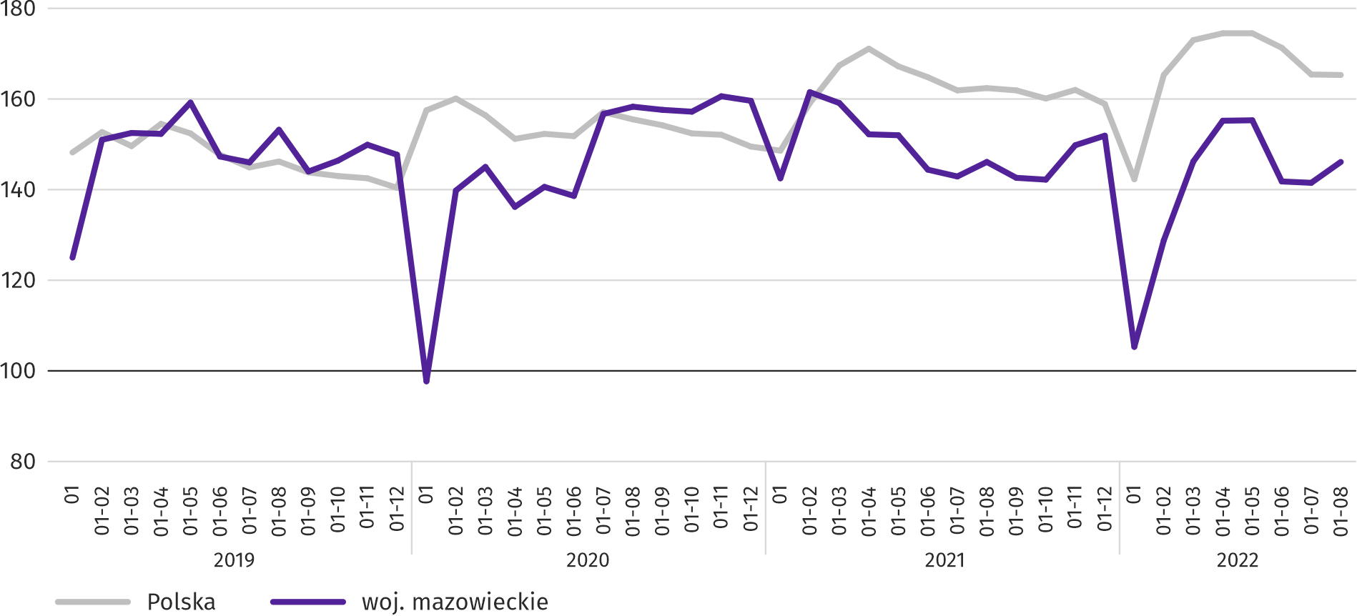
In the period of January–August this year, 25549 dwellings were completed, i.e. fewer than in the corresponding period of the previous year by 3. Most dwellings were completed in m.st. Warszawa (8276), followed by wołomiński (1998) and piaseczyński (1809), and the least in żuromiński (35), lipski (57) and zwoleński (65).
Map 2. Dwellings completed per 10 thousand population ª by powiats in January–August 2022
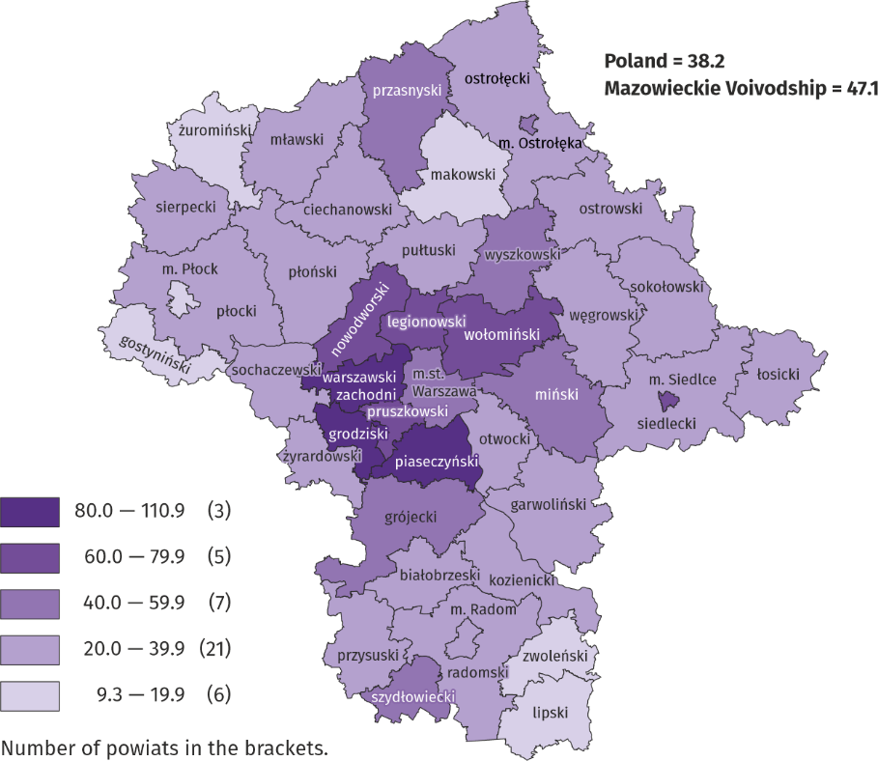
a Population as of 31 December 2021.
The average useful floor area of dwellings completed in the period of eight months of this year amounted to 92.5 m² and was smaller than a year earlier by 3.4 m² than a year earlier. The largest dwellings were completed in siedlecki (150.9 m²), ostrołęcki (142.6 m²) and żuromiński (by 138.5 m2) The smallest were built in Ostrołęka (62.9 m²), m.st. Warszawa (64.5 m²) and Siedlce (64.6 m²).
In August this year, the number of dwellings for which permits have been granted or which have been registered with a construction project amounted to 2745, that is by 2542 (by 48.1%) fewer than a year earlier and by 1686 (by 38.1%) than in the previous month. Of the total number of dwellings, 64.9% were dwellings for sale or rent, and 34.4% private.
In the surveyed month, the construction began in 1599 dwellings, which means an increase by 4421 (by 73.4%) in annual terms and by 1346 (by 45.7%) in monthly terms. Dwellings for sale or rent accounted for 33.6% of their total number, and private 63.9%.
Table 14. Number of dwellings for which permits have been granted or which have been registered with a construction project as well as dwelling in which construction has begun in January–August 2022
SPECIFICATION | Dwellings for which permits have been granted or which have been registered with a construction project |  |  | Dwellings in which construction has begun
 | in absolute numbers | in percent | 01–08 2021=100 | in absolute numbers | in percent | 01–08 2021=100
TOTAL | 38684 | 100,0 | 96,4 | 26100 | 100,0 | 73,7
Private | 9042 | 23,4 | 73,5 | 8167 | 31,3 | 79,7
Cooperative | 121 | 0,3 | 62,1 | 260 | 1,0 | 102,8
For sale or rent | 29286 | 75,7 | 106,4 | 17487 | 67,0 | 70,2
Municipal | 235 | 0,6 | 217,6 | 155 | 0,6 | ok. 12 razy
Company | – | – | . | 31 | 0,1 | .

Domestic market
In August this year, there was an increase both in retail sales and in wholesale compared to the previous year.
Retail sales (at current prices) in trade and non-trade enterprises in August this year, increased by 16.4% compared to the year before. The increase in sales was recorded in units from the group: “solid, liquid and gas fuels” (by 43.0%), “textiles, clothing and footwear” (by 15.3%), “others” (by 14.6%), “food, beverages and tobacco” (by 12.2%), „pharmaceuticals, cosmetics, orthopedic equipment” (by 11.5%), “furniture, electronics and household appliances” (by 11.0%), “other retail sales in non-specialised stores” (by 9.0%). The decrease occurred units from the group “motor vehicles, motorcycles, parts” (by 9.6%) and “press, books, other sales in specialized stores” (by 4.5%).
Compared to July 2022, retail sales increased by 0.9%. The increase in retail sales was recorded in the following groups: “other retail sales in non-specialized stores” (by 5.4%), „furniture, electronics and household appliances” (by 3.9%), „pharmaceuticals, cosmetics, orthopedic equipment” (by 3.4%), “food, beverages and tobacco” (by 3.3%) and “others” (by 2.2%). The largest decrease in sales was recorded in units from the group: “solid, liquid and gas fuels” (by 2.8%), “press, books, other sales in specialized stores” (by 2.0%), “textiles, clothing and footwear” (by 0.9%), “motor vehicles, motorcycles, parts” (by 0.8%).
In the period January–August 2022, retail sales increased by 20.6% annually. The highest increase in sales was achieved by enterprises from the group of "solid, liquid and gas fuels" (by 49.6%), while a decrease in sales was recorded only by enterprises from the group of "motor vehicles, motorcycles, parts" (by 13.7%) .

Table 15. Dynamics and structure (at current prices) of retail sales in August 2022
SPECIFICATION | 08 2022 | 01–08 2022
 | corresponding period of previous year =100 |  | In percent
TOTAL ª | 118,9 | 120,6 | 100,0
of which:
Motor vehicles, motorcycles, parts | 90,4 | 86,3 | 5,5
Solid, liquid and gas fuels | 143,0 | 149,6 | 31,8
Food, beverages and tobacco | 112,2 | 108,5 | 14,3
Other retail sales in non-specialized stores | 109,0 | 121,6 | 2,7
Pharmaceuticals, cosmetics and orthopedic equipment | 111,5 | 120,6 | 3,4
Textiles, clothing and footwear | 115,3 | 135,7 | 4,9
Furniture, electronics and household appliances | 111,0 | 111,0 | 19,2
Press, books and other sales in specialized stores | 95,5 | 102,7 | 6,5
Other | 114,6 | 114,7 | 8,3
a The grouping of enterprises was made on the basis of the Polish Classification of Activities - PKD 2007, including the enterprise to a specific category according to the type of predominant activity, in accordance with the organizational status in the period under consideration. The recorded changes (increase/decrease) in retail sales in particular groups of activity of enterprises may also result from changes in the type of predominant economic activity and organizational changes (e.g. mergers of enterprises). This does not affect the dynamics of retail sales in general.
Wholesale (at current prices) in trade enterprises in August 2022 was by 3.0% higher as compared to the previous month, and by 35.6% higher compared to August 2021. In wholesale enterprises it was higher by 5.1% and by 36.8%, respectively.
In the period of January–August 2022, trade enterprises realised wholesale sales by 29.8% higher than in the previous year, and wholesale enterprises higher by 38.4%.

Entities of the national economy
In August this year, the number of national economy entities entered into the REGON register increased by 0.4% compared to the previous month. More than a month ago (by 7.2%) there were newly registered entities as well as entities removed and suspended (by 1.5% and 1.3%, respectively).
As at the end of August this year, 953378 entities of the national economy were registered in the REGON register, i.e. by 4.3% more than last year and by 0.4% than in the previous month.
In the total number of registered entities, the greatest number is natural persons conducting economic activity. At the end of August this year, there were 617544 of them, i.e. more by 3.6% than in the previous year. The number of companies which were registered in the REGON register amounted to 265355, including 205824 commercial companies and 59109 civil partnerships (annual increase by 6.2%, 8.1% and 0.1%, respectively).
According to the expected number of employees, entities that declared employment of up to 9 persons prevailed upon entry in the REGON register; they constituted 96.9% of all registered units. The share of entities with an estimated number of 10-49 employed persons was 2.5%, and of entities employing more than 49 persons – 0.6%. Over the year, the increase in the number of entities occurred among the smallest entities (up to 9 persons) – by 4.5% and the largest (more than 49 persons) – 0.1%.
Compared to August 2021, the largest increase in the number of entities was recorded in the sections: electricity, gas, steam and air conditioning supply (by 18.5%), information and communication (by 15.3%) and administrative and support service activities (by 7.2%).
Compared to July this year, the number of entities increased, among others, in the sections: electricity, gas, steam and air conditioning supply (by 1.4%), information and communication (by 1.3%), as well as education (by 0.7%).
Chart 13. Entities of the national economy newly registered and removed from the register in August 2022
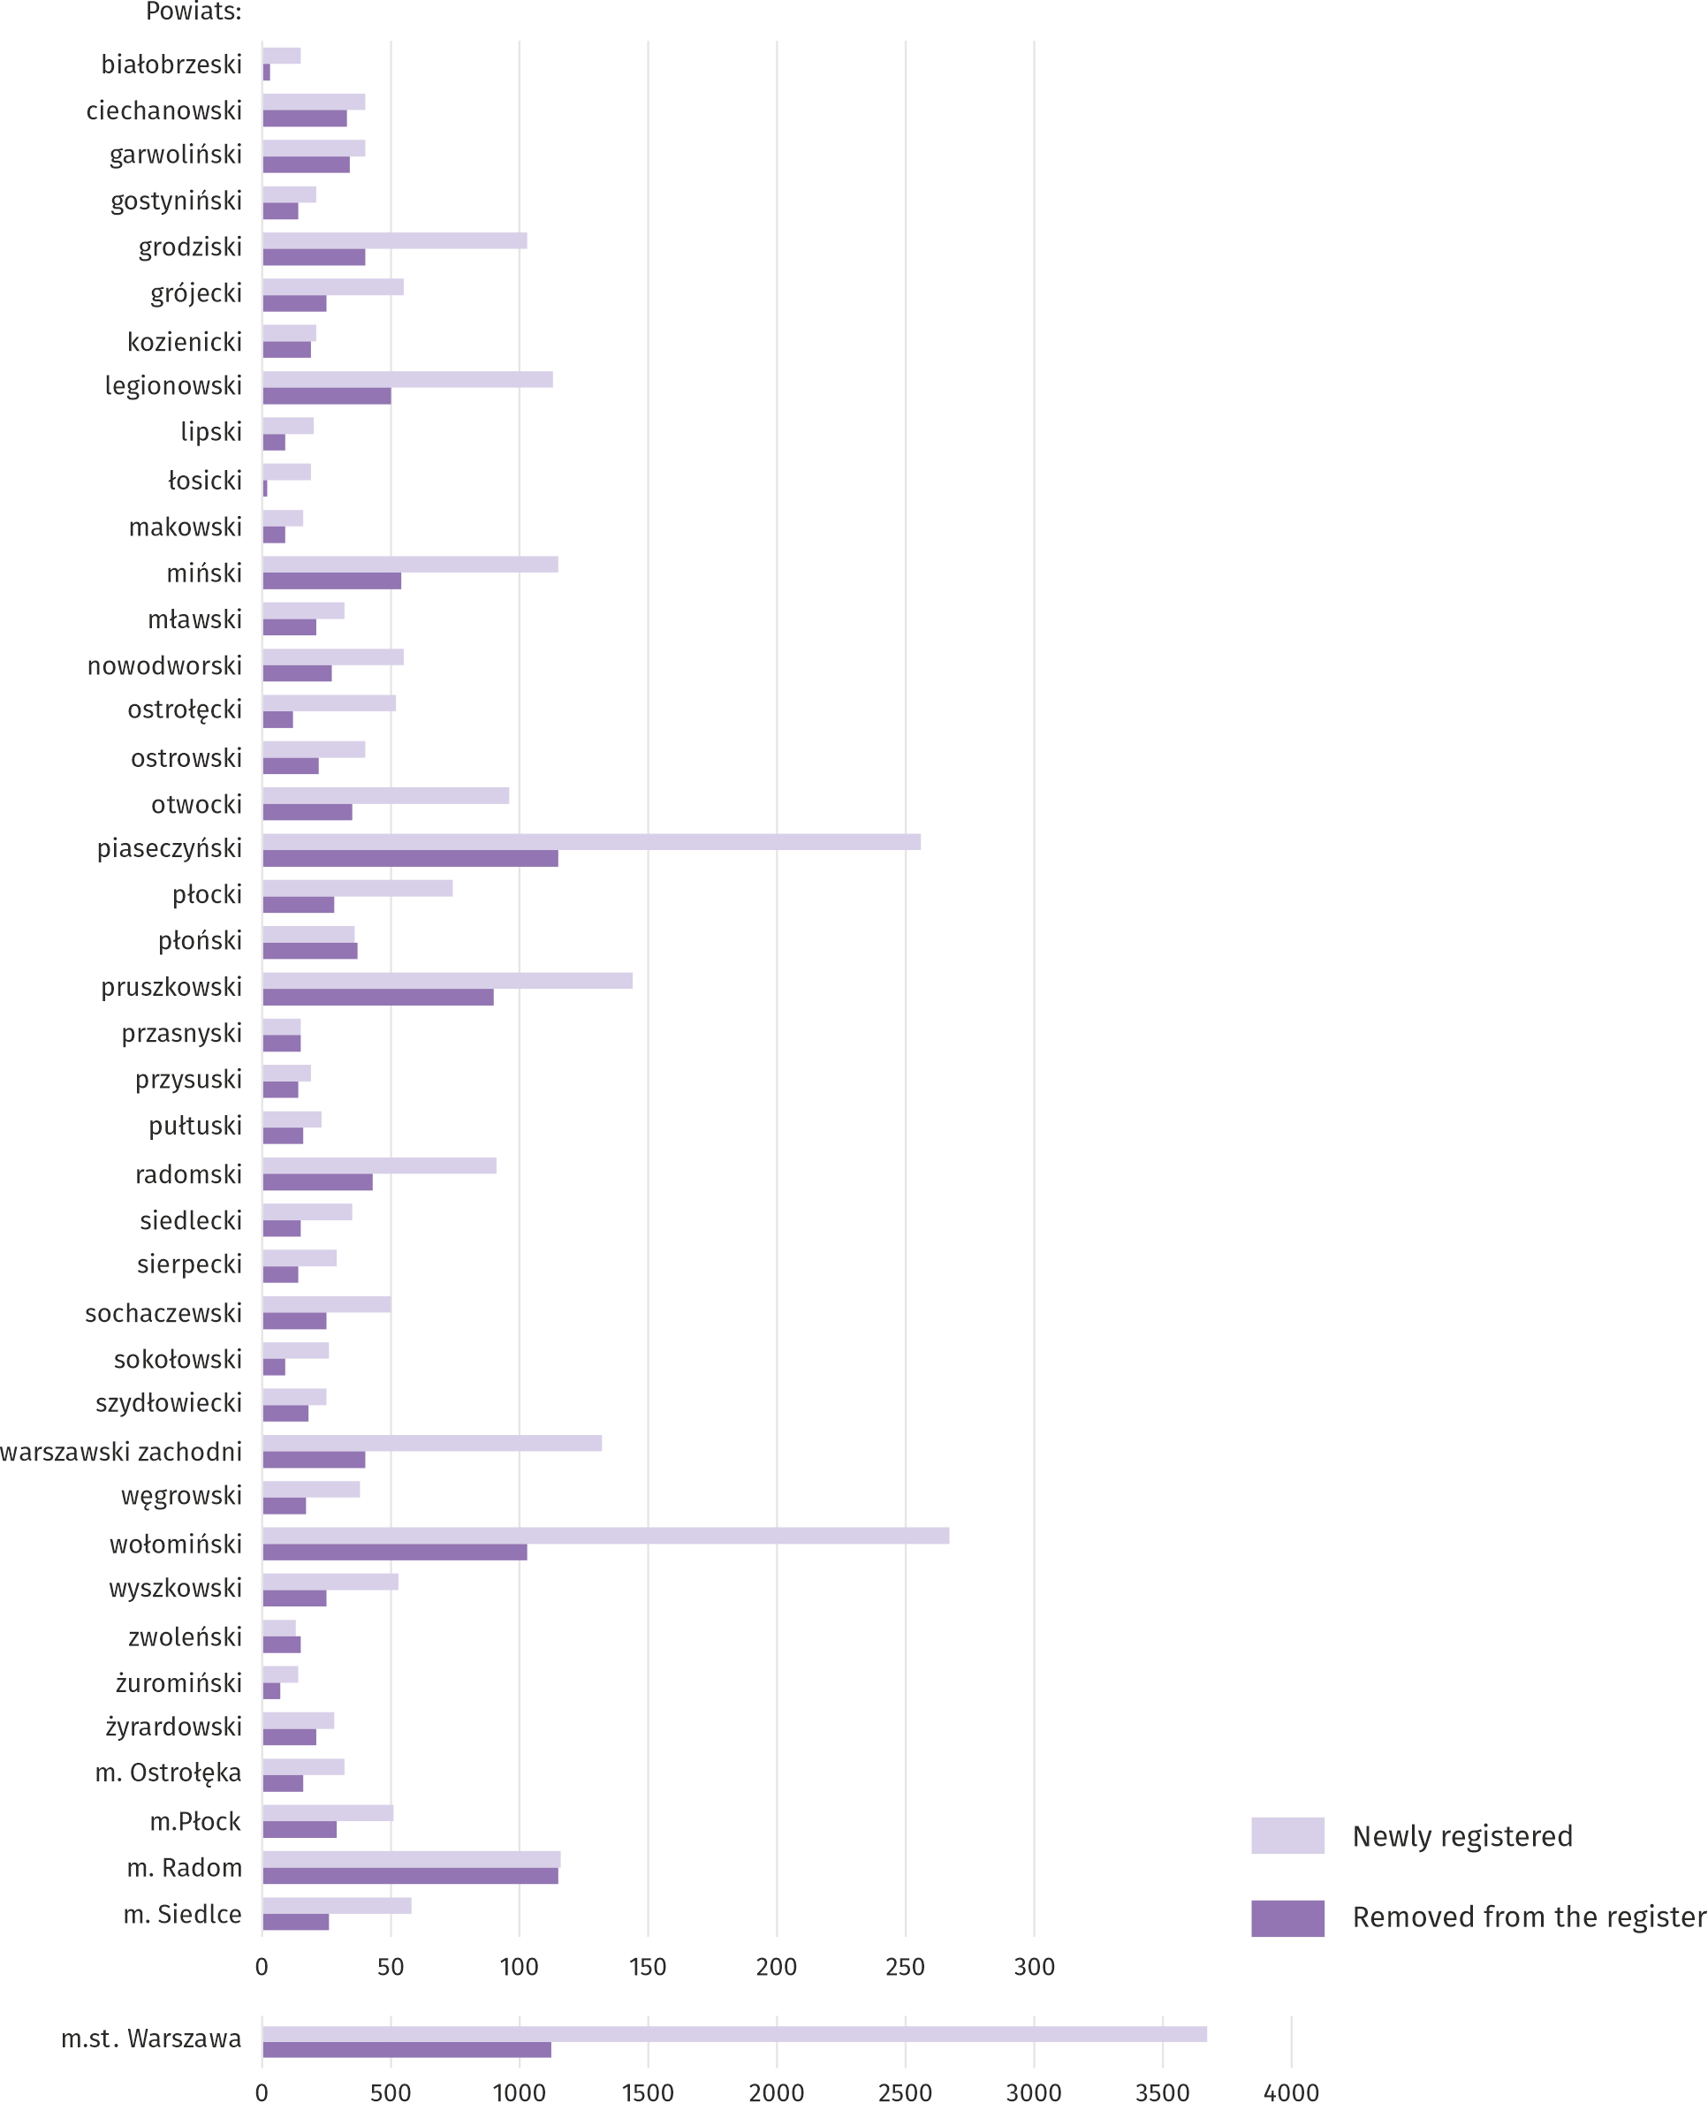
In August this year, 6149 new entities were entered in the REGON register, i.e. by 7.2% more than in the previous month. The newly registered units were dominated by natural persons conducting economic activity, 4420 of whom were registered (by 10.4% more than in July this year). The number of newly registered commercial companies was lower by 3.9%, including companies with limited liability by 4.4%.
In the surveyed month, 2385 entities were removed from the REGON register (by 1.5% more than a month ago), including 1972 natural persons conducting economic activity (by 4.2% more).
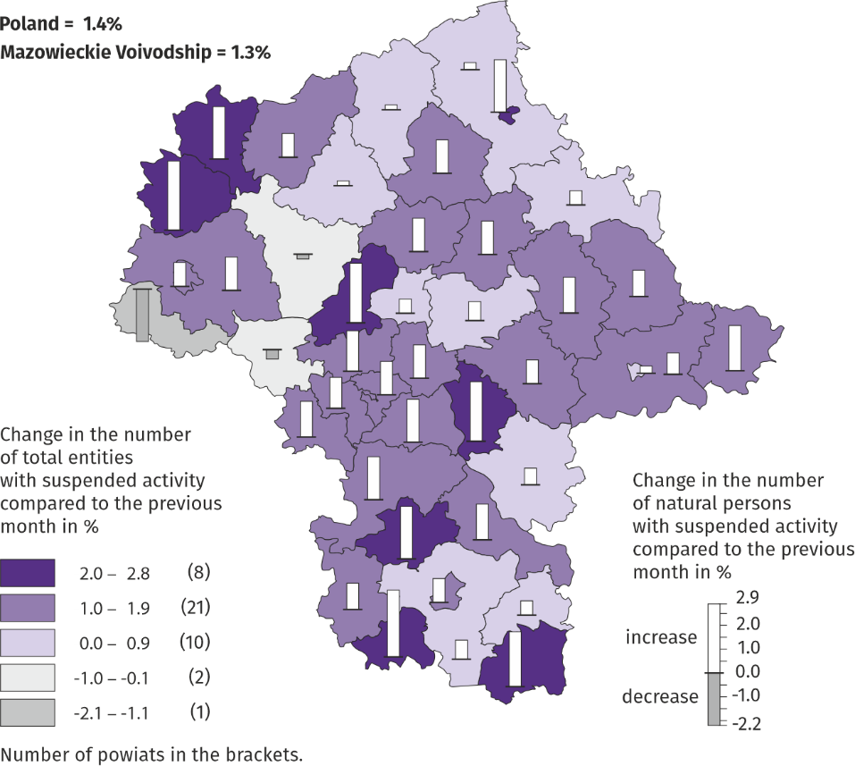
Map 3. Entities of the national economy with suspended activity in August 2022

As at the end of August 2022, there were 113393 entities in the REGON with suspended activity (by 1.3% more than a month ago). The vast majority were natural persons conducting economic activity (90.6%, i.e. the same as in the previous month).

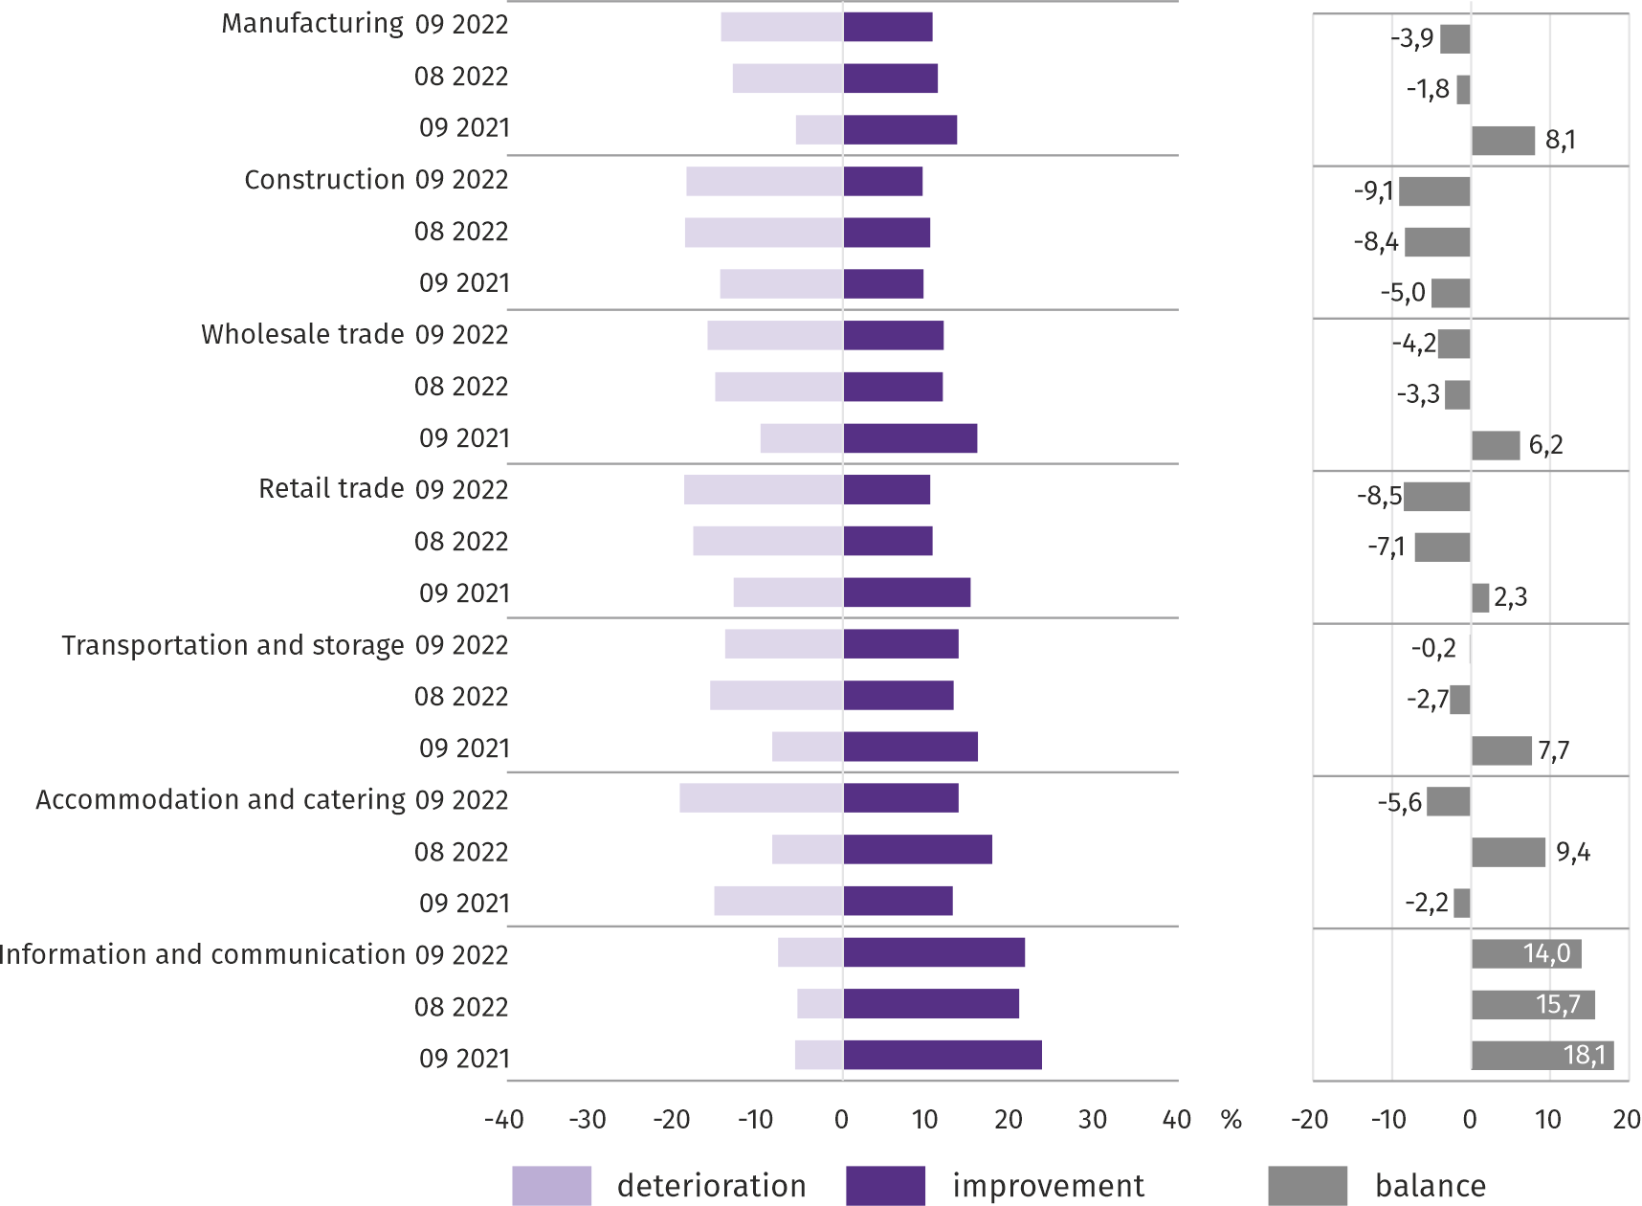
Business tendency
In most of the analysed areas, entrepreneurs in September this year, assessed the economic situation negatively. Only in information and communication the indicator of the general economic climate is positive. The most pessimistic assessments are made by those operating in the field of construction and retail trade.
Chart 14. Indices of the general business climate by type of activity (sections and divisions of NACE Rev.2)
Survey results on the impact of the war in Ukraine on the economic situation
Questions about the impact of the war in Ukraine
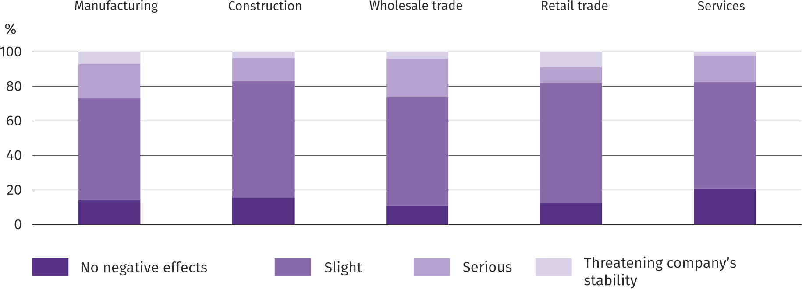
Q1. The negative effects of the war in Ukraine and its consequences for the economic activity conducted by your company will be this month:

Among the entrepreneurs who answered the survey, the most frequent opinions were that the ongoing war was in September this year, insignificant threat to the conduct of business in their companies. The serious and threatening effects of the war were most often felt by entrepreneurs operating in manufacturing and wholesale trade.
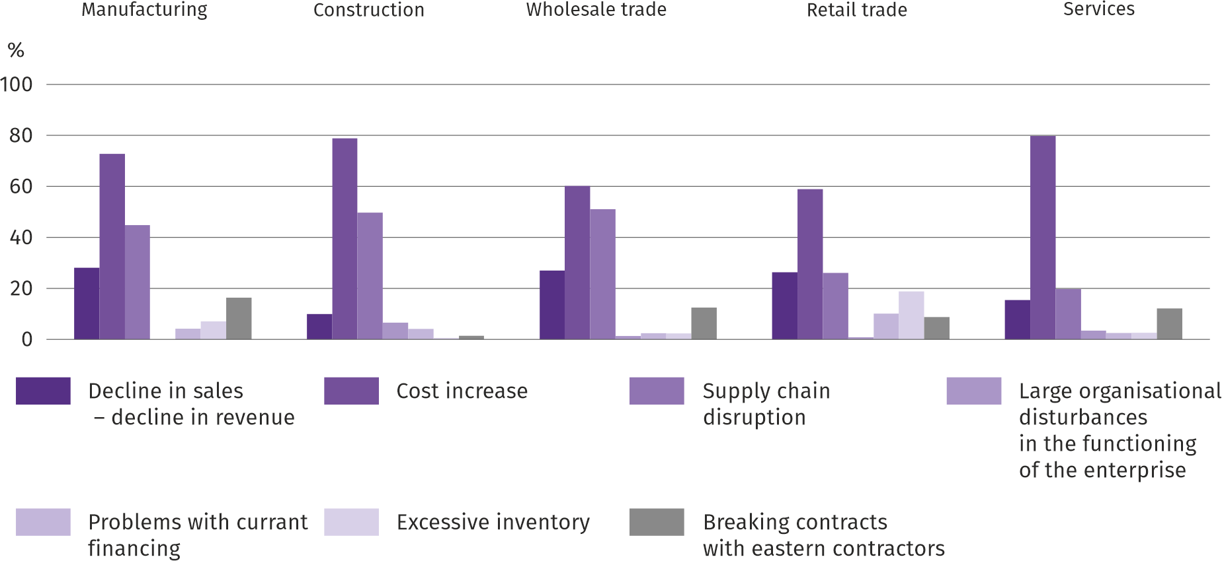
Q2. From the negative effects of the war in Ukraine observed in the last month, the ones that most refer to your company are:

The most common negative consequences of the war in Ukraine were the increase in costs, followed by disruptions in the supply chain and a decrease in sales/decrease in revenue.

Q3. If your company employs employees from Ukraine, did you observe last month in connection with the war in Ukraine:
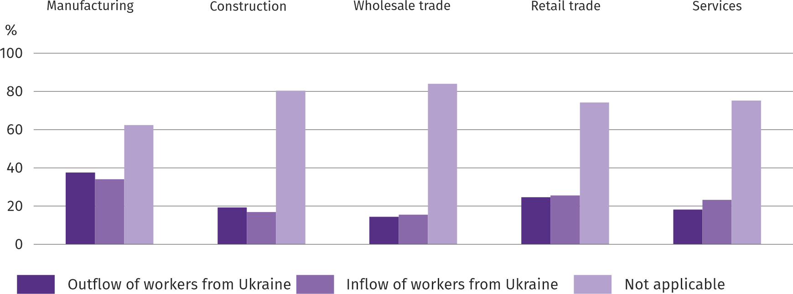
In September this year, In all analysed types of activity, an outflow and inflow of workers from Ukraine was observed in connection with the ongoing war (in the vast majority of cases it was an insignificant move). Both the outflow and the inflow of workers were most often indicated in manufacturing.
Questions about investments
Q4. What are your current forecasts for the level of investments of your company in 2022 in relation to investments made in 2021:
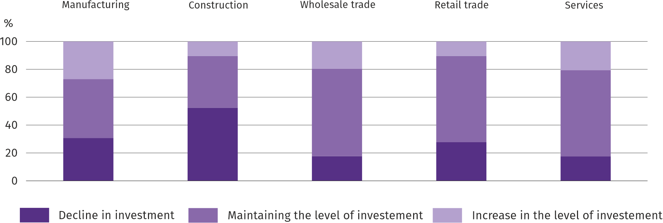
In most of the analysed types of activity, entrepreneurs were of the opinion that investments would remain at the same level compared to 2021. Only in the construction industry, the largest number of entrepreneurs decided that the level of investment would decline.

Q5. Which of the following factors have the greatest impact on reducing the scale of your company's investments in the current year:
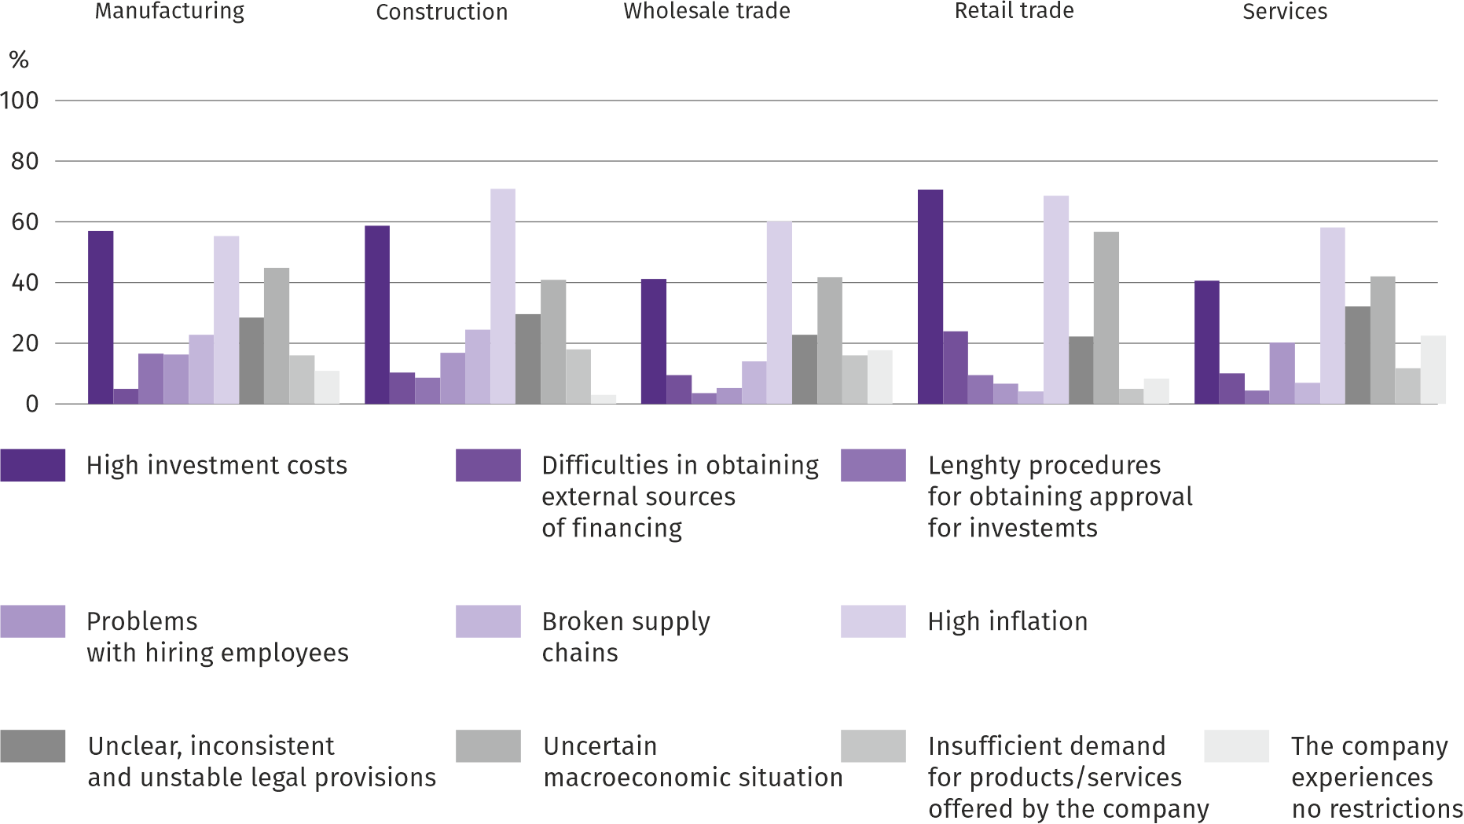
Entrepreneurs most often indicated high inflation, high investment implementation costs and uncertain macroeconomic situation among the factors influencing the limitation of the investment scale in their companies.

More information on the results of the business climate survey can be found on the website of the Statistical Office in Zielona Góra https://zielonagora.stat.gov.pl/osrodki/osrodek-badan-koniunktury/obk-dane/.

Table 16. Selected data on Mazowieckie Voivodship
SPECIFICATION  A – 2021  B – 2022 |  | 01 | 02 | 03 | 04 | 05 | 06 | 07 | 08 | 09 | 10 | 11 | 12
Average employment in the enterprise sector ª  (in thousand persons) | A | 1540,2 | 1538,3 | 1534,8 | 1528,8 | 1532,2 | 1537,7 | 1537,8 | 1536,4 | 1537,6 | 1537,9 | 1541,8 | 1546,6
 | B | 1569,9 | 1571,8 | 1572,5 | 1572,8 | 1572,2 | 1574,9 | 1577,9 | 1577,8
previous month=100 | A | 99,9 | 99,9 | 99,8 | 99,6 | 100,2 | 100,4 | 100,0 | 99,9 | 100,1 | 100,0 | 100,3 | 100,3
 | B | 101,5 | 100,1 | 100,0 | 100,0 | 100,0 | 100,2 | 100,2 | 100,0
corresponding month of previous year=100 | A | 99,2 | 99,2 | 99,3 | 101,0 | 102,2 | 101,8 | 101,2 | 100,5 | 100,3 | 100,2 | 100,3 | 100,3
 | B | 101,9 | 102,2 | 102,5 | 102,9 | 102,6 | 102,4 | 102,6 | 102,7
Registered unemployed persons (in thousand persons; as of end of period) | A | 151,1 | 152,5 | 149,9 | 147,7 | 144,6 | 141,4 | 139,6 | 138,2 | 134,9 | 131,2 | 129,9 | 129,2
 | B | 133,5 | 132,7 | 130,4 | 128,0 | 125,3 | 121,7 | 120,7 | 119,9
Unemployment rate b (in %; as of end of period) | A | 5,3 | 5,4 | 5,3 | 5,2 | 5,1 | 5,0 | 4,9 | 4,9 | 4,8 | 4,6 | 4,6 | 4,6
 | B | 4,7 | 4,7 | 4,6 | 4,5 | 4,4 | 4,3 | 4,2 | 4,2
Job offers (submitted during a month) | A | 13732 | 14151 | 15040 | 15041 | 14658 | 14339 | 15485 | 14674 | 16427 | 18125 | 17141 | 13252
 | B | 16533 | 15627 | 18846 | 14296 | 14943 | 14081 | 12893 | 15270
Unemployed persons per 1 job offer (as of end of period) | A | 21 | 21 | 22 | 17 | 17 | 16 | 16 | 16 | 13 | 14 | 14 | 26
 | B | 16 | 17 | 14 | 16 | 13 | 13 | 16 | 13
Average monthly gross wages and salaries in the en-terprise sector ª (in PLN) | A | 6570,77 | 6519,70 | 7109,13 | 6904,91 | 6594,12 | 6777,25 | 6772,44 | 6746,93 | 6742,14 | 6968,53 | 6875,56 | 7590,74
 | B | 7163,58 | 7275,06 | 7947,19 | 7819,34 | 7450,43 | 7539,43 | 7716,38 | 7671,21
previous month=100 | A | 98,1 | 99,2 | 109,0 | 97,1 | 95,5 | 102,8 | 99,9 | 99,6 | 99,9 | 103,4 | 98,7 | 110,4
 | B | 94,4 | 101,6 | 109,2 | 98,4 | 95,3 | 101,2 | 102,3 | 99,4
corresponding month of previous year=100 | A | 104,5 | 103,7 | 106,1 | 108,4 | 108,4 | 108,7 | 108,0 | 107,9 | 108,4 | 107,7 | 109,7 | 113,3
 | B | 109,0 | 111,6 | 111,8 | 113,2 | 113,0 | 111,2 | 113,9 | 113,7
Price indices:
consumer goods and services ^{c}:
corresponding month of previous year=100 | A | . | . | 102,9 | . | . | 104,3 | . | . | 105,2 | . | . | 107,3
 | B | . | . | 109,5 | . | . | 113,1 | . | .
a In enterprises employing more than 9 persons. b Share of registered unemployed persons in civilian economically active population, estimated at the end of each month. c In the quarter.
Table 16. Selected data on Mazowieckie Voivodship (cont.)
SPECIFICATION  A – 2021  B – 2022 |  | 01 | 02 | 03 | 04 | 05 | 06 | 07 | 08 | 09 | 10 | 11 | 12
Price indices (cont.):
Procurement of cereal grain:
previous month=100 | A | 109,5 | 102,4 | 102,9 | 100,7 | 104,6 | 98,5 | 86,4 | 107,3 | 113,8 | 100,2 | 110,9 | 116,5
 | B | 91,0 | 105,6 | 116,2 | 108,1 | 104,0 | 100,2 | 91,3 | 95,3
corresponding month of previous year=100 | A | 122,8 | 117,9 | 124,4 | 117,2 | 116,3 | 122,8 | 126,0 | 136,8 | 146,1 | 136,9 | 139,8 | 163,7
 | B | 136,0 | 140,2 | 158,3 | 169,9 | 168,9 | 171,7 | 181,4 | 161,2
procurement of cattle for slaughter (excluding calves):
previous month=100 | A | 93,5 | 133,9 | 86,2 | 103,4 | 99,2 | 104,9 | 99,7 | 103,1 | 104,8 | 97,7 | 115,7 | 101,1
 | B | 103,2 | 103,4 | 107,5 | 108,3 | 101,4 | 93,0 | 100,0 | 106,1
corresponding month of previous year=100 | A | 92,0 | 124,4 | 110,5 | 112,7 | 113,5 | 120,7 | 115,8 | 127,4 | 125,3 | 122,1 | 141,9 | 142,9
 | B | 157,8 | 121,9 | 152,0 | 159,3 | 162,8 | 144,3 | 144,6 | 148,8
procurement of pigs for slaughter:
previous month=100 | A | 100,2 | 111,1 | 121,7 | 100,2 | 103,5 | 98,5 | 95,4 | 100,4 | 85,2 | 92,5 | 105,3 | 105,5
 | B | 99,8 | 98,4 | 150,1 | 104,6 | 96,8 | 104,0 | 104,1 | 105,0
corresponding month of previous year=100 | A | 67,0 | 71,3 | 86,4 | 89,7 | 103,3 | 97,3 | 101,9 | 104,1 | 94,2 | 91,0 | 104,2 | 116,2
 | B | 115,7 | 102,5 | 126,4 | 132,0 | 123,4 | 130,3 | 142,2 | 148,7
Ratio of procurement prices ª of pigs for slaughter to marketplace prices of rye | A | . | . | . | . | . | . | 7,9 | 8,0 | 6,1 | 5,2 | 5,4 | 5,3
 | B | 4,7 | 4,6 | 6,1 | 6,0 | 5,7 | 5,9 | 6,4 | 6,8
Sold production of industry ^{b} (at constant prices):
previous month=100 | A | 95,1 | 99,3 | 114,3 | 88,4 | 100,0 | 102,3 | 97,3 | 101,3 | 108,0 | 111,0 | 104,8 | 105,2
 | B | 96,1 | 100,0 | 121,9 | 78,1 | 97,4 | 96,8 | 96,2* | 106,6
corresponding month of previous year=100 | A | 102,7 | 104,9 | 113,2 | 122,4 | 115,9 | 110,2 | 105,9 | 110,6 | 108,5 | 113,6 | 118,3 | 127,1
 | B | 128,4 | 129,2 | 137,8 | 121,8 | 118,6 | 112,2 | 111,0* | 116,9
Construction and assembly production b (at current prices):
previous month=100 | A | 37,4 | 108,5 | 139,6 | 101,3 | 115,2 | 104,5 | 95,1 | 109,0 | 108,0 | 103,0 | 112,7 | 109,1
 | B | 48,5 | 115,8 | 126,5 | 99,8 | 113,8 | 99,0 | 99,8 | 101,9
corresponding month of previous year=100 | A | 87,0 | 77,2 | 89,4 | 90,7 | 104,5 | 100,2 | 100,0 | 108,9 | 107,3 | 105,6 | 120,1 | 98,0
 | B | 127,0 | 135,7 | 122,9 | 121,1 | 119,5 | 113,3 | 118,9 | 111,0
a Current prices excluding VAT. b In enterprises employing more than 9 persons.

Table 16. Selected data on Mazowieckie Voivodship (cont.)
SPECIFICATION  A – 2021  B – 2022 |  | 01 | 02 | 03 | 04 | 05 | 06 | 07 | 08 | 09 | 10 | 11 | 12
Dwellings completed (from the beginning of the year) | A | 3895 | 7185 | 10030 | 13097 | 16000 | 19084 | 22224 | 25552 | 29851 | 33607 | 39200 | 44385
 | B | 2877 | 5732 | 9220 | 13358* | 16353* | 18743* | 22011* | 25549
corresponding month of previous year=100 | A | 145,8 | 115,5 | 109,7 | 111,7 | 108,1 | 104,2 | 91,2 | 92,3 | 90,5 | 90,5 | 93,3 | 95,2
 | B | 73,9 | 79,8 | 91,9 | 102,0* | 102,2* | 98,2* | 99,0* | 100,0
Retail sales of goods ª (at current prices):
previous month=100 | A | 70,1 | 106,4 | 114,3 | 87,7 | 121,4 | 103,0 | 102,9 | 98,8 | 97,9 | 103,9 | 102,5 | 116,9
 | B | 73,9 | 102,5 | 122,9 | 99,4 | 100,4 | 102,6 | 101,3 | 100,9
corresponding month of previous year=100 | A | 88,2 | 97,3 | 122,2 | 127,0 | 121,8 | 113,9 | 110,9 | 110,3 | 112,3 | 115,6 | 125,5 | 115,9
 | B | 122,2 | 117,7 | 126,6 | 143,5 | 118,7 | 118,3 | 116,4 | 118,9
Turnover profitability indicator in enterprises ^{b}:
gross ^{c} (in %) | A | . | . | 7,7 | . | . | 7,1 | . | . | 7,3 | . | . | 6,9
 | B | . | . | 5,6 | . | . | 5,7 | . | .
net ^{d} (in %) | A | . | . | 6,4 | . | . | 5,9 | . | . | 6,1 | . | . | 5,7
 | B | . | . | 4,6 | . | . | 4,7 | . | .
Investment outlays of enterprises ^{b} – from the begin-ning of the year (in million PLN; current prices) | A | . | . | 10470,0 | . | . | 23370,2 | . | . | 38358,4 | . | . | 60121,2
 | B | . | . | 12067,3 | . | . | 26485,4 | . | .
corresponding month of previous year=100 (current prices) | A | . | . | 125,1 | . | . | 124,4 | . | . | 122,3 | . | . | 116,2
 | B | . | . | 115,3 | . | . | 113,3 | . | .
Entities of the national economy ^{e} in the REGON regis-ter (as of end of period) | A | 889125 | 892337 | 895928 | 899078 | 903365 | 907151 | 910555 | 913994 | 918286 | 921713 | 924634 | 927669
 | B | 929689 | 933084 | 936946 | 938904 | 942577 | 946216 | 949552 | 953378
of which commercial companies | A | 182507 | 183477 | 184442 | 185508 | 186906 | 188142 | 189104 | 190318 | 191708 | 193476 | 194760 | 196493
 | B | 197912 | 199278 | 200876 | 201826 | 202713 | 203559 | 204672 | 205824
of which with foreign capital participation | A | 34386 | 34481 | 34550 | 34665 | 34826 | 34968 | 35089 | 35354 | 35579 | 35854 | 36017 | 36305
 | B | 36402 | 36555 | 36649 | 36790 | 36954 | 37154 | 37405 | 37566
a In enterprises employing more than 9 persons. b In enterprises employing more than 49 persons. c Relation of gross financial result to revenues from total activity. d Relation of net financial result to revenues from total activity. e Excluding persons tending private farms in agriculture.
Prepared by:  Statistical Office in Warszawa  Director Zofia Kozłowska  Tel: (+48 22) 464 23 15 | Issued by:  Statistical Information Centre  Marcin Kałuski  Tel: (+48 22) 464 20 91
Press office  Tel: (+48 22) 464 20 91  e-mail: m.kaluski@stat. gov.pl | warszawa.stat.gov.pl/en/
 | @Warszawa_STAT
 | @UrzadStatystycznywWarszawie
 | gus_stat
 | glownyurzadstatystycznygus
 | glownyurzadstatystyczny
In the case of quoting data from the Statistics Poland, please provide information “Statistics Poland data source”, and in the case of publishing calculations made on data published by the Statistics Poland, provide information: “Own study on Statistics Poland data”.
Related information
Statistical Bulletin of Mazowieckie Voivodship
Raport on the socio-economic situation of Mazowieckie Voivodship 2022
Socio-economic situation of voivodships No. 2/2022
Data available in databases
Local Data Bank (BDL)
Knowledge Databases (DBW)
Terms used in official statistics
Average paid employment
Registered unemployed persons
Registered unemployment rate
Monthly gross wages and salaries
Retail prices
Price index of consumer goods and services
Procurement of agricultural products
Procurement prices
Marketplace prices
Pigs
Cattle
Sold production of industry
Construction and assembly production
Dwellings completed
Retail sales of goods (including VAT)
Wholesale (including VAT)
Financial results of enterprises
Investment outlays
Entities of the national economy
Business tendency

The long-term unemployed include persons remaining in the register of the powiat labour office for a total period of more than 12 months in the last 2 years, excluding periods of internship and vocational preparation.
Refers to vacancies and places of occupational activation.
Reporting data – may change after preparing quarterly report.
It applies to legal persons, organizational units without legal personality and natural persons conducting economic activity (excluding natural per-sons tending private farms in agriculture).
The survey was conducted from 1 to 10 August this year, on a sample of industrial, construction, commercial and service units. The questions were di-vided into two sections - questions about the impact of the war in Ukraine on the economic situation and questions about price processes. An-swers to the entire additional block of questions are provided on a voluntary basis. In all questions, the percentage of respondents' answers to a given variant is presented. The data has been aggregated in accordance with the aggregation (weighting) methodology used as standard in the study of the economic situation.

