Socio-economic situation of Mazowieckie Voivodship in January 2021
- In January this year, the average employment in the enterprise sector decreased compared to the previous month (by 0.1%) and compared to the previous year (by 0.8%). The registered unemployment rate amounted to 5.3% and increased both on an annual and on a monthly basis.
- Average monthly gross wages and salaries in the enterprise sector in January this year were lower compared to the previous month (by 1.9%) and higher than in the previous year (by 4.5%).
- On the agricultural market in January this year, the average procurement prices of wheat, rye, cattle for slaughter and milk were higher than in the previous year. However, the prices of potatoes, cattle and pigs for slaughter were lower. On a monthly basis, the prices of plant products and poultry for slaughter were higher, less was paid for cattle for slaughter and milk.
- In January this year, sold production of industry (at constant prices) increased on a yearly basis (by 3.0%), and decreased on a monthly basis (by 4.7%). Construction and assembly production (at current prices) was lower by 13.0% compared to the previous year and by 62.6% than a month earlier.
- The number of dwellings completed in January this year was higher by 57.9% than a year before and by 15.8% compared to December last year. Most of the dwellings were built for sale or rent.
- In January this year, there was an increase in wholesale in annual terms (by 10.2%). The retail sales decreased compared to the previous year (by 11.8%).
- In January this year, 0.5% of economic entities that submitted a report to DG1 indicated the COVID-19 pandemic as a factor causing significant changes in running a business.
- In January this year, the number of economic entities registered in the REGON register was larger by 3.9% than a year before and by 0.2% than in December 2020.
- In most surveyed areas, entrepreneurs in February 2021 assess the economic situation less pessimistic than in January this year.

Contents

Labour market 4
Wages and salaries 7
Agriculture 9
Industry and construction 14
Housing construction 16
Domestic market 18
Impact of COVID-19 pandemic on the activities of the enterprise sector 19
Entities of the national economy 21
Business tendency 23
Selected data on Mazowieckie Voivodship 27

General notes
Data presented in the news release:
- on employment, wages and salaries and sold production of industry and construction, construction and assembly production, as well as retail sales and wholesale concern economic entities employing more than 9 persons,
- on enterprise sector refer to entities conducting economic activity in the field of: forestry and logging; maritime fishing; mining and quarrying; manufacturing; electricity, gas, steam and air conditioning supply; water supply; sewerage, waste management and remediation activities; construction; wholesale and retail trade; repair of motor vehicles and motorcycles; transportation and storage; accommodation and food service activities; information and communication; real estate activities; legal and accounting activities; activities of head offices; management consultancy activities; architectural and engineering activities; technical testing and analysis; advertising and market research; other professional, scientific and technical activities; arts, entertainment and recreation; repair of computers and personal and household goods; other personal service activities,
- on retail prices of foodstuffs and non-foodstuffs as well as services that originate from quotations of prices conducted by interviewers at selected points of sale in selected regions of price surveys; prices of food are collected once a month, with the exception of fruit and vegetables, for which prices are collected twice a month,
- on procurement of agricultural products include procurement from producers from the voivodship; prices are given excluding VAT tax,
- on financial results of enterprises and investment outlays refer to economic entities keeping accounting ledgers (excluding entities whose activity is classified according to the NACE Rev. 2 in the sections “Agriculture, forestry and fishing” and “Financial and insurance activities” as well as higher education institutions) in which the number of employed persons exceeds 49.
Data in value terms are provided at current prices and form the basis for calculating the structure indicators. Dynamic indices are provided on the basis of value at current prices, except for industry, for which the dynamic indices are provided on the basis of value at constant prices (average current prices of 2015).
Relative numbers (indices, percentages) were calculated on the basis of absolute data expressed with higher precision than that presented in the text and tables.
Data have been presented in accordance with the Polish Classification of Activities – PKD 2007 (NACE Rev. 2).

Polish Classification of Activities 2007 – PKD 2007 (NACE Rev. 2)
Abbreviation | Full name
sections
trade; repair of motor vehicles | wholesale and retail trade; repair of motor vehicles and motorcycles
accommodation and catering | accommodation and food service activities
divisions
manufacture of metal products | manufacture of fabricated metal products, except machinery and equipment

Symbols
Symbol | Description
(–) | – magniutude zero
(.) | – data not available, classified data (statistical confidentiality) or providing data impossible or purposeless
(*) | – data revised
∆ | – categories of applied classification are presented in abbreviated form
„Of which” | – indicates that not all elements of the sum are given

Data describing Mazowieckie Voivodship can also be found in statistical publications issued by the Statistical Office in Warszawa and in the publications of Statistics Poland.
The report „Economic situation in Mazowieckie Voivodship in February 2021” will be published on the home page of the Statistical Office in Warszawa: https://warszawa.stat.gov.pl/en on 26 February 2021.
When publishing Statistical Office data – please indicate the source.

Labour market
In January this year, the average employment in the enterprise sector decreased compared to the previous year and to the previous month. The registered unemployment rate increased both in annual and in monthly terms.
Average employment in the enterprise sector in January this year amounted to 1540.2 thousand persons and was by 0.8% lower in annual terms (no changes were recorded in the previous month). Sections which recorded the largest growth include accommodation and catering (by 19.1%), and also, among others, in trade; repair of motor vehicles (by 3.0%) and in transportation and storage (by 2.2%). The highest increase occurred in administrative and support service activities (by 6.9%), and also in manufacturing (by 1.4%) and real estate activities (by 0.1%).
In comparison with December 2020, average employment decreased by 0.1%. The largest decrease was recorded in accommodation and catering (by 5.0%), and also in professional, scientific and technical activities (1.3%) and trade; repair of motor vehicles (by 0.7%). The largest increase occurred in information and communication (by 1.8%), and also in electricity, gas, steam and air conditioning supply (by 1.0%) and real estate activities (by 0.7%).
Table 1. Average employment in the enterprise sector in January 2021
SPECIFICATION | 01 2021
 | In thousands | 01 2020=100
TOTAL | 1540,2 | 99,2
of which:
Industry | 389,0 | 101,1
of which:
manufacturing | 342,6 | 101,4
electricity, gas, steam and air conditioning supply | 24,9 | 97,9
Construction | 89,6 | 99,7
Trade; repair of motor vehicles ^{Δ} | 339,9 | 97,0
Transportation and storage | 274,2 | 97,8
Accommodation and catering ^{Δ} | 28,9 | 80,9
Information and communication | 116,3 | 99,9
Real estate activities | 23,7 | 100,1
Professional, scientific and technical activities ª | 96,1 | 98,4
Administrative and support service activities | 149,4 | 106,9
a Excluding divisions: Research and experimental development work and Veterinary activities.

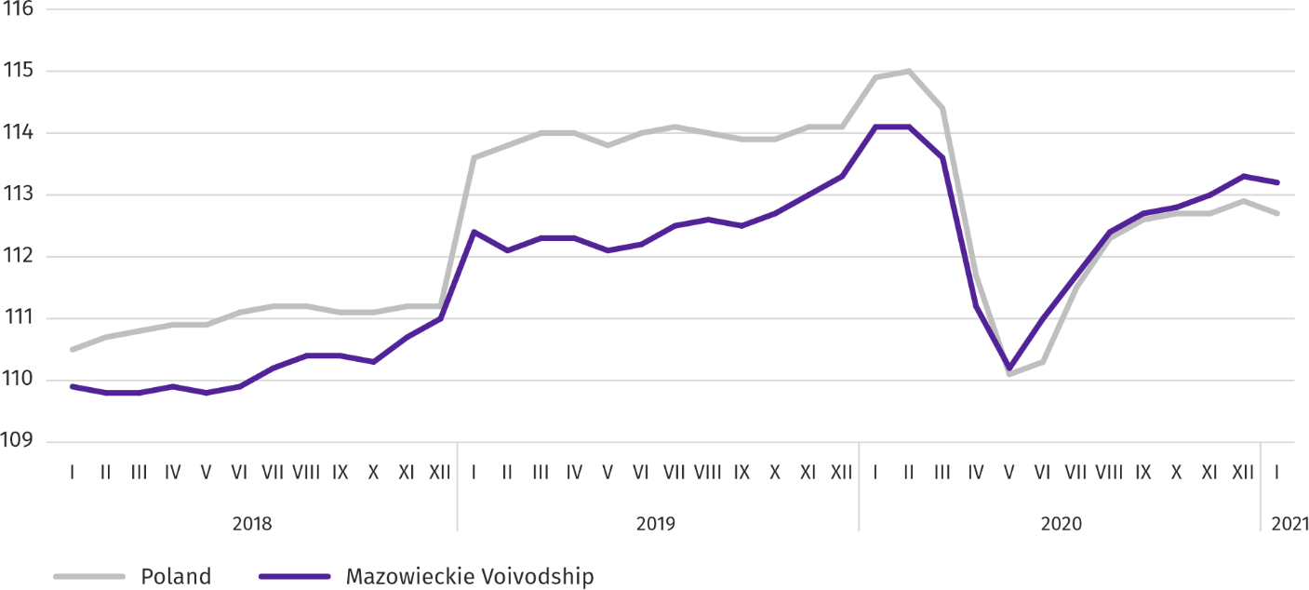
Chart 1. Average employment in the enterprise sector (monthly average 2015=100)

At the end of January this year, the number of unemployed persons registered in labour offices amounted to 151.1 thousand persons and increased on a monthly basis by 4.8 thousand persons (i.e. by 3.3%), and compared to January 2020 by 21.0 thousand persons (i.e. by 16.2%). Women accounted for 50.5% of total registered unemployed persons (a year before 51.0%).
Table 2. Number of unemployed persons and unemployment rate
SPECIFICATION | 2020 |  | 2021
 | 01 | 12 | 01
Registered unemployed persons (as of end of month) in thousands | 130,1 | 146,4 | 151,1
Newly registered unemployed persons (during a month) in thousands | 18,7 | 12,9 | 13,8
Unemployed persons removed from unemployment rolls (during a month) in thousands | 11,8 | 10,7 | 9,0
Registered unemployment rate (as of end of month) in % | 4,6 | 5,2 | 5,3
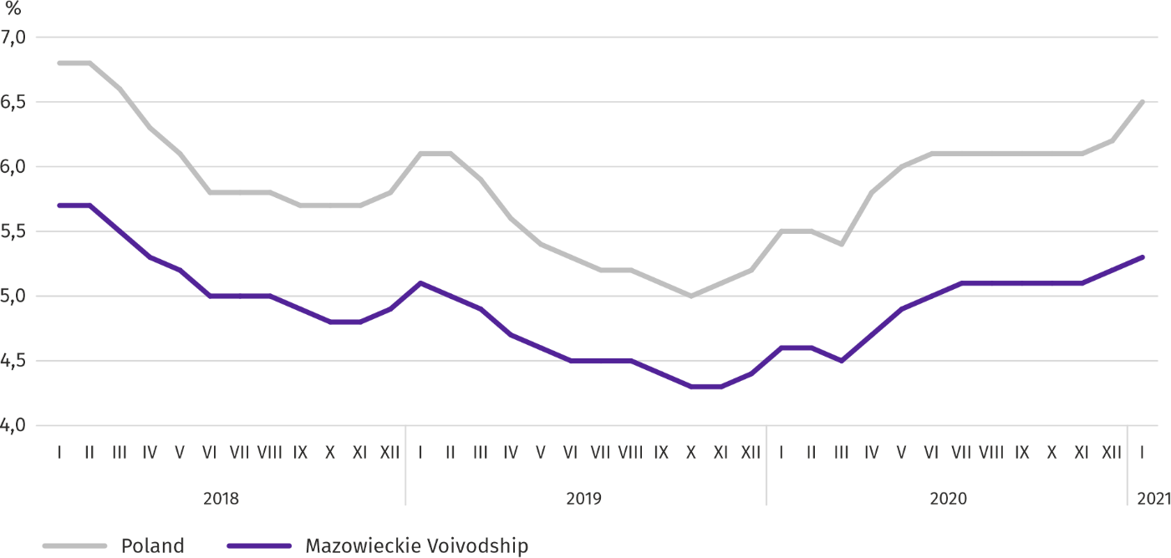
Chart 2. Registered unemployment rate (as of end of month)
Registered unemployment rate at the end of January this year amounted to 5.3% and was lower than the national average (6.5%). It increased by 0.7 pp on a yearly basis, and by 0.1 pp on a monthly basis.
The territorial differentiation of the unemployment rate continued in the voivodship. Powiats with the highest unemployment rate were szydłowiecki (25.3% compared to 24.2% in January 2020), radomski (18.1% compared to 17.1%), przysuski (17.3% compared to 18.2%), and with the lowest – m.st. Warszawa (1.9% compared to 1.3%), warszawski zachodni (2.4% compared to 1.7%) and grójecki (2.7% compared to 2.2%).
Compared to January 2020, the unemployment rate increased in 40 out of 42 powiats. The highest increase was recorded in the powiats: legionowski (by 1.9 pp), wołomiński (by 1.8 pp) and miński (by 1.7 pp). The decrease took place in przysuski (by 0.9 pp) and żuromiński powiat (by 0.3 pp).
Compared to December 2020, the unemployment rate increase by 0.1–1.0 pp took place in 39 powiats. There were no changes in 3 powiats.
Map 1. Registered unemployment rate by powiats in 2021 (as of end of January)
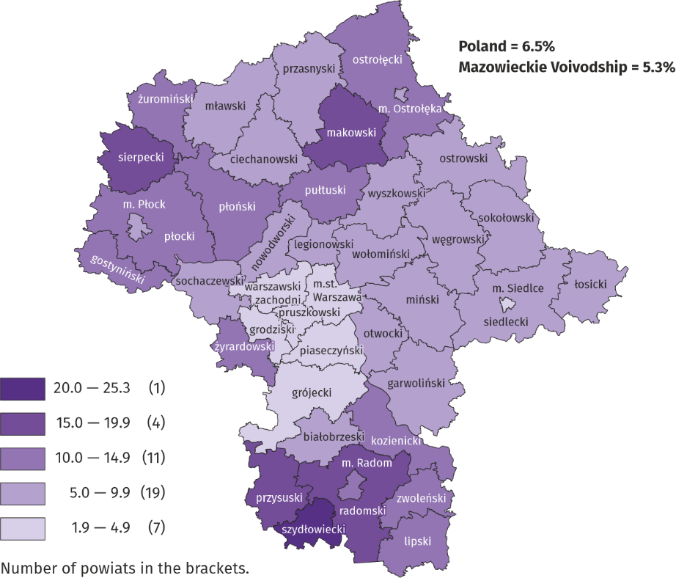

In January this year, 13.8 thousand unemployed persons were registered in labour offices, i.e. more by 6.7% than a month before and less by 26.5% than a year before. Among the newly registered, 76.2% were persons registered once again (81.4% a year before). The share of persons previously not employed amounted to 11.1% (a decrease by 0.8 pp on a yearly basis), persons terminated due to company reasons 5.9% (a 1.3 pp increase). Out of newly registered unemployed persons, 43.0% were rural residents (a decrease by 1.6 pp). Graduates accounted for 7.0% of newly registered unemployed persons (a 0.7 pp increase).
In January this year, 9.0 thousand persons were removed from unemployment rolls, i.e. less by 15.5% than a month before and by 23.9% less than a year before. 5.9 thousand persons (6.2 thousand a year before) were removed from unemployment rolls due to undertaking employment. The share of this category of persons in the total number of persons removed from unemployment rolls increased by 12.8 pp on a yearly basis and amounted to 65.6%. The percentage of persons who started training or traineeship with employer increased as well (by 0.8 pp to 2.1%) and persons who obtained retirement or pension rights (by 0.4 pp to 0.8%). However, there was a decrease in the percentage of persons who lost their status of the unemployed as a result of not confirming readiness to take up work (by 12.5 pp to 9.3%), and persons who voluntarily gave up their status of the unemployed (by 4.1 pp to 4.5%).
At the end of January this year, 126.0 thousand unemployed persons were not entitled to the unemployment benefit, and their share in the total number of the registered unemployed was 83.4% (a 0.7 pp increase in annual terms).
At the end of the surveyed month, 79.6 thousand, i.e. 52.7% out of registered unemployed persons were the long-term unemployed. The number of unemployed persons under the age of 30 amounted to 36.8 thousand, which accounted for 24.3% of the total unemployed (of which persons under the age of 25 constituted 11.6%). Persons aged over 50 amounted to 39.3 thousand (26.0%). 0.8 thousand of unemployed persons, i.e. 0.5% of their total number received social assistance benefits. There were 23.5 thousand persons (i.e. 15.6% of the total unemployed) had at least one child under the age of 6, and persons with a disabled child aged under 18 – 270 persons (0.2% respectively). The number of disabled unemployed persons amounted to 6.3 thousand (i.e. 4.2%).
Chart 3. Registered unemployed persons per job offer (as of end of month)
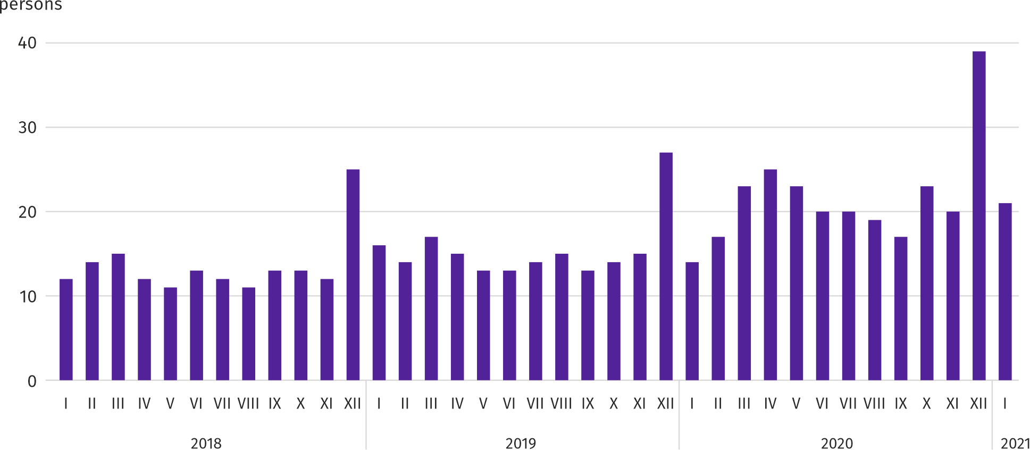

In January this year, 13.7 thousand job offers, i.e. more than a month before (by 24.7%) and less than a year before (by 14.5%) were submitted to labour offices. At the end of month, there were 21 unemployed persons (14 in the previous year) per job offer.
According to the labour offices, as of the end of January this year, 60 companies announced termination of 13.3 thousand employees in the near future (a year before, respectively 35 companies – 7.0 thousand employees).
Wages and salaries
In January this year, the average monthly gross wages and salaries in the enterprise sector increased on a yearly and decreased on a monthly basis.
Average monthly gross wages and salaries in the enterprise sector in January this year amounted to PLN 6570.77 and were by 4.5% higher than a year before (in the previous month the increase was 4.7%). Average wages and salaries increased the most in electricity, gas, steam and air conditioning supply (by 12.2%), and also in information and communication (by 6.8%) and professional, scientific and technical activities (by 6.7%). A decrease was recorded only in accommodation and catering (by 6.7%).
In comparison with December 2020, average wages and salaries increased by 1.9%. The largest decrease was recorded in real estate activities (by 17.6%), and also in construction (by 7.4%) and manufacturing (by 4.9%). The decrease occurred in administrative and support service activities (by 8.8%), information and communication (by 4.0%) and accommodation and catering (by 0.2%).

Chart 4. Relative deviations of average monthly gross wages and salaries in selected sections from average wages and salaries in the enterprise sector in January 2021
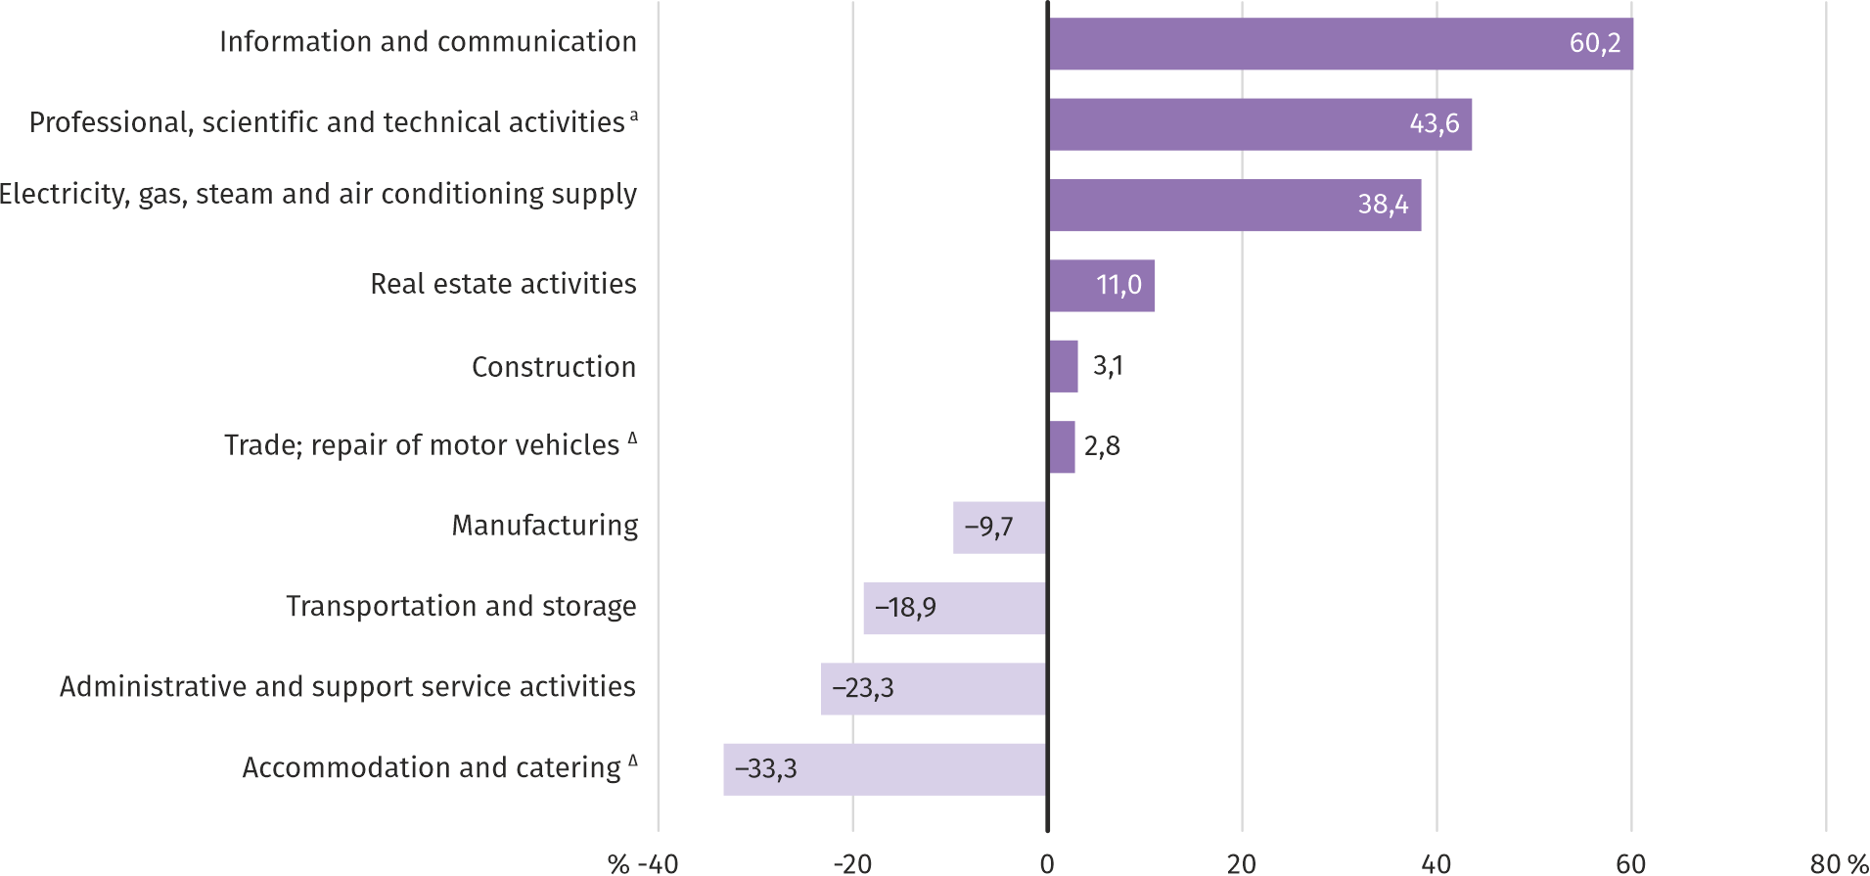
a Excluding divisions: Research and experimental development work and Veterinary activities.
In January this year, the highest average monthly gross wages and salaries were noted in the information and communication section – it exceeded the average wages and salaries in the enterprise sector in the voivodship by 60.2%.
Table 3. Average monthly gross wages and salaries in the enterprise sector in January 2021
SPECIFICATION | 01 2021
 | In PLN | 01 2020=100
TOTAL | 6570,77 | 104,5
of which:
Industry | 6143,05 | 105,0
of which:
manufacturing | 5931,85 | 104,1
electricity, gas, steam and air conditioning supply | 9093,12 | 112,2
Construction | 6773,77 | 106,3
Trade; repair of motor vehicles ^{Δ} | 6754,24 | 104,5
Transportation and storage | 5329,36 | 102,1
Accommodation and catering ^{Δ} | 4380,55 | 93,3
Information and communication | 10527,63 | 106,8
Real estate activities | 7296,81 | 101,8
Professional, scientific and technical activities ª | 9433,31 | 106,7
Administrative and support service activities | 5040,25 | 106,1
a Excluding divisions: Research and experimental development work and Veterinary activities.

Chart 5. Average monthly gross wages and salaries in the enterprise sector (monthly average 2015=100)
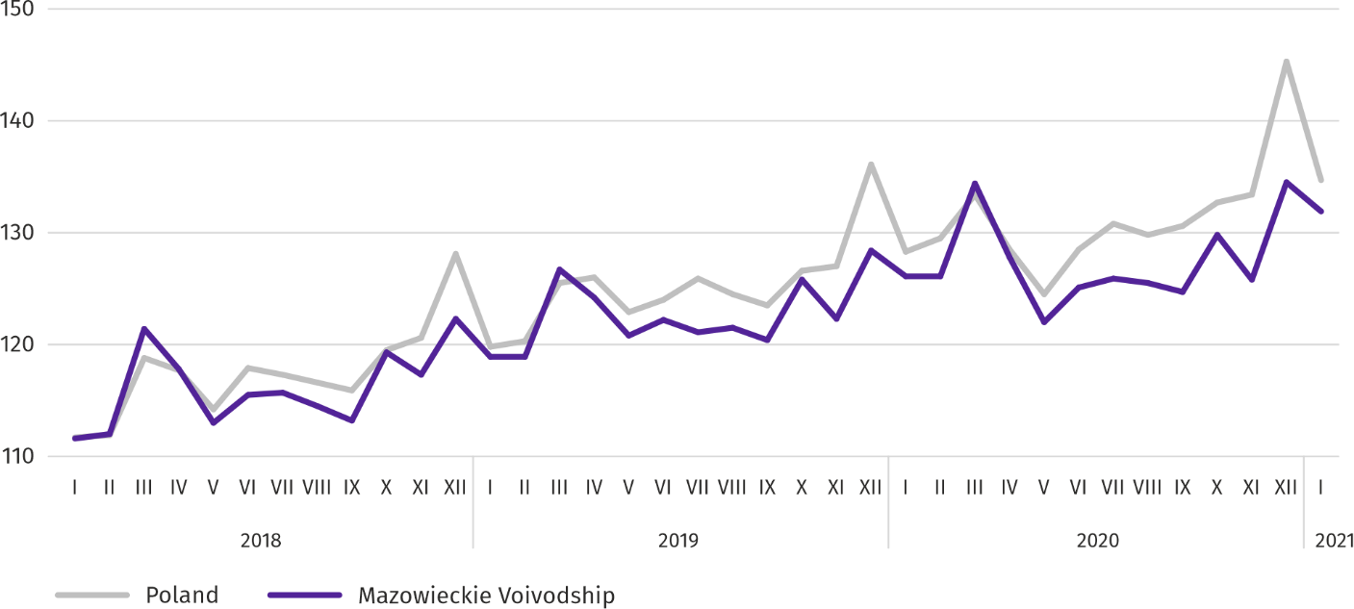

Agriculture
On the agricultural market in January 2021, the average procurement prices of wheat, rye, pigs for slaughter and milk were higher than in the previous year. On the other hand, the prices of potatoes, cattle and poultry for slaughter were lower. On a monthly basis, more was paid for plant products as well as pigs and poultry for slaughter, less for cattle for slaughter and milk.

Due to the current decision to close marketplaces due to the COVID-19 disease threat, January 2021 was another month in which it was not possible to collect data on the prices of agricultural products at marketplaces.
The average air temperature in Mazowieckie Voivodship in January 2021 amounted to -1.7°C and was by 0.1°C higher from the average from the years 1981–2010, while the maximum temperature reached 8.7°C (in Kozienice), and the minimum amounted to -24.0°C (in Siedlce). The average atmospheric precipitation (36.9 mm) accounted for 117.6% of the standard for the multi-year periods (ranging from 73% in Płock to 149% in Kozienice and Siedlce) . The number of days with precipitation, depending on the region, ranged from 14 to 22.
Table 4. Procurement of cereals ª
SPECIFICATION | 07 2020–I 2021 |  | 01 2021
 | in thousand tonnes | corresponding  period of the previous year=100 | in thousand tonnes | 01 2020=100 | 12 2020=100
Grain of basic cereals ^{b} | 362,9 | 130,1 | 34,8 | 95,1 | 92,6
of which:
wheat | 241,2 | 127,4 | 26,6 | 89,5 | 104,7
rye | 55,7 | 110,4 | 2,1 | 90,0 | 36,4
a Excluding procurement realized by natural persons. b Including: wheat, rye, barley, oat, triticale; including cereal mixed, excluding sowing seed.

Deliveries of basic cereals (including cereal mixed, excluding sowing seed) to procurement from last year’s harvest in July 2020-January 2021 were by 30.1% larger than in the corresponding period of previous year. In January 2021, procurement of cereals was smaller than in the previous year by 4.9%, and compared to December 2020 by 7.4%.
Table 5. Procurement of basic animal products ª
SPECIFICATION | 01 2021
 | in thousand tonnes | 01 2020=100 | 12 2020=100
Animals for slaughter ^{b} | 87,4 | 107,5 | 103,6
of which:
cattle (including calves) | 3,0 | 125,4 | 100,8
pigs | 23,6 | 140,8 | 96,2
poultry | 60,7 | 97,9 | 106,9
Milk ^{c} | 218,2 | 99,5 | 102,9
a Excluding procurement by natural persons. b Including cattle, calves, pigs, sheep, horses and poultry; in terms of meat including fats in post-slaughter warm weight. c In million litres.

Deliveries of animals for slaughter to procurement (in post-slaughter warm weight) in January this year, as a result of much greater supply of pigs and cattle for slaughter, were by 7.5% higher than in the previous year. The increase in procurement in monthly terms (by 3.6%) resulted from higher deliveries of pigs for slaughter.
Deliveries of milk to procurement in January this year (218.2 million litres) were by 0.5% smaller than in the previous year and by 2.9 larger than in the previous month.
Table 6. Average prices of basic agricultural products
SPECIFICATION | 01 2021
 | PLN | 01 2020=100 | 12 2020=100
Wheat ª per dt | 89,58 | 125,6 | 106,9
Rye ª per dt | 59,05 | 114,2 | 102,4
Potatoes per dt | 52,58 | 46,9 | 107,5
Animals for slaughter per kg of live weight:
cattle (excluding calves) | 6,13 | 92,0 | 93,5
pigs | 4,06 | 67,0 | 100,2
poultry | 3,44 | 100,1 | 106,2
Milk per 1 hl | 145,71 | 106,4 | 96,9
a Excluding sowing seed.

In January this year, average procurement prices of wheat and rye were higher both on a yearly and on a monthly basis.

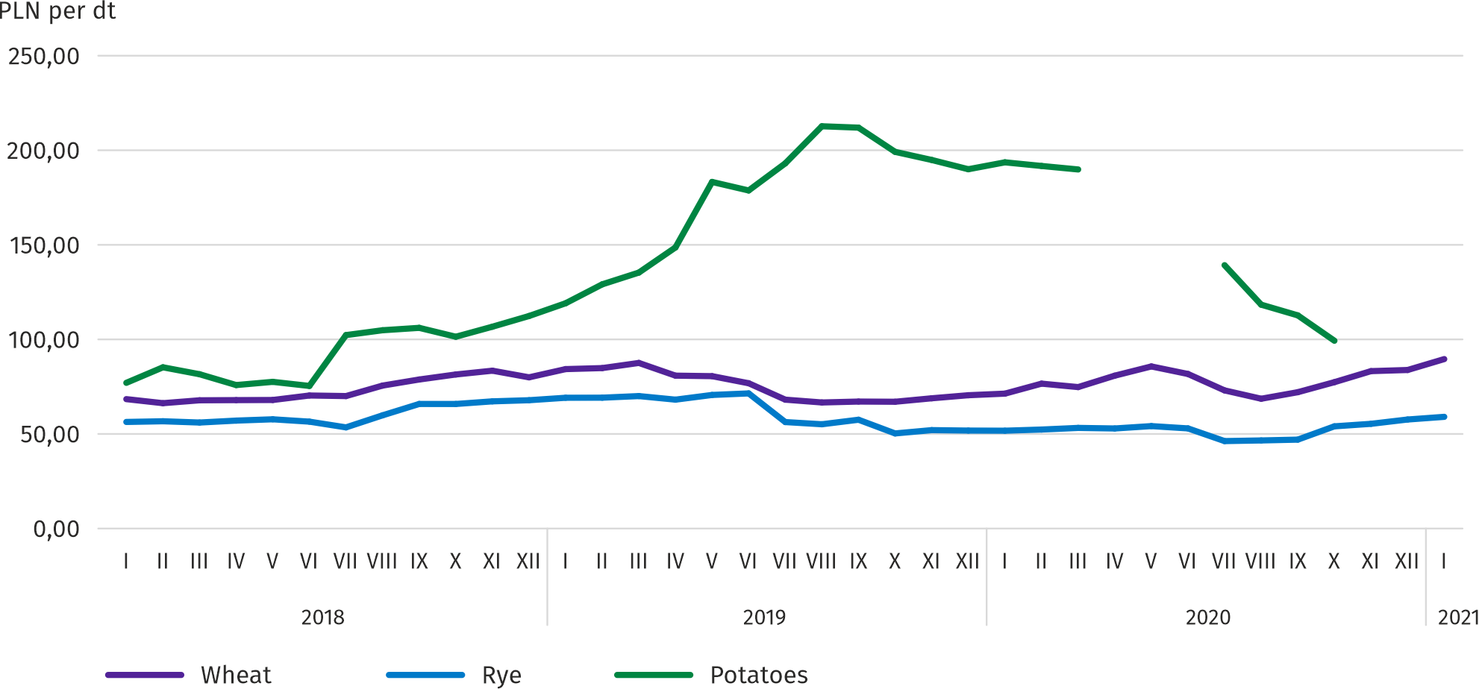
Chart 6. Average marketplace prices of cereals and potatoes

In January 2021, the average procurement price of potatoes was 52.58 PLN/dt, i.e. by 7.5% more than in the previous month and by 53.1% less than in the previous year.
Chart 7. Average procurement prices of animals for slaughter and milk
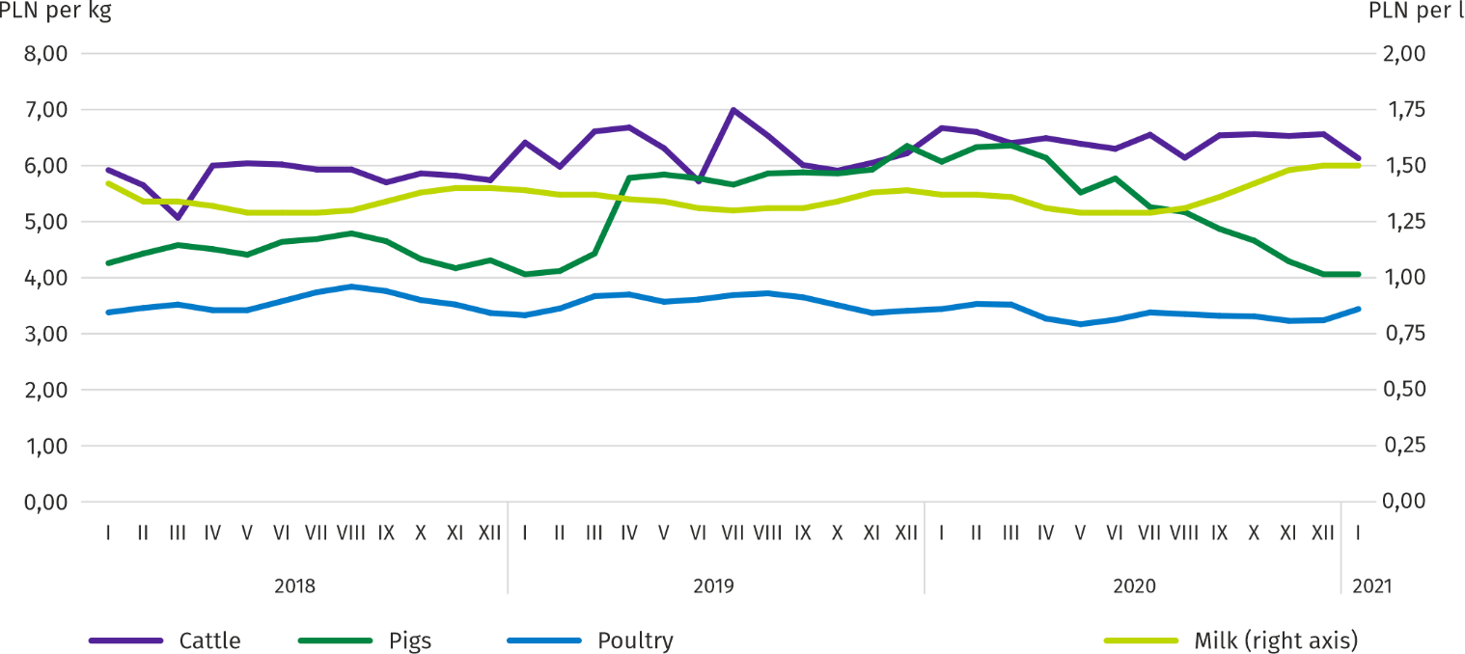

In January this year, the average procurement price of pigs for slaughter was by 33.0% lower than in the previous year, while on a monthly basis higher by 0.2%.

Chart 8. Ratio of average procurement prices of pigs for slaughter to average marketplace prices of rye
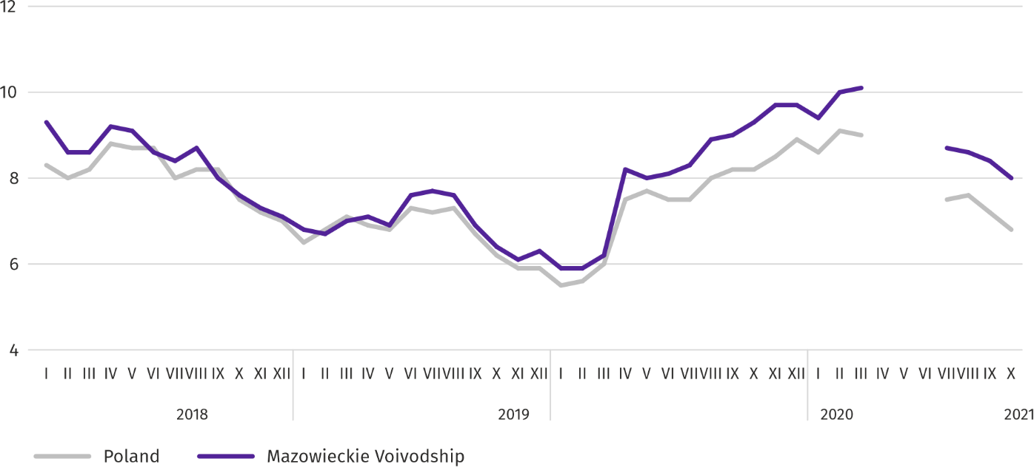

Table 7. Population of pigs in December 2020
SPECIFICATION | In heads | In percent | 12 2019=100
TOTAL ª | 1315715 | 100,0 | 105,6
Piglets weighing less than 20 kg | 146917 | 11,2 | 101,2
Pigs weighing from 20 kg to 50 kg | 424593 | 32,3 | 98,4
Pigs weighing 50 kg and more:
for slaughter | 680140 | 51,7 | 110,4
for breeding | 64065 | 4,9 | 119,9
of which sows | 62754 | 4,8 | 120,3
of which mated | 43164 | 3,3 | 113,9
a Preliminary data.

According to preliminary data, the pig population in December 2020 was 1,315.7 thousand heads and compared to December 2019 increased by 69.9 thousand heads (by 5.6%). The population increase was the result of an increase in the number of pigs for slaughter weighing 50 kg (by 10.4%) and pigs for breeding weighing 50 kg and more (by 19.9%). The share of Mazowieckie Voivodship in the total domestic pig population was 11.2%.

Chart 9. Population of pigs for slaughter
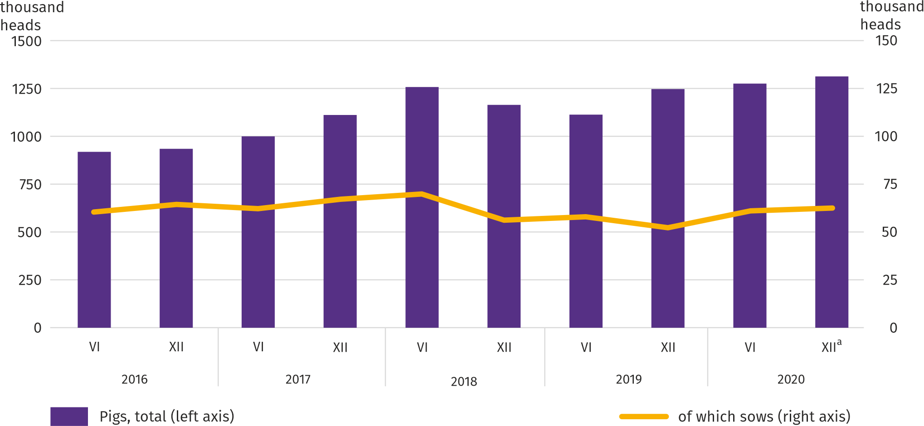

a Preliminary data.

In January 2021, the average procurement price of cattle for slaughter was by 6.5% lower than in the previous year and by 8.0% lower than in the previous year.
Table 8. Population of cattle in December 2020
SPECIFICATION | In heads | In percent | 12 2019=100
TOTAL ª | 1143119 | 100,0 | 98,3
Calves less than 1 year old | 285266 | 25,0 | 99,3
Young cattle between 1 and 2 years | 301874 | 26,4 | 104,1
Cattle over the age of 2 years | 555979 | 48,6 | 94,9
of which cows | 506600 | 44,3 | 97,6
of which dairy | 483430 | 42,3 | 96,4
a Preliminary data.

In December 2020, the total cattle population amounted to 1143.1 thousand heads and was lower by 20.3 thousand heads (by 1.7%) than in December 2019. The relatively largest decrease (by 5.1%) concerned the herd of 2-year-old and older cattle. The share of Mazowieckie Voivodship in the total cattle population amounted to 18.2%.

Chart 10. Population of cattle
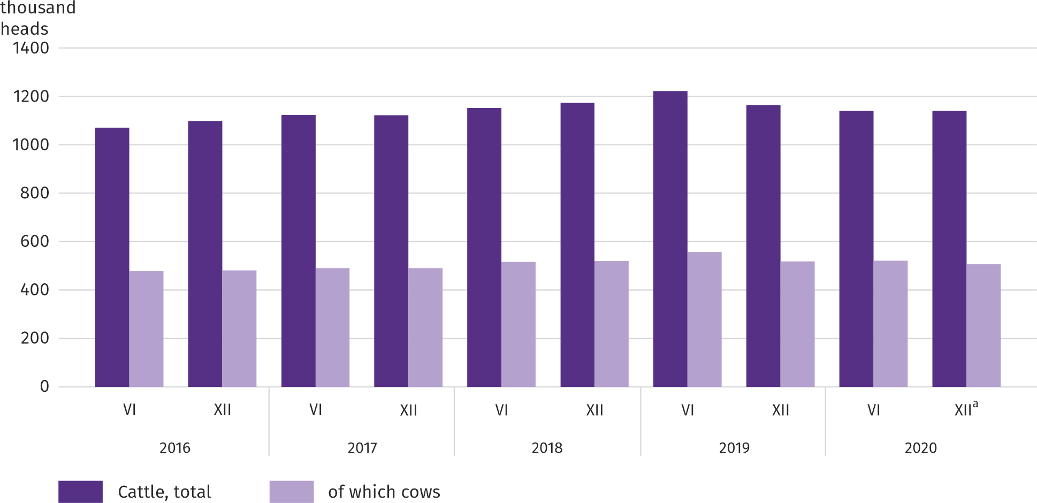
a Preliminary data.

In January 2021, an average of 3.44 PLN was paid per 1 kg of poultry for slaughter, i.e. by 6.2% more than in December 2020, and by 0.1% more than in January last year.
Procurement prices of milk in January 2021, were by 6.4% higher than in the previous year and by 3.1% lower than in the previous month.
Industry and construction
Sold production of industry in January this year, reached the value (at current prices) of PLN 26047.9 million and was (at constant prices) by 3.0% higher than a year before (compared to a 9.9% increase in December last year); as compared to the previous month it decreased by 4.7%.
Sold production in manufacturing (constituting 78.5% of sold production of industry) compared to January last year increased (at constant prices) by 3.2%. There was also an increase (by 1.9%) in sold production in the section of electricity, gas, steam and air conditioning supply (the share of this section represents 18.9% of industrial production).
Chart 11. Sold production of industry (monthly average 2015=100; constant prices)
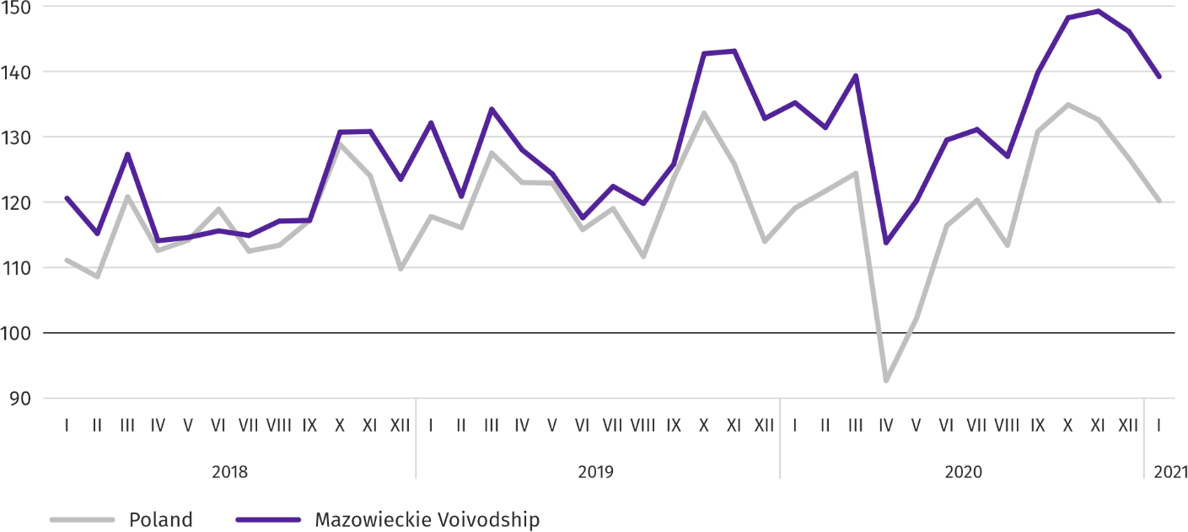

In January this year, the increase in sold production in annual terms was recorded in 17 (out of 33 in the voivodship) divisions of industry, among others, in: manufacture of machinery and equipment n.e.c. (by 30.9%), electrical equipment (by 21.3%), manufacture of computers, electronic and optical products (by 18.4%), manufacture of rubber and plastic products (by 10.2%), food products (by 4.4%). Whereas, there was a decrease, among others, in sold production of beverages (by 22.2%), other non-metallic mineral products (by 14.1%), metal products (by 5.9%), paper and paper products (by 2.8%), chemicals and chemical products (by 1.4%).
Table 9. Dynamics (constant prices) and structure (current prices) of sold production of industry in January 2021
SPECIFICATION | 01 2020=100 | In percent
TOTAL | 103,0 | 100,0
of which:
Manufacturing | 103,2 | 78,5
of which manufacture of:
food products | 104,4 | 20,5
beverages | 77,8 | 1,3
paper and paper products | 97,2 | 2,7
chemicals and chemical products | 98,6 | 5,7
manufacture of rubber and plastic products | 110,2 | 3,8
other non-metallic mineral products | 85,9 | 2,0
metal products ^{Δ} | 94,1 | 4,0
computer, electronic and optical equipment | 118,4 | 7,4
electrical equipment | 121,3 | 6,0
machinery and equipment n.e.c. | 130,9 | 2,1
Electricity, gas, steam and air conditioning supply | 101,9 | 18,9

Labour productivity in industry measured by sold production per employed person, in January this year amounted (at current prices) to PLN 67.0 thousand and was (at constant prices) by 1.8% higher than a year before, with higher by 1.1% average paid employment and the average monthly gross wages and salaries by 5.0%.
Sold production of construction (at current prices) in January this year, reached the value of PLN 3925.1 million and was by 2.8% lower than in the previous year (compared to a 5.4% increase in December last year).
Labour productivity in construction, measured by revenue from the sale of goods and services per employed person in January this year amounted to PLN 43.8 thousand (at current prices) and was by 2.5% lower compared to the corresponding month of last year, with an increase in average employment by 0.3% and in the average monthly gross wages and salaries by 6.3%.
Construction and assembly production (at current prices) in January this year, amounted to PLN 985.7 million and was by 13.0% lower than a year before (compared to a 3.3% decrease in December last year). The decrease in production was recorded in units specializing in civil engineering (by 24.5%) and in entities whose basic activity is the construction of buildings (by 14.3%). However, there was an increase in enterprises performing specialized construction activities (by 11.3%).

Table 10. Dynamics and structure (at current prices) of construction and assembly production in January 2021
SPECIFICATION | 01 2020=100 | In percent
TOTAL | 87,0 | 100,0
Construction of buildings | 85,7 | 25,4
Civil engineering | 75,5 | 42,8
Specialized construction activities | 111,3 | 31,7

Housing construction
In January this year, as compared to the corresponding month of 2020, the number of dwellings completed increased by 57.9%; there were more dwellings for which permits have been granted or which have been registered with a construction project by 5.7%, while less dwellings in which construction has begun – by 18.3%.
According to preliminary data in January this year, there were 4225 dwellings completed, i.e. by 1550 more (by 57.9%) than in the previous year and by 793 (by 15.8%) than in December 2020. Majority of dwellings were built for sale or rent – 3132 (74.1% of their total number), followed by private dwellings – 1091 (25.8%). Compared to January 2020, there were more dwellings for sale or rent by 78.8%, and private dwellings by 18.2%.
The effects of housing construction obtained in Mazowieckie Voivodship in the surveyed month constituted 24.7% of national effects.
Table 11. Number of dwellings completed in January 2021
SPECIFICATION | Dwellings completed |  |  | Average useful floor area per dwelling in m²
 | in absolute numbers | in percent | 01 2020=100
TOTAL | 4225 | 100,0 | 157,9 | 84,9
Private | 1091 | 25,8 | 118,2 | 149,1
For sale or rent | 3132 | 74,1 | 178,8 | 62,5
Municipal | 2 | 0,0 | . | 37,5

Chart 12. Dwellings completed (corresponding period 2015=100)
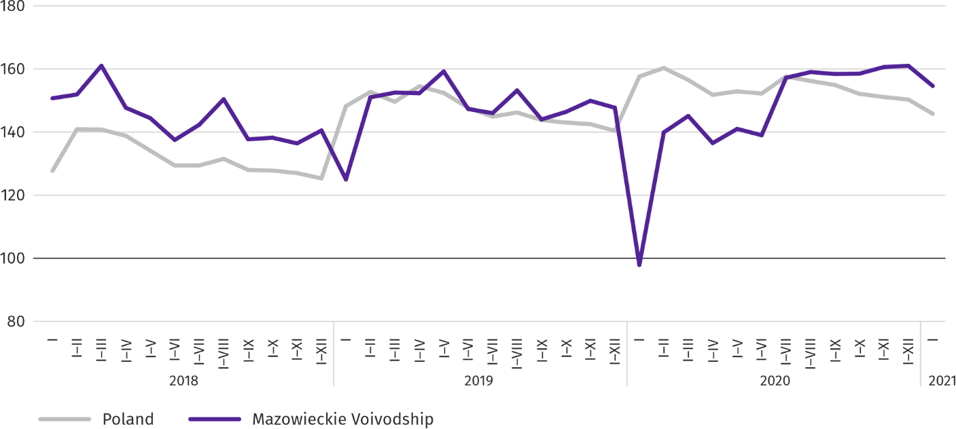

Most dwellings were completed in m.st. Warszawa (2314), followed by mławski (282) and wołomiński (222), and the least in lipski (1) as well as sierpecki powiat (2).
Map 2. Dwellings completed per 10 thousand population ª by powiats in January 2021
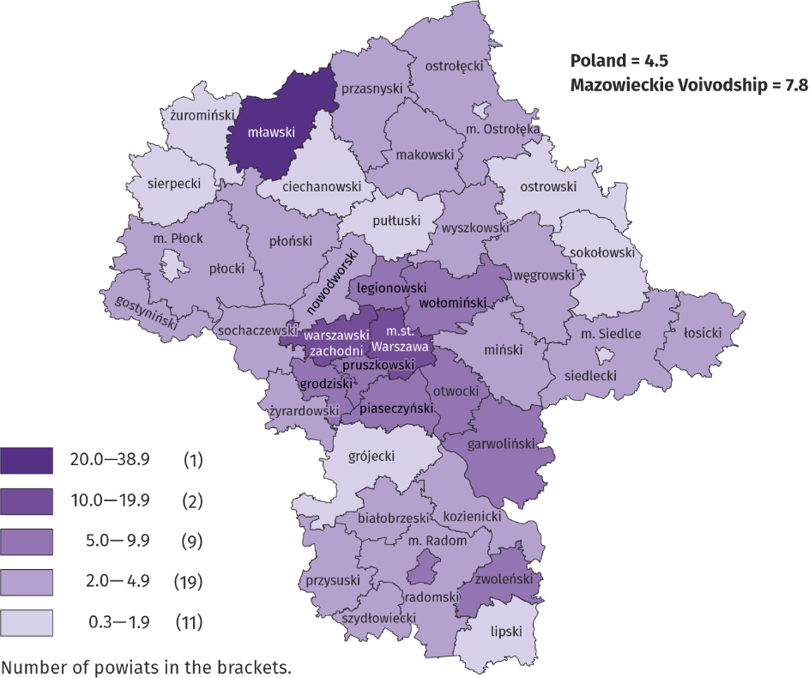

a Population as of 30 June 2020.

The average useful floor area of dwellings completed in January this year amounted to 84.9 m² and was larger than a year earlier by 13.2 m² than a year earlier. The largest dwellings were completed in Siedlce (163.6 m²) and piaseczyński (by 161.9 m²), żyrardowski (161.2 m²) and grodziski powiat (160.7 m²). The smallest were built in lipski (58.8 m²) and mławski powiat (54.7 m²).
In January this year, the number of dwellings for which permits have been granted or which have been registered with a construction project amounted to 4179, that is by 224 (by 5.7%) more than a year earlier and by 1965 (by 32.0%) smaller than in December 2020. Of the total number of dwellings, 72.5% were dwellings for sale or rent, and 27.2% private.
In the surveyed month, the construction began in 2675 dwellings, which means a decrease by 599 (by 18.3%) in annual terms and by 134 (by 5.3%) in monthly terms. Dwellings for sale or rent accounted for 74.8% of their total number, and private 22.7%.
Table 12. Number of dwellings for which permits have been granted or which have been registered with a construction project as well as dwelling in which construction has begun in January 2021
SPECIFICATION | Dwellings for which permits have been granted or which have been registered with a construction project |  |  | Dwellings in which construction has begun
 | in absolute numbers | in percent | 01 2020=100 | in absolute numbers | in percent | 01 2020=100
TOTAL | 4179 | 100,0 | 105,7 | 2675 | 100,0 | 81,7
Private | 1136 | 27,2 | 121,4 | 607 | 22,7 | 89,7
Cooperative | – | – | . | 68 | 2,5 | .
For sale or rent | 3028 | 72,5 | 100,3 | 2000 | 74,8 | 78,5
Public building society | 15 | 0,4 | . | – | – | .

Domestic market
In January this year, there was a decrease in retail sales compared to the previous year and an increase in wholesale.
Retail sales (at current prices) in trade and non-trade enterprises in January this year, decreased by 11.8% compared to the year before. The highest decrease in sales was recorded in units from the group: “textiles, clothing and footwear” (by 59.0%), “other retail sales in non-specialized stores” (by 57.2%), „pharmaceuticals, cosmetics, orthopedic equipment” (by 25.9%), “solid, liquid and gas fuels” (by 21.5%), “other” (by 14.4%), “press, books, other sales in specialized stores” (by 13.5%) and followed by “food, beverages and tobacco” (by 7.5%) and “motor vehicles, motorcycles, parts” (by 0.9%). The increase in sales was recorded in enterprises from the „furniture, electronics and household appliances” group (by 6.6%).
Compared to December 2020, retail sales decreased by 29.9%. The highest drop in sales was recorded in all groups: “textiles, clothing and footwear” (by 65.9%), “other retail sales in non-specialized stores” (by 63.5%), „pharmaceuticals, cosmetics, orthopedic equipment” (by 49.7%), “press, books, other retail sales in specialized stores” (by 45.4%), „furniture, electronics and household appliances” (by 33.9%), “food, beverages and tobacco” (by 32.7%), “other” (by 21.1%) and “motor vehicles, motorcycles, parts” and “solid, liquid and gas fuels” (a decline by 9.7% and 8.2%, respectively).

Table 13. Dynamics and structure (at current prices) of retail sales in January 2021
SPECIFICATION | 01 2020=100 | In percent
TOTAL ª | 88,2 | 100,0
of which:
Motor vehicles, motorcycles, parts | 99,1 | 9,4
Solid, liquid and gas fuels | 78,5 | 24,5
Food, beverages and tobacco | 92,5 | 17,7
Other retail sales in non-specialized stores | 42,8 | 1,2
Pharmaceuticals, cosmetics and orthopedic equipment | 74,1 | 3,1
Textiles, clothing and footwear | 41,0 | 2,5
Furniture, electronics and household appliances | 106,6 | 21,3
Press, books and other sales in specialized stores | 86,5 | 6,6
Other | 85,6 | 9,5
a The grouping of enterprises was made on the basis of the Polish Classification of Activities - PKD 2007, including the enterprise to a specific category according to the type of predominant activity, in accordance with the organizational status in the period under consideration. The recorded changes (increase/decrease) in retail sales in particular groups of activity of enterprises may also result from changes in the type of predominant economic activity and organizational changes (e.g. mergers of enterprises). This does not affect the dynamics of retail sales in general.

Wholesale (at current prices) in trade enterprises in January 2021 was by 5.4% lower as compared to the previous month, but by 10.2% higher compared to January 2020. In wholesale enterprises it was lower by 7.2% and higher by 6.4%, respectively.
Impact of COVID-19 pandemic on the activities of the enterprise sector
In January 2021, the companies most frequently signaling changes related to the COVID-19 pandemic were active in the field of accommodation and catering. The situation resulting from the pandemic most often influenced the change in the number of orders and changes in the number of employees.
In January 2021, in Mazowieckie Voivodship, 0.5% of economic entities that submitted a DG1, report indicated the COVID-19 pandemic as a factor causing significant changes in conducting economic activity (in April 2020, it was 9.4% and 9.6%, respectively). The highest percentage of units experiencing the effects of COVID-19 in December 2020, was recorded in Lubelskie Voivodship (0.7%), and the lowest in Lubuskie (0.2%).

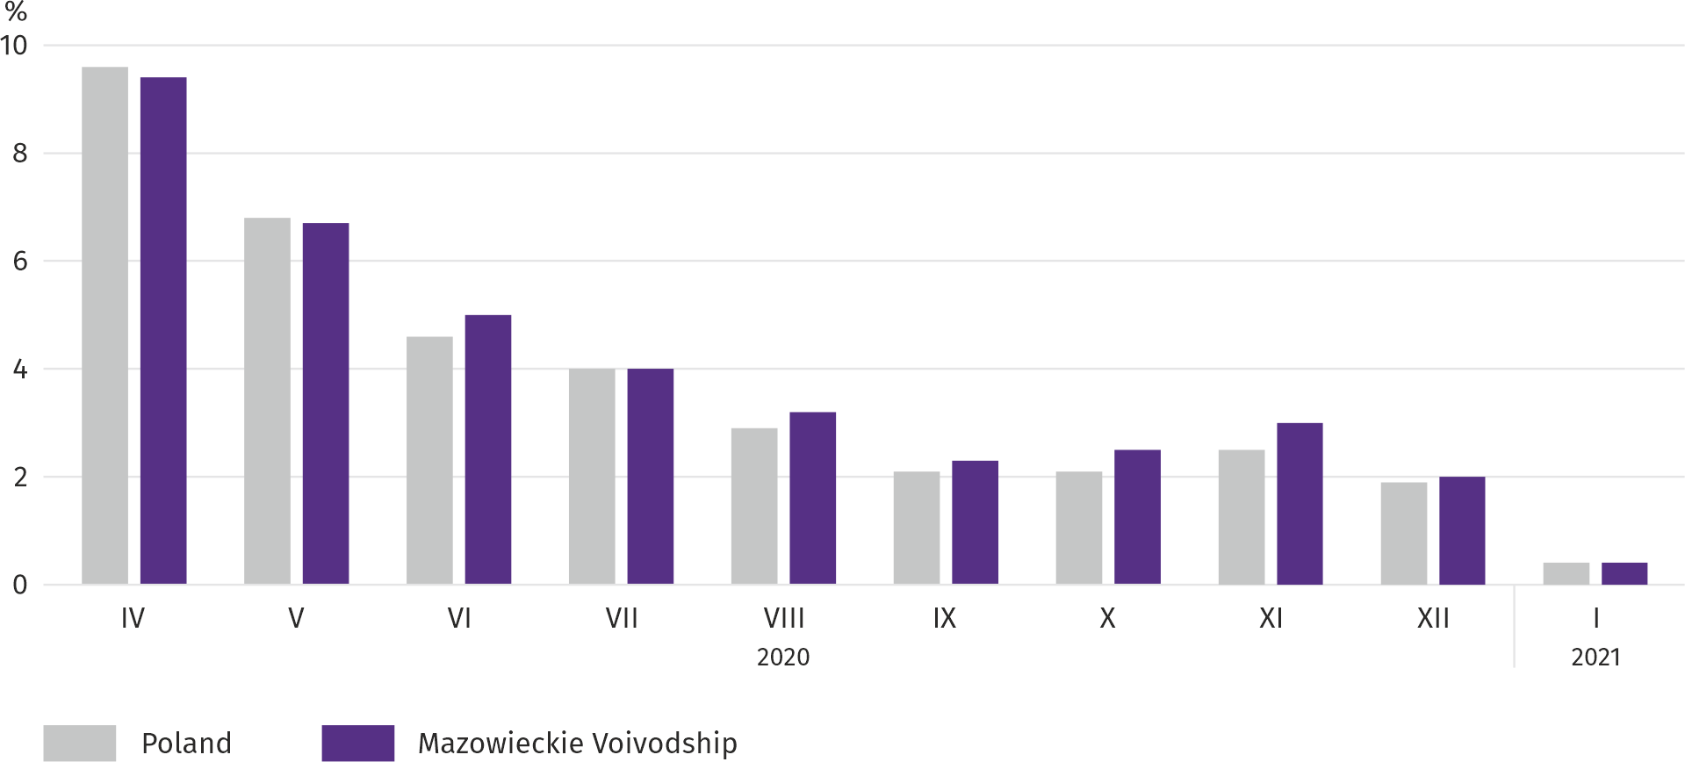
Chart 13. Percentage of units reporting changes caused by COVID-19

In January this year, both in the voivodship and in the country, the enterprises most frequently reporting changes related to the COVID-19 pandemic operated in the field of accommodation and catering (3.3%, 4.2% in the country). Also in April 2020, the most affected enterprises were enterprises operating in the section mentioned above (26.1% and 20.5%, respectively).
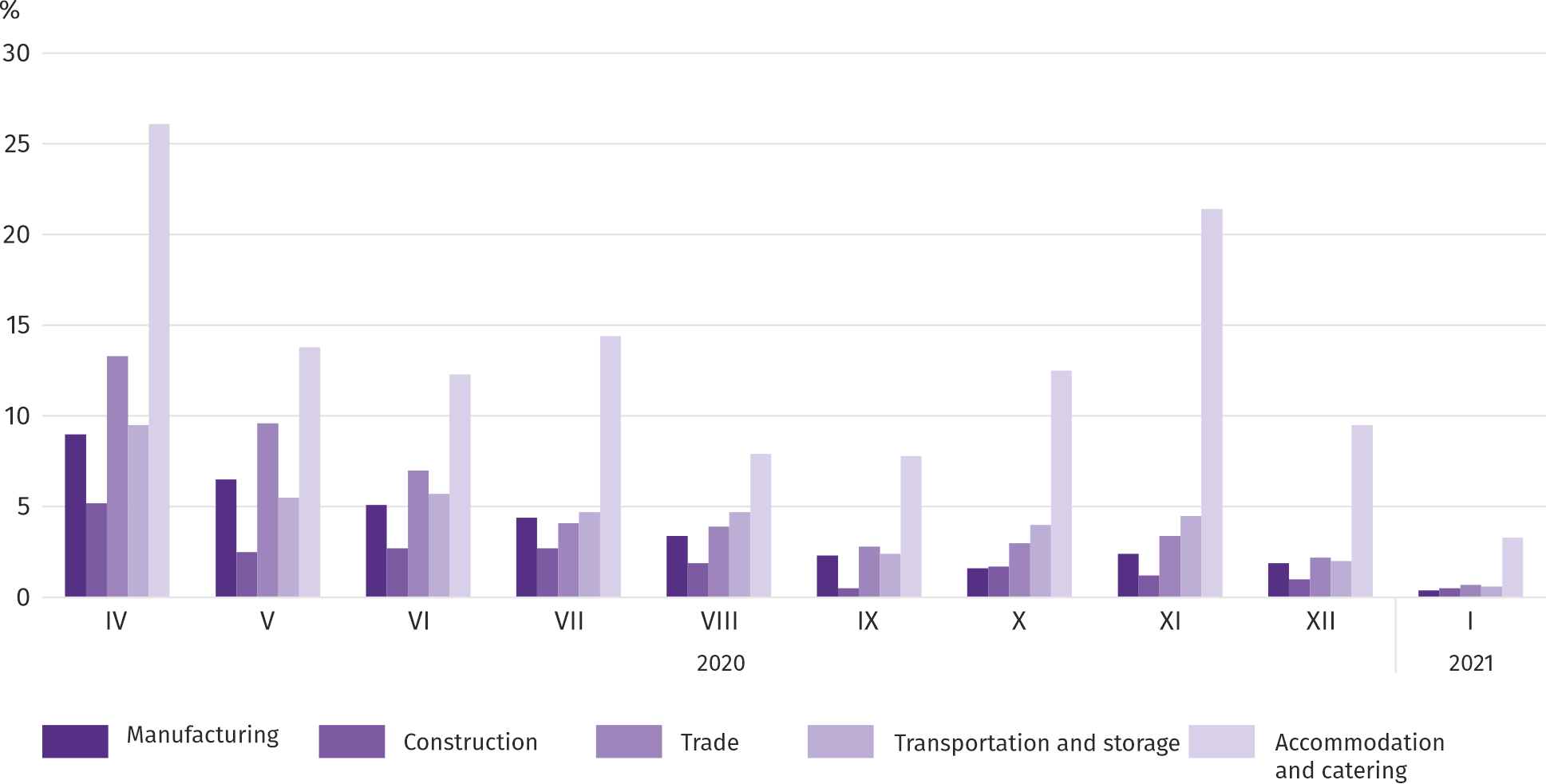
Chart 14. Units reporting changes due to COVID-19 by selected sections

The most common reason for changes in economic activity related to COVID-19 was the change in the number of orders (decrease/increase). In Mazowieckie Voivodship, a decrease in this respect in January this year was indicated by 0.4% of entities (in April last year, it was 6.4% and 6.8%, respectively). The highest percentage of entities affected by a drop in orders occurred in accommodation and catering – 2.5% in the voivodship, and 2.8% nationally.
In the second place among the factors determining the activity and results of enterprises are changes in the number of employees. In January this year, both in the voivodship and in the country they were indicated by 0.1% of units (in April 2020, by 2.1% and 2.2%, respectively). Less noticeable effects of the COVID-19 pandemic are layoffs (0.3%) and employees staying in the so-called stopover (0.02%); nationally by 0.04, respectively.
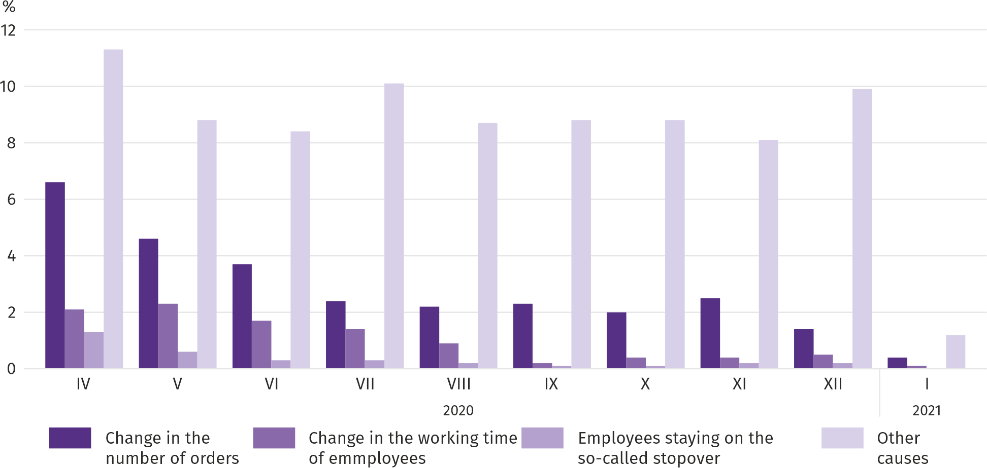
Chart 15. Reasons ª for changes in economic activity due to COVID-19

a Respondents could indicate many reasons at the same time.

In January this year, in the voivodship, the COVID-19 pandemic was indicated by 0.02% of entities as the reason for taking into account corrective invoices, problems with supply from suppliers and payment gridlocks. There were no cases of the separation of the enterprise (or its part), problems with supplies from suppliers and cancellation of previously issued invoices. In general, a pandemic as a cause of changes in conducting economic activity was indicated by 1.2% of enterprises, without specifying any specific reason.

Entities of the national economy
In January this year, compared to the previous month, the number of entities of the national economy increased by 0.2%. On a monthly basis, there were more entities that were removed from the REGON register, entities that suspended their activities as well as new entities registered in the register (by 30.3%, 2.9% and by 1.7%, respectively).
As at the end of January this year, 889125 entities of the national economy were registered in the REGON register, i.e. by 3.9% more than last year and by 0.2% more than in the previous month.
In the total number of registered entities 580219 accounted for natural persons conducting economic activity, which means an increase compared to January 2020 by 3.6%. The number of companies which were registered in the REGON register amounted to 241799, including 182507 commercial companies and 58882 civil partnerships (annual increase by 4.9%, 6.4% and 0.5%, respectively).
According to the expected number of employees, entities that declared employment of up to 9 persons prevailed upon entry in the REGON register; they constituted 96.7% of all registered units. The share of entities with an estimated number of 10-49 employed persons was 2.7%, and of entities employing more than 49 persons – 0.7%. During the year, the number of entities increased only among units declaring employment up to 9 persons (by 4.0%).
Compared to January 2020, the largest increase in the number of entities was recorded in the sections: electricity, gas, steam and air conditioning supply (by 21.8%), information and communication (by 8.1%) and administrative and supporting service activities (by 7.2%).
Compared to December 2020, the number of entities increased, among others, in the sections: electricity, gas, steam and air conditioning supply (by 1.0%), information and communication (by 0.8%), accommodation and catering, administrative and support service activities and health care (by 0.5% each).
In January this year, 5618 new entities were entered in the REGON register, i.e. by 1.7% more than in the previous month. The newly registered units were dominated by natural persons conducting economic activity, 4165 of whom were registered (by 11.0% more than in Decxember 2020). The number of newly registered commercial companies was lower by 16.4%, including companies with limited liability – by 15.5%.
In January this year, 3737 entities were removed from the REGON register (by 30.3% more than a month ago), including 2895 natural persons conducting economic activity (by 16.7% less).
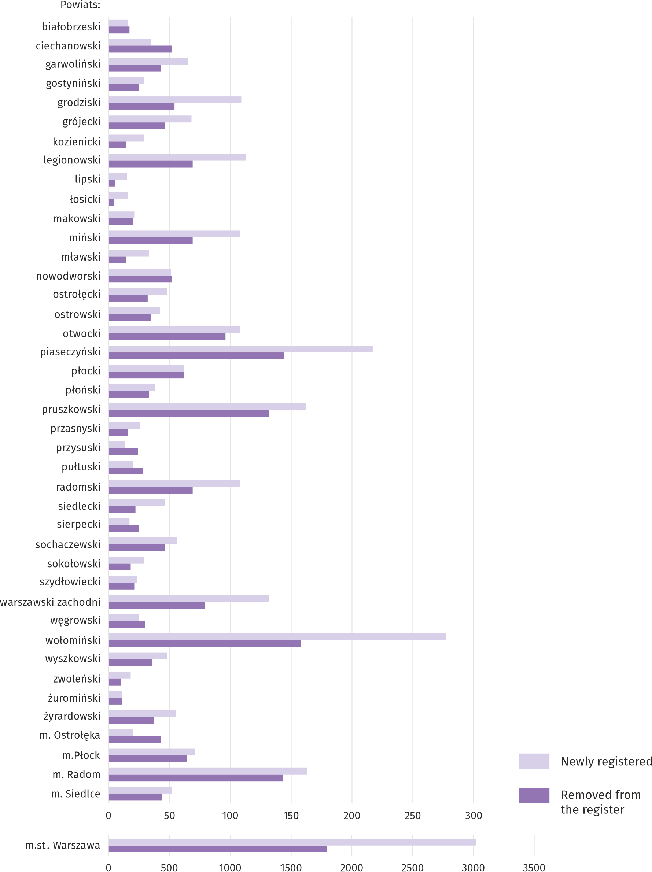
Chart 16. Entities of the national economy newly registered and removed from the register in January 2021

As of the end of January 2021, in the REGON register 92915 entities had suspended activity (by 2.9% more than a month before). The vast majority were natural persons conducting economic activity (90.7%, compared to 90.6% in December 2020).

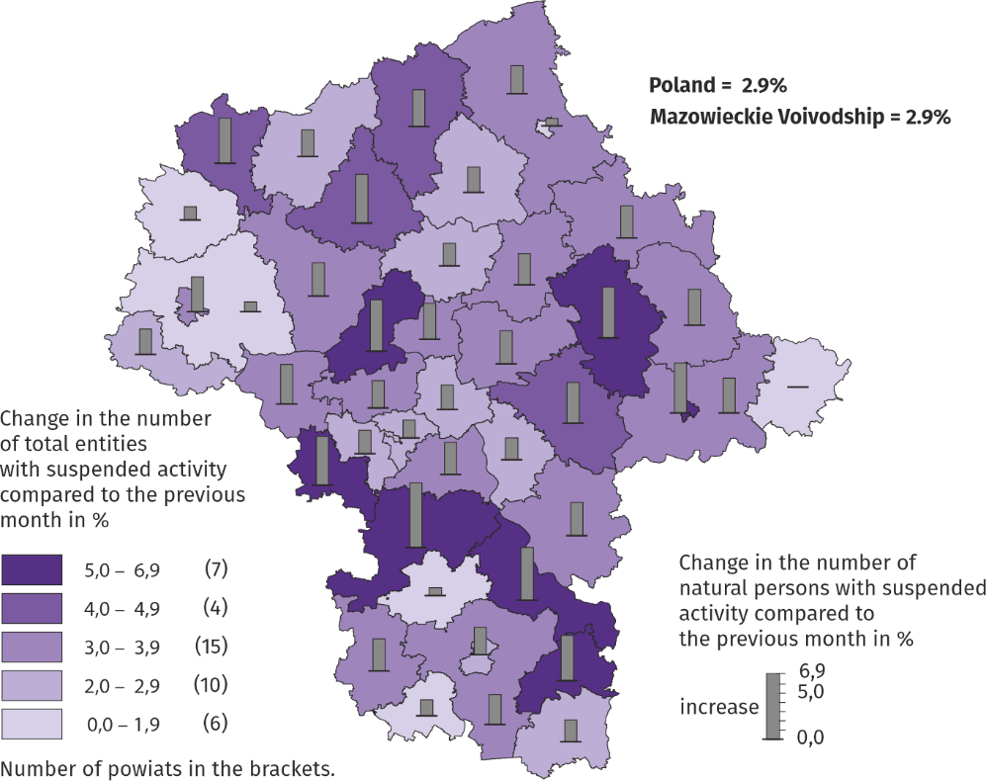
Map 3. Entities of the national economy with suspended activity in January 2021
Business tendency
Entrepreneurs in most surveyed areas in February this year, assess the economic situation less pessimistic than in January 2021. The exceptions are the sections of information and communication and manufacturing, where the ratings are similar to a month ago and construction, where the ratings deteriorated.
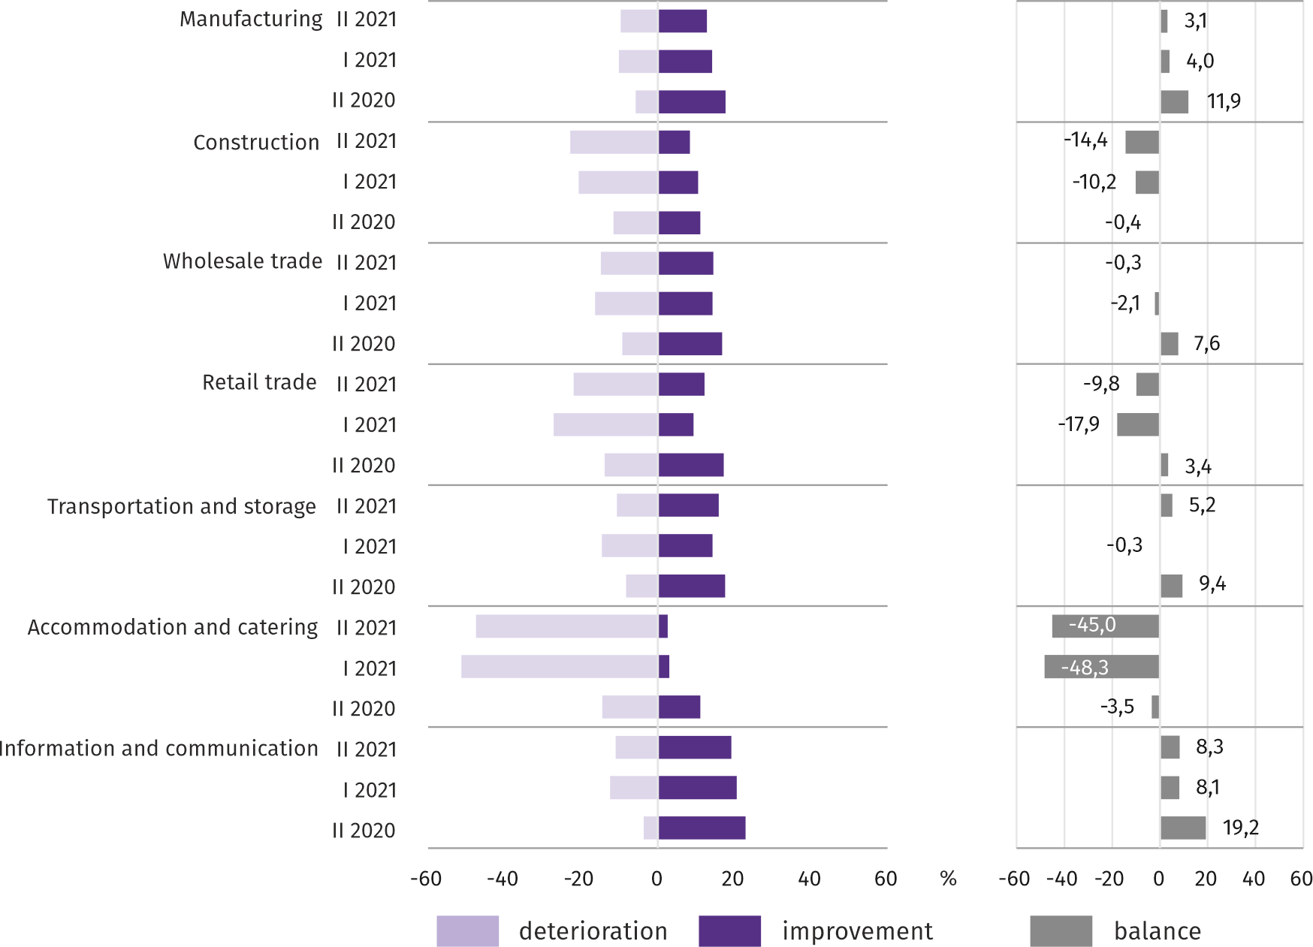
Chart 17. Indices of the general business climate by type of activity (sections and divisions of NACE Rev.2)

Survey results on the impact of the SARS-CoV-2 coronavirus pandemic on the economic situation
Entrepreneurs operating in all surveyed types of activity most often believed that the coronavirus pandemic in February 2021 would have slight negative consequences for their business. The largest percentage of responses indicating that the negative impact of the pandemic will be serious was in construction.
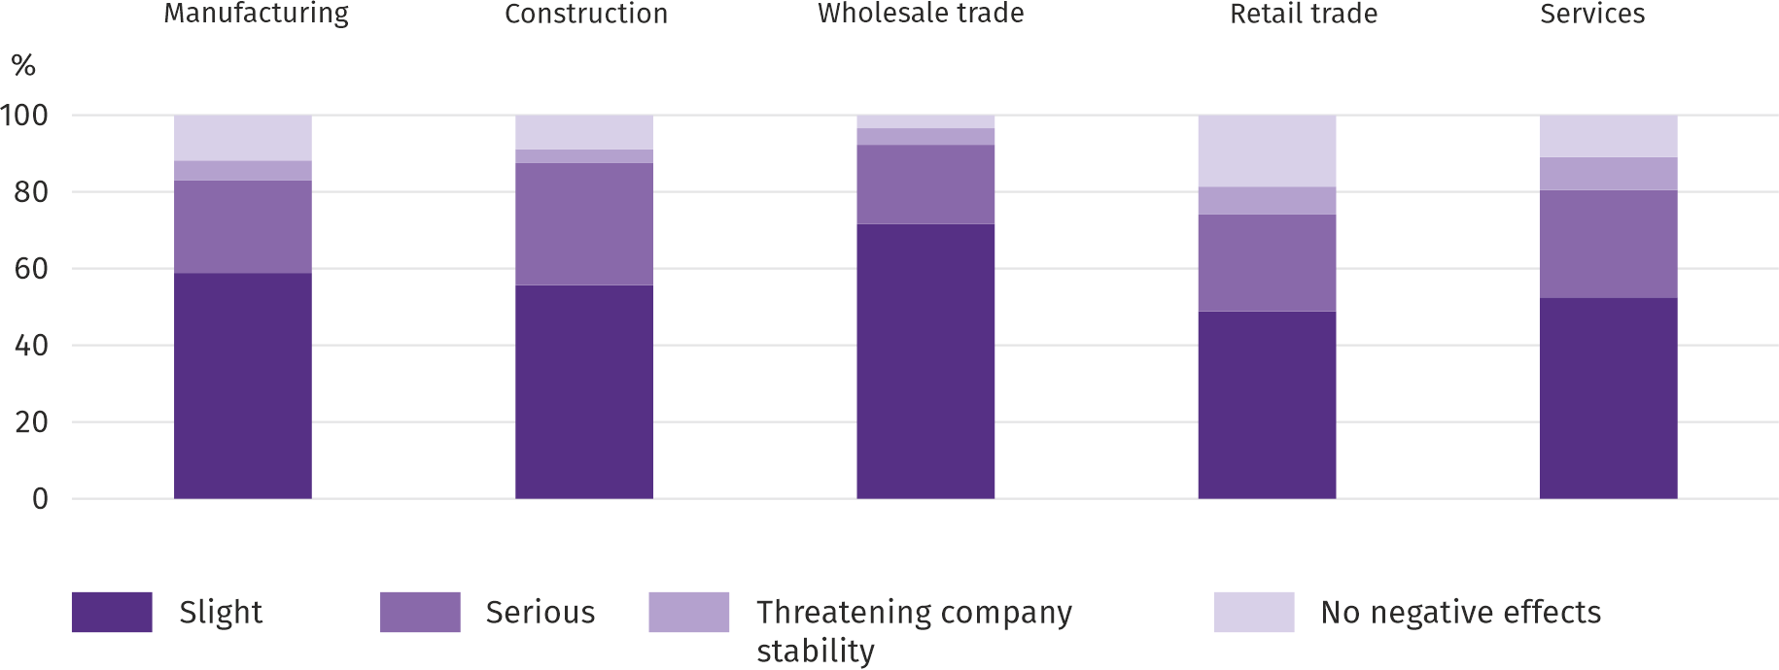
Q1. The negative effects of the "coronavirus" pandemic and its consequences for your business operations will be in the current month:

Remote work or similar forms of work concerned companies operating in services to the greatest extent. The shortage of employees due to quarantine or other restrictions was most severely affected by construction and retail companies.

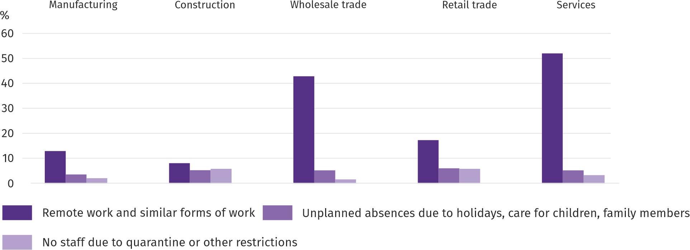
Q2. Please give an estimate of what percentage of your company's employees (regardless of the type of contract: employment, civil law, self-employed workers, interns, agents, etc.) will cover each of the following situations in the current month:

Managers in all business areas predicted a decline in customer orders. The largest reduction in orders was expected by entrepreneurs operating in services.

Q3. What will be the estimated (in percent) change in orders for semi-finished products, raw materials, goods or services etc. placed with your company by your customers this month?
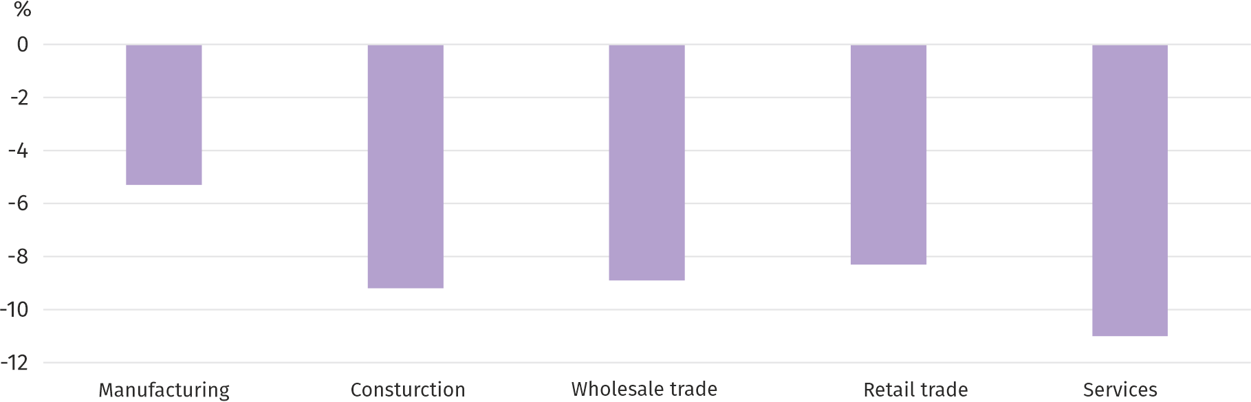
Regardless of the reason for the change and compared to what would happen if there were no pandemic:

When assessing the company's ability to survive while maintaining the current actions and limitations taken to combat the coronavirus by the state authorities in Poland (but also resulting from the actions of other countries, e.g. in the field of border traffic), the largest number of entrepreneurs, regardless of the type of activity conducted, concluded that the company would have survived for more than 6 months.

Q4. If the current actions and restrictions taken to combat the coronavirus by the state authorities in Poland (but also resulting from the actions of other countries, e.g. in the field of border traffic) functioning at the time of filling in the survey would last for a longer period, how many months does your enterprise would be able to survive?
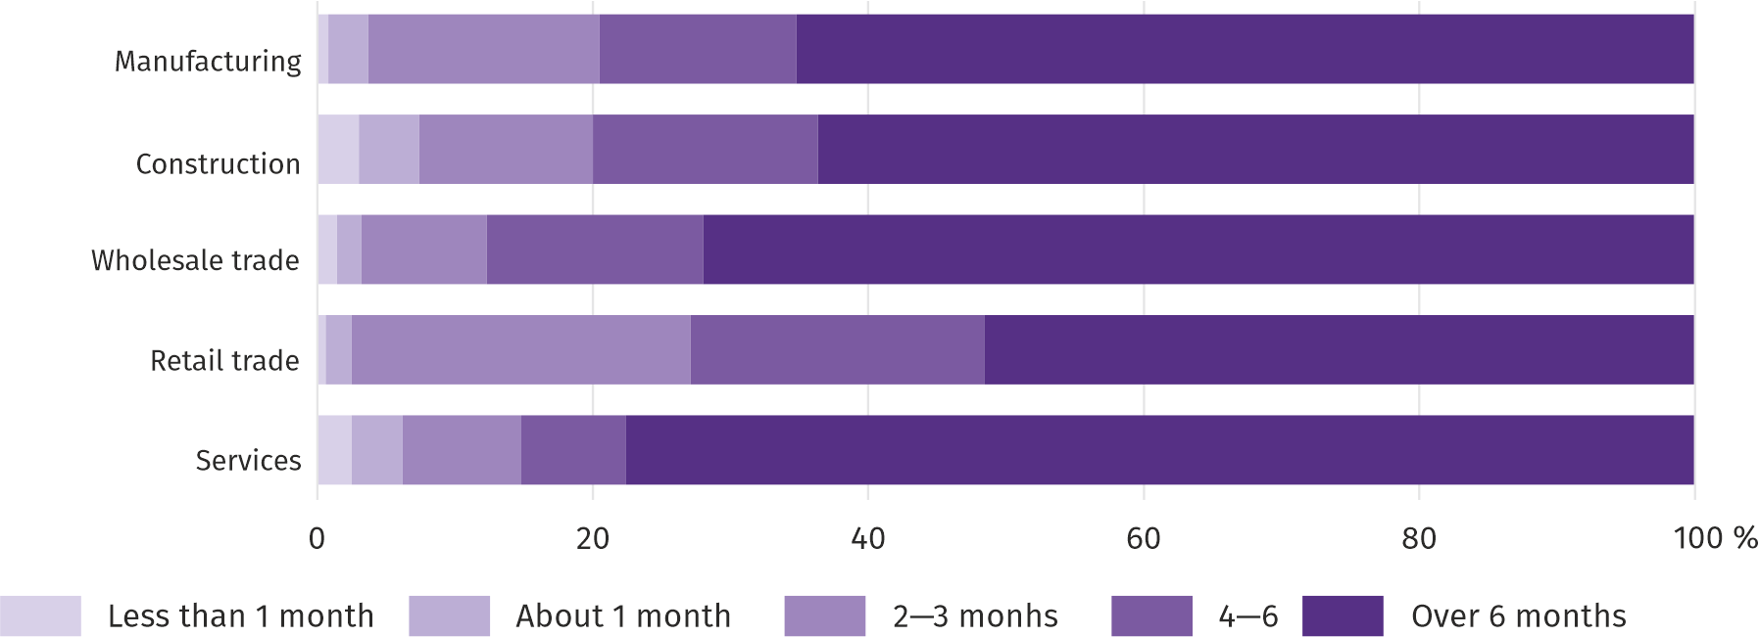

In manufacturing, retail trade and services, most entrepreneurs did not expect the appearance or intensification of payment gridlocks in February this year. The largest percentage of enterprises in which serious or threatening the company's stability was expected occurred in construction, and the smallest – in manufacturing.

Q5. Does your company expect payment gridlocks to emerge or increase in the current month?
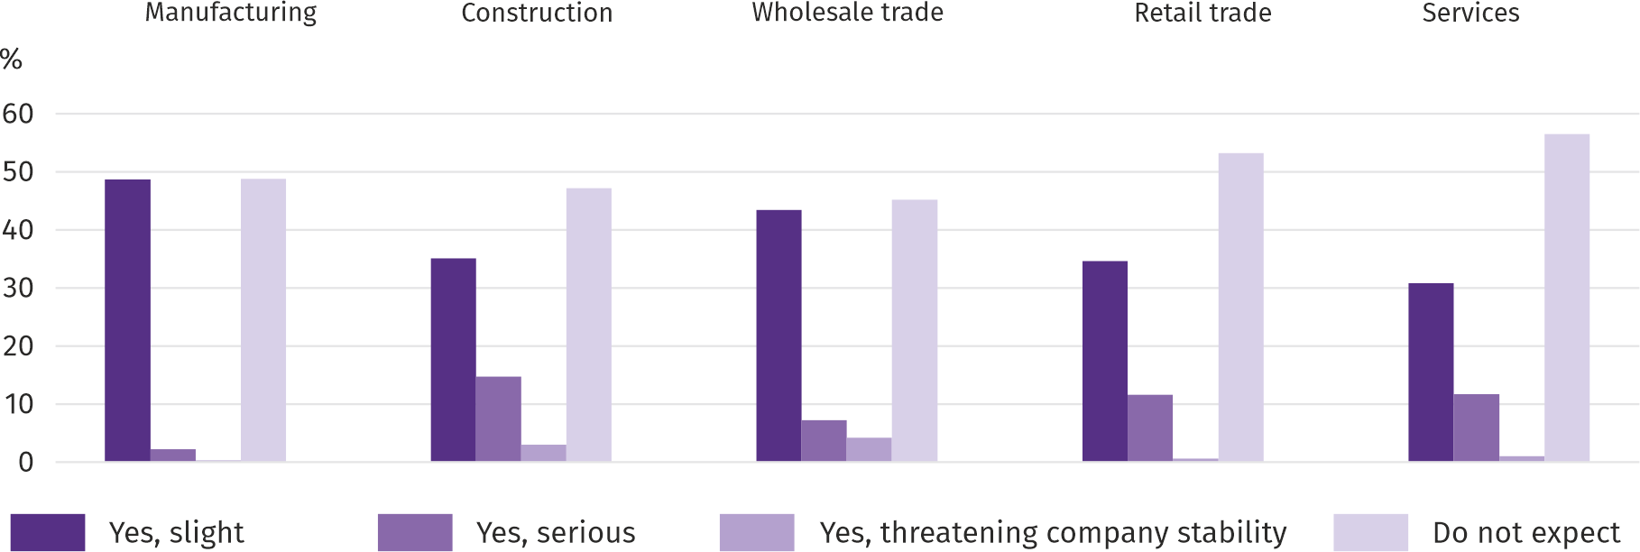
Regardless of the cause of the congestion and compared to what would happen if there were no pandemic:

In most of the surveyed areas of activity, managers expected a decline in employment in February this year compared to the previous month. The largest decrease in employment was expected by entrepreneurs operating in construction.

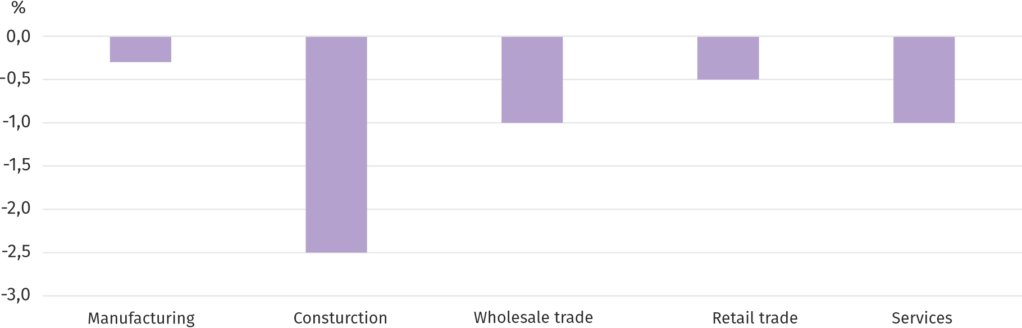
Q6. What will be the estimated (in percent) changes in the employment level in your company this month, in relation to the previous month?

More information on the results of the business climate survey can be found on the website of the Statistical Office in Zielona Góra https://zielonagora.stat.gov.pl/osrodki/osrodek-badan-koniunktury/obk-dane/.

Table 14. Selected data on Mazowieckie Voivodship
SPECIFICATION  A – 2020  B – 2021 |  | 01 | 02 | 03 | 04 | 05 | 06 | 07 | 08 | 09 | 10 | 11 | 12
Average employment in the enterprise sector ª  (in thousand persons) | A | 1552,1 | 1551,5 | 1545,4 | 1513,6 | 1499,3 | 1510,1 | 1519,7 | 1528,9 | 1533,3 | 1535,2 | 1537,7 | 1541,6
 | B | 1540,2
previous month=100 | A | 100,7 | 100,0 | 99,6 | 97,9 | 99,1 | 100,7 | 100,6 | 100,6 | 100,3 | 100,1 | 100,2 | 100,3
 | B | 99,9
corresponding month of previous year=100 | A | 101,6 | 101,9 | 101,3 | 99,2 | 98,4 | 99,0 | 99,4 | 99,9 | 100,3 | 100,3 | 100,1 | 100,0
 | B | 99,2
Registered unemployed persons (in thousand persons; as of end of period) | A | 130,1 | 129,6 | 127,8 | 133,4 | 139,6 | 143,1 | 145,1 | 145,7 | 145,1 | 143,8 | 144,1 | 146,4
 | B | 151,1
Unemployment rate ^{b} (in %; as of end of period) | A | 4,6 | 4,6 | 4,5 | 4,7 | 4,9 | 5,0 | 5,1 | 5,1 | 5,1 | 5,1 | 5,1 | 5,2
 | B | 5,3
Job offers (submitted during a month) | A | 16059 | 14693 | 12277 | 7983 | 11057 | 12516 | 12513 | 11754 | 14062 | 13009 | 13320 | 11016
 | B | 13732
Unemployed persons per 1 job offer (as of end of period) | A | 14 | 17 | 23 | 25 | 23 | 20 | 20 | 19 | 17 | 23 | 20 | 39
 | B | 21
Average monthly gross wages and salaries in the enterprise sector ª (in PLN) | A | 6285,91 | 6284,26 | 6701,01 | 6369,76 | 6084,99 | 6235,99 | 6270,52 | 6252,79 | 6217,86 | 6469,91 | 6267,09 | 6700,01
 | B | 6570,77
previous month=100 | A | 98,2 | 100,0 | 106,6 | 95,1 | 95,5 | 102,5 | 100,6 | 99,7 | 99,4 | 104,1 | 96,9 | 106,9
 | B | 98,1
corresponding month of previous period=100 | A | 106,2 | 106,1 | 106,2 | 103,0 | 101,1 | 102,3 | 103,9 | 103,3 | 103,6 | 103,1 | 102,8 | 104,7
 | B | 104,5
Price indices:
consumer goods and services ^{c}:
corresponding period of previous year=100 | A | . | . | 104,1 | . | . | 103,3 | . | . | 103,1 | . | . | .
 | B | .
a In enterprises employing more than 9 persons. b Share of registered unemployed persons in civilian economically active population, estimated at the end of each month. c In the quarter.

Table 14. Selected data on Mazowieckie Voivodship (cont.)
SPECIFICATION  A – 2020  B – 2021 |  | 01 | 02 | 03 | 04 | 05 | 06 | 07 | 08 | 09 | 10 | 11 | 12
Price indices (cont.):
Procurement of cereal grain:
previous month=100 | A | 102,6 | 106,7 | 97,5 | 107,0 | 105,4 | 93,3 | 84,3 | 98,8 | 106,5 | 107,0 | 108,6 | 99,5
 | B | 109,5
corresponding month of previous year=100 | A | 84,2 | 89,3 | 82,9 | 97,3 | 102,0 | 99,7 | 99,9 | 98,8 | 102,5 | 111,3 | 117,4 | 115,1
 | B | 122,8
procurement of cattle for slaughter (excluding calves):
previous month=100 | A | 107,1 | 99,0 | 97,1 | 101,3 | 98,5 | 98,6 | 104,0 | 93,7 | 106,6 | 100,2 | 99,6 | 100,4
 | B | 93,5
corresponding month of previous year=100 | A | 104,1 | 110,4 | 96,9 | 97,2 | 101,3 | 110,2 | 93,8 | 94,0 | 108,9 | 111,1 | 107,9 | 105,4
 | B | 92,0
procurement of pigs for slaughter:
previous month=100 | A | 95,5 | 104,3 | 100,5 | 96,5 | 89,9 | 104,6 | 91,2 | 98,2 | 94,1 | 95,8 | 92,0 | 94,6
 | B | 100,2
corresponding month of previous year=100 | A | 149,5 | 153,7 | 143,8 | 106,3 | 94,5 | 100,1 | 93,0 | 88,2 | 82,8 | 79,5 | 72,3 | 63,8
 | B | 67,0
Ratio of procurement prices ª of pigs for slaughter to marketplace prices of rye | A | 9,4 | 10,0 | 10,1 | . | . | . | 8,7 | 8,6 | 8,4 | 8,0 | . | .
 | B | .
Sold production of industry ^{b} (at constant prices):
previous month=100 | A | 101,8 | 97,2 | 106,0 | 81,7 | 105,6 | 107,7 | 101,2 | 96,9 | 110,1 | 106,0 | 100,7 | 97,9*
 | B | 95,3
corresponding month of previous year=100 | A | 102,4 | 108,8 | 103,9 | 88,9 | 96,6 | 110,0 | 106,9 | 105,8 | 111,0 | 103,8 | 104,2 | 109,9*
 | B | 103,0
Construction and assembly production ^{b} (at current prices):
previous month=100 | A | 44,4 | 122,3 | 120,5 | 99,9 | 100,0 | 109,0 | 95,2 | 100,1 | 109,6 | 104,7 | 99,1 | 133,8
 | B | 37,4
corresponding month of previous year=100 | A | 111,6 | 93,4 | 97,2 | 95,2 | 90,3 | 90,6 | 77,0 | 74,2 | 71,8 | 90,3 | 98,2 | 103,3
 | B | 87,0
a Current prices excluding VAT. b In enterprises employing more than 9 persons.
Table 14. Selected data on Mazowieckie Voivodship (cont.)
SPECIFICATION  A – 2020  B – 2021 |  | 01 | 02 | 03 | 04 | 05 | 06 | 07 | 08 | 09 | 10 | 11 | 12
Dwellings completed (from the beginning of the year) | A | 2675 | 6227 | 9151 | 11749 | 14848 | 18367 | 24461 | 27795 | 33150 | 37453 | 42026 | 47044
 | B | 4225
corresponding period of previous year=100 | A | 78,3 | 92,6 | 95,1 | 89,7 | 88,6 | 94,3 | 107,7 | 103,7 | 109,9 | 108,2 | 107,2 | 109,0
 | B | 157,9
Retail sales of goods ª (at current prices):
previous month=100 | A | 75,7 | 96,4 | 91,0 | 84,4 | 126,7 | 110,1 | 105,7 | 99,3 | 96,2 | 100,9 | 94,5 | 126,5
 | B | 70,1
corresponding month of previous year=100 | A | 106,0 | 108,1 | 84,7 | 68,6 | 88,2 | 94,5 | 98,8 | 98,7 | 98,1 | 93,7 | 87,8 | 95,2
 | B | 88,2
Turnover profitability indicator in enterprises ^{b}:
gross ^{c} (in %) | A | . | . | 1,8 | . | . | 4,6 | . | . | 4,8 | . | . | .
 | B | .
net ^{d} (in %) | A | . | . | 1,1 | . | . | 3,6 | . | . | 3,9 | . | . | .
 | B | .
Investment outlays of enterprises ^{b} – from the beginning of the year (in million PLN; current prices) | A | . | . | 8368,8 | . | . | 18781,7 | . | . | 31374,2 | . | . | .
 | B | .
corresponding period of previous year=100 (current prices) | A | . | . | 102,2 | . | . | 94,1 | . | . | 96,1 | . | . | .
 | B | .
Entities of the national economy ^{e} in the REGON register (as of end of period) | A | 855961 | 858420 | 860908 | 862303 | 864666 | 867648 | 871377 | 874831 | 878835 | 882422 | 884708 | 887329
 | B | 889125
of which commercial companies | A | 171505 | 172783 | 173778 | 174576 | 175292 | 175968 | 176895 | 177906 | 178966 | 179845 | 180823 | 181948
 | B | 182507
of which with foreign capital participation | A | 33224 | 33365 | 33482 | 33636 | 33734 | 33747 | 33813 | 33920 | 34031 | 34106 | 34232 | 34417
 | B | 34386
a In enterprises employing more than 9 persons. b In enterprises employing more than 49 persons. c Relation of gross financial result to revenues from total activity. d Relation of net financial result to revenues from total activity. e Excluding persons tending private farms in agriculture.

Prepared by | Contact: |  | warszawa.stat.gov.pl/en/
Statistical Office in Warszawa  Director Zofia Kozłowska | tel.: (+48 22) 464 23 15 |  | @Warszawa_STAT
1 Sierpnia 21 | fax: (+48 22) 846 76 67
02-134 Warszawa | e-mail: SekretariatUSWAW@stat.gov.pl

Related information
Statistical Bulletin of Mazowieckie Voivodship
Report on the socio-economic situation of Mazowieckie Voivodship 2020
Socio-economic situation of voivodships No. 3/2020

Data available in databases
Local Data Bank
Knowledge Databases

Terms used in official statistics
Enterprise sector
Average paid employment
Registered unemployed persons
Registered unemployment rate
Average monthly gross wages and salaries
Retail price
Price index of consumer goods and services
Procurement of agricultural products
Procurement prices
Marketplace prices
Pigs
Cattle
Sold production of industry
Sale of construction and assembly production
Dwellings completed
Retail sales of goods
Wholesale
Financial results of enterprises
Investment outlays
Business tendency

In the case of quoting data from the Statistics Poland, please provide information “Statistics Poland data source”, and in the case of publishing calculations made on data published by the Statistics Poland, provide information: “Own study on Statistics Poland data”.

Long-term unemployed include persons remaining in the register rolls of the powiat labour office for the whole period of over 12 months during the last 2 years, excluding periods of traineeship and occupational preparation at the workplace.
Refers to vacancies and places of occupational activation.
The average values of temperature and precipitation were calculated as arithmetic averages of the average monthly values from five hydrological and meteorological stations of the Institute of Meteorology and Water Management located in Kozienice, Mława, Płock, Siedlce and Warszawa.
Reporting data – may change after preparing quarterly report.
The DG1 survey covers entities employing more than 9 persons. All percentages refer to the number of entities that submitted a report in a given month.
It applies to legal persons, organizational units without legal personality and natural persons conducting economic activity (excluding natural persons tending private farms in agriculture).
The survey was conducted on a sample of industrial, construction, commercial and service units. In contrast to the basic economic climate survey, the answers to the additional block of questions were provided on a voluntary basis. Questions 1, 2 and 7 present the structure of answers (percentage of respondents' answers to a given option), and the remaining questions - the average of the values of answers given. The data have been aggregated in accordance with the aggregation (weighting) methodology used as standard in the study of the economic situation.

