Socio-economic situation of Mazowieckie Voivodship in August 2020
- In August this year, the average employment in the enterprise sector decreased compared to the previous year, but increased compared to the previous month. The registered unemployment rate was higher both on an annual and on a monthly basis.
- Average monthly gross wages and salaries in the enterprise sector in August this year were lower compared to the previous month (by 0.3%) but higher than in the previous year (by 3.3%).
- The prices of consumer goods and services in the second quarter of 2020 increased by 3.3% compared to the same period last year; for comparison, in the first quarter of this year, the increase in prices on an annual basis amounted to 4.1%.
- On the agricultural market in August this year, the procurement prices of most plant products and animals for slaughter were lower than in the previous month; more was paid for rye and milk. In annual terms the procurement price of wheat and milk was higher.
- In August this year, sold production of industry (at constant prices) increased on a yearly basis (by 5.5%), and on a monthly basis decreased (by 3.4%). Construction and assembly production (at current prices) was lower by 25.8% than a year before and by 0.1% higher than a month earlier.
- The number of dwellings completed in August this year was lower by 12.6% than a year before and by 35.6% compared to the previous month. Most of the dwellings were built for sale or rent.
- In August this year, there was an increase in wholesale in annual terms (by 0.3%). The retail sales decreased compared to the previous year (by 1.3%).
- At the end of the second quarter of this year, 18.2% of the employed in Mazowieckie Voivodship used the possibility of remote work due to the epidemic. This possibility was used more often in the private sector than in the public sector.
- In August this year, 3.2% of economic entities that submitted the DG1 report indicated the COVID-19 pandemic as a factor causing significant changes in conducting economic activity.
- In August this year, the number of economic entities registered in the REGON register was larger by 3.7% than a year before and by 0.4% than a month earlier.
- In most surveyed areas, entrepreneurs in September this year assess the economic situation similarly as in August this year. The exception is the section of retail trade as well as transportation and storage, where the prices increased.

Contents
Labour market 4
Wages and salaries 7
Retail prices 9
Agriculture 10
Industry and construction 13
Housing construction 15
Domestic market 17
Impact of COVID-19 pandemic on the selected elements of the labour market in Q2 2020 18
Impact of COVID-19 pandemic on the activities of the enterprise sector 20
Entities of the national economy 22
Business tendency 24
Selected data on Mazowieckie Voivodship 28
General notes
Data presented in the news release:
- on employment, wages and salaries and sold production of industry and construction, construction and assembly production, as well as retail sales and wholesale concern economic entities employing more than 9 persons,
- on enterprise sector refer to entities conducting economic activity in the field of: forestry and logging; maritime fishing; mining and quarrying; manufacturing; electricity, gas, steam and air conditioning supply; water supply; sewerage, waste management and remediation activities; construction; wholesale and retail trade; repair of motor vehicles and motorcycles; transportation and storage; accommodation and food service activities; information and communication; real estate activities; legal and accounting activities; activities of head offices; management consultancy activities; architectural and engineering activities; technical testing and analysis; advertising and market research; other professional, scientific and technical activities; arts, entertainment and recreation; repair of computers and personal and household goods; other personal service activities,
- on retail prices of foodstuffs and non-foodstuffs as well as services that originate from quotations of prices conducted by interviewers at selected points of sale in selected regions of price surveys; prices of food are collected once a month, with the exception of fruit and vegetables, for which prices are collected twice a month,
- on procurement of agricultural products include procurement from producers from the voivodship; prices are given excluding VAT tax,
- on financial results of enterprises and investment outlays refer to economic entities keeping accounting ledgers (excluding entities whose activity is classified according to the NACE Rev. 2 in the sections “Agriculture, forestry and fishing” and “Financial and insurance activities” as well as higher education institutions) in which the number of employed persons exceeds 49.
Data in value terms are provided at current prices and form the basis for calculating the structure indicators. Dynamic indices are provided on the basis of value at current prices, except for industry, for which the dynamic indices are provided on the basis of value at constant prices (average current prices of 2015).
Relative numbers (indices, percentages) were calculated on the basis of absolute data expressed with higher precision than that presented in the text and tables.
Data have been presented in accordance with the Polish Classification of Activities – PKD 2007 (NACE Rev. 2).

Polish Classification of Activities 2007 – PKD 2007 (NACE Rev. 2)
Abbreviation | Full name
sections
trade; repair of motor vehicles | wholesale and retail trade; repair of motor vehicles and motorcycles
accommodation and catering | accommodation and food service activities
divisions
manufacture of metal products | manufacture of fabricated metal products, except machinery and equipment

Symbols
Symbol | Description
(–) | – magniutude zero
(.) | – data not available, classified data (statistical confidentiality) or providing data impossible or purposeless
(*) | – data revised
∆ | – categories of applied classification are presented in abbreviated form
„Of which” | – indicates that not all elements of the sum are given

Data describing Mazowieckie Voivodship can also be found in statistical publications issued by the Statistical Office in Warszawa and in the publications of Statistics Poland.
The report „Economic situation in Mazowieckie Voivodship in September 2020” will be published on the home page of the Statistical Office in Warszawa: https://warszawa.stat.gov.pl/en on 30 September 2020.
When publishing Statistical Office data – please indicate the source.

Labour market
In August this year, the average employment in the enterprise sector decreased compared to the previous year, and increased compared to the previous month. The registered unemployment rate increased both in annual and in monthly terms.
Average employment in the enterprise sector in August this year amounted to 1528.9 thousand persons and was by 0.1% lower than a year before (in the previous month there was a 0.6% decrease). The highest employment drop was recorded in accommodation and catering (by 7.9%), and in addition, among others, in electricity, gas, steam and air conditioning supply (by 2.5%), as well as in information and communication (by 2.4%). A growth occurred in manufacturing (by 2.4%), construction (by 0.9%) and professional, scientific and technical activities (by 0.7%).
In comparison with July this year, average employment increased by 0.6%. The largest increase was recorded in accommodation and catering (by 2.4%), and also in, among others, administrative and support service activities (by 1.9%) and manufacturing (by 0.8%). The decrease occurred in electricity, gas, steam and air conditioning supply (by 0.5%), real estate activities (by 0.4%) and professional, scientific and technical activities (by 0.2%).
Table 1. Average employment in the enterprise sector in August 2020
SPECIFICATION | 08 2020 |  | 01–08 2020
 | in thousands | 08 2019=100 | in thousands | 01–08 2019=100
TOTAL | 1528,9 | 99,9 | 1534,5 | 100,5
of which:
Industry | 388,6 | 102,1 | 388,9 | 102,4
of which:
manufacturing | 342,1 | 102,4 | 342,1 | 102,6
electricity, gas, steam and air conditioning supply | 25,1 | 97,5 | 25,3 | 98,5
Construction | 89,6 | 100,9 | 90,3 | 99,8
Trade; repair of motor vehicles ^{Δ} | 341,4 | 98,9 | 342,4 | 99,2
Transportation and storage | 274,7 | 99,9 | 275,6 | 100,7
Accommodation and catering ^{Δ} | 32,7 | 92,1 | 33,1 | 95,6
Information and communication | 113,3 | 97,6 | 114,3 | 98,7
Real estate activities | 23,6 | 98,7 | 23,8 | 101,2
Professional, scientific and technical activities ª | 96,1 | 100,7 | 97,1 | 102,7
Administrative and support service activities | 135,4 | 98,5 | 135,3 | 98,8
a Excluding divisions: Research and experimental development work and Veterinary activities.

In January–August 2020, the average employment in the enterprise sector amounted to 1534.5 thousand persons and was by 0.5% higher than in the corresponding period of 2019 (by 2.2% higher a year before).

Chart 1. Average employment in the enterprise sector (monthly average 2015=100)
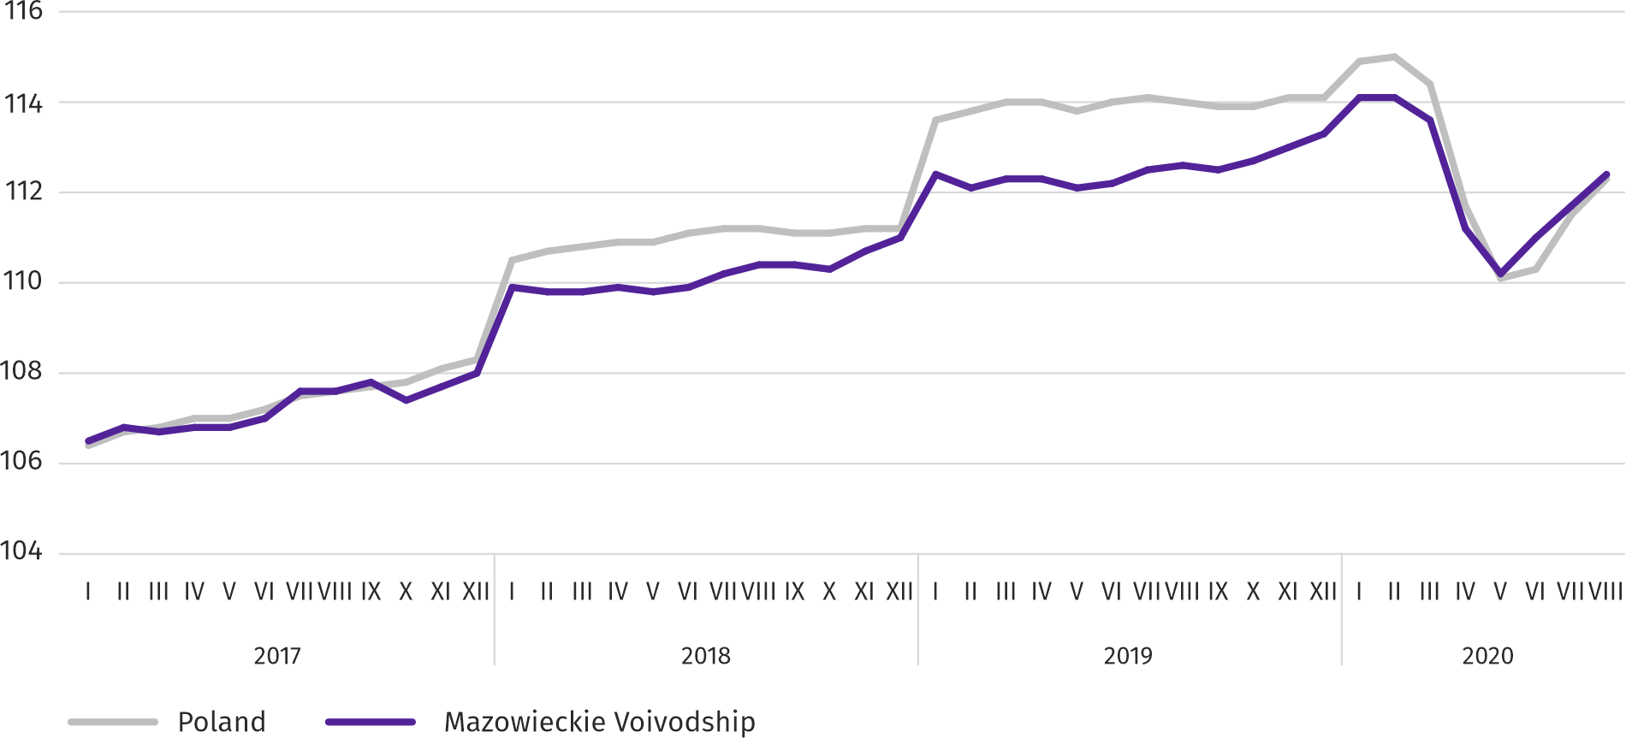
At the end of August this year, the number of unemployed persons registered in labour offices amounted to 145.7 thousand persons and increased on a monthly basis by 0.6 thousand persons (i.e. by 0.4%), and compared to August 2019 by 20.2 thousand persons (i.e. by 16.1%). Women accounted for 51.2% of total registered unemployed persons (a year before 53.4%).
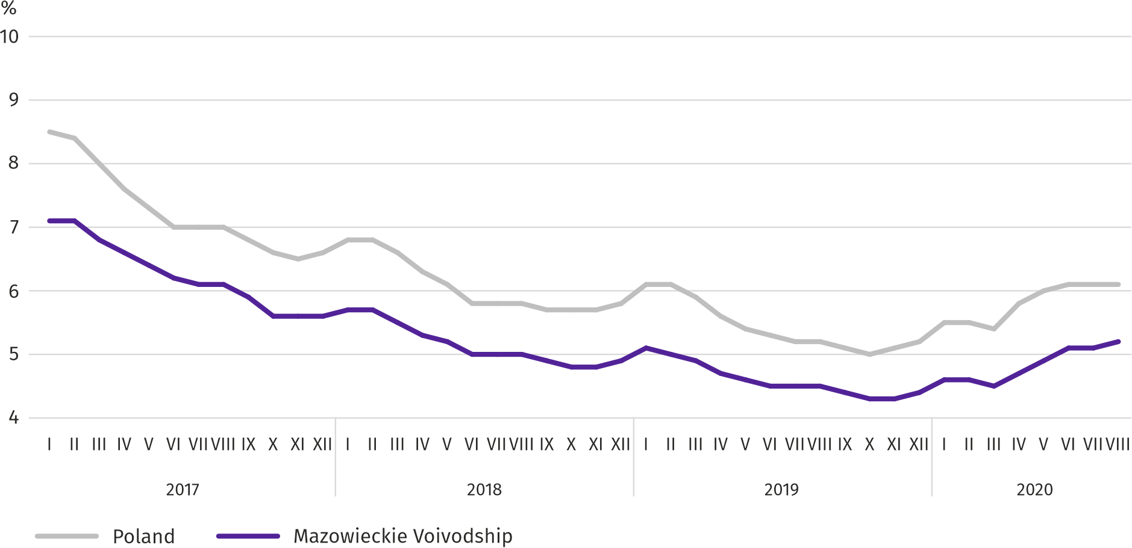
Table 2. Number of unemployed persons and unemployment rate
SPECIFICATION | 2019 | 2020
 | 08 | 07 | 08
Registered unemployed persons (as of end of month) in thousands | 125,6 | 145,1 | 145,7
Newly registered unemployed persons (during a month) in thousands | 14,1 | 13,8 | 12,4
Unemployed persons removed from unemployment rolls (during a month) in thousands | 14,2 | 11,8 | 11,8
Registered unemployment rate (as of end of month) in % | 4,5 | 5,1 | 5,2
Chart 2. Registered unemployment rate (as of end of month)
Registered unemployment rate at the end of August this year amounted to 5.2% and was lower than the national average (6.1%). It increased by 0.7 pp on a yearly basis, and by 0.1 pp on a monthly basis.
The territorial differentiation of the unemployment rate continued in the voivodship. Powiats with the highest unemployment rate were szydłowiecki (24.3% compared to 22.9% in August 2019), radomski (18.1% compared to 16.3%), przysuski (17.1% compared to 18.1%), and with the lowest – m.st. Warszawa (1.8% compared to 1.4%), warszawski zachodni (2.2% compared to 1.7%) and grójecki (2.8% compared to 1.9%).
Compared to August 2019, the unemployment rate increased in 40 out of 42 powiats. The highest increase was recorded in the powiats: zwoleński (by 2.1 pp), gostyniński and wyszkowski (by 1.9 pp each), and radomski (by 1.8 pp). The decrease took place in przysuski (by 1.0 pp) and makowski powiats (by 0.1 pp).
Compared to July 2020, the unemployment rate increase by 0.1–0.2 pp took place in 16 powiats. A decrease by 0.1-0.5 occurred also in 16 powiats. There were no changes in 10 powiats.
Map 1. Registered unemployment rate by powiats in 2019 (as of end of August)
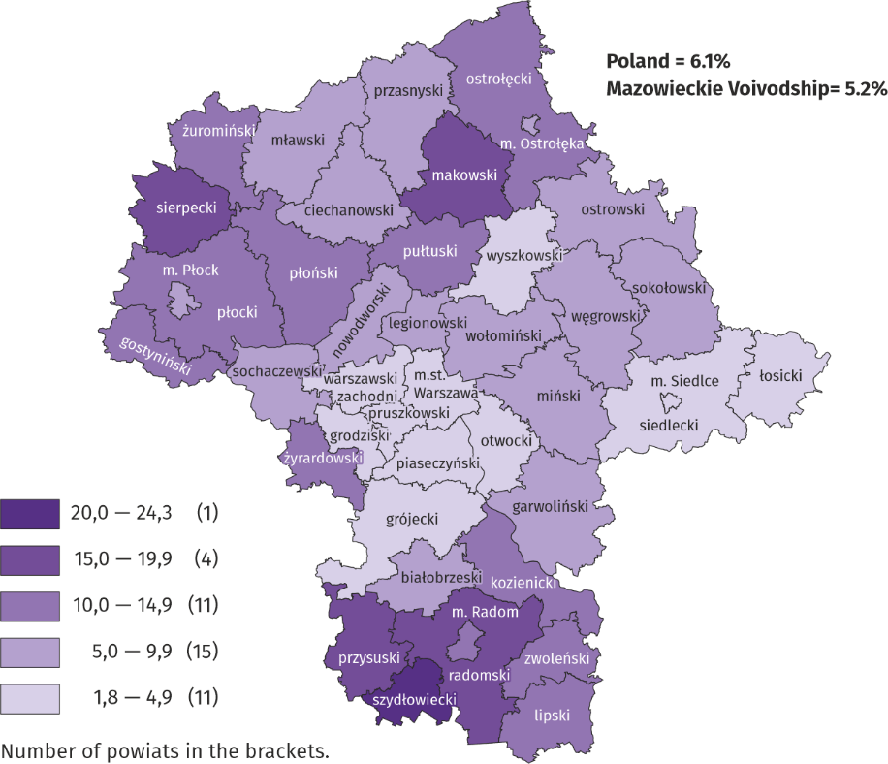

In August this year, 12.4 thousand unemployed persons were registered in labour offices, i.e. less by 10.5% than a month before and by 12.5% than a year before. Among the newly registered, 74.3% were persons registered once again (79.2% a year before). The share of persons previously not employed amounted to 16.2% (a decrease by 1.5 pp on a yearly basis), persons terminated due to company reasons 5.1% (a 1.1 pp increase). Out of newly registered unemployed persons, 42.3% were rural residents (a 1.8 pp decrease). Graduates accounted for 8.5% of newly registered unemployed persons (a 0.9 pp increase).
In August this year, 11.8 thousand persons were removed from unemployment rolls, i.e. less by 0.4% than a month before and by 17.1% less than a year before. 7.8 thousand persons (6.9 thousand a year before) were removed from unemployment rolls due to undertaking employment. The share of this category of persons in the total number of persons removed from unemployment rolls increased by 18.0 pp on a yearly basis and amounted to 66.6%. The percentage of persons who started training or traineeship with employer increased as well (by 4.8 pp to 9.0%). However, there was a decrease in the percentage of persons who lost their status of the unemployed as a result of not confirming readiness to take up work (by 17.4 pp to 8.3%), and persons who voluntarily gave up their status of the unemployed (by 2.9 pp to 4.5%), as well as persons who obtained retirement or pension rights (by 0.1 pp to 0.4%).
At the end of August this year, 120.5 thousand unemployed persons were not entitled to the unemployment benefit, and their share in the total number of the registered unemployed was 82.7% (a 0.3 pp decrease in annual terms).
At the end of the surveyed month, 71.6 thousand, i.e. 49.1% out of registered unemployed persons were the long-term unemployed. The number of unemployed persons under the age of 30 amounted to 36.7 thousand, which accounted for 25.2% of the total unemployed (of which persons under the age of 25 constituted 11.8%). Persons aged over 50 amounted to 37.2 thousand (25.6%). 1.0 thousand of unemployed persons, i.e. 0.7% of their total number received social assistance benefits. There were 23.7 thousand persons (i.e. 16.2% of the total unemployed) had at least one child under the age of 6, and persons with a disabled child aged under 18 – 274 persons (0.2% respectively). The number of disabled unemployed persons amounted to 6.2 thousand (i.e. 4.2%).
Chart 3. Registered unemployed persons per job offer (as of end of month)
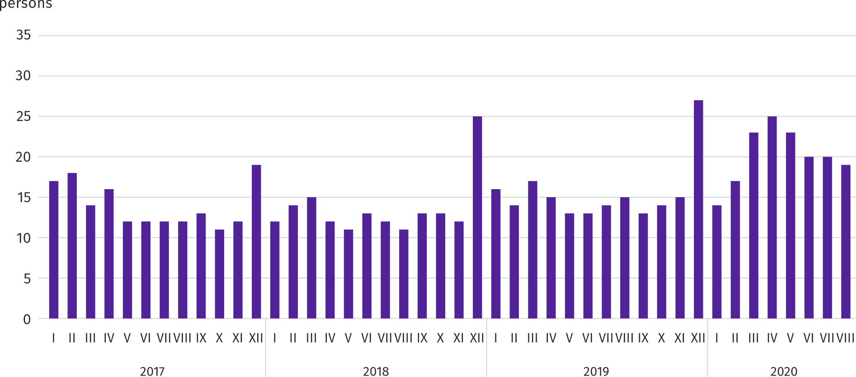

In August this year, 11.8 thousand job offers, i.e. less than a month before (by 6.1%) and a year before (by 10.5%) were submitted to labour offices. At the end of month, there were 19 unemployed persons (15 in the previous year) per job offer.
According to the labour offices, as of the end of August this year, 77 companies announced termination of 16.5 thousand employees in the near future (a year before, respectively 30 companies – 10.1 thousand employees).
Wages and salaries
In August this year, the average monthly gross wages and salaries in the enterprise sector increased on a yearly basis but decreased on a monthly basis.
Average monthly gross wages and salaries in the enterprise sector in August this year amounted to PLN 6252.79 and were by 3.3% higher than a year before (in the previous month the increase was 3.9%). Average wages and salaries increased in trade; repair of motor vehicles (by 6.4%), and moreover, among others, in electricity, gas, steam and air conditioning supply (by 5.7%), as well as in administrative and support service activities (by 5.5%). A decrease was recorded in accommodation and catering (by 3.5%) as well as in transportation and storage (by 2.6%).
In comparison with July this year, average wages and salaries decreased by 0.3%. The largest decrease was recorded in real estate activities (by 4.9%), and also, among others, in electricity, gas, steam and air conditioning supply (by 3.5%), and manufacturing (by 1.3%). The largest increase occurred in construction (by 3.6%), and also, among others, in accommodation and catering (by 1.6%) and informarion and communication (by 1.5%).

Chart 4. Relative deviations of average monthly gross wages and salaries in selected sections from average wages and salaries in the enterprise sector in August 2020
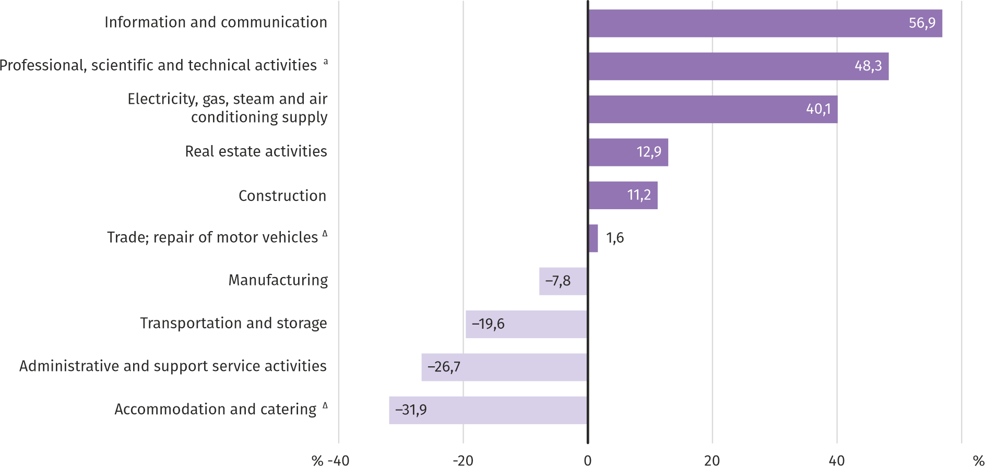
a Excluding divisions: Research and experimental development work and Veterinary activities.
In August this year, the highest average monthly gross wages and salaries were noted in the information and communication section – it exceeded the average wages and salaries in the enterprise sector in the voivodship by 56.9%.
Table 3. Average monthly gross wages and salaries in the enterprise sector in July 2020
SPECIFICATION | 08 2020 |  | 01–08 2020
 | in PLN | 08 2019=100 | in PLN | 01–08 2019=100
TOTAL | 6252,79 | 103,3 | 6316,97 | 104,1
of which:
Industry | 5973,23 | 104,1 | 6067,32 | 105,5
of which:
manufacturing | 5763,57 | 104,2 | 5856,13 | 105,5
electricity, gas, steam and air conditioning supply | 9271,00 | 105,7 | 9283,92 | 107,6
Construction | 6950,68 | 103,7 | 6760,73 | 103,8
Trade; repair of motor vehicles ^{Δ} | 6351,31 | 106,4 | 6442,03 | 104,0
Transportation and storage | 5025,50 | 97,4 | 5045,63 | 101,6
Accommodation and catering ^{Δ} | 4257,17 | 96,5 | 4343,02 | 98,5
Information and communication | 9813,49 | 103,0 | 9892,57 | 104,1
Real estate activities | 7062,46 | 104,6 | 7344,03 | 106,0
Professional, scientific and technical activities ª | 8760,71 | 103,3 | 9003,41 | 103,8
Administrative and support service activities | 4582,92 | 105,5 | 4578,37 | 107,8
a Excluding divisions: Research and experimental development work and Veterinary activities.

In the period January–August 2020, the average monthly gross wages and salaries in the enterprise sector amounted to PLN 6316.97 and were by 4.1% higher than in the corresponding period of 2019 (a year before by 5.7% higher).
Chart 5. Average monthly gross wages and salaries in the enterprise sector (monthly average 2015=100)
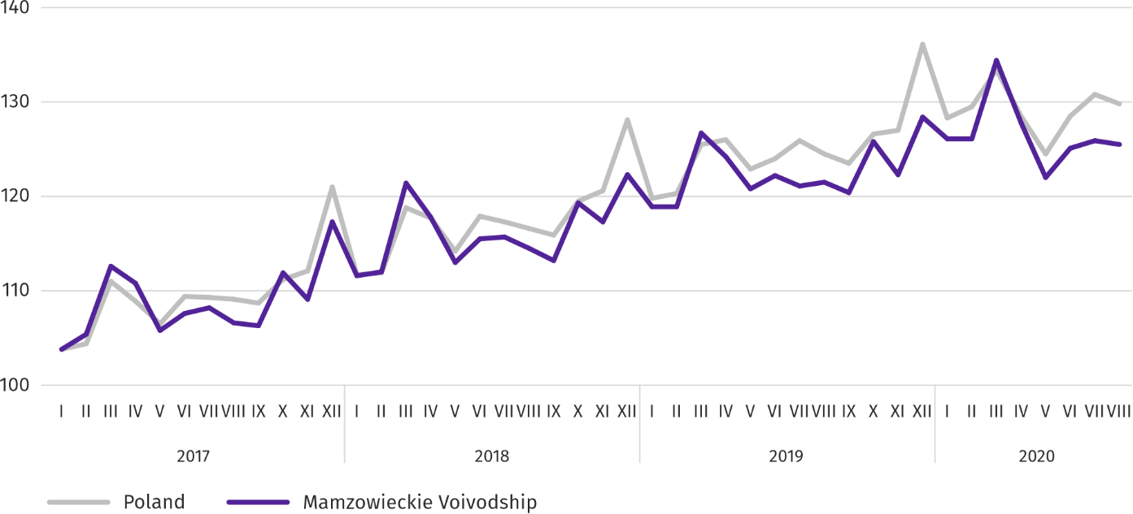
Retail prices
In the second quarter of this year, in Mazowieckie Voivodship, the prices of consumer goods and services increased by 3.3% on a yearly basis; in the second quarter of last year, the increase was 2.2%.

The highest price increase concerned food and non-alcoholic beverages (by 6.6%). The increase also concerned education (by 6.2%), health (by 5.6%), housing fees (by 5.3%), price of alcoholic beverages and tobacco (by 4.9%); the smallest increase in the prices was recorded for goods and services as well as prices of goods and services related to recreation and culture (by 2.7%). A decrease in prices was noted for transport (by 8.2%) and clothing and footwear (by 3.6%).
Table 4. Price indices of consumer goods and services
SPECIFICATION | 2019 |  | 2020
 | Q1 | Q2 | Q1 | Q2
 | corresponding period of previous year=100
TOTAL | 101,0 | 102,2 | 104,1 | 103,3
Food and non-alcoholic beverages | 101,7 | 104,8 | 108,0 | 106,6
Alcoholic beverages and tobacco | 101,2 | 100,7 | 103,6 | 104,9
Clothing and footwear | 97,6 | 98,4 | 97,7 | 96,4
Housing | 100,3 | 101,3 | 104,3 | 105,3
Health | 102,7 | 102,9 | 103,5 | 105,6
Transport | 101,9 | 101,9 | 100,6 | 91,8
Recreation and culture | 102,2 | 102,9 | 102,7 | 102,7
Education | 103,2 | 103,0 | 105,4 | 106,2

In the second quarter of this year, prices of consumer goods and services in Mazowieckie Voivodship went up slightly less than in the country (3.3% compared to 3.2%).
Agriculture
On the agricultural market in August this year, the average procurement prices of most plant and animal products (excluding wheat and milk) were lower than a year before. On a monthly basis, only the prices of rye and milk were higher.

The average air temperature in Mazowieckie Voivodship in August 2020 amounted to 19.7°C and was by 1.8°C higher from the average from the years 1981–2010, while the maximum temperature reached 32.9°C (in Warszawa), and the minimum amounted to 7.0°C (in Kozienice). The average atmospheric precipitation (75.8 mm) accounted for 124% of the standard for the multi-year periods (ranging from 97% in Siedlce to 150% in Warszawa) . The number of days with precipitation, depending on the region, ranged from 11 to 14.
Table 5. Procurement of cereals ª
SPECIFICATION | 07–08 2020 |  | 08 2020
 | in thousand tonnes | corresponding  period of previuous year=100 | in thousand tonnes | 08 2019=100 | 07 2020=100
Grain of basic cereals ^{b} | 156,1 | 118,9 | 114,0 | 176,7 | 270,5
of which:
wheat | 95,5 | 124,8 | 72,8 | 184,9 | 320,2
rye | 31,5 | 93,3 | 20,0 | 148,0 | 174,4
a Excluding procurement realized by natural persons. b Including: wheat, rye, barley, oat, triticale; including cereal mixed, excluding sowing seed.

Deliveries of basic cereals (including cereal mixed, excluding sowing seed) to procurement to be purchased from the beginning of the new season 2020/2021, were by 18.9% larger than in the corresponding period of previous year, with much more wheat (by 24.8%). After this year's harvest, in August this year, grain deliveries were higher by 76.7% than in the previous year.

Table 6. Procurement of basic animal products ª
SPECIFICATION | 01–08 2020 |  | 08 2020
 | in thousand tonnes | 01–08 2019=100 | in thousand tonnes | 08 2019=100 | 07 2020=100
Animals for slaughter ^{b} | 735,8 | 110,6 | 85,3 | 105,4 | 98,2
of which:
cattle (including calves) | 35,5 | 104,3 | 1,3 | 58,5 | 44,9
pigs | 165,2 | 122,5 | 18,3 | 123,9 | 97,7
poultry | 534,3 | 107,9 | 65,6 | 102,8 | 100,7
Milk ^{c} | 1792,1 | 102,1 | 221,6 | 102,1 | 97,4
a In the periond July-August, excluding procurement realized by natural persons. b Including cattle, calves, pigs, sheep, horses and poultry; in terms of meat including fats in post-slaughter warm weight. c In million litres.
From the beginning of this year, producers from Mazowieckie Voivodship supplied 735.8 thousand tonnes of animals for slaughter (in post-slaughter warm weight), i.e. by 10.6% more than a year ago. The increase in procurement concerned all basic animals for slaughter. In August this year, the total supply of animals for slaughter (85.3 thousand tons) was higher in annual terms by 5.4%, and lower in monthly terms by 1.8%. Supplies of cattle for slaughter were much smaller.
Deliveries of milk to procurement in January-August this year (1792.1 million litres) was by 2.1% larger than in the same period of 2019. In August this year, procurement of milk was higher than in the previous year (by 2.1%) and lower than in the previous month (by 2.6%).
Table 7. Average prices of basic agricultural products
SPECIFICATION | 08 2020 |  |  | 01–08 2020
 | PLN | 08 2019=100 | 07 2020=100 | PLN | 01–08 2019=100
Wheat ª per dt | 68,62 | 103,0 | 94,0 | 74,98 | 95,2
Rye ª per dt | 46,57 | 84,5 | 100,7 | 48,90 | 80,3
Potatoes ^{b} per dt | 34,00 | 88,4 | 56,3 | 57,12 | 67,1
Animals for slaughter per kg of live weight:
cattle (excluding calves) | 6,14 | 94,0 | 93,7 | 6,59 | 100,7
pigs | 5,17 | 88,2 | 98,2 | 5,78 | 113,1
poultry | 3,35 | 90,0 | 99,2 | 3,38 | 93,5
Piglet for breeding per head | 131,20 | 100,5 | 101,3 | 132,46 | 98,9
a Excluding sowing seed.

Average procurement prices of wheat and rye in January-August this year were lower than in the corresponding period of previous year. In August this year, the procurement price of wheat was higher on a monthly basis, but lower on a yearly basis. The price of wheat increased compared to August last year, however to smaller extent than in July this year. At the marketplaces, the prices of these cereals were lower both on an annual and monthly basis.
Table 8. Average marketplace prices of cereals and potatoes
SPECIFICATION | 08 2020
 | PLN | 08 2019=100 | 07 2020=100
Wheat per 1 dt | 85,03 | 98,6 | 99,2
Rye per 1 dt | 60,01 | 90,6 | 99,5
Potatoes ª per 1 dt | 118,36 | 55,6 | 85,0
a Edible late.

Chart 6. Average procurement prices of cereals and marketplace prices of potatoes
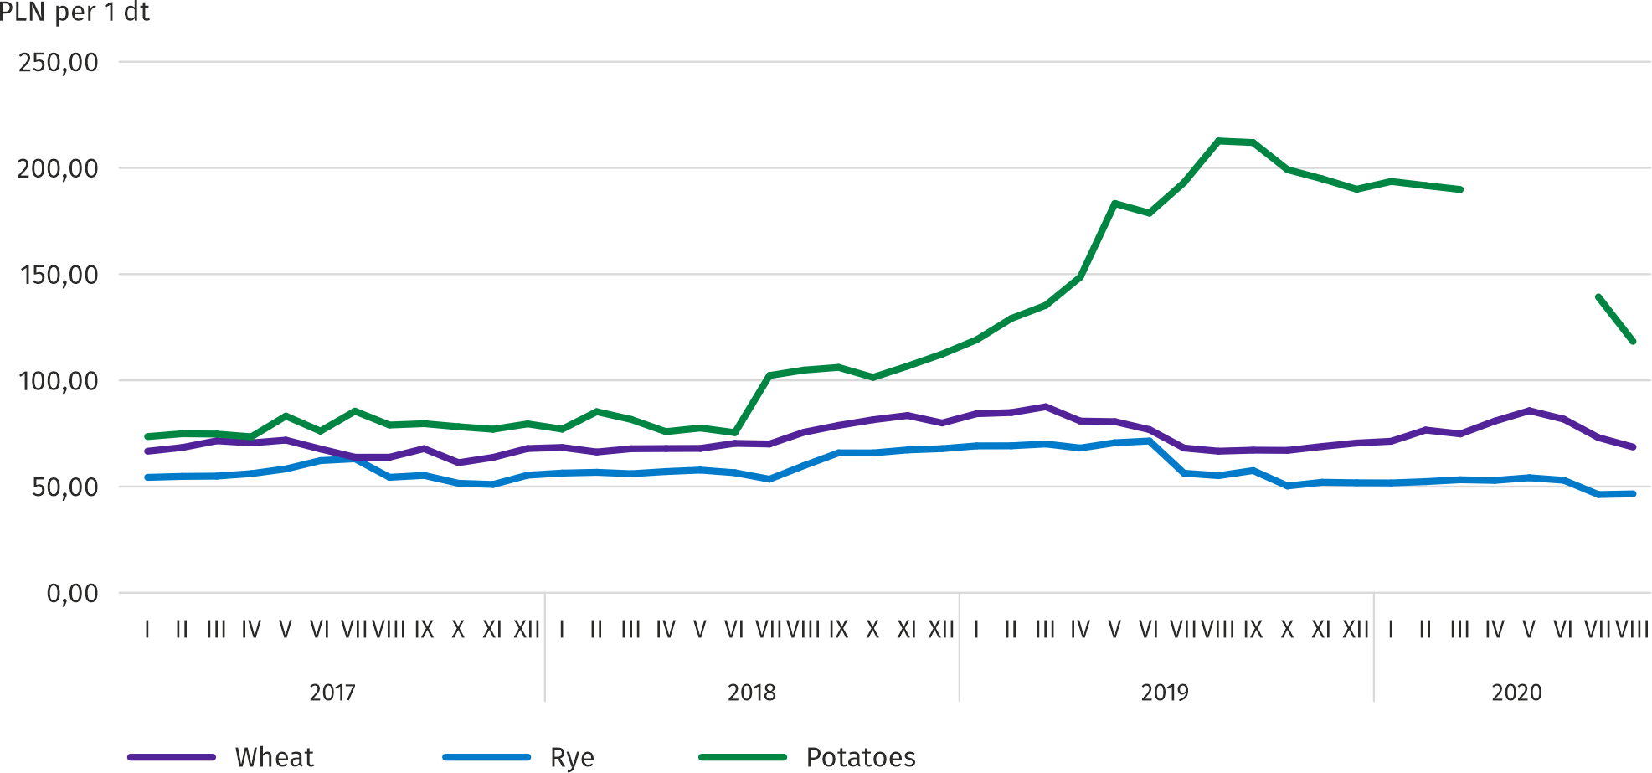

In August this year, the average procurement price of potatoes was 34.00 PLN/dt, i.e. by 43.7% lower than in the previous month and by 11.6% lower than in the previous year. The average price of 1 dt of potatoes at marketplaces was PLN 118.36 and was also much lower in both of these approaches.
Chart 7. Average procurement prices of animals for slaughter and milk
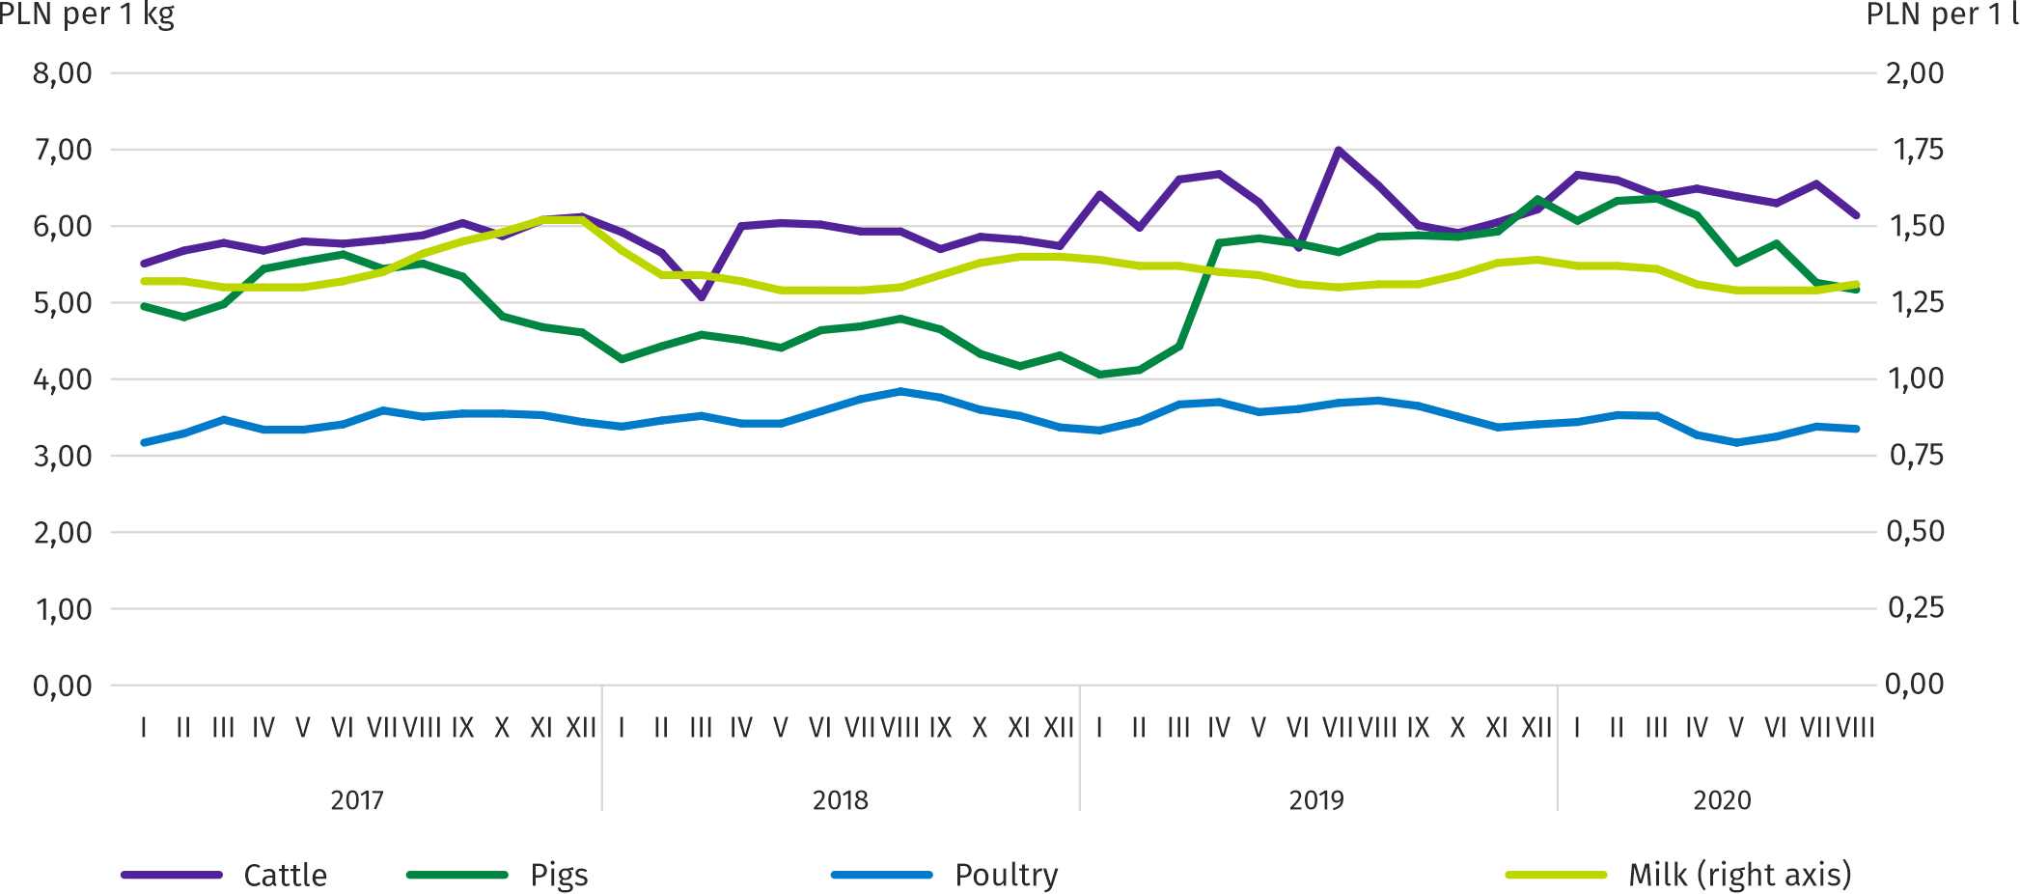

In the period January-August this year, the average procurement price of pigs for slaughter was by 13.1% higher than in the same period of 2019. In August this year, the price of this raw material decreased by 1.8% on a monthly basis (to 5.17PLN/kg), and by 11.8% on a yearly basis.

Chart 8. Ratio of average procurement prices of pigs for slaughter to average marketplace prices of rye
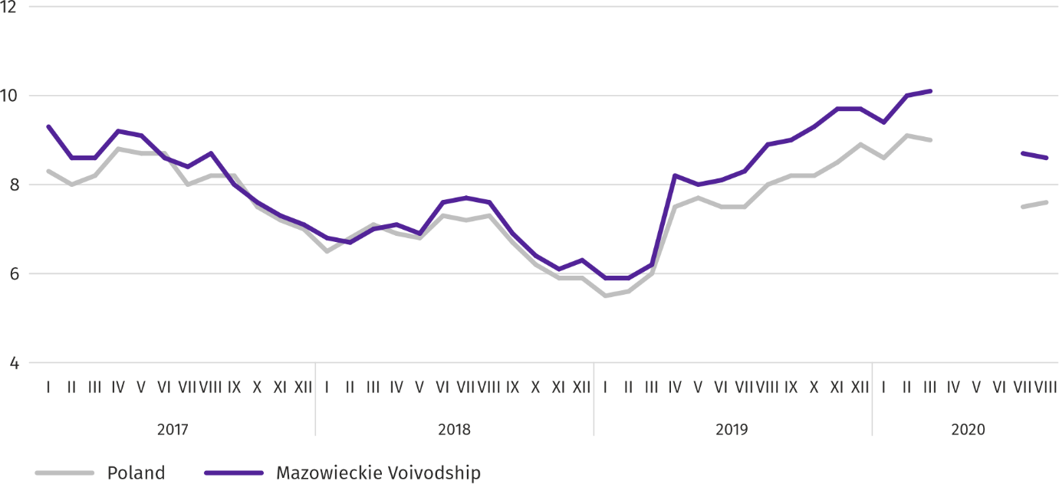

In August this year, an average of 3.35 PLN was paid per 1 kg of poultry for slaughter, i.e. by 0.8% less than in July this year, and by 10.0% less than in August last year. The average price of this raw material in the period January- August this year was by 6.5% lower than in the corresponding period of the previous year.
During eight months of this year, the average procurement price of cattle for slaughter was by 0.7% higher than in the same period of last year. In August this year, with much smaller deliveries, the price of cattle for slaughter was by 6.3% lower than in the previous month, but by 6.0% lower than in the previous year.
Procurement prices of milk in the period January– August this year, with increased supply, were lower than a year ago (by 1.1% on average). In August this year, PLN 131.20 was paid per 100 liters of this raw material, which is more by 1.3% on a monthly basis and by 0.5% more on an annual basis.
Industry and construction
Sold production of industry in August this year, reached the value (at current prices) of PLN 23,744.7 million and was (at constant prices) by 5.5% higher than a year before (compared to a 6.9% inecrease in july this year); as compared to the previous month it decreased by 3.4%.
Sold production in manufacturing (constituting 84.5% of sold production of industry) compared to August last year increased (at constant prices) by 6.0%. There was also an increase (by 1.6%) in sold production in the section of electricity, gas, steam and air conditioning supply (the share of this section represents 12.4% of industrial production).
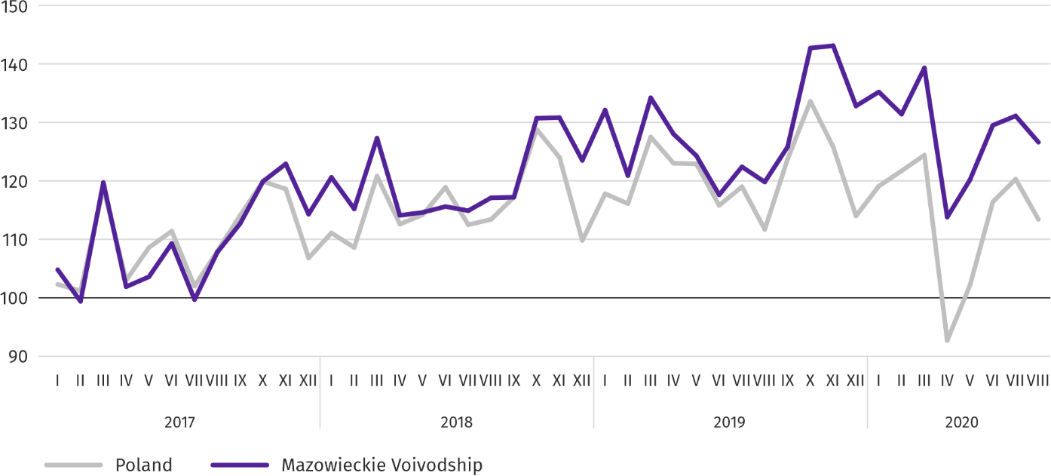
Chart 9. Sold production of industry (monthly average 2015=100; constant prices)
In August this year, the increase in sold production in annual terms was recorded in 22 (out of 33 in the voivodship) divisions of industry, among others, in: manufacture of computers, electronic and optical products (by 36.4%), manufacture of machinery and equipment n.e.c. (by 15.3%), electrical equipment (by 12.6%), food products (by 10.4%), chemicals and chemical products (by 8.5%). Whereas, there was a decrease in manufacture of other non-metallic mineral products (by 9.0%), beverages (by 5.5%).
Table 9. Dynamics (constant prices) and structure (current prices) of sold production of industry in August 2020
SPECIFICATION | 08 2020 | 01–08 2020
 | corresponding period of previous year=100 |  | in percent
TOTAL | 105,5 | 103,6 | 100,0
of which:
Manufacturing | 106,0 | 103,0 | 82,1
of which manufacture of:
food products | 110,4 | 110,3 | 22,7
beverages | 94,5 | 94,8 | 2,1
paper and paper products | 99,6 | 99,1 | 2,8
chemicals and chemical products | 108,5 | 104,6 | 6,1
manufacture of rubber and plastic products | 101,0 | 101,4 | 3,9
other non-metallic mineral products | 91,0 | 94,1 | 3,1
metal products ^{Δ} | 100,1 | 105,9 | 4,1
computer, electronic and optical equipment | 136,4 | 108,4 | 5,2
electrical equipment | 112,6 | 109,2 | 5,2
machinery and equipment n.e.c. | 115,3 | 92,5 | 2,5
Electricity, gas, steam and air conditioning supply | 101,6 | 104,9 | 14,7
Labour productivity in industry measured by sold production per employed person, in August this year amounted (at current prices) to PLN 61.1 thousand and was (at constant prices) by 3.4% higher than a year before, with higher by 2.1% average paid employment and the average monthly gross wages and salaries by 4.1%.
In January–August this year, sold production of industry amounted (at current prices) to PLN 194,996.8 million and was (at constant prices) by 3.6% higher than in the corresponding period of the previous year.
Sold production of construction (at current prices) in August this year reached the value of PLN 6,326.7 million and was by 22.5% lower than in the previous year (compared to a 18.4% decrease in July this year); compared to the previous month it increased by 6.0%. In January-August this year, sold production of construction amounted to PLN 49,506.0 million and was by 6.5% lower compared to the corresponding period of the previous year.
Labour productivity in construction, measured by revenues from the sale of goods and services per employed person in August this year amounted to PLN 70.6 thousand (at current prices) and was by 23.2% lower compared to the corresponding month of the previous year, with an increase in average employment by 0.9% and in the average monthly gross wages and salaries by 3.7%.
Construction and assembly production (at current prices) in August this year amounted to PLN 1,732.2 million and was by 25.8% lower than a year before (compared to a 23.0% decrease in July this year); it increased compared to the previous month by 0.1%. A decrease in production was recorded in in units specializing in civil engineering (by 33.1%) and in enterprises performing specialized construction activities (by 13.4%) and in entities whose basic activity is the construction of buildings (by 10.3%). In January-August this year, construction and assembly production was at the level of PLN 13,182.3 million and was by 8.9% lower compared to the corresponding period of the previous year.
Table 10. Dynamics and structure (at current prices) of construction and assembly production in August 2020
SPECIFICATION | 08 2020 | 01–08 2020
 | corresponding period of previous year=100 |  | In percent
TOTAL | 74,2 | 91,1 | 100,0
Construction of buildings | 89,7 | 82,3 | 24,1
Civil engineering | 66,9 | 91,2 | 53,5
Specialized construction activities | 86,6 | 102,7 | 22,4
Housing construction
In August this year, as compared to the corresponding month of 2019, the number of dwellings completed decreased by 12.6%; there were fewer dwellings for which permits have been granted or which have been registered with a construction project (by 17.2%) and dwellings in which construction has begun (by 6.1%).
According to preliminary data in August this year, there were 3576 dwellings completed, i.e. by 514 fewer (by 12.6%) than in the previous year and by 1973 (by 35.6%) than in the previous month. Majority of dwellings were built for sale or rent – 2685 (75.1% of their total number), followed by private dwellings – 887 (24.8%). Compared to August 2019, there were fewer dwellings for sale or rent by 16.8%, and private dwellings more by 16.3%.
The effects of housing construction obtained in Mazowieckie Voivodship in the surveyed month constituted 21.4% of national effects.
Table 11. Number of dwellings completed in January-August 2020
SPECIFICATION | Dwellings completed |  |  | Average useful floor area per dwelling in m²
 | in absolute numbers | in percent | 01–08 2019=100
TOTAL | 27492 | 100,0 | 102,6 | 83,0
Private | 6445 | 23,4 | 105,7 | 151,0
For sale or rent | 20958 | 76,2 | 104,7 | 62,2
Municipal | 60 | 0,2 | 133,3 | 40,8
Public building society | 29 | 0,1 | 28,4 | 55,0
In January–August this year, there were 27492 dwellings completed, i.e. more by 698, i.e. by 2.6% than in the corresponding period of the previous year.

Chart 10. Dwellings completed (corresponding period 2015=100)
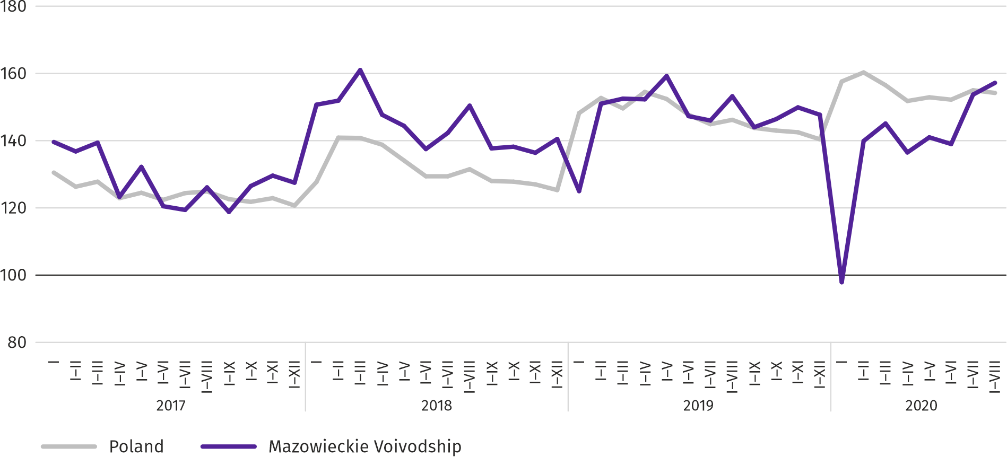

Most dwellings were completed in m.st. Warszawa (13594), followed by piaseczyński (1727) and wołomiński powiat (1617), and the least in łosicki (37) as well as lipski powiat (40).
Map 2. Dwellings completed per 10 thousand population ª by powiats in January-August 2020
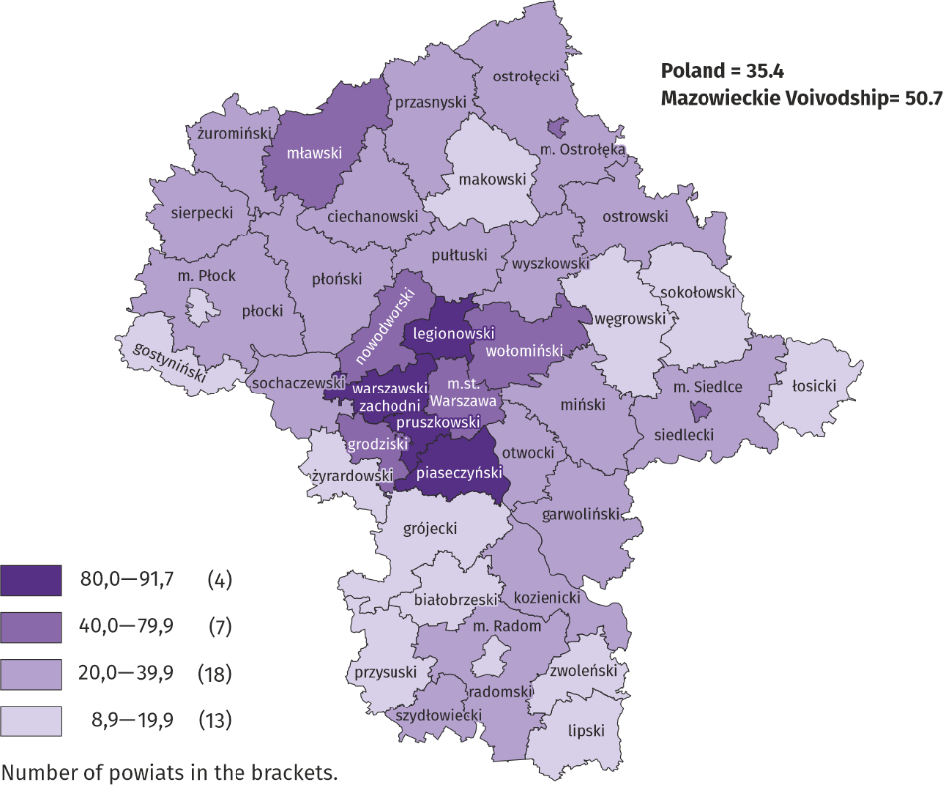

a Population as of 31 December 2019

The average useful floor area of dwellings completed during eight months of this year amounted to 83.0 m² and was slightly larger than a year earlier (by 0.1 m²). The largest dwellings were completed in siedlecki (165.1 m²), ostrołęcki (147.3 m²) and wyszkowski powiat (by 143.6 m²). The smallest were built in m.st. Warszawa (58.5 m²), Siedlce (64.2 m²), Siedlce (65.7 m²) and mławski powiat (66.6 m²).
In August this year, the number of dwellings for which permits have been granted or which have been registered with a construction project amounted to 3554, that is by 736 (by 17.2%) fewer than a year earlier and by 181 (by 4.8%) than in July this year. Of the total number of dwellings, 63.1% were dwellings for sale or rent, and 34.3% private.
In the surveyed month, the construction began in 3773 dwellings, which means a decrease by 246 (by 6.1%) in annual terms and an increase by 462 (by 14.0%) compared to the previous month. Dwellings for sale or rent accounted for 70.9% of their total number, and private 29.1%.
Table 12. Number of dwellings for which permits have been granted or which have been registered with a construction project as well as dwelling in which construction has begun in January-August 2020
SPECIFICATION | Dwellings for which permits have been granted or which have been registered with a construction project |  |  | Dwellings in which construction has begun
 | in absolute numbers | in percent | 01–08 2019=100 | in absolute numbers | in percent | 01–08 2019=100
TOTAL | 27991 | 100,0 | 89,8 | 25165 | 100,0 | 89,2
Private | 8937 | 31,9 | 98,0 | 7997 | 31,8 | 97,6
Cooperative | 62 | 0,2 | 34,8 | – | – | .
For sale or rent | 18919 | 67,6 | 87,6 | 17032 | 67,7 | 86,8
Municipal | 48 | 0,2 | 25,4 | 34 | 0,1 | 40,5
Public building society | 25 | 0,1 | 69,4 | 88 | 0,3 | 37,8
Company | – | – | . | 14 | 0,1 | .
Domestic market
In August this year, there was a decrease in retail sales compared to the previous year and an increase in wholesale.
Retail sales (at current prices) in trade and non-trade enterprises in August 2020 by 1.3% lower than a year before. The highest decrease in sales was recorded in units from the group: “other” (by 12.8%), “solid, liquid and gas fuels” (by 9.9%), “textiles, clothing and footwear” (by 4.8%), “motor vehicles, motorcycles, parts” (by 2.3%), and “food, beverages and tobacco“ (by 2.1%). The highest increase was in enterprises from the group „furniture, electronics and household appliances” (by 10.8%).
Compared to July 2020, retail sales decreased by 0.7%. The highest drop in sales was recorded in the groups: “motor vehicles, motorcycles, parts” (by 17.6%), “pharmaceuticals, cosmetics, orthopedic equipment” (by 6.1%), “other” (by 5.9%), and “press, books, other retail sales in specialized stores” (by 4.4%). “other” (by 6.9%) and „furniture, electronics and household appliances” (by 6.2%). An increase was recorded in the units from the groups: “solid, liquid and gas fuels” (by 4.8%), “food, beverages and tobacco” and “other retail sales in non-specialized stores” (by 3.6% each).
In the period of January–August 2020, retail sales decreased by 7.3% over the year, with the largest decrease in sales in the group of: “textiles, clothing, footwear” (by 23.5%). The increase in sales was recorded in the „furniture, electronics and household appliances” group (by 4.0%).

Table 13. Dynamics and structure (at current prices) of retail sales in August 2020
SPECIFICATION | 08 2020 | 01–08 2020
 | corresponding period of previous year=100 |  | in percent
TOTAL ª | 98,7 | 92,7 | 100,0
of which:
Motor vehicles, motorcycles, parts | 97,7 | 83,9 | 7,0
Solid, liquid and gas fuels | 90,1 | 84,9 | 24,8
Food, beverages and tobacco | 97,9 | 99,6 | 17,3
Other retail sales in non-specialized stores | 98,5 | 81,3 | 2,8
Pharmeceuticals, cosmetics and orthopedic equipment | 102,7 | 93,6 | 3,6
Textiles, clothing and footwear | 95,2 | 76,5 | 4,3
Furniture, electronics and household appliances | 110,8 | 104,0 | 21,0
Press, books and other sales in specialized stores | 100,5 | 91,2 | 7,2
Other | 87,2 | 87,7 | 9,6
a The grouping of enterprises was made on the basis of the Polish Classification of Activities - PKD 2007, including the enterprise to a specific category according to the type of predominant activity, in accordance with the organizational status in the period under consideration. The recorded changes (increase/decrease) in retail sales in particular groups of activity of enterprises may also result from changes in the type of predominant economic activity and organizational changes (e.g. mergers of enterprises). This does not affect the dynamics of retail sales in general.

Wholesale (at current prices) in trade enterprises in August 2020 was by 9.8% lower as compared to the previous month, but by 0.3% higher compared to August 2019. In wholesale enterprises it was lower by 3.6% and 3.0%, respectively.
In the period of January-August 2020, trade enterprises realized wholesale by 5.0% lower than a year before, and wholesale enterprises by 2.7% lower.

The impact of the COVID-19 epidemic on selected elements of the labour market in Q2 2020
In March 2020, an epidemic threat was announced in Poland, followed by an epidemic in connection with the spread of an infectious disease caused by the SARS-CoV-2 virus, known as COVID-19. The solutions introduced by law to prevent and counteract the spread of the aforementioned virus and fight the disease caused by it also applied to the labour market. Among them were, among others, enabling work outside the place of its permanent performance, i.e. remote work, or using a care allowance for the time of caring for a child under 8 due to the closure of a nursery, nursery school, children's club or school.
The epidemic situation that occurred in March 2020 limited the activities of the entities of the national economy in the current form. This was manifested, among others, by employers being open to forms of employment that allowed them to maintain social distance. One of such forms is the aforementioned remote work.
At the end of June 2020, the share of persons who worked remotely (due to the epidemic situation) in the total number of persons employed in Mazowieckie Voivodship was 18.2%. The scale of using this form of work in the private sector was higher than in the public sector (19.2% compared to 15.4%).

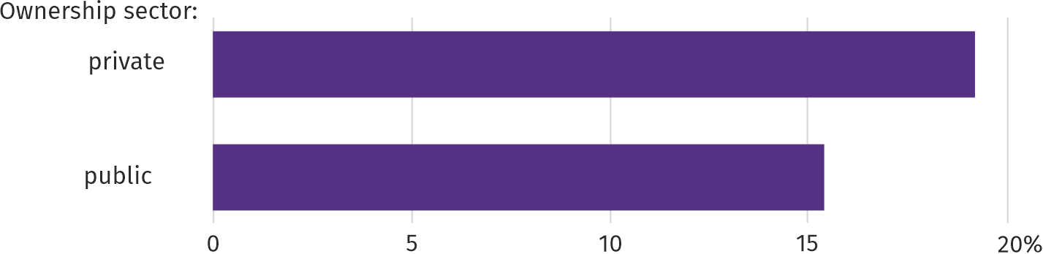
Chart 11. Share of employed persons who, due to the epidemic situation, worked remotely by ownership sector
at the end of the second quarter of 2020

In the scale of the entire economy, the use of remote work in order to reduce the epidemic risk increased with the increase in the size of entities. In Mazowieckie Voivodship, in units employing more than 49 persons, due to the epidemic situation, 19.8% of the employed worked remotely, while in the units employing up to 9 persons – 14.0% of the employed.
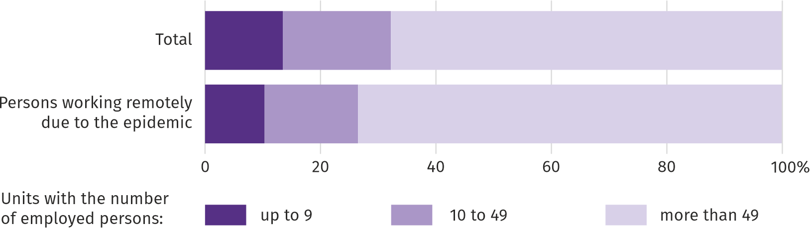
Chart 12. Structure of employed persons by size of units at the end of Q2 of 2020

Remote work caused by the epidemic was implemented by employers in individual voivodhips on a different scale. Its highest share at the end of Q2 2020 was recorded in Mazowieckie (18.2%) and Małopolskie (12.2%) voivodships, and the lowest in the following voivodships: Podlaskie (4.7%), Opolskie and Warmińsko-Mazurskie (4.9%).
By the Act of 2 March 2020 on special solutions related to the prevention, counteracting and combating COVID-19, other infectious diseases and emergencies caused by them, working parents and legal guardians have been able to take advantage of a care allowance for the duration of caring for a child up to 8 years of age due to the closure of the nursery, nursery school, children's club and school. As of the end of the second quarter of this year, in Mazowieckie Voivodship, 2.1% of the employed took advantage of this right. The share of employed persons who stayed at home under the aforementioned act was higher in the private sector than in the public sector (2.4% and 1.0%, respectively).
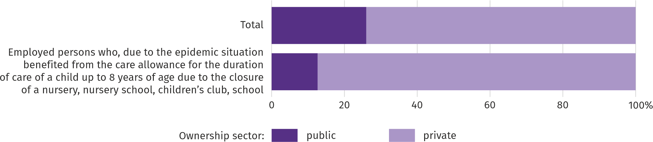
Chart 13. Structure of the employed by ownership sectors at the end of Q2 2020

The use of the COVID-19 prevention instrument by working parents and legal guardians was inversely proportional to the size of the units. In the smallest units it was 3.1%, and in units employing more than 49 persons it was 1.6%.

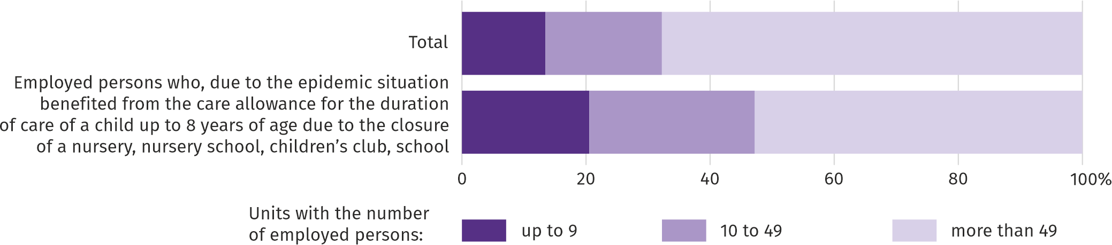
Chart 14. Structure of employed persons by unit size at the end of Q2 2020

The scale of using the possibility of taking care of a child for the discussed reason was similar in voivodships. Due to the epidemic situation, the share of working parents and legal guardians using the right to care for a child oscillated around 2-3%.
Impact of the COVID-19 pandemic on the activities of the enterprise sector
In August this year, the companies most frequently signaling changes related to the COVID-19 pandemic were active in the field of accommodation and catering. The situation resulting from the pandemic most often influenced the change in the number of orders and changes in the number of employees.
In August this year, in Mazowieckie Voivodship, 3.2% of economic entities that submitted a DG1 report indicated the COVID-19 pandemic as a factor causing significant changes in conducting economic activity; in the country 2.9%. This percentage is systematically decreasing (in April it was 9.4% and 9.6%, respectively). The highest percentage of units experiencing the effects of COVID-19 in August this year was recorded in Podkarpackie (3.5%) and Śląskie (3.4%) voivodships, and the lowest – in Opolskie (1.6%), Świętokrzyskie and Warmińsko-Mazurskie (1.9% each).
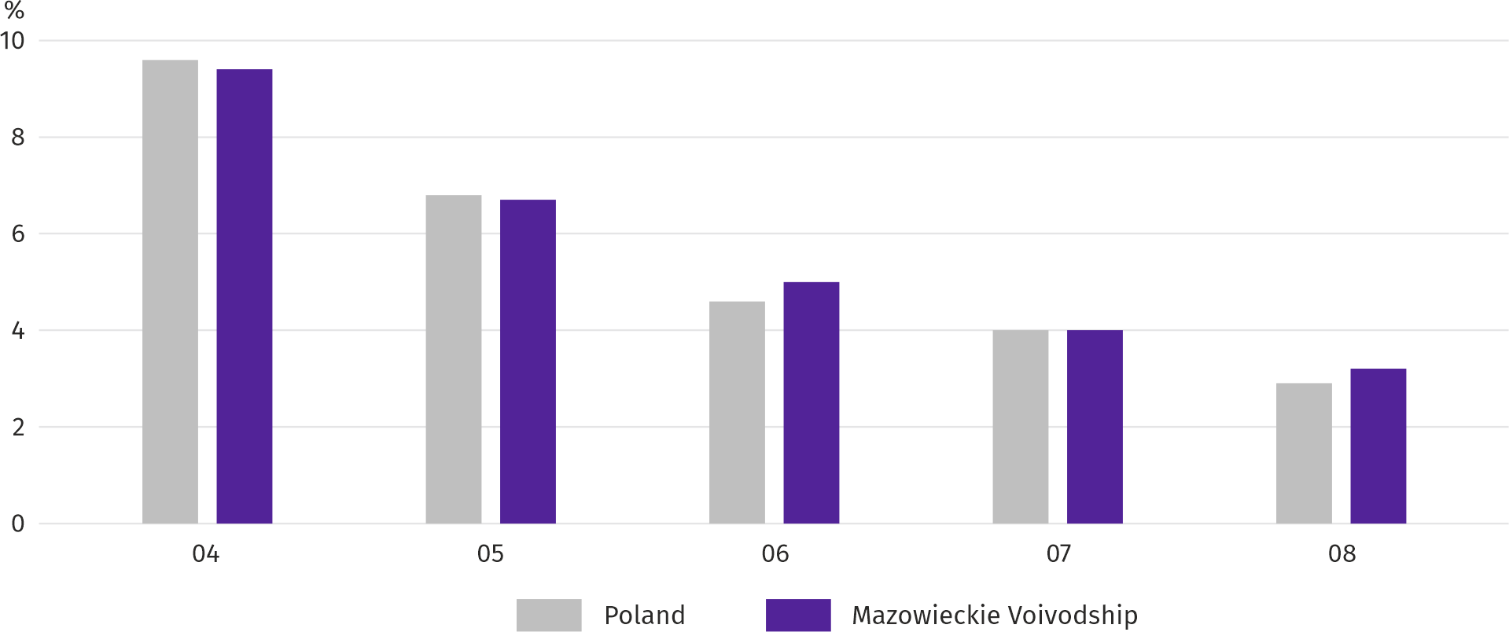
Chart 15. Percentage of entities reporting changes caused by COVID-19

In August this year, both in the voivodship and in the country, the enterprises most frequently reportin changes related to the COVID-19 pandemic operated in the field of accommodation and catering (7.9%, 5.7% in the country). Also in April this year, the most affected enterprises were enterprises operating in the section mentioned above (26.1% and 20.5%, respectively).
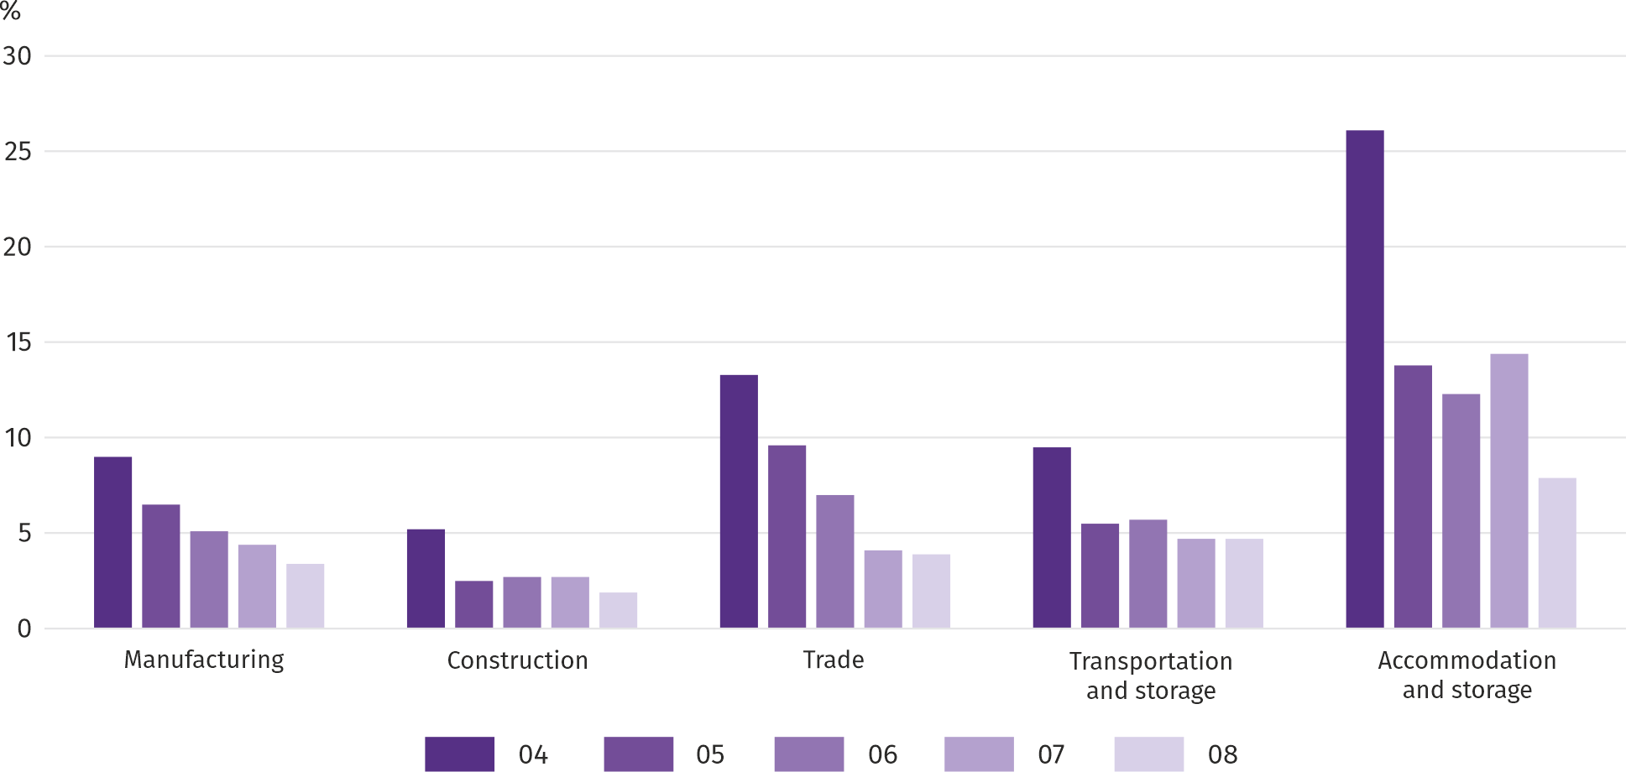
Chart 16. Units reporting changes due to COVID-19 by selected sections

The most common cause of changes in economic activity related to COVID-19 was the change in the number of orders. In August this year, in Mazowieckie Voivodship, a decrease in this respect was indicated by 1.6% of entities, and in Poland by 1.4% (in April this year it was 6.4% and 6.8%, respectively). In manufacturing, the number of orders decreased the most – in the voivodship by 2.5%, in Poland by 2.2%. The increase in the number of orders both in the voivodship and in the country was signaled in August by 0.5% of enterprises (four months earlier, 0.3% each). In the voivodship, the highest increase was recorded in the section of other service activities (by 2.8%); in the country – accommodation and catering (by 2.6%).
In the second place among the factors determining the activity and results of enterprises are changes in the number of employees. In August this year, both in the voivodship and in the country, they were indicated by 0.9% of units (in April this year, by 2.1% and 2.2%, respectively). Less noticeable effects of the COVID-19 pandemic are layoffs and employees staying in the so-called stopover. In August, both these situations were indicated by 0.2% of enterprises in the voivodship; nationally, 0.2% and 0.1%, respectively.
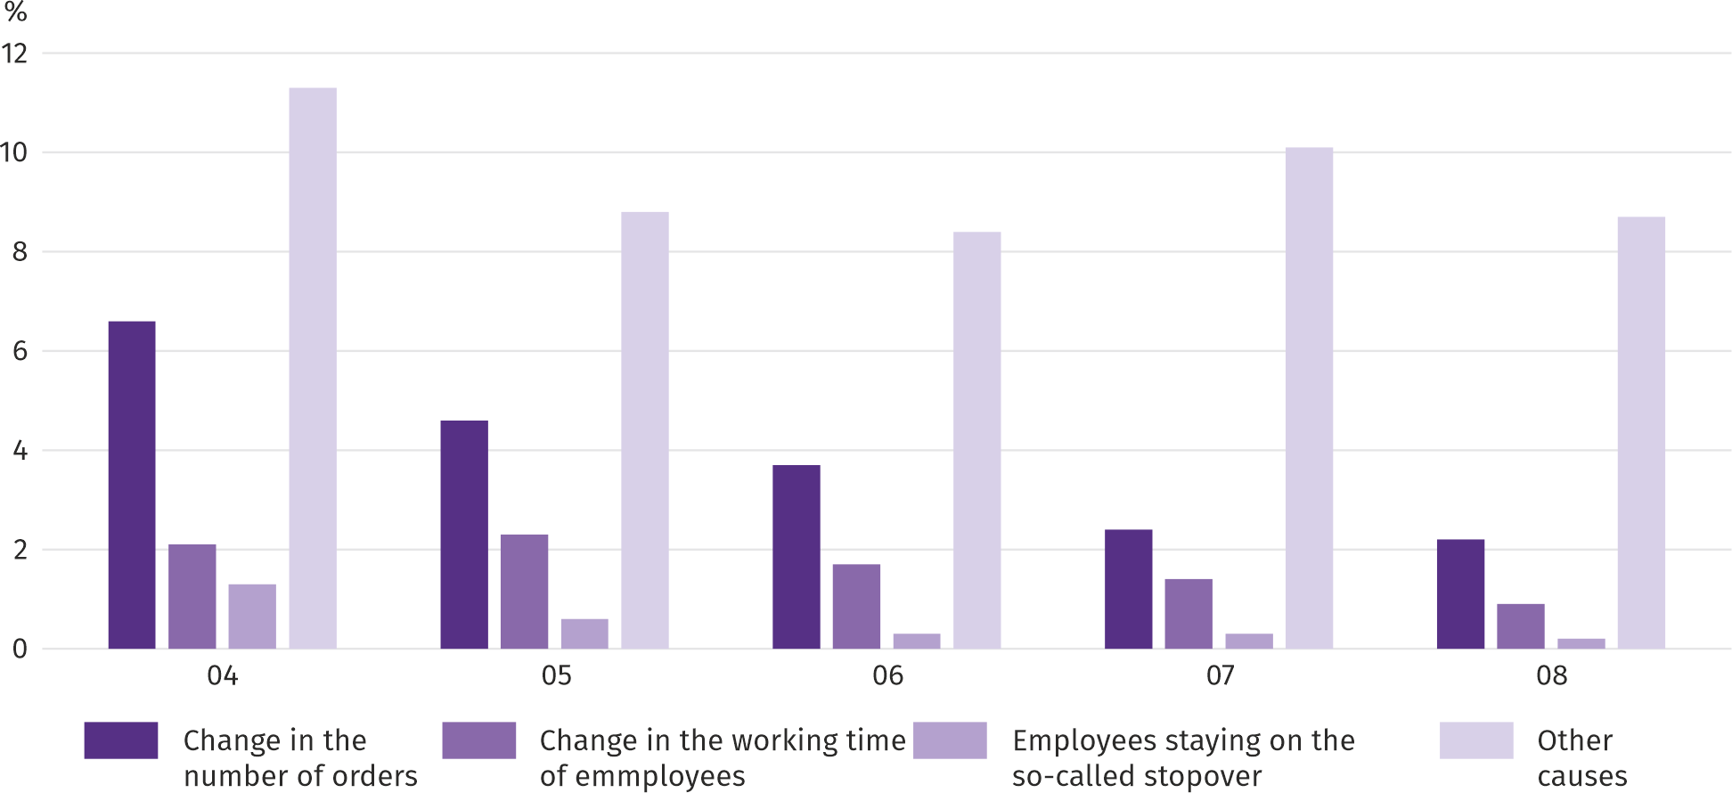
Chart 17. Reasons ª for changes in economic activity due to COVID-19

a Respondents could indicate many reasons at the same time.

In August this year, in the voivodship, the COVID-19 pandemic as the cause of problems with supply from suppliers, payment bottlenecks and production suspension was indicated by less than 0.1% of entities. There were no cases of spinning off the enterprise (or its part). However, every eleventh enterprise indicated a pandemic as a cause of changes in the conduct of economic activity, without indicating a specific reason.
Entities of the national economy
In August this year, compared to the previous month, the number of entities of the national economy increased by 0.4%. Decrease on a monthly basis was recorded both in the number of entities removed from the REGON register and new entities registered in the REGON register (by 14.9% and 7.3%, respectively). The number of entities that suspended their activities decreased as well (by 0.4%).
As at the end of August this year, 874831 entities of the national economy were registered in the REGON register, i.e. by 3.7% more than last year and by 0.4% more than in the previous year.
In the total number of registered entities 571318 accounted for natural persons conducting economic activity, which means an increase compared to the corresponding period of the previous year by 3.3%. The number of companies which were registered in the REGON register amounted to 237028, including 177906 commercial companies and 58713 civil partnerships (annual increase by 5.1%, 6.8% and 0.4%, respectively).
According to the expected number of employees, entities that declared employment of up to 9 persons prevailed upon entry in the REGON register; they constituted 96.6% of all registered units. The share of entities with an estimated number of 10-49 employed persons was 2.7%, and of entities employing more than 49 persons – 0.7%. During the year, the number of entities increased only among units declaring employment up to 9 persons (by 3.9%).
Compared to August 2019, the largest increase in the number of entities was recorded in the sections: electricity, gas, steam and air conditioning supply (by 20.4%), information and communication (by 8.3%) and administrative and supporting service activities (by 6.7%).
Compared to the previous month, the number of entities increased, among others, in the sections: electricity, gas, steam and air conditioning supply (by 3.6%), administrative and support service activities (by 0.8%), construction and arts, entertainment and recreation (by 0.7% each).
In August this year 5266 new entities were entered in the REGON register, i.e. by 7.3% less than in the previous month. The newly registered units were dominated by natural persons conducting economic activity, 3739 of whom were registered (by 10.3% less than in July this year). The number of newly registered commercial companies was 5.7% higher, including companies with limited liability – by 6.3%.
In August this year, 1708 entities were removed from the REGON register (by 14.9% less than a month ago), including 1369 natural persons conducting economic activity (by 10.1% less).

Chart 18. Entities of the national economy newly registered and removed from the register in August 2020
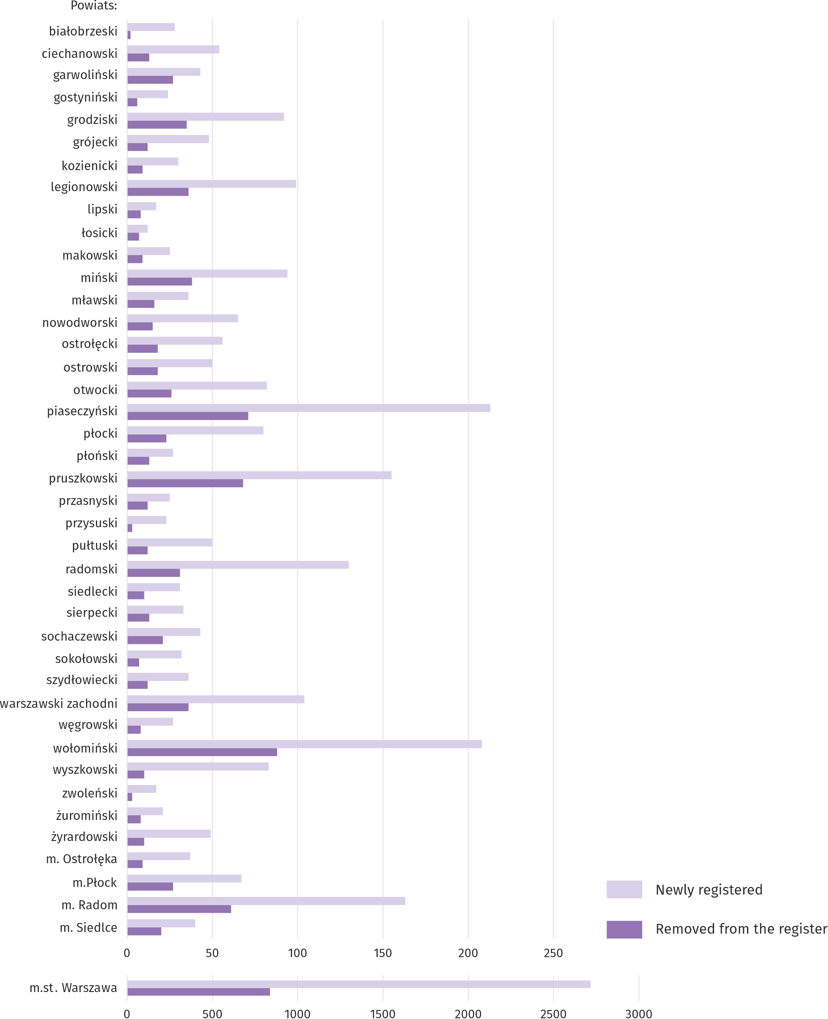

As of the end of August this year, in the REGON register 84896 entities had suspended activity (by 0.4% less than a month before). The vast majority were natural persons conducting economic activity (90.5% compared to 90.6% in July this year).

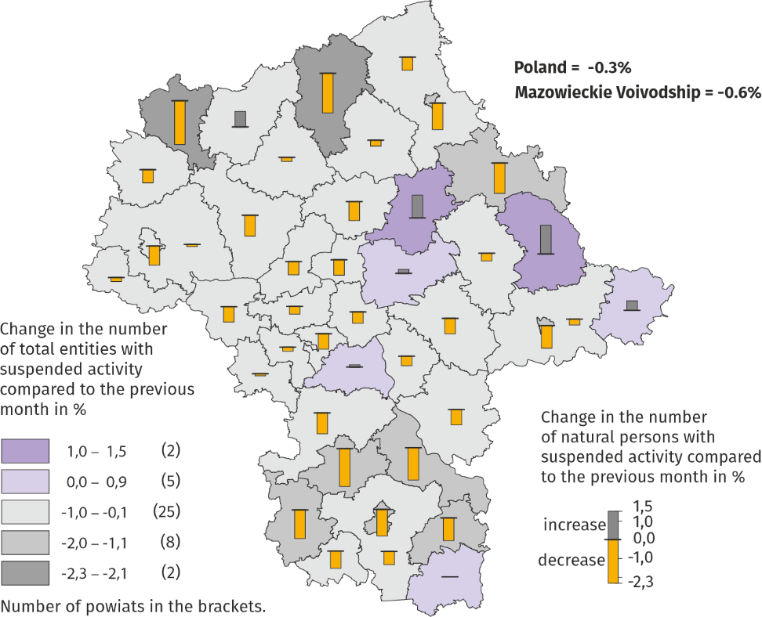
Map 3. Entities of the national economy with suspended activity in August 2020
Business tendency
Entrepreneurs in most surveyed areas in September this year, assess the economic situation similarly as in August this year. The exceptions were the sections of retail sales and transportation and storage, where the ratings went up.
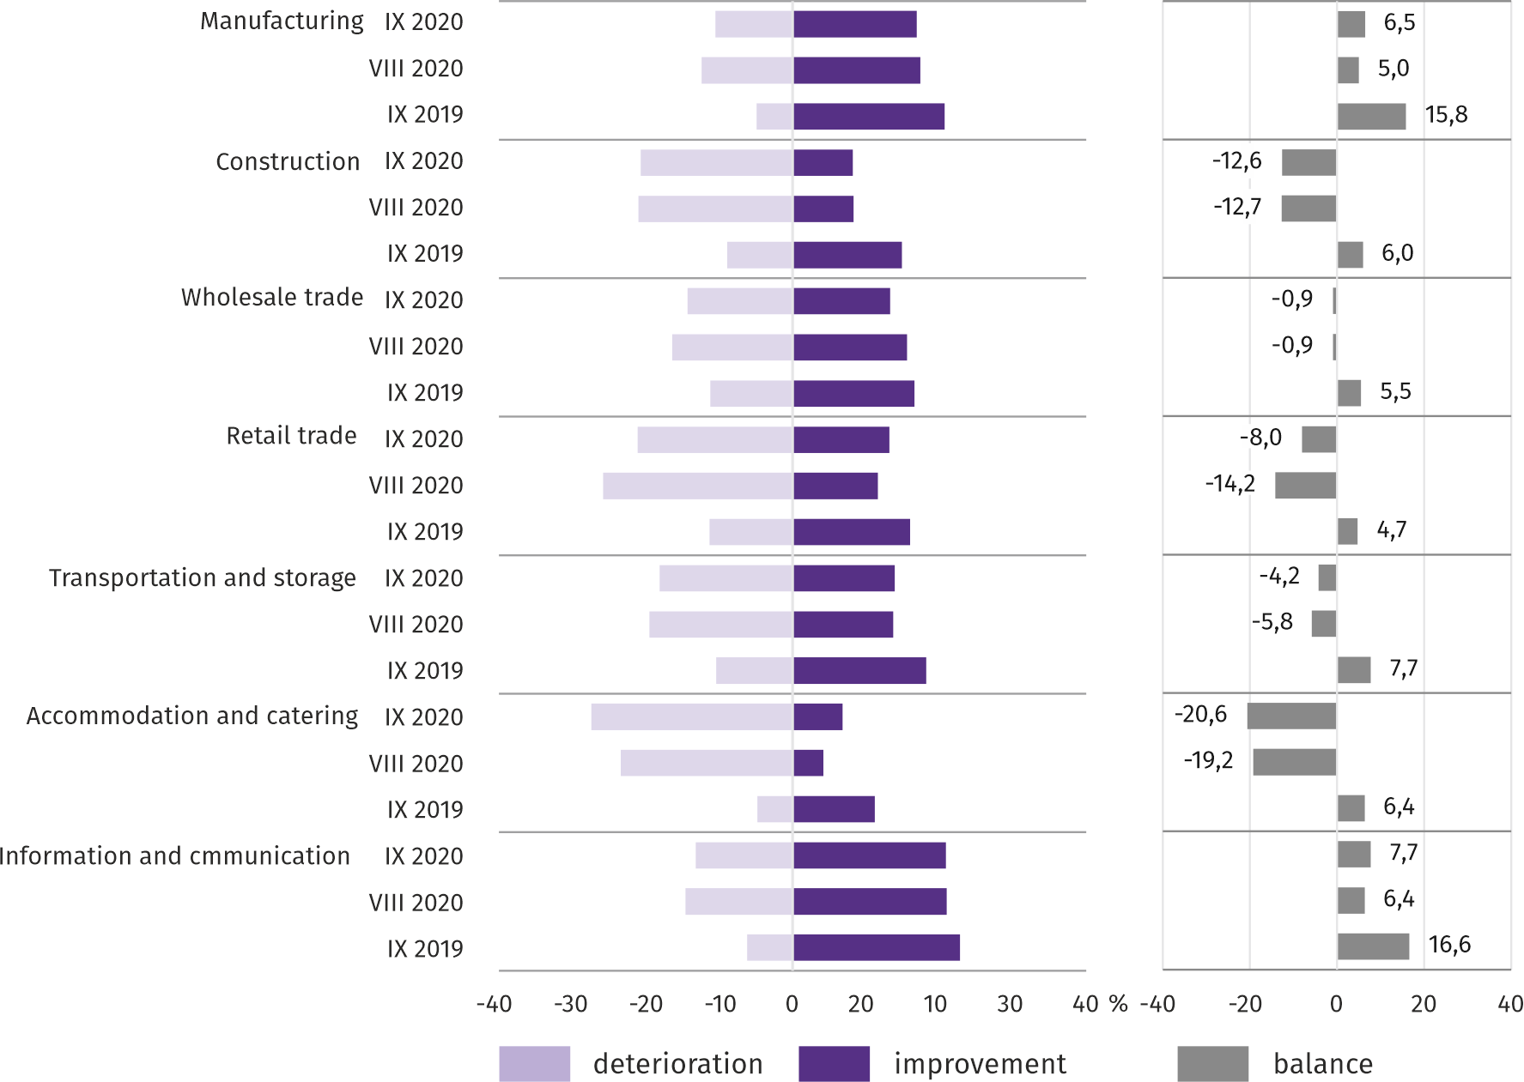
Chart 19. Indices of the general business climate by type of activity (sections and divisions of NACE Rev.2)

Survey results on the impact of the SARS-CoV-2 coronavirus pandemic on the economic situation
Entrepreneurs operating in all surveyed types of activity most often believed that the coronavirus pandemic in September would have slight negative consequences for their business. The largest percentage of responses indicating that the negative impact of the pandemic will be serious was in retail sales.
The representatives of most of the surveyed areas of activity (except for wholesale trade) most often stated that their company did not use any form of assistance under the so-called Anti-crisis shield. In most of the surveyed entities, the main form of aid used under the so-called The anti-crisis shield included exemptions and deferrals for the payment of taxes and social security contributions, while in manufacturing wage subsidies, and in construction – loans or subsidies and other financial aid.

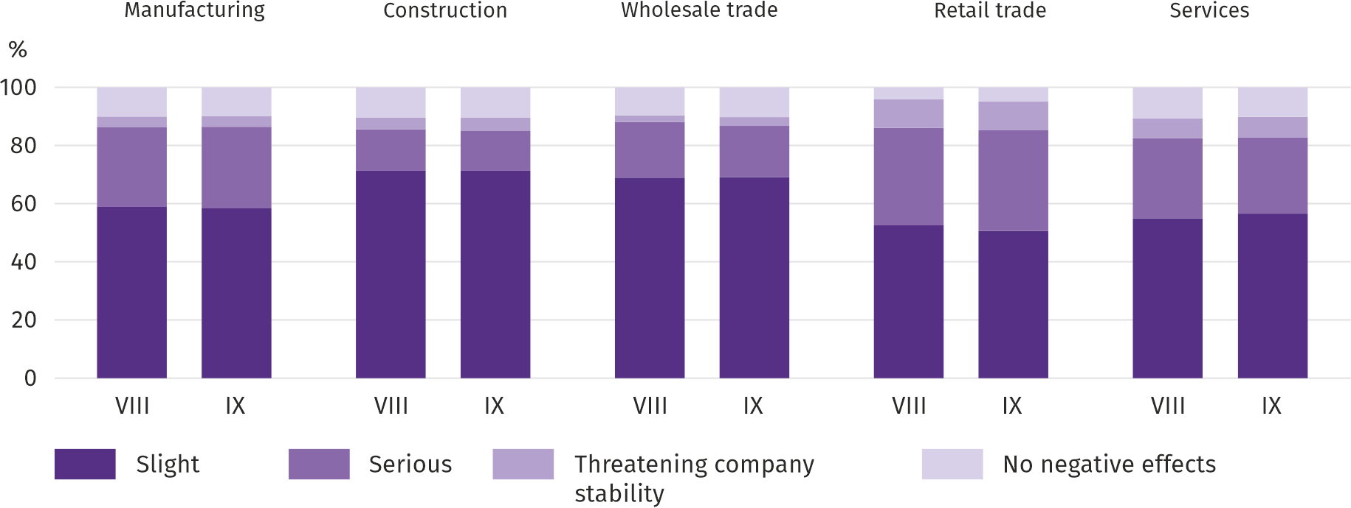
Question 1. The negative effects of the "coronavirus" pandemic and its consequences for your economic activity were (in August) and will be (in September):

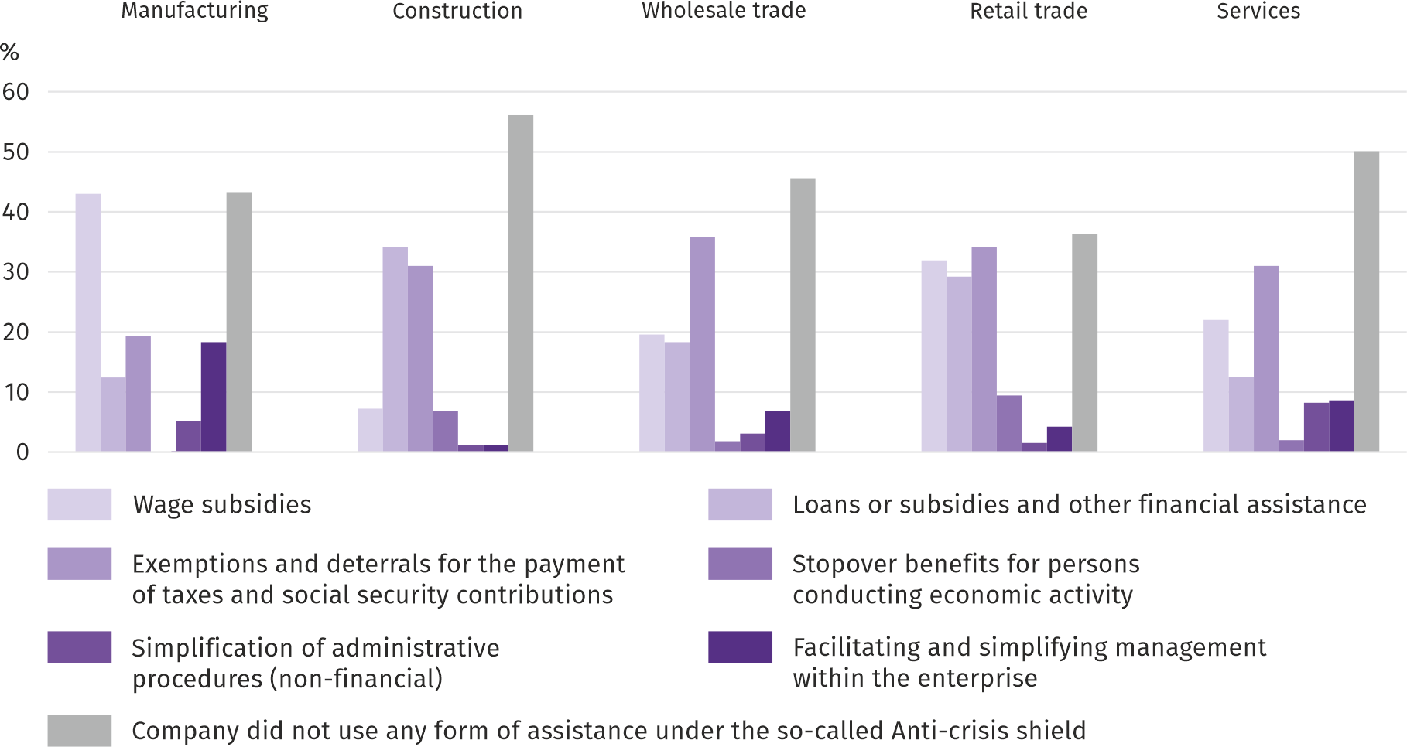
Q. 2. What forms of assistance and facilities under the so-called The anti-crisis shield your company has used so far?

Among the presented types of activities, remote work and similar forms of work were most popular among those employed in services and wholesale trade. In services, unplanned absence of employees due to holidays, childcare, family care etc. was slightly more frequent than in other areas of activity. Lack of employees due to quarantine or other restrictions was most often reported in retail trade.

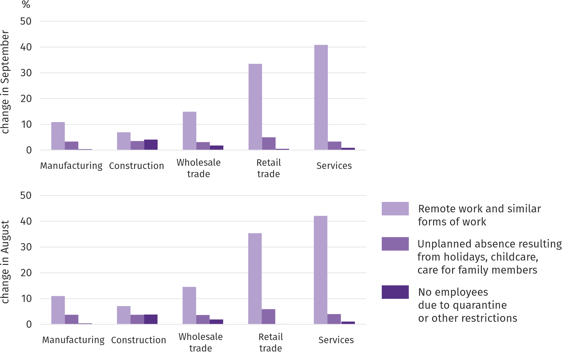
Q. 3. Please provide an estimate which percentage of your company's employees (irrespective of the type of employment contract, civil law contract, self-employed workers, trainees, agents, etc.) has been covered (in August) and will cover (in September) each of the following situations:

Entrepreneurs from all the presented areas of economic activity predicted a decline in orders both placed with sup-pliers and accepted from customers in September. A drop lower than a month earlier in both cases was expected only in construction.
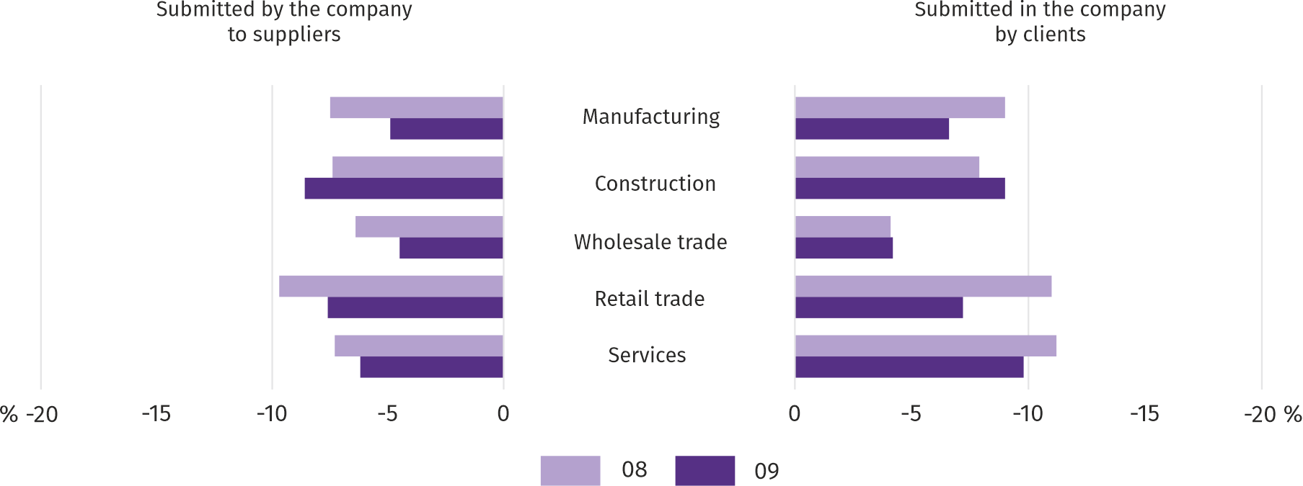
Q. 4-5. What was (in August) and will be (in September) the estimated (in percentage) change in orders for semi-finished products, raw materials, goods or services etc. made by your company with suppliers and placed in your company by cus-tomers?

When assessing the company's ability to survive while maintaining the current actions and limitations taken to combat the coronavirus by the state authorities in Poland (but also resulting from the actions of other countries, e.g. in the field of border traffic), the largest number of entrepreneurs in construction concluded that the company would have survived for more than 6 months.

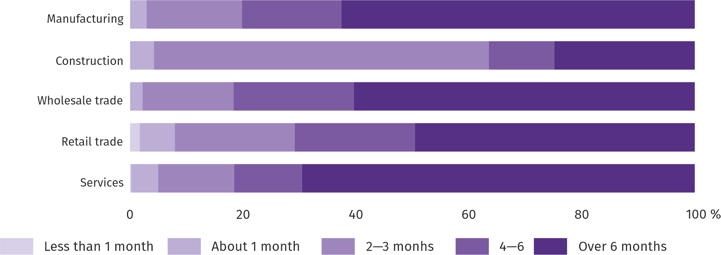
Q. 6. If current actions taken to combat coronavirus by the state authorities in Poland (but also resulting from actions of other countries, e.g. in border traffic), functioning at the time of completing the survey would last for a long time, how many months your company would be able to survive?
Among the presented types of activity, representatives of the retail trade expected the largest decrease in investment compared to the previous year.

Q. 7. What are your current forecasts for the level of investments of your company in 2020 in relation to the investments made in 2019?

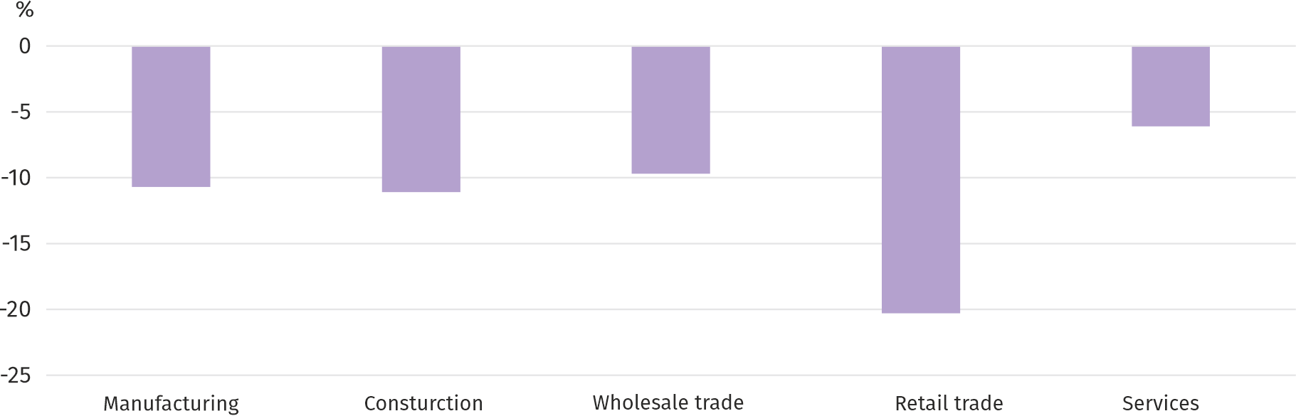

More information on the results of the business climate survey can be found on the website of the Statistical Office in Zielona Góra https://zielonagora.stat.gov.pl/osrodki/osrodek-badan-koniunktury/obk-dane/.

Table 14. Selected data on Mazowieckie Voivodship
SPECIFICATION  A – 2019  B – 2020 |  | 01 | 02 | 03 | 04 | 05 | 06 | 07 | 08 | 09 | 10 | 11 | 12
Average employment in the enterprise sector ª  (in thousand persons) | A | 1527,0 | 1522,3 | 1525,2 | 1525,9 | 1523,5 | 1524,8 | 1529,5 | 1530,8 | 1528,6 | 1530,9 | 1536,1 | 1541,1
 | B | 1552,1 | 1551,5 | 1545,4 | 1513,6 | 1499,3 | 1510,1 | 1519,7 | 1528,9
previous month=100 | A | 101,3 | 99,7 | 100,2 | 100,0 | 99,8 | 100,1 | 100,3 | 100,1 | 99,9 | 100,2 | 100,3 | 100,3
 | B | 100,7 | 100,0 | 99,6 | 97,9 | 99,1 | 100,7 | 100,6 | 100,6
corresponding month of previous year=100 | A | 102,5 | 102,2 | 102,4 | 102,4 | 102,3 | 102,3 | 102,3 | 102,2 | 102,1 | 102,3 | 102,2 | 102,3
 | B | 101,6 | 101,9 | 101,3 | 99,2 | 98,4 | 99,0 | 99,4 | 99,9
Registered unemployed persons (in thousand persons; as of end of period) | A | 143,4 | 142,4 | 138,8 | 133,8 | 130,1 | 126,7 | 125,6 | 125,6 | 123,3 | 120,9 | 121,9 | 123,2
 | B | 130,1 | 129,6 | 127,8 | 133,4 | 139,6 | 143,1 | 145,1 | 145,7
Unemployment rate ^{b} (in %; as of end of period) | A | 5,1 | 5,0 | 4,9 | 4,7 | 4,6 | 4,5 | 4,5 | 4,5 | 4,4 | 4,3 | 4,3 | 4,4
 | B | 4,6 | 4,6 | 4,5 | 4,7 | 4,9 | 5,1 | 5,1 | 5,2
Job offers (submitted during a month) | A | 17000 | 15394 | 15971 | 15065 | 15153 | 13859 | 13573 | 13132 | 14628 | 14386 | 12061 | 10281
 | B | 16059 | 14693 | 12277 | 7983 | 11057 | 12516 | 12513 | 11754
Unemployed persons per 1 job offer (as of end of period) | A | 16 | 14 | 17 | 15 | 13 | 13 | 14 | 15 | 13 | 14 | 15 | 27
 | B | 14 | 17 | 23 | 25 | 23 | 20 | 20 | 19
Average monthly gross wages and salaries in the enterprise sector ª (in PLN) | A | 5919,32 | 5920,22 | 6311,43 | 6185,82 | 6020,53 | 6093,26 | 6036,91 | 6053,18 | 6000,45 | 6273,41 | 6098,25 | 6402,10
 | B | 6285,91 | 6284,26 | 6701,01 | 6369,76 | 6084,99 | 6235,99 | 6270,52 | 6252,79
previous month=100 | A | 97,2 | 100,0 | 106,6 | 98,0 | 97,3 | 101,2 | 99,1 | 100,3 | 99,1 | 104,5 | 97,2 | 105,0
 | B | 98,2 | 100,0 | 106,6 | 95,1 | 95,5 | 102,5 | 100,6 | 99,7
corresponding month of previous period=100 | A | 106,6 | 106,2 | 104,5 | 105,5 | 107,1 | 106,1 | 104,9 | 106,3 | 106,5 | 105,6 | 104,5 | 105,2
 | B | 106,2 | 106,1 | 106,2 | 103,0 | 101,1 | 102,3 | 103,9 | 103,3
Price indices:
consumer goods and services ^{c}:
corresponding period of previous year=100 | A | . | . | 101,0 | . | . | 102,2 | . | . | 102,7 | . | . | 102,7
 | B | . | . | 104,1 | . | . | 103,3 | . | .
a In enterprises employing more than 9 persons. b Share of registered unemployed persons in civilian economically active population, estimated at the end of each month. c In the quarter.
Table 14. Selected data on Mazowieckie Voivodship (cont.)
SPECIFICATION  A – 2019  B – 2020 |  | 01 | 02 | 03 | 04 | 05 | 06 | 07 | 08 | 09 | 10 | 11 | 12
Price indices (cont.):
Procurement of cereal grain:
previous month=100 | A | 104,3 | 100,6 | 105,0 | 91,2 | 100,6 | 95,4 | 84,1 | 99,9 | 102,7 | 98,5 | 102,9 | 101,5
 | B | 102,6 | 106,7 | 97,5 | 107,0 | 105,4 | 93,3 | 84,3 | 98,8
corresponding month of previous year=100 | A | 123,3 | 128,6 | 131,0 | 118,7 | 119,6 | 112,3 | 97,9 | 89,4 | 85,9 | 81,6 | 81,4 | 85,5
 | B | 84,2 | 89,3 | 82,9 | 97,3 | 102,0 | 99,7 | 99,9 | 98,8
procurement of cattle for slaughter (excluding calves):
previous month=100 | A | 111,7 | 93,3 | 110,6 | 101,0 | 94,5 | 90,6 | 122,2 | 93,5 | 92,0 | 98,2 | 102,5 | 102,8
 | B | 107,1 | 99,0 | 97,1 | 101,3 | 98,5 | 98,6 | 104,0 | 93,7
corresponding month of previous year=100 | A | 108,1 | 105,8 | 130,2 | 111,3 | 104,4 | 95,0 | 117,7 | 110,1 | 105,5 | 100,8 | 104,0 | 108,5
 | B | 104,1 | 110,4 | 96,9 | 97,2 | 101,3 | 110,2 | 93,8 | 94,0
procurement of pigs for slaughter:
previous month=100 | A | 94,2 | 101,5 | 107,5 | 130,6 | 101,1 | 98,7 | 98,2 | 103,6 | 100,2 | 99,8 | 101,1 | 107,2
 | B | 95,5 | 104,3 | 100,5 | 96,5 | 89,9 | 104,6 | 91,2 | 98,2
corresponding month of previous year=100 | A | 95,1 | 93,0 | 96,7 | 128,1 | 132,4 | 124,2 | 120,7 | 122,4 | 126,3 | 135,2 | 142,1 | 147,6
 | B | 149,5 | 153,7 | 143,8 | 106,3 | 94,5 | 100,1 | 93,0 | 88,2
Ratio of procurement prices ª of pigs for slaughter to marketplace prices of rye | A | 5,9 | 5,9 | 6,2 | 8,2 | 8,0 | 8,1 | 8,3 | 8,9 | 9,0 | 9,3 | 9,7 | 9,7
 | B | 9,4 | 10,0 | 10,1 | . | . | . | 8,7 | 8,6
Sold production of industry ^{b} (at constant prices):
previous month=100 | A | 106,1 | 91,5 | 111,0 | 95,4 | 97,1 | 94,6 | 104,1 | 97,9 | 105,0 | 113,4 | 100,3 | 92,8
 | B | 101,8 | 97,2 | 106,0 | 81,7 | 105,6 | 107,7 | 101,2* | 96,6
corresponding month of previous year=100 | A | 109,5 | 104,9 | 105,3 | 112,2 | 108,6 | 101,9 | 106,6 | 102,5 | 107,5 | 109,3 | 109,5 | 106,7
 | B | 102,4 | 108,8 | 103,9 | 88,9 | 96,6 | 110,0 | 106,9* | 105,5
Construction and assembly production ^{b} (at current prices):
previous month=100 | A | 40,1 | 146,1 | 115,8 | 102,0 | 105,4 | 108,7 | 112,1 | 103,8 | 113,3 | 83,2 | 91,1 | 127,3
 | B | 44,4 | 122,3 | 120,5 | 99,9 | 100,0 | 109,0 | 95,2 | 100,1
corresponding month of previous year=100 | A | 90,1 | 154,2 | 114,3 | 124,5 | 107,2 | 106,8 | 108,1 | 124,4 | 130,9 | 88,2 | 87,9 | 100,8
 | B | 111,6 | 93,4 | 97,2 | 95,2 | 90,3 | 90,6 | 77,0 | 74,2
a Current prices excluding VAT. b In enterprises employing more than 9 persons.
Table 14. Selected data on Mazowieckie Voivodship (cont.)
SPECIFICATION  A – 2019  B – 2020 |  | 01 | 02 | 03 | 04 | 05 | 06 | 07 | 08 | 09 | 10 | 11 | 12
Dwellings completed (from the beginning of the year) | A | 3417 | 6721 | 9618 | 13103 | 16758 | 19476 | 22704 | 26794 | 30151 | 34604 | 39214 | 43159
 | B | 2675 | 6227 | 9151 | 11749* | 14848* | 18367* | 23916* | 27492
corresponding period of previous year=100 | A | 83,0 | 99,4 | 94,7 | 103,1 | 110,2 | 107,2 | 102,5 | 101,9 | 104,6 | 106,0 | 109,9 | 105,1
 | B | 78,3 | 92,6 | 95,1 | 89,7* | 88,6* | 94,3* | 105,3* | 102,6
Retail sales of goods ª (at current prices):
previous month=100 | A | 79,4 | 94,5 | 116,2 | 104,2 | 98,6 | 102,7 | 101,2 | 99,3 | 96,7 | 105,7 | 100,7 | 116,8
 | B | 75,7 | 96,4 | 91,0 | 84,4 | 126,7 | 110,1 | 105,7 | 99,3
corresponding month of previous year=100 | A | 104,5 | 104,5 | 105,7 | 110,5 | 106,2 | 104,7 | 105,6 | 103,8 | 104,7 | 104,5 | 106,4 | 111,2
 | B | 106,0 | 108,1 | 84,7 | 68,6 | 88,2 | 94,5 | 98,8 | 98,7
Turnover profitability indicator in enterprises ^{b}:
gross ^{c} (in %) | A | . | . | 3,8 | . | . | 5,3 | . | . | 5,0 | . | . | 4,6
 | B | . | . | 1,8 | . | . | 4,6 | . | .
net ^{d} (in %) | A | . | . | 3,0 | . | . | 4,3 | . | . | 4,1 | . | . | 3,7
 | B | . | . | 1,1 | . | . | 3,6 | . | .
Investment outlays of enterprises ^{b} – from the beginning of the year (in million PLN; current prices) | A | . | . | 8186,7 | . | . | 19969,2 | . | . | 32656,9 | . | . | 50991,5
 | B | . | . | 8368,8 | . | . | 18781,7 | . | .
corresponding period of previous year=100 (current prices) | A | . | . | 120,7 | . | . | 118,4 | . | . | 115,9 | . | . | 108,7
 | B | . | . | 102,2 | . | . | 94,1 | . | .
Entities of the national economy ^{e} in the REGON register (as of end of period) | A | 819274 | 822655 | 826407 | 829983 | 833385 | 836698 | 840124 | 843374 | 846686 | 850340 | 853160 | 854457
 | B | 855961 | 858420 | 860908 | 862303 | 864666 | 867648 | 871377 | 874831
of which commercial companies | A | 160010 | 160971 | 161997 | 162973 | 163843 | 164635 | 165630 | 166585 | 167542 | 168588 | 169648 | 170518
 | B | 171505 | 172783 | 173778 | 174576 | 175292 | 175968 | 176895 | 177906
of which with foreign capital participation | A | 31667 | 31718 | 31813 | 31996 | 32205 | 32384 | 32603 | 32747 | 32863 | 32966 | 33117 | 33215
 | B | 33224 | 33365 | 33482 | 33636 | 33734 | 33747 | 33813 | 33920
a In enterprises employing more than 9 persons. b In enterprises employing more than 49 persons. c Relation of gross financial result to revenues from total activity. d Relation of net financial result to revenues from total activity. e Excluding persons tending private farms in agriculture.

Prepared by | Contact: |  | warszawa.stat.gov.pl/en/
Statistical Office in Warszawa  Director Zofia Kozłowska | tel.: (+48 22) 464 23 15 |  | @Warszawa_STAT
1 Sierpnia 21 | fax: (+48 22) 846 76 67
02-134 Warszawa | e-mail: SekretariatUSWAW@stat.gov.pl

Related information
Statistical Bulletin of Mazowieckie Voivodship
Report on the socio-economic situation of Mazowieckie Voivodship in 2018
Socio-economic situation of voivodships No. 1/2020

Data available in databases
Local Data Bank
Knowledge Databases

Terms used in official statistics
Enterprise sector
Average paid employment
Registered unemployed persons
Registered unemployment rate
Average monthly gross wages and salaries
Retail price
Price index of consumer goods and services
Procurement of agricultural products
Procurement prices
Marketplace prices
Pigs
Cattle
Sold production of industry
Sale of construction and assembly production
Dwellings completed
Retail sales of goods
Wholesale
Financial results of enterprises
Investment outlays
Koniunktura gospodarcza

In the case of quoting data from the Statistics Poland, please provide information “Statistics Poland data source”, and in the case of publishing calculations made on data published by the Statistics Poland, provide information: “Own study on Statistics Poland data”.

Long-term unemployed include persons remaining in the register rolls of the powiat labour office for the whole period of over 12 months during the last 2 years, excluding periods of traineeship and occupational preparation at the workplace.
Refers to vacancies and places of occupational activation.
The average values of temperature and precipitation were calculated as arithmetic averages of the average monthly values from five hydrological and meteorological stations of the Institute of Meteorology and Water Management located in Kozienice, Mława, Płock, Siedlce and Warszawa.
Reporting data – may change after preparing quarterly report.
Covered by the "Demand for labour" survey.
It applies to legal persons, organizational units without legal personality and natural persons conducting economic activity (excluding natural persons tending private farms in agriculture).
The survey was conducted on a sample of industrial, construction, commercial and service units. In contrast to the basic economic climate survey, the answers to the additional block of questions were provided on a voluntary basis. Questions 1, 2 and 7 present the structure of answers (percentage of respondents' answers to a given option), and the remaining questions - the average of the values of answers given. The data have been aggregated in accordance with the aggregation (weighting) methodology used as standard in the study of the economic situation.

