Socio-economic situation of Mazowieckie Voivodship in February 2020
- In February this year, the average employment in the enterprise sector was higher than a year before (by 1.9%). The registered unemployment rate amounted to 4.6% and decreased on a yearly basis, but did not change on a monthly basis.
- Average monthly gross wages and salaries in the enterprise sector in February this year were higher than in the previous year (by 6.1%).
- Retail prices of consumer goods and services in the fourth quarter of 2019 increased by 2.7% in annual terms (the same increase was recorded in the third quarter of 2019).
- On the agricultural market in February this year, the procurement prices of plant products and milk were lower than in the previous year, and prices of animals for slaughter were higher. On a monthly basis, prices of cattle for slaughter and potatoes were lower, and the prices of cereals, pigs and poultry for slaughter as well as milk were higher.
- In February this year, sold production of industry increased in annual terms (by 8.7%, at constant prices). Construction and assembly production was lower than a year before (by 6.6%, at current prices).
- The number of dwellings completed in February this year was higher than a year before by 3.1%. Most of the dwellings were built for sale or rent.
- In February this year, there was an increase in retail sales in annual terms (by 8.1%). The wholesale was higher than a year before (by 6.6%).
- In 2019, the financial results of enterprises were higher than those achieved a year ago. The basic economic and financial indicators have barely changed.
- Investment outlays incurred by enterprises in 2019 were (at current prices) higher than in the previous year by 8.7%. The cost estimate value of newly started investments was higher than in 2018 (by 25.0%).

Contents
Labour market 4
Wages and salaries 7
Retail prices 9
Agriculture 9
Industry and construction 13
Housing construction 15
Domestic market 17
Financial results of enterprises 18
Investment outlays 20
Selected data on Mazowieckie Voivodship 21
General notes
Data presented in the news release:
- on employment, wages and salaries and sold production of industry and construction, construction and assembly production, as well as retail sales and wholesale concern economic entities employing more than 9 persons,
- on enterprise sector refer to entities conducting economic activity in the field of: forestry and logging; maritime fishing; mining and quarrying; manufacturing; electricity, gas, steam and air conditioning supply; water supply; sewerage, waste management and remediation activities; construction; wholesale and retail trade; repair of motor vehicles and motorcycles; transportation and storage; accommodation and food service activities; information and communication; real estate activities; legal and accounting activities; activities of head offices; management consultancy activities; architectural and engineering activities; technical testing and analysis; advertising and market research; other professional, scientific and technical activities; arts, entertainment and recreation; repair of computers and personal and household goods; other personal service activities,
- on retail prices of foodstuffs and non-foodstuffs as well as services that originate from quotations of prices conducted by interviewers at selected points of sale in selected regions of price surveys; prices of food are collected once a month, with the exception of fruit and vegetables, for which prices are collected twice a month,
- on procurement of agricultural products include procurement from producers from the voivodship; prices are given excluding VAT tax,
- on financial results of enterprises and investment outlays refer to economic entities keeping accounting ledgers (excluding entities whose activity is classified according to the NACE Rev. 2 in the sections “Agriculture, forestry and fishing” and “Financial and insurance activities” as well as higher education institutions) in which the number of employed persons exceeds 49.
Data in value terms are provided at current prices and form the basis for calculating the structure indicators. Dynamic indices are provided on the basis of value at current prices, except for industry, for which the dynamic indices are provided on the basis of value at constant prices (average current prices of 2015).
Relative numbers (indices, percentages) were calculated on the basis of absolute data expressed with higher precision than that presented in the text and tables.
Data have been presented in accordance with the Polish Classification of Activities – PKD 2007 (NACE Rev. 2).

Polish Classification of Activities 2007 – PKD 2007 (NACE Rev.2)
Abbreviation | Full name
sections
trade; repair of motor vehicles | wholesale and retail trade; repair of motor vehicles and motorcycles
accommodation and catering | accommodation and food service activities
divisions
manufacture of metal products | manufacture of fabricated metal products, except machinery and equipment

Symbols
Symbol | Description
(–) | – magnitude zero
(.) | – data not available, classified data (statistical confidentiality) or providing data impossible or purposrless
(*) | – data revised
∆ | – categories of applied classification are presented in abbreviated form
„Of which” | – indicates that not all elements of the sum are given

Data describing Mazowieckie Voivodship can also be found in statistical publications issued by the Statistical Office in Warszawa and in the publications of Statistics Poland.
The report „Economic situation in Mazowieckie Voivodship in February 2020” will be published on the home page of the Statistical Office in Warszawa: https://warszawa.stat.gov.pl/en on 31st March 2020.
When publishing Statistical Office data – please indicate the source.

Labour market
In February this year, a higher year-on-year increase was recorded in employment in the enterprise sector compared to the previous month. The registered unemployment rate decreased on a yearly basis but did not change on a monthly basis.
Average employment in the enterprise sector in February this year amounted to 1551.5 thousand persons and was by 1.9% higher than a year before (in the previous month there was a 1.6% increase). Employment growth was recorded in, among others, accommodation and catering (by 4.3%), professional, scientific and technical activities (by 3.8%) as well as in transportation and communication (by 3.0%). A decrease was recorded in construction (by 2.1%) and in electricity, gas, steam and air conditioning supply (by 0.6%).
Table 1. Average employment in the enterprise sector in February 2020
SPECIFICATION | II 2020 |  | I–II 2020
 | in thousands | II 2019=100 | in thousands | I–II 2019=100
TOTAL | 1551,5 | 101,9 | 1552,1 | 101,9
of which:
Industry | 385,5 | 102,2 | 385,1 | 102,3
of which:
manufacturing | 338,6 | 102,3 | 338,3 | 102,4
electricity, gas, steam and air conditioning supply | 25,4 | 99,4 | 25,5 | 99,4
Construction | 90,1 | 97,9 | 90,3 | 97,8
Trade; repair of motor vehicles^{Δ} | 350,6 | 101,8 | 350,6 | 101,9
Transportation and storage | 280,7 | 103,0 | 280,4 | 102,7
Accommodation and catering ^{Δ} | 36,1 | 104,3 | 36,1 | 104,6
Information and communication | 115,9 | 100,9 | 116,1 | 101,0
Real estateactivities | 23,6 | 100,9 | 23,6 | 101,1
Professional, scientific and technical activities ª | 97,9 | 103,8 | 97,8 | 103,9
Administrative and support service activities | 137,1 | 100,9 | 138,3 | 100,7
a Excluding divisions: Research and experimental development work and Veterinary activities.

In the period January–February 2020, the average employment in the enterprises sector amounted to 1552.1 thousand persons and was by 1.9% higher than In the corresponding period of 2019 (higher by 2.3% a year before).

Chart 1. Average employment in the enterprise sector (monthly average 2015=100)
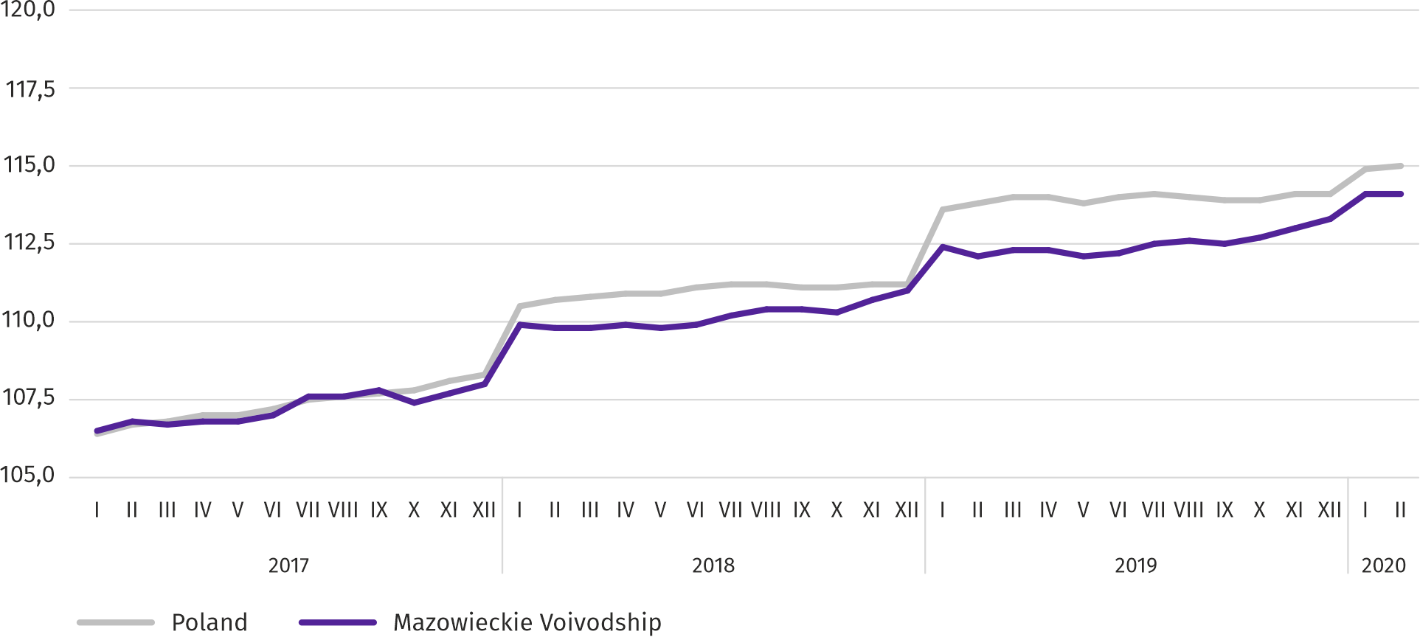

At the end of February this year, the number of unemployed persons registered in labour offices amounted to 129.6 thousand persons and decreased on a monthly basis by 0.5 thousand persons (i.e. by 0.4%), and compared to February 2019 it decreased by 12.7 thousand persons (i.e. by 8.9%). Women accounted for 50.8% of total registered unemployed persons (a year before 51.2%).
Table 2. Number of unemployed persons and unemployment rate
SPECIFICATION | 2019 | 2020
 | II | I | II
Registered unemployed persons (as of end of month) in thousands | 142,4 | 130,1 | 129,6
Newly registered unemployed persons (during a month) in thousands | 15,0 | 18,7 | 13,6
Unemployed persons removed from unemployment rolls (during a month) in thousands | 16,0 | 11,8 | 14,0
Registered unemployment rate (as of end of month) in % | 5,0 | 4,6 | 4,6
Chart 2. Registered unemployment rate (as of end of month)
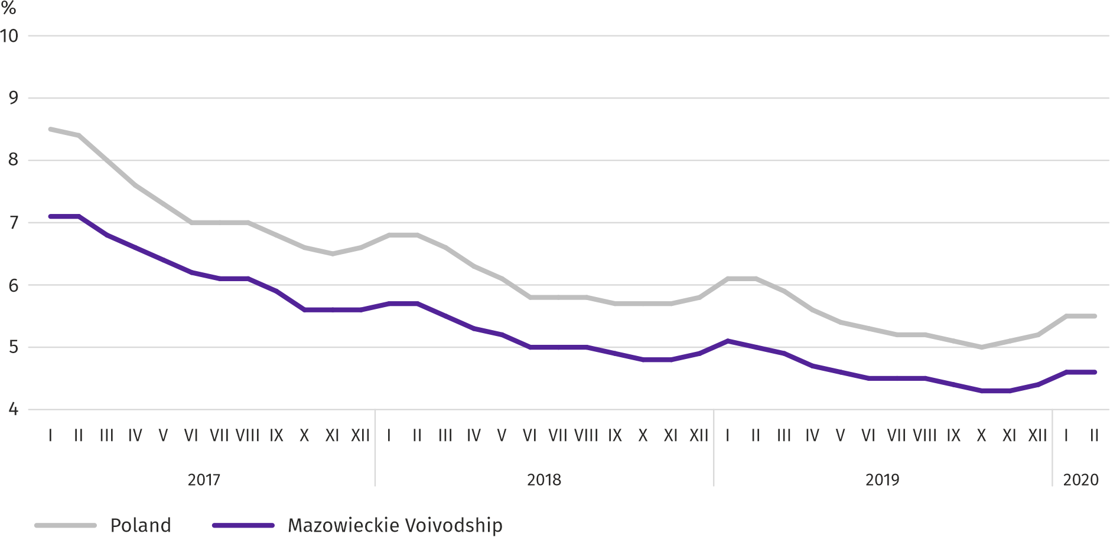
Registered unemployment rate at the end of February this year amounted to 4.6% and was lower than the national average (5.5%). It decreased by 0.4 pp on a yearly basis, and remained the same on a monthly basis.
The territorial differentiation of the unemployment rate continued in the voivodship. Powiats with the highest unemployment rate were szydłowiecki (23.9% compared to 24.8% in February 2019), przysuski (17.8% compared to 18.5%) and radomski (17.1% compared to 17.7%), and with the lowest – m.st. Warszawa (1.3% compared to 1.5%), warszawski zachodni (1.8% compared to 2.1%) and grójecki (2.2% compared to 2.3%).
Compared to February 2019, the unemployment rate fell in 41 out of 42 powiats. The largest decrease was recorded in the powiats: gostyniński (by 2.2 pp), sierpecki (by 1.8 pp) and łosicki (by 1.6 pp), while the smallest in the powiats: białobrzeski, grójecki (by 0.1 pp), m.st. Warszawa (by 0.2 pp) as well as grodziski, miński and warszawski zachodni (by 0.3 pp each). The increase occurred only in sokołowski powiat (by 0.2 pp).
Map 1. Registered unemployment rate by powiats in 2019 (as of end of February)
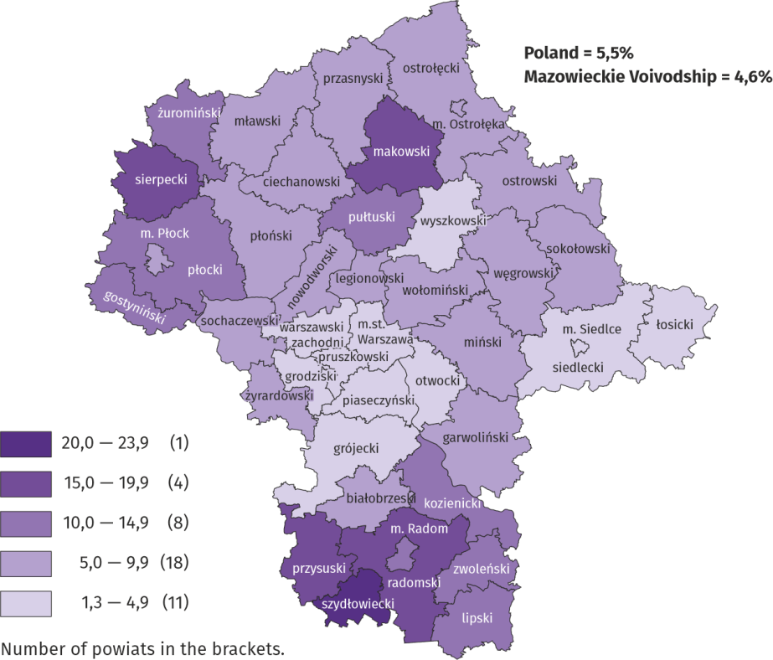

In January this year, 13.6 thousand unemployed persons were registered in labour offices, i.e. less by 27.7% than a month before and less by 12.2% than a year before. Among the newly registered, 79.2% were persons registered once again (80.3% a year before). The share of persons previously not employed amounted to 13.2% (a decrease by 1.6 pp on a yearly basis), persons terminated due to company reasons 4.1% (a 0.7 pp increase). Out of newly registered unemployed persons, 42.1% were rural residents (a decrease by 0.1 pp). Graduates accounted for 6.8% of newly registered unemployed persons (a 1.3 pp drop).
In February this year, 14.0 thousand persons were removed from unemployment rolls, i.e. more by 18.6% than a month before and by 15.0% less than a year before. 7.0 thousand persons (7.7 thousand a year before) were removed from unemployment rolls due to undertaking employment. The share of this category of persons in the total number of persons removed from unemployment rolls increased by 2.3 pp on a yearly basis and amounted to 50.2%. The percentage of persons who lost their status of the unemployed as a result of not confirming readiness to take up work increased as well (by 0.7 pp to 20.7%). However, there was a decrease in the percentage of persons who voluntarily gave up their status of the unemployed (by 1.9 pp to 6.5%) as well as persons who started training or traineeship with employer (by 0.1 pp to 9.7%). The share of persons who obtained retirement or pension rights amounted to 0.4% and did not change on a yearly basis.
At the end of February year, 107.3 thousand unemployed persons were not entitled to the unemployment benefit, and their share in the total number of the registered unemployed was 82.8% (a 0.6 pp decrease in annual terms).
At the end of the surveyed month, 65.2 thousand, i.e. 50.3% out of registered unemployed persons were the long-term unemployed. The number of unemployed persons under the age of 30 amounted to 31.9 thousand, which accounted for 24.6% of the total unemployed (of which persons under the age of 25 constituted 11.8%). Persons aged over 50 amounted to 35.2 thousand (27.2%). 1.3 thousand of unemployed persons, i.e. 1.0% of their total number received social assistance benefits. There were 22.6 thousand persons (i.e. 17.5% of the total unemployed) had at least one child under the age of 6, and persons with a disabled child aged under 18 – 295 persons (0.2% respectively). The number of disabled unemployed persons amounted to 6.5 thousand (i.e. 5.0%).
Chart 3. Registered unemployed persons per job offer (as of end of month)
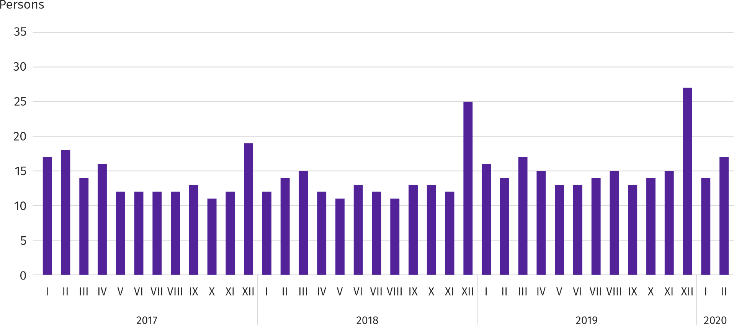

In February this year, 14.7 thousand job offers, i.e. less than a month before (by 8.5%) and than a year before (by 4.6%) were submitted to labour offices. At the end of month, there were 17 unemployed persons (14 in the previous year) per job offer.
According to the labour offices, as of the end of February this year, 32 companies announced termination of 10.2 thousand employees in the near future (a year before, respectively 30 companies – 10.7 thousand employees).
Wages and salaries
In February this year, the average monthly gross wages and salaries in the enterprise sector grew slower on a yearly basis than a month before.
Average monthly gross wages and salaries in the enterprise sector in February this year amounted to PLN 6284.26 and were by 6.1% higher than a year before (in the previous month the increase was 6.2%). Average wages and salaries increased, among others, in administrative and support service activities (by 11.0%), construction (by 10.6%), manufacturing (by 9.3%). The decrease was recorded in electricity, gas, steam and air conditioning supply (by 3.9%).
Chart 4. Relative deviations of average monthly gross wages and salaries in selected sections from average wages and salaries in the enterprise sector in February 2020
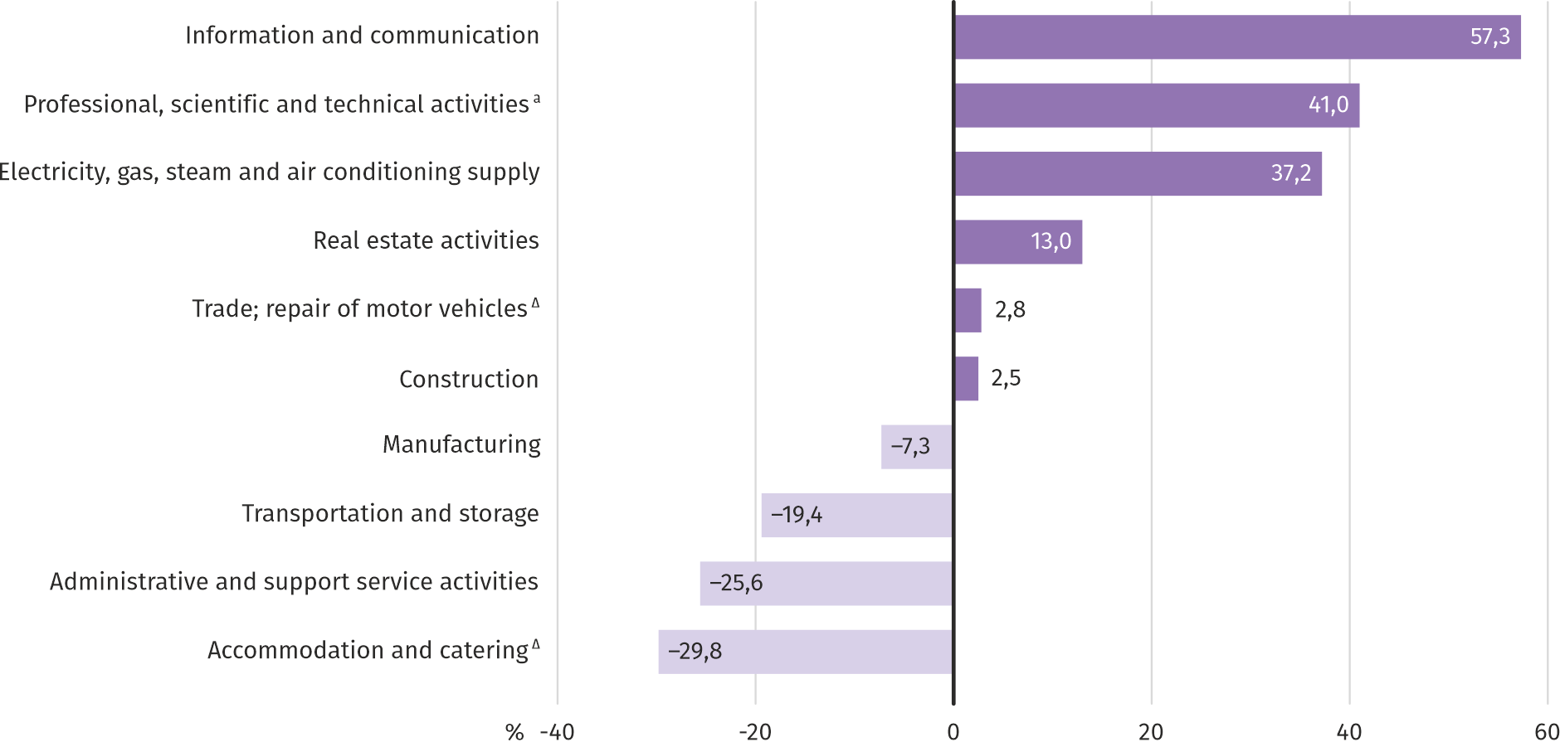
a Excluding divisions: Research and experimental development work and Veterinary activities.
In February 2020, the highest average monthly gross wages and salaries were noted in the information and communication section – it exceeded the average wages and salaries in the enterprise sector in the voivodship by 57.3%.
Table 3. Average monthly gross wages and salaries in the enterprise sector in February 2020
SPECIFICATION | II 2020 |  | I–II 2020
 | in PLN | II 2019=100 | in PLN | I–II 2019=100
TOTAL | 6284,26 | 106,1 | 6269,51 | 105,9
of which:
Industry | 5994,53 | 107,4 | 5907,60 | 106,4
of which:
manufacturing | 5824,58 | 109,3 | 5742,28 | 107,7
electricity, gas, steam and air conditioning supply | 8620,61 | 96,1 | 8405,18 | 98,1
Construction | 6438,50 | 110,6 | 6439,55 | 108,7
Trade; repair of motor vehicles^{Δ} | 6462,80 | 104,0 | 6437,63 | 104,5
Transportation and storage | 5062,08 | 105,6 | 5118,40 | 105,8
Accommodation and catering ^{Δ} | 4412,92 | 109,2 | 4558,09 | 107,7
Information and communication | 9883,16 | 104,5 | 9854,72 | 105,3
Real estate activities | 7103,98 | 107,0 | 7131,65 | 105,4
Professional, scientific and technical activities ª | 8863,43 | 104,5 | 8837,12 | 103,9
Administrative and support service activities | 4675,95 | 111,0 | 4698,53 | 111,3
a Excluding divisions: Research and experimental development work and Veterinary activities.

In the period January-February 2020, the average monthly gross wages and salaries in the enterprise sector amounted to PLN 6269.51 and was by 5.9% higher than in the corresponding period of 2019 (by 6.6% higher a year before).
Chart 5. Average monthly gross wages and salaries in the enterprise sector (monthly average 2015=100)
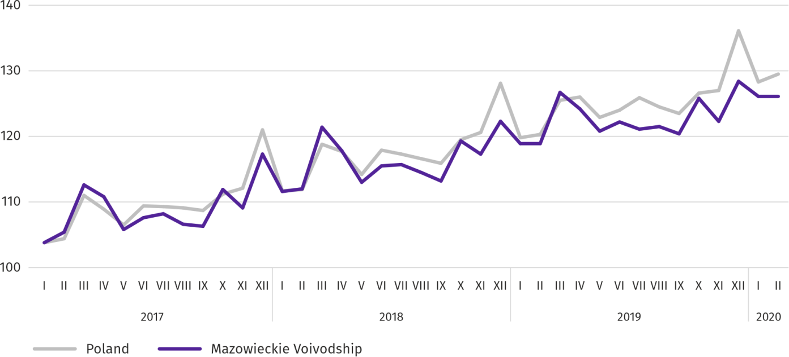
Retail prices
In the fourth quarter of 2019, prices of consumer goods and services in Mazowieckie Voivodship increased by 2.7% on a yearly basis; in the fourth quarter of 2018, the increase was 1.4%.
The largest increase concerned the prices of food and non-alcoholic beverages (by 6.8%); in addition, there was an increase in the field of human health and education (3.7% each), recreation and culture (2.9%), as well as prices related to the use of housing (by 1.6%) and prices of alcoholic beverages and tobacco (by 1.2%). A drop in prices was recorded in transport (by 2.0%) and in the clothing and footwear group (by 1.5%).
Table 4. Indices of consumer goods and services
SPECIFICATION | 2018 |  | 2019
 | Q3 | Q4 | Q3 | Q4
 | corresponding period of previous year = 100
TOTAL | 101,9 | 101,4 | 102,7 | 102,7
Food and non-alcoholic beverages | 102,1 | 100,9 | 107,2 | 106,8
Alcoholic beverages and tobacco | 101,8 | 101,7 | 100,9 | 101,2
Clothing and footwear | 96,2 | 97,8 | 99,1 | 98,5
Housing | 101,8 | 101,7 | 101,5 | 101,6
Human health | 102,3 | 102,2 | 103,9 | 103,7
Transport | 107,0 | 104,9 | 99,5 | 98,0
Recreation and culture | 103,0 | 102,3 | 102,2 | 102,9
Education | 102,7 | 103,4 | 103,2 | 103,7

The annual increase in prices recorded in the fourth quarter of 2019 in Mazowieckie Voivodship was slightly lower than the national average (2.7% compared to 2.8%).

Agriculture
On the agricultural market in February this year, the average procurement prices of cereals, potatoes and milk were lower than in the previous year. In monthly terms, the prices of potatoes and cattle for slaughter were lower, and the prices of cereals, pigs for slaughter and milk were higher.

The average air temperature in Mazowieckie Voivodship in February 2020 amounted to 3.5°C and was by 4.7°C higher from the average from the years 1981–2010, while the maximum temperature reached 14.5°C, and the minimum amounted to -6.1°C (both temperatures registered in Kozienice). The average atmospheric precipitation (48.8 mm) accounted for 196% of the standard for the multi-year periods (ranging from 130% in Płock to 221% in Kozienice). The number of days with precipitation, depending on the region, ranged from 20 to 22.

Table 5. Procurement of cerealsª
SPECIFICATION | VII 2019–II 2020 |  | II 2020
 | in thousand tonnes | corresponding  period of previuous year=100 | in thousand tonnes | II 2019=100 | I 2020=100
Grain of basic cereals ^{b} | 395,2 | 102,2 | 48,3 | 127,1 | 132,1
of which:
wheat | 267,1 | 95,5 | 39,3 | 135,0 | 132,3
rye | 70,9 | 134,9 | 2,6 | 59,0 | 113,0
a In January-February 2020, excluding procurement carried out by natural persons. b Includes: wheat, rye, barley, oats, triticale; including cereal mixed, excluding sowing seed.

Deliveries of basic cereals (including cereal mixed, excluding sowing seed) to procurement from the previous year’s production in July 2019–February 2020, were by 2.2% higher than in the corresponding period of previous year. In February this year, procurement of cereals was larger by 32.1% than in the previous month and by 27.1% than in a previous year.
Table 6. Procurement of basic animal products ª
SPECIFICATION | I–II 2020 |  | II 2020
 | in thousand tonnes | I–II 2019=100 | in thousand tonnes | II 2019=100 | I 2020=100
Animals for slaughter^{b} | 162,3 | 108,0 | 81,0 | 116,1 | 99,7
of which:
cattle (includingcalves) | 5,6 | 117,9 | 3,2 | 161,2 | 133,7
pigs | 31,8 | 119,9 | 15,1 | 125,6 | 89,9
poultry | 124,8 | 105,0 | 62,7 | 112,5 | 101,1
Milk ^{c} | 428,1 | 103,8 | 208,8 | 103,9 | 95,2
a Excluding procurement carried out by natural persons. b Including cattle, calves, pigs, sheep, horses and poultry; in terms of meat including fats in post-slaughter warm weight. c In million litres..

From the beginning of this year producers from Mazowieckie Voivodship supplied 162.3 thousand tonnes of animals for slaughter to procurement (in post-slaughter warm weight), i.e. 8.0% more than a year ago. The increase in procurement concerned both pigs (by 19.9%), cattle (by 17.9%) and poultry (by 5.0%). In February this year the total supply of animals for slaughter (81.0 thousand tonnes) was higher by 16.1% on an annual basis and 0.3% lower on a monthly basis (decline in procurement was for pigs for slaughter).
Procurement of milk in January-February this year (428.1 million litres) was by 3.8% larger than in the same period of 2019. In February this year, procurement of milk amounted to 208.8 million litres and was lower by 4.8% than in the previous month, but higher by 3.9% than in the previous year.

Table 7. Average prices of basic agricultural products
SPECIFICATION | II 2020 |  |  | I–II 2020
 | PLN | II 2019=100 | I 2020=100 | PLN | I–II 2019=100
Wheatª per dt | 76,60 | 90,3 | 107,4 | 74,33 | 87,9
Ryeª per dt | 52,33 | 75,6 | 101,2 | 52,04 | 75,2
Potatoes ^{b} per dt | 103,20 | 94,1 | 92,0 | 107,66 | 102,8
Animals for slaughter per kg of live weight:
cattle (excluding calves) | 6,60 | 110,4 | 99,0 | 6,63 | 106,4
pigs | 6,33 | 153,7 | 104,3 | 6,19 | 151,6
poultry | 3,53 | 102,1 | 102,6 | 3,48 | 102,7
Piglet for breeding per head | 137,36 | 99,9 | 100,3 | 137,15 | 99,2
a Excluding sowing seed.

Both procurement and marketplace prices of wheat and rye in February this year were below the level recorded in the previous year. At marketplaces, the prices of these cereals were also lower than in the previous month.
Table 8. Average procurement prices of cereals and marketplace prices of potatoes
SPECIFICATION | II 2020 |  |  | I–II 2020
 | PLN | II 2019=100 | I 2020=100 | PLN | I–II 2019=100
Wheat per dt | 86,13 | 91,5 | 98,4 | 86,83 | 93,3
Rye per dt | 63,20 | 90,4 | 98,0 | 63,86 | 92,0
Potatoesª per dt | 191,70 | 148,5 | 99,0 | 192,66 | 155,2
a Edible late.
Chart 6. Average procurement prices of cereals and marketplace prices of potatoes
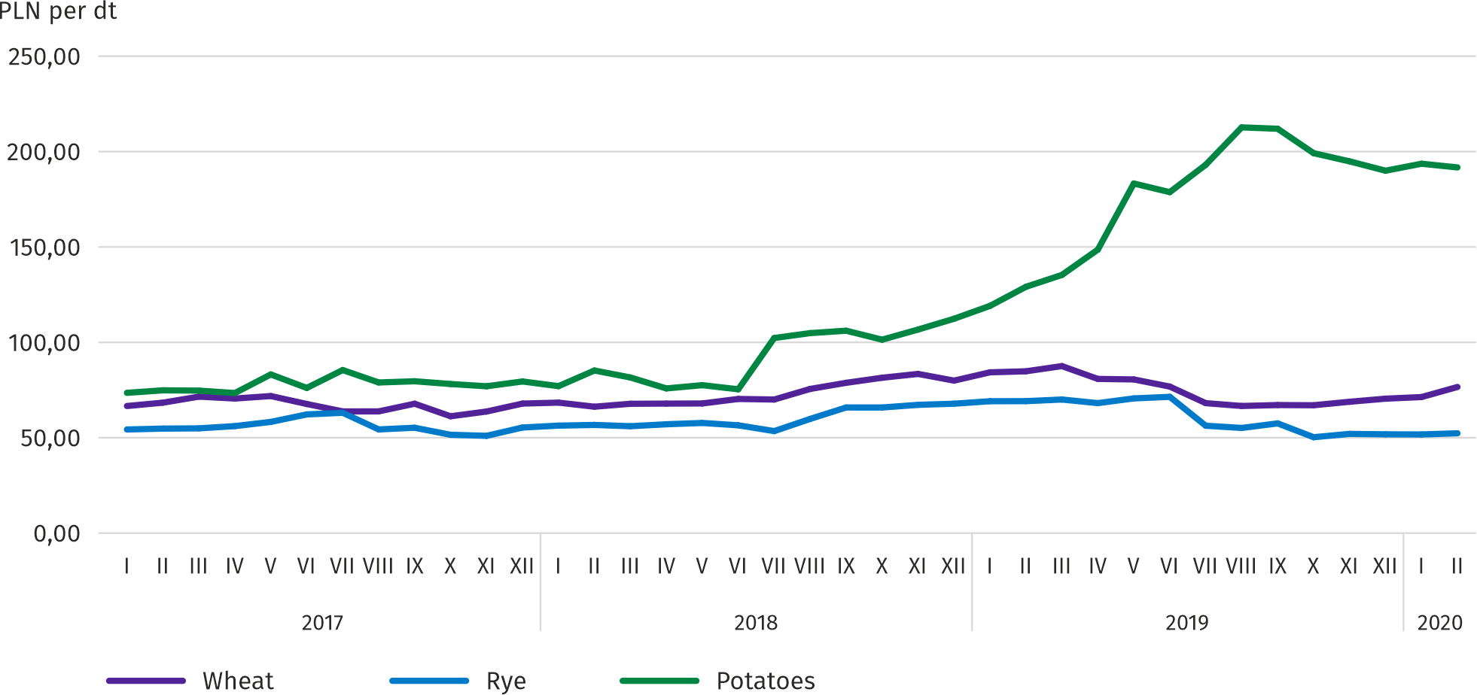
In February this year the seasonal increase in procurement prices of potatoes observed since November 2019 was halted – the average price of this raw material was by 5.9% lower than a month before and by 5.9% lower than a year before. Marketplace price of potatoes decreased on a monthly basis by 1.0% and it was still significantly higher on a yearly basis – by 48.5%.
Chart 7. Average procurement prices of animals for slaughter and milk
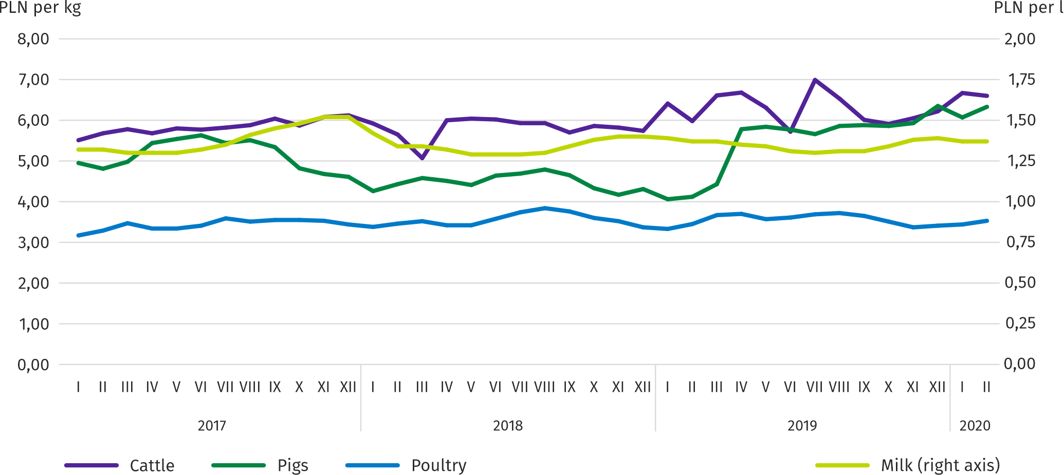

In February this year procurement prices of pigs for slaughter, after a decrease in the previous month, increased to the level of PLN 6.33 per kg, i.e. by 4.3%. Compared to February 2019, the average price of animals for slaughter was higher by 54%. The ratio of procurement prices of pigs for slaughter to the marketplace prices of rye in February 2020 amounted to 10.0 (compared to 9.4 in the previous month).
Chart 8. Ratio of average procurement prices of pigs for slaughter to average marketplace prices of rye
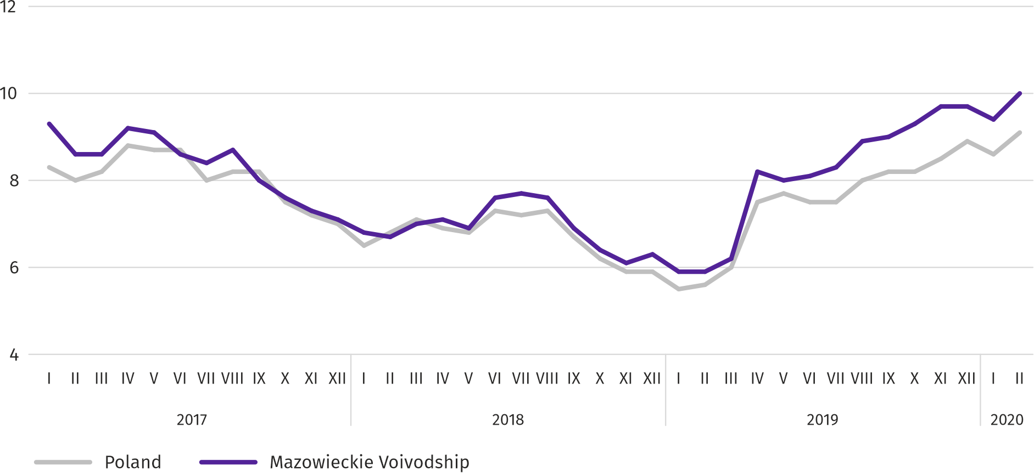

In February 2020, at significantly higher (in monthly terms by 33.8%) supplies of cattle for slaughter to procurement, the average price of this raw material was by 1.0% lower than a month earlier and by 10.4% higher than a year before.
The procurement prices of poultry for slaughter have been increasing since December last year. On average, 2.6% more was paid to suppliers for 1 kg of poultry for slaughter than in January this year, and by 2.1% more than in February last year.
In February this year, the procurement price of milk, after a decrease recorded in the previous month, increased slightly. For 100 liters of this raw material, PLN 137.36 was paid, i.e. 0.3% more on a monthly basis and 0.1% less on an annual basis.
Industry and construction
Sold production of industry in February this year, reached the value (at current prices) of PLN 25266.1 million and was (at constant prices) by 8.7% higher than a year before (compared to a 2.4% increase in January this year); as compared to the previous month it decreased by 2.9%.
Sold production in manufacturing (constituting 78.6% of sold production of industry) compared to February last year increased (at constant prices) by 9.8%. There was also an increase (by 5.7%) in sold production in the section of electricity, gas, steam and air conditioning supply (the share of this section represents 19.1% of industrial production).
Chart 9. Sold production of industry (monthly average 2015=100; constant prices)
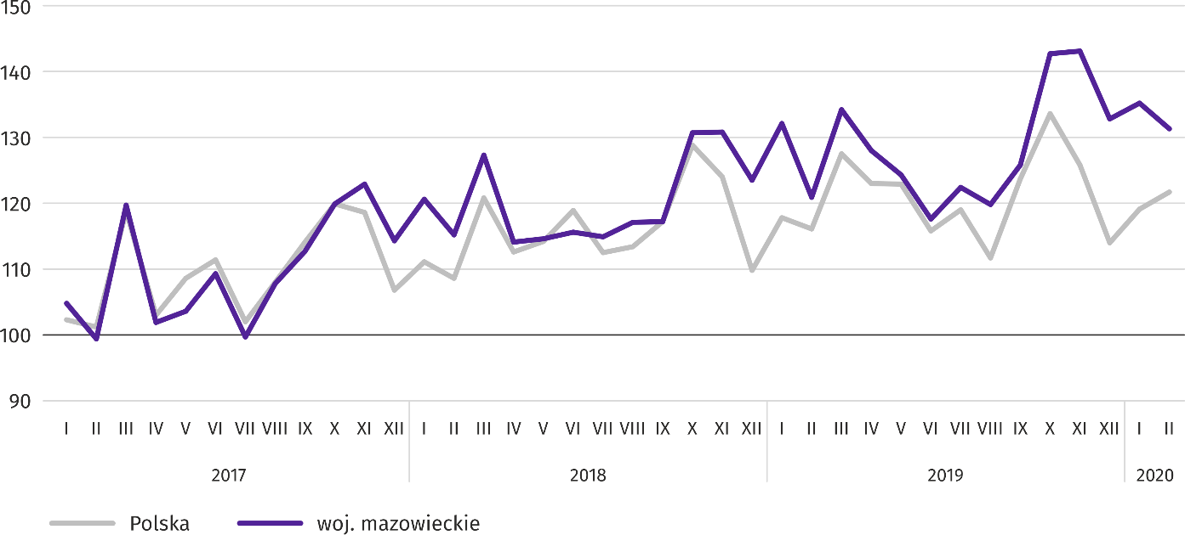

In February this year, the increase in sold production in annual terms was recorded in 27 (out of 33 in the voivodship) divisions of industry, among others, in: manufacture of metal products (by 24.0%), computer, electronic and optical products (by 19.6%), electrical equipment (by 16.9%), beverages (by 13.5%), machinery and equipment n.e.c. (by 12.1%), chemicals and chemical products (by 10.6%).
Table 9. Indices (constant prices) and structure (current prices) of sold production of industry in February 2020
SPECIFICATION | II 2020=100 | I–II 2020
 | corresponding period of previous year=100 |  | in percent
TOTAL | 108,7 | 105,2 | 100,0
of which:
Manufacturing | 109,8 | 107,1 | 78,2
of which manufacture of:
food products | 105,8 | 103,3 | 19,5
beverages | 113,5 | 107,3 | 1,7
paper and paper products | 101,3 | 96,6 | 2,6
chemicals and chemical products | 110,6 | 104,1 | 5,7

Table 9. Indices (constant prices) and structure (current prices) of sold production of industry in February 2020 (cont.)
SPECIFICATION | II 2020=100 | I–II 2020
 | corresponding period of previous year=100 |  | in percent
Manufacturing (cont.)
manufacture of rubber and plastic products | 106,6 | 105,9 | 3,6
other non-metallic mineral products | 100,7 | 103,5 | 2,5
metal products ^{Δ} | 124,0 | 121,7 | 4,1
computer, electronic and optical equipment | 119,6 | 127,4 | 5,7
Electrical equipment | 116,9 | 111,3 | 5,1
machinery and equipment n.e.c. | 112,1 | 98,6 | 2,0
Electricity, gas, steam and air conditioning supply | 105,7 | 99,7 | 19,4

Labour productivity in industry measured by sold production per employed person, in February this year amounted (at current prices) to PLN 65.5 thousand and was (at constant prices) by 6.3% higher than a year before, with larger by 2.2% average paid employment and an increase in the average monthly gross wages and salaries by 7.4%.
In the period January–February this year, sold production of industry amounted (in current prices) to PLN 51484.9 million and was (at constant prices) 5.2% higher than in the corresponding period of the previous year.
Sold production of construction (at current prices) in February this year reached the value of PLN 4761.3 million and was by 4.4% higher than in the previous year (compared to a 16.4% increase in January this year). In January–February this year, sold production of construction amounted to PLN 9352.9 million and was by 7.1% higher compared to the corresponding period of the previous year.
Labour productivity in construction, measured by revenues from the sale of goods and services per employed person in February this year amounted to PLN 52.8 thousand (at current prices) and was by 6.7% higher compared to the corresponding month of 2018, with a decrease in average employment by 2.1% and an increase in average monthly gross wages and salaries by 10.6%.
Construction and assembly production (at current prices) in February this year amounted to PLN 1384.7 million and was by 6.6% lower than a year before (compared to a 11.6% increase in January last year). An increase in production was recorded in enterprises performing specialized construction activities (by 19.7%) and in units specializing in civil engineering and (by 7.8%). On the other hand, there was a decrease in entities whose basic activity is the construction of buildings (by 32.4%). In January–February this year, construction and assembly production amounted to PLN 2524.8 million and was by 0.5% Lower compared to the corresponding period of the previous year.
Table 10. Indices and structure (at current prices) of construction and assembly production in February 2020
SPECIFICATION | II 2020=100 | I–II 2020
 | corresponding period of previous year=100 |  | in percent
TOTAL | 93,4 | 99,5 | 100,0
Construction of buildings | 67,6 | 76,1 | 27,4
Civil engineering | 107,8 | 110,6 | 46,8
Specialized construction activities | 119,7 | 116,3 | 25,7

Housing construction
In February this year, as compared to the corresponding month of 2019, the number of dwellings completed increased by 3.1%; there were more dwellings in which construction has begun (by 26.5%) and dwellings for which permits have been granted or which have been registered with a construction project (by 16.8%).
According to preliminary data in February 2019, there were 3413 dwellings completed, i.e. by 103 more than in the previous year. Majority of dwellings were built for sale or rent – 2558 (74.9% of their total number), followed by private dwellings – 847 (24.8%); a year earlier, the share of these forms amounted to 75.8% and 22.2%, respectively. Compared to February 2019, there were more dwellings for sale or rent by 2.0%, and private dwellings by 15.2%.
The effects of housing construction obtained in Mazowieckie Voivodship in the surveyed month constituted 21.3% of national effects.
Table 11. Number of dwellings completed in January–February 2020
SPECIFICATION | Dwellings completed |  |  | Average useful floor area per dwelling in m²
 | in absolutenumbers | in percent | I–II2019=100
TOTAL | 6121 | 100,0 | 91,0 | 91,1
Private | 1817 | 29,7 | 116,9 | 149,0
For sale or rent | 4296 | 70,2 | 85,7 | 66,7
Municipal | 8 | 0,1 | 17,8 | 40,9

In the period January–February this year, 6121 dwellings were completed, i.e. fewer than in the same period last year
by 9.0%; only in private construction there were more dwellings built than a year earlier.
Chart 10. Dwellings completed (corresponding period 2015=100)
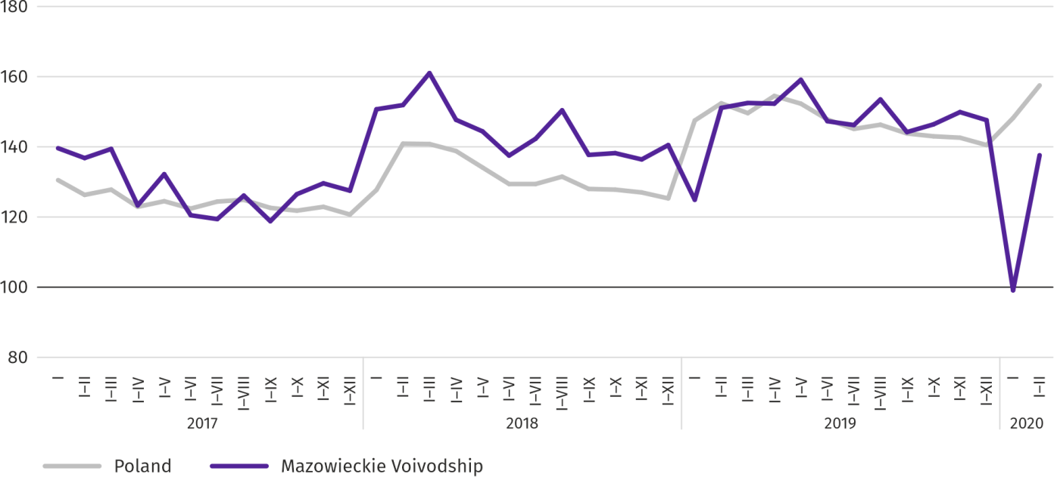

Most dwellingswerecompleted in m.st. Warszawa (2661), followed by piaseczyński (672) and pruszkowski powiat (353), and the least in sokołowski (9) and Ostrołęka (11).

Map 2. Dwellings completed per 10 thousand population ª by powiats in January–February 2020

a Population as of 30 June 2019
The average useful floor area of dwellings completed in the period of two months this year amounted to 91.1 m² and was larger than a year earlier by 8.3 m². The largest dwellings were completed in pułtuski (176.1 m²), sokołowsk (173.1 m²) and grójecki powiat (169.8 m²). The smallest were built in Siedlce (56.9 m²), żuromiński powiat (61.2 m²) and Płock (64.6 m²).
In February this year, the number of dwellings for which permits have been granted or which have been registered with a construction project amounted to 3253, that is by 469 (by 16.8%) more than a year earlier. Of the total number of dwellings, 71.5% were dwellings for sale or rent, and 28.5% private.
In the surveyed month, the construction began in 4183 dwellings, i.e. in 876 more (by 26.5%) compared to February 2019; dwellings for sale or rent accounted for 79.1% of their total number, and private 20.9%.
Table 12. Number of dwellings for which permits have been granted or which have been registered with a construction project as well as dwelling in which construction has begun in January–February 2020
SPECIFICATION | Dwellings for which permits have been granted or which have been registered with a construction project |  |  | Dwellings in which construction has begun
 | in absolute numbers | in percent | I–II 2019=100 | in absolute numbers | in percent | I–II 2019=100
TOTAL | 7208 | 100,0 | 113,9 | 7457 | 100,0 | 116,7
Private | 1862 | 25,8 | 106,6 | 1550 | 20,8 | 142,9
Cooperative | 5346 | 74,2 | 124,0 | 5859 | 78,6 | 115,3
For sale or rent | – | – | . | 34 | 0,5 | 340,0
Municipal | – | – | . | 14 | 0,2 | .

Domestic market
In February this year, both retail sales and wholesale were higher than in the previous year.
Retail sales (at current prices) in trade and non-trade enterprises in February 2020 was by 8.1% higher than a year before. The highest increase in sales was recorded in units from the group: “food, beverages and tobacco” (by 12.7%), “pharmaceuticals, cosmetics, orthopedic equipment” (by 10.2%), “other retail sales in non-specialized stores” (by 10.0%), “solid, liquid and gas fuels” (by 9.0%). A decrease was recorded in the groups: “other” (by 4.0%) and “press, books, other sales in specialized stores” (by 0.8%).
Compared to January 2020, retail sales were lower by 3.6%. The highest decrease in sales was recorded in the “textiles, clothing, footwear” group (by 16.6%), followed by “press, books, other sales in specialized stores” (by 8.7%), as well as “motor vehicles, motorcycles, parts” (by 7.0%).
In the period January–February 2020, retail sales increased by 7.2% over the year, with the largest increase in sales achieved by companies from the "food, beverages and tobacco" group (by 13.5%), and the deepest decline was in entities from the "other" group (by 3.9%).
Table 13. Indices and structure (at current prices) of retail sales in February 2020
SPECIFICATION | II 2020 | I–II 2020
 | corresponding period of previous year=100 |  | in percent
TOTALª | 108,1 | 107,2 | 100,0
of which:
Motor vehicles, motorcycles, parts | 107,3 | 107,7 | 8,2
Solid, liquid and gas fuels | 109,0 | 107,6 | 27,4
Food, beverages and tobacco | 112,7 | 113,5 | 17,1
Other retail sales in non-specialized stores | 110,0 | 105,3 | 2,5
Pharmeceuticals, cosmetics and orthopedic equipment | 110,2 | 109,9 | 3,9
Textiles, clothing and footwear | 103,8 | 102,8 | 4,9
Furniture, electronics and household appliances | 107,6 | 106,2 | 18,1
Press, books and other sales in specialized stores | 99,2 | 96,4 | 6,5
Other | 96,0 | 96,1 | 9,5
a The grouping of enterprises was made on the basis of the Polish Classification of Activities - PKD 2007, including the enterprise to a specific category according to the type of predominant activity, in accordance with the organizational status in the period under consideration. The recorded changes (increase/decrease) in retail sales in particular groups of activity of enterprises may also result from changes in the type of predominant economic activity and organizational changes (e.g. mergers of enterprises). This does not affect the dynamics of retail sales in general.

Wholesale (at current prices) in trade enterprises in February 2020 was by 7.5% higher as compared to the previous month, and by 6.6% higher compared to February 2019. In wholesale enterprises it was higher by 0.8% and 2.0%, respectively.
In the period January–February 2020, wholasele in trade enterprises was by 2.8% higher than a year before, and in wholesale enterprises by 0.5% higher.

Financial results of enterprises
In 2019, gross and net financial results of the surveyed enterprises were higher than in the previous year, except for the result of financial operations. The first and second degree financial liquidity indicators were more favourable than a year before.
In 2019, gross and net financial results of the surveyed enterprises, due to significantly higher result on sale of products, goods and materials sold as well as result on other operational activity were more favourable than in the previous year. The cost level indicator as well as gross and net profitability rate did not change.
Table 14. Revenues, costs and financial results of enterprises
SPECIFICATION | I–XII 2018 | I–XII 2019
 | In milion PLN
Revenues from total activity | 1013692,0 | 1079220,5
of which revenues from sale of products, goods and materials | 976949,9 | 1044065,1
Costs of obtaining revenues from total activity | 967038,8 | 1029425,3
of which of cost of products, goods and materials sold | 933350,2 | 998338,7
Result on sale of products, goods and materials | 43599,7 | 45726,4
Result on other operational activity | -144,8 | 1945,9
Result of financial operations | 3198,3 | 2122,9
Gross financial result | 46653,2 | 49795,2
Net financial result | 37903,2 | 40460,1
net profit | 46184,1 | 46395,2
gross profit | 8280,9 | 5935,1

Revenues from total activity as well as costs of obtaining these revenues in 2019 were by 6.5% higher than in the previous year. Consequently, the cost level indicator did not change. Net revenues from sale of products, goods and materials as well as costs of this activity were higher than in the previous year by 6.9% and 7.0%, respectively. In terms of value, the highest increase in net revenues from the sale of products, goods and materials was recorded in trade; repair of motor vehicles and in manufacturing.
Financial result on sale of products, goods and materials was by 4.9% higher than in the previous year and amounted to PLN 45,726.4 million. The result on other operational activity was estimated at PLN 1,945.9 million compared to minus PLN 144.8 million. Much worse than a year before, was the result on financial operations (PLN 2,122.9 million compared to PLN 3,198.3 million), which was a consequence of a faster decline in financial revenues (by 7.4%) than financial costs (by 2.6%).
As a result, the gross financial result reached PLN 4,9795.2 million and was higher by PLN 3,142.0 million (by 6.7%) from the result obtained in the first half of 2018. Encumbrances on gross financial result increased in annual terms by 6.7% to PLN 9,335.2 million. The net financial result was estimated at PLN 40,460.1 million and was higher by PLN 2,556.8 million (by 6.7%) compared to the result obtained a year earlier; net profit increased by 0.5%, and net loss decreased by 28.3%.
In the analyzed period, 80.4% of the surveyed enterprises showed a net profit (79.7% a year before). The share of revenues of enterprises showing net profit in the total amount of revenues from total activity increased from 85.8% to 87.8%. In manufacturing, 84.1% of enterprises showed a net profit (in 2018 – 85.4%), and the share of revenues generated by these enterprises in the revenues of total entities of this section accounted for 95.3% (92.8% a year earlier).
In the surveyed enterprises, there were no changes in the profitability of business operations – the cost level indicator and gross and net turnover profitability indicators remained at the last year’s level; the gross sales profitability indicator decreased by 0.1 pp. The first and second degree liquidity indicators were higher by 1.4 and 0.3 pp, respectively.
Table 15. Economic relations in enterprises
SPECIFICATION | I–XII 2018 | I–XII 2019
 | in %
Cost level indicator | 95,4 | 95,4
Gross sales profitability indicator | 4,5 | 4,4
Gross turnover profitability indicator | 4,6 | 4,6
Net turnover profitability indicator | 3,7 | 3,7
First degree financial liquidity indicator | 44,9 | 46,3
Second degree financial liquidity indicator | 110,9 | 111,2

Out of 16 sections, the most profitable types of activity were, among others, accommodation and catering (net turnover profitability indicator 10.6%) as well as water supply; sewerage, waste management and remediation activities (indicator 8.0%). Compared to the 2018, the improvement in net turnover profitability was recorded in 6 sections, with the highest increase in information and communication (by 4.1 pp).
Chart 11. Net turnover profitability indicator
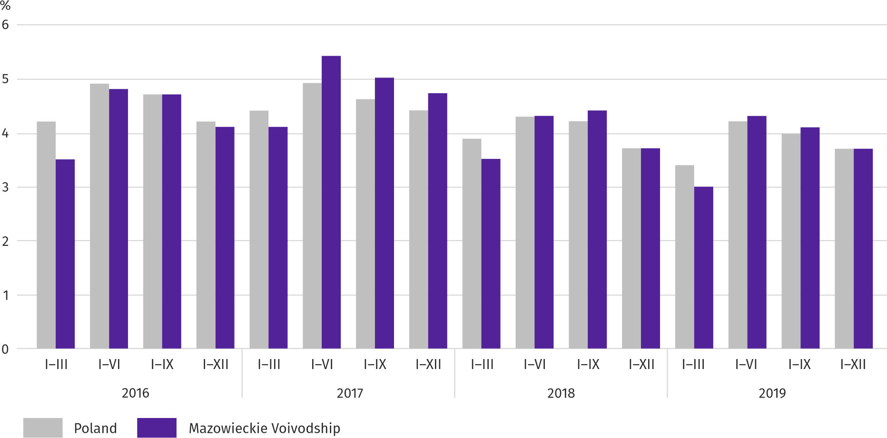

The value of current assets of the surveyed enterprises at the end of December 2019 amounted to PLN 382,581.7 million and was by 8.7% higher than a year before, with stocks higher by 9.8%, short-term dues – by 6.4%, short-term investments – by 11.9% and short-term inter-period settlements – by 3.4%. In the material structure of current assets, the share of short-term investments increased (from 30.0% to 30.9%) and the stocks (from 22.5% to 22.8%), however the share of short-term dues decreased (from 44.2% to 43.2%), as well as short-term inter-period settlements (from 3.3% to 3.1%). In the structure of stocks, the share of semi-finished products and works in progress increased (from 11.9% to 13.0%), whereas the share of goods decreased (from 45.2% to 44.0%), as well as the share of finished products (from 12.8% to 12.2%) and materials (from 28.5% to 28.4%).
Financial current assets were mainly short-term liabilities – the ratio of short-term liabilities to current assets amounted to 66.6% against 66.9% a year earlier.
Long- and short-term liabilities (excluding special funds) at the end of December 2019 amounted to PLN 412,488.7 million and were by 11.9% higher than a year before. Long-term liabilities accounted for 38.2% of total liabilities (at 36.1% in December 2018), and their value amounted to PLN 157,610.1 million and was by 18.3% larger than a year earlier. Short-term liabilities of surveyed enterprises amounted to PLN 25,4878.6 million and were higher by 8.3% per year, of which liabilities for deliveries and services – by 6.2%, and for taxes, duties, insurance and other benefits – by 6.5%.
Investment outlays
In 2019, investment outlays of the surveyed enterprises were at the higher level than a year before. Whereas the estimated value of newly-started investments was higher.
Investment outlays carried out in 2019 by enterprises based in Mazowieckie Voivodship reached the value of PLN 50,991.5 million and were (at current prices) by 8.7% higher than in the corresponding period of 2018. Outlays on buildings and structures increased by 4.2%, while on purchases – by 12.8%, of which outlays on machinery, technical equipment and tools as well as transport equipment were higher by 3.5%, and outlays on transport equipment – by 40.4%. The share of purchases in total outlays amounted to 55.7% (53.7% a year before).
Chart 12. Investment outlays (current prices; increase/decrease compared to the previous year)
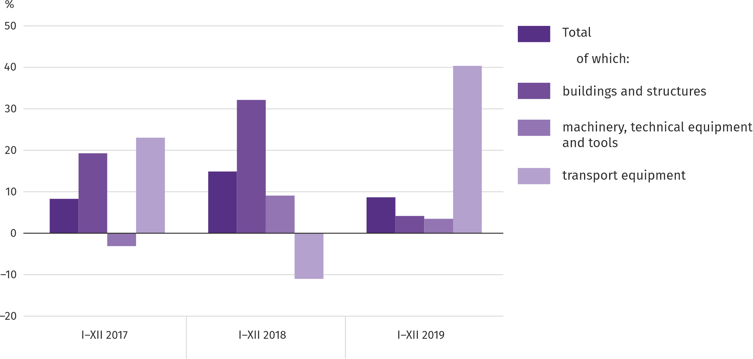

An increase in investment outlays was observed, among others, in water supply; sewerage, waste management and remediation activities (by 24.5%), real estate activities (by 14.8%) and in manufacturing (by 12.4%). A decrease in outlays was recorded, among others, in accommodation and catering (by 18.5%) and in electricity, gas, steam and air conditioning supply (by 14.8%).
In 2019, mainly enterprises operating in the field of transportation and storage invested (which accounted for 29.1% of total outlays incurred), in the field of manufacturing (19.7%) as well as electricity, gas, steam and air conditioning supply (10.8%). In the structure of outlays by sections, as compared to the corresponding period of the previous year, the share of outlays incurred increased the most in enterprises engaged in administrative and support service activities (by 3.4 pp), while the share of outlays of enterprises engaged in electricity, gas, steam and air conditioning supply decreased the most (by 3.0 pp).
In 2019, there were 40832 investments started, i.e. by 68.4% less than a year before. The total estimated value of newly-started investments amounted to PLN 31,014.6 million and was by 25.0% higher than in 2018. 62.3% of estimated value of all newly-started investments (51.3% a year before) was for the improvement (i.e. reconstruction, extension or modernization) of existing fixed assets. On a yearly basis, the largest decrease was recorded in the estimated value of investments started by enterprises operating in real estate activities (by 111.5%) and in transportation and storage (by 91.5%).

Table 16. Selected data on Mazowieckie Voivodship
SPECIFICATION  A – 2019  B – 2020 |  | I | II | III | IV | V | VI | VII | VIII | IX | X | XI | XII
Average employment in the enterprise sectorª  (in thousand persons) | A | 1527,0 | 1522,3 | 1525,2 | 1525,9 | 1523,5 | 1524,8 | 1529,5 | 1530,8 | 1528,6 | 1530,9 | 1536,1 | 1541,1
 | B | 1552,1 | 1551,5
previousmonth=100 | A | 101,3 | 99,7 | 100,2 | 100,0 | 99,8 | 100,1 | 100,3 | 100,1 | 99,9 | 100,2 | 100,3 | 100,3
 | B | 100,7 | 100,0
corresponding month of previous year=100 | A | 102,5 | 102,2 | 102,4 | 102,4 | 102,3 | 102,3 | 102,3 | 102,2 | 102,1 | 102,3 | 102,2 | 102,3
 | B | 101,6 | 101,9
Registered unemployed persons(in thousand persons; as of end of period) | A | 143,4 | 142,4 | 138,8 | 133,8 | 130,1 | 126,7 | 125,6 | 125,6 | 123,3 | 120,9 | 121,9 | 123,2
 | B | 130,1 | 129,6
Unemployment rate ^{b}(in %; as of end of period) | A | 5,1 | 5,0 | 4,9 | 4,7 | 4,6 | 4,5 | 4,5 | 4,5 | 4,4 | 4,3 | 4,3 | 4,4
 | B | 4,6 | 4,6
Job offers (submitted during a month) | A | 17000 | 15394 | 15971 | 15065 | 15153 | 13859 | 13573 | 13132 | 14628 | 14386 | 12061 | 10281
 | B | 16059 | 14693
Unemployed persons per 1 job offer (as of end of period) | A | 16 | 14 | 17 | 15 | 13 | 13 | 14 | 15 | 13 | 14 | 15 | 27
 | B | 14 | 17
Average monthly gross wages and salaries in the enterprise sectorª (in PLN) | A | 5919,32 | 5920,22 | 6311,43 | 6185,82 | 6020,53 | 6093,26 | 6036,91 | 6053,18 | 6000,45 | 6273,41 | 6098,25 | 6402,10
 | B | 6285,91 | 6284,26
previousmonth=100 | A | 97,2 | 100,0 | 106,6 | 98,0 | 97,3 | 101,2 | 99,1 | 100,3 | 99,1 | 104,5 | 97,2 | 105,0
 | B | 98,2 | 100,0
corresponding month of previous period=100 | A | 106,6 | 106,2 | 104,5 | 105,5 | 107,1 | 106,1 | 104,9 | 106,3 | 106,5 | 105,6 | 104,5 | 105,2
 | B | 106,2 | 106,1
Priceindices:
consumer goods and services ^{c}:
corresponding period of previous year=100 | A | . | . | 101,0 | . | . | 102,2 | . | . | 102,7 | . | . | 102,7
 | B | . | .
a In enterprises employing more than 9 persons. b Share of registered unemployed persons in civilian economically active population, estimated at the end of each month. c In the quarter.
Table 16. Selected data on Mazowieckie Voivodship (cont.)
SPECIFICATION  A – 2019  B – 2020 |  | I | II | III | IV | V | VI | VII | VIII | IX | X | XI | XII
Priceindices (cont.):
Procurement of cerealgrain:
previousmonth=100 | A | 104,3 | 100,6 | 105,0 | 91,2 | 100,6 | 95,4 | 84,1 | 99,9 | 102,7 | 98,5 | 102,9 | 101,5
 | B | 102,6 | 106,7
corresponding month of previous year=100 | A | 123,3 | 128,6 | 131,0 | 118,7 | 119,6 | 112,3 | 97,9 | 89,4 | 85,9 | 81,6 | 81,4 | 85,5
 | B | 84,2 | 89,3
procurement of cattle for slaughter (excluding calves):
previousmonth=100 | A | 111,7 | 93,3 | 110,6 | 101,0 | 94,5 | 90,6 | 122,2 | 93,5 | 92,0 | 98,2 | 102,5 | 102,8
 | B | 107,1 | 99,0
corresponding month of previous year=100 | A | 108,1 | 105,8 | 130,2 | 111,3 | 104,4 | 95,0 | 117,7 | 110,1 | 105,5 | 100,8 | 104,0 | 108,5
 | B | 104,1 | 110,4
procurement of pigs for slaughter:
previousmonth=100 | A | 94,2 | 101,5 | 107,5 | 130,6 | 101,1 | 98,7 | 98,2 | 103,6 | 100,2 | 99,8 | 101,1 | 107,2
 | B | 95,5 | 104,3
corresponding month of previous year=100 | A | 95,1 | 93,0 | 96,7 | 128,1 | 132,4 | 124,2 | 120,7 | 122,4 | 126,3 | 135,2 | 142,1 | 147,6
 | B | 149,5 | 153,7
Ratio of procurement prices ªof pigs for slaughter to marketplace prices of rye | A | 5,9 | 5,9 | 6,2 | 8,2 | 8,0 | 8,1 | 8,3 | 8,9 | 9,0 | 9,3 | 9,7 | 9,7
 | B | 9,4 | 10,0
Sold production of industry ^{b} (at constant prices):
previousmonth=100 | A | 106,1 | 91,5 | 111,0 | 95,4 | 97,1 | 94,6 | 104,1 | 97,9 | 105,0 | 113,4 | 100,3 | 92,8
 | B | 101,8 | 97,1
corresponding month of previous year=100 | A | 109,5 | 104,9 | 105,3 | 112,2 | 108,6 | 101,9 | 106,6 | 102,5 | 107,5 | 109,3 | 109,5 | 106,7
 | B | 102,4* | 108,7
Construction and assembly production ^{b} (at current prices):
previousmonth=100 | A | 40,1 | 146,1 | 115,8 | 102,0 | 105,4 | 108,7 | 112,1 | 103,8 | 113,3 | 83,2 | 91,1 | 127,3
 | B | 44,4 | 122,3
corresponding month of previous year=100 | A | 90,1 | 154,2 | 114,3 | 124,5 | 107,2 | 106,8 | 108,1 | 124,4 | 130,9 | 88,2 | 87,9 | 100,8
 | B | 111,6 | 93,4
a Current prices excluding VAT. b In enterprises employing more than 9 persons.
Table 16. Selected data on Mazowieckie Voivodship (cont.)
SPECIFICATION  A – 2019  B – 2020 |  | I | II | III | IV | V | VI | VII | VIII | IX | X | XI | XII
Dwellings completed (from the beginning of the year) | A | 3414 | 6724 | 9615 | 13103 | 16748 | 19467 | 22744 | 26836 | 30193 | 34597* | 39206* | 43151*
 | B | 2708 | 6121
corresponding period of previous year=100 | A | 82,9 | 99,5 | 94,7 | 103,1 | 110,1 | 107,1 | 102,7 | 102,1 | 104,8 | 105,9* | 109,9* | 105,0*
 | B | 79,3 | 91,0
Retail sales of goods ª (at current prices):
previousmonth=100 | A | 79,4 | 94,5 | 116,2 | 104,2 | 98,6 | 102,7 | 101,2 | 99,3 | 96,7 | 105,7 | 100,7 | 116,8
 | B | 75,7 | 96,4
corresponding month of previous year=100 | A | 104,5 | 104,5 | 105,7 | 110,5 | 106,2 | 104,7 | 105,6 | 103,8 | 104,7 | 104,5 | 106,4 | 111,2
 | B | 106,0 | 108,1
Turnover profitability indicator in enterprises ^{b}:
gross ^{c} (in %) | A | . | . | 3,8 | . | . | 5,3 | . | . | 5,0 | . | . | 4,6
 | B | . | .
net ^{d} (in %) | A | . | . | 3,0 | . | . | 4,3 | . | . | 4,1 | . | . | 3,7
 | B | . | .
Investment outlays of enterprises ^{b} – from the beginning of the year (in million PLN; current prices) | A | . | . | 8186,7 | . | . | 19969,2 | . | . | 32656,9 | . | . | 50991,5
 | B | . | .
corresponding period of previous year=100 (current prices) | A | . | . | 120,7 | . | . | 118,4 | . | . | 115,9 | . | . | 108,7
 | B | . | .
Entities of the national economy^{e} in the REGON register (as of end of period) | A | 819274 | 822655 | 826407 | 829983 | 833385 | 836698 | 840124 | 843374 | 846686 | 850340 | 853160 | 854457
 | B | 855961 | 858420
of which commercial companies | A | 160010 | 160971 | 161997 | 162973 | 163843 | 164635 | 165630 | 166585 | 167542 | 168588 | 169648 | 170518
 | B | 171505 | 172783
of which with foreign capital participation | A | 31667 | 31718 | 31813 | 31996 | 32205 | 32384 | 32603 | 32747 | 32863 | 32966 | 33117 | 33215
 | B | 33224 | 33365
a In enterprises employing more than 9 persons. b In enterprises employing more than 49 persons. c Relation of gross financial result to revenues from total activity. d Relation of net financial result to revenues from total activity. e Excluding persons tending private farms in agriculture.

Prepared by | Contact: |  | warszawa.stat.gov.pl/en/
Statistical Office in Warszawa  Director Zofia Kozłowska | tel.:(+48 22) 4642315 |  | @Warszawa_STAT
1 Sierpnia 21 | fax: (+48 22) 846 76 67
02-134Warszawa | e-mail: SekretariatUSWAW@stat.gov.pl

Related information
Statistical Bulletin of Mazowieckie Voivodship
Report on the socio-economic situation of Mazowieckie Voivodship in 2018
Socio-economic situation of voivodships No. 3/2019

Data available in databases
Local Data Bank
Knowledge Databases

Terms used in official statistics
Enterprise sector
Average paid employment
Registered unemployed persons
Registered unemployment rate
Average monthly gross wages and salaries
Retail price
Price index of consumer goods and services
Procurement of agricultural products
Procurement prices
Marketplace prices
Pigs
Cattle
Sold production of industry
Sale of construction and assembly production
Dwellings completed
Retail sales of goods
Wholesale
Financial results of enterprises
Investment outlays

Long-term unemployed include persons remaining in the register rolls of the powiatlabour office for the whole period of over 12 months during the last 2 years, excluding periods of traineeship and occupational preparation at the workplace.
Refers to vacancies and places of occupational activation.
The average values of temperature and precipitation were calculated as arithmetic averages of the average monthly values from five hydrological and meteorological stations of the Institute of Meteorology and Water Management located in Kozienice, Mława, Płock, Siedlce and Warszawa.
Reporting data – may change after preparing quarterly report.

