Socio-economic situation of Mazowieckie Voivodship in January 2020
- In January this year, the average employment in the enterprise sector was higher than a year before (by 1.6%). The registered unemployment rate amounted to 4.6% and decreased on a yearly basis, but increased on a monthly basis.
- Average monthly gross wages and salaries in the enterprise sector in January this year were higher than in the previous year (by 6.2%).
- On the agricultural market in January this year, the procurement prices of potatoes, cattle and poultry for slaughter were higher than in the previous year and in the previous month. In both approaches, rye and milk prices were lower. Prices of pigs for slaughter were lower than in the previous month, but much higher than a year before.
- In January this year, sold production of industry increased in annual terms (by 2.3%, at constant prices). Construction and assembly production was higher than a year before (by 11.6%, at current prices).
- The number of dwellings completed in January this year was lower than a year before by 20.7%. Most of the dwellings were built for sale or rent.
- In January this year, there was an increase in retail sales in annual terms (by 6.0%). The wholesale was lower than a year before (by 1.0%).

Contents
Labour market 4
Wages and salaries 7
Agriculture 9
Industry and construction 13
Housing construction 15
Domestic market 18
Selected data on Mazowieckie Voivodship 19
General notes
Data presented in the news release:
- on employment, wages and salaries and sold production of industry and construction, construction and assembly production, as well as retail sales and wholesale concern economic entities employing more than 9 persons,
- on enterprise sector refer to entities conducting economic activity in the field of: forestry and logging; maritime fishing; mining and quarrying; manufacturing; electricity, gas, steam and air conditioning supply; water supply; sewerage, waste management and remediation activities; construction; wholesale and retail trade; repair of motor vehicles and motorcycles; transportation and storage; accommodation and food service activities; information and communication; real estate activities; legal and accounting activities; activities of head offices; management consultancy activities; architectural and engineering activities; technical testing and analysis; advertising and market research; other professional, scientific and technical activities; arts, entertainment and recreation; repair of computers and personal and household goods; other personal service activities,
- on retail prices of foodstuffs and non-foodstuffs as well as services that originate from quotations of prices conducted by interviewers at selected points of sale in selected regions of price surveys; prices of food are collected once a month, with the exception of fruit and vegetables, for which prices are collected twice a month,
- on procurement of agricultural products include procurement from producers from the voivodship; prices are given excluding VAT tax,
- on financial results of enterprises and investment outlays refer to economic entities keeping accounting ledgers (excluding entities whose activity is classified according to the NACE Rev. 2 in the sections “Agriculture, forestry and fishing” and “Financial and insurance activities” as well as higher education institutions) in which the number of employed persons exceeds 49.
Data in value terms are provided at current prices and form the basis for calculating the structure indicators. Dynamic indices are provided on the basis of value at current prices, except for industry, for which the dynamic indices are provided on the basis of value at constant prices (average current prices of 2015).
Relative numbers (indices, percentages) were calculated on the basis of absolute data expressed with higher precision than that presented in the text and tables.
Data have been presented in accordance with the Polish Classification of Activities – PKD 2007 (NACE Rev. 2).

Polish Classification of Activities 2007 – PKD 2007 (NACE Rev. 2)
Abbreviation | Full name
sections
trade; repair of motor vehicles | wholesale and retail trade; repair of motor vehicles and motorcycles
accommodation and catering | accommodation and food service activities
divisions
manufacture of metal products | manufacture of fabricated metal products, except machinery and equipment

Symbols
Symbol | Description
(—) | – magnitude zero
(.) | – data not available or not reliable
(*) | – data revised
(∆) | – categories of applied classification are presented in abbreviated form
„Of which” | – indicates that not all elements of the sum are given

Data describing Mazowieckie Voivodship can also be found in statistical publications issued by the Statistical Office in Warszawa and in the publications of Statistics Poland.
The report „Economic situation in Mazowieckie Voivodship in February 2020” will be published on the home page of the Statistical Office in Warszawa: https://warszawa.stat.gov.pl/en on 27th February 2020.
When publishing Statistical Office data – please indicate the source.

Labour market
In January this year, a lower year-on-year increase was recorded in employment in the enterprise sector compared to the previous month. The registered unemployment rate decreased on a yearly basis and increased on a monthly basis.
Average employment in the enterprise sector in January this year amounted to 1552.1 thousand persons and was by 1.6% higher than a year before (in the previous month there was a 2.3% increase). Employment growth was recorded in, among others, accommodation and catering (by 3.6%), professional, scientific and technical activities (by 3.5%) as well as in transportation and communication (by 3.1%). A decrease was recorded in information and communication (by 2.7%), construction (by 2.6%) and in electricity, gas, steam and air conditioning supply (by 0.9%).
Table 1. Average employment in the enterprise sector in January 2020
SPECIFICATION | I 2020
 | in thousands | I 2019=100
TOTAL | 1552,1 | 101,6
of which:
Industry | 384,6 | 102,3
of which:
manufacturing | 337,8 | 102,4
electricity, gas, steam and air conditioning supply | 25,5 | 99,1
Construction | 89,8 | 97,4
Trade; repair of motor vehicles ^{Δ} | 350,5 | 101,9
Transportation and storage | 280,3 | 103,1
Accommodation and catering ^{Δ} | 35,7 | 103,6
Information and communication | 116,4 | 97,3
Real estate activities | 23,6 | 101,3
Professional, scientific and technical activities ª | 97,7 | 103,5
Administrative and support service activities | 139,8 | 101,0
a Excluding divisions: Research and experimental development work and Veterinary activities.

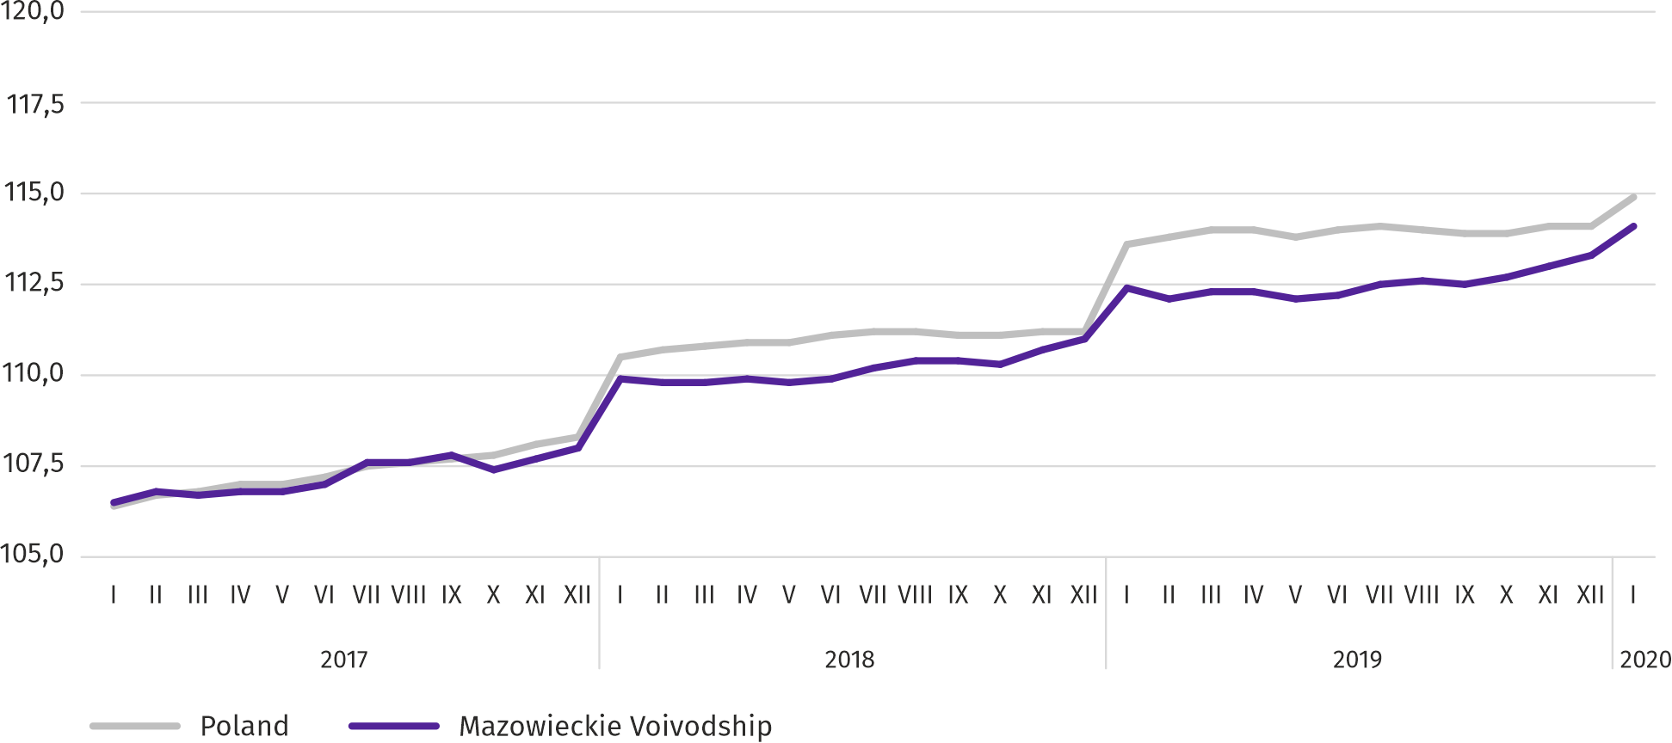
Chart 1. Average employment in the enterprise sector (monthly average 2015=100)
At the end of January this year, the number of unemployed persons registered in labour offices amounted to 130.1 thousand persons and increased on a monthly basis by 6.9 thousand persons (i.e. by 5.6%), and compared to January 2019 it decreased by 13.3 thousand persons (i.e. by 9.3%). Women accounted for 51.0% of total registered unemployed persons (a year before 51.5%).
Table 2. Number of unemployed persons and unemployment rate
SPECIFICATION | 2019 |  | 2020
 | I | XII | I
Registered unemployed persons (as of end of month) in thousands | 143,4 | 123,2 | 130,1
Newly registered unemployed persons (during a month) in thousands | 20,8 | 13,7 | 18,7
Unemployed persons removed from unemployment rolls (during a month) in thousands | 13,9 | 12,4 | 11,8
Registered unemployment rate (as of end of month) in % | 5,1 | 4,4 | 4,6
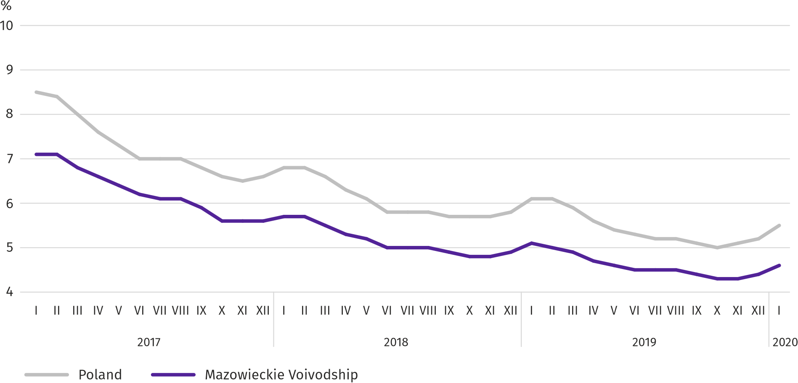
Chart 2. Registered unemployment rate (as of end of month)
Registered unemployment rate at the end of January this year amounted to 4.6% and was lower than the national average (5.5%). It decreased by 0.5 pp on a yearly basis, and increased by 0.2 pp on a monthly basis.
The territorial differentiation of the unemployment rate continued in the voivodship. Powiats with the highest unemployment rate were szydłowiecki (23.9% compared to 25.1% in January 2019), przysuski (18.3% compared to 18.8%) and radomski (17.1% compared to 17.8%), and with the lowest – m.st. Warszawa (1.3% compared to 1.5%), warszawski zachodni (1.7% compared to 2.1%) and grójecki (2.2% compared to 2.3%).
Compared to January 2019, the unemployment rate decreased in all powiats. The largest decrease was recorded in the powiats: gostyniński (by 2.1 pp), sierpecki (by 1.8 pp) and łosicki (by 1.5 pp), while the smallest in the powiats: grójecki, liplski and sokołowski (by 0.1 pp each) as well as m.st. Warszawa and mławski (by 0.2 pp each).
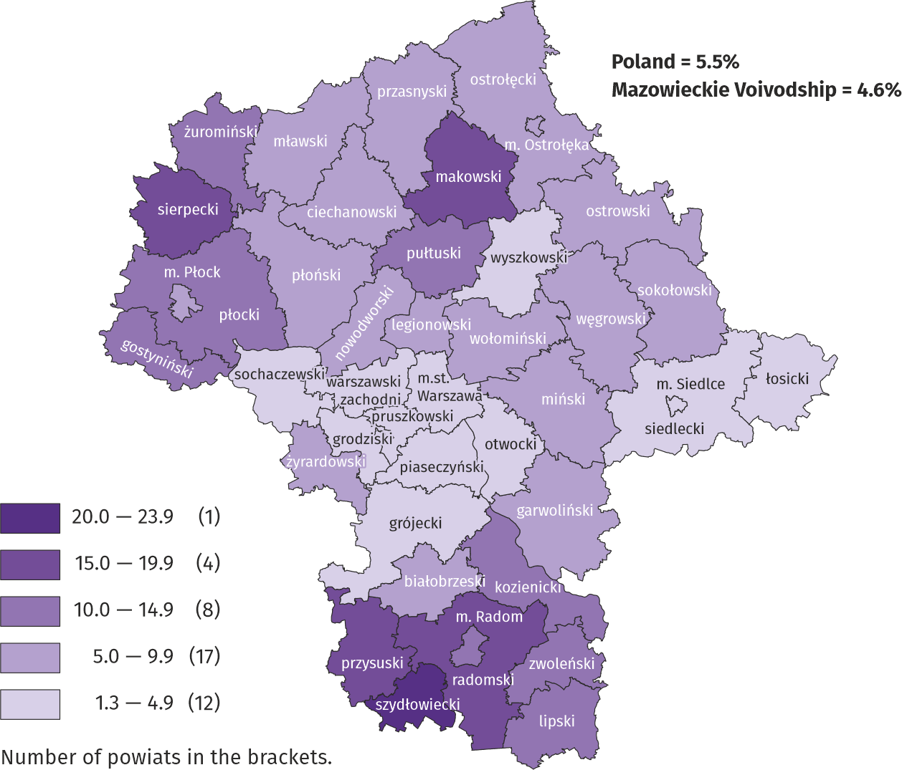
Map 1. Registered unemployment rate by powiats in 2019 (as of end of January)

In January this year, 18.7 thousand unemployed persons were registered in labour offices, i.e. more by 36.9% than a month before and by 9.8% than a year before. Among the newly registered, 81.4% were persons registered once again (81.5% a year before). The share of persons previously not employed amounted to 11.9% (a decrease by 2.1 pp on a yearly basis), persons terminated due to company reasons 4.6% (a 0.7 pp increase). Out of newly registered unemployed persons, 44.6% were rural residents (a decrease by 0.1 pp). Graduates accounted for 6.3% of newly registered unemployed persons (a 1.2 pp drop).
In January this year, 11.8 thousand persons were removed from unemployment rolls, i.e. less by 4.2% than a month before and by 15.0% less than a year before. 6.2 thousand persons (7.2 thousand a year before) were removed from unemployment rolls due to undertaking employment. The share of this category of persons in the total number of persons removed from unemployment rolls increased by 1.2 pp on a yearly basis and amounted to 52.8%. The percentage of persons who lost their status of the unemployed as a result of not confirming readiness to take up work increased as well (by 0.7 pp to 21.8%). However, there was a decrease in the percentage of persons who voluntarily gave up their status of the unemployed (by 0.6 pp to 8.6%), persons who obtained retirement or pension rights (by 0.3 pp to 0.4%) as well as persons who started training or traineeship with employer (by 0.2 pp to 1.3%).
At the end of January this year, 107.6 thousand unemployed persons were not entitled to the unemployment benefit, and their share in the total number of the registered unemployed was 82.7% (a 0.8 pp decrease in annual terms).
At the end of the surveyed month, 65.9 thousand, i.e. 50.7% out of registered unemployed persons were the long-term unemployed. The number of unemployed persons under the age of 30 amounted to 31.5 thousand, which accounted for 24.2% of the total unemployed (of which persons under the age of 25 constituted 11.7%). Persons aged over 50 amounted to 35.5 thousand (27.3%). 1.0 thousand of unemployed persons, i.e. 0.8% of their total number received social assistance benefits. There were 22.8 thousand persons (i.e. 17.5% of the total unemployed) had at least one child under the age of 6, and persons with a disabled child aged under 18 – 296 persons (0.2% respectively). The number of disabled unemployed persons amounted to 6.6 thousand (i.e. 5.0%).
Chart 3. Registered unemployed persons per job offer (as of end of month)
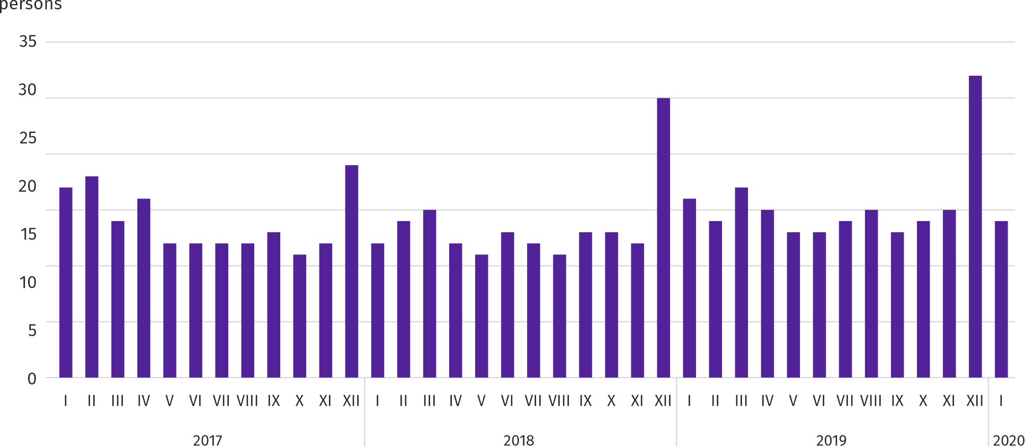
In January this year, 16.1 thousand job offers, i.e. more than a month before (by 56.2%) and less than a year before (by 5.5%) were submitted to labour offices. At the end of month, there were 14 unemployed persons (16 in the previous year) per job offer.
According to the labour offices, as of the end of January this year, 35 companies announced termination of 7.0 thousand employees in the near future (a year before, respectively 28 companies – 9.9 thousand employees).
Wages and salaries
In January this year, the average monthly gross wages and salaries in the enterprise sector grew faster on a yearly basis than a month before.
Average monthly gross wages and salaries in the enterprise sector in January this year amounted to PLN 6285.91 and were by 6.2% higher than a year before (in the previous month the increase was 5.2%). Average wages and salaries increased, among others, in administrative and support service activities (by 12.5%), real estate activities (by 9.3%) and information and communication (by 8.4%).
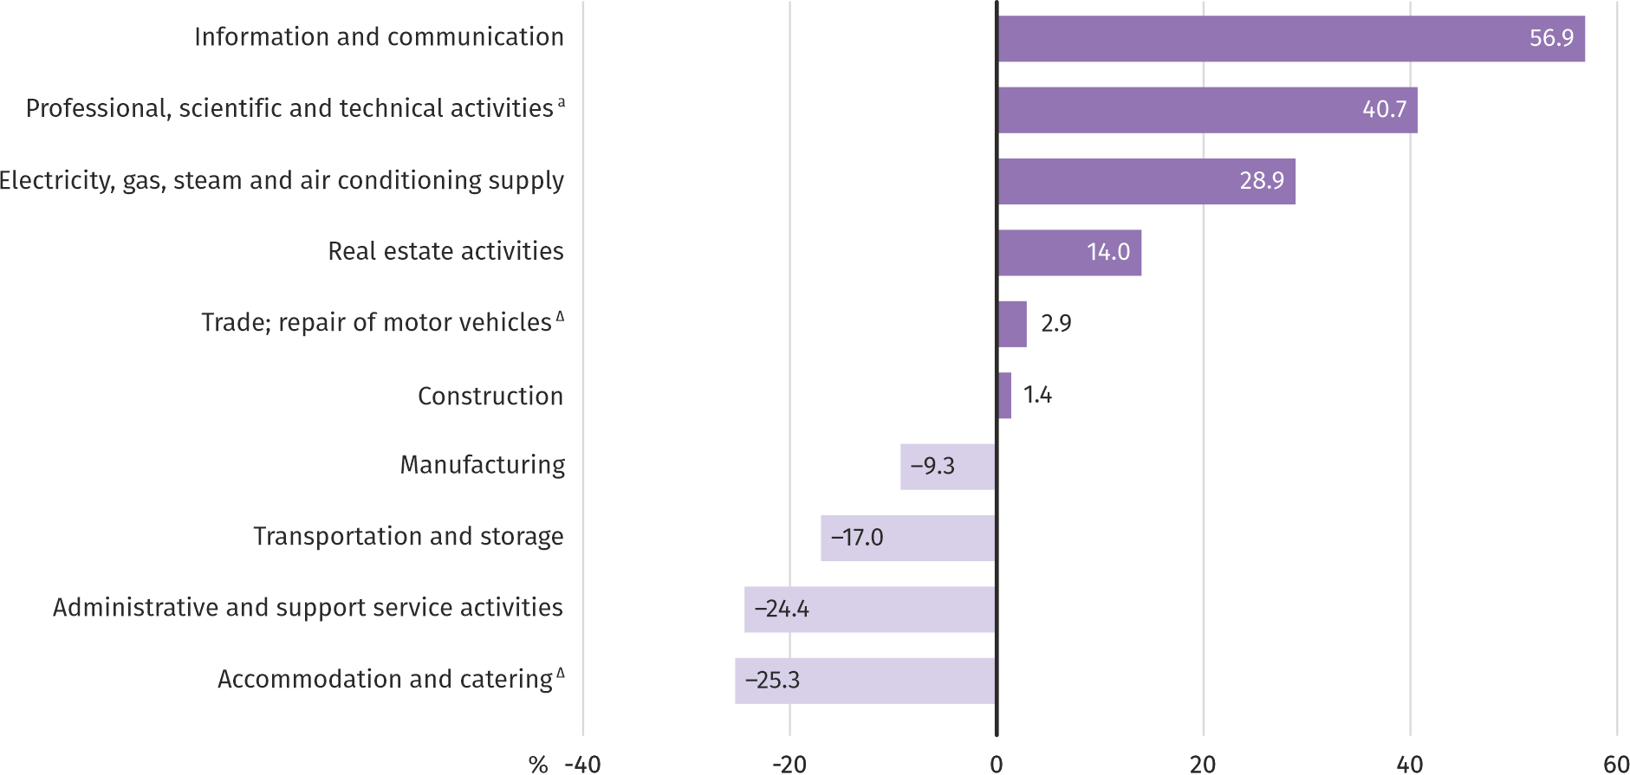
Chart 4. Relative deviations of average monthly gross wages and salaries in selected sections from average wages and salaries in the enterprise sector in January 2020

a Excluding divisions: Research and experimental development work and Veterinary activities.
In January 2020, the highest average monthly gross wages and salaries were noted in the information and communication section – it exceeded the average wages and salaries in the enterprise sector in the voivodship by 56.9%.
Table 3. Average monthly gross wages and salaries in the enterprise sector in January 2020
SPECIFICATION | I 2020
 | in PLN | I 2019=100
TOTAL | 6285,91 | 106,2
of which:
Industry | 5848,90 | 106,7
of which:
manufacturing | 5699,00 | 107,7
electricity, gas, steam and air conditioning supply | 8101,81 | 101,0
Construction | 6372,95 | 106,8
Trade; repair of motor vehicles ^{Δ} | 6466,15 | 104,6
Transportation and storage | 5219,97 | 105,3
Accommodation and catering ^{Δ} | 4693,57 | 108,3
Information and communication | 9859,97 | 108,4
Real estate activities | 7166,37 | 109,3
Professional, scientific and technical activities ª | 8844,71 | 103,7
Administrative and support service activities | 4751,45 | 112,5
a Excluding divisions: Research and experimental development work and Veterinary activities.

Chart 5. Average monthly gross wages and salaries in the enterprise sector (monthly average 2015=100)
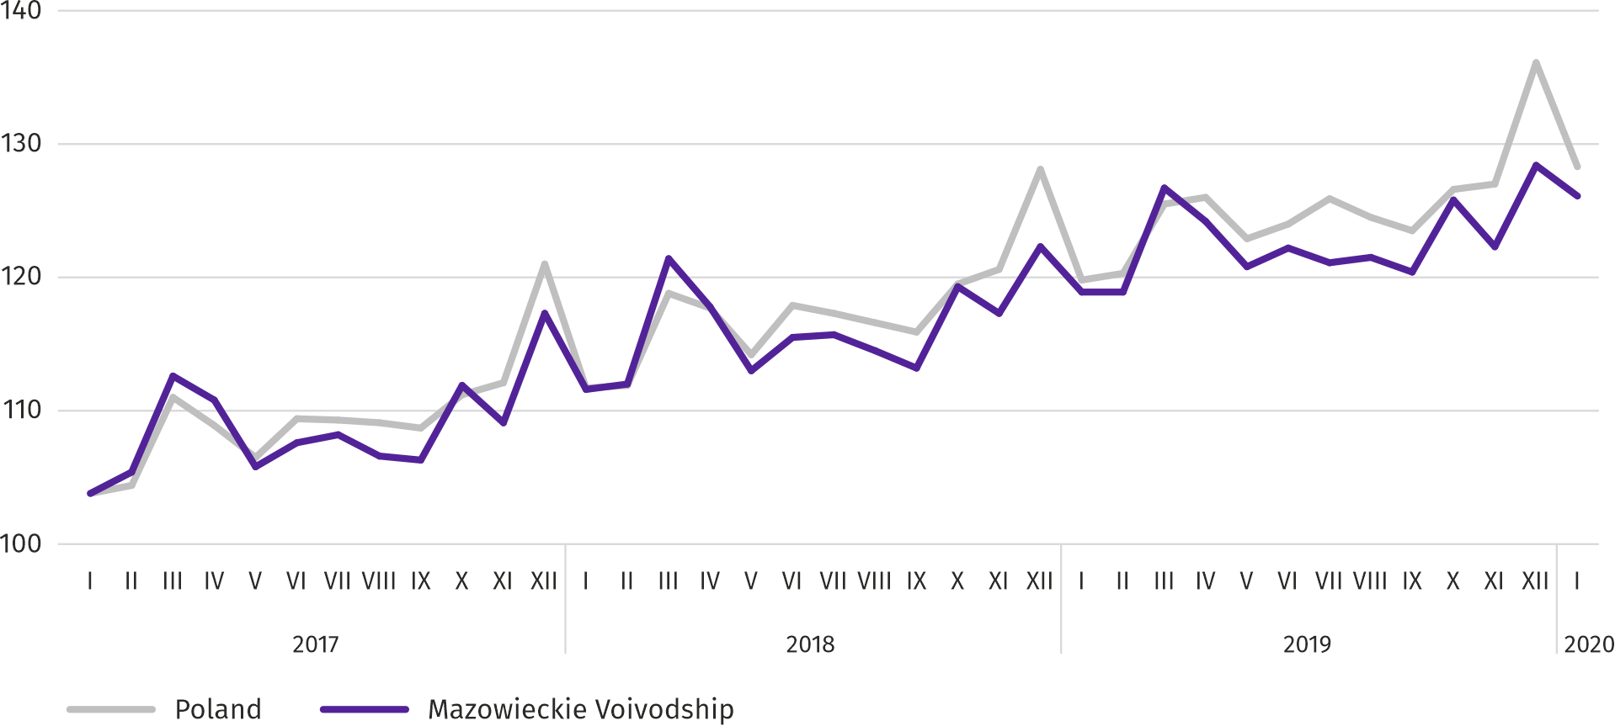

Agriculture
On the agricultural market in January this year, the average procurement prices of potatoes and cattle and poultry for slaughter were higher both on a monthly and annual basis; rye and milk prices were lower. Prices of pigs for slaughter were much higher than in the previous year and lower than in the previous month.
The average air temperature in Mazowieckie Voivodship in January 2020 amounted to 2.2°C and was by 4.2°C higher from the average from the years 1981–2010, while the maximum temperature reached 9.9°C (in Warszawa), and the minimum amounted to -5.5°C (in Kozienice). The average atmospheric precipitation (29.7 mm) accounted for 105% of the standard for the multi-year periods (ranging from 90% in Siedlce to 115% in Kozienice) . The number of days with precipitation, depending on the region, ranged from 12 to 14.
Table 4. Procurement of cereals ª
SPECIFICATION | VII 2019–I 2020 |  | I 2020
 | in thousand tonnes | corresponding  period of previuous year=100 | in thousand tonnes | I 2019=100 | XII 2019=100
Grain of basic cereals ^{b} | 278,9 | 112,8 | 36,6 | 121,4 | 141,6
of which:
wheat | 189,3 | 107,8 | 29,7 | 127,3 | 149,8
rye | 50,5 | 146,4 | 2,3 | 89,8 | 71,9
a Excluding procurement carried out by natural persons. b Includes: wheat, rye, barley, oats, triticale; including cereal mixed, excluding sowing seed.
Deliveries of basic cereals (including cereal mixed, excluding sowing seed) to procurement from the previous year’s production in July 2019–January 2020, were by 12.8% higher than in the corresponding period of previous year. In January this year, procurement of cereals was larger by 41.6% than in the previous month and by 21.4% than in a previous year.
Table 5. Procurement of basic animal products ª
SPECIFICATION | I 2020
 | in thousand tonnes | I 2019=100 | XII 2019=100
Animals for slaughter ^{b} | 81,3 | 101,0 | 102,4
of which:
cattle (including calves) | 2,4 | 86,7 | 77,8
pigs | 16,7 | 115,2 | 99,9
poultry | 62,1 | 98,4 | 104,4
Milk ^{c} | 219,3 | 103,7 | 103,3
a In the period of July–December excluding procurement carried out by natural persons. b Including cattle, calves, pigs, sheep, horses and poultry; in terms of meat including fats in post-slaughter warm weight. c In million litres.

Deliveries of animals for slaughter (in post-slaughter warm weight) in January this year, as a result of a much larger supply of pigs for slaughter, were by 1.0% larger than a year before. On the other hand, the drop in procurement in monthly terms (by 2.4%) was the result of larger supplies of poultry for slaughter.
Procurement of milk in January this year was by 3.3% larger than in the previous month and by 3.7% than in the previous year.
Table 6. Average prices of basic agricultural products
SPECIFICATION | Procurement prices |  |  | Marketplace prices
 | I 2020
 | PLN | I 2019=100 | XII 2019=100 | PLN | I 2019=100 | XII 2019=100
Wheat ª per dt | 71,32 | 84,6 | 101,2 | 87,53 | 95,1 | 102,8
Rye ª per dt | 51,72 | 74,8 | 99,9 | 64,51 | 93,6 | 98,5
Potatoes ^{b} per dt | 112,16 | 113,4 | 116,3 | 193,62 | 162,6 | 101,9
Animals for slaughter per kg of live weight:
cattle (excluding calves) | 6,67 | 104,1 | 107,1 | . | . | .
pigs | 6,07 | 149,5 | 95,5 | . | . | .
poultry | 3,44 | 103,1 | 100,7 | . | . | .
Piglet for breeding per head | 136,95 | 98,6 | 98,6 | . | . | .
a At procurement, excluding sowing seed. b At marketplaces – edible late.

Both procurement and marketplace prices of wheat and rye in January this year were below the level recorded in the previous year. In both markets, rye prices were also lower than in the previous month.

Chart 6. Average procurement prices of cereals and marketplace prices of potatoes
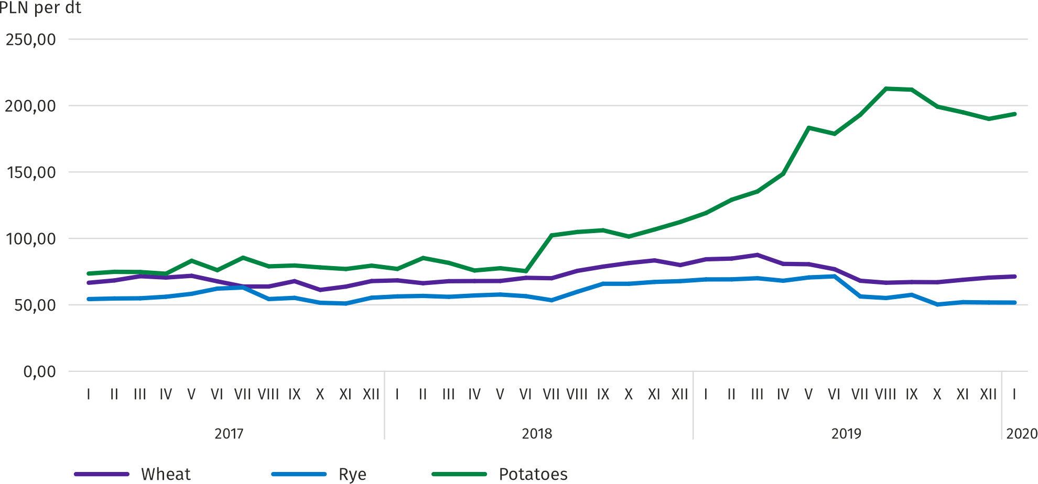
In January this year the seasonal increase in procurement prices of potatoes observed since November 2019 was maintained – the average price of this raw material was by 16.3% higher than a month before and by 13.4% than a year before. Marketplace price of potatoes increased on a monthly basis by 1.9% and it was still significantly higher on a yearly basis – by 62.6%.

Chart 7. Average procurement prices of animals for slaughter and milk
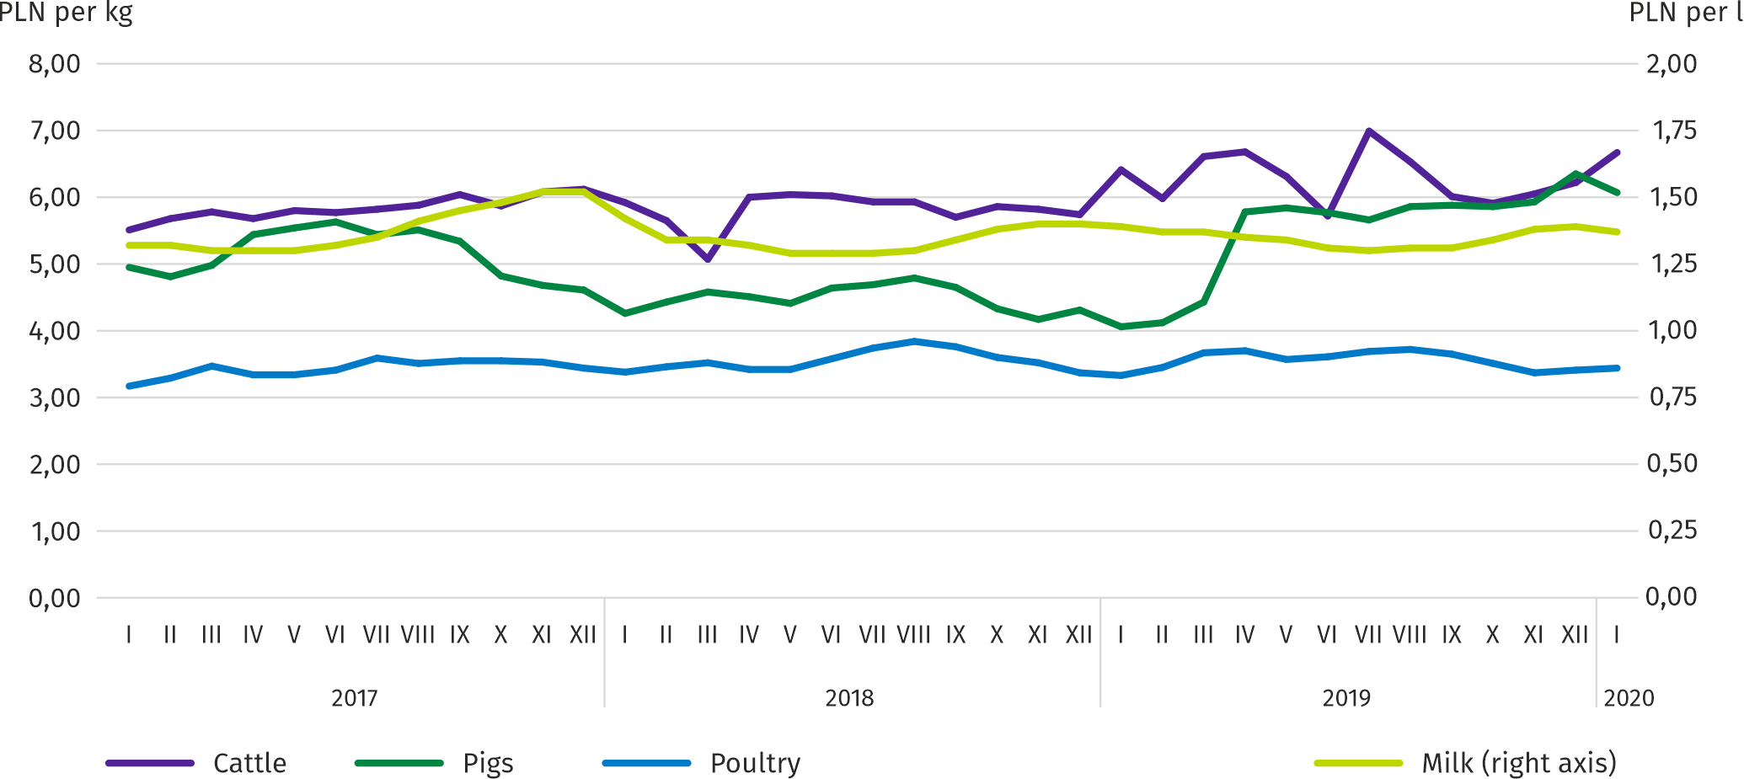
In January this year procurement prices of pigs for slaughter, after a significant increase in the previous month, decreased to the level of PLN 6.07 per kg, i.e. by 4.5%. Compared to January 2019, the average price of animals for slaughter was higher by nearly 50%. The ratio of procurement prices of pigs for slaughter to the marketplace prices of rye in January 2020 amounted to 9.4 (compared to 9.7 in December 2019).
Chart 8. Ratio of average procurement prices of pigs for slaughter to average marketplace prices of rye
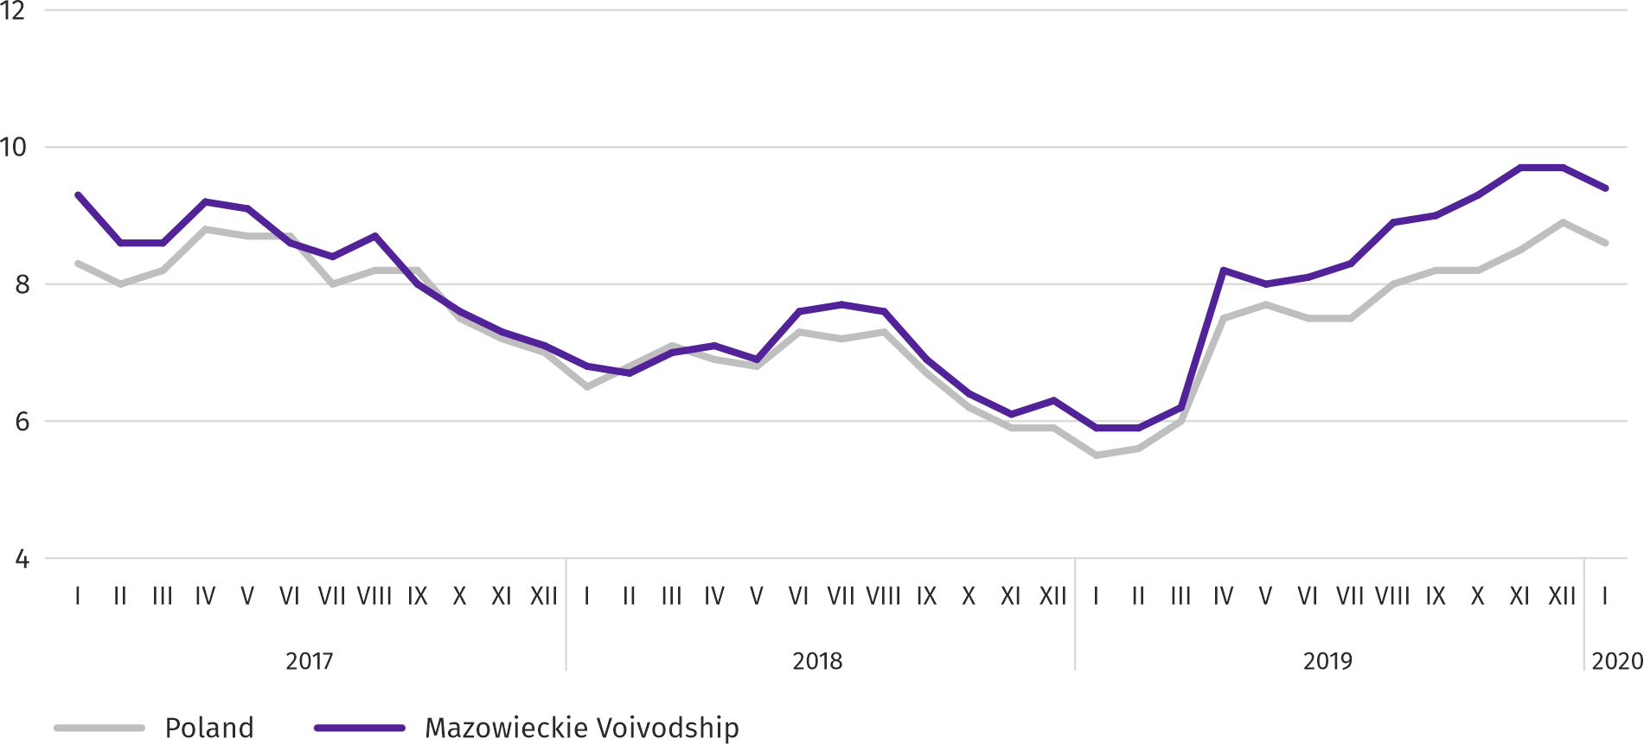

Table 7. Population of pigs in December 2019
SPECIFICATION | In heads | In percent | XII 2018=100
TOTAL ª | 1245855 | 100,0 | 107,1
Piglets weighing less than 20 kg | 145181 | 11,7 | 96,0
Pigs weighing from 20 kg to 50 kg | 431333 | 34,6 | 103,3
Pigs weighing 50 kg and more:
for slaughter | 615923 | 49,4 | 114,7
for breeding | 53418 | 4,3 | 93,2
of which sows | 52182 | 4,2 | 92,9
of which mated | 37888 | 3,0 | 102,6
a Preliminary data.

According to preliminary data, the population of pigs in December 2019 was 1245.9 thousand heads and, compared to December 2018, it increased by 82.9 thousand heads (by 7.1%). The increase in the population was the result of an increase in the number of piglets (by 3.3%) and pigs for slaughter weighing 50 kg and more (by 14.7%). The share of Mazowieckie Voivodship in the total domestic pig population was 11.1%.
Chart 9. Population of pigs
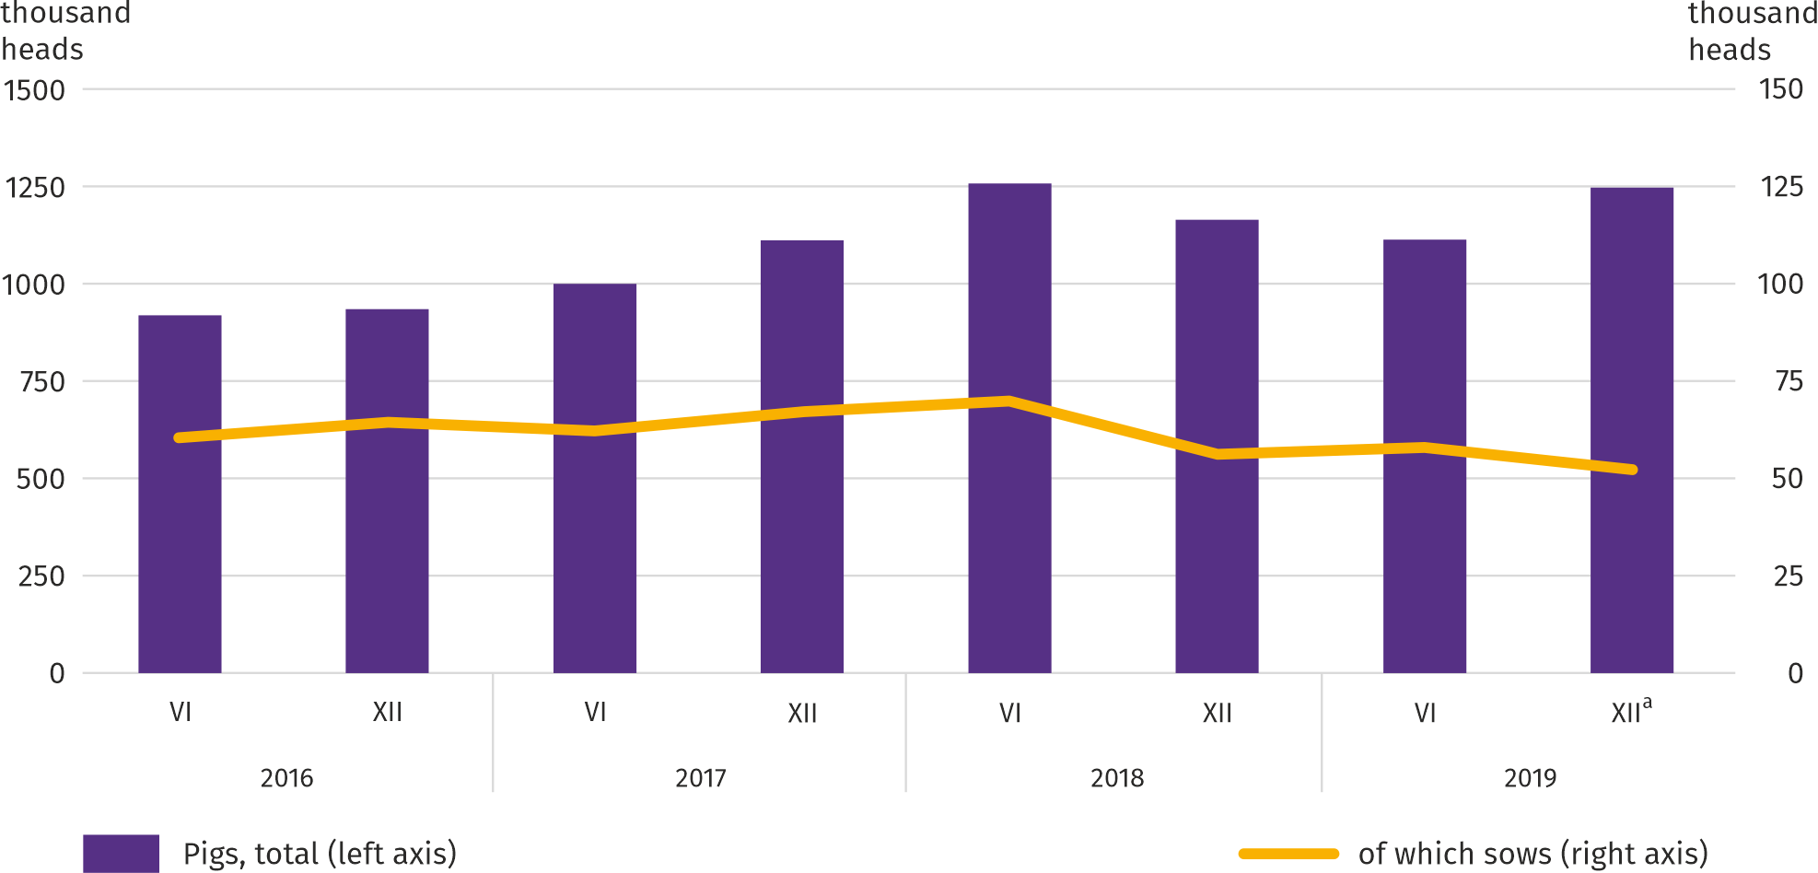
a Preliminary data.

In January 2020, at significantly lower (in monthly terms by 22.3%) supplies of cattle for slaughter to procurement, the average price of this raw material was by 7.1% higher than a month earlier and by 4.1% higher than a year before.

Table 8. Population of cattle in January 2020
SPECIFICATION | In heads | In percent | XII 2018=100
TOTAL ª | 1165330 | 100,0 | 99,2
Calves less than 1 year old | 289201 | 24,8 | 98,2
Young cattle between 1 and 2 years | 290106 | 24,9 | 95,6
Cattle over the age of 2 years | 586024 | 50,3 | 101,7
of which cows | 519299 | 44,6 | 99,5
of which dairy | 501531 | 43,0 | 99,5
a Preliminary data.

In December 2019, the total cattle population was 1165.3 thousand heads and was smaller by 8.9 thousand heads (by 0.8%) than in December 2018. The relatively largest decrease (by 4.4%) concerned a herd of young cattle from 1 to 2 years old. The share of Mazowieckie Voivodship in the total domestic cattle population was 18.6%.
Chart 10. Cattle population
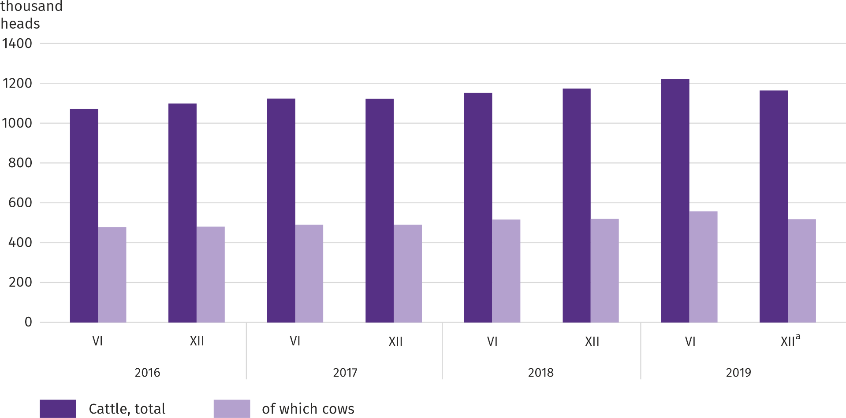
a Preliminary data.

The average procurement price of poultry for slaughter increased again. In January this year, on average, for 1 kg of poultry for slaughter, suppliers were paid 0.7% more than in December last year and 3.1% more than in January last year.
In January this year the upward trend in milk prices, observed since October last year, has been halted. In procurement, PLN 136.95 was paid for 100 liters of this raw material, i.e. 1.4% less both on a monthly and annual basis.
Industry and construction
Sold production of industry in January this year, reached the value (at current prices) of PLN 26264.8 million and was (at constant prices) by 2.3% higher than a year before (compared to a 6.7% increase in December this year); as compared to the previous month it increased by 1.8%.
Sold production in manufacturing (constituting 77.7% of sold production of industry) compared to January last year increased (at constant prices) by 4.4%. There was also a decrease (by 4.2%) in sold production in the section of electricity, gas, steam and air conditioning supply (the share of this section represents 20.1% of industrial production).
Chart 11. Sold production of industry (monthly average 2015=100; constant prices)
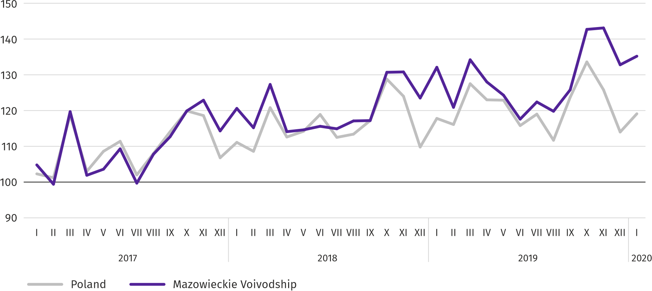
In January this year, the increase in sold production in annual terms was recorded in 24 (out of 33 in the voivodship) divisions of industry, among others, in: manufacture of computer, electronic and optical products (by 35.7%), metal products (by 18.4%), electrical equipment (by 7.6%), other non-metallic mineral products (by 5.6%). Whereas, there was a decrease in sold production of, among others, machinery and equipment n.e.c. (by 19.3%), paper and paper products (by 7.7%).
Table 9. Indices (constant prices) and structure (current prices) of sold production of industry in January 2020
SPECIFICATION | I 2019=100 | In percent
TOTAL | 102,3 | 100,0
of which:
Manufacturing | 104,4 | 77,7
of which manufacture of:
food products | 99,5 | 19,8
beverages | 100,1 | 1,7
paper and paper products | 92,3 | 2,6
chemicals and chemical products | 100,4 | 5,6
manufacture of rubber and plastic products | 102,8 | 3,5
other non-metallic mineral products | 105,6 | 2,4
metal products ^{Δ} | 118,4 | 4,0
computer, electronic and optical equipment | 135,7 | 6,2
electrical equipment | 107,6 | 5,2
machinery and equipment n.e.c. | 80,7 | 1,6
Electricity, gas, steam and air conditioning supply | 95,8 | 20,1

Labour productivity in industry measured by sold production per employed person, in January this year amounted (at current prices) to PLN 68.3 thousand and was (at constant prices) the same as a year before, with larger by 2.3% average paid employment and an increase in the average monthly gross wages and salaries by 6.7%.
Sold production of construction (at current prices) in January this year reached the value of PLN 4037.0 million and was by 16.4% higher than in the previous year (compared to a 10.0% increase in December last year).
Labour productivity in construction, measured by revenues from the sale of goods and services per employed person in January this year amounted to PLN 44.9 thousand (at current prices) and was by 19.5% higher compared to the corresponding month of 2018, with a decrease in average employment by 2.6% and an increase in average monthly gross wages and salaries by 6.8%.
Construction and assembly production (at current prices) in January this year amounted to PLN 1132.6 million and was by 11.6% lower than a year before (compared to a 0.8% increase in December last year). An increase in production was recorded in enterprises performing specialized construction activities (by 29.4%) and in units specializing in civil engineering and (by 19.0% each). On the other hand, there was a decrease in entities whose basic activity is the construction of buildings (by 10.8%).
Table 10. Indices and structure (at current prices) of construction and assembly production in January 2020
SPECIFICATION | I 2019=100 | In percent
TOTAL | 111,6 | 100,0
Construction of buildings | 89,2 | 25,8
Civil engineering | 119,0 | 49,4
Specialized construction activities | 129,4 | 24,8
Housing construction
In January this year, as compared to the corresponding month of 2019, the number of dwellings completed decreased by 20.7%; there were more dwellings for which permits have been granted or which have been registered with a construction project (by 11.5%) and dwellings in which construction has begun (by 6.1%).
According to preliminary data in December 2019, there were 2708 dwellings completed, i.e. by 706 fewer than in the previous year. Majority of dwellings were built for sale or rent – 1738 (64.2% of their total number), followed by private dwellings – 970 (35.8%); a year earlier, the share of these forms amounted to 73.3% and 24.0%, respectively. Compared to January 2019, there were less dwellings for sale or rent by 30.5%, and private dwellings by 18.4%.
The effects of housing construction obtained in Mazowieckie Voivodship in the surveyed month constituted 15.6% of national effects.
Table 11. Number of dwellings completed in January 2020
SPECIFICATION | Dwellings completed |  |  | Average useful floor area per dwelling in m²
 | in absolute numbers | in percent | I 2019=100
TOTAL | 2708 | 100,0 | 79,3 | 102,4
Private | 970 | 35,8 | 118,4 | 148,9
Cooperative | – | – | . | .
For sale or rent | 1738 | 64,2 | 69,5 | 76,5
Municipal | – | – | . | .
Public building society | – | – | . | .
Company | – | – | . | .

Chart 12. Dwellings completed (corresponding period 2015=100)
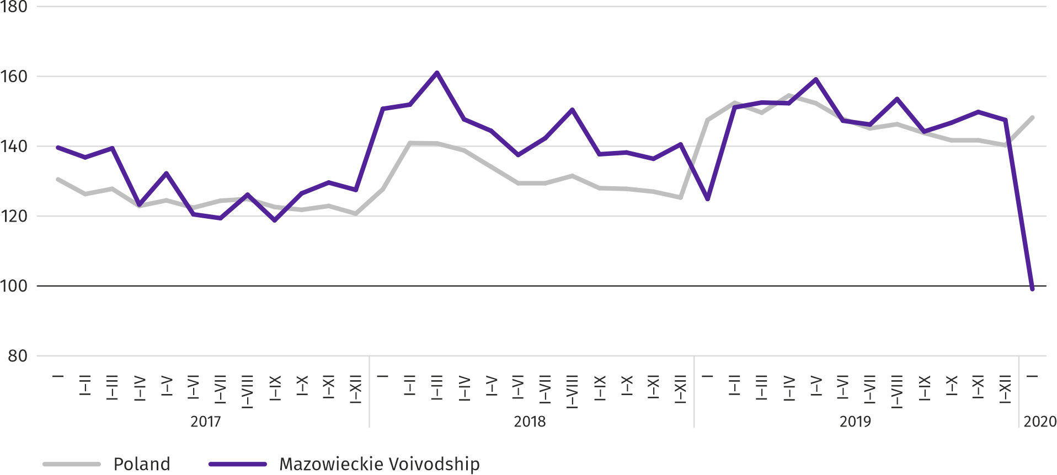

Most dwellings were completed in m.st. Warszawa (1056), followed by piaseczyński (270) and warszawski zachodni powiat (191), and the least in mławski (3) and łosicki powiat (4).
Map 2. Dwellings completed per 10 thousand population ª by powiats in January 2020
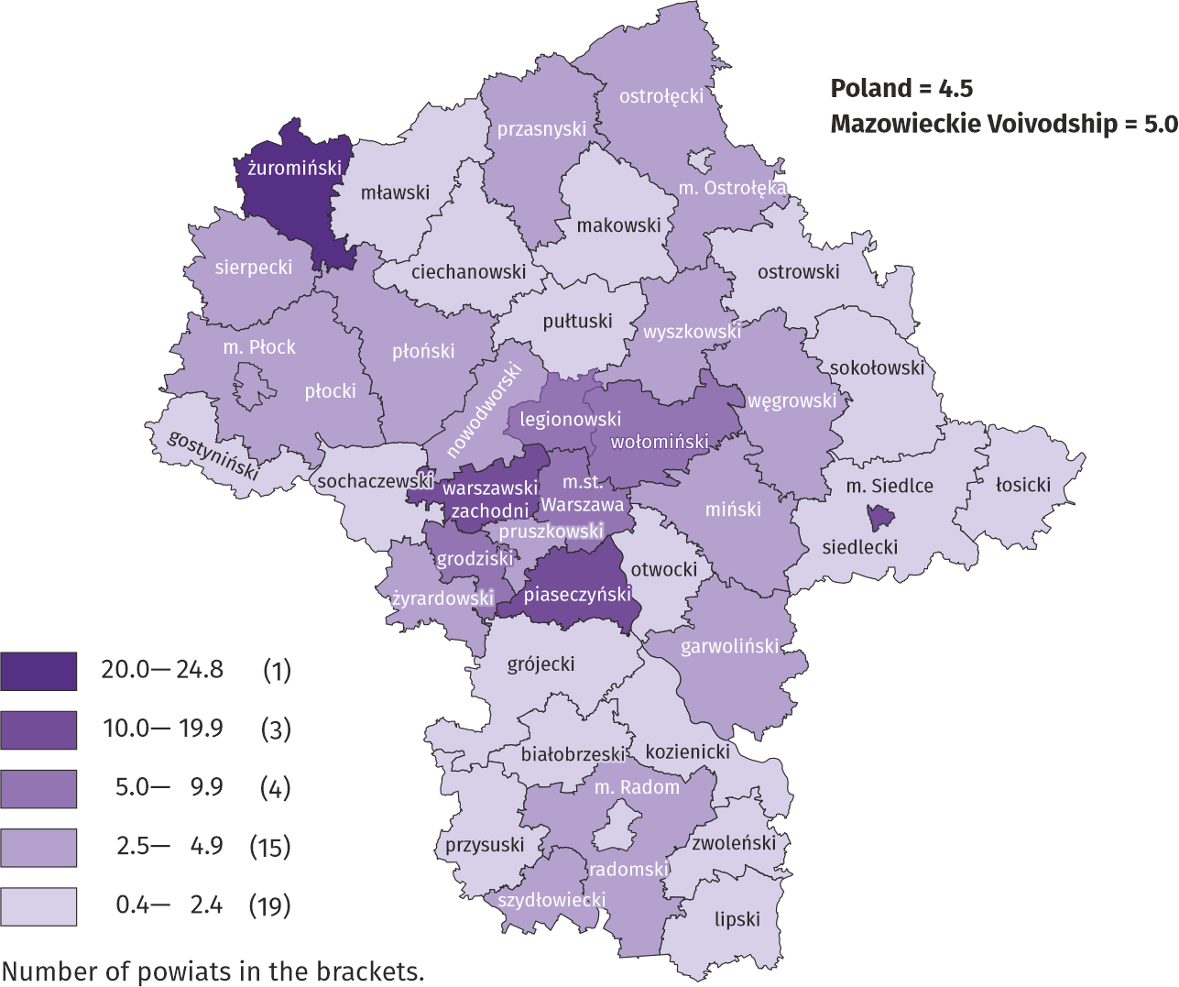

a Population as of 30 June 2019

The average useful floor area of dwellings completed in January this year amounted to 102.4 m² and was larger than a year earlier by 20.0 m². The largest dwellings were completed in pułtuski (204.6 m²), grójecki (186.9 m²) and przasnyski powiat (176.4 m²). The smallest were built in Siedlce (55.2 m²), żuromiński powiat (58.0 m²) and Płock (61.4 m²).
In January this year, the number of dwellings for which permits have been granted or which have been registered with a construction project amounted to 3955, that is by 409 (by 11.5%) more than a year earlier. Of the total number of dwellings, 76.3% were dwellings for sale or rent, and 23.7% private.
In the surveyed month, the construction began in 3274 dwellings, i.e. in 189 more (by 6.1%) compared to January 2019; dwellings for sale or rent accounted for 77.9% of their total number, and private 20.7%.
Table 12. Number of dwellings for which permits have been granted or which have been registered with a construction project as well as dwelling in which construction has begun in January 2020
SPECIFICATION | Dwellings for which permits have been granted or which have been registered with a construction project |  |  | Dwellings in which construction has begun
 | in absolute numbers | in percent | I 2019=100 | in absolute numbers | in percent | I 2019=100
TOTAL | 3955 | 100,0 | 111,5 | 3274 | 100,0 | 106,1
Private | 936 | 23,7 | 110,5 | 677 | 20,7 | 180,5
Cooperative | – | – | . | – | – | .
For sale or rent | 3019 | 76,3 | 115,4 | 2549 | 77,9 | 94,4
Municipal | – | – | . | 34 | 1,0 | 340,0
Public building society | – | – | . | – | – | .
Company | – | – | . | 14 | 0,4 | .

Domestic market
In January this year, retail sales were higher than in the previous year, while wholesale was lower.
Retail sales (at current prices) in trade and non-trade enterprises in January this year was by 6.0% higher than a year before. The highest increase in sales was recorded in units from the group: “food, beverages and tobacco” (by 11.8%), “motor vehicles, motorcycles, parts” (by 9.2%), “solid, liquid and gas fuels” (by 7.9%), “textiles, clothing and footwear” (by 7.0%). A decrease was recorded in two groups: “other” (by 7.1%) and “press, books, other sales in specialized stores” (by 6.4%).
Compared to December 2019, retail sales were lower by 24.3%. The highest decrease in sales was recorded in all groups, and the largest in the groups: “other retail sales in non-specialized stores” (by 43.1%), “press, books, other sales in specialized stores” (by 39.3%), “furniture, electronics and household appliances” (by 37.9%), “food, beverages and tobacco” (by 28.9%), “textiles, clothing, footwear” (by 28.8%).
Table 13. Indices and structure (at current prices) of retail sales in January 2020
SPECIFICATION | I 2019=100 | In percent
TOTAL ª | 106,0 | 100,0
of which:
Motor vehicles, motorcycles, parts | 109,2 | 8,3
Solid, liquid and gas fuels | 107,9 | 27,5
Food, beverages and tobacco | 111,8 | 16,8
Other retail sales in non-specialized stores | 100,5 | 2,4
Pharmeceuticals, cosmetics and orthopedic equipment | 103,5 | 3,7
Textiles, clothing and footwear | 107,0 | 5,3
Furniture, electronics and household appliances | 104,9 | 17,6
Press, books and other sales in specialized stores | 93,6 | 6,7
Other | 92,9 | 9,8
a The grouping of enterprises was made on the basis of the Polish Classification of Activities - PKD 2007, including the enterprise to a specific category according to the type of predominant activity, in accordance with the organizational status in the period under consideration. The recorded changes (increase/decrease) in retail sales in particular groups of activity of enterprises may also result from changes in the type of predominant economic activity and organizational changes (e.g. mergers of enterprises). This does not affect the dynamics of retail sales in general.

Wholesale (at current prices) in trade enterprises in January 2020 was by 6.8% lower as compared to the previous month, but by 1.0% lower compared to January 2019. In wholesale enterprises it was lower by 5.1% and 2.1%, respectively.

Table 14. Selected data on Mazowieckie Voivodship
SPECIFICATION  A – 2019  B – 2020 |  | I | II | III | IV | V | VI | VII | VIII | IX | X | XI | XII
Average employment in the enterprise sector ª  (in thousand persons) | A | 1527,0 | 1522,3 | 1525,2 | 1525,9 | 1523,5 | 1524,8 | 1529,5 | 1530,8 | 1528,6 | 1530,9 | 1536,1 | 1541,1
 | B | 1552,1
previous month=100 | A | 101,3 | 99,7 | 100,2 | 100,0 | 99,8 | 100,1 | 100,3 | 100,1 | 99,9 | 100,2 | 100,3 | 100,3
 | B | 100,7
corresponding month of previous year=100 | A | 102,5 | 102,2 | 102,4 | 102,4 | 102,3 | 102,3 | 102,3 | 102,2 | 102,1 | 102,3 | 102,2 | 102,3
 | B | 101,6
Registered unemployed persons (in thousand persons; as of end of period) | A | 143,4 | 142,4 | 138,8 | 133,8 | 130,1 | 126,7 | 125,6 | 125,6 | 123,3 | 120,9 | 121,9 | 123,2
 | B | 130,1
Unemployment rate ^{b} (in %; as of end of period) | A | 5,1 | 5,0 | 4,9 | 4,7 | 4,6 | 4,5 | 4,5 | 4,5 | 4,4 | 4,3 | 4,3 | 4,4
 | B | 4,6
Job offers (submitted during a month) | A | 17000 | 15394 | 15971 | 15065 | 15153 | 13859 | 13573 | 13132 | 14628 | 14386 | 12061 | 10281
 | B | 16059
Unemployed persons per 1 job offer (as of end of period) | A | 16 | 14 | 17 | 15 | 13 | 13 | 14 | 15 | 13 | 14 | 15 | 27
 | B | 14
Average monthly gross wages and salaries in the enterprise sector ª (in PLN) | A | 5919,32 | 5920,22 | 6311,43 | 6185,82 | 6020,53 | 6093,26 | 6036,91 | 6053,18 | 6000,45 | 6273,41 | 6098,25 | 6402,10
 | B | 6285,91
previous month=100 | A | 97,2 | 100,0 | 106,6 | 98,0 | 97,3 | 101,2 | 99,1 | 100,3 | 99,1 | 104,5 | 97,2 | 105,0
 | B | 98,2
corresponding month of previous period=100 | A | 106,6 | 106,2 | 104,5 | 105,5 | 107,1 | 106,1 | 104,9 | 106,3 | 106,5 | 105,6 | 104,5 | 105,2
 | B | 106,2
Price indices:
consumer goods and services ^{c}:
corresponding period of previous year=100 | A | . | . | 101,0 | . | . | 102,2 | . | . | 102,7 | . | . | .
 | B | .
a In enterprises employing more than 9 persons. b Share of registered unemployed persons in civilian economically active population, estimated at the end of each month. c In the quarter.
Table 14. Selected data on Mazowieckie Voivodship (cont.)
SPECIFICATION  A – 2019  B – 2020 |  | I | II | III | IV | V | VI | VII | VIII | IX | X | XI | XII
Price indices (cont.):
Procurement of cereal grain:
previous month=100 | A | 104,3 | 100,6 | 105,0 | 91,2 | 100,6 | 95,4 | 84,1 | 99,9 | 102,7 | 98,5 | 102,9 | 101,5
 | B | 102,6
corresponding month of previous year=100 | A | 123,3 | 128,6 | 131,0 | 118,7 | 119,6 | 112,3 | 97,9 | 89,4 | 85,9 | 81,6 | 81,4 | 85,5
 | B | 84,2
procurement of cattle for slaughter (excluding calves):
previous month=100 | A | 111,7 | 93,3 | 110,6 | 101,0 | 94,5 | 90,6 | 122,2 | 93,5 | 92,0 | 98,2 | 102,5 | 102,8
 | B | 107,1
corresponding month of previous year=100 | A | 108,1 | 105,8 | 130,2 | 111,3 | 104,4 | 95,0 | 117,7 | 110,1 | 105,5 | 100,8 | 104,0 | 108,5
 | B | 104,1
procurement of pigs for slaughter:
previous month=100 | A | 94,2 | 101,5 | 107,5 | 130,6 | 101,1 | 98,7 | 98,2 | 103,6 | 100,2 | 99,8 | 101,1 | 107,2
 | B | 95,5
corresponding month of previous year=100 | A | 95,1 | 93,0 | 96,7 | 128,1 | 132,4 | 124,2 | 120,7 | 122,4 | 126,3 | 135,2 | 142,1 | 147,6
 | B | 149,5
Ratio of procurement prices ª of pigs for slaughter to marketplace prices of rye | A | 5,9 | 5,9 | 6,2 | 8,2 | 8,0 | 8,1 | 8,3 | 8,9 | 9,0 | 9,3 | 9,7 | 9,7
 | B | 9,4
Sold production of industry ^{b} (at constant prices):
previous month=100 | A | 106,1 | 91,5 | 111,0 | 95,4 | 97,1 | 94,6 | 104,1 | 97,9 | 105,0 | 113,4 | 100,3 | 92,8*
 | B | 101,8
corresponding month of previous year=100 | A | 109,5 | 104,9 | 105,3 | 112,2 | 108,6 | 101,9 | 106,6 | 102,5 | 107,5 | 109,3 | 109,5 | 106,7*
 | B | 102,3
Construction and assembly production ^{b} (at current prices):
previous month=100 | A | 40,1 | 146,1 | 115,8 | 102,0 | 105,4 | 108,7 | 112,1 | 103,8 | 113,3 | 83,2 | 91,1 | 127,3
 | B | 44,4
corresponding month of previous year=100 | A | 90,1 | 154,2 | 114,3 | 124,5 | 107,2 | 106,8 | 108,1 | 124,4 | 130,9 | 88,2 | 87,9 | 100,8
 | B | 111,6
a Current prices excluding VAT. b In enterprises employing more than 9 persons.
Table 14. Selected data on Mazowieckie Voivodship (cont.)
SPECIFICATION  A – 2019  B – 2020 |  | I | II | III | IV | V | VI | VII | VIII | IX | X | XI | XII
Dwellings completed (from the beginning of the year) | A | 3414 | 6724 | 9615 | 13103 | 16748 | 19467 | 22744 | 26836 | 30193 | 34677 | 39188 | 43103
 | B | 2708
corresponding period of previous year=100 | A | 82,9 | 99,5 | 94,7 | 103,1 | 110,1 | 107,1 | 102,7 | 102,1 | 104,8 | 106,2 | 109,8 | 104,9
 | B | 79,3
Retail sales of goods ª (at current prices):
previous month=100 | A | 79,4 | 94,5 | 116,2 | 104,2 | 98,6 | 102,7 | 101,2 | 99,3 | 96,7 | 105,7 | 100,7 | 116,8
 | B | 75,7
corresponding month of previous year=100 | A | 104,5 | 104,5 | 105,7 | 110,5 | 106,2 | 104,7 | 105,6 | 103,8 | 104,7 | 104,5 | 106,4 | 111,2
 | B | 106,0
Turnover profitability indicator in enterprises ^{b}:
gross ^{c} (in %) | A | . | . | 3,8 | . | . | 5,3 | . | . | 5,0 | . | . | .
 | B | .
net ^{d} (in %) | A | . | . | 3,0 | . | . | 4,3 | . | . | 4,1 | . | . | .
 | B | .
Investment outlays of enterprises ^{b} – from the beginning of the year (in million PLN; current prices) | A | . | . | 8186,7 | . | . | 19969,2 | . | . | 32656,9 | . | . | .
 | B | .
corresponding period of previous year=100 (current prices) | A | . | . | 120,7 | . | . | 118,4 | . | . | 115,9 | . | . | .
 | B | .
Entities of the national economy ^{e} in the REGON register (as of end of period) | A | 819274 | 822655 | 826407 | 829983 | 833385 | 836698 | 840124 | 843374 | 846686 | 850340 | 853160 | 854457
 | B | 855961
of which commercial companies | A | 160010 | 160971 | 161997 | 162973 | 163843 | 164635 | 165630 | 166585 | 167542 | 168588 | 169648 | 170518
 | B | 171505
of which with foreign capital participation | A | 31667 | 31718 | 31813 | 31996 | 32205 | 32384 | 32603 | 32747 | 32863 | 32966 | 33117 | 33215
 | B | 33224
a In enterprises employing more than 9 persons. b In enterprises employing more than 49 persons. c Relation of gross financial result to revenues from total activity. d Relation of net financial result to revenues from total activity. e Excluding persons tending private farms in agriculture.

Prepared by | Contact: |  | warszawa.stat.gov.pl/en
Statistical Office in Warszawa  Director Zofia Kozłowska | tel.: (+48 22) 464 23 15 |  | @Warszawa_STAT
1 Sierpnia 21 | fax: (+48 22) 846 76 67
02-134 Warszawa | e-mail: SekretariatUSWAW@stat.gov.pl

Related information
Statistical Bulletin of Mazowieckie Voivodship
Report on the socio-economic situation of Mazowieckie Voivodship in 2018
Socio-economic situation of voivodships No. 3/2019

Data available in databases
Local Data Bank
Knowledge Databases

Terms used in official statistics
Enterprise sector
Average paid employment
Registered unemployed persons
Registered unemployment rate
Average monthly gross wages and salaries
Retail price
Price index of consumer goods and services
Procurement of agricultural products
Procurement prices
Marketplace prices
Pigs
Cattle
Sold production of industry
Sale of construction and assembly production
Dwellings completed
Retail sales of goods
Wholesale
Financial results of enterprises
Investment outlays

Long-term unemployed include persons remaining in the register rolls of the powiat labour office for the whole period of over 12 months during the last 2 years, excluding periods of traineeship and occupational preparation at the workplace.
Refers to vacancies and places of occupational activation.
The average values of temperature and precipitation were calculated as arithmetic averages of the average monthly values from five hydrological and meteorological stations of the Institute of Meteorology and Water Management located in Kozienice, Mława, Płock, Siedlce and Warszawa.
Reporting data – may change after preparing quarterly report.

