Statistic of Warszawa No. 10/2021

In October 2021, there was an increase in the average employment and in the number of unemployed persons compared to the corresponding period of previous year. Sold production of industry and construction and assembly production were higher than in the previous year. Retail sales and wholesale increased as well. October was also characterized by a lower number of dwellings completed than in the previous year as well as dwellings in which construction has begun and a higher number of permits issued.

 127.1

Dynamics of sold production of construction y/y

Average paid employment

Average paid employment in the enterprise sector in October 2021 was by 0.3 thousand higher than a year before

Average paid employment in the enterprise sector in October 2021 amounted to 1088.8 thousand persons and was at a similar level to September 2021 and by 346 persons higher than in October 2020.

Compared to September 2021, an increase in the average employment was recorded in the following sections: professional, scientific and technical activities (by 0.8%), real estate activities (by 0.6%), information and communication (by 0.4%), transportation and storage (by 0.2%), trade; repair of motor vehicles (by 0.1%).

Whereas a decrease in the average employment was recorded in the following sections: industry (by 0.6%), accommodation and catering (by 0.3%), administrative and support service activities as well as construction (by 0.2% each).

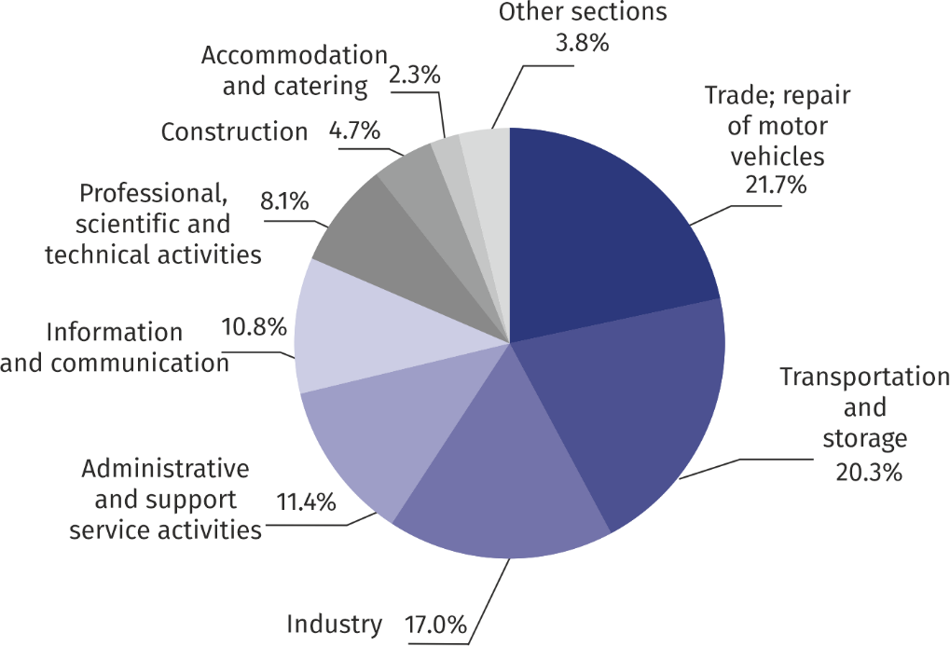Chart 1. Structure of average employment by PKD (NACE Rev.2) sections in October 2021

As compared to October 2020, an increase in the average employment was recorded in the sections: information and communication (by 6.0%), administrative and support service activities (by 2.3%), professional, scientific and technical activities (by 2.2%).

A decrease in the average employment was recorded in the sections: accommodation and catering (by 5.4%), transportation and storage (by 2.3%), real estate activities (by 1.8%), industry (by 1.7%), construction and trade; repair of motor vehicles (by 0.4% each).

Registered unemployment

At the end of October 2021, the number of registered unemployed persons was by 2.4% higher than in the previous year, and the unemployment rate increased by 0.1 pp

.

At the end of October 2021, the number of registered unemployed persons amounted to 25050 and was by 657 persons, i.e. by 2.6% smaller than at the end of September 2021 and by 582 persons, i.e. by 2.4% larger than in the corresponding period of 2020.

The number of registered unemployed women amounted to 12097, which accounted for 48.3% of the total unemployed (48.3% a month and 48.9% a year before) and 18.1% of unemployed women in Mazowieckie Voivodship. As compared to September 2021, the number of unemployed women decreased by 310 persons, i.e. by 2.5% and compared to October 2020 increased by 130 persons, i.e. by 1.1%.

The registered unemployment rate amounted to 1.9% (as in the previous month, and 1.8% in the previous year), the average in Mazowieckie Voivodship was 4.6% (4.8% a month before, and 5.1% a year before), while the national average was 5.5% (5.6% a month and 6.1% a year before).

In October 2021, there were 2112 unemployed persons registered in labour offices (2097 in September 2021, and 2774 in October 2020). Registered unemployed persons accounted for 16.8% of the total registered unemployed in the Voivodship.

The number of persons registering for the first time amounted to 777 (a month before 766), which accounted for 36.8% of the total unemployed who registered in October 2021 and 23.5% of persons registering for the first time in the Voivodship. The share of persons terminated due to company reasons among unemployed persons registered in October 2021 amounted to 2.6% (4.0% in Mazowieckie Voivodship), 2.1% a month before and 4.1% a year before.

In October 2021, 2769 persons were removed from unemployment rolls (2441 in September 2021, and 2731 in October 2020), which accounted for 17.1% of unemployed persons removed from unemployment rolls in Mazowieckie Voivodship. Out of the unemployed removed from unemployment rolls, 1908 persons took up work. Moreover, 382 persons lost their status of the unemployed as a result of not confirming their readiness to take up work. The reason for removing from the register was also starting training or traineeship, acquisition of retirement rights of pre-retirement benefit, acquisition of pension rights, voluntarily gave up the status of the unemployed and other.

There were 22167 persons who were not entitled to the unemployment benefit, i.e. 88.5% of the total unemployed (20232 persons a year before, i.e. 82.7%). Whereas 2883 unemployed persons were entitled to the unemployment benefit.

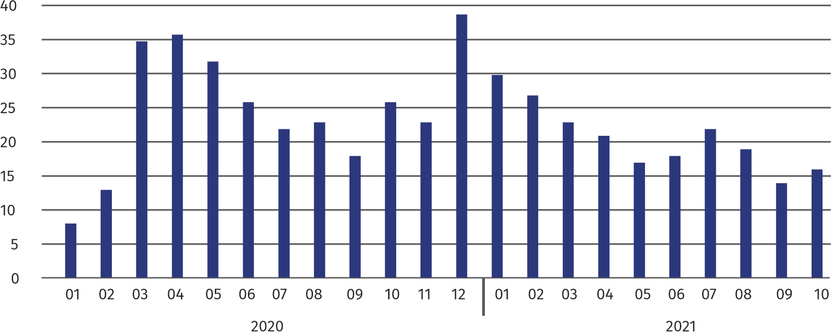**Chart 2. Number of unemployed persons per job offer (as of end of month)**

In October 2021, there were 39.8% more job offers than a year before

In October 2021, there were 4352 job offers submitted to labour offices, which accounted for 24.0% of job offers in Mazowieckie Voivodship and at the end this month the labour offices had job offers for 1556 persons. At the end of October 2021 there were 16 persons per one job offer (14 a month before and 26 a year before), in Mazowieckie Voivodship 14 persons (13 in the previous month and 23 in the previous year) registered as unemployed.

Wages and salaries

The average monthly gross wages and salaries in the enterprise sector in October 2021 amounted to PLN 7395.46 and were by 4.1% higher as compared to the previous month and by 7.3% higher than in the corresponding period of 2020.

Compared to September 2021, the increase in the average gross wages and salaries was recorded in the following sections: construction (by 21.2%), transportation and storage (by 14.6%), professional, scientific and technical activities (by 2.9%), industry (by 2.2%), real estate activities (by 1.9%), trade; repair of motor vehicles (by 1.2%).

Average monthly gross wages and salaries in the enterprise sector in October 2021 amounted to PLN 7395.46 and was by 7.3% higher than in October 2020

On the other hand, the decrease in the average wages and salaries was recorded in the sections: information and communication (by 2.1%), administrative and support service activities (by 1.4%), accommodation and catering (by 0.2%).

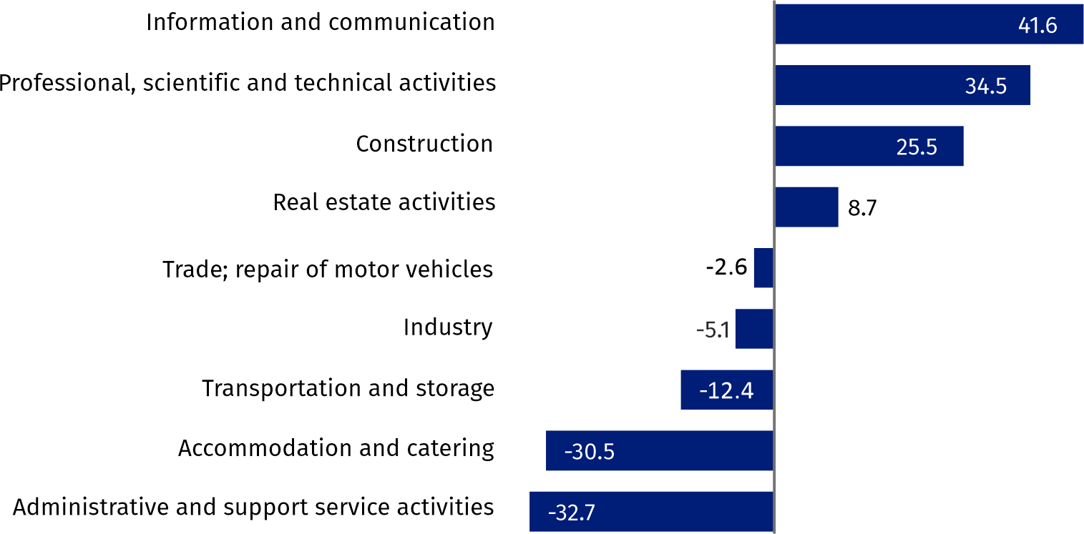Chart 3. Relative deviations (in %) of monthly gross wages and salaries in selected sections from  
average wages and salaries in enterprise sector in October 2021

Compared to October 2020, an increase in the average gross wages and salaries was recorded in the sections: accommodation and catering (by 16.9%), professional, scientific and real estate activities (by 11.5%), industry (by 8.2%), administrative and support service activities (by 8.1%), information and communication (by 7.1%), construction (by 6.6%), real estate activities (by 5.9%), trade; repair of motor vehicles (by 5.8%), transportation and storage (by 4.1%).

Industry

Sold production in manufacturing (at constant prices) in October 2021 was by 1.4% larger than a year before

Sold production of industry in October 2021 amounted (at current prices) to PLN 15976.4 million and was (at constant prices) larger as compared to the corresponding period of 2020 by 18.6%. As compared to October 2020, an increase by 1.4% was recorded in sold production in manufacturing.

In the period January-October 2021, sold production of industry amounted to PLN 132373.2 million (at current prices) and was (at constant prices) higher by 10.4% than in the corresponding period of 2020. There was a production increase in manufacturing by 7.2%.

Among divisions included in manufacturing, the sales increase was recorded, among others, in: manufacture of products of wood, cork, straw and wicker (by 62.9%), manufacture of motor vehicles, trailers and semi-trailers (by 45.5%), manufacture of textiles (by 41.8%), manufacture of wearing apparel (by 31.3%), other manufacturing (by 29.5%), manufacture of beverages (by 22.4%), manufacture of computer, electronic and optical products (by 21.7%), manufacture of electrical equipment (by 21.6%), repair and installation of machinery and equipment (by 20.1%), manufacture of other transport equipment (by 19.1%), manufacture of metal products (by 15.9%), manufacture of furniture (by 13.6%), manufacture of other non-metallic mineral products (by 11.5%).

The decrease in sales was recorded, among others, in: manufacture of pharmaceutical products (by 15.1%), manufacture of coke and refined petroleum products (by 13.0%), manufacture of food products (by 4.6%), manufacture of chemicals and chemical products (by 3.4%),

Labour productivity in construction measured by production per employed person, in January-October 2021 amounted to PLN 715.2 thousand (at current prices) and was – at constant prices – by 11.7% higher than in the previous year.

**Construction**

Sold production of construction in October 2021 amounted (at current prices) to PLN 5009.8 million and compared to September 2021 was larger by 7.0%, and compared to the corresponding period of the previous year it increased by 27.1%.

In the period January-October 2021, sold production of construction reached PLN 44831.6 million, i.e. by 6.6% larger than in the corresponding period of 2020.

Construction and assembly production (at current prices) in October 2021 was by 20.3% larger than a year before

Construction and assembly production in October 2021 reached PLN 1273.0 million (at current prices) and accounted for 25.4% of sold production of construction. As compared to the previous month, construction and assembly production increased by 5.0%, and compared to October 2020 it was higher by 20.3%.

In the period January-October 2021, construction and assembly production was at the level of PLN 10392.7 million and accounted for 23.2% of sold production of construction (24.1% a year before). Compared to the corresponding period of previous year construction and assemby production was larger by 2.3%.

The increase in production in relation to the corresponding period of 2020 occurred in units dealing with specialized construction activities (by 11.9%) and civil engineering (by 5.8%), while the decrease in production was recorded in entities dealing with construction of buildings (by 12.3%).

Labour productivity measured by production per employed person in construction in October 2021 amounted to PLN 98.6 thousand and was by 7.2% higher than a month before and by 27.7% higher than in October 2020.

Trade

Retail sales (at current prices) in trade and non-trade enterprises in October 2021 were by 13.8% larger than in October 2020

Retail sales in trade and non-trade enterprises in October 2021 (at current prices) were by 3.2% larger than in September 2021 and by 13.8% higher compared to October 2020.

Compared to September 2021, there was an increase In the sales textiles, clothing and footwear (by 13.2%), retail sales conducted by mail order houses (by 11.3%), sales of food, beverages and tobacco (by 9.2%), sales of motor vehicles, motorcycles, parts (by 8.0%), other sales (by 4.8%), sales of pharmaceuticals, cosmetics, orthopedic equipment (by 3.7%), sales of solid, liquid and gas fuels (by 2.1%).

Whereas there was a decrease in sales of press, books, other sales in specialized stores (by 2.9%), other retail sales in non-specialized stores (by 1.5%), sales of furniture, electronics and household appliances (by 0.5%).

Compared to October 2020, there was an increase in retail sales conducted by mail order houses as well as sales of textiles, clothing and footwear (by 40.7% each), sales of solid, liquid and gas fuels (by 37.6%), sales of textiles, clothing and footwear (by 14.8%), sales of press, books, other sales in specialized stores (by 15.5%), sales of pharmaceuticals, cosmetics, orthopedic equipment (by 13.9%), other sales (by 13.4%), sales of food, beverages and tobacco (by 7.1%), other retail sales in non-specialized stores (by 6.9%), sales of furniture, electronics and household appliances (by 3.9%),

Whereas there was a decrease in the sales of motor vehicles, motorcycles, parts (by 7.8%).

In the period January-October 2021, retail sales increased by 11.7% compared to the corresponding period of 2020.

Wholesale in trade enterprises in October 2021 (at current prices) was by 0.3% larger as compared to the previous month and by 6.3% higher as compared to October 2020, and in wholesale enterprises it was lower by 0.5% and higher by 11.1%, respectively.

Wholesale (at current prices) in trade enterprises was by 6.3% higher than a year before

In the period January-October 2021, trade units realized wholesale by 15.5% larger than in the previous year, while wholesale enterprises by 13.5% higher.

**Housing construction[1]**

According to preliminary data, 1053 dwellings were completed in Warszawa in October 2021, i.e. by 44.3% less than in the previous year.

In the period January-October 2021, 13747 dwellings were completed (by 26.8% less than in the corresponding period of 2020), and in Mazowieckie Voivodship 33554 dwellings, i.e. by 9.7% less than in January–October 2020. The decrease in the number of dwellings completed was recorded in construction for sale or rent from 17960 to 13041 dwellings, i.e. by 27.4% less. Whereas an increase occurred in municipal construction from 100 to 156, i.e. by 56.0% more, in private construction from 470 to 550, i.e. by 17.0% more.

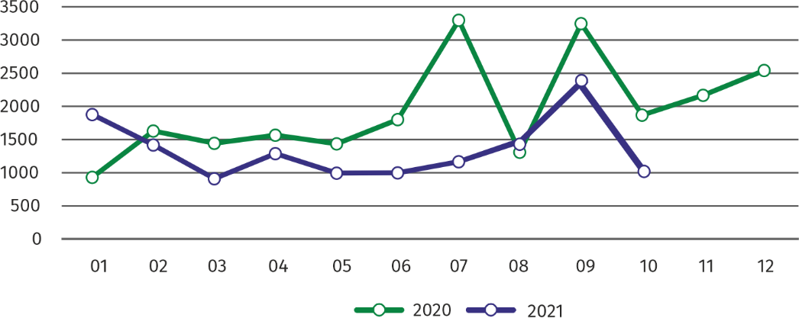Chart 4. Dwellings completed

In January-October 2021, the construction began in 15987 dwellings, i.e. by 28.5% more than in the corresponding period of the previous year

In October 2021, the construction began in 1413dwellings, i.e. 3.4% less than in October 2020.

In January-September 2021, the construction began in 15987dwellings (by 28.5% more than in the corresponding period of 2020), of which: 15152in construction for sale or rent, 718in private construction**,** 117 in cooperative construction.

The number of dwellings for which permits have been issued or for which have been registered with a construction project in October 2021 amounted to 2078 and was by 3.1% higher than the year before.

In January–October 2021, the number of dwellings for which permits have been granted or which have been registered with a construction project amounted to 15585 (by 25.1% more than in the corresponding period of 2020), of which 772 dwellings in buildings built by private investors.

The average useful floor area of a dwelling completed in January**-**October 2021, amounted to 64.1 m2 and increased compared to the corresponding period of 2020 by 4.2 m2. In private construction, the average useful floor area of dwellings amounted to 187.0 m2 (by 15.1 m2 fewer than in the corresponding period of 2020), in construction for sale or rent — 59.2 m2 (by 2.8 m2 more), in municipal construction — 38.5 m2 (by 6.0 m2 fewer).

**Entities of the national economy [2]**

At the end of October 2021, the most numerous group of entities by kind of conducted activity represented units dealing with professional, scientific and technical activities

At the end of October 2021, there were 495082 entities of the national economy registered in the REGON register in Warszawa, which accounted for 53.7% of the total in Mazowieckie Voivodship. Compared with September 2021, the number of entities of the national economy increased by 2345 (i.e. by 0.5%), and compared to October 2020 increased by 22867 (i.e. by 4.8%).

As of the end of October 2021, there were 223214 legal persons and organizational units without legal personality registered in the REGON register, of which 154783 commercial companies. The number of these entities increased compared to the previous month by 0.7% and 0.9%, whereas on an annual basis by 5.7% and 7.7%, respectively.

The number of registered natural persons conducting economic activity as of the end of October 2021 amounted to 271868 and compared to September 2021 it was higher by 0.3%, and compared to the corresponding period of the previous year increased by 4.1%.

In the capital city, in October 2021 the most numerous were entities dealing with professional, scientific and technical activities (19.5% of total registered units), trade; repair of motor vehicles (18.2%), information and communication (10.5%).

Compared to September 2021, the number of entities increased among others in the sections: electricity, gas, steam and air conditioning supply (by 2.1%), water supply; sewerage, waste management and remediation activities as well as information and communication (by 1.0% each), health care and social welfare (by 0.9%). However, there was a decrease in the number of entities in the section of mining and quarrying (by 0.3%) and public administration and national defense; compulsory social security (by 0.2% each).

In comparison with October 2020, the largest increase was recorded in the sections: electricity, gas, steam and air conditioning supply (by 23.5%), information and communication (by 10.6%), accommodation and catering (by 7.4%), health care and social welfare (by 7.3%). Whereas a decrease in the number of entities was recorded in the section of mining and quarrying (by 2.7%).

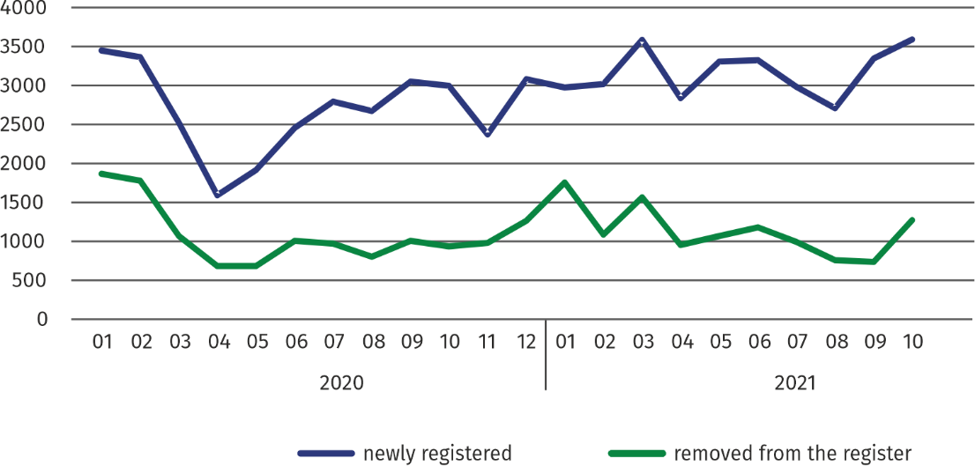**Chart 5. Entities newly registered and removed from the register**

In October 2021, the number of newly registered entities was 7.2% larger than a month earlier, and the number of suspended activities increased by 0.4%

In October 2021, 3640 new entities were entered into the REGON register, i.e. by 7.2% more than in the previous month. The newly registered entities were dominated by natural persons conducting economic activity – 2061 (by 3.5% more than in September 2021). The number of newly registered commercial companies was higher than in the previous month by 13.3%, including limited liability companies – by 14.2%.

In October 2021, 1312 entities were removed from the REGON register (compared to 770 in the previous month), including 1262 natural persons conducting economic activity (by 96.6% more). The most units removed from the register were dealing with: professional, scientific and technical activities (19.1%), trade; repair of motor vehicles (18.4%), transportation and storage (11.4%).

As of the end of October 2021, 47930 entities had suspended activity in the REGON register (by 0.4% more than a month before). The vast majority were natural persons conducting economic activity (85.4%).

In the case of quoting data from Statistics Poland, please provide information: "Source of data – Statistics Poland", and in the case of publishing calculations made on data published by Statistics Poland, please provide information: "Own study based on Statistics Poland data".

|  |  |
| --- | --- |
| Prepared by:  **Statistical Office in Warszawa**  **Director Zofia Kozłowska**  Tel.: (+48 22) 464 23 15 | Issued by: **Statistical Information Centre**  **Marcin Kałuski**  Tel.: (+48 22) 464 20 91 |

|  |  |  |  |  |  |
| --- | --- | --- | --- | --- | --- |
|  | [warszawa.stat.gov.pl](https://warszawa.stat.gov.pl/)/en/ |  | [@Warszawa_STAT](https://twitter.com/Warszawa_STAT) |  | @[UrzadStatystycznywWarszawie](https://www.facebook.com/UrzadStatystycznywWarszawie) |



**Related information**

[Communication and Announcements](https://warszawa.stat.gov.pl/en/communiqus-and-announcements/communiqus-and-announcements/)

**Data available in databases**

[Local Data Bank →Labour market](https://bdl.stat.gov.pl/BDL/dane/podgrup/temat)

**Terms used in official statistics**

[Registered unemployed persons](https://stat.gov.pl/en/metainformation/glossary/terms-used-in-official-statistics/2958,term.html)

[Registered unemployment rate](https://stat.gov.pl/en/metainformation/glossary/terms-used-in-official-statistics/2390,term.html)

[Average paid employment](https://stat.gov.pl/en/metainformation/glossary/terms-used-in-official-statistics/376,term.html)

[Average monthly gross wages and salaries](https://stat.gov.pl/en/metainformation/glossary/terms-used-in-official-statistics/693,term.html)

[Dwellings completed](https://stat.gov.pl/en/metainformation/glossary/terms-used-in-official-statistics/201,term.html)

[Gross turnover profitability indicator](https://stat.gov.pl/en/metainformation/glossary/terms-used-in-official-statistics/587,term.html)

[Net turnover profitability indicator](https://stat.gov.pl/en/metainformation/glossary/terms-used-in-official-statistics/587,term.html)

1. Reporting data – may change after preparing quarterly reports.
2. Applies to legal persons, organizational units without legal personality and natural persons conducting economic activity (excluding natural persons tending private farms in agriculture).