Statistics of Warszawa No. 7/2021

In July 2021 there was an increase in the average employment and an increase in the number of unemployed persons. Sold production of industry and construction and assembly production were higher than in the previous year. Retail sales and wholesale increased as well. July was also characterized by a much lower number of dwellings completed than a year before and significantly higher number of permits issued and dwellings in which construction has begun.

 107.4

Dynamics of construction and assembly production y/y

Average employment

Average employment in the enterprise sector in July 2021 was by 1.0% higher than a year before

Average employment in the enterprise sector in July 2021 amounted to 1087.8 thousand persons and was similar to June 2021 and by 11.0 thousand persons, i.e. by 1.0% higher than in July 2020.

Compared to June 2021, an increase in the average employment was recorded in the following sections: accommodation and catering (by 3.4%), administrative and support service activities (by 0.5%), information and communication (by 0.4%), real estate activities (by 0.2%).

Whereas a decrease in the average employment was recorded in the following sections: industry (by 0.5%), transportation and storage as well as professional, scientific and technical activities (by 0.3% each), trade; repair of of real estate activities (by 0.1%).

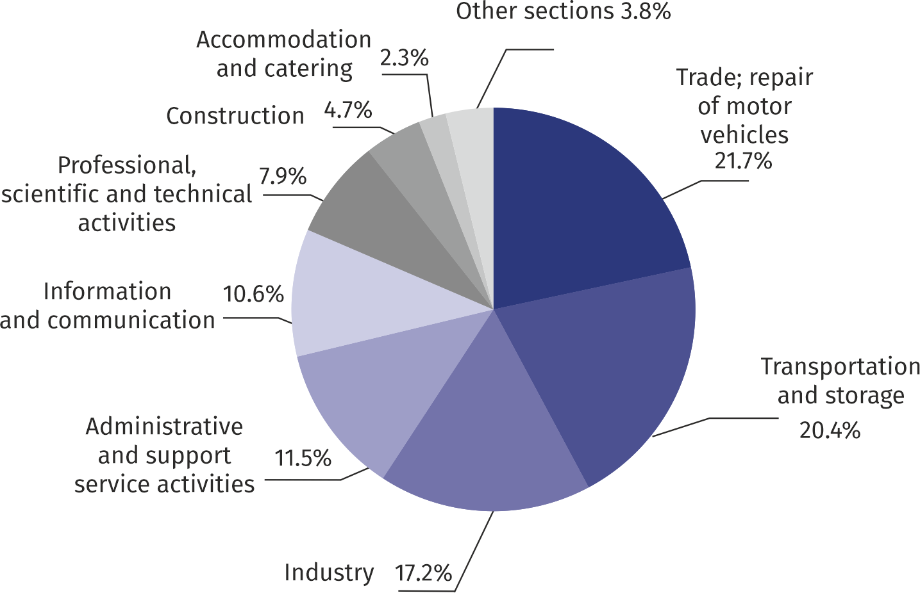Chart 1. Structure of average employment by PKD (NACE Rev.2) sections in July 2021

As compared to July 2020, an increase in the average employment was recorded in the sections: administrative and support service activities (by 8.4%), information and communication (by 4.7%), trade; repair of motor vehicles (by 0.4%), industry (by 0.3%).

A decrease in the average employment was recorded in the sections: real estate activities (by 3.6%), accommodation and catering (by 3.4%), transportation and storage (by 1.3%), construction (by 0.8%), professional, scientific and technical activities (by 0.6%),

Registered unemployment

At the end of July 2021, the number of registered unemployed persons was by 11.4% higher than in the previous year and the unemployment rate increased by 0.2 pp

At the end of July 2021, the number of registered unemployed persons amounted to 26194 and was by 192 persons, i.e. by 0.7% smaller than at the end of June 2021 and by 2678 persons, i.e. by 11.4% larger than in the corresponding period of 2020.

The number of registered unemployed women amounted to 12787, which accounted for 48.8% of the total unemployed (48.7% a month and 48.9% a year before) and 17.9% of unemployed women in Mazowieckie Voivodship. As compared to June 2021, the number of unemployed women decreased by 71 persons, i.e. by 0.6% compared to July 2020 increased by 1282 persons, i.e. by 11.1%.

The registered unemployment rate amounted to 1.9% (2.0% in the previous month, and 1.7% in the previous year), the average in Mazowieckie Voivodship was 4.9% (5.0% a month before, and 5.1% a year before), while the national average was 5.8% (5.9% a month and 6.1% a year before).

In July 2021, there were 2196 unemployed persons registered in labour offices (1918 in June 2021, and 2780 in July 2020). Registered unemployed persons accounted for 18.9% of the total registered unemployed in the Voivodship.

The number of persons registering for the first time amounted to 728 (a month before 597), which accounted for 33.2% of the total unemployed who registered in July 2021 and 25.9% of persons registering for the first time in the Voivodship. The share of persons terminated due to company reasons among unemployed persons registered in July 2021 amounted to 3.5% (4.7% in Mazowieckie Voivodship), 3.8% a month before and 3.9% a year before.

In July 2021, 2388 persons were removed from unemployment rolls (2336 in June 2021, and 1906 in July 2020), which accounted for 17.9% of unemployed persons removed from unemployment rolls in Mazowieckie Voivodship. Out of the unemployed removed from unemployment rolls, 1641 persons took up work. Moreover, 396 persons lost their status of the unemployed as a result of not confirming their readiness to take up work, and 76 voluntarily gave up the status of the unemployed. The reason for removing from the register was also starting training or traineeship, acquisition of retirement rights of pre-retirement benefit, acquisition of pension rights and other.

There were 22612 persons who were not entitled to the unemployment benefit, i.e. 86.3% of the total unemployed (19254 persons a year before, i.e. 81.9%). Whereas 3582 unemployed persons were entitled to the unemployment benefit.

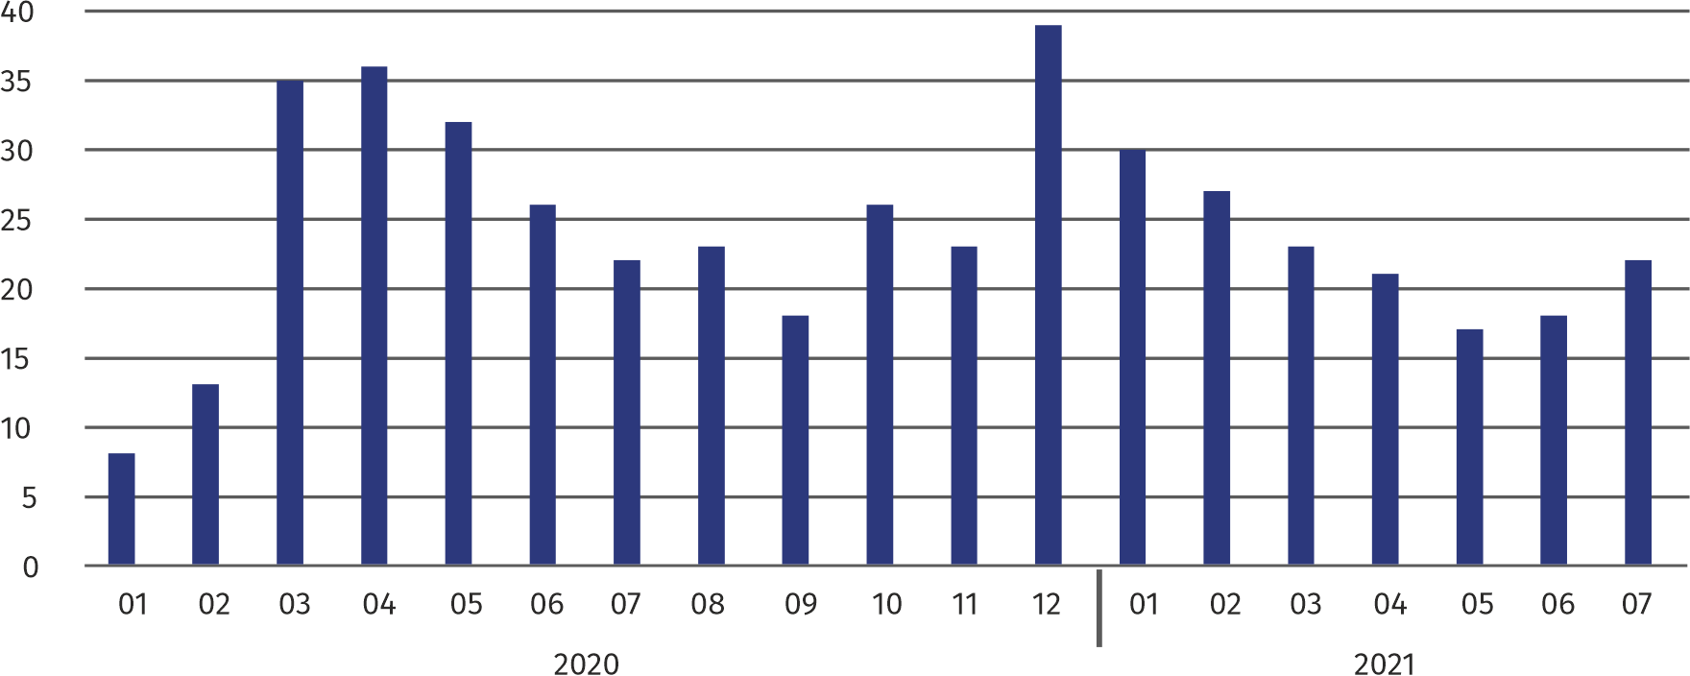**Chart 2. Number of unemployed persons per job offer (as of end of month)**

In July 2021, there were 9.7% more job offers than a year before

In July 2021, there were 3125 job offers submitted to labour offices, which accounted for 20.2% of job offers in Mazowieckie Voivodship and at the end this month the labour offices had job offers for 1169 persons. At the end of July 2021 there were 22 persons per one job offer (18 a month before and 22 a year before), in Mazowieckie Voivodship 16 persons (as in the previous month and 20 in the previous year) registered as unemployed.

Wages and salaries

Average monthly gross wages and salaries in the enterprise sector in June 2021 amounted to PLN 7121.16 and was by 7.5% higher than in July 2020

The average monthly gross wages and salaries in the enterprise sector in July 2021 amounted to PLN 7121.16 and were by 1.0% higher as compared to the previous month and by 7.5% higher than in the corresponding period of 2020.

Compared to June 2021, the increase in the average gross wages and salaries was recorded in the following sections: accommodation and catering (by 6.4%), information and communication (by 4.2%), administrative and support service activities (by 2.7%), transportation and storage (by 1.7%), industry (by 1.5%).

On the other hand, the decrease in the average wages and salaries was recorded in the sections: real estate activities (by 3.3%), professional, scientific and technical activities (by 3.2%), construction (by 2.8%); trade; repair of motor vehicles (by 0.2%).

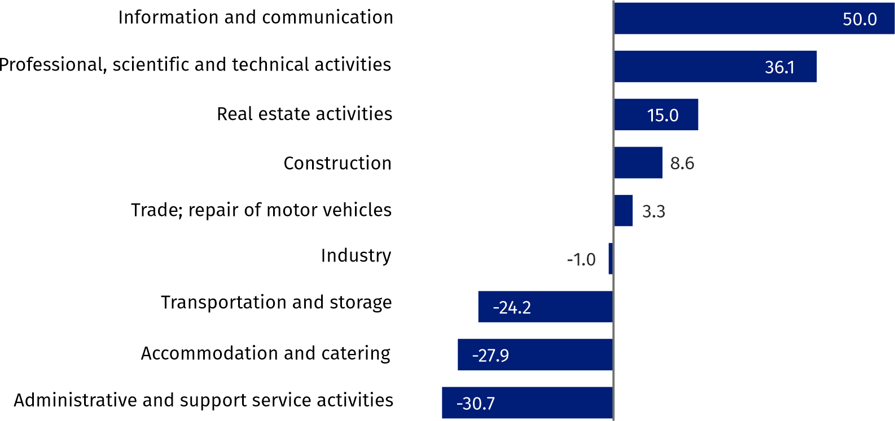Chart 3. Relative deviations (in %) of monthly gross wages and salaries in selected sections from  
average wages and salaries in enterprise sector in July 2021

Compared to July 2020, an increase in the average gross wages and salaries was recorded in the sections: accommodation and catering (by 19.8%), information and communication (by 9.4%), professional, scientific and technical activities (by 8.7%), trade; repair of motor vehicles (by 7.9%), administrative and support service activities (by 7.1%), construction (by 6.2%), transportation and storage (by 6.1%), industry (by 5.0%), real estate activities (by 3.2%).

industry

Sold production in manufacturing (at constant prices) in July 2021 was by 7.0% larger than a year before

Sold production of industry in July 2021 amounted (at current prices) to PLN 11760.1 million and was (at constant prices) larger as compared to the corresponding period of 2020 by 1.8%. As compared to July 2020, an increase by 7.0% was recorded in sold production in manufacturing.

In the period January-July 2021, sold production of industry amounted to PLN 88802.8 million (at current prices) and was (at constant prices) higher by 7.7% than in the corresponding period of 2020. There was a production increase in manufacturing by 9.7%.

Among divisions included in manufacturing, the sales increase was recorded, among others, in: manufacture of wearing apparel (by 54.7%), manufacture of products of wood, cork, straw and wicker (by 52.5%), manufacture of motor vehicles, trailers and semi-trailers (by 50.9%), other manufacturing (by 40.0%), manufacture of electrical equipment (by 35.6%), manufacture of computer, electronic and optical products (by 30.3%), manufacture of textiles (by 29.8%), repair and installation of machinery and equipment (by 28.5%), manufacture of furniture (by 27.0%), manufacture of metal products (by 21.3%), manufacture of beverages (by 17.1%), manufacture of basic metals (by 16.1%), manufacture of rubber products and plastics (by 8.8%), manufacture of other non-metallic mineral products (by 7.5%).

The decrease in sales was recorded, among others, in: manufacture of pharmaceutical products (by 19.8%), manufacture of coke and refined petroleum products (by 15.4%), manufacture of other transport equipment (by 5.5%), manufacture of food products (by 3.3%), manufacture of chemicals and chemical products (by 2.0%).

Labour productivity in construction measured by production per employed person, in January-July 2021 amounted to PLN 475.3 thousand (at current prices) and was – at constant prices – by 8.2% higher than in the previous year.

Construction

Sold production of construction in July 2021 amounted (at current prices) to PLN 4341.8 million and compared to June 2021 was smaller by 4.2%, and compared to the corresponding period of the previous year it increased by 17.5%.

In the period January-July 2021, sold production of construction reached PLN 29608.3 million, i.e. by 7.5% larger than in the corresponding period of 2020.

Construction and assembly production (at current prices) in July 2021 was by 7.4% larger than a year before

Construction and assembly production in July 2021 reached PLN 1015.3 million (at current prices) and accounted for 23.4% of sold production of construction. As compared to the previous month, construction and assembly production decreased by 7.2%, and compared to July 2020 it was higher by 7.4%.

In the period January-July 2021, construction and assembly production was at the level of PLN 6540.7 million and accounted for 22.1% of sold production of construction (23.5% a year before). Compared to the corresponding period of previous year construction and assemby production was larger by 0.8%.

The increase in production in relation to the corresponding period of 2020 occurred in units dealing with specialized construction activities (by 27.9%), while the decrease in production was recorded in entities dealing with construction of buildings (by 15.9%) and civil engineering (by 0.8%).

Labour productivity measured by production per employed person in construction in July 2021 amounted to PLN 85.0 thousand and was by 4.3% lower than a month before and by 18.4% higher than in July 2020.

Trade

Retail sales (at current prices) in trade and non-trade enterprises in July 2021 were by 11.4% larger than in July 2020

Retail sales in trade and non-trade enterprises in July 2021 (at current prices) were by 0.7% larger than in June 2021 and by 11.4% higher compared to July 2020.

Compared to June 2021, there was an increase in sales of solid, liquid and gas fuels (by 7.1%), sales of food, beverages and tobacco (by 5.9%), other sales (by 4.9%), retail sales conducted by mail order houses (by 2.1%), sales of furniture, electronics and household appliances (by 0.5%).

Whereas there was a decrease in other retail sales in non-specialized stores (by 15.4%), sales of textiles, clothing and footwear (by 7.8%), sales of press, books, other sales in specialized stores (by 1.6%), sales of motor vehicles, motorcycles, parts (by 1.3%), sales of pharmaceuticals, cosmetics and orthopedic equipment (by 0.9%).

Compared to July 2020, there was an increase in retail sales conducted by mail order houses (by 47.8%), sales of solid, liquid and gas fuels (by 38.8%), sales of press, books, other sales in specialized stores (by 12.0%), sales of furniture, electronics and household appliances (by 8.7%), sales of food, beverages and tobacco (by 7.8%), sales of textiles, clothing and footwear (by 7.4%), other sales (by 6.3%), other retail sales in non-specialized stores (by 2.3%).

Whereas there was a decrease in the sales of motor vehicles, motorcycles, parts (by 5.5%), sales of pharmaceuticals, cosmetics, orthopedic equipment (by 1.0%).

In the period January-July 2021, retail sales increased by 13.1% compared to the corresponding period of 2020.

Wholesale in trade enterprises in July 2021 (at current prices) was by 4.2% smaller as compared to the previous month and by 6.7% higher as compared to July 2020, and in wholesale enterprises it was lower by 1.6% and 8.0% higher, respectively.

Wholesale (at current prices) in trade enterprises was by 6.7% higher than a year before

In the period January-July 2021, trade units realized wholesale by 16.0% larger than in the previous year, while wholesale enterprises by 12.0% higher.

**Housing construction[1]**

According to preliminary data, 1192 dwellings were completed in Warszawa in July 2021, i.e. by 64.2% less than in the previous year.

In the period January-July 2021, 8754 dwellings were completed (by 28.7% less than in the corresponding period of 2020), and in Mazowieckie Voivodship 21910 dwellings, i.e. by 10.1% less than in January–July 2020. The decrease in the number of dwellings completed was recorded in construction for sale or rent from 11930 to 8179 dwellings, i.e. by 31.4% less. Whereas an increase occurred in municipal construction from 16 to 156, i.e. by 875.0% more, in private construction from 338 to 419, i.e. by 24.0% more.

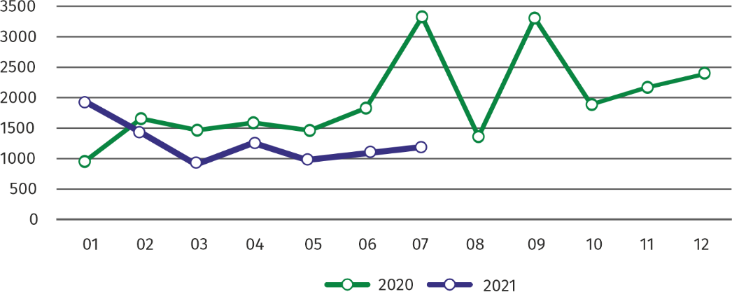Chart 4. Dwellings completed

In January-July 2021, the construction began in 10035 dwellings, i.e. by 38.5% more than in the corresponding period of the previous year

In January-July 2021, the construction began in 10035 dwellings (by 38.5% more than in the corresponding period of 2020), of which: 9500 in construction for sale or rent, 535 in private construction.

In January**–**July 2021, the number of dwellings for which permits have been granted or which have been registered with a construction project amounted to 9803 (by 27.2% more than in the corresponding period of 2020), of which 570 dwellings in buildings built by private investors.

The average useful floor area of a dwelling completed in January**-**July 2021, amounted to 67.0 m2 and increased compared to the corresponding period of 2020 by 7.2 m2. In private construction, the average useful floor area of dwellings amounted to 183.9 m2 (by 24.4 m2 fewer than in the corresponding period of 2020), in construction for sale or rent — 61.6 m2 (by 6.0 m2 more), in municipal construction — 38.5 m2 (by 0.7 m2 fewer).

**Entities of the national economy [2]**

At the end of July 2021, the most numerous group of entities by kind of conducted activity represented units dealing with professional, scientific and technical activities

At the end of July 2021, there were 488319 entities of the national economy registered in the REGON register in Warszawa, which accounted for 53.6% of the total in Mazowieckie Voivodship. Compared with June 2021, the number of entities of the national economy increased by 1942 (i.e. by 0.4%), and compared to July 2020 increased by 21827 (i.e. by 4.7%).

As of the end of July 2021, there were 219407 legal persons and organizational units without legal personality registered in the REGON register, of which 151301 commercial companies. The number of these entities increased compared to the previous month by 0.4% and 0.5%, whereas on an annual basis by 5.3% and 7.0%, respectively.

The number of registered natural persons conducting economic activity as of the end of July 2021 amounted to 268912 and compared to June 2021 it was higher by 0.4%, and compared to the corresponding period of the previous year increased by 4.2%.

In the capital city, in July 2021 the most numerous were entities dealing with professional, scientific and technical activities (19.5% of total registered units), trade; repair of motor vehicles (18.4%), information and communication (10.4%).

Compared to June 2021, the number of entities increased among others in the sections: electricity, gas, steam and air conditioning supply (by 1.3%), information and communication (by 0.9%), mining and quarrying (by 0.8%), construction, accommodation and catering, professional, scientific and technical activities, administrative and support service activities, education as well as health care and social welfare (by 0.5% each).

In comparison with July 2020, the largest increase was recorded in the sections: electricity, gas, steam and air conditioning supply (by 27.8%), information and communication (by 9.8%), accommodation and catering (by 7.4%), health care and social welfare (by 7.2%), arts, entertainment and recreation (by 7.0%). Whereas a decrease in the number of entities was recorded in the section of mining and quarrying (by 1.9%), water supply; sewerage, waste management and remediation activities (by 0.4%).

**Chart 5. Entities newly registered and removed from the register**

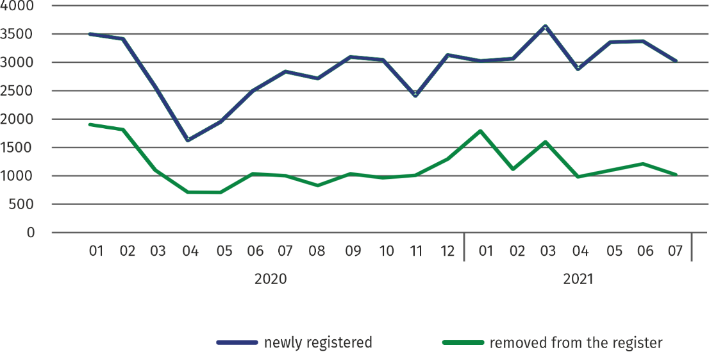

In July 2021, the number of newly registered entities was 10.2% smaller than a month earlier, and the number of suspended activities increased by 1.8%

In July 2021, 3029 new entities were entered into the REGON register, i.e. by 10.2% less than in the previous month. The newly registered entities were dominated by natural persons conducting economic activity – 1841 (by 6.4% less than in June 2021). The number of newly registered commercial companies was lower than in the previous month by 17.5%, including limited liability companies – by 15.8%.

In July 2021, 1031 entities were removed from the REGON register (compared to 1219 in the previous month), including 665 natural persons conducting economic activity (by 25.5% less). The most units removed from the register were dealing with: professional, scientific and technical activities (17.8%), trade; repair of motor vehicles (17.0%), information and communication (9.8%).

As of the end of July 2021, 47287 entities had suspended activity in the REGON register (by 1.8% more than a month before). The vast majority were natural persons conducting economic activity (85.4%).

In the case of quoting data from Statistics Poland, please provide information: "Source of data – Statistics Poland", and in the case of publishing calculations made on data published by Statistics Poland, please provide information: "Own study based on Statistics Poland data".

|  |  |  |
| --- | --- | --- |
| Prepared by:  **Statistical Office in Warszawa**  **Director Zofia Kozłowska**  Tel.: (+48 22) 464 23 15 | |  | | --- | | Issued by: **Statistical Information Centre**  **Marcin Kałuski**  Tel.: (+48 22) 464 20 91 **e-mail:** [**m.kaluski@stat.gov.pl**](mailto:m.kaluski@stat.gov.pl) | |

|  |  |  |
| --- | --- | --- |
|  |  |  |
| **Press office**  Tel.: (+48 22) 464 20 91  **e-mail:** [**m.kaluski@stat.gov.pl**](mailto:m.kaluski@stat.gov.pl) |  |  |
|  | [warszawa.stat.gov.pl](https://warszawa.stat.gov.pl/)/en/  @[Warszawa](https://twitter.com/Warszawa_STAT)_STAT |
|  |  |
|  |  |



**Related information**

[Communication and Announcements](https://warszawa.stat.gov.pl/en/communiqus-and-announcements/communiqus-and-announcements/)

**Data available in databases**

[Local Data Bank →Labour market](https://bdl.stat.gov.pl/BDL/dane/podgrup/temat)

**Terms used in official statistics**

[Registered unemployed persons](https://stat.gov.pl/en/metainformation/glossary/terms-used-in-official-statistics/2958,term.html)

[Registered unemployment rate](https://stat.gov.pl/en/metainformation/glossary/terms-used-in-official-statistics/2390,term.html)

[Average paid employment](https://stat.gov.pl/en/metainformation/glossary/terms-used-in-official-statistics/376,term.html)

[Average monthly gross wages and salaries](https://stat.gov.pl/en/metainformation/glossary/terms-used-in-official-statistics/693,term.html)

[Dwellings completed](https://stat.gov.pl/en/metainformation/glossary/terms-used-in-official-statistics/201,term.html)

[Gross turnover profitability indicator](https://stat.gov.pl/en/metainformation/glossary/terms-used-in-official-statistics/587,term.html)

[Net turnover profitability indicator](https://stat.gov.pl/en/metainformation/glossary/terms-used-in-official-statistics/587,term.html)

1. Reporting data – may change after preparing quarterly reports.
2. Applies to legal persons, organizational units without legal personality and natural persons conducting economic activity (excluding natural persons tending private farms in agriculture).