Statistics of Warszawa No. 5/2021

In May 2021 there was a slight increase in the average employment and an increase in the number of unemployed persons as well as the unemployment rate. There was an increase in sold production of industry and in construction and assembly production. Retail sales were also higher than in the previous year. May was also characterized by a lower number of dwellings completed than a year before and a slightly higher number of dwellings in which construction has begun as well as the number of permits issued.

 122.7

Dynamics of sold production in manufacturing y/y

Average employment

Average employment in the enterprise sector in May 2021 was by 2.0% higher than a year before

Average employment in the enterprise sector in May 2021 amounted to 1082.7 thousand persons and was by 1.3 thousand persons, i.e. by 0.1% higher than in April 2021 and by 21.6 thousand persons, i.e. by 2.0% higher than in May 2020.

Compared to April 2021, an increase in the average employment was recorded in the following sections: accommodation and catering (by 2.4%), trade; repair of motor vehicles (by 0.6%), construction, professional, scientific and technical activities as well as real estate activities (by 0.5% each) information and communication (by 0.1%).

Whereas a decrease in the average employment was recorded in the sections: administrative and support service activities and industry (by 0.4% each), transportation and storage (by 0.1%).

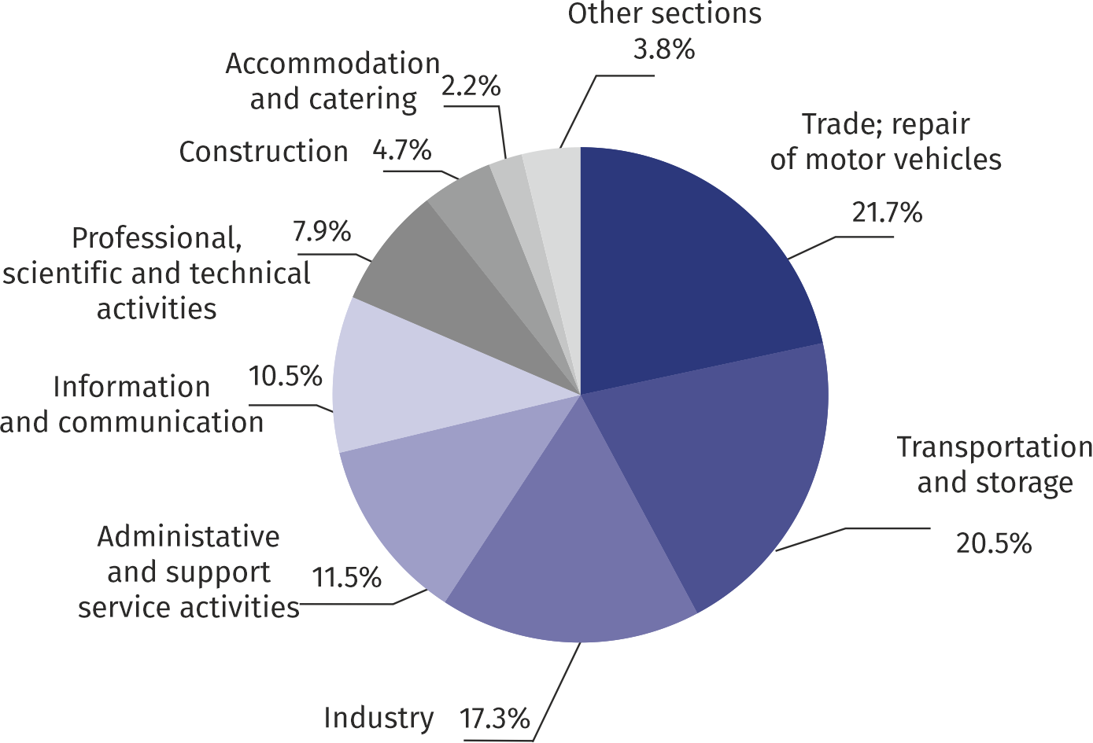Chart 1. Structure of average employment by PKD (NACE Rev.2) sections in May 2021

As compared to May 2020, an increase in the average employment was recorded in the sections: administrative and support service activities (by 8.5%), industry (by 5.8%), information and communication (by 2.6%); trade; repair of motor vehicles (by 1.8%), arts, entertainment and recreation (by 0.6%).

A decrease in the average employment was recorded in the sections: accommodation and catering (by 3.7%), real estate activities (by 3.2%), construction as well as transportation and storage (by 1.1% each), professional, scientifica and technical activities (by 1.0%).

Registered unemployment

At the end of May 2021, the number of registered unemployed persons amounted to 26804 and was by 16 persons, i.e. by 0.1% smaller than at the end of April 2021 and by 5819 persons, i.e. by 27.7% larger than in the corresponding period of 2020.

At the end of May 2021, the number of registered unemployed persons was by 27.7% higher than in the previous year and the unemployment rate increased by 0.4 pp

The number of registered unemployed women amounted to 13083, which accounted for 48.8% of the total unemployed (48.8% a month before, and 48.7% a year before) and 17.9% of unemployed women in Mazowieckie Voivodship. As compared to April 2021, the number of unemployed women increased by 3 persons, and compared to May 2020 increased by 2854 persons, i.e. by 27.9%.

The registered unemployment rate amounted to 2.0% (as in the previous month, and 1.6% in the previous year), the average in Mazowieckie Voivodship was 5.1% (5.2% a month before, and 4.9% a year before), while the national average was 6.1% (6.3% a month before, and 6.0% a year before).

In May 2021, there were 2113 unemployed persons registered in labour offices (2295 in April 2021, and 2576 in May 2020). Registered unemployed persons accounted for 20.3% of the total registered unemployed in the voivodship.

The number of persons registering for the first time amounted to 733 (a month before 859), which accounted for 34.7% of the total unemployed who registered in May 2021 and 24.3% of persons registering for the first time in the voivodship. The share of persons terminated due to company reasons among unemployed persons registered in May 2021 amounted to 2.8% (5.3% in Mazowieckie Voivodship), 3.2% a month before and 4.3% a year before.

In May 2021, 2129 persons were removed from unemployment rolls (1937 in April 2021, and 632 in May 2020), which accounted for 15.8% of unemployed persons removed from unemployment rolls in Mazowieckie Voivodship. Out of unemployed persons removed from unemployment rolls, 1680 persons took up work. Moreover, 26 persons lost their status of the unemployed as a result of not confirming their readiness to take up work. The reason for removing from the register was also voluntarily giving up the status of the unemployed, acquisition of retirement rights of pre-retirement benefit, acquisition of pension rights, starting training or traineeship and other.

There were 23063 persons who were not entitled to the unemployment benefit, i.e. 86.0% of the total unemployed (17328 persons a year before, i.e. 82.6%). Whereas 3741 unemployed persons were entitled to the unemployment benefit.

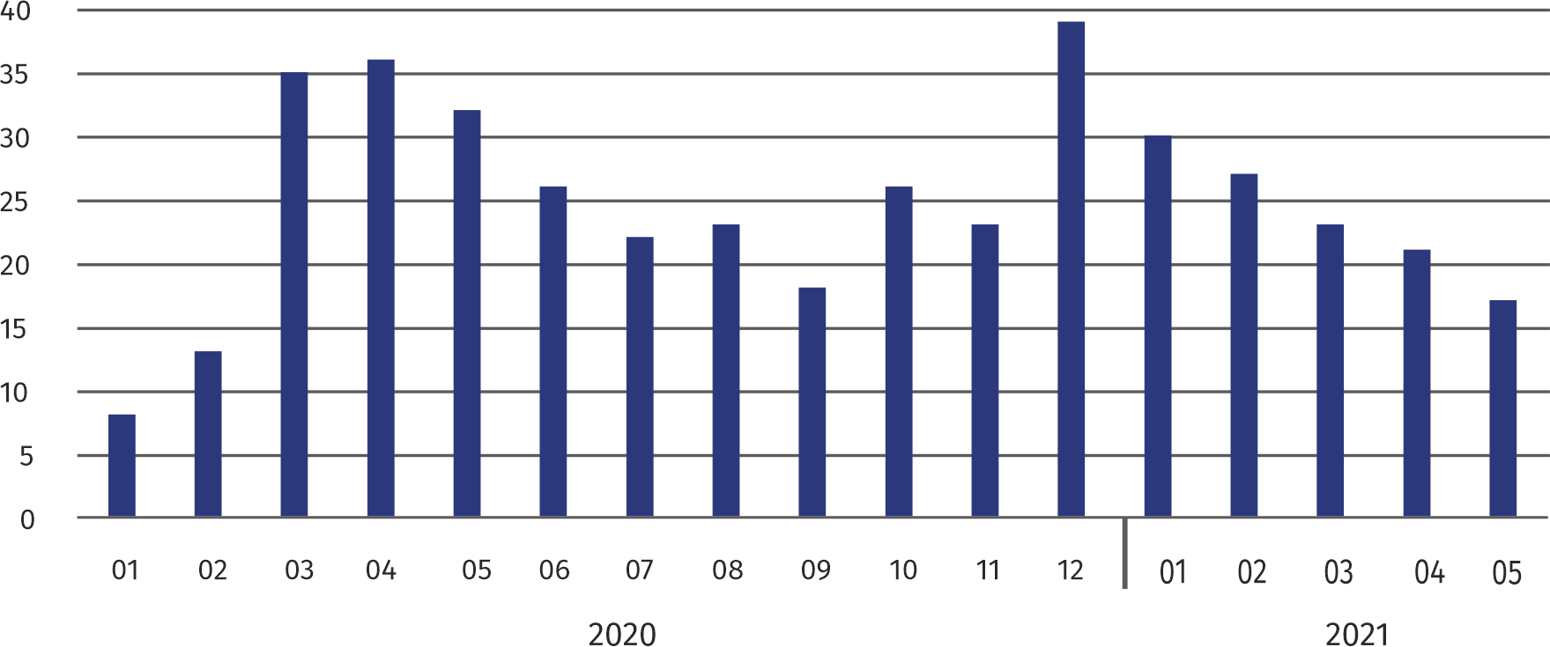**Chart 2. Number of unemployed persons per job offer (as of end of month)**

In May 2021, there were 80.8% more job offers than a year before

In May 2021, there were 3342 job offers submitted to labour offices, which accounted for 22.8% of job offers in Mazowieckie Voivodship and at the end this month the labour offices had job offers for 1624 persons. At the end of May 2021 there were 17 persons per one job offer (21 a month before and 32 a year before), in Mazowieckie Voivodship 17 persons (17 in the previous month and 23 in the previous year) registered as unemployed.

Wages and salaries

Average monthly gross wages and salaries in the enterprise sector in May 2021 amounted to PLN 6949.29 and was by 7.5% higher than in May 2020

The average monthly gross wages and salaries in the enterprise sector in May 2021 amounted to PLN 6949.29 and were by 4.9% lower as compared to the previous month and by 7.5% higher than in the corresponding period of 2020.

Compared to April 2021, the decrease in the average gross wages and salaries was recorded in the following sections: construction (by 22.1%), professional, scientific and technical activities (by 6.5%), trade; repair of motor vehicles (by 5.7%), industry (by 5.2%), information and communication (by 4.3%), arts, entertainment and recreation (by 3.6%), administrative and support service activities (by 2.1%), accommodation and catering (by 0.3%).

On the other hand, the increase in the average wages and salaries was recorded in the sections of real estate activities (by 4.1%) as well as transportation and storage (by 1.4%).

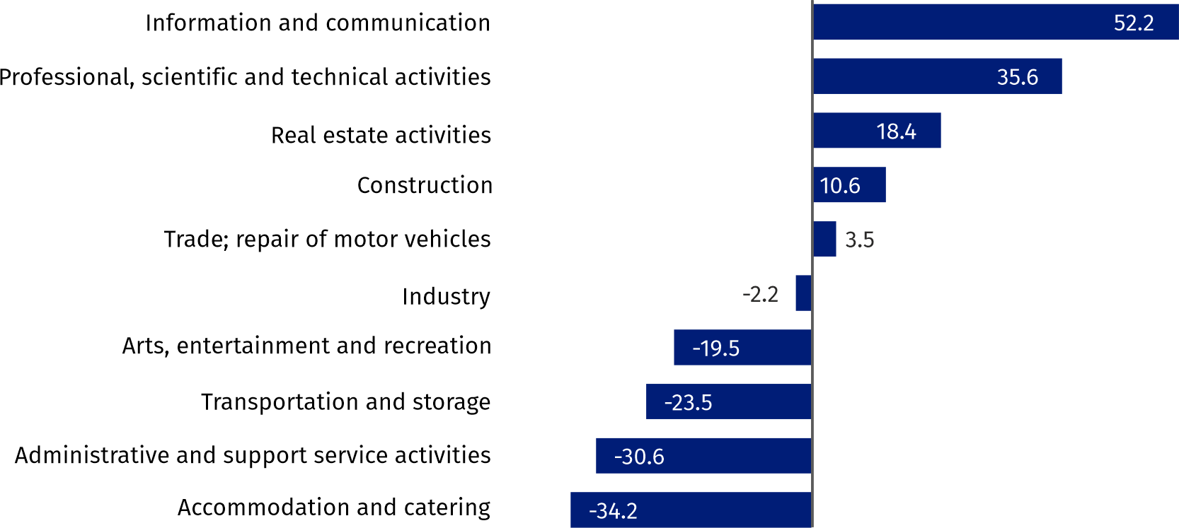Chart 3. Relative deviations (in %) of monthly gross wages and salaries in selected sections from  
average wages and salaries in enterprise sector in May 2021

Compared to May 2020, an increase in the average gross wages and salaries was recorded in the sections: accommodation and catering (by 15.8%), administrative and support service activities (by 9.9%), information and communication (by 8.9%), industry (by 8.3%), trade; repair of motor vehicles (by 7.8%), professional, scientific and technical activities (by 6.4%), arts, entertainment and recreation (by 6.3%), transportation and storage (by 6.1%), construction (by 3.9%), real estate activities (by 2.8%).

Industry

Sold production in manufacturing (at constant prices) in May 2021 was by 22.7% larger than a year before

Sold production of industry in May 2021 amounted (at current prices) to PLN 11864.3 million and was (at constant prices) larger as compared to the corresponding period of 2020 by 6.8%. As compared to May 2020, an increase by 22.7% was recorded in sold production in manufacturing.

In the period January-May 2021, sold production of industry amounted to PLN 63375.1 million (at current prices) and was (at constant prices) higher by 10.4% than in the corresponding period of 2020. There was a production increase in manufacturing by 17.6%.

Among divisions included in manufacturing, the sales increase was recorded, among others, in: manufacture of textiles (by 68.2%), manufacture of motor vehicles, trailers and semi-trailers (by 57.0%), manufacture of electrical equipment (by 47.0%), manufacture of products of wood, cork, straw and wicker (by 46.2%), manufacture of wearing apparel (by 42.2%), other manufacturing (by 31.3%), manufacture of computer, electronic and optical products (by 30.0%), repair and installation of machinery and equipment (by 26.2%), manufacture of food products (by 21.7%), manufacture of furniture (by 21.4%), manufacture of metal products (by 14.2%), rubber and plastic products (by 11.8%), manufacture of basic metals (by 9.3%) manufacture of beverages (by 8.8%), manufacture of machinery and equipment n.e.c. (by 8.1%), manufacture of other non-metallic mineral products (by 2.5%), manufacture of chemicals and chemical products (by 0.9%).

The decrease in sales was recorded, among others, in: manufacture of coke and refined petroleum products (by 21.6%), manufacture of pharmaceutical products (by 16.9%), manufacture of other transport equipment (by 2.6%), manufacture of paper and paper products (by 2.3%), printing and reproduction of recorded media (by 1.7%).

Labour productivity in construction measured by production per employed person, in January-May 2021 amounted to PLN 339.2 thousand (at current prices) and was – at constant prices – by 6.0% higher than in the previous year.

Construction

Sold production of construction in May 2021 amounted (at current prices) to PLN 4377.0 million and compared to April 2021 was larger by 14.4%, and compared to the corresponding period of the previous year it increased by 21.0%.

In the period January-May 2021, sold production of construction reached PLN 19813.5 million, i.e. by 7.5% larger than in the corresponding period of 2020.

Construction and assembly production (at current prices) in May 2021 was by 4.9% larger than a year before

Construction and assembly production in May 2021 reached PLN 1006.0 million (at current prices) and accounted for 23.0% of sold production of construction. As compared to the previous month, construction and assembly production increased by 13.9%, and compared to May 2020 it was higher by 4.9%.

In the period January-May 2021, construction and assembly production was at the level of PLN 4225.2 million and accounted for 21.3% of sold production of construction (24.1% a year before). Compared to the corresponding period of previous year construction and assemby production was smaller by 4.9%.

The decrease in production in relation to the corresponding period of 2020 occurred in entities dealing with: construction of buildings (by 21.5%) and civil engineering (by 4.9%), while the increase was recorded in units dealing with specialized construction activities (by 20.5%).

Labour productivity measured by production per employed person in construction in May 2021 amounted to PLN 86.0 thousand and was by 13.8% higher than a month before and by 22.3% higher than in May 2020.

Trade

Retail sales (at current prices) in trade and non-trade enterprises in May 2021 was by 23.3% larger than in May 2020

Retail sales in trade and non-trade enterprises in May 2021 (at current prices) were by 29.1% larger than in April 2021 and by 23.3% higher compared to May 2020.

Compared to April 2021, there was an increase in other retail sales in non-specialized stores (by 274.9%), sales of textiles, clothing and footwear (by 208.3%), sales of press, books, other sales in specialized stores (by 102.8%), sales of furniture, electronics and household appliances (by 34.0%), sales of pharmaceuticals, cosmetics and orthopedic equipment (by 27.7%), sales of solid, liquid and gas fuels (by 4.6%), other sales (by 3.3%), sales of motor vehicles, motorcycles, parts (by 1.6%).

Whereas there was a decrease in retail sales conducted by mail order houses (by 13.3%), sales of food, beverages and tobacco (by 5.4%).

Compared to May 2020, there was an increase in other retail sales in non-specialized stores (by 60.0%), sales of solid, liquid and gas fuels (by 49.5%), sales of textiles, clothing and footwear (by 46.6%), retail sales conducted by mail order houses (by 46.2%), sales of pharmaceuticals, cosmetics and orthopedic equipment (by 39.4%), sales of motor vehicles, motorcycles, parts (by 35.4%), sales of press, books, other sales in specialized stores (by 23.9%), sales of furniture, electronics and household appliances (by 9.8%), other sales (by 7.6%), sales of food, beverages and tobacco (by 5.9%).

In the period January-May 2021, retail sales increased by 11.8% compared to the corresponding period of 2020.

Wholesale in trade enterprises in May 2021 (at current prices) was by 1.3% larger as compared to the previous month and by 33.3% higher as compared to May 2020, and in wholesale enterprises it was higher by 7.2% and 27.0%, respectively.

Wholesale (at current prices) in trade enterprises was by 33.3% higher than a year before

In the period January-May 2021, trade units realized wholesale by 17.9% larger than in the previous year, while wholesale enterprises by 12.5% higher.

**Housing construction[1]**

According to preliminary data, 941 dwellings were completed in Warszawa in May 2021, i.e. by 35.6% less than in the previous year.

In the period January-May 2021, 6465 dwellings were completed (by 9.3% less than in the corresponding period of 2020), and in Mazowieckie Voivodship 15827 dwellings, i.e. by 6.9% more than in January–May 2020. The decrease in the number of dwellings completed was recorded in construction for sale or rent from 6878 to 6002 dwellings, i.e. by 12.7% less. Whereas an increase occurred in municipal construction from 16 to 156, i.e. by 875.0% more, in private construction from 234 to 307, i.e. by 31.2% more.

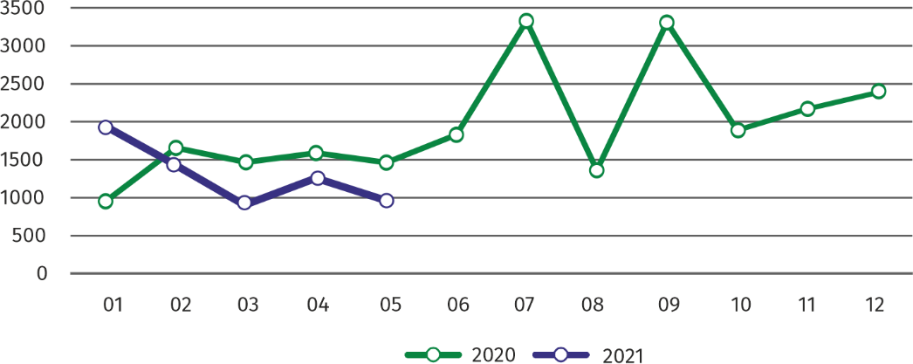Chart 4. Dwellings completed

In January-May 2021, the construction began in 6400 dwellings (by 16.5% more than in the corresponding period of 2020), of which: 6185 in construction for sale or rent, 215 in private construction.

In January-May 2021, the construction began in 6400 dwellings, i.e. by 16.5% more than in the corresponding period of the previous year

In January**–**May 2021, the number of dwellings for which permits have been granted or which have been registered with a construction project amounted to 6231 (by 35.5% more than in the corresponding period of 2020), of which 364 dwellings in buildings built by private investors.

The average useful floor area of a dwelling completed in January**-**May 2021, amounted to 66.4 m2 and increased compared to the corresponding period of 2020 by 3.5 m2. In private construction, the average useful floor area of dwellings amounted to 179.5 m2 (by 28.2 m2 fewer than in the corresponding period of 2020), in construction for sale or rent — 61.3 m2 (by 3.3 m2 more), in municipal construction — 38.5 m2 (by 0.7 m2 less).

**Entities of the national economy [2]**

At the end of May 2021, the most numerous group of entities by kind of conducted activity represented units dealing with professional, scientific and technical activities

At the end of May 2021, there were 484281 entities of the national economy registered in the REGON register in Warszawa, which accounted for 53.6% of the total in Mazowieckie Voivodship. Compared with April 2021, the number of entities of the national economy increased by 2242 (i.e. by 0.5%), and compared to May 2020 increased by 21005 (i.e. by 4.5%).

As of the end of May 2021, there were 217505 legal persons and organizational units without legal personality registered in the REGON register, of which 149587 commercial companies. The number of these entities increased compared to the previous month by 0.6% and 0.8%, whereas on an annual basis by 5.1% and 6.9%, respectively.

The number of registered natural persons conducting economic activity as of the end of May 2021 amounted to 266776 and compared to April 2021 it was higher by 0.4%, and compared to the corresponding period of the previous year increased by 4.0%.

In the capital city, in May 2021 the most numerous were entities dealing with professional, scientific and technical activities (19.5% of total registered units), trade; repair of motor vehicles (18.4%), information and communication (10.3%).

Compared to April 2021, the number of entities increased among others in the sections: electricity, gas, steam and air conditioning supply (by 2.4%), mining and quarrying (by 1.1%), public administration and national defense; compulsory social security (by 1.0%), accommodation and catering as well as information and communication (by 0.9% each). Whereas there was a decrease in the number of entities in the section of water supply; sewerage, waste management and remediation activities (by 0.2%).

In comparison with May 2020, the largest increase was recorded in the sections: electricity, gas, steam and air conditioning supply (by 28.1%), information and communication (by 9.0%), accommodation and catering (by 7.6%), arts, entertainment and recreation (by 7.1%). Whereas a decrease in the number of entities was recorded in the section of mining and quarrying (by 0.3%).

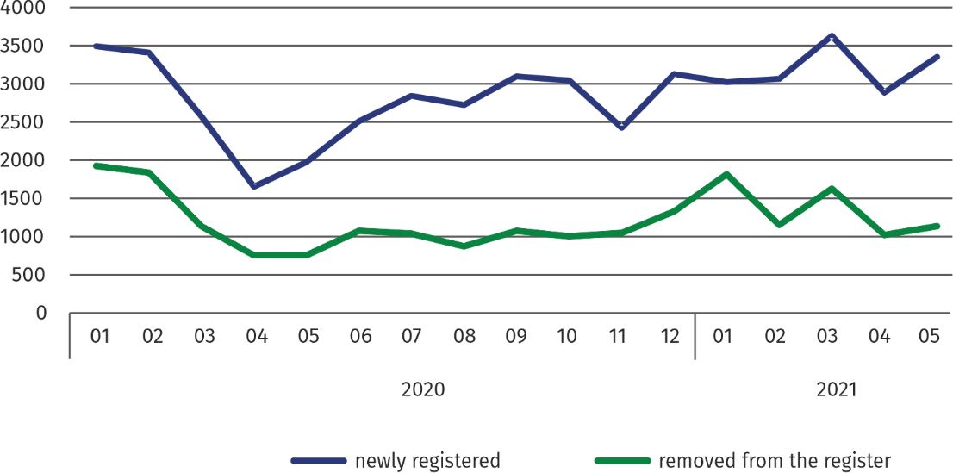**Chart 5. Entities newly registered and removed from the register**

In May 2021, the number of newly registered entities was 16.4% higher than a month earlier, and the number of suspended activities decreased by 0.1%

In May 2021, 3356 new entities were entered into the REGON register, i.e. by 16.4% more than in the previous month. The newly registered entities were dominated by natural persons conducting economic activity – 1963 (by 15.3% more than in April 2021). The number of newly registered commercial companies was higher by 20.8%, including limited liability companies – by 22.5%.

In May 2021, 1104 entities were removed from the REGON register (compared to 989 in the previous month), including 916 natural persons conducting economic activity (by 14.8% more). The most units removed from the register were dealing with: trade; repair of motor vehicles (19.7%), professional, scientific and technical activities (18.8%), information and communication (10.0%).

As of the end of May 2021, 46346 entities had suspended activity in the REGON register (by 0.1% less than a month before). The vast majority were natural persons conducting economic activity (85.3%).

In the case of quoting data from Statistics Poland, please provide information: "Source of data – Statistics Poland", and in the case of publishing calculations made on data published by Statistics Poland, please provide information: "Own study based on Statistics Poland data".

|  |  |
| --- | --- |
| Prepared by:  **Statistical Office in Warszawa**  **Director Zofia Kozłowska**  Tel.: (+48 22) 464 23 15 | Issued by: **Statistical Information Centre**  **Marcin Kałuski**  Tel.: (+48 22) 464 20 91 **e-mail:** [**m.kaluski@stat.gov.pl**](mailto:m.kaluski@stat.gov.pl) |

|  |  |  |
| --- | --- | --- |
|  |  |  |
| **Press office**  Tel.:(+48 22) 464 20 91  **e-mail:** [**m.kaluski@stat.gov.pl**](mailto:m.kaluski@stat.gov.pl) |  |  |
|  | [warszawa.stat.gov.pl](https://warszawa.stat.gov.pl/)/en/  @[Warszawa](https://twitter.com/Warszawa_STAT)_STAT |
|  |  |
|  |  |



**Related information**

[Communication and Announcements](https://warszawa.stat.gov.pl/en/communiqus-and-announcements/communiqus-and-announcements/)

**Data available in databases**

[Local Data Bank →Labour market](https://bdl.stat.gov.pl/BDL/dane/podgrup/temat)

**Terms used in official statistics**

[Registered unemployed persons](https://stat.gov.pl/en/metainformations/glossary/terms-used-in-official-statistics/2958,term.html)

[Registered unemployment rate](https://stat.gov.pl/en/metainformations/glossary/terms-used-in-official-statistics/2390,term.html)

[Average paid employment](https://stat.gov.pl/en/metainformations/glossary/terms-used-in-official-statistics/376,term.html)

[Average monthly gross wages and salaries](https://stat.gov.pl/en/metainformations/glossary/terms-used-in-official-statistics/693,term.html)

[Dwellings completed](https://stat.gov.pl/en/metainformations/glossary/terms-used-in-official-statistics/201,term.html)

[Gross turnover profitability indicator](https://stat.gov.pl/metainformacje/slownik-pojec/pojecia-stosowane-w-statystyce-publicznej/587,pojecie.html)

[Net turnover profitability indicator](https://stat.gov.pl/metainformacje/slownik-pojec/pojecia-stosowane-w-statystyce-publicznej/587,pojecie.html)

1. Reporting data – may change after preparing quarterly reports.
2. Applies to legal persons, organizational units without legal personality and natural persons conducting economic activity (excluding natural persons tending private farms in agriculture).