Statistics of Warszawa No. 4/2021

In April 2021 there was a slight increase in the average employment and an increase in the number of unemployed persons as well as the unemployment rate. There was an increase in sold production of industry and a decrease in construction and assembly production. April was characterized by a lower number of dwellings completed than a year earlier and a much higher number of dwellings in which construction has begun and the number of permits issued.

 132.0

Dynamics of sold production in manufacturing y/y

Average employment

Average employment in the enterprise sector in April 2021 was by 1.1% higher than a year before

Average employment in the enterprise sector in April 2021 amounted to 1081.4 thousand persons and was by 4.7 thousand persons, i.e. by 0.4% lower than in March 2021 and by 11.3 thousand persons, i.e. by 1.1% higher than in April 2020.

Compared to March 2021, a decrease in the average employment was recorded in the following sections: real estate activities (by 2.7%), administrative and support service activities (by 1.6%), trade; repair of motor vehicles (by 0.9%), professional, scientific and technical activities (by 0.8%), transportation and storage and accommodation and catering (by 0.5% each), (by 0.3%), arts, entertainment and recreation (by 0.4%).

Whereas the increase in the average employment occurred in the following sections: industry (by 0.9  
%), construction (by 0.2%), information and communication (by 0.1%).

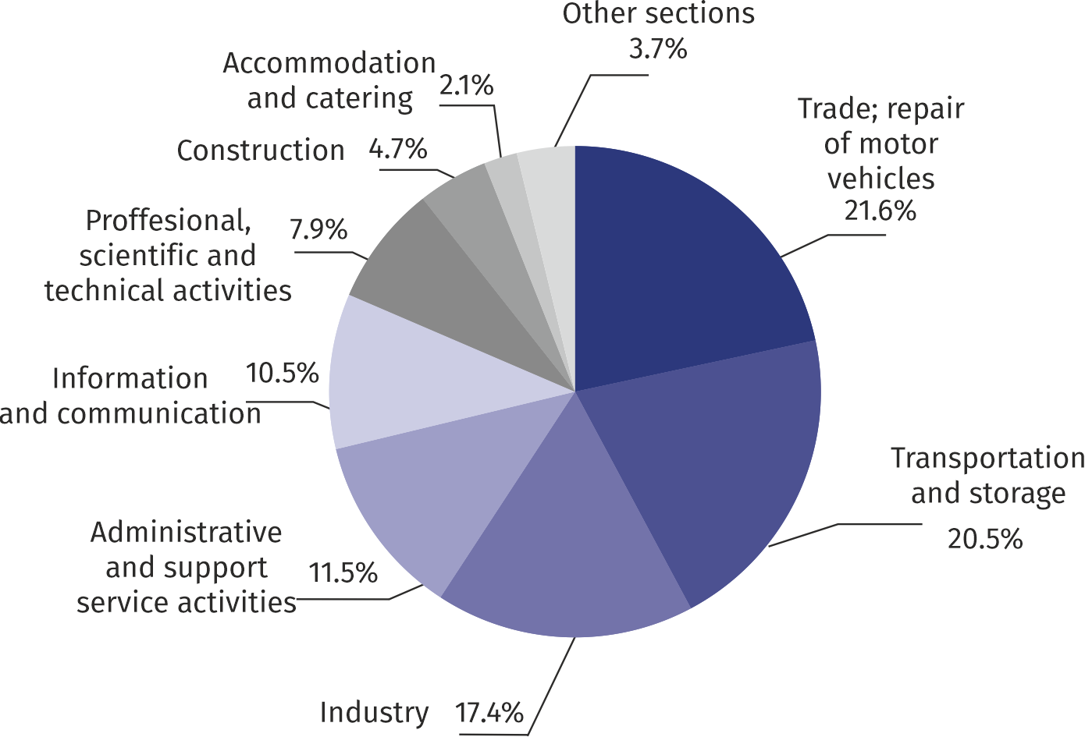Chart 1. Structure of average employment by PKD (NACE Rev.2) sections in April 2021

As compared to April 2020, an increase in the average employment was recorded in the sections: administrative and support service activities (by 7.3%) industry (by 5.4%), information and communication (by 1.0%).

A decrease in the average employment was recorded in the sections: accommodation and catering (by 7.3%), real estate activities (by 3.3%), construction (2.4%), professional, scientific and technical activities (by 1.8%), arts, entertainment and recreation (by 1.1%), transportation and storage (by 0.9%), trade; repair of motor vehicles (by 0.1%).

Registered unemployment

At the end of April 2021, the number of registered unemployed persons amounted to 26820 and was by 358 persons, i.e. by 1.4% larger than at the end of March 2021 and by 7779 persons, i.e. by 40.9% larger than in the corresponding period of 2020.

The number of registered unemployed women amounted to 13080, which accounted for 48.8% of the total unemployed (as in a month and a year before) and 17.6% of unemployed women in Mazowieckie Voivodship. As compared to March 2021, the number of unemployed women increased by 157 persons, i.e. by 1.2%, and compared to April 2020 increased by 3781 persons, i.e. by 40.7%.

The registered unemployment rate amounted to 2.0% (as in the previous month, and 1.4% in the previous year), the average in Mazowieckie Voivodship was 5.2% (5.3% a month before, and 4.7% a year before), while the national average was 6.3% (6.4% a month before, and 5.8% a year before).

At the end of April 2021, the number of registered unemployed persons was by 40.9% higher than in the previous year and the unemployment rate increased by 0.6 pp

In April 2021, there were 2295 unemployed persons registered in labour offices (2866 in March 2021, and 1859 in April 2020). Registered unemployed persons accounted for 22.1% of the total registered unemployed in the voivodship.

The number of persons registering for the first time amounted to 859 (a month before 997), which accounted for 37.4% of the total unemployed who registered in April 2021 and 35.2% of persons registering for the first time in the voivodship. The share of persons terminated due to company reasons among unemployed persons registered in April 2021 amounted to 3.2% (4.8% in Mazowieckie Voivodship), 3.5% a month before and 3.6% a year before.

In April 2021, 1937 persons were removed from unemployment rolls (2307 in March 2021, and 729 in April 2020), which accounted for 15.3% of unemployed persons removed from unemployment rolls in Mazowieckie Voivodship. Out of unemployed persons removed from unemployment rolls, 1484 persons took up work. Moreover, 89 persons lost their status of the unemployed as a result of not confirming their readiness to take up work. The reason for removing from the register was also voluntarily giving up the status of the unemployed, acquisition of retirement rights of pre-retirement benefit, acquisition of pension rights, starting training or traineeship and other.

There were 22916 persons who were not entitled to the unemployment benefit, i.e. 85.4% of the total unemployed (15848 persons a year before, i.e. 83.2%). Whereas 3904 unemployed persons were entitled to the unemployment benefit.

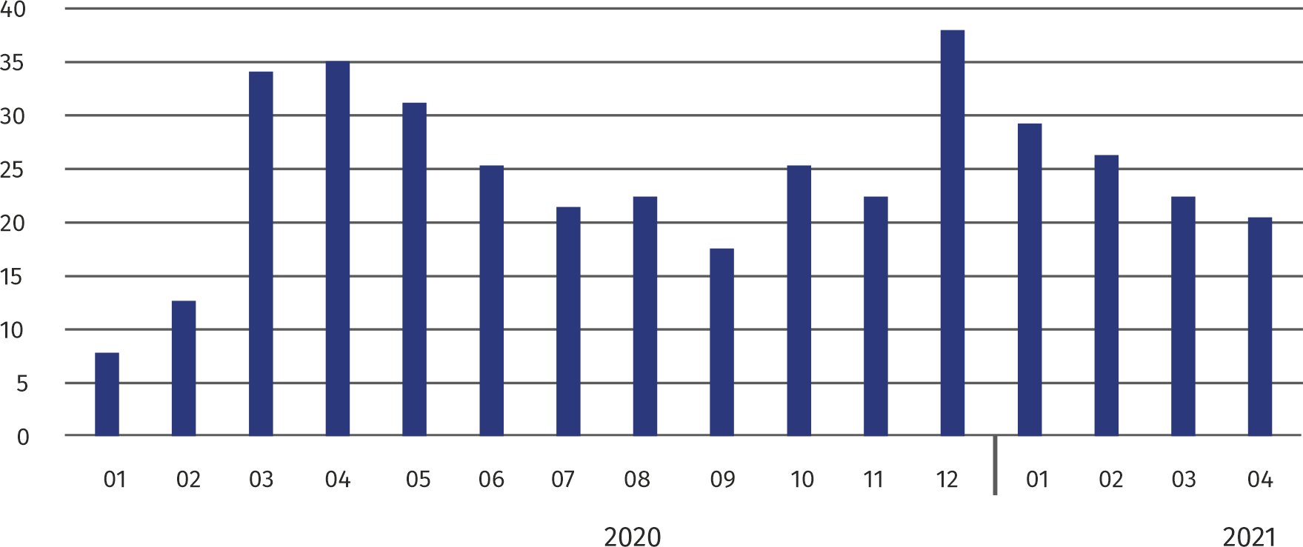**Chart 2. Number of unemployed persons per job offer (as of end of month)**

In April 2021, there were 90.5% more job offers than a year before

In April 2021, there were 2977 job offers submitted to labour offices, which accounted for 19.8% of job offers in Mazowieckie Voivodship and at the end this month the labour offices had job offers for 1298 persons. At the end of April 2021 there were 21 persons per one job offer (23 a month before and 36 a year before), in Mazowieckie Voivodship 17 persons (22 in the previous month and 25 in the previous year) registered as unemployed.

Wages and salaries

The average monthly gross wages and salaries in the enterprise sector in April 2021 amounted to PLN 7305.26 and were by 4.2% higher as compared to the previous month and by 8.1% higher than in the corresponding period of 2020.

Average monthly gross wages and salaries in the enterprise sector in April 2021 amounted to PLN 7305.526 and were by 8.1% higher than in April

Compared to March 2021, the decrease in the average gross wages and salaries was recorded in the following sections: real estate activities (by 18.7%), professional, scientific and technical activities (by 9.9%), industry (by 9.5%), trade; repair of motor vehicles (by 5.3%), information and communication (by 3.7%), administrative and support service activities (by 2.3%), accommodation and catering (by 1.3%).

On the other hand, the increase in the average wages and salaries was recorded in the sections: construction (by 20.1%), arts, entertainment and recreation (by 3.0%), transportation and storage (by 0.2%).

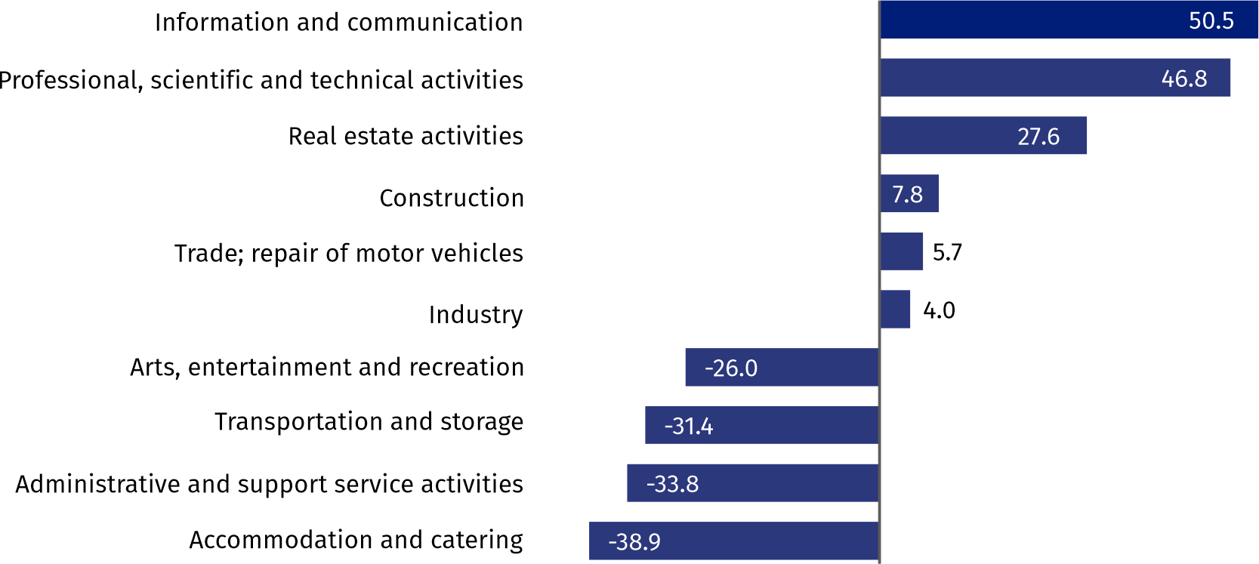Chart 3. Relative deviations (in %) of monthly gross wages and salaries in selected sections from  
average wages and salaries in enterprise sector in April 2021

Compared to April 2020, an increase in the average gross wages and salaries was recorded in the sections: construction (by 14.0%), trade; repair of motor vehicles (by 13.6%), accommodation and catering (by 11.6%), information and communication (by 10.8%), professional, scientific and technical activities (by 9.4%), industry (by 5.3%), administrative and support service activities (by 4.7%), arts, entertainment and recreation (by 4.0%), transportation and storage (by 1.3%), real estate activities (by 0.6%).

Industry

Sold production in manufacturing (at constant prices) in April 2021 was by 32.0% larger than a year before

Sold production of industry in April 2021 amounted (at current prices) to PLN 12054.9 million and was (at constant prices) larger as compared to the corresponding period of 2020 by 11.0%. As compared to April 2020, an increase by 32.0% was recorded in sold production in manufacturing.

In the period January-April 2021, sold production of industry amounted to PLN 51086.4 million (at current prices) and was (at constant prices) higher by 8.8% than in the corresponding period of 2020. There was a production increase in manufacturing by 17.3%.

Among divisions included in manufacturing, the sales increase was recorded, among others, in: manufacture of motor vehicles, trailers and semi-trailers (by 60.7%), manufacture of electrical equipment (by 49.9%), other manufacturing (by 37.8%), manufacture of products of wood, cork, straw and wicker (by 36.4%), manufacture of textiles (by 35.5%), manufacture of wearing apparel (by 26.7%), manufacture of food products (by 24.5%), manufacture of computer, electronic and optical products (by 24.3%), manufacture of furniture (by 16.9%), repair and installation of machinery and equipment (by 15.7%), manufacture of rubber and plastic products (by 12.3%), manufacture of metal products (by 11.6%), manufacture of basic metals (by 10.8%), manufacture of beverages (by 6.3%), manufacture of chemicals and chemical equipment (by 4.1%).

The decrease in sales was recorded, among others, in: manufacture of coke and refined petroleum products (by 26.1%), manufacture of pharmaceutical products (by 14.8%), printing and reproduction of recorded media (by 9.4%), manufacture of paper and paper products (by 4.7%), manufacture of other non-metallic mineral products (by 3.8%), manufacture of other transport equipment (by 2.6%), manufacture of machinery and equipment n.e.c. (by 0.3%),

Labour productivity in construction measured by production per employed person, in January-April 2021 amounted to PLN 271.7 thousand (at current prices) and was – at constant prices – by 4.3% higher than in the previous year.

Construction

Sold production of construction in April 2021 amounted (at current prices) to PLN 3826.0 million and compared to March 2021 was larger by 0.5%, and compared to the corresponding period of the previous year it increased by 6.4%.

In the period January-April 2021, sold production of construction reached PLN 14882.3 million, i.e. by 1.8% larger than in the corresponding period of 2020.

Construction and assembly production (at current prices) in April 2021 was by 1.1% smaller than a year before

Construction and assembly production in April 2021 reached PLN 883.0 million (at current prices) and accounted for 23.1% of sold production of construction. As compared to the previous month, construction and assembly production remained at the same level and compared to April 2020 it was lower by 1.1%.

In the period January-April 2021, construction and assembly production was at the level of PLN 3159.5 million and accounted for 21.2% of sold production of construction (23.6% a year before). Compared to the corresponding period of previous year construction and assemby production was smaller by 8.3%.

The decrease in production in relation to the corresponding period of 2020 occurred in entities dealing with: construction of buildings (by 17.5%) and civil engineering (by 12.9%), while the increase was recorded in units dealing with specialized construction activities (by 15.9%).

Labour productivity measured by production per employed person in construction in April 2021 amounted to PLN 75.6 thousand and was by 0.3% higher than a month before and by 9.1% higher than in April 2020.

Trade

Retail sales (at current prices) in trade and non-trade enterprises in April 2021 was by 25.2% larger than in April 2020

Retail sales in trade and non-trade enterprises in April 2021 (at current prices) were by 16.1% smaller than in March 2021 and by 25.2% higher compared to April 2020.

Compared to March 2021, there was a decrease in the sales of textiles, clothing and footwear (by 49.6%), sales of press, books, other sales in specialized stores (by 35.2%), other retail sales in non-specialized stores (by 34.8%), sales of furniture, electronics and household appliances (by 21.6%), sales of pharmaceuticals, cosmetics and orthopaedic equipment (by 10.2%), retail sales conducted by mail order houses (by 10.1%), sales of motor vehicles, motorcycles, parts (by 9.3%), other sales (by 7.9%), sales of food, beverages and tobacco (by 4.8%).

However, there was an increase in the sales of solid, liquid and gas fuels (by 0.3%).

Compared to April 2020, there was an increase in the sales of motor vehicles, motorcycles, parts (by 86.8%), sales of solid, liquid and gas fuels (by 74.9%), retail sales conducted by mail order houses (by 41.9%), sales of pharmaceuticals, cosmetics and orthopaedic equipment (by 41.2%), sales of textiles, clothing and footwear (by 38.1%), other retail sales in non-specialized stores (by 28.5%), other sales (by 22.4%), sales of food, beverages and tobacco (by 10.9%), sales of press, books, other sales in specialized stores (by 5.0%), sales of furniture, electronics and household appliances (by 2.7%),

In the period January-April 2021, compared to the corresponding period of 2020, retail sales increased by 9.0%

Wholesale in trade enterprises in April 2021 (at current prices) was by 12.3% smaller as compared to the previous month and by 50.3% higher as compared to April 2020, and in wholesale enterprises it was lower by 14.2% and by 28.9% higher, respectively.

Wholesale (at current prices) in trade enterprises was by 50.3% higher than a year before

In the period January-April 2021, trade units realized wholesale by 18.6% larger than in the previous year, while wholesale enterprises by 11.9% higher.

**Housing construction[1]**

According to preliminary data, 1251 dwellings were completed in Warszawa in April 2021, i.e. by 21.3% less than in the previous year.

In the period January-April 2021, 6091 dwellings were completed (by 7.5% more than in the corresponding period of 2020), and in Mazowieckie Voivodship 13708 dwellings, i.e. by 16.9% more than in January–April 2020. The increase in the number of dwellings completed was recorded in private construction from 190 to 349 dwellings, i.e. by 83.7% more, in construction for sale or rent from 5461 to 5586 dwellings, i.e. by 2.3% more, in municipal construction from 16 to 156 dwellings.

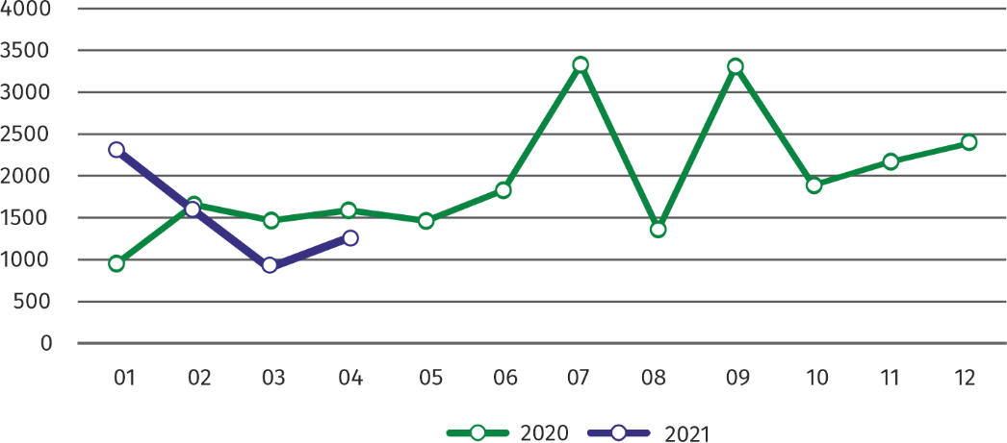Chart 4. Dwellings completed

In January-April 2021, the construction began in 4271 dwellings (by 15.7% less than in the corresponding period of 2020), of which: 4100 in construction for sale or rent, 171 in private construction.

In January-April 2021, the construction began in 4271 dwellings, i.e. by 15.7% less than in the corresponding period of the previous year

In January**–**April 2021, the number of dwellings for which permits have been granted or which have been registered with a construction project amounted to 3888 (by 6.2% less than in the corresponding period of 2020), of which 321 dwellings in buildings built by private investors.

The average useful floor area of a dwelling completed in January**-**April 2021, amounted to 64.9 m2 and increased compared to the corresponding period of 2020 by 1.5 m2. In private construction, the average useful floor area of dwellings amounted to 154.6 m2 (by 56.9 m2 fewer than in the corresponding period of 2020), in construction for sale or rent — 60.1 m2 (by 1.8 m2 more), in municipal construction — 38.5 m2 (by 0.7 m2 less).

**Entities of the national economy[2]**

At the end of April 2021, the most numerous group of entities by kind of conducted activity represented units dealing with professional, scientific and technical activities

At the end of April 2021, there were 482039 entities of the national economy registered in the REGON register in Warszawa, which accounted for 53.6% of the total in Mazowieckie Voivodship. Compared with March 2021, the number of entities of the national economy increased by 1846 (i.e. by 0.4%), and compared to April 2020 increased by 19924 (i.e. by 4.3%).

As of the end of April 2021, there were 216284 legal persons and organizational units without legal personality registered in the REGON register, of which 148449 commercial companies. The number of these entities increased compared to the previous month by 0.5% and 0.7%, whereas on an annual basis by 4.9% and 6.5%, respectively.

The number of registered natural persons conducting economic activity as of the end of April 2021 amounted to 265755 and compared to March 2021 it was higher by 0.3%, and compared to the corresponding period of the previous year increased by 3.9%.

In the capital city, in April 2021 the most numerous were entities dealing with professional, scientific and technical activities (19.5% of total registered units), trade; repair of motor vehicles (18.5%), information and communication (10.2%).

Compared to March 2021, the number of entities increased, among others, in the sections: electricity, gas, steam and air conditioning supply (by 2.4%), information and communication (by 0.8%), health care and social welfare (by 0.6%), agriculture, forestry and fishing, construction, real estate activities, professional, scientific and technical activities (by 0.5%). Whereas there was a decrease in the number of entities in the sections of mining and quarrying (by 0.5%), water supply; sewerage, waste management and remediation activities (by 0.2%).

In comparison with April 2020, the largest increase was recorded in the sections: electricity, gas, steam and air conditioning supply (by 25.5%), information and communication (by 8.5%), accommodation and catering (by 6.9%). Whereas a decrease in the number of entities was recorded in the section of mining and quarrying (by 1.6%).

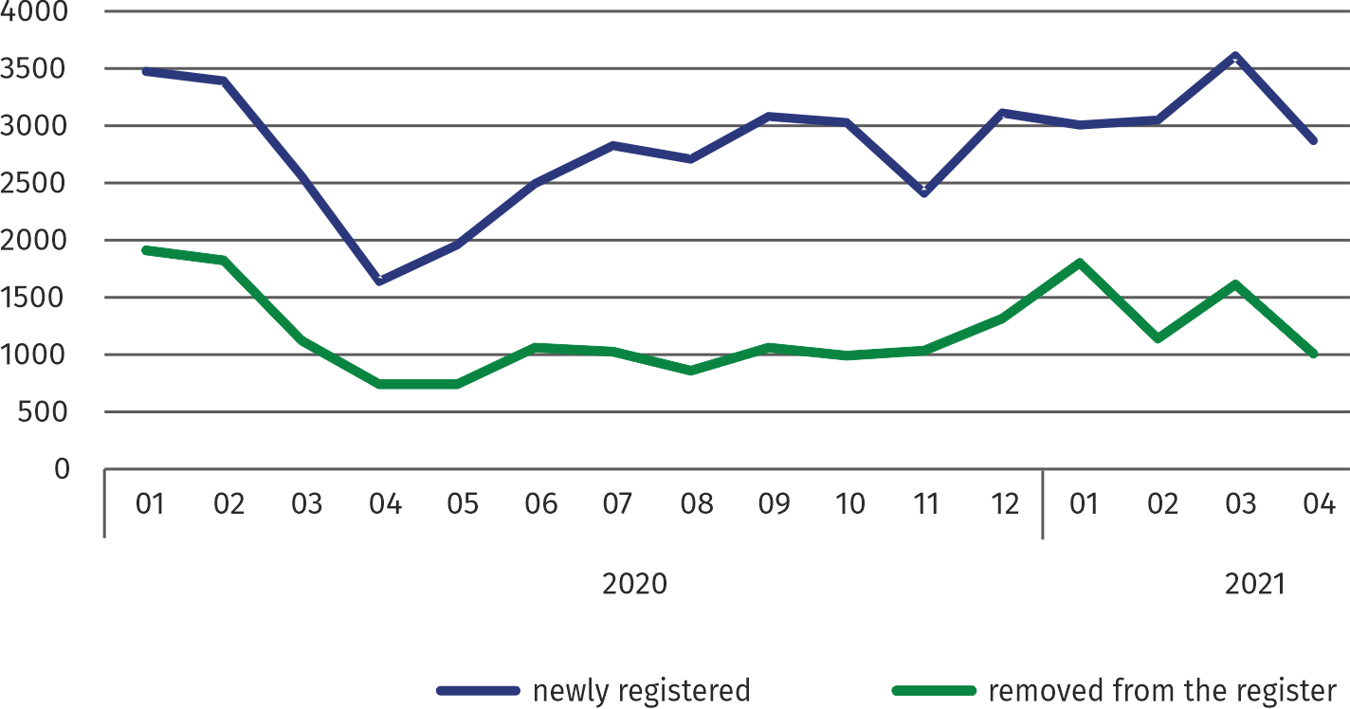**Chart 5. Entities newly registered and removed from the register**

In April 2021, the number of newly registered entities was 20.7% smaller than a month earlier, and the number of suspended activities increased by 0.6%

In April 2021, 2882 new entities were entered into the REGON register, i.e. by 20.7% less than in the previous month. The newly registered entities were dominated by natural persons conducting economic activity – 1703 (by 24.9% less than in March 2021). The number of newly registered commercial companies was higher by 13.4%, including limited liability companies – by 16.7%.

In April 2021, 989 entities were removed from the REGON register (compared to 1603 in the previous month), including 798 natural persons conducting economic activity (by 28.1% less). The most units removed from the register were dealing with: professional, scientific and technical activities (by 18.5%), trade; repair of motor vehicles (18.1%), transportation and storage (9.2%).

As of the end of April 2021, 46401 entities had suspended activity in the REGON register (by 0.6% more than a month before). The vast majority were natural persons conducting economic activity (85.5%).

In the case of quoting data from Statistics Poland, please provide information: "Source of data – Statistics Poland", and in the case of publishing calculations made on data published by Statistics Poland, please provide information: "Own study based on Statistics Poland data".

|  |  |
| --- | --- |
| Prepared by:  **Statistical Office in Warszawa**  **Director Zofia Kozłowska**  Tel.: (+48 22) 464 23 15 | Issued by:  **Statistical Information Centre**  **Marcin Kałuski**  Tel.: (+48 22) 464 20 91 **e-mail:** [**m.kaluski@stat.gov.pl**](mailto:m.kaluski@stat.gov.pl) |

|  |  |  |
| --- | --- | --- |
|  |  |  |
| **Press office**  Tel.: (+48 22) 464 20 91  **e-mail:** [**m.kaluski@stat.gov.pl**](mailto:m.kaluski@stat.gov.pl) |  |  |
|  | [warszawa.stat.gov.pl](https://warszawa.stat.gov.pl/)/en/  @[Warszawa](https://twitter.com/Warszawa_STAT)_STAT |
|  |  |
|  |  |



**Related information**

[Communication and Announcements](https://warszawa.stat.gov.pl/en/communiqus-and-announcements/communiqus-and-announcements/)

**Data available in databases**

[Local Data Bank →Labour market](https://bdl.stat.gov.pl/BDL/dane/podgrup/temat)

**Terms used in officaial statistics**

[Registered unemployed persons](https://stat.gov.pl/en/metainformations/glossary/terms-used-in-official-statistics/2958,term.html)

[Registered unemployment rate](https://stat.gov.pl/en/metainformations/glossary/terms-used-in-official-statistics/2390,term.html)

[Average paid employment](https://stat.gov.pl/en/metainformations/glossary/terms-used-in-official-statistics/376,term.html)

[Average monthly gross wages and salaries](https://stat.gov.pl/en/metainformations/glossary/terms-used-in-official-statistics/693,term.html)

[Dwellings completed](https://stat.gov.pl/en/metainformations/glossary/terms-used-in-official-statistics/201,term.html)

[Gross turnover profitability indicator](https://stat.gov.pl/metainformacje/slownik-pojec/pojecia-stosowane-w-statystyce-publicznej/587,pojecie.html)

[Net turnover profitability indicator](https://stat.gov.pl/metainformacje/slownik-pojec/pojecia-stosowane-w-statystyce-publicznej/587,pojecie.html)

1. Reporting data – may change after preparing quarterly reports..
2. Applies to legal persons, organizational units without legal personality and natural persons conducting economic activity (excluding natural persons tending private farms in agriculture).