Statistics of Warszawa No.3/2020

In March 2020, average employment, despite a slight decrease compared to the previous month, was higher than in the previous year, and the number of unemployed remained at a lower level than in March 2019. A further increase in sold production of industry was observed, while the dynamics of construction and assembly production was lower y/y. Retail sales in trade and non-trade enterprises fell compared to the previous year. March was also characterized by a greater number of dwellings completed than a year earlier. At the same time, the number of dwellings in which construction has begun and the permits issued decreased.

81.5

Dynamics of retail sales in trade and non-trade units (at current prices) y/y

Average employment

Average employment in the enterprise sector in March 2020 was by 1.3% higher than   
a year before

Average employment in the enterprise sector in March 2020 amounted to 1094.2 thousand persons and was by 4.2 thousand persons, i.e. by 0.4% lower than in February 2020 and by 14.3 thousand persons, i.e. by 1.3% higher than in March 2019.

Compared to February 2020, a decrease in the average employment was recorded in the following sections: accommodation and catering (by 2.0%), transportation and storage (by 0.7%), trade; repair of motor vehicles (by 0.6%), industry (by 0.4%), construction (by 0.3%), professional, scientific and technical activities (by 0.1%).

Whereas an increase in the average employment was recorded in the sections: information and communication (by 0.5%), arts, entertainment and recreation (by 0.2%), real estate activities (by 0.1%)

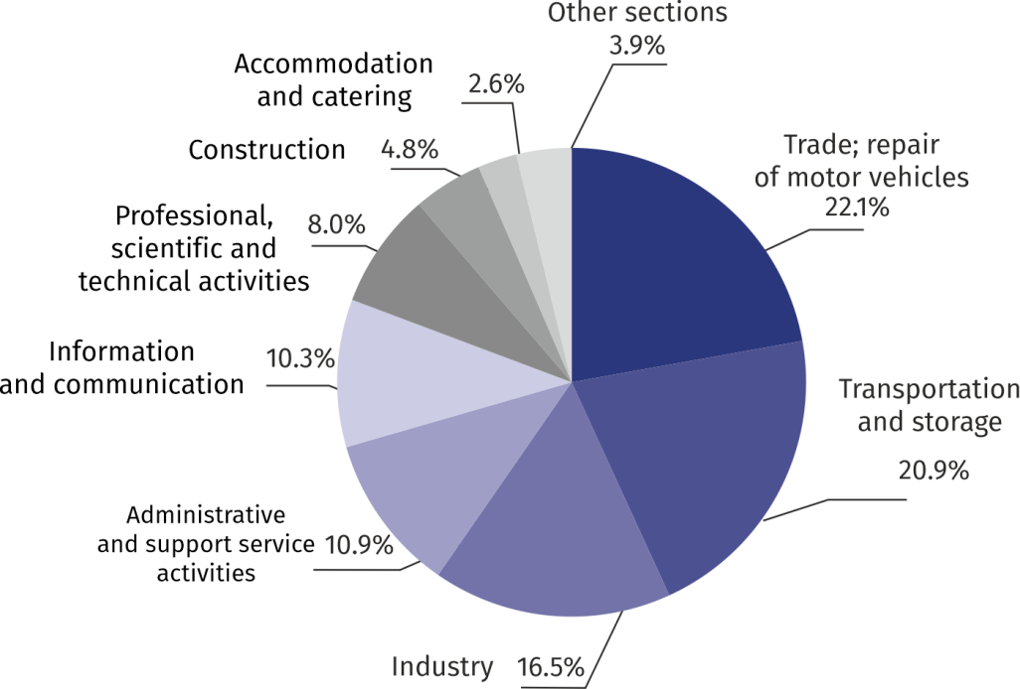

Chart 1.Structure of average employment by PKD (NACE Rev.2) sections in March 2020

As compared to March 2019, an increase in the average employment was recorded in the following sections: arts, entertainment and recreation (by 9.0%),transportation and storage (by 1.8%), industry (by 1.7%),trade; repair of motor vehiclesand administrative and support service activities (by 1.6% each), professional, scientific and technical activities (by 1.4%), real estate activities and (by 0.9%), information and communication (by 0.8%), accommodation and catering (by 0.7%).

A decrease in the average employment was recorded in the construction section(by 3.9%).

Registered unemployment

At the end of March 2020, the number of registered unemployed persons was by 9.1% smaller than a year before, and the unemployment rate amounted to 1.3%

At the end of March 2020, the number of registered unemployed persons amounted to 17911 and was by 111 persons, i.e. by 0.6% lower than at the end of February 2020 and by 1788 persons, i.e. by 9.1% smaller than in the corresponding period of 2019.

The number of registered unemployed women amounted to 8746, which accounted for 48.8% of the total unemployed (as a month before, and a year before 49.5%) and 13.5% of unemployed women in Mazowieckie Voivodship. As compared to February 2020, the number of unemployed women decreased by 54 persons, i.e. by 0.6%, and compared to March 2019 decreased by 1001 persons, i.e. by 10.3%.

The registered unemployment rate amounted to 1.3% (as in the previous month, and 1.5% in the previous year), the average in Mazowieckie Voivodship was 4.5% (4.6% a month before, and 4.9% a year before), while the national average was 5.4% (5.5%a month before, and 5.9% a year before).

In March 2020, there were 2207 unemployed persons registered in labour offices (2571 in February 2020, and 2860 in March 2019). Registered unemployed persons accounted for 19.7% of the total registered unemployed in the voivodship.

The number of persons registering for the first time amounted to 723 (a month before 795), which accounted for 32.8% of the total unemployed who registered in March 2020 and 28.6% of persons registering for the first time in the voivodship. The share of persons terminated due to company reasons among unemployed persons registered in March 2020 amounted to 2.1% (5.1% in Mazowieckie Voivodship), 2.6% a month before and 1.9% a year before.

In March 2020, the number of persons removed from unemployment rolls was by 24.6% smaller than a year before

In March 2020, 2318 persons were removed from unemployment rolls (2559 in February 2020, and 3074 in March 2019), which accounted for 17.7% of unemployed persons removed from unemployment rolls in Mazowieckie Voivodship. Out of unemployed persons removed from unemployment rolls, 1133 persons took up work. Moreover, 754 persons lost their status of the unemployed as a result of not confirming their readiness to take up work. The reason for removing from the register was also voluntarily giving up the status of the unemployed, starting training or traineeship, acquisition of retirement rights of pre-retirement benefit, acquisition of pension rights and other.

There were 14962persons who were not entitled to the unemployment benefit, i.e. 83.5% of the total unemployed (16652 persons a year before, i.e. 84.5%). Whereas 2949 unemployed persons were entitled to the unemployment benefit.

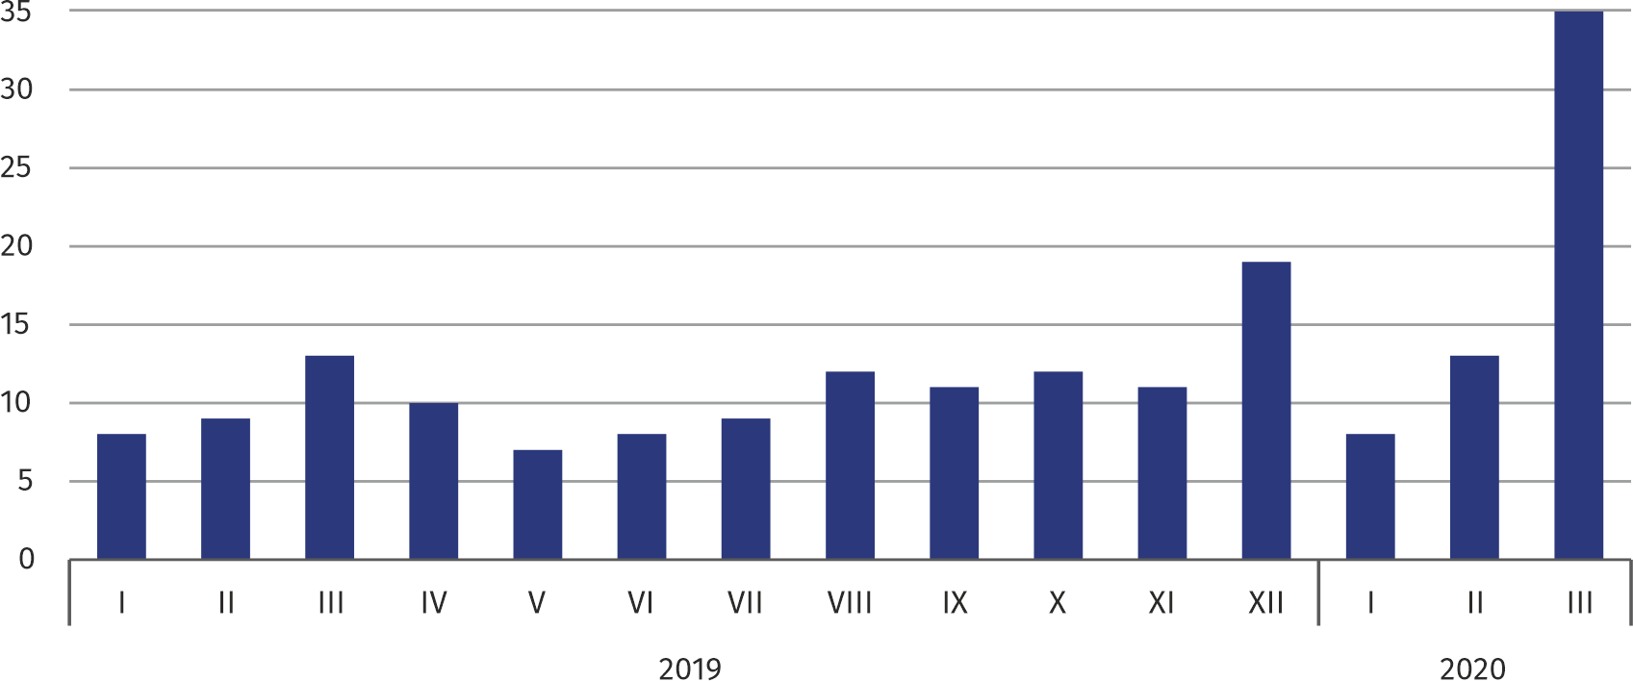**Chart 2. Number of unemployed persons per job offer (as of end of month)**

In March 2020, 19.5% less job offers were reported than a year before

In March 2020, there were 2740 job offers submitted to labour offices, which accounted for 22.3% of job offers in Mazowieckie Voivodship and at the end this month the labour offices had job offers for 518 persons. At the end of March 2020, there were 35 persons per one job offer (13 a month before just as a year before), in Mazowieckie Voivodship 23 persons (17 in the previous month and in the previous year) registered as unemployed.

Wages and salaries

The average monthly gross wages and salaries in the enterprise sector in March 2020 amounted to PLN 7216.13 and were by 8,6% higher as compared to the previous month and by 5.9% higher than in the corresponding period of 2019.

Average monthly gross wages and salaries in the enterprise sector in March 2020 amounted to PLN 7216.13 and were by 5.9% higher than in March 2019

Compared to February 2020, the increase in the average gross wages and salaries was recorded in the following sections:real estate activities (by 29.5%), professional, scientific and technical activities (by 19.6%), trade; repair of motor vehicles (by 10.1%), information and communication (by 9.9%), construction (by 9.7%), industry (by 8.4%), accommodation and catering (by 6.5%),administrative and support service activities (by 2.3%).

Whereas a decrease in the average gross wages and salaries was recorded in the sections: arts, entertainment and recreation (by 1.7%), transportation and storage (by 1.1%).

Chart 3.Relative deviations (in %) of monthly gross wages and salaries in selected sections from  
average wages and salaries in enterprise sector in March 2020

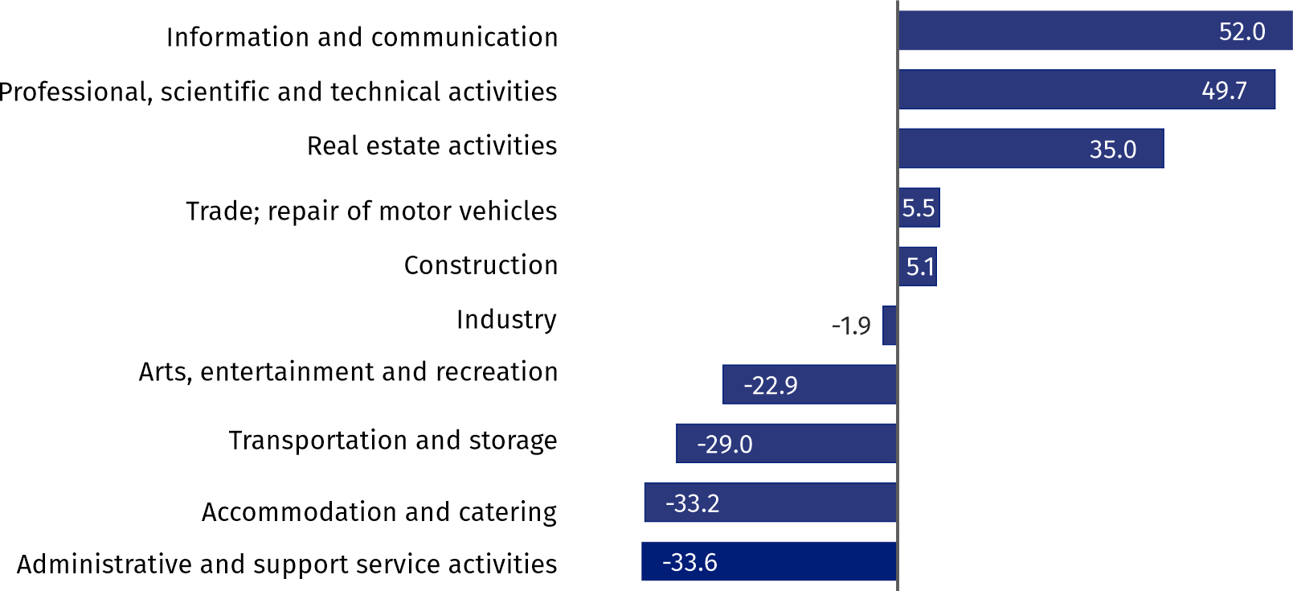

Compared to March 2019, an increase in the average gross wages and salaries was recorded in the sections: administrative and support service activities (by 12.5%), construction (by 10.6%),real estate activities (by 7.7%), trade; repair of motor vehicles and (by 7.0%), industry (by 6.8%), professional, scientific and technical activities (by 5.6%), transportation and storage (by 4.7%), arts, entertainment and recreation (by 2.4%), information and communication (by 1.9%), accommodation and catering (by 0.8%).

Industry

Sold production in manufacturing (at constant prices) in March 2020 was by 8.9% larger than a year before

Sold production of industry in March 2020 amounted (at current prices) to PLN 12495.5 million and was (at constant prices) larger as compared to the corresponding period of 2019 by 8.5%. As compared to March 2019, an increase by 8.9% was recorded in sold production in manufacturing.

In the period January–March 2020, the sold production of industry amounted to PLN 35472.3 million (at current prices) and was (at constant prices) higher by 5.7% than in the corresponding period of 2019. In manufacturing production increased by 8.4%.

Among divisions included in manufacturing, the sales increase was recorded, among others, in: manufacture of chemicals and chemical products (by 37.6%), manufacture of pharmaceutical products (by 28.6%), other manufacturing (by 22.1%), manufacture of textiles (by 22.0%), repair, installation of machinery and equipment (17.4%), manufacture of metal products (by 15.9%), manufacture of coke and refined petroleum products (by 15.5%), manufacture of furniture (by 14.1%), manufacture of food products (by 12.0%).

The decrease in sales was recorded, among others, in: manufacturing of other transport equipment (by 37.1%), manufacture of leather and related products (by 26.2%), manufacture of computer, electronic and optical products (by 13.4%), manufacture of basic metals (by 5.3%), manufacture of motor vehicles, trailers and semi-trailers (by 4.9%), manufacture of other non-metallic mineral products (by 4.2%).

Labour productivity in industry, measured by the value of sold production per employed person in January–March 2020 amounted to PLN 195.8 thousand (at current prices) and was – at constant prices – by 3.6% higher than a year before.

Construction

Sold production of construction in March 2020 amounted (at current prices) to PLN 3915.9 million and compared to February 2020 was higher by 21.9%, and compared to the corresponding period of the previous year it increased by 4.4%.

In January–March 2020, sold production of construction reached the value of PLN 10397.8 million, i.e. by 3.1% larger than in the corresponding period of 2019.

Construction and assembly production (at current prices) in March 2020 was by 19,7% smaller than a year before

Construction and assembly production in March 2020 reached PLN 957.3 million (at current prices) and accounted for 24.4% of sold production of construction. As compared to the previous month, construction and assembly production increased by 14.1%, and compared to March 2019 it was lower by 19.7%.

In the period January–March 2020, construction and assembly production amounted to PLN 2463.8 million and constituted 23.7% of the sold production of construction (28.8% a year before). In comparison with the same period last year, construction and assembly production was lower by 15.1%.

The decrease in production in relation to the corresponding period of 2019 occurred in entities conducting activity in civil engineering (by 19.8%), in entities conducting activity in the field of construction of buildings (by 15.5%)andin companies carrying out specialized construction activities (by 1.8%).

Labour productivity measured by production per employed person in construction, in March 2020 amounted to PLN 75.2 thousand and was by 22.2% higher than a month before and by 8.6% higher than in March 2019.

Trade

Retail sales (at current prices) in trade and non-trade enterprises in March 2020 was by 18.5% smaller than in March 2019

Retail sales in trade and non-trade enterprises in March 2020 (at current prices) were by 10.5% smaller than in February 2020 and by 18.5% lower compared to March 2019.

Compared to February 2020, there was, among others, lower sales of: textiles, clothing, footwear (by 55.6%), pharmaceuticals, cosmetics and orthopedic equipment (by 20.0%), press, books, other sales in specialized stores (by 18.5%), sales ofmotor vehicles, motorcycles, parts (by 18.0%), sales of solid, liquid and gas fuels (by 8.3%), other sales (by 7.5%).

However, there was an increase in, among others: sales of food, beverages and tobacco (by 4.2%), sales of furniture and household equipment (by 0.7%).

Retail sales (at current prices) of textiles, clothing and footwear was by 2/3 smaller than in the previous year

As compared to March 2019, there was a decrease, among others, in the sales of: textiles, clothing and footwear (by 61.5%),other retail sales in non-specialized stores (by 46.5%), sales of press, books, other sales in specialized stores (by 32.5%), motor vehicles, motorcycles, parts (by 30.8%), furniture, electronics and household appliances (by 16.8%), pharmaceuticals, cosmetics, orthopedic equipment (by 16.3%), other sales (by 13.6%),sales of solid, liquid and gas fuels (by 11.4%).

However, there was an increase in sales conducted by mail order houses (by 68.8%), sales of food, beverages and tobacco (by 12.4%).

In January-March 2020, compared to the same period of 2019, retail sales decreased by 1.2%.

Wholesale in trade enterprises in March 2020 (at current prices) was by 6.1% larger as compared to the previous month and by 0.1% higher as compared to March 2019, and in wholesale enterprises it was higher by 13.7% and by 2.3% respectively.

Wholesale (at current prices) in trade enterprises was by 0.1% higher than a year before

In the period January–March 2020, trade units realized wholesale by 4.2% higher than in the previous year, while wholesale enterprises by 2.8% higher.

**Housing construction[1]**

According to preliminary data, 1592 dwellings were completed in Warszawa in March 2020, i.e. by 29.6% more than in the previous year.

In January–March 2020, there were 4253 completed dwellings (by 11.5% less than in the corresponding period of 2019), and in Mazowieckie Voivodship 9213 dwellings, i.e. by 4.2% less than in January–March 2019. The decrease in the number of dwellings completed was recorded in construction for sale or rent from 4402 to 4014 dwellings, i.e. by 8.8% less. Whereas an increase was recorded in private construction from 132 to 239 dwellings, i.e. by 81.1% more.

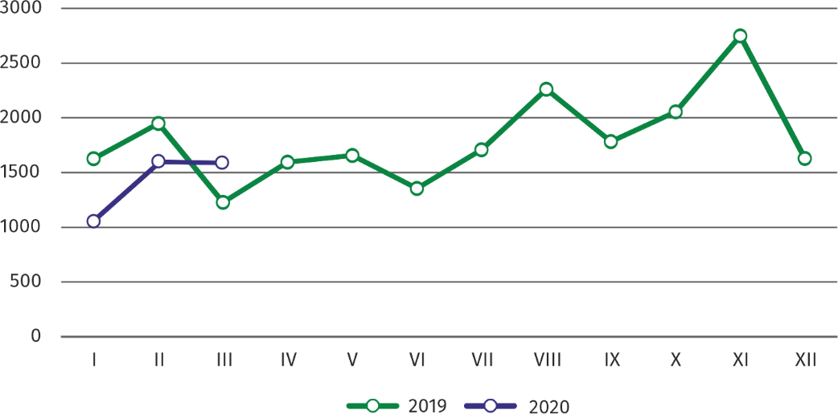Chart 4. Dwellings completed

In January–March 2020, the construction began in 4274 dwellings (by 26.5% less than in the corresponding period of 2019), of which: 4151 in construction for sale or rent, 123 in private construction .

In January–March 2020, the construction began in 4274 dwellings, i.e. by 26.5% less than in the corresponding period of the previous year

In January–March 2020, the number of dwellings for which permits have been granted or which have been registered with a construction project amounted to 3634 (by 10.3% less than in the corresponding period of 2019), of which 137 dwellings in buildings built by private investors.

The average useful floor area of a dwelling completed in January–March 2020, amounted to 64.7 m2 and increased compared to the corresponding period of 2019 by 4.1 m2. In private construction, the average useful floor area of dwellings amounted to — 179.6 m2 (by 11.0 m2 fewer than in the corresponding period of 2019), in construction for sale or rent — 57.9m2 (by 0.7 m2 more).

Entities of the national economy[2]

At the end of March 2020, the most numerous group of entities by kind of conducted activity represented units dealing with professional, scientific and technical activities

At the end of March 2020 there were 461238 entities of the national economy registered in the REGON register in Warszawa, which accounted for 53.6% of the total in Mazowieckie Voivodship. Compared with December 2019, the number of entities of the national economy increased by 4900 (i.e. by 1.1%), and compared to March 2019 increased by 21262 (i.e. by 4.8%).

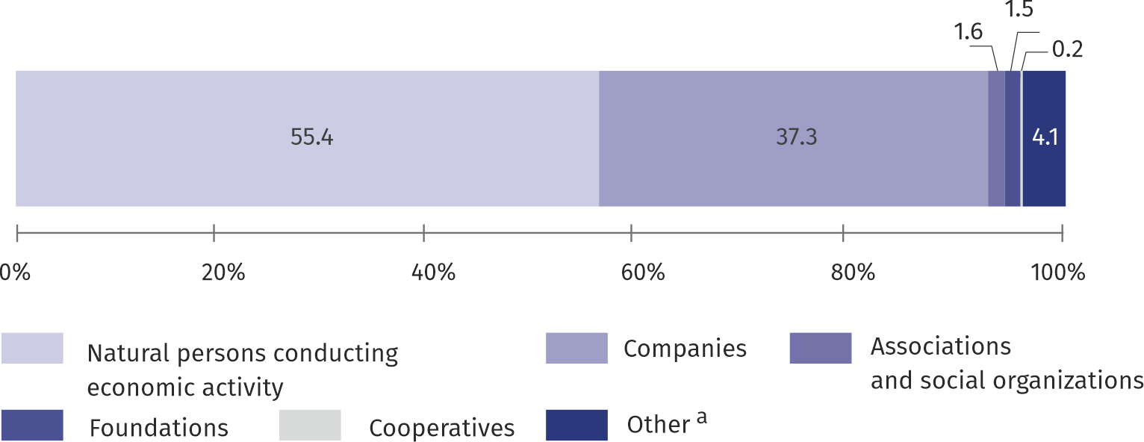**Chart 5. Structure of entities of the national economy by legal status in 2020**

**As of 31st March**

a Of which state owned enterprises.

In the capital city, in March 2020 the most numerous were entities dealing with professional, scientific and technical activities – 89544 (19.4%), trade; repair of motor vehicles – 86923 (18.8%), information and communication – 45248 (9.8%), construction – 33697 (7.3%), real estate activities – 28446 (6.2%), other service activities – 27602 (6.0%), manufacturing – 24183 (5.2%).

Compared to December 2019, the number of entities increased among others in the sections: electricity, gas, steam and air conditioning supply (by 6.9%), information and communication (by 2.2%),administrative and support service activities (by 2.0%),water supply; sewerage, waste management and remediation activities (by 1.7%), real estate activities (by 1.6%), professional, scientific and technical activities (by 1.4%).

In comparison with March 2019 the number of entities increased in the sections: electricity, gas, steam and air conditioning supply (by 18.2%), information and communication (by 9.3%), administrative and support service activities (by 7.1%),professional, scientific and technical activities (by 6.0%), real estate activities and human health and social work activities (by 5.9% each),construction (by 5.5%), arts, entertainment and recreation (by 5.4%), accommodation and catering (by 5.3%).

Whereas a decrease in the number of entieties was recorded in the mininig and quarrying section (by 2.1%).

|  |  |
| --- | --- |
| Prepared by:  **Statistical Office in Warszawa**  **Director Zofia Kozłowska** Tel.: (+48 22) 464 2315 | Issued by: **Statistical Information Centre** **Marcin Kałuski**Tel.: (+48 22) 464 20 91**e-mail:** [**m.kaluski@stat.gov.pl**](mailto:m.kaluski@stat.gov.pl) |

|  |  |  |
| --- | --- | --- |
|  |  |  |
| **Press office**  Tel.:(+48 22)464 20 91  **e-mail:**[**m.kaluski@stat.gov.pl**](mailto:m.kaluski@stat.gov.pl) |  |  |
|  | [warszawa.stat.gov.pl](https://warszawa.stat.gov.pl/)/en/  @[Warszawa](https://twitter.com/Warszawa_STAT)_STAT |
|  |  |
|  |  |

**Related information**

[Communication and Announcements](https://warszawa.stat.gov.pl/en/communiqus-and-announcements/communiqus-and-announcements/)

**Data available in databases**

[Local Data Bank →Labour market](https://bdl.stat.gov.pl/BDL/dane/podgrup/temat)

**Terms used in official statistics**

[Registered unemployed persons](https://stat.gov.pl/en/metainformations/glossary/terms-used-in-official-statistics/2958,term.html)

[Registered unemployment rate](https://stat.gov.pl/en/metainformations/glossary/terms-used-in-official-statistics/2390,term.html)

[Average paid employment](https://stat.gov.pl/en/metainformations/glossary/terms-used-in-official-statistics/376,term.html)

[Average monthly gross wages and salaries](https://stat.gov.pl/en/metainformations/glossary/terms-used-in-official-statistics/693,term.html)

[Dwellings completed](https://stat.gov.pl/en/metainformations/glossary/terms-used-in-official-statistics/201,term.html)

[Gross turnover profitability indicator](https://stat.gov.pl/metainformacje/slownik-pojec/pojecia-stosowane-w-statystyce-publicznej/587,pojecie.html)

[Net turnover profitability indicator](https://stat.gov.pl/metainformacje/slownik-pojec/pojecia-stosowane-w-statystyce-publicznej/587,pojecie.html)

1. Reporting data – may change after preparing quarterly reports.
2. Excluding persons tending private farms in agriculture.