Statistics of Warszawa No. 10/2019

In October 2019, 23.3% more dwellings were completed than a year before

In October 2019, positive changes in the economy continued. The increase in average employment was at a similar level as in the previous months. A decrease in the number of unemployed persons and the registered unemployment rate was observed. The average monthly gross wages and salaries were still higher than in the previous year. A further increase in sold production of industry was observed, whereas construction and assembly production recorded a significant decrease in annual terms. Both retail and wholesale were higher than in the previous year. In October, there were more dwellings completed than in the previous year.

 111.0

Dynamics of sold production of industry y/y

Average paid employment

Average employment in the enterprise sector in October 2019 was by 1.8% higher than a year before

Average employment in the enterprise sector in October 2019 amounted to 1085.6 thousand persons and was by 3.0 thousand persons, i.e. by 0.3% higher than in September 2019 and by 19.2 thousand persons, i.e. by 1.8% higher than in October 2018.

Compared to September 2019, an increase in the average employment was recorded in the following sections: trade; repair of motor vehicles (by 1.2%), arts, entertainment and recreation (by 0.9%), industry and professional scientific and technical activities (by 0.2% each), construction and transportation and storage (by 0.1% each).

Whereas a decrease in the average employment was recorded in the sections: accommodation and catering (by 0.9% each), administrative and support service activities (by 0.4%), information and communication (by 0.1%).

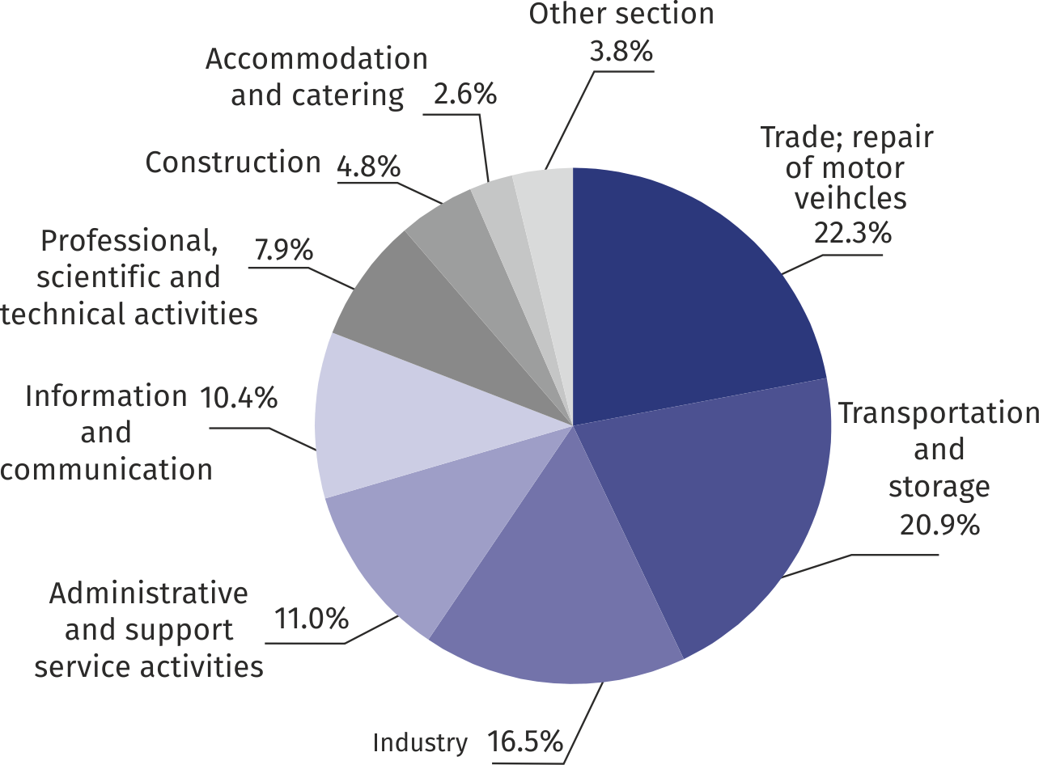Chart 1. Structure of average employment by PKD sections in October 2019

As compared to October 2018, an increase in the average employment was recorded in the following sections: arts, entertainment and recreation (by 10.8%), professional, scientific and technical activities (by 7.9%), real estate activities (by 6.8%), trade; repair of motor vehicles (by 4.8%), transportation and storage (by 3.2%), accommodation and catering (by 1.2%).

A decrease in the average employment was recorded in the following sections: industry (by 2.5%), construction (by 1.5%), administrative and support service activities (by 1.4%), information and communication (by 0.9%).

Registered unemployment

At the end of October 2019, the number of registered unemployed persons was by 13.7% smaller than a year before, and the unemployment rate amounted to 1.3%

At the end of October 2019, the number of registered unemployed persons amounted to 17455 and was by 714 persons, i.e. by 3.9% smaller than at the end of September 2019 and by 2761 persons, i.e. by 13.7% smaller than in the corresponding period of 2018.

The number of registered unemployed women amounted to 8738, which accounted for 50.1% of the total unemployed (a month before 50.5%, and a year before 50.8%) and 13.8% of unemployed women in Mazowieckie Voivodship. As compared to September 2019, the number of unemployed women decreased by 436 persons, i.e. by 4.8%, and compared to October 2018 decreased by 1539 persons, i.e. by 15.0%.

The registered unemployment rate amounted to 1.3% (1.4% in the previous month, and 1.5% in the previous year), the average in Mazowieckie Voivodship was 4.3% (4.4% a month before, and 4.8% a year before), while the national average was 5.0% (5.1% in the previous month, and 5.7% a year before).

In October 2019, there were 2831 unemployed persons registered in labour offices (2736 in September 2019, and 2991 in October 2018). Registered unemployed persons accounted for 18.1% of the total registered unemployed in the voivodship.

The number of persons registering for the first time amounted to 797 (a month before 844), which accounted for 28.2% of the total unemployed who registered in October 2019 and 22.6% of persons registering for the first time in the voivodship. The share of persons terminated due to company reasons among unemployed persons registered in October 2019 amounted to 2.8% (3.6% in Mazowieckie Voivodship), 2.5% a month before and 1.5% a year before.

In October 2019, the number of persons removed from unemployment rolls was by 10.6% smaller than a year before

In October 2019, 3545 persons were removed from unemployment rolls (3122 in September 2019, and 3965 in October 2018), which accounted for 19.6% of unemployed persons removed from unemployment rolls in Mazowieckie Voivodship. Out of unemployed persons removed from unemployment rolls, 1674 took up work. Moreover, 1223 persons lost their status of the unemployed as a result of not confirming their readiness to take up work. The reason for removing from the register was also voluntarily giving up the status of the unemployed, starting training or traineeship, acquisition of retirement rights of pre-retirement benefit, acquisition of pension rights and other.

There were 14446 persons who were not entitled to the unemployment benefit, i.e. 82.8% of the total unemployed (17138 persons a year before, i.e. 84.8%). Whereas 3009 unemployed persons were entitled to the unemployment benefit.

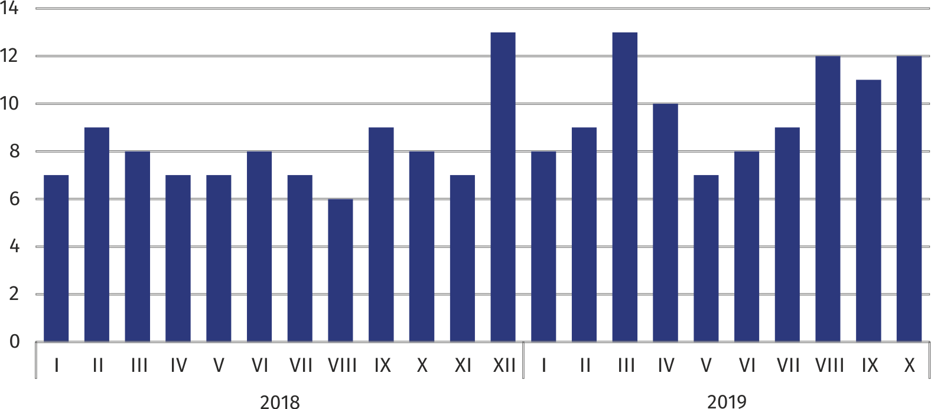**Chart 2. Number of unemployed persons per job offer (as of end of month)**

In September 2019, there were 3811 job offers submitted to labour offices, which accounted for 26.5% of job offers in Mazowieckie Voivodship and at the end this month the labour offices had job offers for 1413 persons. At the end of October 2019, there were 12 persons per one job offer (11 a month before, 8 a year before), in Mazowieckie Voivodship 14 persons (13 in the previous month and in the previous year) registered as unemployed.

In October 2019, 12.6% less job offers were reported than a year before

Wages and salaries

Average monthly gross wages and salaries in the enterprise sector in October 2019 amounted to PLN 6685.13 and were by 5.0% higher than in October 2018

The average monthly gross wages and salaries in the enterprise sector in October 2019 amounted to PLN 6685.13 and were by 5.4% higher as compared to the previous month and by 5.0% higher than in the corresponding period of 2018.

Compared to September 2019, the increase in the average gross wages and salaries was recorded in the following sections: transportation and storage (by 22.7%), construction (by 11.0%), arts, entertainment and recreation (by 7.7%), trade; repair of motor vehicles (by 2.8%), accommodation and catering (by 2.3%), industry (by 1.6%), administrative and support service activities (by 1.3%).

Whereas the decrease in the average gross wages and salaries was recorded in the following sections: professional, scientific and technical activities (by 1.6%), information and communication and real estate activities (by 0.2% each).

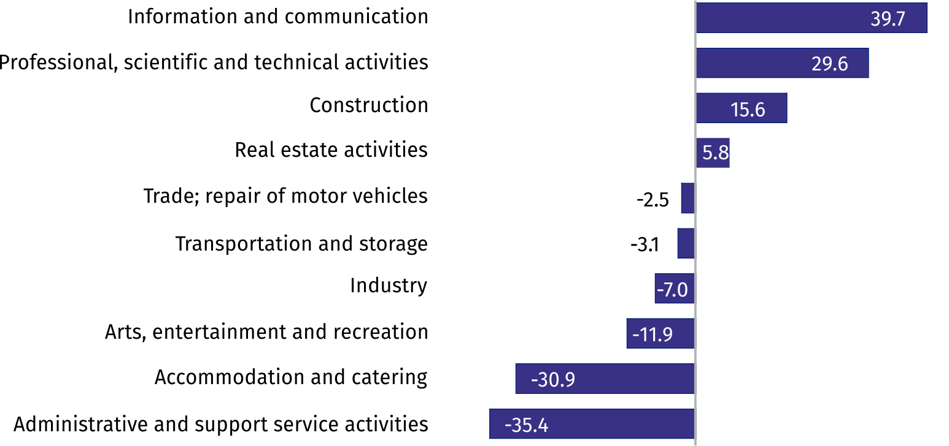Chart 3. Relative deviations (in %) of monthly gross wages and salaries in selected sections from average wages and salaries in enterprise sector in October 2019

Compared to October 2018, an increase in the average gross wages and salaries was recorded in the sections: administrative and support service activities (by 10.8%), transportation and storage (by 7.1%), accommodation and catering (by 7.0%), trade; repair of motor vehicles and construction, arts, entertainment and recreation as well as professional, scientific and technical activities (by 4.5% each), industry (by 3.9%), construction (b 3.0%), real estate activities (by 2.5%), information and communication (by 1.6%).

Industry

Sold production in manufacturing (at constant prices) in October 2019 was by 7.6% larger than a year before

Sold production of industry in October 2019 amounted (at current prices) to PLN 12204.5 million and was (at constant prices) larger as compared to the corresponding period of 2018 by 11.0%. As compared to October 2018, an increase by 7.6% was recorded in sold production in manufacturing.

In January–October 2019, sold production of industry amounted to PLN 106908.8 million (at current prices) and was (at constant prices) higher by 4.6% than in the corresponding period of 2018. Production in manufacturing recorded a 8.7% increase.

Among divisions included in manufacturing, the sales increase was recorded, among others, in: manufacture of computer, electronic and optical products (by 42.0%), manufacture of machinery and equipment n.e.c. (by 19.0%), manufacture of food products (by 16.6%), printing and reproduction of recorded media (by 15.3%), manufacture of beverages (by 14.9%), manufacture of chemicals and chemical products (by 14.6%), repair and installation of machinery and equipment (by 13.0%).

The decrease in sales was recorded, among others, in: other manufacturing (by 28.9%), manufacture of leather and related products (by 18.4%), manufacture of products of wood, cork, straw and wicker (by 17.1%), manufacture of furniture (by 9.9%), manufacture of motor vehicles, trailers and semi-trailers (by 8.3%), manufacture of paper and paper products (by 7.1%), manufacture of metal products (by 3.4%).

Labour productivity in industry, measured by the value of sold production per employed person in January–October 2019 amounted to PLN 598.8 thousand (at current prices) and was – at constant prices – by 6.8% higher than a year before.

Construction

Sold production of construction in October 2019 amounted (at current prices) to PLN 4930.2 million and compared to September 2019 was larger by 9.7%, and compared to the corresponding period of the previous year, it decreased by 0.1%.

In January–October 2019, sold production of construction reached the value of PLN 45047.2 million, i.e. by 10.9% larger than in the corresponding period of 2018.

Construction and assembly production (at current prices) in October 2019 was by 18.5% smaller than a year before

Construction and assembly production in October 2019 reached PLN 1301.4 million (at current prices) and accounted for 26.4% of sold production of construction. As compared to the previous month, construction and assembly production increased by 3.1%, and compared to October 2018 it was lower by 18.5%.

In January–October 2019, construction and assembly production was at the level of PLN 10909.2 million and accounted for 24.2% of sold production of construction (28.3% a year before). As compared to the corresponding period of the previous year, construction and assembly production was smaller by 4.9%.

The decrease in production in relation to the corresponding period of 2018 occurred in entities conducting activity in the field of construction of buildings (by 11.5%) and in companies carrying out specialized construction activities (by 5.8%). Whereas an increase in production was recorded in entities conducting activity in civil engineering (by 0.2%).

Labour productivity measured by production per employed person in construction, in October 2019 amounted to PLN 95.3 thousand and was by 9.6% higher than a month before and by 1.4% higher than in October 2018.

Trade

Retail sales (at current prices) in trade and non-trade enterprises in October 2019 was by 6.0% larger than in October 2018

Retail sales in trade and non-trade enterprises in October 2019 (at current prices) were by 5.1% larger than in September 2019 and by 6.0% higher compared to October 2018.

Compared to September 2019, larger, among others, were: retail sales conducted by mail order houses (by 31.5%), sales of pharmaceuticals, cosmetics, orthopedic equipment (by 15.5%), sales of food, beverages and tobacco (by 8.8%), motor vehicles, motorcycles, parts (by 7.7%), textiles, clothing, footwear (by 5.1%), solid, liquid and gas fuels (by 4.6%).

However, the decrease was recorded in: sales of press, books, other sales in specialized stores (by 2.8%), other retail sales in non-specialized stores (by 0.8%).

As compared to October 2018, the sales were higher, among others, in the groups: „retail sales conducted by mail order houses” (by 108.1%), “furniture, electronics and household appliances” (by 13.7%), “pharmaceuticals, cosmetics, orthopedic equipment” (by 12.8%). The increase was also recorded in: food, beverages and tobacco (by 8.9%), textiles, clothing and footwear (by 8.0%), other retail sales in non-specialized stores (by 6.8%).

However, the decrease was recorded in the sales of solid, liquid and gas fuels (by 7.1%), motor vehicles, motorcycles, parts (by 0.3%).

In January–October 2019, as compared to the corresponding period of 2018, the retail sales went up by 8.5%.

Wholesale (at current prices) in trade enterprises was by 2.4% higher than a year before

Wholesale in trade enterprises in October 2019 (at current prices) was by 10.9% larger as compared to the previous month and by 2.4% higher as compared to October 2018, and in wholesale enterprises it was higher by 11.8% and 0.6%, respectively.

In January–October 2019, wholesale in trade units was by 5.6% higher than a year before, while in wholesale enterprises it was higher by 3.0%.

**Housing construction[1]**

According to preliminary data, 2137 dwellings were completed in Warszawa in October 2019, i.e. by 23.3% more than a year before.

In January–October 2019, 17345 dwellings were completed (by 6.4% less than in the corresponding period of 2018), and in Mazowieckie Voivodship 34728 dwellings, i.e. by 6.3% more than in January-October 2018. The drop in the number of dwellings completed was recorded in municipal construction from 68 to 12, i.e. by 82.4% less, in construction for sale or rent from 17892 to 16437 dwellings, i.e. by 8.1% less. Whereas the increase was recorded in company construction from 1 to 18 dwellings and in private construction from 522 to 525, i.e. by 0.6% more. Moreover, in January–October 2019, 353 dwellings were completed by cooperatives.

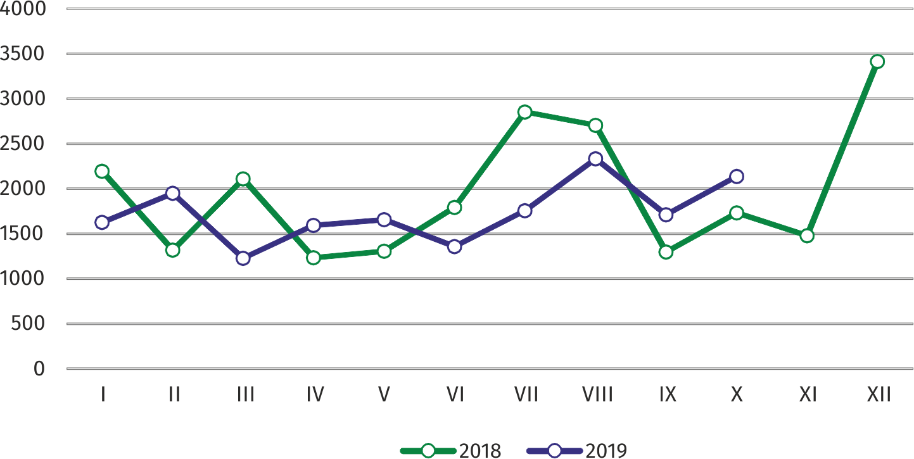Chart 4. Dwellings completed

In January–October 2019, the construction began in 19113 dwellings, i.e. by 11.8% less than in the corresponding period of the previous year

In January–October 2019, the construction began in 19113 dwellings (by 11.8% less than in the corresponding period of 2018), of which: 17866 in construction for sale or rent, 779 in private construction, 253 in cooperative construction, 215 in dwellings built by public building societies.

In January–October 2019, the number of dwellings for which permits have been granted or which have been registered with a construction project amounted to 18932 (by 8.3% less than in the corresponding period of 2018), of which 527 dwellings buildings built by private investors.

The average useful floor area of a dwelling completed in January–October 2019, amounted to 60.4 m2 and increased compared to the corresponding period of 2018 by 0.4 m2. In private construction, the average useful floor area of dwellings amounted to 186.3 m2 (by 9.3 m2 fewer than in the corresponding period of 2018), in cooperative construction — 57.5 m2, in construction for sale or rent — 56.5 m2 (by 0.4 m2 more), in municipal construction — by 40.8 m2 (by 11.3 m2 fewer), in company construction — 34.1 m2.

|  |  |
| --- | --- |
| Prepared by:  **Mazovian Centre for Regional Surveys**  **Statistical Office in Warszawa**  **Małgorzata Bieńkowska**  **Joanna Podolska** Tel: +48 22 464 21 96, 22 464 20 96**e-mail:** [**m.bienkowska@stat.gov.pl**](mailto:m.bienkowska@stat.gov.pl)**e-mail:** [**j.podolska@stat.gov.pl**](mailto:j.podolska@stat.gov.pl) | Issued by: **Statistical Information Centre** **Marcin Kałuski**Tel: +48 22 464 20 91**e-mail:** [**m.kaluski@stat.gov.pl**](mailto:m.kaluski@stat.gov.pl) |

|  |  |  |
| --- | --- | --- |
| Translated by:  **Agnieszka Gromek-Żukowska**  Tel: +48 22 464 22 42  **e-mail:** [**a.gromek-zukowska@stat.gov.pl**](mailto:a.gromek-zukowska@stat.gov.pl) |  |  |
| **Press office**  Tel.:+48 22 464 20 91  **e-mail:** [**m.kaluski@stat.gov.pl**](mailto:m.kaluski@stat.gov.pl) |  |  |
|  | [warszawa.stat.gov.pl](https://warszawa.stat.gov.pl/)/en  @[Warszawa](https://twitter.com/Warszawa_STAT)_STAT |
|  |  |
|  |  |



**Related information**

[Communication and Announcements](https://warszawa.stat.gov.pl/en/communiqus-and-announcements/communiqus-and-announcements/)

**Data available in databases**

[Local Data Bank → Labour](https://bdl.stat.gov.pl/BDL/dane/podgrup/temat) market

**Terms used in official statistics**

[Registered unemployed persons](https://stat.gov.pl/en/metainformations/glossary/terms-used-in-official-statistics/2958,term.html)

[Registered unemployment rate](https://stat.gov.pl/en/metainformations/glossary/terms-used-in-official-statistics/2390,term.html)

[Average paid employment](https://stat.gov.pl/en/metainformations/glossary/terms-used-in-official-statistics/376,term.html)

[Average monthly gross wages and salaries](https://stat.gov.pl/en/metainformations/glossary/terms-used-in-official-statistics/693,term.html)

[Dwellings completed](https://stat.gov.pl/en/metainformations/glossary/terms-used-in-official-statistics/201,term.html)

[Gross turnover profitability indicator](https://stat.gov.pl/en/metainformations/glossary/terms-used-in-official-statistics/587,term.html)

[Net turnover profitability indicator](https://stat.gov.pl/en/metainformations/glossary/terms-used-in-official-statistics/587,term.html)

1. Reporting data – may change after preparing quarterly reports.