Statistics of Warszawa No. 7/2019

In July 2019, 38.4% less dwellings were completed than a year before

In July 2019, the average employment in the enterprise sector was by 1.9% higher as compared to the previous year. The number of registered unemployed persons was lower than in the previous month and in the previous year. The average monthly gross wages and salaries in the enterprise sector increased by 5.4% in annual terms. As compared to July 2018, the increase was recorded in sold production of industry and sold production of construction. Both retail sales and wholesale were higher compared to the previous year. In July this year, fewer dwellings were completed than a year earlier.

 116.8

Indices of sold production of construction y/y

Average paid employment

Average employment in the enterprise sector in July 2019 was by 1.9% higher than a year before

Average employment in the enterprise sector in July 2019 amounted to 1083.8 thousand persons and was by 4.4 thousand persons, i.e. by 0.4% higher than in June 2019 and by 20.6 thousand persons, i.e. by 1.9% higher than in July 2018.

Compared to June 2019, an increase in the average employment was recorded in the following sections: administrative and support service activities (by 2.0%), accommodation and catering (by 1.7%), information and communication (by 1.0%), industry (by 0.3%), arts, entertainment and recreation and transportation and storage (by 0.2% each), professional scientific and technical activities (by 0.1%).

Whereas a decrease in the average employment was recorded in the following sections: construction (by 0.7%), trade; repair of motor vehicles and real estate activities (by 0.1% each).

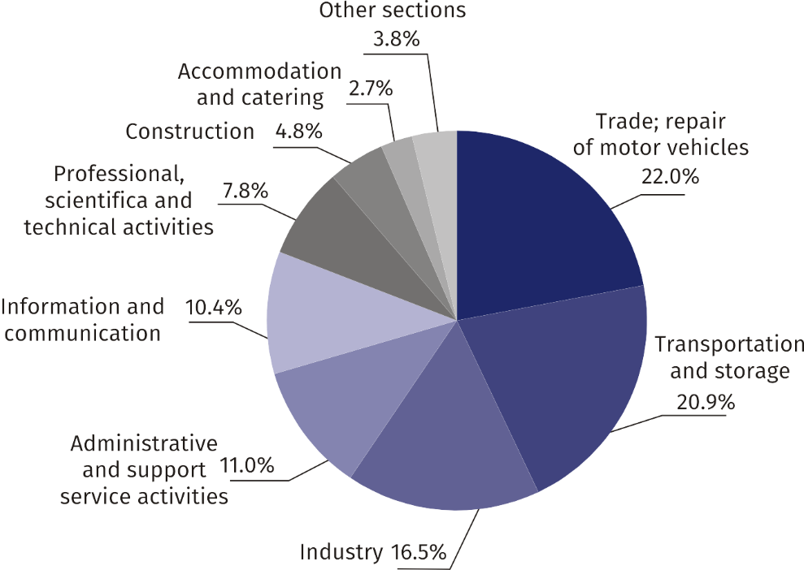Chart 1. Structure of average employment by PKD sections in July 2019

In comparison to July 2018, an increase in the average employment was recorded in the following sections: arts, entertainment and recreation (by 10.6%), real estate activities (by 7.7%), professional, scientific and technical activities (by 6.6%), trade; repair of motor vehicles (by 4.1%), transportation and storage (by 3.7%), information and communication (by 1.2%).

A decrease in the average employment was recorded in the following sections: industry (by 2.1%), accommodation and catering (by 1.4%), construction and administrative and support service activities (by 1.1% each).

Registered unemployment

At the end of July 2019, the number of registered unemployed persons was by 17.2% smaller than a year before, and the unemployment rate was 1.4%

At the end of July 2019, the number of registered unemployed persons amounted to 18490 and was by 73 persons, i.e. by 0.4% smaller than at the end of June 2019 and by 3834 persons, i.e. by 17.2% smaller than in the corresponding period of 2018.

The number of registered unemployed women amounted to 9326, which accounted for 50.4% of the total unemployed (a month before 49.8%, and a year before 51.3%) and 14.0% of unemployed women in Mazowieckie Voivodship. As compared to June 2019, the number of unemployed women increased by 89 persons, i.e. by 1.0%, and compared to July 2018 it decreased by 2122 persons, i.e. by 18.5%.

The registered unemployment rate amounted to 1.4% (as in the previous month, and 1.7% in the previous year), the average in Mazowieckie Voivodship was 4.5% (same as a month before, and 5.0% a year before), while the national average was 5.2% (5.3% a month before, and 5.8% a year before).

In July 2019, there were 2997 unemployed persons registered in labour offices (2389 in June 2019, and 2965 in July 2018). Registered unemployed persons accounted for 19.3% of the total registered unemployed in the voivodship.

The number of persons registering for the first time amounted to 866 (a month before 651), which accounted for 28.9% of the total unemployed who registered in July 2019 and 25.7% of persons registering for the first time in the voivodship. The share of persons terminated due to company reasons among unemployed persons registered in July 2019 amounted to 2.6% (3.9% in Mazowieckie Voivodship), 3.2% a month before and 1.9% a year before.

In July 2019, the number of persons removed from unemployment rolls was by 10.6% smaller than a year before

In July 2019, 3070 persons were removed from unemployment rolls (2750 in June 2019, and 3433 in July 2018), which accounted for 18.5% of unemployed persons removed from unemployment rolls in Mazowieckie Voivodship. Out of unemployed persons removed from unemployment rolls, 1354 took up work. Moreover, 1028 persons lost their status of the unemployed as a result of not confirming their readiness to take up work. The reason for removing from the register was also voluntarily giving up the status of the unemployed, starting training or traineeship, acquisition of retirement rights of pre-retirement benefit, acquisition of pension rights and other.

There were 15295 persons who were not entitled to the unemployment benefit, i.e. 82.7% of the total unemployed (18840 persons a year before, i.e. 84.4%). Whereas 3195 unemployed persons were entitled to the unemployment benefit.

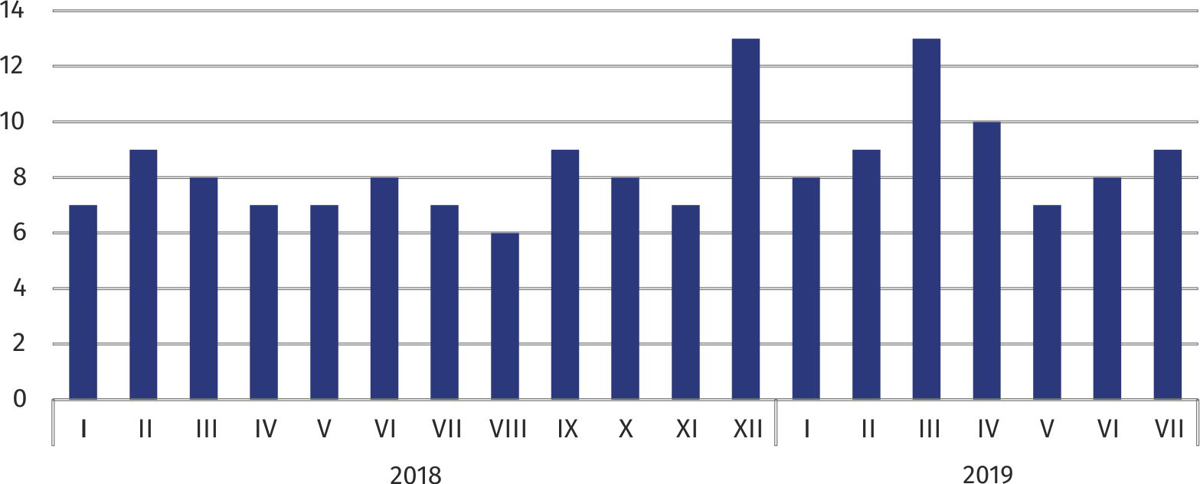**Chart 2. Number of unemployed persons per job offer (as of end of month)**

In July 2019, there were 3678 job offers submitted to labour offices, which accounted for 27.1% of job offers in Mazowieckie Voivodship and at the end this month the labour offices had job offers for 1952 persons. At the end of July 2019, there were 9 persons per one job offer (8 a month before, 7 a year before), in Mazowieckie Voivodship 14 persons (13 in the previous month and 12 in the previous year) registered as unemployed.

In July 2019, 24.2% less job offers were reported than a year before

Wages and salaries

Average monthly gross wages and salaries in the enterprise sector in July 2019 amounted to PLN 6393.10 and were by 5.4% higher than in July 2018

The average monthly gross wages and salaries in the enterprise sector in July 2019 amounted to PLN 6393.10 and were by 0.4% lower as compared to the previous month and by 5.4% higher than in the corresponding period of 2018.

Compared to June 2019, the decrease in the average gross wages and salaries was recorded in the following sections: construction (by 3.9%), trade; repair of motor vehicles (by 2.7%), information and communication (by 1.2%), transportation and storage (by 0.8%), industry (by 0.2%).

Whereas the increase in the average gross wages and salaries was recorded in the following sections: arts, entertainment and recreation (by 18.0%), accommodation and catering (by 7.0%), administrative and support service activities (by 3.5%), real estate activities (by 2.7%), professional, scientific and technical activities (by 1.8%).

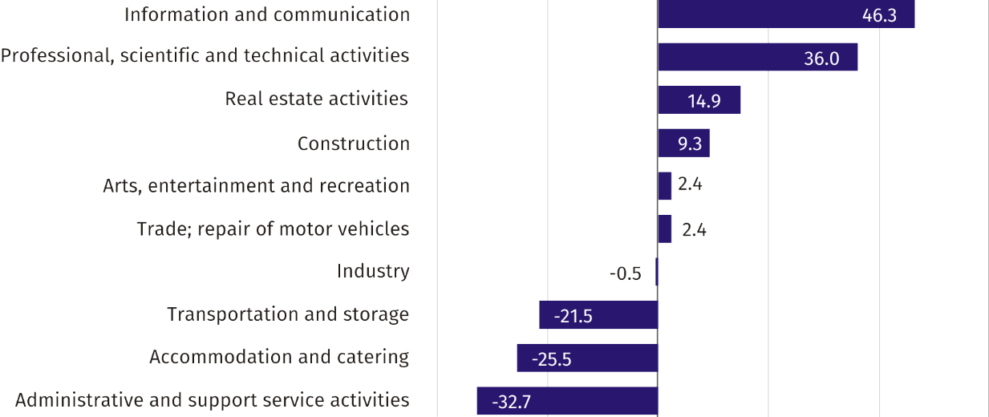Chart 3. Relative deviations (in %) of monthly gross wages and salaries in selected sections from average wages and salaries in enterprise sector in July 2019

Compared to July 2018, an increase in the average gross wages and salaries was recorded in the sections: administrative and support service activities (by 13.8%), accommodation and catering (by 7.4%), transportation and storage (by 6.4%), industry (by 5.3%), information and communication (by 5.0%), arts, entertainment and recreation (by 4.1%), professional, scientific and technical activities (by 3.7%), trade; repair of motor vehicles and real estate activities (by 3.5% each), construction (by 1.1%).

Industry

Sold production in manufacturing (at constant prices) in July 2019 was by 7.7% larger than a year before

Sold production of industry in July 2019 amounted (at current prices) to PLN 10051.2 million and was (at constant prices) larger as compared to the corresponding period of 2018 by 5.8%. As compared to July 2018, an increase by 7.7% was recorded in sold production in manufacturing.

In January–July 2019, sold production of industry amounted to PLN 75337.8 million (at current prices) and was (at constant prices) higher by 5.4% than in the corresponding period of 2018. Production in manufacturing recorded a 7.9% increase.

Among divisions included in manufacturing, the sales increase was recorded, among others, in: manufacture of computer, electronic and optical products (by 43.4%), manufacture of machinery and equipment n.e.c. (by 27.5%), manufacture of chemicals and chemical products (by 24.2%), manufacture of other transport equipment (by 23.2%), manufacture of beverages (by 17.8%), printing and reproduction of recorded media (by 16.9%), manufacture of food products (by 12.5%), manufacture of rubber and plastic products (by 11.2%).

The decrease in sales was recorded, among others, in: other manufacturing (by 37.8%), manufacture of coke and refined petroleum products (by 33.4%), manufacture of products of wood, cork, straw and wicker (by 19.0%), manufacture of furniture (by 11.4%), manufacture of motor vehicles, trailers and semi-trailers (by 9.6%), manufacture of leather and related products (by 7.9%), manufacture of pharmaceutical products (by 7.3%), manufacture of paper and paper products (by 6.5%), manufacture of clothing (by 5.0%).

Labour productivity in industry, measured by the value of sold production per employed person in January–July 2019 amounted to PLN 422.0 thousand (at current prices) and was – at constant prices – by 7.8% higher than a year before.

Construction

Sold production of construction in July 2019 amounted (at current prices) to PLN 5019.8 million and compared to June 2019 was larger by 6.7%, and compared to the corresponding period of the previous year, it increased by 16.8%.

In January–July 2019, sold production of construction reached the value of PLN 30333.6 million, i.e. by 16.7% larger than in the corresponding period of 2018.

Construction and assembly production (at current prices) in July 2019 was by 3.5% larger than a year before

Construction and assembly production in July 2019 reached PLN 1424.3 million (at current prices) and accounted for 28.4% of sold production of construction. As compared to the previous month, construction and assembly production increased by 13.2%, and compared to July 2018 it was higher by 3.5%.

In January–July 2019, construction and assembly production was at the level of PLN 7670.5 million and accounted for 25.3% of sold production of construction (28.1% a year before). As compared to the corresponding period of the previous year, construction and assembly production was larger by 4.9%.

The increase in production in relation to the corresponding period of 2018 occurred in entities conducting activity in civil engineering (by 19.8%). Whereas a decrease in production was recorded in entities conducting activity in the field of construction of buildings (by 8.7%) and in companies carrying out specialized construction activities (by 5.7%).

Labour productivity measured by production per employed person in construction, in July 2019 amounted to PLN 96.1 thousand and was by 7.4% higher than a month before and by 18.1% higher than in July 2018.

Trade

Retail sales (at current prices) realized by trade and non-trade enterprises in July 2019 was by 6.6% larger than in July 2018

Retail sales in trade and non-trade enterprises in July 2019 (at current prices) were by 0.1% smaller than in June 2019 and by 6.6% higher compared to July 2018.

Compared to June 2019, smaller, among others, were: other retail sales in non-specialized stores (by 21.9%), sales of textiles, clothing and footwear (by 11.3%), sales of motor vehicles, motorcycles, parts (by 7.2%).

However, the increase was recorded, among others, in: other sales (by 10.7%), sales of furniture, electronics and household appliances (by 4.2%), press, books and other sales in specialized stores (by 2.8%), retail sales conducted by mail order houses (by 1.6%), food, beverages and tobacco (by 1.4%).

As compared to July 2018, the sales were higher, among others, in the groups: „retail sales conducted by mail order houses” (by 54.9%), “furniture, electronics and household appliances” (by 17.4%), „other retail sales in non-specialized stores“ (by 10.7%). The increase was also recorded in the sales of: food, beverages and tobacco (by 7.8%), “textiles, clothing, footwear” (by 7.4%), pharmaceuticals, cosmetics and orthopedic equipment (by 6.4%), press, books, other sales in specialized stores (by 6.1%).

However, the decrease was recorded in the sales of solid, liquid and gas fuels (by 7.0%).

In January–July 2019, as compared to the corresponding period of 2018, the retail sales went up by 8.4%.

Wholesale (at current prices) in trade enterprises was by 10.2% higher than a year before

Wholesale in trade enterprises in July 2019 (at current prices) was by 1.3% larger as compared to the previous month and by 10.2% higher as compared to July 2018, and in wholesale enterprises it was higher by 4.7% and by 6.6%, respectively.

In January–July 2019, wholesale in trade units was by 9.1% higher than a year before, while in wholesale enterprises it was higher by 6.3%.

**Housing construction[1]**

According to preliminary data, 1756 dwellings were completed in Warszawa in July 2019, i.e. by 38.4% less than a year before.

In January–July 2019, 11282 dwellings were completed (by 11.9% less than in the corresponding period of 2018), and in Mazowieckie Voivodship 22834 dwellings, i.e. by 3.1% more than in January-July 2018. The drop in the number of dwellings completed was recorded in construction for sale or rent from 12454 to 10506, i.e. by 15.6% less. Whereas the increase was recorded in private construction from 350 to 411 dwellings, i.e. by 17.4% more. Moreover, in January–July 2019, 347 dwellings were completed by cooperatives and 18 in company construction.

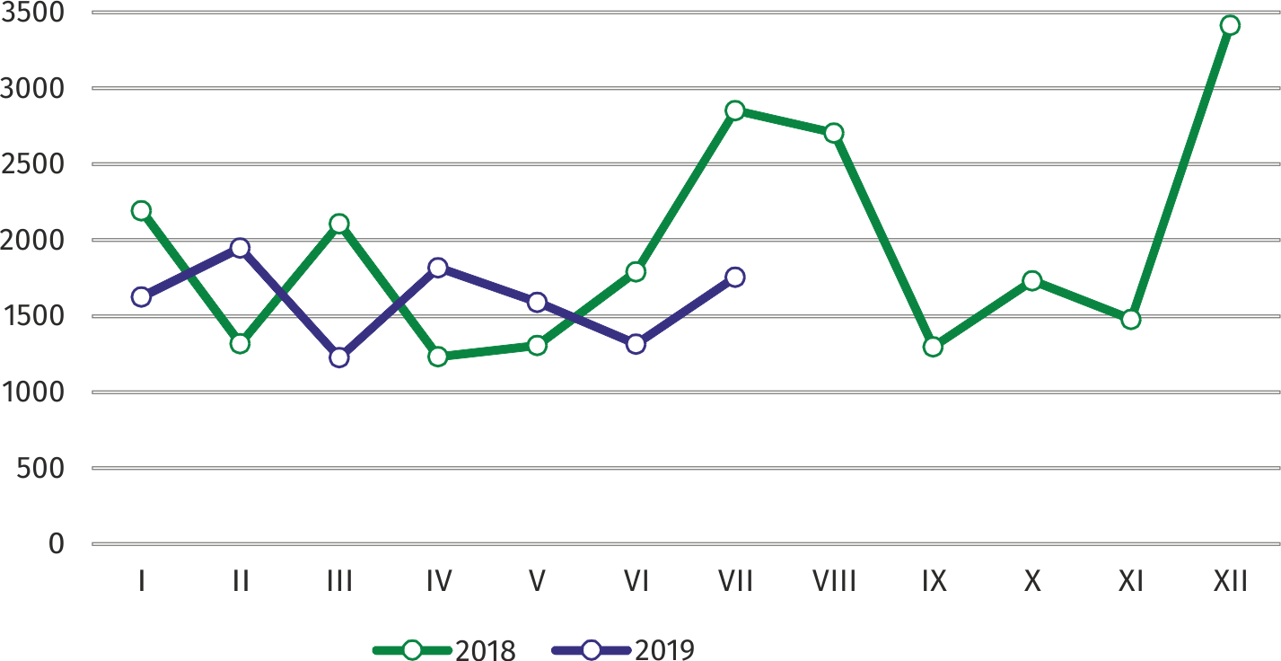Chart 4. Dwellings completed

In January–July 2019, the construction began in 12240 dwellings (by 14.9% less than in the corresponding period of 2018), of which: 11592 in construction for sale or rent, 351 in private construction, 215 in dwellings built by public building societies, 82 in cooperative construction.

In January–July 2019, the construction began in 12240 dwellings, i.e. by 14.9% less than in the corresponding period of the previous year

In January–July 2019, the number of dwellings for which permits have been granted or which have been registered with a construction project amounted to 12081 (by 15.9% less than in the corresponding period of 2018), of which 368 dwellings buildings built by private investors.

The average useful floor area of a dwelling completed in January–July 2019, amounted to 61.2 m2 and increased compared to the corresponding period of 2018 by 0.5 m2. In private construction, the average useful floor area of dwellings amounted to 177.0 m2 (by 22.1 m2 fewer than in the corresponding period of 2018), in construction for sale or rent — 56.8 m2 (as in the previous year), in cooperatives — 57.7 m2, in company construction — 34.1 m2.

|  |  |
| --- | --- |
| Prepared by:  **Mazovian Centre for Regional Surveys**  **Statistical Office in Warszawa**  **Małgorzata Bieńkowska**  **Joanna Podolska** Tel: +48 22 464 21 96, + 48 22 464 20 96**e-mail:** [**m.bienkowska@stat.gov.pl**](mailto:m.bienkowska@stat.gov.pl)**e-mail:** [**j.podolska@stat.gov.pl**](mailto:j.podolska@stat.gov.pl) | Issued by: **Statistical Information Centre** **Marcin Kałuski**Tel: +48 22 464 20 91**e-mail:** [**m.kaluski@stat.gov.pl**](mailto:m.kaluski@stat.gov.pl) |

|  |  |  |
| --- | --- | --- |
| Translated by:  **Agnieszka Gromek-Żukowska**  Tel: +48 22 464 22 42  **e-mail:** [**a.gromek-zukowska@stat.gov.pl**](mailto:a.gromek-zukowska@stat.gov.pl) |  |  |
| **Press office**  Tel.:+ 4822 464 20 91  **e-mail:** [**m.kaluski@stat.gov.pl**](mailto:m.kaluski@stat.gov.pl) |  |  |
|  | [warszawa.stat.gov.pl](https://warszawa.stat.gov.pl/)/en/  @[Warszawa](https://twitter.com/Warszawa_STAT)_STAT |
|  |  |
|  |  |



**Related information**

Communications and Announcements

**Data available in databases**

[Local Data Bank → Labour](https://bdl.stat.gov.pl/BDL/dane/podgrup/temat) market

**Terms used in official statistics**

[Registered unemployed persons](https://stat.gov.pl/en/metainformations/glossary/terms-used-in-official-statistics/2958,term.html)

[Registered unemployment rate](https://stat.gov.pl/en/metainformations/glossary/terms-used-in-official-statistics/2390,term.html)

[Average paid employment](https://stat.gov.pl/en/metainformations/glossary/terms-used-in-official-statistics/376,term.html)

[Average monthly gross wages and salaries](https://stat.gov.pl/en/metainformations/glossary/terms-used-in-official-statistics/693,term.html)

[Dwellings completed](https://stat.gov.pl/en/metainformations/glossary/terms-used-in-official-statistics/201,term.html)

[Gross turnover profitability rate](https://stat.gov.pl/metainformacje/slownik-pojec/pojecia-stosowane-w-statystyce-publicznej/587,pojecie.html)

[Net turnover profitability rate](https://stat.gov.pl/metainformacje/slownik-pojec/pojecia-stosowane-w-statystyce-publicznej/587,pojecie.html)

1. Reporting data – may change after preparing quarterly reports.