Statistics of Warszawa No. 9/2026
In September 2026, there was a decrease in the average employment and an increase in the number of unemployed persons compared to the corresponding period of previous year. Sold production of industry as well as construction and assembly production were higher than a year ago. Both retail and wholesale sales increased compared to the previous year. September 2026 was characterised by a significantly lower number of dwellings completed than a year earlier.

Average paid employment
Average paid employment in the enterprise sector in September 2026 amounted to 1106.9 thousand persons (converted into full-time equivalents) and was by 1.6 thousand persons, i.e. by 0.1% smaller than in August 2026, and by 7.4 thousand persons, i.e. by 0.7% smaller than in September 2025.
Compared to August 2026, the decrease in the average employment was recorded in the following sections: accommodation and catering (by 1.4%), transportation and storage (by 0.8%), construction (by 0.7%), industry (by 0.3%), trade; repair of motor vehicles (by 0.1%).
Whereas an increase in the average employment was recorded in the sections: professional, scientific and technical activities (by 0.8%), information and communication (by 0.4%), administrative and support service activities as well as real estate activities (by 0.1% each).

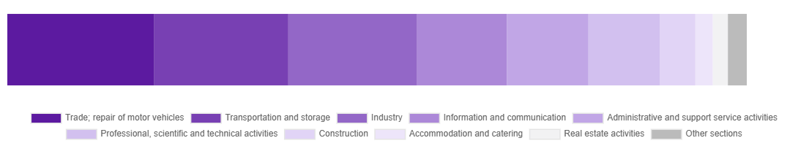
Chart 1. Structure of average paid employment by sections of PKD in September 2026

Compared to September 2025, a decrease in average employment was recorded in the sections: real estate activities (by 3.1%), accommodation and catering (by 3.1%), transportation and storage (by 2.0%), trade; repair of motor vehicles (by 1.7%), industry (by 0.9%), construction (by 0.5%).
An increase in average employment occurred in the sections: professional, scientific and technical activities (by 2.3%), information and communication (by 0.8%), administrative and support service activities (by 0.5%).

Registered unemployment*
At the end of September 2026, the number of registered unemployed persons amounted to 22639 and was by 649 persons, i.e. by 3.0% larger than at the end of August 2026 and by 1208 persons, i.e. by 5.6% larger than in the corresponding period of 2025.
The number of registered unemployed women amounted to 11051, which accounted for 48.8% of the total unemployed (49.0% a month before, and 47.9% a year before) and 19.2% of unemployed women in Mazowieckie Voivodship. As compared to August 2026, the number of unemployed women increased by 286 persons, i.e. by 2.7%, and compared to September 2025 it increased by 785 persons, i.e. by 7.6%.
The registered unemployment rate amounted to 1.7% (1.6% in the previous month and in the previous year), in Mazowieckie Voivodship it was 4.5% (as a month before and 4.4% a year before), while in the country at a level of 5.8% (as a month before and 5.6% a year before).
In September 2026, there were 3466 unemployed persons registered in labour offices (2870 in August 2026, and 2991 in September 2025). Registered unemployed persons accounted for 26.6% of the total registered unemployed in the Voivodship.
The number of persons registering for the first time amounted to 1345 (1128 a month before), which accounted for 38.8% of the total unemployed who registered in September 2026 and 28.8% of persons registering for the first time in the Voivodship. The share of persons terminated due to company reasons among unemployed persons registered in September 2026 amounted to 3.3% (4.2% in Mazowieckie Voivodship), 3.7% a month before and 4.0% a year before.
In September 2026, 2817 persons were removed from unemployment rolls (3059 in August 2026, and 3974 in September 2025), which accounted for 20.3% of unemployed persons removed from unemployment rolls in Mazowieckie Voivodship. Out of the unemployed removed from unemployment rolls, 1342 persons took up work. Moreover, 1115 persons lost their status of the unemployed as a result of not maintaining contact with the labour office at least once every 90 days. The reason for removing from the register was also starting training or traineeship, acquisition of retirement or pension rights, and others.

There were 19813 persons who were not entitled to the unemployment benefit, i.e. 87.5% of the total unemployed (18652 persons a year before, i.e. 87.0%), whereas 2826 unemployed persons were entitled to the unemployment benefit.
In September 2026, there were 1590 job offers* submitted to labour offices, which accounted for 40.4% of job offers in Mazowieckie Voivodship and at the end this month the labour offices had job offers for 1322 persons. At the end of September 2026, there were 17 persons per one job offer (15 in the previous month, 18 a year ago), while in Mazowieckie Voivodship, there were 27 persons (26 a month before, and 29 a year before) registered as unemployed.

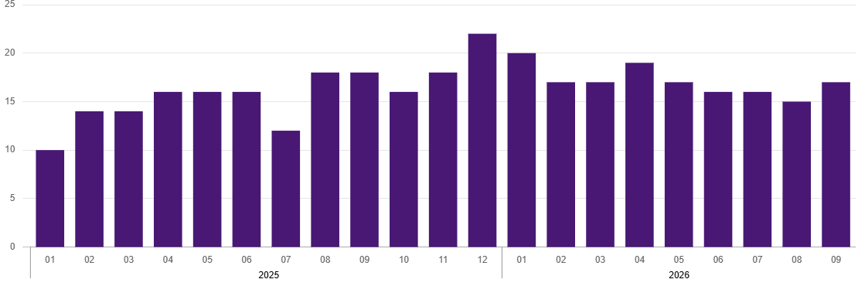
Chart 2. Number of unemployed persons per job offer (as of end of month)
* On 1 June 2025, the new Act on the Labour Market and Employment Services (Journal of Laws of 2025, item 620) entered into force, introducing changes to the rules for registering and recording unemployed persons. As a result, some published data has been adjusted to reflect the current legal status and statutory terminology, which may affect the comparability of current data with previous periods.
Wages and salaries
The average monthly gross wages and salaries in the enterprise sector in September 2026 amounted to PLN 11143.52 and were by 0.9% lower as compared to the previous month and by 6.6% higher than in the corresponding period of 2025.
Compared to August 2026, a decrease in the average gross wages and salaries was recorded in the following sections: information and communication (by 3.2%), trade; repair of motor vehicles as well as transportation and storage (by 1.3% each), administrative and support service activities (by 0.7%), real estate activities (by 0.3%).
Whereas an increase in the average gross wages and salaries was recorded in the sections: professional, scientific and technical activities (by 2.6%), industry (by 1.8%), accommodation and catering (by 0.4%).
Compared to September 2025, an increase in the average gross wages and salaries was recorded in the sections: trade; repair of motor vehicles and industry (by 7.3% each), professional, scientific and technical activities and information and communication (by 7.0% each), real estate activities (by 6.9%), accommodation and catering (by 5.9%), administrative and support service activities (by 5.5%), transportation and storage (by 4.9%), construction (by 3.7%).

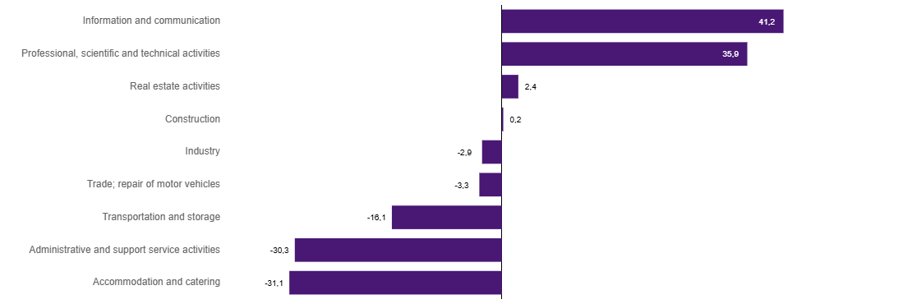
Chart 3. Relative deviations (in %) of monthly gross wages and salaries in selected sections from average wages and salaries in enterprise sector in Warszawa in September 2026

Construction
Sold production of construction in September 2026 amounted (at current prices) to PLN 6534.5 million and compared to August 2026 was larger by 9.6% and compared to the corresponding period of previous year it decreased by 7.6%.
In January-September 2026, sold production of construction reached the value of PLN 53255.4 million, i.e. by 3.2% smaller than in the corresponding period of 2025.
Construction and assembly production in September 2026 amounted to PLN 1778.3 million (at current prices) and accounted for 27.2% of sold production of construction. Compared to the previous month, construction and assembly production increased by 4.0%, and compared to September 2025 it was larger by 2.2%.
In January-September 2026, construction and assembly production amounted to PLN 13244.8 million and accounted for 24.9% of sold production of construction (23.1% a year before). Compared to the corresponding period of previous year, construction and assembly production was larger by 4.3%.
An increase in production in relation to the corresponding period of 2025 occurred in units dealing with civil engineering (by 11.1%) and construction of buildings (by 1.3%), while a decrease in production was recorded in specialised construction activities (by 4.2%).
Labour productivity measured by production per employed person in construction in September 2026 amounted to PLN 123.3 thousand and was by 10.3% higher than a month before and by 7.1% lower than in September 2025.

Trade
Retail sales in trade and non-trade enterprises in September 2026 (at current prices) were by 0.6% smaller than in August 2026 and by 10.8% higher compared to September 2025.
Compared to August 2026, there was a decline in sales of newspapers, books, other retail sales in specialised stores (by 9.4%), sales of food, beverages and tobacco (by 6.1%), sales of solid, liquid and gas fuels (by 3.6%), sales of furniture, electronic goods and household equipment (by 1.7%), and sales of textiles, clothing and footwear (by 1.0%).
Whereas an increase was recorded in sales of motor vehicles, motorcycles, parts (by 13.1%), other retail sales in non-specialised stores (by 9.2%), sales in the “others” group (by 5.2%), and sales of pharmaceuticals, cosmetics, orthopaedic equipment (by 3.2%).
Compared to September 2025, there was an increase, among others, in: sales of solid, liquid and gas fuels (by 27.5%), sales in the “0thers” group (by 20.7%), other retail sales in non-specialised stores (by 16.5%).
While a decrease was recorded in sales of motor vehicles, motorcycles, parts, (by 4.4%), sales of food, beverages and tobacco (by 2.0%).
In January-September 2026, retail sales increased by 5.8% compared to the corresponding period of 2025.
Wholesale in trade enterprises in September 2026 (at current prices) was by 21.8% higher as compared to the previous month and by 13.4% higher than in September 2025, and in wholesale enterprises it was higher by 19.6% and by 12.8%, respectively.
In January-September 2026, retail units achieved wholesale that was 12.8% higher than a year ago, while wholesale enterprises achieved wholesale that was 13.1% higher.

Industry
The sold production of industry in September 2026 amounted to (in current prices) PLN 17037.9 million and was (at constant prices) larger than in the corresponding month of 2025 by 6.5%. As compared to September 2025, an increase in sold production of industry was recorded in manufacturing by 7.1%.
In the period January-September 2026, sold production of industry amounted to PLN 144027.2 million (at current prices) and was (at constant prices) higher by 5.6% than that achieved in the same period of 2025. In manufacturing, an increase in production by 5.9% was recorded.
Among the divisions classified as manufacturing, the increase in sales was recorded, among others, in: manufacture of textiles (by 115.9%), manufacture of beverages (by 45.8%), repair and installation of machinery and equipment (by 29.2%), manufacture of computer, electronic and optical products (by 26.9%), manufacture of basic metals (by 17.5%), manufacture of furniture (by 10.0%), other manufacturing (by 9.0%), manufacture of pharmaceutical products (by 6.2%), manufacture of food products (by 5.4%), manufacture of machinery and equipment n.e.c. (by 3.7%), manufacture of paper and paper products (by 1.5%), manufacture of chemicals and chemical products (by 1.2%), manufacture of motor vehicles, trailers and semi-trailers (by 0.9%), manufacture of other non-metallic mineral products (by 0.1%).
The decrease in sales was recorded, among others, in: manufacture of wearing apparel (by 24.8%), manufacture of products of wood, cork, straw and wicker (by 20.4%), manufacture of metal products (by 13.3%), manufacture of electrical equipment (by 10.8%), printing and reproduction of recorded media (by 6.4%), manufacture of coke and refined petroleum products (by 1.4%), manufacture of rubber and plastics (by 0.4%).
Labour productivity in industry measured by production per employed person, in January-September 2026 amounted to PLN 746.8 thousand (at current prices) and was – at constant prices – by 6.7% higher than in the previous year.
Residential construction
According to preliminary data, 896 dwellings were completed in Warszawa in September 2026, i.e. by 47.6% less than in the previous year.
In the period January-September 2026, 11353 dwellings were completed (by 12.4% less than in the corresponding period of 2025), and 29324 dwellings in Mazowieckie Voivodship, i.e. 4.9% less than in January-September 2025. The number of completed dwellings decreased in cooperative construction from 260 to 48, i.e., 81.5% less, in construction intended for sale or rent from 11993 to 10493, i.e., 12.5% less. Meanwhile, there was an increase in public building societies from 239 to 245, i.e., 2.5% more, in private construction from 462 to 467, i.e. by 1.1% more. Furthermore, 100 dwellings were completed in company construction between January and September 2026.
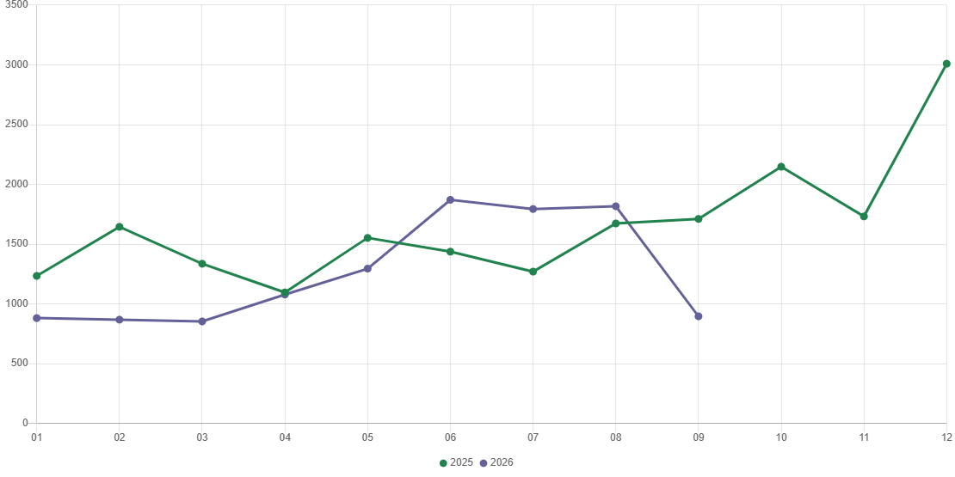
Chart 4. Dwellings completed
In January-September 2026, construction begun in 10593 dwellings (by 3.8% more than in the corresponding period of 2025) of which: 10191 in construction for sale or rent, 402 in private construction.
In January-September 2026, the number of dwellings for which permits have been granted or which have been registered with a construction project amounted to 11215 (by 4.9% more than in the corresponding period of 2025), of which 354 dwellings in buildings built by private investors.
The average useful floor area of a dwelling completed in January-September 2026, amounted to 61.1 m² and decreased by 0.4 m² compared to the corresponding period of 2025. In private construction, the average useful floor area of dwellings amounted to 146.8 m² (by 34.6 m² less than in the corresponding period of 2025), in cooperative construction – 62.2 m² (by 9.0 m² more), in construction for sale or rent – 57.9 m² (by 0.5 m² more) in public building societies – 46.1 m² (by 1.9 m² less), in company construction – 35.8 m².

Entities of the national economy
At the end of September 2026, there were 613502 entities of the national economy registered in the REGON register in Warszawa, which accounted for 55.0% of the total in Mazowieckie Voivodship. Compared with August 2026, the number of entities of the national economy increased by 1517 (i.e. by 0.2%), and compared to September 2025 increased by 19880 (i.e. by 3.3%).
As of the end of September this year, there were 277755 legal persons and organisational units without legal personality registered in the REGON register, of which 202190 commercial companies. The number of these entities increased by 0.3% and 0.4%, respectively, compared to the previous month, by 3.8% and 4.5%, respectively, on an annual basis.
The number of registered natural persons conducting economic activity as of the end of September 2026 amounted to 335747 and compared to August 2026 it was higher by 0.2%, and compared to the corresponding period of the previous year increased by 3.0%.
In Warszawa, in September 2026, the most numerous were entities dealing with: professional, scientific and technical activities (19.4% of total registered units), trade; repair of motor vehicles (15.4%), as well as information and communication (13.1%).
Compared to August 2026, the number of entities increased, among others, in the sections: education (by 0.7%), public administration and defence; compulsory social security and arts, entertainment and recreation (by 0.6% each), human health and social work activities (by 0.4%), mining and quarrying, water supply; sewerage, waste management and remediation activities, real estate activities, construction, information and communication, professional, scientific and technical activities (by 0.3% each). However there was a decrease in the number of entities in the section of agruculture, forestry and fishing (by 0.2%).
Compared to September 2025, the largest increase in the number of entities was recorded, among others, in the sections: administrative and support service activities (by 7.5%), human health and social work activities (by 6.0%), education (by 5.5%), electricity, gas, steam and air conditioning supply (by 5.1%), construction (by 4.8%), information and communication (by 4.2%). Whereas a decrease in the number of entities was noted in the sections: mining and quarrying (by 2.1%), water supply; sewerage, waste management and remediation activities (by 1.0%), agriculture, forestry and fishing (by 0.4%), trade; repair of motor vehicles (by 0.1%).
In September 2026, 3485 new entities were entered into the REGON register, i.e. by 14.4% more than in the previous month. The newly registered entities were dominated by natural persons conducting economic activity – 1912 (by 20.0% more than in August 2026). The number of newly registered commercial companies was higher compared to the previous month by 6.5%, including limited liability companies – higher by 5.8%.

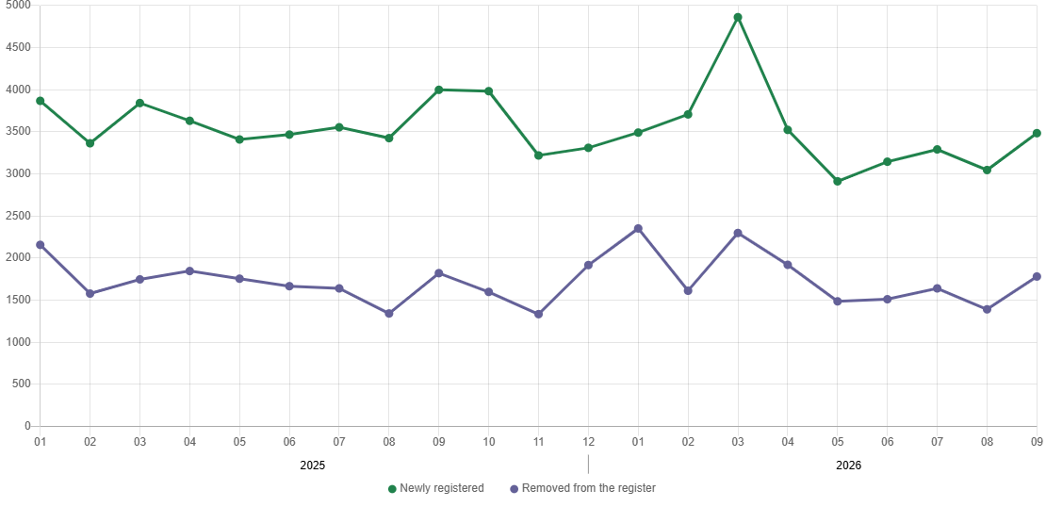
Chart 5. Entities newly registered and removed from the register

In September 2026, 1782 entities were removed from the REGON register (compared to 1392 in the previous month), including 1061 natural persons conducting economic activity (by 22.4% more).
As of the end of September 2026, 79008 entities had suspended activity in the REGON register (by 1.2% less than a month before). The vast majority were natural persons conducting economic activity (90.7%).

When quoting this publication, please provide its title and indicate the Statistical Office in Warszawa as the author. When publishing your own calculations based on data from this publication, please include the following statement: Author’s work based on data from the publication entitled ‘Statistics of Warszawa No. 9/2026’ by the Statistical Office in Warszawa.

Prepared by:  Statistical Office in Warszawa  Director Agnieszka Ajdyn  Phone: (+48 22) 464 23 15 | Issued by:  Mazovian Centre for Regional Surveys  Information Centre  Mobile: (+48) 783 940 141
Press office in the Statistical Office in Warszawa  Mobile: (+48) 783 940 141  e-mail: m.kaluski@stat.gov.pl |   warszawa.stat.gov.pl/en/

@Warszawa_STAT

@UrzadStatystycznywWarszawie

gus_stat

glownyurzadstatystycznygus

glownyurzadstatystyczny

Related information
Communications and Announcements
Data available in databases
Local Data Bank → Labour market
Terms used in official statistics
Registered unemployed persons
Registered unemployment rate
Average paid employment
Average monthly gross wages and salaries
Dwellings completed

