Statistics of Warszawa No. 10/2025
In October 2025, there was a decrease in the average employment and an increase in the number of unemployed persons compared to the corresponding period of previous year. Both sold production of industry and construction and assembly production were higher than in the previous year. Retail sales slightly increased while wholesale decreased compared to the previous year. October was characterised by a significantly higher number of dwellings completed than a year earlier.

Average paid employment
Average paid employment in the enterprise sector in October 2025 amounted to 1110.2 thousand persons (converted into full-time equivalents) and was by 4.1 thousand persons, i.e. by 0.4% smaller than in September 2025, and by 10.9 thousand persons, i.e. by 1.0% smaller than in October 2024.
Compared to September 2025, the decrease in the average employment was recorded in the following sections: industry (by 2.0%), accommodation and catering (by 1.4%), real estate activities (by 0.3%), administrative and support service activities (by 0.2%), trade; repair of motor vehicles and transportation and storage (by 0.1% each).

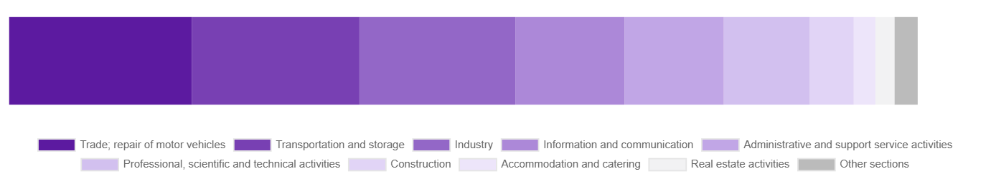
Chart 1. Structure of average paid employment by sections of PKD in October 2025

While an increase in the average employment was recorded in the sections: construction (by 0.9%) and professional, scientific and technical activities (by 0.4%).
Compared to October 2024, a decrease in average employment was recorded in the sections: accommodation and catering (by 6.6%), trade; repair of motor vehicles (by 5.3%), transportation and storage (by 4.9%), administrative and support service activities (by 1.2%).
An increase in average employment occurred in the sections: real estate activities (by 15.5%), professional, scientific and technical activities (by 6.7%), industry (by 2.2%), construction (by 1.8%), information and communication (by 0.3%).

Registered unemployment
At the end of October 2025, the number of registered unemployed persons amounted to 21535 and was by 104 persons, i.e. by 0.5% larger than at the end of September 2025 and by 2589 persons, i.e. by 13.7% larger than in the corresponding period of 2024.
The number of registered unemployed women amounted to 10335, which accounted for 48.0% of the total unemployed (47.9% a month and 47.5% a year before) and 18.4% of unemployed women in Mazowieckie Voivodship. As compared to September 2025, the number of unemployed women increased by 69 persons, i.e. by 0.7% and compared to October 2024 increased by 1332 persons, i.e. by 14.8%.
The registered unemployment rate amounted to 1.6% (as in the previous month and 1.4% in the previous year), in Mazowieckie Voivodship it was 4.4% (as a month before and 4.0% a year before), while in the country at a level of 5.6% (as a month before and 4.9% a year before).
In October 2025, there were 3107 unemployed persons registered in labour offices (2991 in September 2025, and 2841 in October 2024). Registered unemployed persons accounted for 22.3% of the total registered unemployed in the Voivodship.
The number of persons registering for the first time amounted to 1366 (1323 a month before), which accounted for 44.0% of the total unemployed who registered in October 2025 and 29.9% of persons registering for the first time in the Voivodship. The share of persons terminated due to company reasons among unemployed persons registered in October 2025 amounted to 3.6% (3.8% in Mazowieckie Voivodship), 4.0% a month before and 3.0% a year before.
In October 2025, 3003 persons were removed from unemployment rolls (3974 in September 2025, and 2825 in October 2024), which accounted for 20.3% of unemployed persons removed from unemployment rolls in Mazowieckie Voivodship. Out of the unemployed removed from unemployment rolls, 1682 persons took up work. Moreover, 865 persons lost their status of the unemployed as a result of not confirming their readiness to take up work. The reason for removing from the register was also starting training or traineeship, acquisition of retirement or pension rights, and others.

There were 18834 persons who were not entitled to the unemployment benefit, i.e. 87.5% of the total unemployed (16353 persons a year before, i.e. 86.3%), whereas 2701 unemployed persons were entitled to the unemployment benefit.

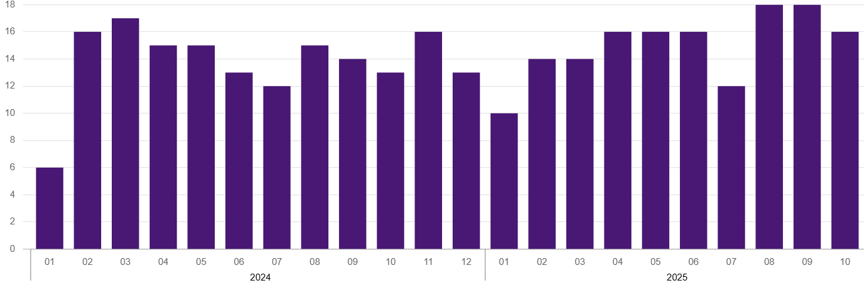
Chart 2. Number of unemployed persons per job offer (as of end of month)

In October 2025, there were 1674 job offers submitted to labour offices, which accounted for 33.6% of job offers in Mazowieckie Voivodship and at the end this month the labour offices had job offers for 1323 persons. At the end of October 2025, there were 16 persons per one job offer (18 in the previous month and 13 in the previous year), while in Mazowieckie Voivodship, there were 27 persons registered as unemployed (29 a month berore and 14 a year before).
Wages and salaries
The average monthly gross wages and salaries in the enterprise sector in October 2025 amounted to PLN 10606.89 and were by 1.5% higher as compared to the previous month and by 4.3% higher than in the corresponding period of 2024.
Compared to September 2025, an increase in the average gross wages and salaries was recorded in the following sections: construction (by 10.5%), trade; repair of motor vehicles (by 2.6%), real estate activities and accommodation and catering (by 2.5% each), administrative and support service activities (by 1.8%), transportation and storage (by 1.4%), information and communication (by 1.0%), industry (by 0.2%).
Whereas a decrease in the average wages and salaries was recorded in the sections of professional, scientific and technical activities (by 3.3%).
Compared to October 2024, an increase in the average gross wages and salaries was recorded in the sections: information and communication (by 8.5%), accommodation and catering (by 8.1%), industry (by 7.5%), administrative and support service activities (by 7.4%), professional, scientific and technical activities (by 6.8%), construction (by 6.2%), trade; repair of motor vehicles (by 3.6%), real estate activities (by 0.2%).
Whereas a decrease in the average gross wages and salaries was recorded in the section of transportation and storage (by 7.4%).

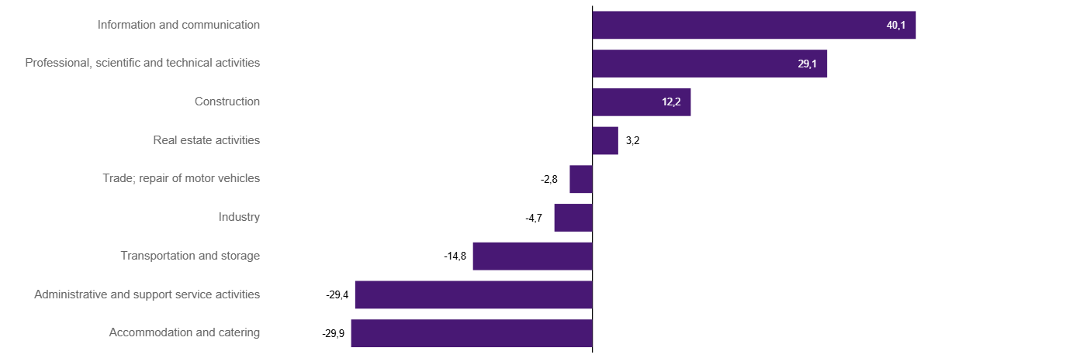
Chart 3. Relative deviations (in %) of monthly gross wages and salaries in selected sections from average wages and salaries in enterprise sector in Warszawa in October 2025

Construction
Sold production of construction in October 2025 amounted (at current prices) to PLN 6631.6 million and compared to September 2025 was smaller by 6.2% and compared to the corresponding period of the previous year it increased by 4.7%.
In January-October 2025, the sold production of construction reached the value of PLN 63130.5 million, i.e. by 9.4% larger than in the corresponding period of 2024.
Construction and assembly production in October 2025 amounted to PLN 1763.2 million (at current prices) and accounted for 26.6% of sold production of construction. Compared to the previous month, construction and assembly production increased by 1.4%, and compared to October 2024 it was larger by 21.9%.
In the period January–October 2025, construction and assembly production amounted to PLN 14691.4 million and accounted for 23.3% of the sold construction production (21.1% a year earlier). Compared to the same period last year, construction and assembly production was higher by 20.4%.
The increase in production in relation to the corresponding period of 2024 occurred in units dealing with: specialised construction activities (by 59.9%), and construction of buildings (by 57.5%), while a decrease in units dealing with civil engineering (by 9.9%).
Labour productivity measured by production per employed person in construction in October 2025 amounted to PLN 123.4 thousand and was by 7.0% lower than a month before and by 2.8% higher than in October 2024.

Trade
Retail sales in trade and non-trade enterprises in October 2025 (at current prices) were by 6.3% larger than in September 2025 and by 0.1% higher compared to October 2024.
Compared to September 2025, the increase was recorded in sales of textiles, clothing and footwear (by 19.8%), sales in the “other” group (by 14.8%), sales of food, beverages and tobacco (by 7.9%) sales of pharmaceuticals, cosmetics, orthopedic equipment (by 5.0%), other retail sales in non-specialised stores (by 4.2%), sales of press, books, other retail sales in specialised stores (by 3.0%), sales of solid, liquid and gas fuels (by 2.5%), sales of furniture, electronic goods and household equipment (by 2.0%), sales of motor vehicles, motorcycles, parts (by 1.4%).
Compared to October 2024, there was increase in sales in the „other” group (by 13.9%), sales of textiles, clothing and footwear (by 10.2%), sales of press, books, other sales in specialised stores (by 9.3%), sales of food, beverages and tobacco (by 5.1%), other retail sales in non-specialised stores (by 2.9%).
However, there was a decrease in sales of motor vehicles, motorcycles, parts (by 10.4%), sales of furniture, electronic goods and household equipment (by 3.2%), sales of pharmaceuticals, cosmetics, orthopedic equipment (by 1.9%), sales of solid, liquid and gas fuels (by 1.9%).
In the period January-October 2025 compared to the same period in 2024, retail sales decreased by 0.4%.
Wholesale in trade enterprises in October 2025 (at current prices) was by 9.6% larger as compared to the previous month and by 0.2% lower than in October 2024, and in wholesale enterprises it was higher by 3.3% and lower by 6.3%, respectively.
In the period January–October 2025, retail units achieved wholesale sales that were 5.9% lower than a year ago, while wholesale enterprises by 5.7% lower.

Industry
The sold production of industry in October 2025 amounted to (in current prices) PLN 16597.2 million and was (at constant prices) larger than in the corresponding month of 2024 by 5.7%. As compared to October 2024, an increase in sold production of industry was recorded in manufacturing by 6.3%.
In the period January-October 2025, sold production of industry amounted to PLN 154245.8 million (at current prices) and was (at constant prices) higher by 5.1% than that achieved in the same period of 2024. In manufacturing, an increase in production by 5.7% was recorded.
Among the divisions classified as manufacturing, the increase in sales was recorded, among others, in: manufacture of motor vehicles, trailers and semi-trailers (by 130.9%), manufacture of furniture (by 28.3%), manufacture of wearing apparel (by 24.7%), manufacture of products of wood, cork, straw and wicker (by 18.4%), manufacture of metal products (by 16.8%), manufacture of machinery and equipment n.e.c. (by 15.2%), manufacture of rubber and plastics (by 11.3%), manufacture of electrical equipment (by 6.6%), manufacture of food products (by 5.7%), manufacture of other non-metallic mineral products (by 5.4%), manufacture of pharmaceutical products (by 4.6%), manufacture of chemicals and chemical products (by 4.2%), printing and reproduction of recorded media (by 2.1%), manufacture of paper and paper products (by 1.6%), manufacture of basic metals (by 1.1%).
The decrease in sales was recorded, among others, in: manufacture of textiles products (by 19.3%), repair and installation of machinery and equipment (by 17.8%), manufacture of coke and refined petroleum products (by 17.5%), manufacture of computer, electronic and optical products (by 8.5%), other manufacturing (by 3.9%), manufacture of beverages (by 0.5%).
Labour productivity in industry measured by production per employed person, in January-October 2025 amounted to PLN 793.6 thousand (at current prices) and was – at constant prices – by 1.5% higher than in the previous year.

Residential construction
According to preliminary data, 2213 dwellings were completed in Warszawa in October 2025, i.e. by 124.7% more than in the previous year.
In the period January-October 2025, 14901 dwellings were completed (by 36.7% more than in the corresponding period of 2024), and 35079 dwellings in Mazowieckie Voivodship, i.e. by 16.2% more than in January-October 2024. An increase in the number of dwellings was recorded in construction for sale or rent from 10379 to 13879, i.e. by 33.7% more, in private construction from 453 to 517, i.e. by 14.1% more. Moreover, 264 dwellings were completed in cooperative construction, and 241 dwellings were completed by private buildings society in the period January-October 2025.

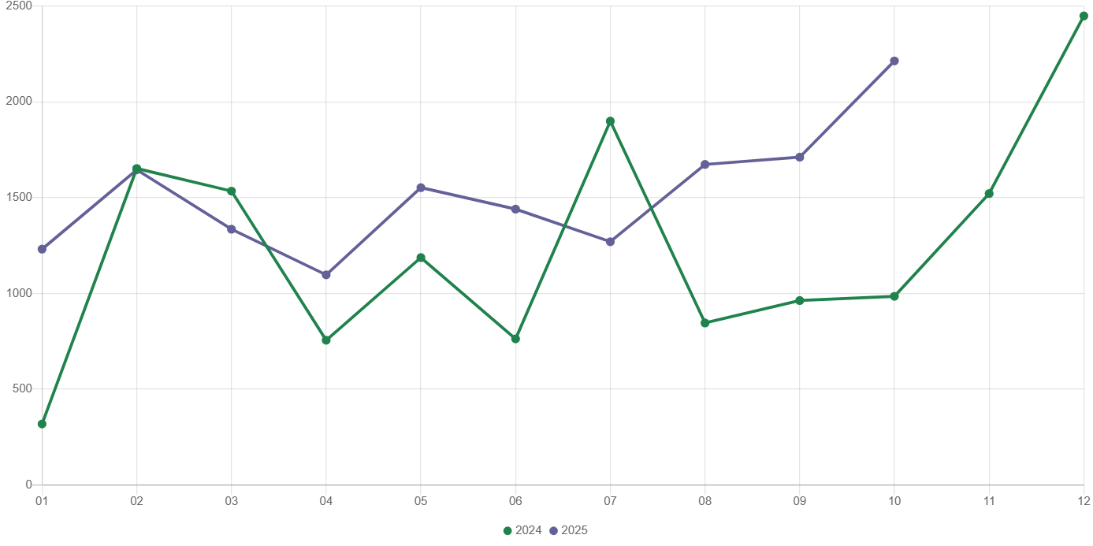
Chart 4. Dwellings completed
In January-October 2025, construction begun in 12217 dwellings (by 10.1% less than in the corresponding period of 2024) of which: 11793 in construction for sale or rent, 424 in private construction.
In January-October 2025, the number of dwellings for which permits have been granted or which have been registered with a construction project amounted to 12327 (by 28.5% less than in the corresponding period of 2024), of which 397 dwellings in buildings built by private investors.
The average useful floor area of a dwelling completed in January-October 2025, amounted to 60.7 m² and decreased compared to the corresponding period of 2024 by 4.0 m². In private construction, the average useful floor area of dwellings amounted to 178.0 m² (by 4.5 m² less than in the corresponding period of 2024), in construction for sale or rent – 56.7 m² (by 3.0 m² less), in cooperative construction — 52.4 m² , in dwellings built by public building society – 47.6 m².

Entities of the national economy
At the end of October 2025, there were 595914 entities of the national economy registered in the REGON register in Warszawa, which accounted for 54.9% of the total in Mazowieckie Voivodship. Compared with September 2025, the number of entities of the national economy increased by 2292 (i.e. by 0.4%), and compared to October 2024 increased by 22132 (i.e. by 3.9%).
As of the end of October this year, there were 268424 legal persons and organisational units without legal personality registered in the REGON register, of which 194246 commercial companies. The number of these entities increased by 0.3% and 0.4%, respectively compared to the previous month, and on an annual basis by 3.6% and 4.3%, respectively.
The number of registered natural persons conducting economic activity as of the end of October 2025 amounted to 327490 and compared to September 2025 it was higher by 0.4%, and compared to the corresponding period of the previous year increased by 4.0%.
In Warszawa, in October 2025, the most numerous were entities dealing with: professional, scientific and technical activities (19.4% of total registered units), trade; repair of motor vehicles (15.9%), as well as information and communication (13.0%).
Compared to September 2025, the number of entities increased, among others, in the sections: human health and social work activities (by 0.9%), administrative and support service activities (by 0.8%), education and information and communication (by 0.6% each), electricity, gas, steam and air conditioning supply and construction (by 0.5% each), financial and insurance activities, real estate activities and professional, scientific and technical activities (by 0.4% each). However there was a decrease in the number of entities in the sections: mining and quarrying and agriculture, forestry and fishing (by 0.8% each), water supply; sewerage, waste management and remediation activities (by 0.5%).
Compared to October 2024, the largest increase in the number of entities was recorded in the sections: administrative and support service activities (by 10.6%), human health and social work activities (by 7.4%), electricity, gas, steam and air conditioning supply (by 6.6%), education (by 6.1%), construction (by 5.6%), information and communication (by 5.2%). Whereas a decrease was noted in the sections: trade; repair of motor vehicles (by 0.6%), water supply; sewerage, waste management and remediation activities (by 0.4%).
In October 2025, 3984 new entities were entered into the REGON register, i.e. by 0.4% less than in the previous month. The newly registered entities were dominated by natural persons conducting economic activity – 2565 (by 0.3% less than in September 2025). The number of newly registered commercial companies was smaller compared to the previous month by 0.9%, including limited liability companies – less by 1.2%.
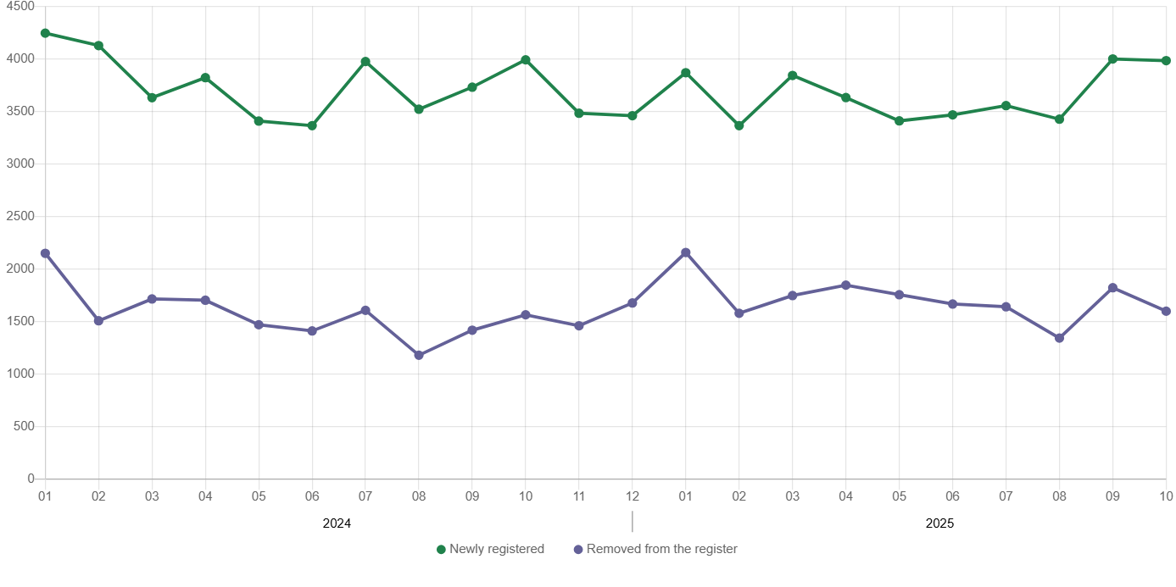
Chart 5. Entities newly registered and removed from the register

In October 2025, 1599 entities were removed from the REGON register (compared to 1822 in the previous month), including 1097 natural persons conducting economic activity (by 2.9% less).
As of the end of October 2025, 71679 entities had suspended activity in the REGON register (by 0.6% more than a month before). The vast majority were natural persons conducting economic activity (91.2%).

When quoting Statistics Poland data, please provide the information: “Source of data: Statistics Poland”, and when publishing calculations made on data published by Statistics Poland, please include the following disclaimer: “Own study based on figures from Statistics Poland”.
Prepared by:  Statistical Office in Warszawa  Director Agnieszka Ajdyn  Phone: (+48 22) 464 23 15 | Issued by:  Statistical Information Centre  Marcin Kałuski  Mobile: (+48) 783 940 141

warszawa.stat.gov.pl/en/

@Warszawa_STAT

@UrzadStatystycznywWarszawie

gus_stat

glownyurzadstatystycznygus

glownyurzadstatystyczny

Related information
Communications and Announcements
Data available in databases
Local Data Bank → Labour market
Terms used in official statistics
Registered unemployed persons
Registered unemployment rate
Average paid employment
Average monthly gross wages and salaries
Dwellings completed

