Statistics of Warszawa No. 9/2025
In September 2025, there was a decrease in the average employment and an increase in the number of unemployed persons compared to the corresponding period of previous year. Both sold production of industry and construction and assembly production were higher than in the previous year. Retail and wholesale sales were higher than a year earlier. September was characterised by a higher number of dwellings completed than a year earlier.

Average paid employment
Average paid employment in the enterprise sector in September 2025 amounted to 1114.3 thousand persons (converted into full-time equivalents) and was by 0.1 thousand persons, i.e. by 0.01% larger than in August 2025, and by 10.4 thousand persons, i.e. by 0.9% smaller than in September 2024.
Compared to August 2025, an increase in the average employment was recorded in the following sections: administrative and support service activities (by 0.6%), real estate activities (by 0.3%), professional, scientific and technical activities, information and communication and industry (by 0.1% each).

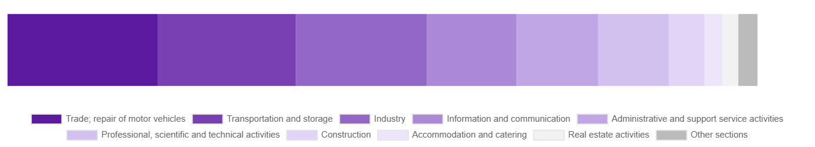
Chart 1. Structure of average paid employment by sections of PKD in September 2025

While a decrease in the average employment was recorded in the following sections: accommodation and catering (by 1.6%), construction and trade; repair of motor vehicles (by 0.2% each).
Compared to September 2024, a decrease in average employment was recorded in the sections: accommodation and catering (by 5.8%), trade; repair of motor vehicles (by 5.5%), transportation and storage (by 5.3%), administrative and support service activities (by 0.5%).
An increase in average employment occurred in the sections: real estate activities (by 16.0%), industry (by 4.3%), professional, scientific and technical activities (by 3.4%), construction (by 1.0%), information and communication (by 0.5%).

Registered unemployment
At the end of September 2025, the number of registered unemployed persons amounted to 21431 and was by 983 persons, i.e. by 4.4% smaller than at the end of August 2025 and by 2501 persons, i.e. by 13.2% larger than in the corresponding period of 2024.
The number of registered unemployed women amounted to 10266, which accounted for 47.9% of the total unemployed (47.3% a month and 47.7% a year before) and 18.1% of unemployed women in Mazowieckie Voivodship. As compared to August 2025, the number of unemployed women decreased by 344 persons, i.e. by 3.2% and compared to September 2024 increased by 1244 persons, i.e. by 13.8%.
The registered unemployment rate amounted to 1.6% (1.7% in the previous month and 1.4% in the previous year), in Mazowieckie Voivodship it was 4.4% (as a month before and 4.0% a year before), while in the country at a level of 5.6% (5.5% a month before and 5.0% a year before).
In September 2025, there were 2991 unemployed persons registered in labour offices (2686 in August 2025, and 2535 in September 2024). Registered unemployed persons accounted for 20.3% of the total registered unemployed in the Voivodship.
The number of persons registering for the first time amounted to 1323 (1132 a month before), which accounted for 44.2% of the total unemployed who registered in September 2025 and 26.3% of persons registering for the first time in the Voivodship. The share of persons terminated due to company reasons among unemployed persons registered in September 2025 amounted to 4.0% (3.8% in Mazowieckie Voivodship), 4.0% a month before and 1.6% a year before.
In September 2025, 3974 persons were removed from unemployment rolls (1433 in August 2025, and 2832 in September 2024), which accounted for 25.9% of unemployed persons removed from unemployment rolls in Mazowieckie Voivodship. Out of the unemployed removed from unemployment rolls, 1494 persons took up work. Moreover, 2048 persons lost their status of the unemployed as a result of not confirming their readiness to take up work. The reason for removing from the register was also starting training or traineeship, acquisition of retirement or pension rights, and others.

There were 18652 persons who were not entitled to the unemployment benefit, i.e. 87.0% of the total unemployed (16416 persons a year before, i.e. 86.7%), whereas 2779 unemployed persons were entitled to the unemployment benefit.

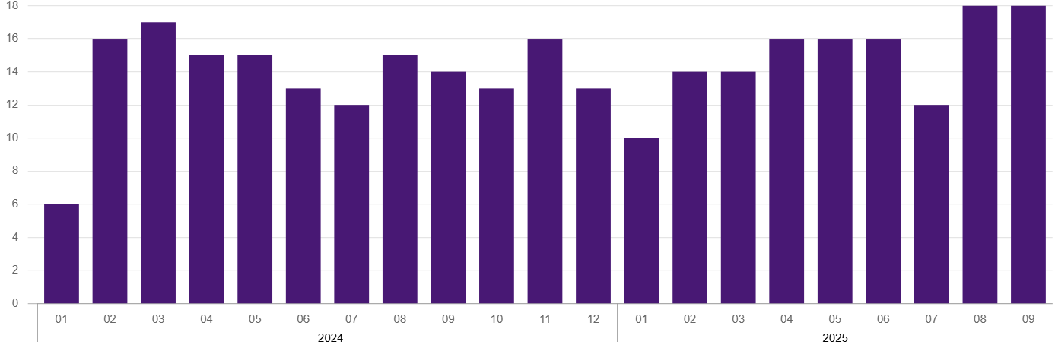
Chart 2. Number of unemployed persons per job offer (as of end of month)

In September 2025, there were 1568 job offers submitted to labour offices, which accounted for 31.2% of job offers in Mazowieckie Voivodship and at the end this month the labour offices had job offers for 1199 persons. At the end of September 2025, there were 18 persons per one job offer (as in the previous month and 14 in the previous year), while in Mazowieckie Voivodship, there were 29 persons registered as unemployed (30 a month berore and 14 a year before).
Wages and salaries
The average monthly gross wages and salaries in the enterprise sector in September 2025 amounted to PLN 10454.16 and were by 0.5% lower as compared to the previous month and by 7.7% higher than in the corresponding period of 2024.
Compared to August 2025, a decrease in the average gross wages and salaries was recorded in the following sections: administrative and support service activities (by 2.4%), trade; repair of motor vehicles and accommodation and catering (by 1.7% each), information and communication (by 1.3%), construction and transportation and storage (by 0.3% each), real estate activities (by 0.2%).
Whereas an increase in the average wages and salaries was recorded in the sections: professional, scientific and technical activities (by 3.6%) and industry (by 2.0%).
Compared to September 2024, an increase in the average gross wages and salaries was recorded in the sections: construction, transportation and storage, professional, scientific and technical activities and industry (by 8.6% each), information and communication (by 7.6%), administrative and support service activities (by 6.3%), accommodation and catering (by 6.3%), trade; repair of motor vehicles (by 4.6%), real estate activities (by 0.7%).

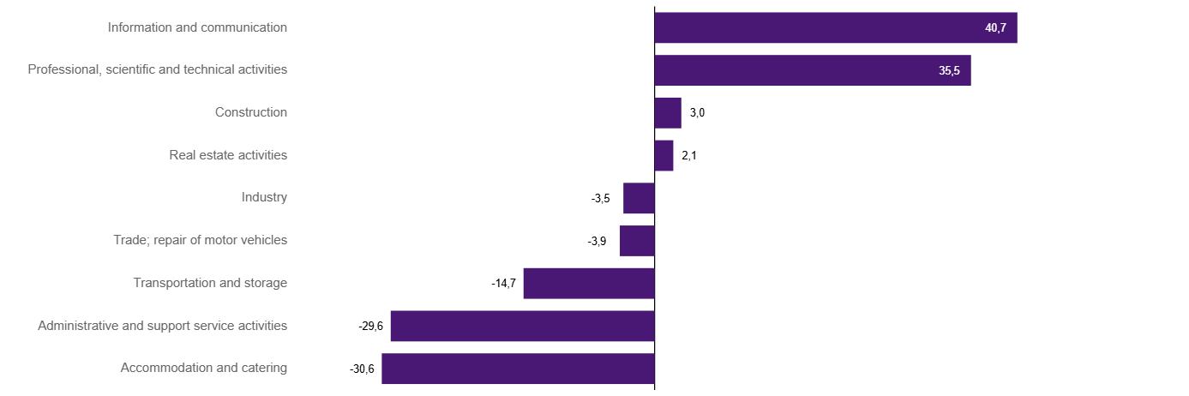
Chart 3. Relative deviations (in %) of monthly gross wages and salaries in selected sections from average wages and salaries in enterprise sector in Warszawa in September 2025

Construction
Sold production of construction in September 2025 amounted (at current prices) to PLN 7068.9 million and compared to August 2025 was larger by 14.2% and compared to the corresponding period of the previous year it increased by 21.3%.
In January-September 2025, the sold production of construction reached the value of PLN 54999.3 million, i.e. by 9.6% larger than in the corresponding period of 2024.
Construction and assembly production in September 2025 amounted to PLN 1739.3 million (at current prices) and accounted for 24.6% of sold production of construction. Compared to the previous month, construction and assembly production increased by 16.5%, and compared to September 2024 it was larger by 24.9%.
In the period January–September 2025, construction and assembly production amounted to PLN 12701.1 million and accounted for 23.1% of the sold construction production (21.5% a year earlier). Compared to the same period last year, construction and assembly production was higher by 17.8%.
The increase in production in relation to the corresponding period of 2024 occurred in units dealing with: specialised construction activities (by 50.3%), and construction of buildings (by 48.4%), while a decrease in units dealing with civil engineering (by 7.8%).
Labour productivity measured by production per employed person in construction in September 2025 amounted to PLN 132.7 thousand and was by 14.4% higher than a month before and by 20.1% higher than in September 2024.

Trade
Retail sales in trade and non-trade enterprises in September 2025 (at current prices) were by 2.5% smaller than in August 2025 and by 0.7% higher compared to September 2024.
Compared to August 2025, the decrease was recorded in sales of press, books, other retail sales in specialised stores (by 11.0%), sales of food, beverages and tobacco (by 7.5%), sales of furniture, electronic goods and household equipment (by 5.8%), sales of textiles, clothing and footwear (by 4.5%), and sales of solid, liquid and gas fuels (by 4.4%).
However, there was an increase in retail sales in non-specialised stores (by 16.7%), sales of motor vehicles, motorcycles, parts (by 13.4%), sales in the “other” group (by 3.2%).
Compared to September 2024, the increase was recorded in other retail sales in non-specialised stores (by 13.6%), sales in the “other” group (by 11.5%), sales of press, books, other sales in specialised stores (by 7.0%), sales of textiles, clothing and footwear (by 6.4%), sales of food, beverages and tobacco (by 4.7%) and sales of pharmaceuticals, cosmetics and orthopedic equipment (by 0.8%).
However the decrease was recorded in sales of motor vehicles, motorcycles, parts (by 7.2%), sales of furniture electronic goods and household equipment (by 0.9%), sales of solid, liquid and gas fuels (by 0.6%).
In the period January-September 2025 compared to the same period in 2024, retail sales decreased by 1.0%.
Wholesale in trade enterprises in September 2025 (at current prices) was by 19.9% larger as compared to the previous month and by 0.7% higher than in September 2024, and in wholesale enterprises it was higher by 17.1% and higher by 0.3%, respectively.
In the period January–September 2025, retail units achieved wholesale sales that were 6.3% lower than a year ago, while wholesale enterprises by 5.2% lower.

Industry
The sold production of industry in September 2025 amounted to (in current prices) PLN 15668.2 million and was (at constant prices) larger than in the corresponding month of 2024 by 6.4%. As compared to September 2024, an increase in sold production of industry was recorded in manufacturing by 7.6%.
In the period January-September 2025, sold production of industry amounted to PLN 136785.3 million (at current prices) and was (at constant prices) higher by 5.1% than that achieved in the same period of 2024. In manufacturing, an increase in production by 5.7% was recorded.
Among the divisions classified as manufacturing, the increase in sales was recorded, among others, in: manufacture of motor vehicles, trailers and semi-trailers (by 128.6%), manufacture of furniture (by 26.8%), manufacture of products of wood, cork, straw and wicker (by 22.2%), manufacture of wearing apparel (by 19.8%), manufacture of metal products (by 18.0%), manufacture of machinery and equipment n.e.c. (by 14.2%), manufacture of rubber and plastics (by 12.6%), manufacture of electrical equipment (by 8.6%), manufacture of pharmaceutical products (by 7.7%), manufacture of other non-metallic mineral products (by 6.1%), manufacture of chemicals and chemical products (by 3.9%), manufacture of food products (by 3.2%), manufacture of paper and paper products (by 1.6%), manufacture of beverages (by 0.2%).
The decrease in sales was recorded, among others, in: manufacture of coke and refined petroleum products (by 17.8%), manufacture of textile products (by 17.2%), manufacture of computer, electronic and optical products (by 10.9%), repair and installation of machinery and equipment (by 7.3%), other manufacturing (by 3.6%), printing and reproduction of recorded media (by 0.1%).
Labour productivity in industry measured by production per employed person, in January-September 2025 amounted to PLN 701.7 thousand (at current prices) and was – at constant prices – by 1.3% higher than in the previous year.

Residential construction
According to preliminary data, 1732 dwellings were completed in Warszawa in September 2025, i.e. by 79.9% more than in the previous year.
In the period January-September 2025, 12688 dwellings were completed (by 27.9% more than in the corresponding period of 2024), and 30570 dwellings in Mazowieckie Voivodship, i.e. by 14.7% more than in January-September 2024. An increase in the number of dwellings was recorded in construction for sale or rent from 9443 to 11704, i.e. by 23.9% more, in private construction from 404 to 479, i.e. by 18.6% more. Moreover, 264 dwellings were completed in cooperative construction, and 241 dwellings were completed by private buildings society in the period January-September 2025.

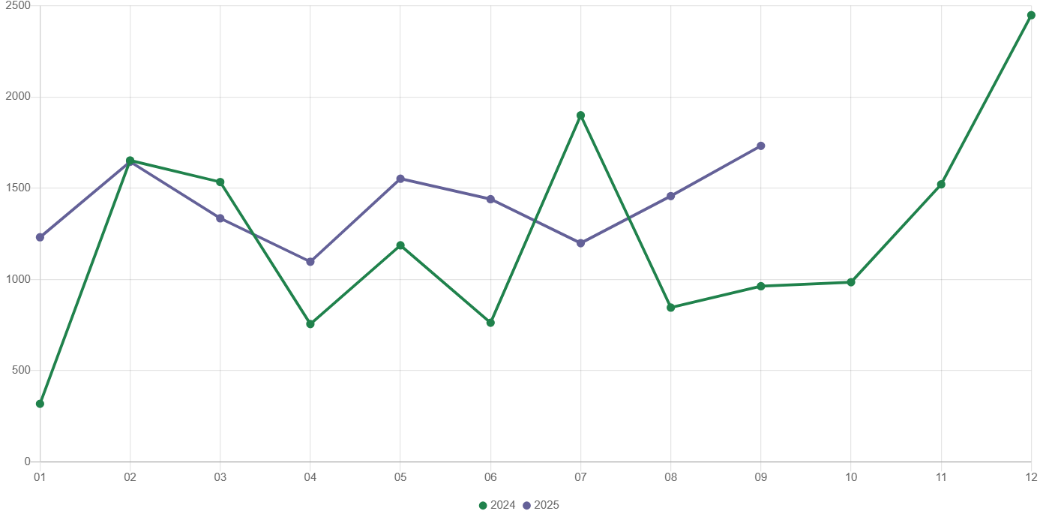
Chart 4. Dwellings completed
In January-September 2025, construction begun in 10209 dwellings (by 16.7% less than in the corresponding period of 2024) of which: 9826 in construction for sale or rent, 383 in private construction.
In January-September 2025, the number of dwellings for which permits have been granted or which have been registered with a construction project amounted to 10665 (by 32.8% less than in the corresponding period of 2024), of which 365 dwellings in buildings built by private investors.
The average useful floor area of a dwelling completed in January-September 2025, amounted to 60.9 m² and decreased compared to the corresponding period of 2024 by 3.7 m². In private construction, the average useful floor area of dwellings amounted to 178.5 m² (by 4.0 m² less than in the corresponding period of 2024), in construction for sale or rent – 56.5 m² (by 3.3 m² less), in cooperative construction — 52.4 m² , in dwellings built by public building society – 47.6 m².

Entities of the national economy
At the end of September 2025, there were 593622 entities of the national economy registered in the REGON register in Warszawa, which accounted for 54.9% of the total in Mazowieckie Voivodship. Compared with August 2025, the number of entities of the national economy increased by 1981 (i.e. by 0.3%), and compared to September 2024 increased by 22153 (i.e. by 3.9%).
As of the end of September this year, there were 267535 legal persons and organisational units without legal personality registered in the REGON register, of which 193543 commercial companies. The number of these entities increased by 0.3% each compared to the previous month, and on an annual basis by 3.7% and 4.4%, respectively.
The number of registered natural persons conducting economic activity as of the end of September 2025 amounted to 326087 and compared to August 2025 it was higher by 0.4%, and compared to the corresponding period of the previous year increased by 4.0%.
In Warszawa, in September 2025, the most numerous were entities dealing with: professional, scientific and technical activities (19.3% of total registered units), trade; repair of motor vehicles (16.0%), as well as information and communication (13.0%).
Compared to August 2025, the number of entities increased, among others, in the sections: education (by 0.9%), administrative and support service activities (by 0.8%), electricity, gas, steam and air conditioning supply (by 0.7%), art, entertainment and recreation, human health and social work activities and construction (by 0.5% each), water supply; sewerage, waste management and remediation activities, accommodation and catering, financial and insurance activities, other service activities, professional, scientific and technical activities (by 0.4% each). However there was a decrease in the number of entities in the section of agriculture, forestry and fishing (by 0.1%).
Compared to September 2024, the largest increase in the number of entities was recorded in the sections: administrative and support service activities (by 10.5%), human health and social work activities (by 7.2%), electricity, gas, steam and air conditioning supply (by 6.7%), education (by 6.0%), construction (by 5.7%). Whereas a decrease was noted in the section of trade; repair of motor vehicles (by 0.5%).
In September 2025, 4000 new entities were entered into the REGON register, i.e. by 16.8% more than in the previous month. The newly registered entities were dominated by natural persons conducting economic activity – 2573 (by 17.9% more than in August 2025). The number of newly registered commercial companies was larger compared to the previous month by 11.8%, including limited liability companies – larger by 11.6%.
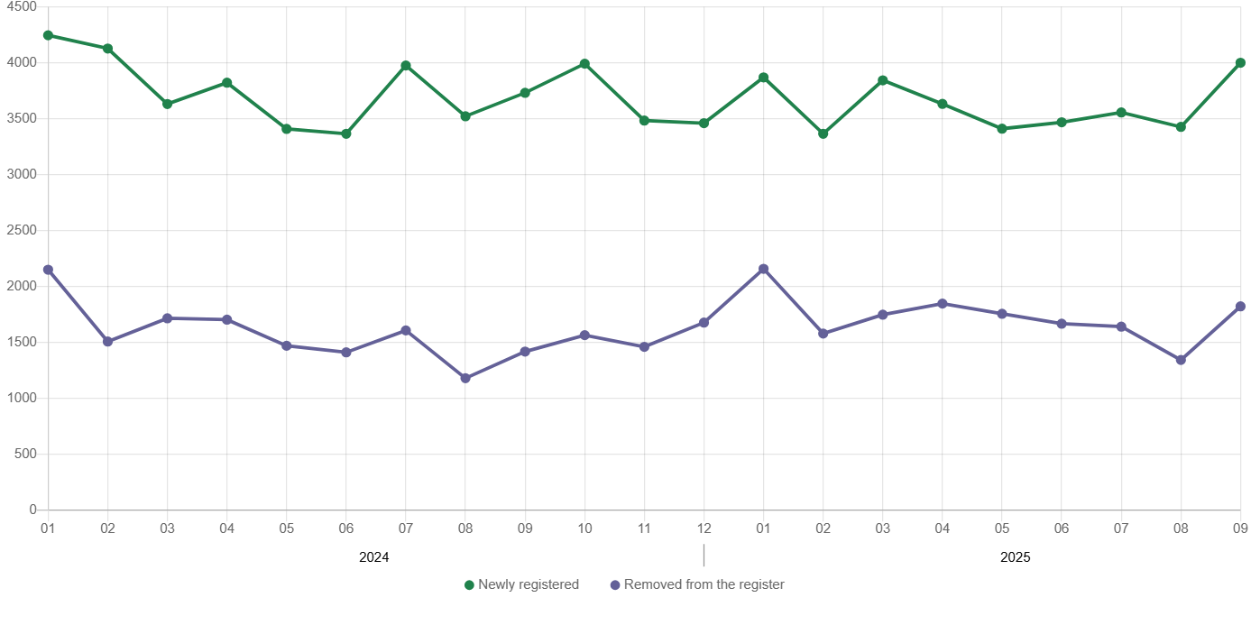
Chart 5. Entities newly registered and removed from the register

In September 2025, 1822 entities were removed from the REGON register (compared to 1343 in the previous month), including 1130 natural persons conducting economic activity (by 16.1% more).
As of the end of September 2025, 71280 entities had suspended activity in the REGON register (by 1.1% less than a month before). The vast majority were natural persons conducting economic activity (91.3%).

When quoting Statistics Poland data, please provide the information: “Source of data: Statistics Poland”, and when publishing calculations made on data published by Statistics Poland, please include the following disclaimer: “Own study based on figures from Statistics Poland”.
Prepared by:  Statistical Office in Warszawa  Director Agnieszka Ajdyn  Phone: (+48 22) 464 23 15 | Issued by:  Statistical Information Centre  Marcin Kałuski  Mobile: (+48) 783 940 141

warszawa.stat.gov.pl/en/

@Warszawa_STAT

@UrzadStatystycznywWarszawie

gus_stat

glownyurzadstatystycznygus

glownyurzadstatystyczny

Related information
Communications and Announcements
Data available in databases
Local Data Bank → Labour market
Terms used in official statistics
Registered unemployed persons
Registered unemployment rate
Average paid employment
Average monthly gross wages and salaries
Dwellings completed

