Statistics of Warszawa No. 8/2025
In August 2025, there was a decrease in the average employment and an increase in the number of unemployed persons compared to the corresponding period of previous year. Both sold production of industry and construction and assembly production were higher than in the previous year. Retail and wholesale sales were lower than a year earlier. August was characterised by a higher number of dwellings completed than a year earlier.

Average paid employment
Average paid employment in the enterprise sector in August 2025 amounted to 1114.2 thousand persons (converted into full-time equivalents) and was by 1.2 thousand persons, i.e. by 0.1% smaller than in July 2025, and by 11.0 thousand persons, i.e. by 1.0% smaller than in August 2024.
Compared to July 2025, a decrease in the average employment was recorded in the following sections: transportation and storage (by 0.5%), professional, scientific and technical activities, real estate activities, industry (by 0.2% each), trade; repair of motor vehicles (by 0.1%).

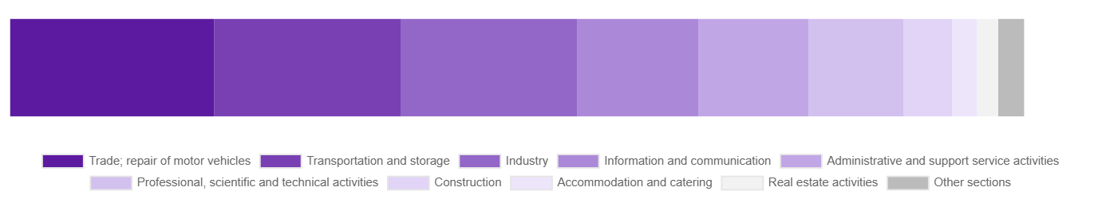
Chart 1. Structure of average paid employment by sections of PKD in August 2025

While an increase in the average employment was recorded in the following sections: accommodation and catering (by 0.7%), construction (by 0.4%), administrative and support service activities (by 0.3%).
Compared to August 2024, a decrease in average employment was recorded in the sections: transportation and storage (by 5.5%), trade; repair of motor vehicles (by 5.4%), accommodation and catering (by 5.2%), administrative and support service activities (by 0.9%).
An increase in average employment occurred in the sections: real estate activities (by 16.2%), industry (by 4.1%), professional, scientific and technical activities (by 3.7%), construction (by 0.8%), information and communication (by 0.5%).

Registered unemployment
At the end of August 2025, the number of registered unemployed persons amounted to 22414 and was by 1253 persons, i.e. by 5.9% larger than at the end of July 2025 and by 3187 persons, i.e. by 16.6% larger than in the corresponding period of 2024.
The number of registered unemployed women amounted to 10610, which accounted for 47.3% of the total unemployed (46.8% a month and 47.6% a year before) and 18.4% of unemployed women in Mazowieckie Voivodship. As compared to July 2025, the number of unemployed women increased by 705 persons, i.e. by 7.1% and compared to August 2024 increased by 1451 persons, i.e. by 15.8%
The registered unemployment rate amounted to 1.7% (1.6% in the previous month and 1.4% in the previous year), in Mazowieckie Voivodship it was 4.4% (4.3% a month brfore and 4.1% a year before), while in the country at a level of 5.5% (5.4% a month before and 5.0% a year before).
In August 2025, there were 2686 unemployed persons registered in labour offices (2780 in July 2025, and 2188 in August 2024). Registered unemployed persons accounted for 21.9% of the total registered unemployed in the Voivodship.
The number of persons registering for the first time amounted to 1132 (1124 a month before), which accounted for 42.1% of the total unemployed who registered in August 2025 and 30.1% of persons registering for the first time in the Voivodship. The share of persons terminated due to company reasons among unemployed persons registered in August 2025 amounted to 4.0% (4.6% in Mazowieckie Voivodship), 4.6% a month before and 2.1% a year before.
In August 2025, 1433 persons were removed from unemployment rolls (1670 in July 2025, and 2346 in August 2024), which accounted for 17.8% of unemployed persons removed from unemployment rolls in Mazowieckie Voivodship. Out of the unemployed removed from unemployment rolls, 1083 persons took up work. Moreover, 25 persons lost their status of the unemployed as a result of not confirming their readiness to take up work. The reason for removing from the register was also starting training or traineeship, acquisition of retirement or pension rights, and others.

There were 19418 persons who were not entitled to the unemployment benefit, i.e. 86.6% of the total unemployed (16682 persons a year before, i.e. 86.8%), whereas 2996 unemployed persons were entitled to the unemployment benefit.

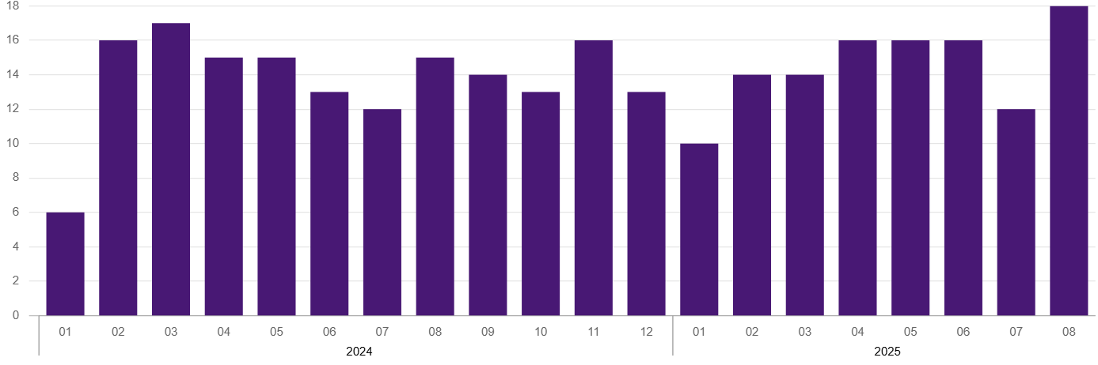
Chart 2. Number of unemployed persons per job offer (as of end of month)

In August 2025, there were 1527 job offers submitted to labour offices, which accounted for 34.5% of job offers in Mazowieckie Voivodship and at the end this month the labour offices had job offers for 1251 persons. At the end of August 2025, there were 18 persons per one job offer (12 in the previous month and 15 in the previous year), while in Mazowieckie Voivodship, there were 30 persons registered as unemployed (24 a month berore and 16 a year before).
Wages and salaries
The average monthly gross wages and salaries in the enterprise sector in August 2025 amounted to PLN 10507.13 and were by 1.2% lower as compared to the previous month and by 6.4% higher than in the corresponding period of 2024.
Compared to July 2025, a decrease in the average gross wages and salaries was recorded in the following sections: accommodation and catering (by 4.2%), administrative and support service activities (by 3.1%), industry (by 3.0%), real estate activities (by 2.7%), construction (by 1.5%), transportation and storage (by 1.3%), trade; repair of motor vehicles (by 1.1%), professional, scientific and technical activities (by 0.8%).
Whereas an increase in the average wages and salaries was recorded in the information and communication section (by 0.8%).
Compared to August 2024, an increase in the average gross wages and salaries was recorded in the sections: transportation and storage (by 8.0%), accommodation and catering (by 7.8%), construction (by 7.6%), industry (by 7.2%), information and communication (by 7.1%), administrative and support service activities (by 6.5%), trade; repair of motor vehicles (by 4.3%), professional, scientific and technical activities (by 3.0%), real estate activities (by 0.5%).

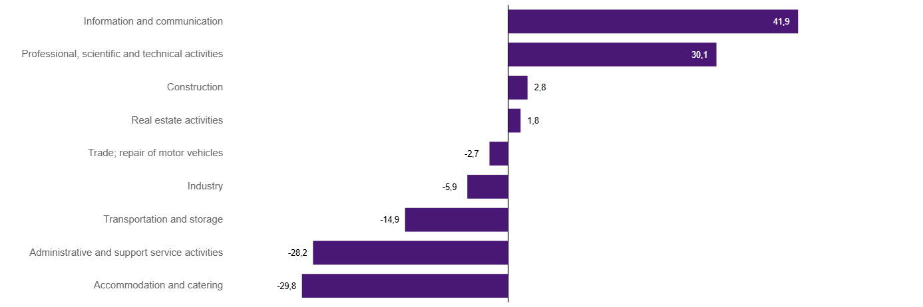
Chart 3. Relative deviations (in %) of monthly gross wages and salaries in selected sections from average wages and salaries in enterprise sector in Warszawa in August 2025

Construction
Sold production of construction in August 2025 amounted (at current prices) to PLN 6191.8 million and compared to July 2025 was smaller by 6.3% and compared to the corresponding period of the previous year it decreased by 0.4%.
In January-August 2025, the sold production of construction reached the value of PLN 49422.6 million, i.e. by 8.0% larger than in the corresponding period of 2024.
Construction and assembly production in August 2025 amounted to PLN 1492.7 million (at current prices) and accounted for 24.1% of sold production of construction. Compared to the previous month, construction and assembly production decreased by 3.2%, and compared to August 2024 it was larger by 14.2%.
In the period January–August 2025, construction and assembly production amounted to PLN 10881.3 million and accounted for 22.0% of the sold construction production (21.3% a year earlier). Compared to the same period last year, construction and assembly production was higher by 11.9%.
The increase in production in relation to the corresponding period of 2024 occurred in units dealing with: construction of buildings (by 51.6%) and specialised construction activities (by 35.7%), while a decrease in units dealing with civil engineering (by 14.1%).
Labour productivity measured by production per employed person in construction in August 2025 amounted to PLN 116.0 thousand and was by 6.7% lower than a month before and by 1.2% lower than in August 2024.

Trade
Retail sales in trade and non-trade enterprises in August 2025 (at current prices) were by 3.1% smaller than in July 2025 and by 2.1% lower compared to August 2024.
Compared to July 2025, the decrease was recorded in sales of motor vehicles, motorcycles, parts (by 9.1%), sales in the “other” group (by 7.9%), sales of furniture, electronic goods and household equipment (by 4.8%), other retail sales in non-specialised stores (by 4.7%), sales of pharmaceuticals, cosmetics, orthopedic equipment (by 3.2%), and sales of solid, liquid and gas fuels (by 3.0%).
However, there was an increase in sales of food, beverages and tobacco (by 2.6%) and sales of textiles, clothing and footwear (by 2.2%).
Compared to August 2024, the decrease was recorded in sales motor vehicles, motorcycles, parts (by 7.5%), sales of solid, liquid and gas fuels (by 3.1%), sales of furniture, electronic goods and household equipment (by 1.6%), and other retail sales in non-specialised stores (by 0.2%).
However the largest increase was recorded in sales of textiles, clothing and footwear (by 8.2%), and also in sales in the “other” group (by 2.1%), sales of press, books, other retail sales in specialised stores (by 1.9%), sales of food, beverages and tobacco (by 1.9%).
In the period January-August 2025 compared to the same period in 2024, retail sales decreased by 1.4%.
Wholesale in trade enterprises in August 2025 (at current prices) was by 8.4% smaller as compared to the previous month and by 5.1% lower than in August 2024, and in wholesale enterprises it was lower by 1.8% and lower by 6.2%, respectively.
In the period January–August 2025, retail units achieved wholesale sales that were 7.3% lower than a year ago, while wholesale enterprises by 6.8% lower.

Industry
The sold production of industry in August 2025 amounted to (in current prices) PLN 13737,9 million and was (at constant prices) larger than in the corresponding month of 2024 by 3.0%. As compared to August 2024, an increase in sold production of industry was recorded in manufacturing by 5.4%.
In the period January-August 2025, sold production of industry amounted to PLN 120946.5 million (at current prices) and was (at constant prices) higher by 5.0% than that achieved in the same period of 2024. In manufacturing, an increase in production by 5.6% was recorded.
Among the divisions classified as manufacturing, the increase in sales was recorded, among others, in: manufacture of motor vehicles, trailers and semi-trailers (by 124.7%), manufacture of products of wood, cork, straw and wicker (by 27.7%), manufacture of metal products (by 22.1%), manufacture of wearing apparel (by 20.4%), manufacture of machinery and equipment n.e.c. (by 13.0%), manufacture of rubber and plastics (by 12.1%), manufacture of pharmaceutical products (by 10.0%), manufacture of electrical equipment (by 7.9%), manufacture of furniture (by 7.2%), manufacture of other non-metallic mineral products (by 4.7%), manufacture of food products (by 4.1%), manufacture of chemicals and chemical products (by 1.6%), manufacture of beverages (by 1.5%), manufacture of paper and paper products (by 1.3%).
The decrease in sales was recorded, among others, in: manufacture of coke and refined petroleum products (by 15.7%), manufacture of textile products (by 15.6%), manufacture of computer, electronic and optical products (by 11.5%), repair and installation of machinery and equipment (by 7.9%), other manufacturing (by 5.3%), printing and reproduction of recorded media (by 4.0%), manufacture of basic metals (by 1.4%).
Labour productivity in industry measured by production per employed person, in January-August 2025 amounted to PLN 620.3 thousand (at current prices) and was – at constant prices – by 1.1% higher than in the previous year.

Residential construction
According to preliminary data, 1457 dwellings were completed in Warszawa in August 2025, i.e. by 72.2% more than in the previous year.
In the period January-August 2025, 10956 dwellings were completed (by 22.3% more than in the corresponding period of 2024), and 26855 dwellings in Mazowieckie Voivodship, i.e. by 11.0% more than in January-August 2024. An increase in the number of dwellings was recorded in construction for sale or rent from 8523 to 10388, i.e. by 21.9% more, in private construction from 361 to 438, i.e. by 21.3% more. Moreover, 66 dwellings were completed by private buildings society, and 64 dwellings in cooperative construction in the period January-August 2025.

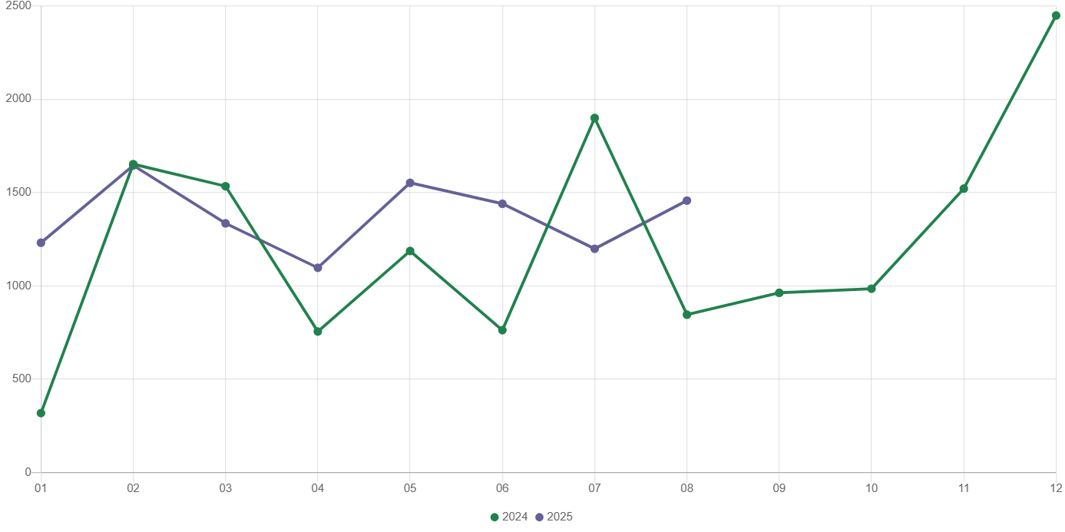
Chart 4. Dwellings completed
In January- August 2025, construction begun in 8634 dwellings (by 22.2% less than in the corresponding period of 2024) of which: 8296 in construction for sale or rent, 338 in private construction.
In January-August 2025, the number of dwellings for which permits have been granted or which have been registered with a construction project amounted to 9332 (by 35.0% less than in the corresponding period of 2024), of which 333 dwellings in buildings built by private investors.
The average useful floor area of a dwelling completed in January-August 2025, amounted to 61.3 m² and decreased compared to the corresponding period of 2024 by 3.7 m². In private construction, the average useful floor area of dwellings amounted to 179.9 m² (by 1.4 m² less than in the corresponding period of 2024), in construction for sale or rent – 56.5 m² (by 3.8 m² less), in public building society— 49.9 m² , and in cooperative construction – 49.4 m².

Entities of the national economy
At the end of August 2025, there were 591641 entities of the national economy registered in the REGON register in Warszawa, which accounted for 54.9% of the total in Mazowieckie Voivodship. Compared with July 2025, the number of entities of the national economy increased by 2023 (i.e. by 0.3%), and compared to August 2024 increased by 22302 (i.e. by 3.9%).
As of the end of August this year, there were 266836 legal persons and organisational units without legal personality registered in the REGON register, of which 193006 commercial companies. The number of these entities increased by 0.3% and 0.4%, respectively compared to the previous month, and on an annual basis by 3.8% and 4.6%, respectively.
The number of registered natural persons conducting economic activity as of the end of August 2025 amounted to 324805 and compared to July 2025 it was higher by 0.3%, and compared to the corresponding period of the previous year increased by 4.0%.
In Warszawa, in August 2025, the most numerous were entities dealing with: professional, scientific and technical activities (19.3% of total registered units), trade; repair of motor vehicles (16.0%), as well as information and communication (13.0%).
Compared to July 2025, the number of entities increased, among others, in the sections: electricity, gas, steam and air conditioning supply and administrative and support service activities (by 0.8% each), education (by 0.7%), art, entertainment and recreation, human health and social work activities, construction and information and communication (by 0.5% each), accommodation and catering and professional, scientific and technical activities (by 0.4% each). However there was a decrease in the number of entities in the section of agriculture, forestry and fishing (by 1.0%).
Compared to August 2024, the largest increase in the number of entities was recorded in the sections: administrative and support service activities (by 10.2%), human health and social work activities (by 7.3%), electricity, gas, steam and air conditioning supply (by 6.5%), education (by 5.9%), construction (by 5.7%), information and communication (by 5.2%). Whereas a decrease was noted in the sections: water supply; sewerage, waste management and remediation activities (by 0.3%) and trade; repair of motor vehicles (by 0.2%).
In August 2025, 3426 new entities were entered into the REGON register, i.e. by 3.6% less than in the previous month. The newly registered entities were dominated by natural persons conducting economic activity – 2182 (by 0.8% less than in July 2025). The number of newly registered commercial companies was smaller compared to the previous month by 8.5%, including limited liability companies – smaller by 7.9%.
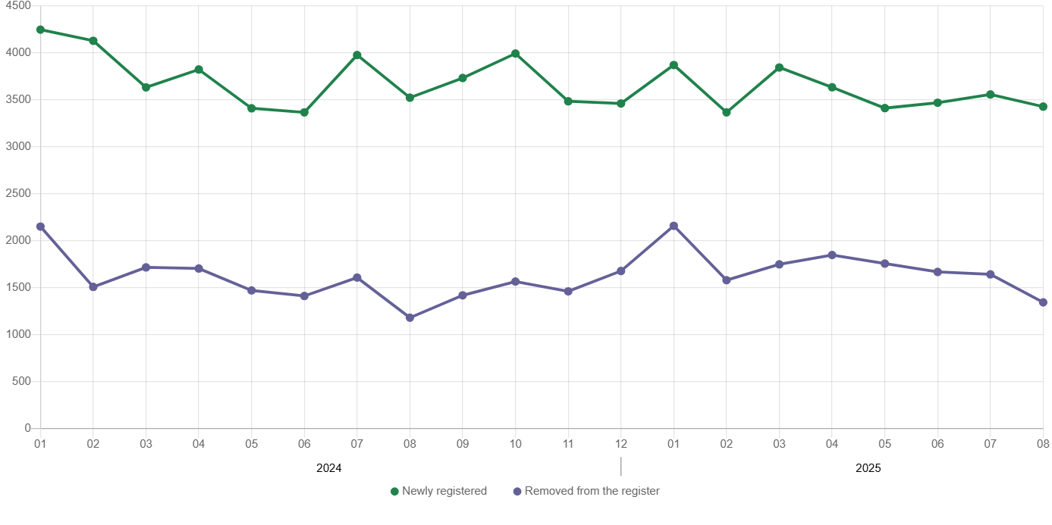
Chart 5. Entities newly registered and removed from the register

In August 2025, 1343 entities were removed from the REGON register (compared to 1641 in the previous month), including 973 natural persons conducting economic activity (by 9.3% less).
As of the end of August 2025, 72100 entities had suspended activity in the REGON register (by 1.2% more than a month before). The vast majority were natural persons conducting economic activity (91.6%).

When quoting Statistics Poland data, please provide the information: “Source of data: Statistics Poland”, and when publishing calculations made on data published by Statistics Poland, please include the following disclaimer: “Own study based on figures from Statistics Poland”.
Prepared by:  Statistical Office in Warszawa  Director Agnieszka Ajdyn  Phone: (+48 22) 464 23 15 | Issued by:  Statistical Information Centre  Marcin Kałuski  Mobile: (+48) 783 940 141

warszawa.stat.gov.pl/en/

@Warszawa_STAT

@UrzadStatystycznywWarszawie

gus_stat

glownyurzadstatystycznygus

glownyurzadstatystyczny

Related information
Communications and Announcements
Data available in databases
Local Data Bank → Labour market
Terms used in official statistics
Registered unemployed persons
Registered unemployment rate
Average paid employment
Average monthly gross wages and salaries
Dwellings completed

