Statistics of Warszawa No. 7/2025
In July 2025, there was a decrease in the average employment and an increase in the number of unemployed persons compared to the corresponding period of previous year. Both sold production of industry and construction and assembly production were higher than in the previous year. Retail and wholesale sales were lower than a year earlier. July was characterised by a lower number of dwellings completed than a year earlier.

Average paid employment
Average paid employment in the enterprise sector in July 2025 amounted to 1115.3 thousand persons (converted into full-time equivalents) and was by 1.2 thousand persons, i.e. by 0.1% larger than in June 2025, and by 12.1 thousand persons, i.e. by 1.1% smaller than in July 2024.
Compared to June 2025, an increase in the average employment was recorded in the following sections: industry (by 5.6%), accommodation and catering (by 1.8%), administrative and support service activities and construction (by 0.1% each).

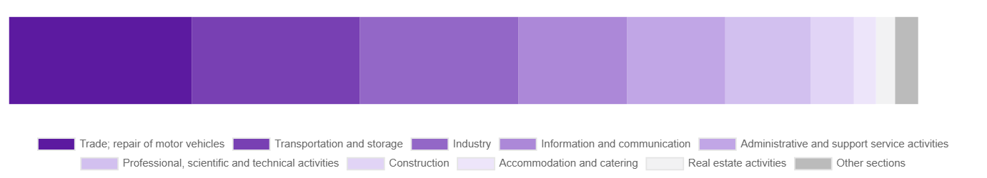
Chart 1. Structure of average paid employment by sections of PKD in July 2025

While a decrease in the average employment was recorded in the following sections: professional, scientific and technical activities (by 8.3%), information and communication (by 0.2%), transportation and storage (by 0.1%).
Compared to July 2024, a decrease in average employment was recorded in the sections: accommodation and catering (by 5.9%), trade; repair of motor vehicles (by 5.6%), transportation and storage (by 4.9%), administrative and support service activities (by 1.3%), construction (by 0.5%).
An increase in average employment occurred in the sections: real estate activities (by 16.4%), professional, scientific and technical activities (by 3.9%), industry (by 3.8%), information and communication (by 0.5%).

Registered unemployment
At the end of July 2025, the number of registered unemployed persons amounted to 21161 and was by 1110 persons, i.e. by 5.5% larger than at the end of June 2025 and by 1776 persons, i.e. by 9.2% larger than in the corresponding period of 2024.
The number of registered unemployed women amounted to 9905, which accounted for 46.8% of the total unemployed (46.6% a month and 47.3% a year before) and 17.8% of unemployed women in Mazowieckie Voivodship. As compared to June 2025, the number of unemployed women increased by 567 persons, i.e. by 6.1% and compared to July 2024 increased by 737 persons, i.e. by 8.0%.
The registered unemployment rate amounted to 1.6% (1.5% in the previous month and 1.4% in the previous year), in Mazowieckie Voivodship it was 4.3% (4.1% a month and a year before), while in the country at a level of 5.4% (5.2% a month before and 5.0% a year before).
In July 2025, there were 2780 unemployed persons registered in labour offices (2069 in June 2025, and 2661 in July 2024). Registered unemployed persons accounted for 20.9% of the total registered unemployed in the Voivodship.
The number of persons registering for the first time amounted to 1124 (745 a month before), which accounted for 40.4% of the total unemployed who registered in July 2025 and 27.7% of persons registering for the first time in the Voivodship. The share of persons terminated due to company reasons among unemployed persons registered in July 2025 amounted to 4.6% (4.8% in Mazowieckie Voivodship), 3.1% a month before and 3.0% a year before.
In July 2025, 1670 persons were removed from unemployment rolls (1736 in June 2025, and 2210 in July 2024), which accounted for 20.0% of unemployed persons removed from unemployment rolls in Mazowieckie Voivodship. Out of the unemployed removed from unemployment rolls, 1300 persons took up work. Moreover, 21 persons lost their status of the unemployed as a result of not confirming their readiness to take up work. The reason for removing from the register was also starting training or traineeship, acquisition of retirement or pension rights, and others.

There were 18252 persons who were not entitled to the unemployment benefit, i.e. 86.3% of the total unemployed (16773 persons a year before, i.e. 86.5%), whereas 2909 unemployed persons were entitled to the unemployment benefit.

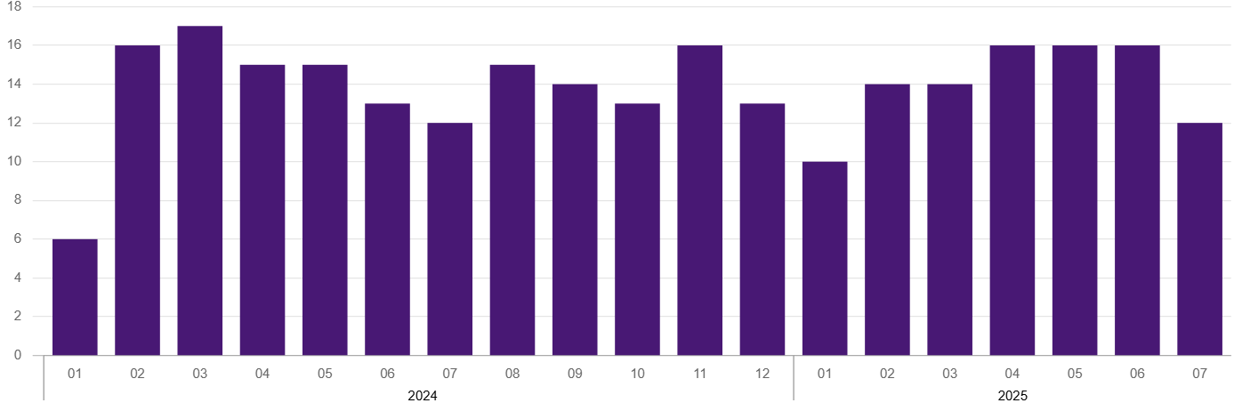
Chart 2. Number of unemployed persons per job offer* (as of end of month)

In July 2025, there were 2070 job offers* submitted to labour offices, which accounted for 36.6% of job offers in Mazowieckie Voivodship and at the end this month the labour offices had job offers for 1700 persons. At the end of July 2025, there were 12 persons per one job offer (16 in the previous month and 12 in the previous year), while in Mazowieckie Voivodship, there were 24 persons registered as unemployed (28 a month berore and 13 a year before).
Wages and salaries
The average monthly gross wages and salaries in the enterprise sector in July 2025 amounted to PLN 10630.76 and were by 1.3% higher as compared to the previous month and by 8.2% higher than in the corresponding period of 2024.
Compared to June 2025, an increase in the average gross wages and salaries was recorded in the following sections: accommodation and catering (by 5.2%), professional, scientific and technical activities (by 3.9%), construction (by 3.6%), real estate activities (by 3.4%), administrative and support service activities (by 3.3%), transportation and storage (by 1.8%), information and communication (by 1.5%).
Whereas a decrease in the average wages and salaries was recorded in the industry section (by 1.2%).
Compared to July 2024, an increase in the average gross wages and salaries was recorded in the sections: transportation and storage (by 11.8%), industry (by 9.9%), administrative and support service activities (by 9.8%), construction (by 7.9%), information and communication (by 7.4%), professional, scientific and technical activities (by 7.3%), accommodation and catering (by 7.1%), real estate activities (by 3.6%), trade; repair of motor vehicles (by 3.2%).
* From 1 June 2025, data on job offers are not fully comparable with earlier periods due to methodological changes resulting from the entry into force of the Act on the Labour Market and Employment Services (Journal of Laws of 2025 item 620).

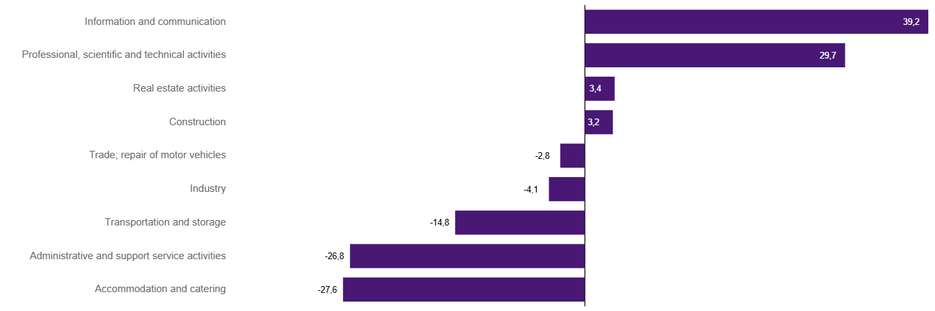
Chart 3. Relative deviations (in %) of monthly gross wages and salaries in selected sections from average wages and salaries in enterprise sector in Warszawa in July 2025

Construction
Sold production of construction in July 2025 amounted (at current prices) to PLN 6610.5 million and compared to June 2025 was smaller by 3.6% and compared to the corresponding period of the previous year it increased by 0.1%.
In January-July 2025, the sold production of construction reached the value of PLN 43805.8 million, i.e. by 11.1% larger than in the corresponding period of 2024.
Construction and assembly production in July 2025 amounted to PLN 1541.5 million (at current prices) and accounted for 23.3% of sold production of construction. Compared to the previous month, construction and assembly production decreased by 1.1%, and compared to July 2024 it was larger by 23.1%.
In the period January–July 2025, construction and assembly production amounted to PLN 9469.7 million and accounted for 21.6% of the sold construction production (21.5% a year earlier). Compared to the same period last year, construction and assembly production was higher by 11.4%.
The increase in production in relation to the corresponding period of 2024 occurred in units dealing with: construction of buildings (by 55.2%) and specialised construction activities (by 30.3%), while a decrease in units dealing with civil engineering (by 14.4%).
Labour productivity measured by production per employed person in construction in July 2025 amounted to PLN 124.3 thousand and was by 3.7% lower than a month before and by 0.7% higher than in July 2024.

Trade
Retail sales in trade and non-trade enterprises in July 2025 (at current prices) were by 3.4% larger than in June 2025 and by 0.9% lower compared to July 2024.
Compared to June 2025, the increase was recorded in sales of furniture, electronic goods and household equipment (by 12.7%), sales of pharmaceuticals, cosmetics, orthopedic equipment (by 6.5%), sales in the “other” group and sales of food, beverages and tobacco (by 5.7% each), sales of motor vehicles, motorcycles, parts (by 4.4%), sales of press, books, other retail sales in specialised stores (by 3.7%), sales of solid, liquid and gas fuels (by 2.7%).
However, there was a decrease in other retail sales in non-specialised stores (by 18.1%), sale of textiles, clothing and footwear (by 7.7%).
Compared to July 2024, the largest decrease was recorded in sales motor vehicles, motorcycles, parts (by 10.6%), and also sales of solid, liquid and gas fuels (by 1.5%), sales of textiles, clothing and footwear (by 0.9%).
However the increase was recorded in sales of press, books, other retail sales in specialized stores (by 7.1%), other retail sales in non-specialised stores (by 6.5%), sales in the “other” group (by 5.1%), sales of pharmaceuticals, cosmetics, orthopedic equipment (by 4.1%), sales of food, beverages and tobacco (by 4.0%), and sales of furniture, electronic goods and household equipment (by 2.1%).
In the period January-July 2025 compared to the same period in 2024, retail sales decreased by 1.2%.
Wholesale in trade enterprises in July 2025 (at current prices) was by 0.7% smaller as compared to the previous month and by 4.2% lower than in July 2024, and in wholesale enterprises it was lower by 3.2% and lower by 5.6%, respectively.
In the period January–July 2025, retail units achieved wholesale sales that were 7.7% lower than a year ago, while wholesale enterprises by 6.7% lower.

Industry
The sold production of industry in July 2025 amounted to (in current prices) PLN 14423.5 million and was (at constant prices) larger than in the corresponding month of 2024 by 2.6%. As compared to July 2024, an increase in sold production of industry was recorded in manufacturing by 3.2%.
In the period January-July 2025, sold production of industry amounted to PLN 106848.6 million (at current prices) and was (at constant prices) higher by 4.9% than that achieved in the same period of 2024. In manufacturing, an increase in production by 5.2% was recorded.
Among the divisions classified as manufacturing, the increase in sales was recorded, among others, in: manufacture of motor vehicles, trailers and semi-trailers (by 126.1%), manufacture of products of wood, cork, straw and wicker (by 29.8%), manufacture of metal products (by 23.4%), manufacture of wearing apparel (by 13.7%), manufacture of rubber and plastics (by 13.5%), manufacture of pharmaceutical products (by 8.9%), manufacture of electrical equipment (by 7.6%), manufacture of machinery and equipment n.e.c. (by 7.5%), manufacture of other non-metallic mineral products (by 4.7%), manufacture of food products (by 4.1%), manufacture of beverages (by 2.1%), manufacture of paper and paper products (by 2.0%), manufacture of chemicals and chemical products (by 1.7%).
The decrease in sales was recorded, among others, in: manufacture of coke and refined petroleum products (by 18.2%), manufacture of computer, electronic and optical products (by 11.6%), repair and installation of machinery and equipment (by 8.3%), manufacture of textile products (by 8.1%), other manufacturing (by 5.0%), manufacture of furniture (by 4.9%), printing and reproduction of recorded media (by 2.7%), manufacture of basic metals (by 0.7%).
Labour productivity in industry measured by production per employed person, in January-July 2025 amounted to PLN 548.2 thousand (at current prices) and was – at constant prices – by 1.2% higher than in the previous year.

Residential construction
According to preliminary data, 1199 dwellings were completed in Warszawa in July 2025, i.e. by 36.9% less than in the previous year.
In the period January-July 2025, 9740 dwellings were completed (by 20.1% more than in the corresponding period of 2024), and 23771 dwellings in Mazowieckie Voivodship, i.e. by 11.4% more than in January-July 2024. An increase in the number of dwellings was recorded in private construction from 306 to 379, i.e. by 23.9% more, in construction for sale or rent from 7732 to 9231, i.e. by 19.4% more,. Moreover, 66 dwellings were completed by private buildings society, and 64 dwellings in cooperative construction in the period January-July 2025.

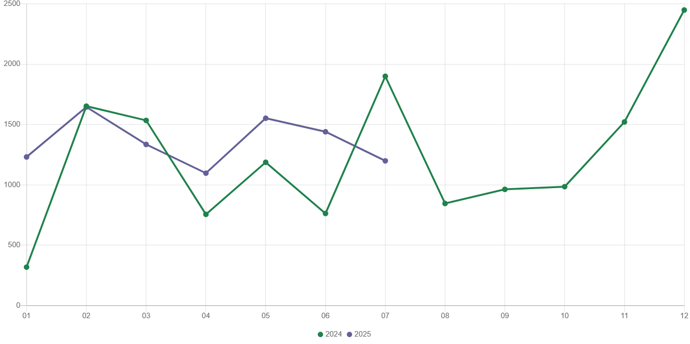
Chart 4. Dwellings completed
In January-July 2025, construction begun in 7975 dwellings (by 16.0% less than in the corresponding period of 2024) of which: 7673 in construction for sale or rent, 302 in private construction.
In January-July 2025, the number of dwellings for which permits have been granted or which have been registered with a construction project amounted to 8416 (by 36.1% less than in the corresponding period of 2024), of which 303 dwellings in buildings built by private investors.
The average useful floor area of a dwelling completed in January-July 2025, amounted to 58.0 m² and decreased compared to the corresponding period of 2024 by 6.8 m². In private construction, the average useful floor area of dwellings amounted to 183.0 m² (by 2.2 m² more than in the corresponding period of 2024), in construction for sale or rent – 53.0 m² (by 7.4 m² less), in public building society— 51.4 m² , and in cooperative construction – 49.4 m².

Entities of the national economy
At the end of July 2025, there were 589618 entities of the national economy registered in the REGON register in Warszawa, which accounted for 54.9% of the total in Mazowieckie Voivodship. Compared with June 2025, the number of entities of the national economy increased by 1822 (i.e. by 0.3%), and compared to July 2024 increased by 22460 (i.e. by 4.0%).
As of the end of July this year, there were 265909 legal persons and organisational units without legal personality registered in the REGON register, of which 192195 commercial companies. The number of these entities increased by 0.3% and 0.4%, respectively compared to the previous month, and on an annual basis by 3.9% and 4.6%, respectively.
The number of registered natural persons conducting economic activity as of the end of July 2025 amounted to 323709 and compared to June 2025 it was higher by 0.3%, and compared to the corresponding period of the previous year increased by 4.0%.
In Warszawa, in July 2025, the most numerous were entities dealing with: professional, scientific and technical activities (19.3% of total registered units), trade; repair of motor vehicles (16.1%), as well as information and communication (13.0%).
Compared to June 2025, the number of entities increased, among others, in the sections: electricity, gas, steam and air conditioning supply and administrative and support service activities (by 0.7% each), construction (by 0.6%), human health and social work activities (by 0.5%), real estate activities, information and communication and professional, scientific and technical activities (by 0.4% each), accommodation and catering, education and manufacturing (by 0.3% each). However there was a decrease in the number of entities in the sections: mining and quarrying (by 1.6%), water supply; sewerage, waste management and remediation activities (by 0.2%), as well as agriculture, forestry and fishing (by 0.1%).
Compared to July 2024, the largest increase in the number of entities was recorded in the sections: administrative and support service activities (by 9.8%), human health and social work activities (by 7.3%), electricity, gas, steam and air conditioning supply (by 6.4%), education (by 5.9%), construction (by 5.8%), information and communication (by 5.2%).
In July 2025, 3555 new entities were entered into the REGON register, i.e. by 2.5% more than in the previous month. The newly registered entities were dominated by natural persons conducting economic activity – 2200 (by 0.3% more than in June 2025). The number of newly registered commercial companies was larger compared to the previous month by 8.2%, including limited liability companies – larger by 6.0%.
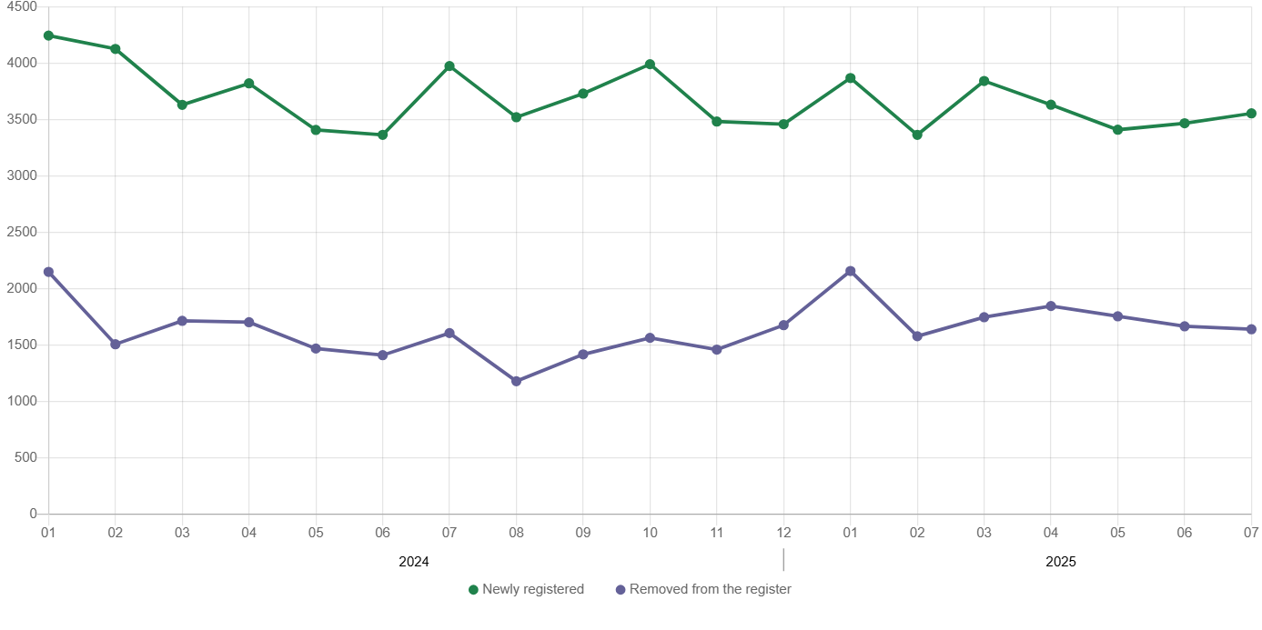
Chart 5. Entities newly registered and removed from the register

In July 2025, 1641 entities were removed from the REGON register (compared to 1667 in the previous month), including 1073 natural persons conducting economic activity (by 11.9% more).
As of the end of July 2025, 71220 entities had suspended activity in the REGON register (by 3.0% more than a month before). The vast majority were natural persons conducting economic activity (91.6%).

When quoting Statistics Poland data, please provide the information: “Source of data: Statistics Poland”, and when publishing calculations made on data published by Statistics Poland, please include the following disclaimer: “Own study based on figures from Statistics Poland”.
Prepared by:  Statistical Office in Warszawa  Director Agnieszka Ajdyn  Phone: (+48 22) 464 23 15 | Issued by:  Statistical Information Centre  Marcin Kałuski  Phone: (+48) 783 940 141
Press office  Phone: (+48) 783 940 141  e-mail: m.kaluski@stat. gov.pl |   warszawa.stat.gov.pl/en/

@Warszawa_STAT

@UrzadStatystycznywWarszawie

gus_stat

glownyurzadstatystycznygus

glownyurzadstatystyczny

Related information
Communications and Announcements
Data available in databases
Local Data Bank → Labour market
Terms used in official statistics
Registered unemployed persons
Registered unemployment rate
Average paid employment
Average monthly gross wages and salaries
Dwellings completed

