Statistics of Warszawa No. 6/2025
In June 2025, there was a decrease in the average employment and an increase in the number of unemployed persons compared to the corresponding period of previous year. Sold production of industry was lower and construction and assembly production was higher than in the previous year. Both retail sales and wholesale were lower than a year earlier. June was characterised by a higher number of dwellings completed than a year earlier.

Average paid employment
Average paid employment in the enterprise sector in June 2025 amounted to 1114.1 thousand persons (converted into full-time equivalents) and was by 1.8 thousand persons, i.e. by 0.2% larger than in May 2025, and by 12.0 thousand persons, i.e. by 1.1% smaller than in June 2024.
Compared to May 2025, an increase in the average employment was recorded in the following sections: professional, scientific and technical activities (by 9.2%), administrative and support service activities (by 0.6%), accommodation and catering (by 0.3%), construction and transportation and storage (by 0.1% each).

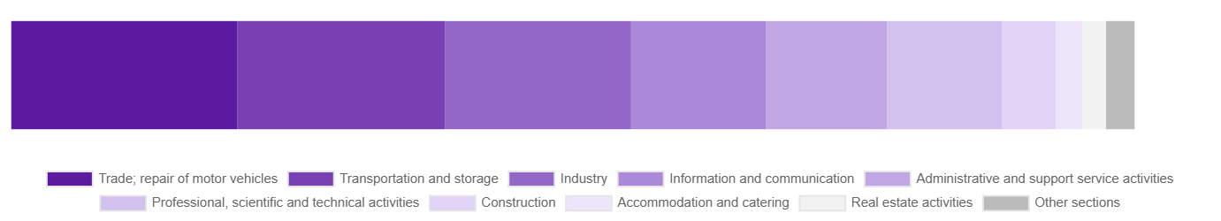
Chart 1. Structure of average paid employment by sections of PKD in June 2025

While a decrease in the average employment was recorded in the following sections: industry (by 4.5%), trade; repair of motor vehicles, information and communication and real estate activities (by 0.1% each).
Compared to June 2024, a decrease in average employment was recorded in the sections: accommodation and catering (by 6.3%), transportation and storage (by 5.4%), trade; repair of motor vehicles (by 5.3%), industry (by 1.4%), administrative and support service activities (by 1.3%), construction (by 0.2%).
An increase in average employment occurred in the sections: real estate activities (by 16.6%), professional, scientific and technical activities (by 13.6%), information and communication (by 0.9%).

Registered unemployment
At the end of June 2025, the number of registered unemployed persons amounted to 20051 and was by 333 persons, i.e. by 1.7% larger than at the end of May 2025 and by 1117 persons, i.e. by 5.9% larger than in the corresponding period of 2024.
The number of registered unemployed women amounted to 9338, which accounted for 46.6% of the total unemployed (46.8% a month and 46.9% a year before) and 17.6% of unemployed women in Mazowieckie Voivodship. As compared to May 2025, the number of unemployed women increased by 102 persons, i.e. by 1.1% and compared to June 2024 increased by 449 persons, i.e. by 5.1%.
The registered unemployment rate amounted to 1.5% (1.4% in the previous month and in the previous year), in Mazowieckie Voivodship it was 4.1% (4.0% a month and a year before), while in the country at a level of 5.2% (5.0% a month before and 4.9% a year before).
In June 2025, there were 2069 unemployed persons registered in labour offices (2403 in May 2025, and 2393 in June 2024). Registered unemployed persons accounted for 20.5% of the total registered unemployed in the Voivodship.
The number of persons registering for the first time amounted to 745 (895 a month before), which accounted for 36.0% of the total unemployed who registered in June 2025 and 26.5% of persons registering for the first time in the Voivodship. The share of persons terminated due to company reasons among unemployed persons registered in June 2025 amounted to 3.1% (4.7% in Mazowieckie Voivodship), 4.1% a month before and 2.2% a year before.
In June 2025, 1736 persons were removed from unemployment rolls (2845 in May 2025, and 2648 in June 2024), which accounted for 22.3% of unemployed persons removed from unemployment rolls in Mazowieckie Voivodship. Out of the unemployed removed from unemployment rolls, 1338 persons took up work. Moreover, 40 persons lost their status of the unemployed as a result of not confirming their readiness to take up work. The reason for removing from the register was also starting training or traineeship, acquisition of retirement or pension rights, and others.

There were 17270 persons who were not entitled to the unemployment benefit, i.e. 86.1% of the total unemployed (16322 persons a year before, i.e. 86.2%), whereas 2781 unemployed persons were entitled to the unemployment benefit.

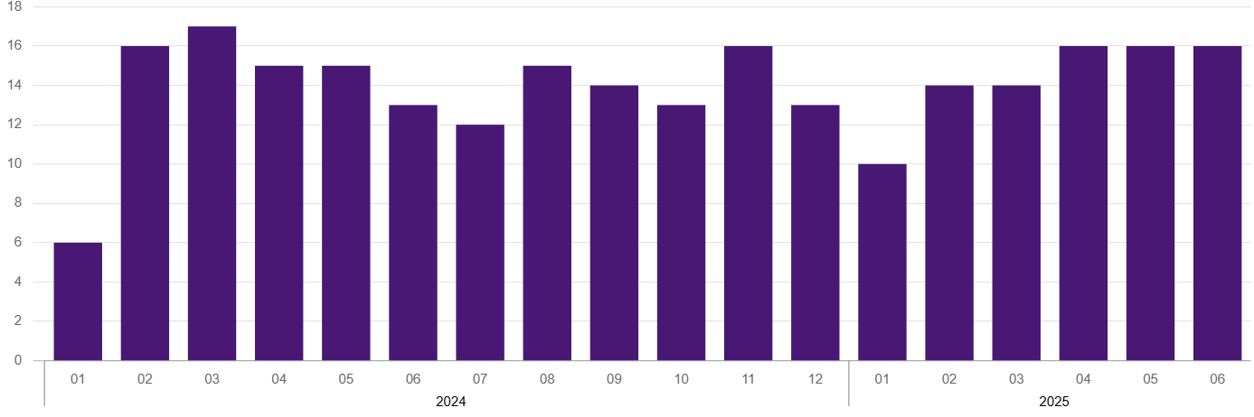
Chart 2. Number of unemployed persons per job offer* (as of end of month)

In June 2025, there were 1742 job offers* submitted to labour offices, which accounted for 41.1% of job offers in Mazowieckie Voivodship and at the end this month the labour offices had job offers for 1275 persons. At the end of June 2025, there were 16 persons per one job offer (28 persons in Mazowieckie Voivodship) registered as unemployed.
Wages and salaries
The average monthly gross wages and salaries in the enterprise sector in June 2025 amounted to PLN 10491.08 and were by 0.1% higher as compared to the previous month and by 8.5% higher than in the corresponding period of 2024.
Compared to May 2025, an increase in the average gross wages and salaries was recorded in the following sections: industry (by 5.2%), trade; repair of motor vehicles (by 2.3%), transportation and storage (by 2.2%), accommodation and catering (by 0.5%).
Whereas a decrease in the average wages and salaries was recorded in the sections: information and communication (by 6.7%), construction (by 3.1%), professional, scientific and technical activities (by 2.8%), real estate activities (by 1.8%), administrative and support service activities (by 0.9%).
Compared to June 2024, an increase in the average gross wages and salaries was recorded in the sections: transportation and storage (by 15.4%), administrative and support service activities (by 10.1%), industry (by 9.0%), accommodation and catering (by 8.0%), information and communication (by 6.4%), professional, scientific and technical activities (by 5.0%), construction (by 4.8%), trade; repair of motor vehicles (by 4.0%), real estate activities (by 0.6%).
* From 1 June 2025, data on job offers are not fully comparable with earlier periods due to methodological changes resulting from the entry into force of the Act on the Labour Market and Employment Services (Journal of Laws of 2025 item 620).

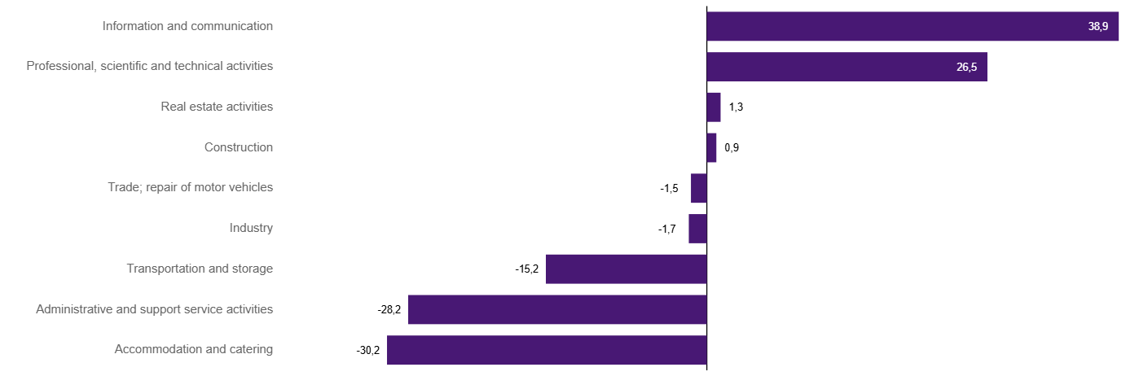
Chart 3. Relative deviations (in %) of monthly gross wages and salaries in selected sections from average wages and salaries in enterprise sector in Warszawa in June 2025

Construction
Sold production of construction in June 2025 amounted (at current prices) to PLN 6857.9 million and compared to May 2025 was larger by 0.7% and to the corresponding period of the previous year it increased by 6.6%.
In January-June 2025, the sold production of construction reached the value of PLN 36942.4 million, i.e. by 17.3% larger than in the corresponding period of 2024.
Construction and assembly production in June 2025 amounted to PLN 1558.5 million (at current prices) and accounted for 22.7% of sold production of construction. Compared to the previous month, construction and assembly production increased by 9.2%, and compared to June 2024 it was larger by 10.8%.
In the period January–June 2025, construction and assembly production amounted to PLN 7747.2 million and accounted for 21.0% of the sold construction production (22.5% a year earlier). Compared to the same period last year, construction and assembly production was higher by 9.5%.
The increase in production in relation to the corresponding period of 2024 occurred in units dealing with: construction of buildings (by 61.2%) and specialised construction activities (by 33.8%), while a decrease in units dealing with civil engineering (by 20.8%).
Labour productivity measured by production per employed person in construction in June 2025 amounted to PLN 129.2 thousand and was by 0.6% higher than a month before and by 6.8% higher than in June 2024.

Trade
Retail sales in trade and non-trade enterprises in June 2025 (at current prices) were by 0.4% smaller than in May 2025 and by 0.7% lower compared to June 2024.
Compared to May 2025, the decrease was recorded in sales of furniture, electronic goods and household equipment (by 6.9%), sales of pharmaceuticals, cosmetics, orthopedic equipment (by 4.7%), sales of food, beverages and tobacco (by 3.3%), sales of press, books, other sales in specialised stores (by 2.9%), and sales in the “other” group (by 1.3%).
However, there was an increase in other retail sales in non-specialised stores (by 19.8%), sale of textiles, clothing and footwear (by 13.9%), and also sales of solid, liquid and gas fuels (by 1.9%), sales of motor vehicles, motorcycles, parts (by 1.6%).
Compared to June 2024, the largest decrease was recorded in sales motor vehicles, motorcycles, parts (by 14.1%), followed by sales of furniture, electronic goods and household equipment (by 2.5%), and sales of solid, liquid and gas fuels (by 0.8%).
However the increase was recorded in other retail sales in non-specialised stores (by 14.1%), sales of textiles, clothing and footwear (by 7.1%), sales in the “other” group (by 6.2%), sales of food, beverages and tobacco (by 4.3%), and sales of press, books, other retail sales in specialized stores (by 3.1%), and sales of pharmaceuticals, cosmetics, orthopedic equipment (by 1.6%).
In the period January-June 2025 compared to the same period in 2024, retail sales decreased by 0.8%.
Wholesale in trade enterprises in June 2025 (at current prices) was by 3.7% larger as compared to the previous month and by 5.3% lower than in June 2024, and in wholesale enterprises it was higher by 4.5% and lower by 5.9%, respectively.
In the period January–June 2025, retail units achieved wholesale sales that were 6.5% lower than a year ago, while wholesale enterprises by 7.5% lower.

Industry
The sold production of industry in June 2025 amounted to (in current prices) PLN 13661.0 million and was (at constant prices) smaller than in the corresponding month of 2024 by 3.4%. As compared to June 2024, a decrease in sold production of industry was recorded in manufacturing by 4.4%.
In the period January-June 2025, sold production of industry amounted to PLN 86108.1 million (at current prices) and was (at constant prices) lower by 1.4% than that achieved in the same period of 2024. In manufacturing, a decrease in production by 2.1% was recorded.
Among the divisions classified as manufacturing, the increase in sales was recorded, among others, in: manufacture of food products (by 21.5%), repair and installation of machinery and equipment (by 11.0%), manufacture of furniture (by 10.9%), manufacture of computer, electronic and optical products (by 9.4%), manufacture of coke and refined petroleum products (by 9.1%), printing and reproduction of recorded media (by 3.6%), manufacture of basic metals and manufacture of beverages (by 1.6% each).
The increase in sales was recorded, among others, in: manufacture of motor vehicles, trailers and semi-trailers (by 127.9%), manufacture of wearing apparel (by 23.9%), manufacture of metal products (by 22.6%), manufacture of rubber and plastics (by 12.7%), manufacture of pharmaceutical products (by 12.2%), manufacture of products of wood, cork, straw and wicker (by 11.8%), manufacture of electrical equipment (by 8.5%), manufacture of other non-metallic mineral products (by 6.4%), manufacture of machinery and equipment n.e.c. (by 4.1%), other manufacturing (by 2.9%), manufacture of chemicals and chemical products (by 2.6%), manufacture of paper and paper products (by 2.4%), manufacture of textile products (by 1.4%).
Labour productivity in industry measured by production per employed person, in January-June 2025 amounted to PLN 466.6 thousand (at current prices) and was – at constant prices – by 0.1% higher than in the previous year.

Residential construction
According to preliminary data, 1451 dwellings were completed in Warszawa in June 2025, i.e. by 90.2% more than in the previous year.
In the period January-June 2025, 8541 dwellings were completed (by 37.5% more than in the corresponding period of 2024), and 19879 dwellings in Mazowieckie Voivodship, i.e. by 13.3% more than in January-June 2024. An increase in the number of dwellings was recorded in construction for sale or rent from 5875 to 8108, i.e. by 38.0% more, in private construction from 264 to 303, i.e. by 14.8% more. Moreover, 66 dwellings were completed by private buildings society, and 64 dwellings in cooperative construction in the period January-June 2025.

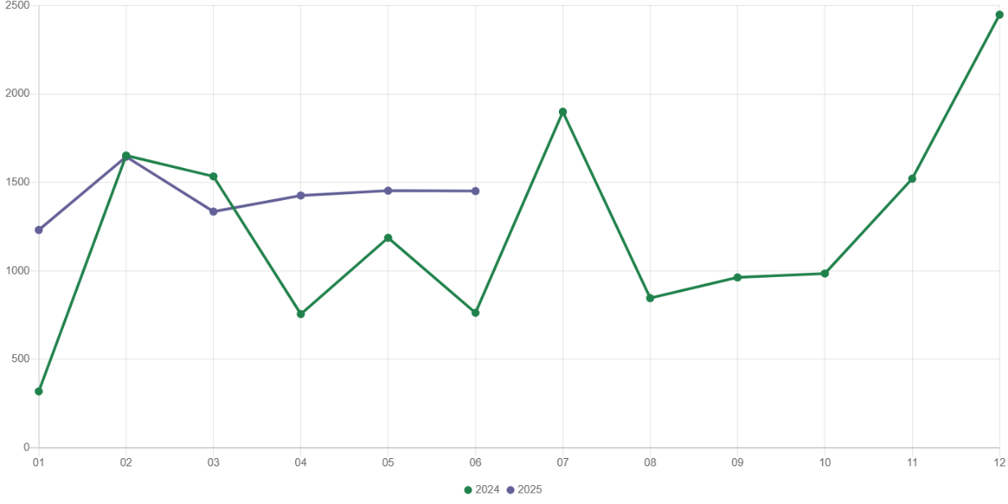
Chart 4. Dwellings completed
In January-June 2025, construction begun in 7003 dwellings (by 17.1% less than in the corresponding period of 2024) of which: 6732 in construction for sale or rent, 271 in private construction.
In January-June 2025, the number of dwellings for which permits have been granted or which have been registered with a construction project amounted to 6404 (by 44.7% less than in the corresponding period of 2024), of which 261 dwellings in buildings built by private investors.
The average useful floor area of a dwelling completed in January-June 2025, amounted to 55.7 m² and decreased compared to the corresponding period of 2024 by 9.6 m². In private construction, the average useful floor area of dwellings amounted to 185.1 m² (by 6.6 m² more than in the corresponding period of 2024), in public building society— 51.4 m² , in construction for sale or rent – 50.9 m² (by 9.6 m² less), and in cooperative construction – 49.4 m².

Entities of the national economy
At the end of June 2025, there were 587796 entities of the national economy registered in the REGON register in Warszawa, which accounted for 54.9% of the total in Mazowieckie Voivodship. Compared with May 2025, the number of entities of the national economy increased by 1762 (i.e. by 0.3%), and compared to June 2024 increased by 22867 (i.e. by 4.0%).
As of the end of June this year, there were 265089 legal persons and organisational units without legal personality registered in the REGON register, of which 191486 commercial companies. The number of these entities increased by 0.2% each compared to the previous month, and on an annual basis by 4.0% and 4.8%, respectively.
The number of registered natural persons conducting economic activity as of the end of June 2025 amounted to 322707 and compared to May 2025 it was higher by 0.4%, and compared to the corresponding period of the previous year increased by 4.1%.
In Warszawa, in June 2025, the most numerous were entities dealing with: professional, scientific and technical activities (19.3% of total registered units), trade; repair of motor vehicles (16.1%), as well as information and communication (13.0%).
Compared to May 2025, the number of entities increased, among others, in the sections: art, entertainment and recreation and administrative and support service activities (by 0.8% each), accommodation and catering and construction (by 0.5%), education and information and communication (by 0.4% each), transportation and storage as well as human health and social work activities, professional, scientific and technical activities (by 0.3% each). However there was a decrease in the number of entities in the sections: water supply; sewerage, waste management and remediation activities (by 0.4%), as well as electricity, gas, steam and air conditioning supply (by 0.2%).
Compared to June 2024, the largest increase in the number of entities was recorded in the sections: administrative and support service activities (by 9.6%), human health and social work activities (by 7.3%), agriculture, forestry and fishing (by 6.8%), electricity, gas, steam and air conditioning supply (by 6.4%), education (by 6.0%), construction (by 5.8%), information and communication (by 5.4%), art, entertainment and recreation and accommodation and catering (by 4.6% each).
In June 2025, 3468 new entities were entered into the REGON register, i.e. by 1.7% more than in the previous month. The newly registered entities were dominated by natural persons conducting economic activity – 2193 (by 0.5% less than in May 2025). The number of newly registered commercial companies was larger compared to the previous month by 5.3%, including limited liability companies – larger by 7.1%.
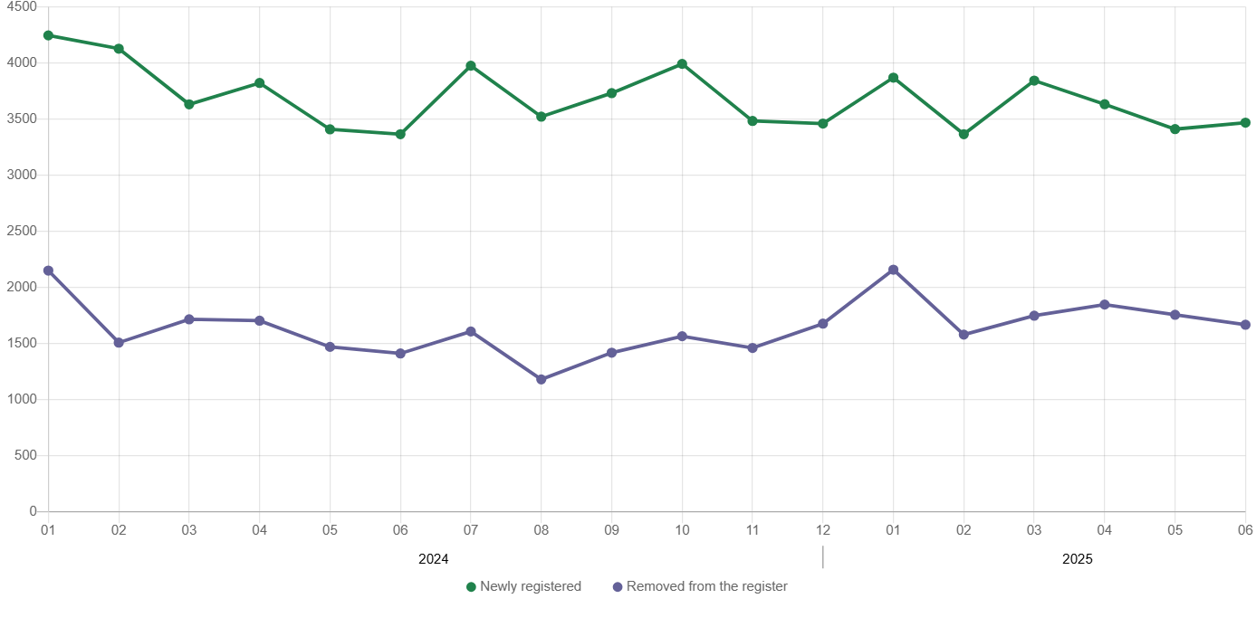
Chart 5. Entities newly registered and removed from the register

In June 2025, 1667 entities were removed from the REGON register (compared to 1756 in the previous month), including 959 natural persons conducting economic activity (by 6.9% less).
As of the end of June 2025, 69136 entities had suspended activity in the REGON register (by 2.9% less than a month before). The vast majority were natural persons conducting economic activity (91.5%).

When quoting Statistics Poland data, please provide the information: “Source of data: Statistics Poland”, and when publishing calculations made on data published by Statistics Poland, please include the following disclaimer: “Own study based on figures from Statistics Poland”.
Prepared by:  Statistical Office in Warszawa  Director Agnieszka Ajdyn  Phone: (+48 22) 464 23 15 | Issued by:  Statistical Information Centre  Marcin Kałuski  Phone: (+48) 783 940 141
Press office  Phone: (+48) 783 940 141  e-mail: m.kaluski@stat. gov.pl |   warszawa.stat.gov.pl/en/

@Warszawa_STAT

@UrzadStatystycznywWarszawie

gus_stat

glownyurzadstatystycznygus

glownyurzadstatystyczny

Related information
Communications and Announcements
Data available in databases
Local Data Bank → Labour market
Terms used in official statistics
Registered unemployed persons
Registered unemployment rate
Average paid employment
Average monthly gross wages and salaries
Dwellings completed

