Statistics of Warszawa No. 1/2023
In January 2023, there was an increase in the average employment and a decrease in the number of unemployed persons compared to the corresponding period of previous year. Sold production of industry was lower than a year earlier, while construction and assembly production was higher. There was an increase both in retail sales and wholesale compared to January last year. January 2023 was also characterised by a higher, than in the previous year, number of dwellings completed and dwellings in which construction has begun, and a much lower number of permits issued.

Average paid employment
Average paid employment in the enterprise sector in January 2023 amounted to 1137.9 thousand persons (converted into full-time equivalents) and was by 10.0 thousand persons, i.e. by 0.9% higher than in December 2022, and by 27.1 thousand persons, i.e. by 2.4% higher than in January 2022.
Compared to December 2022, an increase in the average employment was recorded in the following sections: professional, scientific and technical activities (by 4.0%), information and communication (by 3.2%), construction (by 1.5%), administrative and support service activities (by 1.0%), real estate activities (by 0.7%), transportation and storage (by 0.6%).
Whereas a decrease (by 0.9%) in the average employment was recorded in the trade; repair of motor vehicles section.

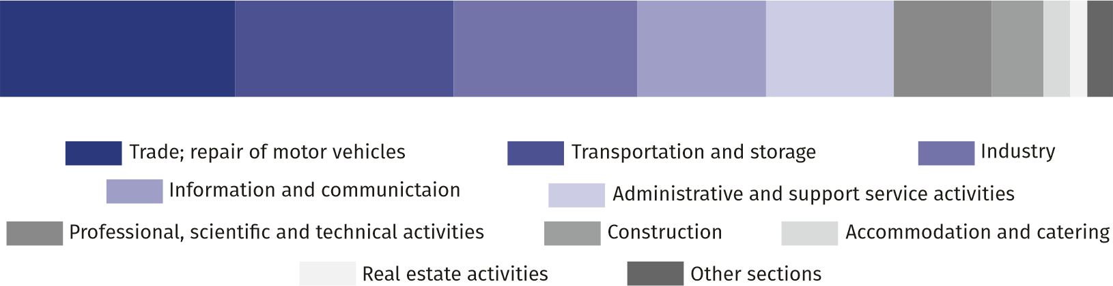
Chart 1. Structure of average paid employment by sections of PKD in January 2023

As compared to January 2022, an increase in the average employment was recorded in the sections: professional, scientific and technical activities (by 10.9%), information and communication (by 7.2%), construction (by 2.6%), administrative and support service activities (by 2.1%), real estate activities (by 1.1%), transportation and storage (by 0.8%).
A decrease in the average employment was recorded in the section of industry (by 0.9%) and trade; repair of motor vehicles (by 0.1%).

Registered unemployment
At the end of January 2023, the number of registered unemployed persons amounted to 20749 and was by 577 persons, i.e. by 2.9% larger than at the end of December 2022 and by 3389 persons, i.e. by 14.0% smaller than in the corresponding period of 2022.
The number of registered unemployed women amounted to 10220, which accounted for 49.3% of the total unemployed (49.7% a month and 47.7% a year before) and 16.7% of unemployed women in Mazowieckie Voivodship. As compared to December 2022, the number of unemployed women increased by 187 persons, i.e. by 1.9% and compared to January 2022 decreased by 1286 persons, i.e. by 11.2%.
The registered unemployment rate amounted to 1.5% (1.4% in the previous month, 1.7% in the previous year), the average in Mazowieckie Voivodship was 4.4% (4.2% a month before, and 4.8% a year before), while the national average was 5.5% (5.2% a month before and 5.9% a year before).
In January 2023, there were 2882 unemployed persons registered in labour offices (2362 in December 2022, and 1996 in January 2022). Registered unemployed persons accounted for 17.7% of the total registered unemployed in the Voivodship.
The number of persons registering for the first time amounted to 1085 (a month before 759), which accounted for 37.6% of the total unemployed who registered in January 2023 and 27.8% of persons registering for the first time in the Voivodship. The share of persons terminated due to company reasons among unemployed persons registered in January 2023 amounted to 1.5% (4.5% in Mazowieckie Voivodship), 1.9% a month and 2.2% a year before.
In January 2023, 2305 persons were removed from unemployment rolls (2953 in December 2022, and 1990 in January 2022), which accounted for 20.8% of unemployed persons removed from unemployment rolls in Mazowieckie Voivodship. Out of the unemployed removed from unemployment rolls, 1132 persons took up work. Moreover, 744 persons lost their status of the unemployed as a result of not confirming their readiness to take up work. The reason for removing from the register was also starting training or traineeship, acquisition of retirement rights of pre-retirement benefit, acquisition of pension rights, voluntarily gave up the status of the unemployed and other.

There were 18366 persons who were not entitled to the unemployment benefit, i.e. 88.5% of the total unemployed (21442 persons a year before, i.e. 88.8%). Whereas 2383 unemployed persons were entitled to the unemployment benefit.

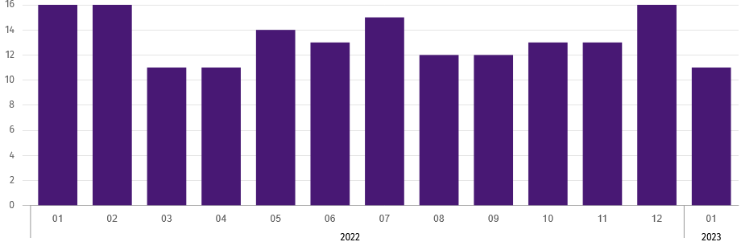
Chart 2. Number of unemployed persons per job offer (as of end of month)
In January 2023, there were 3425 job offers submitted to labour offices, which accounted for 20.2% of job offers in Mazowieckie Voivodship and at the end this month the labour offices had job offers for 1859 persons. At the end of January 2023 there were 11 persons per one job offer (16 a month and a year before), in Mazowieckie Voivodship 15 persons (28 a month before, 16 a year before) registered as unemployed.

Wages and salaries
The average monthly gross wages and salaries in the enterprise sector in January 2023 amounted to PLN 8395.76 and were by 4.7% lower as compared to the previous month and by 11.6% higher than in the corresponding period of 2022
Compared to December 2022, the decrease in the average gross wages and salaries was recorded in the following sections: construction (by 14.3%), transportation and storage (by 12.5%), real estate activities (by 12.2%), professional, scientific and technical activities (by 6.4%), industry (by 5.0%), trade; repair of motor vehicles (by 3.4%).
On the other hand, an increase in the average gross wages and salaries occurred in the administrative and support service activities section (by 4.4%) and information and communication (by 2.4%).

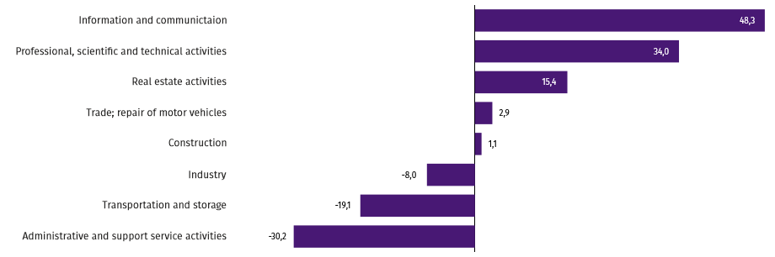
Chart 3. Relative deviations (in %) of monthly gross wages and salaries in selected sections from average wages and salaries in enterprise sector in Janury 2023

Compared to January 2022, an increase in the average gross wages and salaries was recorded in the sections: transportation and storage (by 18.8%), information and communication (by 14.3%), real estate activities (by 12.4%), administrative and support service activities (by 9.8%), trade; repair of motor vehicles and industry (by 9.4% each), professional, scientific and technical activities (by 6.2%), construction (by 2.6%).

Construction
Sold production of construction in January 2023 amounted (at current prices) to PLN 3906.1 million and compared to December 2022 was smaller by 45.9%, and compared to the corresponding period of the previous year it increased by 25.2%.
Construction and assembly production in January 2023 amounted to PLN 811.6 million (at current prices) and accounted for 20.8% of sold production of construction. Compared to the previous month, construction and assembly production decreased by 46.7%, and compared to January 2022 it was larger by 14.2%.
The increase in production in relation to the corresponding period of 2022 occurred in units dealing with specialised construction activities (by 44.9%), and civil engineering (by 21.0%), whereas a decrease in production was recorded in units dealing with construction of buildings (by 27.2%).
Labour productivity measured by production per employed person in construction in January 2023 amounted to PLN 73.9 thousand and was by 46.7% lower than a month before and by 22.0% higher than in January 2022.

Trade
Retail sales in trade and non-trade enterprises in January 2023 (at current prices) were by 27.4% lower than in December 2022 and by 11.9% higher compared to January 2022.
Compared to December 2022, there was a decrease, among others, in: sales of press, books, other retail sales in specialised stores (by 42.1%), retail sales conducted by mail order houses (by 39.9%), other retail sales in non-specialised stores ( (by 36.9%), sales of food, beverages and tobacco (by 36.6), sales of furniture, electronic goods and household appliances (by 31.0%), sales of pharmaceuticals, cosmetics, orthopedic equipment (by 30.9%), sales of textiles, clothing and footwear (by 22.2%), sales in the group of “others” (by 20.8%), sales of solid, liquid and gas fuels (by 11.8%).
On the other hand, sales of motor vehicles, motorcycles and parts increased (by 9.0%).
Compared to January 2022, there was an increase, among others, in the sales of pharmaceuticals, cosmetics, orthopedic equipment (by 42.9%), sales of textiles, clothing and footwear (by 36.4%), other retail sales in non-specialised stores (by 22.2%), sales of solid, liquid and gas fuels (by 14.7%), sales of food, beverages and tobacco (by 14.6%), sales of motor vehicles, motorcycles, parts (by 13.7%), sales in the group of “others” (by `12.6%), sales of furniture, electronic goods and household appliances (by 6.6%), sales of press, books, other retail sales in specialised stores (by 0.4%).
Whereas there was a decrease in the retail sales conducted by mail order houses (by 23.4%).
Wholesale in trade enterprises in January 2023 (at current prices) was by 13.9% smaller as compared to the previous month and by 6.9% higher as compared to January 2022, and in wholesale enterprises it was lower by 16.8% and lower by 2.1%, respectively.

Industry
Sold production of industry in January 2023 amounted (at current prices) to PLN 28693.4 million and was (at constant prices) smaller as compared to the corresponding period of 2022 by 7.0%. As compared to January 2022, an increase by 2.9% was recorded in sold production in manufacturing.
Among divisions included in manufacturing, the sales increase was recorded, among others, in: printing and reproduction of printed media (by 91.7%), manufacture of furniture (by 28.5%), manufacture of wearing apparel (by 27.1%), other manufacturing (by 26.9%), manufacture of machinery and equipment n.e.c. (by 21.5%), manufacture of pharmaceutical products (by 20.9%), manufacture of rubber and plastic products (by 12.9%), manufacture of food products (by 10.4%), manufacture of chemicals and chemical products (by 7.1%), manufacture of basic metals (by 1.7%).
The decrease was recorded, among others, in: manufacture of textile products (by 41.3%), manufacture of other transport equipment (by 29.1%), manufacture of metal products (by 25.2%), manufacture of computers, electronic and optical products (by 20.2%), manufacture of beverages (by 16.3%), manufacture of coke and refined petroleum products (by 14.2%), manufacture of products of wood, cork, straw and wicker (by 13.9%), manufacture of motor vehicles, motorcycles, parts (by 10.9%), manufacture of electrical equipment (by 5.2%), repair and installation of machinery and equipment (by 1.9%), manufacture of paper and paper products (by 1.7%), manufacture of other non-metallic mineral products (by 0.3%).
Labour productivity in industry measured by production per employed person, in January 2023 amounted to PLN 152.9 thousand (at current prices) and was – at constant prices – by 6.2% lower than in the previous year.

Housing construction
According to preliminary data, 986 dwellings were completed in Warszawa in January 2023 (by 41.7% more than in the corresponding period of 2022), and 3224 in Mazowieckie Voivodship, i.e. by 12.1% more than in January 2022. The increase in the number of dwellings completed was recorded in construction for sale or rent from 569 to 903, i.e. by 58.7%, in private construction from 63 to 83, i.e. by 31.7%.

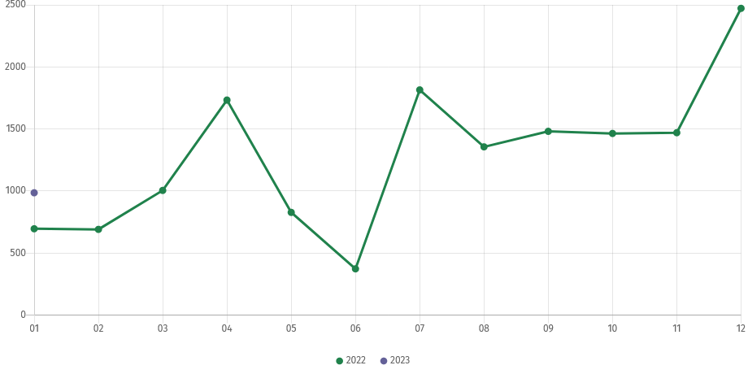
Chart 4. Dwellings completed
In January 2023, the construction began in 1267 dwellings (by 70.5% more than in the corresponding period of 2022), of which: 1250 in construction for sale or rent, 17 in private construction.
In January 2023, the number of dwellings for which permits have been granted or which have been registered with a construction project amounted to 747 (by 50.5% less than in the corresponding period of 2022), of which 35 dwellings in buildings built by private investors.
The average useful floor area of a dwelling completed in January 2023, amounted to 71.5 m² and increased by 2.5 m². In private construction, the average useful floor area of dwellings amounted to 170.2 m² (by 17.7 m² fewer than in the corresponding period of 2022), in construction for sale or rent — 62.5 m² (by 5.0 m² more).

Entities of the national economy
At the end of January 2023, there were 527396 entities of the national economy registered in the REGON register in Warszawa, which accounted for 54.3% of the total in Mazowieckie Voivodship. Compared with December 2022, the number of entities of the national economy increased by 1921 (i.e. by 0.4%), and compared to January 2022 by 26538 (i.e. by 5.3%).
As of the end of January this year, there were 238789 legal persons and organisational units without legal personality registered in the REGON register, of which 168763 commercial companies. The number of these entities increased compared to the previous month by 0.4% and 0.5%, whereas on an annual basis by 5.2% and 6.7%, respectively.
The number of registered natural persons conducting economic activity as of the end of January 2023 amounted to 288607 and compared to December 2022 it was higher by 0.4%, and compared to the corresponding period of the previous year increased by 5.4%.
In Warszawa, in January 2023 the most numerous were entities dealing with professional, scientific and technical activities (19.4% of total registered units), trade; repair of motor vehicles (17.4%), as well as information and communication (11.9%).
Compared to December 2022, the number of entities increased, among others, in the sections: electricity, gas, steam and air conditioning supply by (1.5%), information and communication (by 1.3%), households employing employees and producing products for their own needs (by 0.6%), health care and social welfare, administrative and support service activities (by 0.5% each). However, there was a decrease in the number of entities in the section of water supply; sewerage, waste management and remediation activities (by 0.6%), mining and quarrying (by 0.3%).
In comparison with January 2022, the largest increase was recorded in the sections: electricity, gas, steam and air conditioning supply by (17.3%), information and communication (by 17.2%), administrative and support service activities (by 7.0%), education (by 6.3%), health care and social welfare (by 6.2%). Whereas a decrease in the number of entities was recorded in the section of financial and insurance activities (by 0.2%).

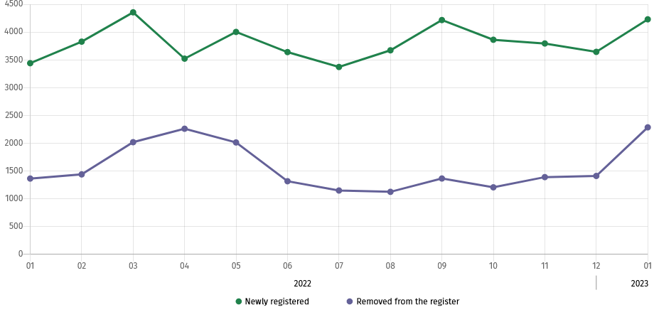
Chart 5. Entities newly registered and removed from the register

In January 2023, 4229 new entities were entered into the REGON register, i.e. by 16.1% more than in the previous month. The newly registered entities were dominated by natural persons conducting economic activity – 2822 (by 20.5% more than in December 2022). The number of newly registered commercial companies was larger than in the previous month by 12.6%, including limited liability companies – larger by 14.4%.
In January 2023, 2284 entities were removed from the REGON register (compared to 1409 in the previous month), including 1745 natural persons conducting economic activity (by 65.9% more).
As of the end of January 2023, 58921 entities had suspended activity in the REGON register (by 3.0% more than a month before). The vast majority were natural persons conducting economic activity (85.0%).

In the case of quoting data from Statistics Poland, please provide information: "Source of data – Statistics Poland", and in the case of publishing calculations made on data published by Statistics Poland, please provide information: "Own study based on Statistics Poland data”.

Prepared by:  Statistical Office in Warszawa  Acting Director Agnieszka Ajdyn  Tel.: (+48 22) 464 23 15 | Issued by:  Statistical Information Centre  Marcin Kałuski  Tel.: (+48 22) 464 20 91
Press office  Tel.: (+48 22) 464 20 91  e-mail: m.kaluski@stat. gov.pl | warszawa.stat.gov.pl/en/
 | @Warszawa_STAT
 | @UrzadStatystycznywWarszawie
 | gus_stat
 | glownyurzadstatystycznygus
 | glownyurzadstatystyczny
Related information
Communications and Announcements
Data available in databases
Local Data Bank → Labour market
Terms used in official statistics
Registered unemployed persons
Registered unemployment rate
Average paid employment
Average monthly gross wages and salaries
Dwellings completed
Gross turnover profitability indicator
Net turnover profitability indicator

