Statistics of Warszawa No. 11/2022
102.9
Indices of average paid employment y/y
In November 2022, there was an increase in the average employment and a decrease in the number of unemployed persons compared to the corresponding period of previous year. Both sold production of industry and construction and assembly production were lower than a year earlier. There was an increase both in retail sales and wholesale compared to November last year. November this year was also characterised by a lower, than in the previous year, number of dwellings completed and dwellings in which construction has begun as well as number of permits issued.

Average paid employment
Average paid employment in the enterprise sector in November 2022 was by 2.9% higher than a year before

Average paid employment in the enterprise sector in November 2022 amounted to 1124.4 thousand persons and was by 3.0 thousand persons, i.e. by 0.3% higher than in October 2022, and by 31.6 thousand persons, i.e. by 2.9% higher than in November 2021.
Compared to October 2022, an increase in the average employment was recorded in the following sections: administrative and support service activities (by 1.7%), accommodation and catering (by 0.8%), real estate activities (by 0.6%), professional, scientific and technical activities as well as transportation and storage (by 0.4% each).
Whereas a decrease in the average employment was recorded in the section: industry (by 0.3%), construction (by 0.2%), trade; repair of motor vehicles (by 0.1%).

Chart 1. Structure of average paid employment by sections of PKD in November 2022
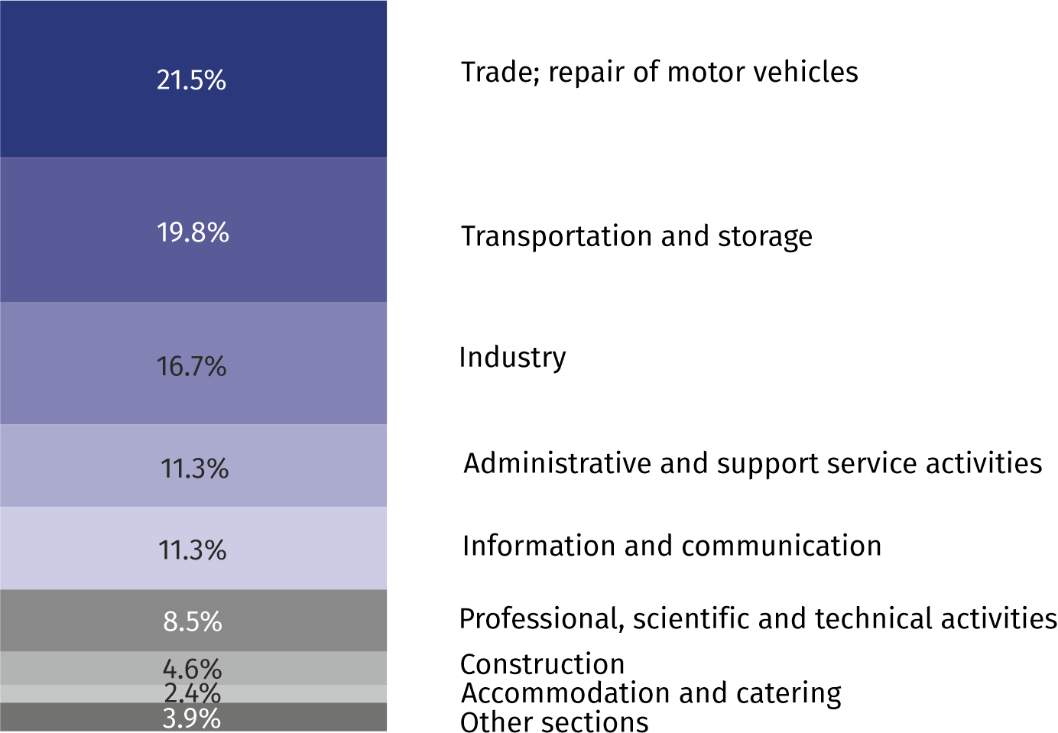
As compared to November 2021, an increase in the average employment was recorded in the sections: accommodation and catering (by 8.9%), information and communication (by 7.7%), professional, scientific and technical activities (by 7.3%), construction and trade; repair of motor vehicles, (by 2.5% each), administrative and support service activities (by 1.3%), transportation and storage (by 0.9%), industry (0.7%).
A decrease in the average employment was recorded in the section of real estate activities (by 1.4%).
Registered unemployment
At the end of November 2022, the number of registered unemployed persons amounted to 20763 and was by 416 persons, i.e. by 2.0% smaller than at the end of October 2022 and by 3872 persons, i.e. by 15.7% smaller than in the corresponding period of 2021.
At the end of November 2022, the number of registered unemployed persons was by 15.7% smaller than in the previous year
The number of registered unemployed women amounted to 10456, which accounted for 50.4% of the total unemployed (50.8% a month and 48.3% a year before) and 17.7% of unemployed women in Mazowieckie Voivodship. As compared to October 2022, the number of unemployed women decreased by 293 persons, i.e. by 2.7% and compared to November 2021 decreased by 1441 persons, i.e. by 12.1%.
The registered unemployment rate amounted to 1.5% (as in the previous month), the average in Mazowieckie Voivodship was 4.2% (as a month before, and 4.8% a year before), while the national average was 5.1% (as a month before and 5.8% a year before).
In November 2022, there were 2685 unemployed persons registered in labour offices (2852 in October 2022, and 2079 in November 2021). Registered unemployed persons accounted for 19.1% of the total registered unemployed in the Voivodship.
The number of persons registering for the first time amounted to 984 (a month before 1160), which accounted for 36.6% of the total unemployed who registered in November 2022 and 28.4% of persons registering for the first time in the Voivodship. The share of persons terminated due to company reasons among unemployed persons registered in November 2022 amounted to 1.3% (3.4% in Mazowieckie Voivodship), 1.4% a month and a year before.
In November 2022, 3101 persons were removed from unemployment rolls (3704 in October 2022, and 2494 in September 2021), which accounted for 21.5% of unemployed persons removed from unemployment rolls in Mazowieckie Voivodship. Out of the unemployed removed from unemployment rolls, 1555 persons took up work. Moreover, 963 persons lost their status of the unemployed as a result of not confirming their readiness to take up work. The reason for removing from the register was also starting training or traineeship, acquisition of retirement rights of pre-retirement benefit, acquisition of pension rights, voluntarily gave up the status of the unemployed and other.
There were 18466 persons who were not entitled to the unemployment benefit, i.e. 88.9% of the total unemployed (21774 persons a year before, i.e. 88.4%). Whereas 2297 unemployed persons were entitled to the unemployment benefit.

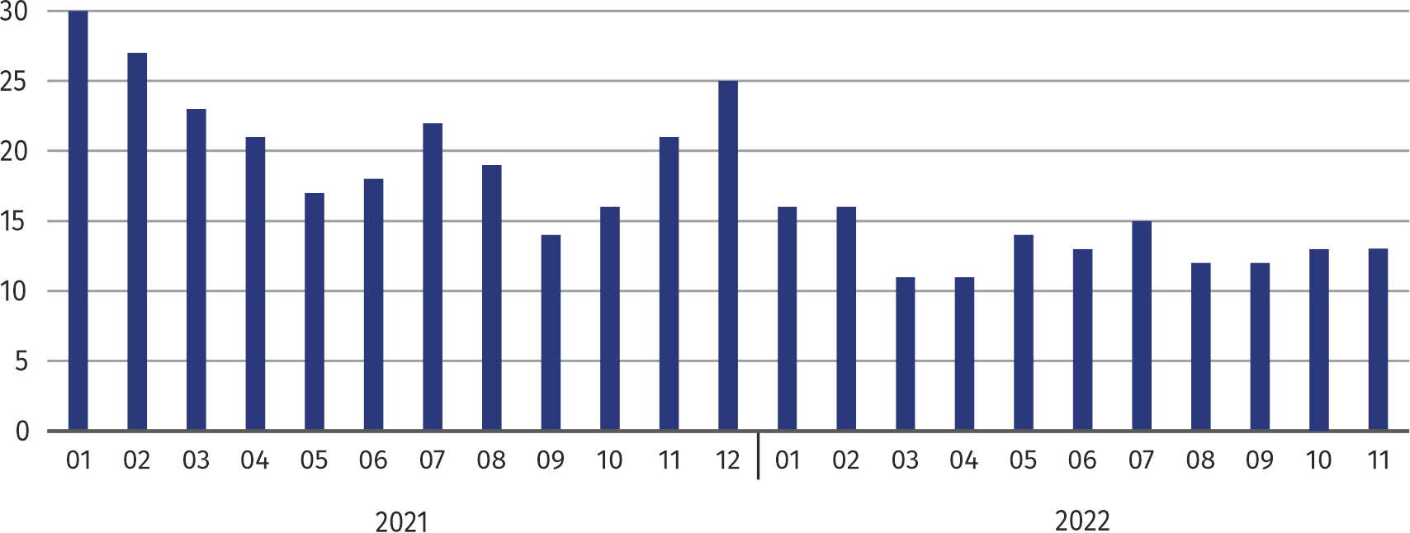
Chart 2. Number of unemployed persons per job offer (as of end of month)
In November 2022, there were more job offers by 1.7% than in the previous year

In November 2022, the share of the unemployed who were not entitled to the unemployment benefit was 0.5 pp higher than the year before

In November 2022, there were 3281 job offers submitted to labour offices, which accounted for 20.0% of job offers in Mazowieckie Voivodship and at the end this month the labour offices had job offers for 1610 persons. At the end of November 2022 there were 13 persons per one job offer (as a month before and 21 a year before), in Mazowieckie Voivodship 15 persons (17 a month and 14 a year before) registered as unemployed.
Average monthly gross wages and salaries in the enterprise sector in November 2022 amounted to PLN 8,128.08 and were by 12.1% higher than in November 2021

Wages and salaries
The average monthly gross wages and salaries in the enterprise sector in November 2022 amounted to PLN 8128.08 and were by 2.2% lower as compared to the previous month and by 12.1% higher than in the corresponding period of 2021.
Compared to October 2022, the decrease in the average gross wages and salaries was recorded in the following sections: transportation and storage (by 10.1%), construction (by 9.3%), administrative and support service activities (by 1.0%), trade; repair of motor vehicles (by 0.7%), information and communication (by 0.5%).
On the other hand, the increase in the average gross wages and salaries was recorded in the following sections: industry (by 3.0%), accommodation and catering (by 1.6%), professional, scientific and technical activities (by 1.0%), real estate activities (by 0.3%).

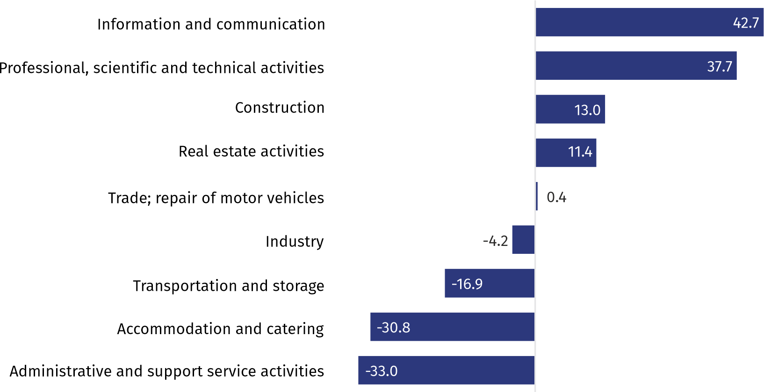
Chart 3. Relative deviations (in %) of monthly gross wages and salaries in selected sections from average wages and salaries in enterprise sector in November 2022
Compared to November 2021, an increase in the average gross wages and salaries was recorded in the sections: construction (by 14.1%), real estate activities (by 13.3%), professional, scientific and technical activities (by 13.2%), trade; repair of motor vehicles (by 12.4%), transportation and storage (by 11.9%), administrative and support service activities (by 11.4%), information and communication (by 11.3%), industry (by 9.6%), accommodation and catering (by 4.9%).

Industry
Sold production in manufacturing (at constant prices) in November 2022 was by 1.3% smaller than a year before

Sold production of industry in November 2022 amounted (at current prices) to PLN 23437.7 million and was (at constant prices) smaller as compared to the corresponding period of 2021 by 6.8%. As compared to November 2021, a decrease by 1.3% was recorded in sold production in manufacturing.
In the period January–November 2022, sold production of industry amounted to PLN 224947.0 million (in current prices) and was (in constant prices) higher by 12.5% than that achieved in the corresponding period of 2021. In manufacturing, an increase in production by 7.8% was recorded.
Among divisions included in manufacturing, the sales increase was recorded, among others, in: manufacture of coke and petrol products (by 42.6%), manufacture of pharmaceutical products (by 36.2%), repair and installation of machinery and equipment (by 25.5%), manufacture of chemicals and chemical products (by 18.9%), manufacture of rubber and plastic products (by 16.9%), manufacture of other transport equipment and manufacture of furniture (by 15.3% each).
The decrease was recorded, among others, in: manufacture of metal products (by 25.3%), manufacture of paper and paper products (by 11.5%), manufacture of beverages (by 4.4%).
Labour productivity in industry measured by production per employed person, in January–November 2022 amounted to PLN 1201.8 thousand (at current prices) and was – at constant prices – by 11.6% higher than in the previous year.

Construction
Sold production of construction in November 2022 amounted (at current prices) to PLN 6449.7 million and compared to October 2022 was higher by 2.0%, and compared to the corresponding period of the previous year it increased by 28.2%.
In the period of January-November 2022, sold production of construction reached the value of PLN 63718.8 million, i.e. 26.8% larger than in the corresponding period of 2021.
Construction and assembly production (at constant prices) in November 2022 was by 7.5% smaller than a year before

Construction and assembly production in November 2022 amounted to PLN 1249.6 million (at current prices) and accounted for 19.4% of sold production of construction. Compared to the previous month, construction and assembly production increased by 0.1%, and compared to November 2021 it was smaller by 7.5%.
In the period January-November 2022, construction and assembly production amounted to PLN 12735.9 million and accounted for 20.0% of sold construction production (23.5% the year before). Compared to the corresponding period of the previous year, construction and assembly production was higher by 8.1%.
The increase in production in relation to the corresponding period of 2021 occurred in units dealing with construction of buildings (by 22.1%), civil engineering (by 4.7%), and specialised construction activities (by 2.2%).
Labour productivity measured by production per employed person in construction in November 2022 amounted to PLN 124.4 thousand and was by 2.2% higher than a month before and by 25.0% higher than in November 2021.

Trade
Retail sales (at current prices) in trade and non-trade enterprises in November 2022 were by 12.2% larger than in November 2021

Retail sales in trade and non-trade enterprises in November 2022 (at current prices) were by 4.9% higher than in October 2022 and by 12.2% higher compared to November 2021.
Compared to October 2022, there was an increase, among others, in: retail sales conducted by mail order houses (by 33.6%), sales of pharmaceuticals, cosmetics, orthopedic equipment (by 21.5%), sales of furniture, electronic goods and household appliances (by 8.2%), sales of press, books, other retail sales in specialsed stores (by 6.5%).
Whereas there was a decrease in the sales in the group of other sales (by 2.0%), sales of solid, liquid and gas fuels (by 0.9%), sales of motor vehicles, motorcycles, parts as well as sales of food, beverages and tobacco (by 0.5% each).
Compared to November 2021, there was an increase, among others, in the retail sales conducted by mail order houses (by 28.7%), sales of textiles, clothing and footwear (by 26.0%), other retail sales in non-specialised stores ( (by 25.6%), sales of food, beverages and tobacco (by 22.8%), sales of solid, liquid and gas fuels (by 21.4%), sales of pharmaceuticals, cosmetics, orthopedic equipment (by 20.1%).
Whereas there was a decrease in the sales of motor vehicles, motorcycles, parts (by 5.0%).
In the period January-November 2022, compared to the corresponding period of 2021, retail sales increased by 17.2%.
Wholesale in trade enterprises in November 2022 (at current prices) was by 5.7% larger as compared to the previous month and by 25.1% higher as compared to November 2021, and in wholesale enterprises it was higher by 6.5% and higher by 25.4%, respectively.
Wholesale (at current prices) in trade enterprises was by 25.1% higher than a year before

In the period of January-November 2022, trade enterprises realised wholesale sales by 26.2% higher than in the previous year, while wholesale enterprises by 30.7% higher.
Housing construction
According to preliminary data, 1470 dwellings were completed in Warszawa in November 2022, i.e. by 47.7% less than in the corresponding period of 2021.
In the period of January-November 2022, 12912 dwellings were completed (by 21.7% less than in the corresponding period of 2021), and in Mazowieckie Voivodship, 37650 dwellings, i.e. by 4.0% less than in the period of January-November 2021. A decrease in the number of completed dwellings was recorded in construction for sale or rent from 15739 to 11845, i.e. by 24.7% less. Whereas there was an increase in private construction from 597 to 655, i.e. by 9.7% more. In addition, in the period of January–November 2022, 412 apartments in cooperative housing were completed.

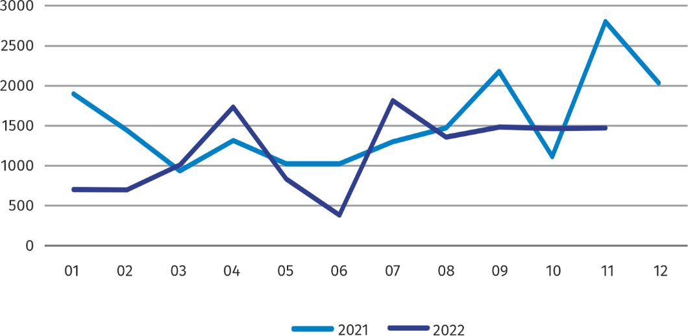
Chart 4. Dwellings completed
In January-November 2022, the construction began in 11886 dwellings, i.e. by 30.2% less than in the corresponding period of the previous year

In November 2022, the construction began in 975 dwellings, i.e. by 5.6% less than in November 2021.
In January–November 2022, the construction began in 11886 dwellings (by 30.2% less than in the corresponding period of 2021), of which: 11253 in construction for sale or rent, 482 in private construction, 120 in cooperative construction, 31 in company construction.
The number of dwellings for which permits have been granted or which have been registered with a construction project in November 2022 amounted to 458 and was by 59.2% lower than in the previous year.
In the period of January–November 2022, the number of dwellings for which permits have been granted or which have been registered with a construction project amounted to 18694 (11.8% more than in the corresponding period of 2021), including 497 dwellings built by private investors.
The average useful floor area of a dwelling completed in January–November 2022, amounted to 63.8 m² and decreased compared to the corresponding period of 2021 by 1.3 m². In private construction, the average useful floor area of dwellings amounted to 177.8 m² (by 15.9 m² fewer than in the corresponding period of 2021), in cooperative construction — 58.4 m², in construction for sale or rent — 57.7 m² (by 2.8 m² fewer).

Entities of the national economy
At the end of November 2022, the most numerous group of entities by kind of conducted activity represented units dealing with professional, scientific and technical activities

At the end of November 2022, there were 523093 entities of the national economy registered in the REGON register in Warszawa, which accounted for 54.2% of the total in Mazowieckie Voivodship. Compared with October 2022, the number of entities of the national economy increased by 2330 (i.e. by 0.4%), and compared to November 2021 by 26101 (i.e. by 5.3%).
As of the end of November 2021, there were 236870 legal persons and organisational units without legal personality registered in the REGON register, of which 167041 commercial companies. The number of these entities increased compared to the previous month by 0.4% and 0.5%, whereas on an annual basis by 5.6% and 7.2%, respectively.
The number of registered natural persons conducting economic activity as of the end of November 2022 amounted to 286223 and compared to October 2022 it was higher by 0.5%, and compared to the corresponding period of the previous year decreased by 5.0%.
In Warszawa, in November 2022 the most numerous were entities dealing with professional, scientific and technical activities (19.4% of total registered units), trade; repair of motor vehicles (17.5%), as well as information and communication (11.7%).
Compared to October 2022, the number of entities increased, among others, in the sections: electricity, gas, steam and air conditioning supply by (1.5%), information and communication (by 1.2%), health care and social welfare (by 0.8%), public administration and national defence; compulsory social security (by 0.7%). However, there was a decrease in the number of entities in the sections: mining and quarrying as well as agriculture, forestry and fishing (by 0.3% each).
In comparison with November 2021, the largest increase was recorded in the sections: electricity, gas, steam and air conditioning supply by (16.6%), electricity, gas, steam and air conditioning supply by (15.7%), administrative and support service activities (by 7.1%), health care and social welfare as well as construction (by 6.2% each).

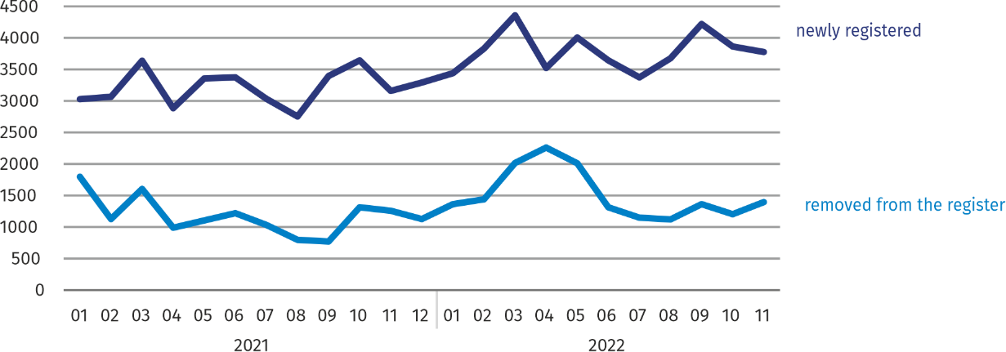
Chart 5. Entities newly registered and removed from the register
In November 2022, the number of newly registered entities was 1.7% smaller than a month earlier, and the number of suspended activities increased by 0.8%

In November 2022, 3794 new entities were entered into the REGON register, i.e. by 1.7% less than in the previous month. The newly registered entities were dominated by natural persons conducting economic activity – 2481 (by 4.6% less than in October 2022). The number of newly registered commercial companies was larger than in the previous month by 6.4%, including limited liability companies – larger by 7.3%.
In November 2022, 1388 entities were removed from the REGON register (compared to 1204 in the previous month), including 919 natural persons conducting economic activity (by 8.5% more).
As of the end of November 2022, 56488 entities had suspended activity in the REGON register (by 0.8% more than a month before). The vast majority were natural persons conducting economic activity (85.5%).

In the case of quoting data from Statistics Poland, please provide information: "Source of data – Statistics Poland", and in the case of publishing calculations made on data published by Statistics Poland, please provide information: "Own study based on Statistics Poland data”.

Prepared by:  Statistical Office in Warszawa  Acting Director Agnieszka Ajdyn  Tel.: (+48 22) 464 23 15 | Issued by:  Statistical Information Centre  Marcin Kałuski  Tel.: (+48 22) 464 20 91
Press office  Tel.: (+48 22) 464 20 91  e-mail: m.kaluski@stat. gov.pl | warszawa.stat.gov.pl/en/
 | @Warszawa_STAT
 | @UrzadStatystycznywWarszawie
 | gus_stat
 | glownyurzadstatystycznygus
 | glownyurzadstatystyczny
Related information
Communication and Announcements
Data available in databases
Local Data Bank → Labour market
Terms used in official statistics
Registered unemployed persons
Registered unemployment rate
Average paid employment
Average monthly gross wages and salaries
Dwellings completed
Gross turnover profitability indicator
Net turnover profitability indicator

Reporting data – may change after preparing quarterly reports.
Applies to legal persons, organizational units without legal personality and natural persons conducting economic activity (excluding natural persons tending private farms in agriculture).

